## Beginning C++ Programming Slides

Main Course Slides.

## Welcome and Introduction to the Course

* About me
* My assumptions
* Your background
* The curriculum and Modern C++
* Practice!
* Please ask questions

## Why Learn C++?

* Popular
  + Lots of code is still written in C++
  + Programming language popularity indexes
  + Active community, GitHub, stack overﬂow
* Relevant
  + Windows, Linux, Mac OSX, Photoshop, Illustrator, MySQL, MongoDB, Game engines, more …
  + Amazon, Apple, Microsoft, PayPal, Google, Facebook, MySQL, Oracle, HP, IBM, more…
  + VR, Unreal Engine, Machine learning, Networking & Telecom, more…
* Powerful
  + fast, ﬂexible, scalable, portable
  + Procedural and Object-oriented
* Good career opportunities
  + C++ skills always in demand
  + C++ = Salary++

## Modern C++ and the C++ Standard

* Early 1970s
  + C Programming Language
  + Dennis Ritchie
* 1979
  + Bjarne Stroustrup
  + C with Classes
* 1983
  + Name changed to C++
* 1989
  + First commercial release
* 1998
  + C++98 Standard
* 2003
  + C++03 Standard
* 2011
  + C++11 Standard
* 2014
  + C++14 Standard
* 2017
  + C++17 Standard

## Modern C++ and the C++ Standard

* Classical C++
  + Pre C++11 Standard
* Modern C++
  + C++11
    - Lots of new features
  + C++14
    - Smaller changes
  + C++17
    - Simpliﬁcation
  + Best practices
  + Core Guidelines

## How does it all work?

* You must tell the computer EXACTLY what to do
  + Program – like a recipe
* Programming language
  + source code
  + high-level
  + for humans
* Editor – used to enter program text
  + .cpp and .h ﬁles
* Binary or other low-level representation
  + object code
  + for computers
* Compiler – translates from high-level to low-level
* Linker – links together our code with other libraries
  + Creates executable program
* Testing and Debugging – ﬁnding and ﬁxing program errors

## The C++ Build Process

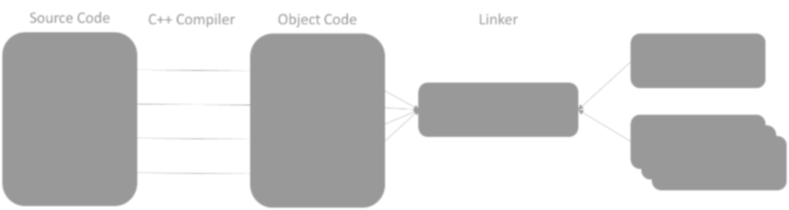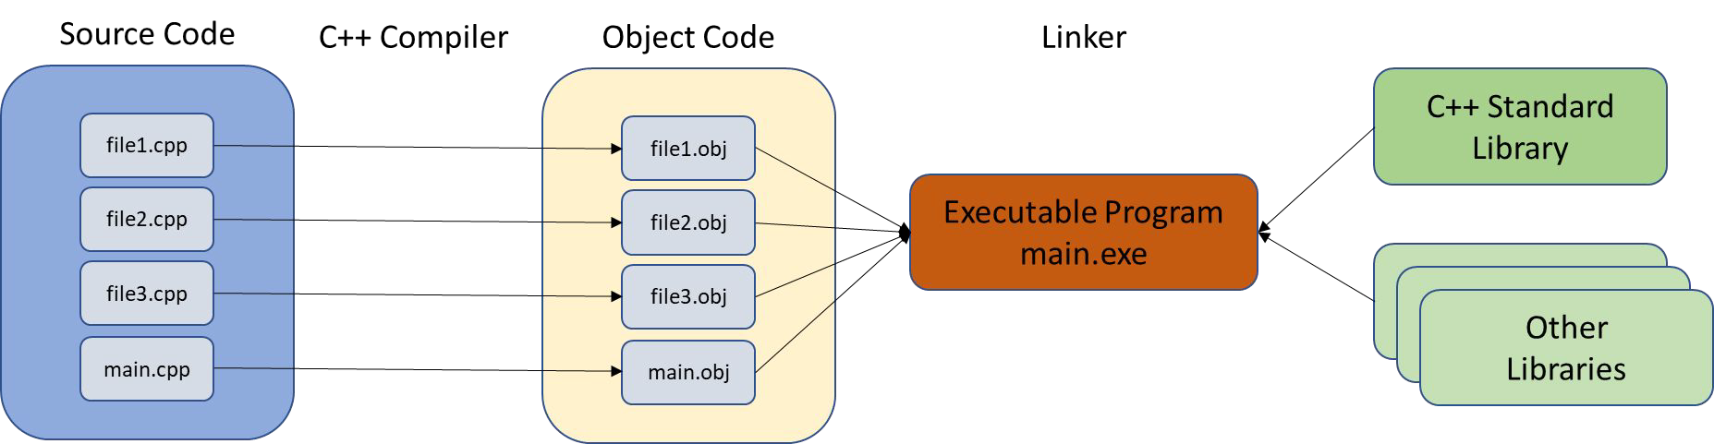

Integrated Development Environments (IDEs)

* Editor
* Compiler
* Linker
* Debugger
* Keep everything in sync
* CodeLite
* Code::Blocks
* NetBeans
* Eclipse
* CLion
* Dev-C++
* KDevelop
* Visual Studio
* Xcode

## Section Overview

* Microsoft Windows, Mac OSX, Ubuntu Linux 18.04
  + C++ Compiler
  + CodeLite Integrated Development Environment (IDE)
  + Conﬁgure CodeLite
  + Create a Default CodeLite Project Template
* Using the Command-line
* Using a Web-based compiler

## Using the command-line interface

* A text editor (not a Word Processor)
* A command-prompt or terminal window
* An installed C++ compiler
* No need for an IDE
* Simple, eﬃcient workﬂow
* Better as you gain experience
* Can be used if you are overwhelmed by IDEs
* Useful if hardware resources are limited
* Getting Started
* Structure of a C++ Program
* Variables and Constants
* Arrays and Vectors
* Strings in C++
* Expressions, Statements and Operators
* Statements and Operators
* Determining Control Flow
* Functions
* Pointers and References
* OOP – Classes and Objects
* Operator Overloading
* Inheritance
* Polymorphism
* Smart Pointers
* The Standard Template Library (STL)
* I/O Streams
* Exception Handling

Challenge Exercises

* At the end of most course sections
* Develop real C++ programs using what we discussed in the section
* Section challenges
  + Description
  + Starting project
  + Completed solution
* Have fun and keep coding!

Quizzes

* At the end of most sections
* Reinforce the concepts learned in each section
* Quiz style
  + Multiple choice
  + Fill in blank
  + Concept oriented vs. code oriented

## Section Overview

* CodeLite IDE Quick Tour
* Our ﬁrst program
  + Building
  + Running
  + Errors
  + Warnings

## Compiler Errors

* Programming languages have rules
* Syntax errors – something wrong with the structure

std::cout << “Errors << std::endl;

return 0

* Semantic errors – something wrong with the meaning

a + b; When it doesn’t make sense to add a and b

## Compiler Warnings

Do NOT ignore them!

* The compiler has recognized an issue with your code that could lead to a potential problem
* It’s only a warning because the compiler is still able to generate correct machine code

int miles_driven;

std::cout << miles_driven;

warning: 'miles_driven' is used uninitialized …

## Linker Errors

* The linker is having trouble linking all the object ﬁles together to create an executable
* Usually there is a library or object ﬁle that is missing

## Runtime Errors

* Errors that occur when the program is executing
* Some typical runtime errors
  + Divide by zero
  + File not found
  + Out of memory

Can cause your program to ‘crash’

Exception Handling can help deal with runtime errors

## Logic Errors

* Errors or bugs in your code that cause your program to run incorrectly
* Logic errors are mistakes made by the programmer

Suppose we have a program that determines if a person can vote in an election and you must be 18 years or older to vote.

if (age > 18) {

std::cout << “Yes, you can vote!”;

}

Test your code!!

## Section Overview

The Structure of a C++ Program

* Basic Components
* Preprocessor Directives
* The main function
* Namespaces
* Comments
* Basic I/O

## The Structure of a C++ Program

Components of a C++ Program

* Keywords
* Identiﬁers
* Operators
* Punctuation
* Syntax

## Keywords

* Have special meaning in C++
* Are reserved by the C++ language

#include <iostream>

**int** main() {

**int** favorite_number;

std::cout << "Enter your favorite number between 1 and 100: "; std::cin >> favorite_number;

std::cout << "Amazing!! That's my favorite number too!" << std::endl;

std::cout << "No really!!, " << favorite_number << " is my favorite number!" <<std::endl;

**return** 0;

}

## Identiﬁers

* Programmer-deﬁned names
* Not part of the C++ language
* Used to name variables, functions, etc.

#include <iostream> int **main**() {

int **favorite_number**;

**std**::**cout** << "Enter your favorite number between 1 and 100: ";

**std**::**cin** >> **favorite_number**;

**std**::**cout** << "Amazing!! That's my favorite number too!" << **std**::**endl**;

**std**::**cout** << "No really!!, " << **favorite_number** << " is my favorite number!" <<**std**::**endl**; return 0;

}

## Operators

* Arithmetic operators, assignment, <<, >>
* Are reserved by the C++ language

#include <iostream> int main() {

int favorite_number;

std::cout **<<** "Enter your favorite number between 1 and 100: "; std::cin **>>** favorite_number;

std::cout **<<** "Amazing!! That's my favorite number too!" **<<** std::endl;

std::cout **<<** "No really!!, " **<<** favorite_number **<<** " is my favorite number!" **<<**std::endl; return 0;

}

## Punctuation

* Special characters that separate, terminate items

#include <iostream> int main() **{**

int favorite_number**;**

std**::**cout << **"**Enter your favorite number between 1 and 100: **"**; std**::**cin >> favorite_number;

std**::**cout << "Amazing!! That's my favorite number too!**"** << std**::**endl**;**

std**::**cout << **"**No really!!, **"** << favorite_number << **"** is my favorite number!**"** <<std**::**endl**;** return 0**;**

**}**

## Syntax

* How the programming elements are put together to form a program
* Programming languages have rules

#include <iostream>

**int** main() {

**int** favorite_number;

std::cout << "Enter your favorite number between 1 and 100: "; std::cin >> favorite_number;

std::cout << "Amazing!! That's my favorite number too!" << std::endl;

std::cout << "No really!!, " << favorite_number << " is my favorite number!" <<std::endl;

**return** 0;

}

Modiﬁed slightly

* Added comments
* Using namespace instead of std::

// Preprocessor directive that include the iostream library headers

#include <iostream>

// use the std namespace

using namespace std;

/* Start of the program

* program execution always begins with main()

*/

int main() {

int favorite_number;

// declare my favorite number variable

// Note that I'm no longer using std::

// Prompt the user to enter their favorite number

cout << "Enter your favorite number between 1 and 100: ";

// read the user's input into the variable favorite_number

Modiﬁed slightly

**// Preprocessor directive that include the iostream library headers**

#include <iostream>

**// use the std namespace using namespace std;**

**/* Start of the program**

**\* program execution always begins with main()**

**\*/**

int main() {

int favorite_number; **// declare my favorite number variable**

**// Note that I'm no longer using std::**

**// Prompt the user to enter their favorite number**

cout << "Enter your favorite number between 1 and 100: ";

**// read the user's input into the variable favorite_number**

cin >> favorite_number;

**// Out put the results to the user**

cout << "Amazing!! That's my favorite number too!" << endl;

cout << "No really!!, " << favorite_number << " is my favorite number!" << endl;

return 0;

}

## Preprocessor Directives

* What is a preprocessor?
* What does it do?
* Directives start with ‘#’
* Commands to the preprocessor

#include <iostream> #include “myfile.h”

#if #elif #else #endif

## Comments

* Ignored by the compiler
* Used to explain your code
* Two styles

int favorite_number;

// This will store my favorite number

// The following lines convert Euros to US Dollars

/* This is a comment

that spans multiple lines.

All of these lines will be ignored by the compiler

*/

// Why should be have to explain our own code?

## Functions

* main() is a required function in C++
* Break up your code into units of functionality
* Can optionally receive and return information

/* This is a function that expects two integers a and b

It calculates the sum of a and b and returns it to the caller Note that we specify that the function returns an int

*/

int add_numbers(int a, int b)

{

return a + b;

}

// I can call the function and use the value that is returns cout << add_numbers(20, 40);

## Preprocessor Directives

* What is a preprocessor?
* What does it do?
* Directives start with ‘#’
* Commands to the preprocessor

#include <iostream> #include “myfile.h”

#if #elif #else #endif

#ifdef #ifndef #define #undef

#line #error #pragma

## The main() function

* Every C++ program must have exactly 1 main( ) function
* Starting point of program execution
* return 0 indicates successful program execution
* 2 versions that are both valid

int main()

{

// code

return 0;

}

program.exe

int main(int argc, char *argv[])

{

// code

return 0;

}

program.exe argument1 argument2

## Namespaces

* Why std::cout and not just cout?
* What is a naming conﬂict?
* Names given to parts of code to help reduce naming conﬂicts
* std is the name for the C++ ‘standard’ namespace
* Third-party frameworks will have their own namespaces
* Scope resolution operator ::
* How can we use these namespaces?

## Explicitly using namespaces

#include <iostream> int main()

{

int favorite_number;

**std::**cout << "Enter your favorite number between 1 and 100: ";

**std::**cin >> favorite_number;

**std**::cout << "Amazing!! That's my favorite number too!" << **std**::endl; **std**::cout << "No really!!, " << favorite_number

<< " is my favorite number!" << **std**::endl;

return 0;

}

## The using namespace directive

#include <iostream>

**using namespace std;** // Use the **entire** std namespace

int main()

{

int favorite_number;

cout << "Enter your favorite number between 1 and 100: "; cin >> favorite_number;

cout << "Amazing!! That's my favorite number too!" << endl; cout << "No really!!, " << favorite_number

<< " is my favorite number!" << endl;

return 0;

}

## Qualiﬁed using namespace variant

#include <iostream>

**using std::cout; // use only what you need using std::cin;**

**using std::endl;**

int main()

{

int favorite_number;

cout << "Enter your favorite number between 1 and 100: "; cin >> favorite_number;

cout << "Amazing!! That's my favorite number too!" << endl; cout << "No really!!, " << favorite_number

<< " is my favorite number!" << endl;

return 0;

}

## Basic I/O using cin and cout

cout, cin, cerr, and clog are objects representing streams

cout

* standard output stream
* console

cin

* standard input stream
* keyboard

<<

* Insertion operator
* output streams

>>

* extraction operator
* input streams

## cout and <<

* Insert the data into the cout stream

cout << data;

* Can be chained

cout << "data 1 is " << data1;

* Does not automatically add line breaks

|  |  |  |  |  |  |  |  |  |  |
| --- | --- | --- | --- | --- | --- | --- | --- | --- | --- |
| cout | << | "data | 1 | is | " | << | data1 | << | endl; |
| cout | << | "data | 1 | is | " | << | data1 | << | "\n"; |

## cin and >>

* Extract data from the cin stream based on data’s type

cin >> data;

* Can be chained

cin >> data1 >> data2;

* Can fail if the entered data cannot be interpreted

data could have an undetermined value

Variables and Constants

* Declaring variables
* C++ primitive types
  + integer
  + ﬂoating point
  + boolean
  + character
* sizeof operator

Variables and Constants

* What is a constant?
* Declaring constants
* Literal constants
* Constant expressions

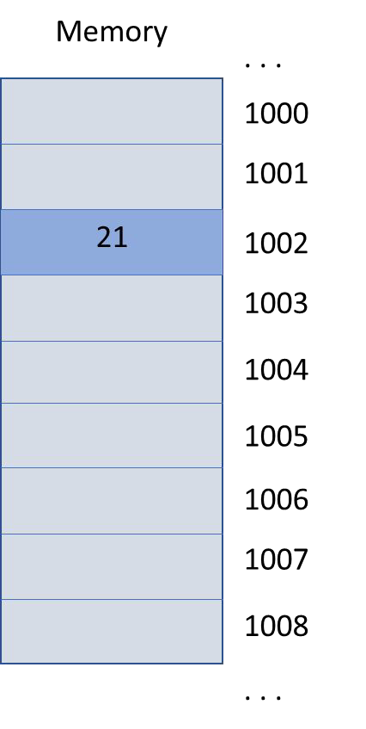

move 21 to location 1002

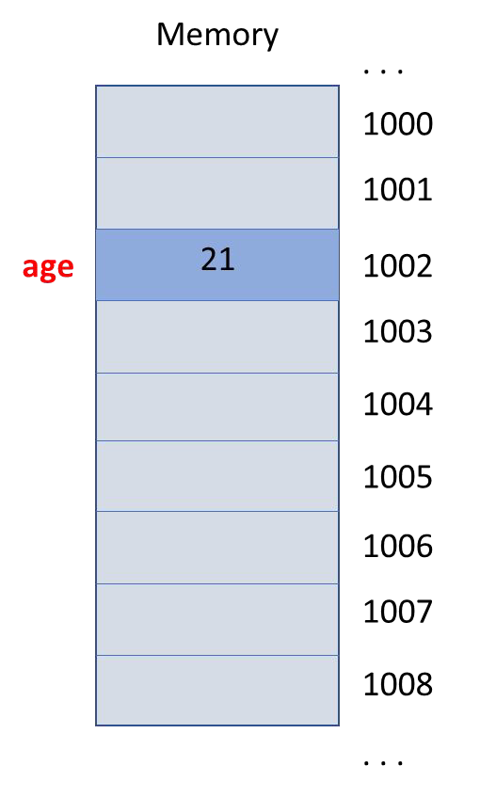

move 21 to age

* A variable is an abstraction for a memory location
* Allow programmers to use meaningful names and not memory addresses
* Variables have
  + Type – their category (integer, real number, string, Person, Account…)
  + Value – the contents (10, 3.14. “Frank”…)
* Variables must be declared before they are used
* A variables value may change

age = 21; // Compiler error

**int age;**

age = 21;

Declaring Variables

**VariableType VariableName**;

int age; double rate; string name;

Account franks_account; Person james;

Naming Variables

* Can contain letters, numbers, and underscores
* Must begin with a letter or underscore (_)
  + cannot begin with a number
* Cannot use C++ reserved keywords
* Cannot redeclare a name in the same scope
  + remember that C++ is case sensitive

Naming Variables

|  |  |
| --- | --- |
| Legal | Illegal |
| Age | int |
| age | $age |
| _age | 2014_age |
| My_age | My age |
| your_age_in_2014 | Age+1 |
| INT | cout |
| Int | return |

Naming Variables – Style and Best Practices

* Be consistent with your naming conventions
  + myVariableName vs. my_variable_name
  + avoid beginning names with underscores
* Use meaningful names
  + not too long and not too short
* Never use variables before initializing them
* Declare variables close to when you need them in your code

Initializing Variables

int age; // uninitialized

int age = 21; // C-like initialization

int age (21); // Constructor initialization

int age {21}; // C++11 list initialization syntax

* Fundamental data types implemented directly by the C++ language
* Character types
* Integer types
  + signed and unsigned
* Floating-point types
* Boolean type
* Size and precision is often compiler-dependent
  + #include <climits>

Type sizes

* Expressed in bits
* The more bits the more values that can be represented
* The more bits the more storage required

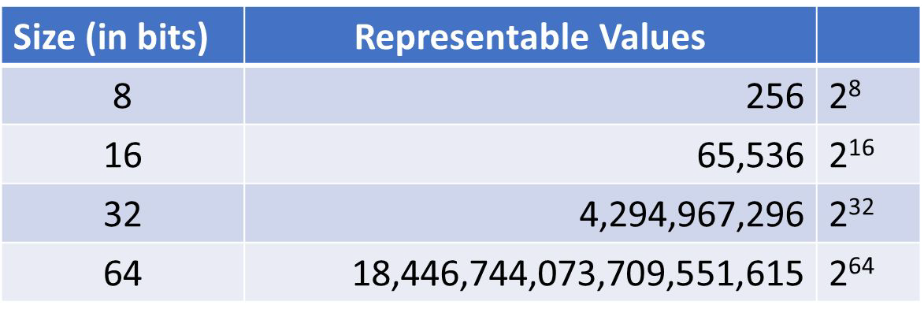

Character Types

* Used to represent single characters, ‘A’, ‘X’, ‘@’
* Wider types are used to represent wide character sets

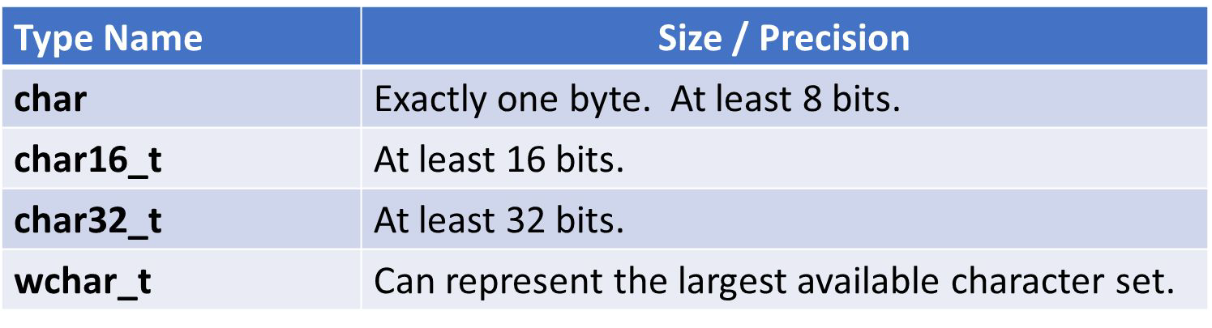

Integer Types

* Used to represent whole numbers
* Signed and unsigned versions

Integer Types

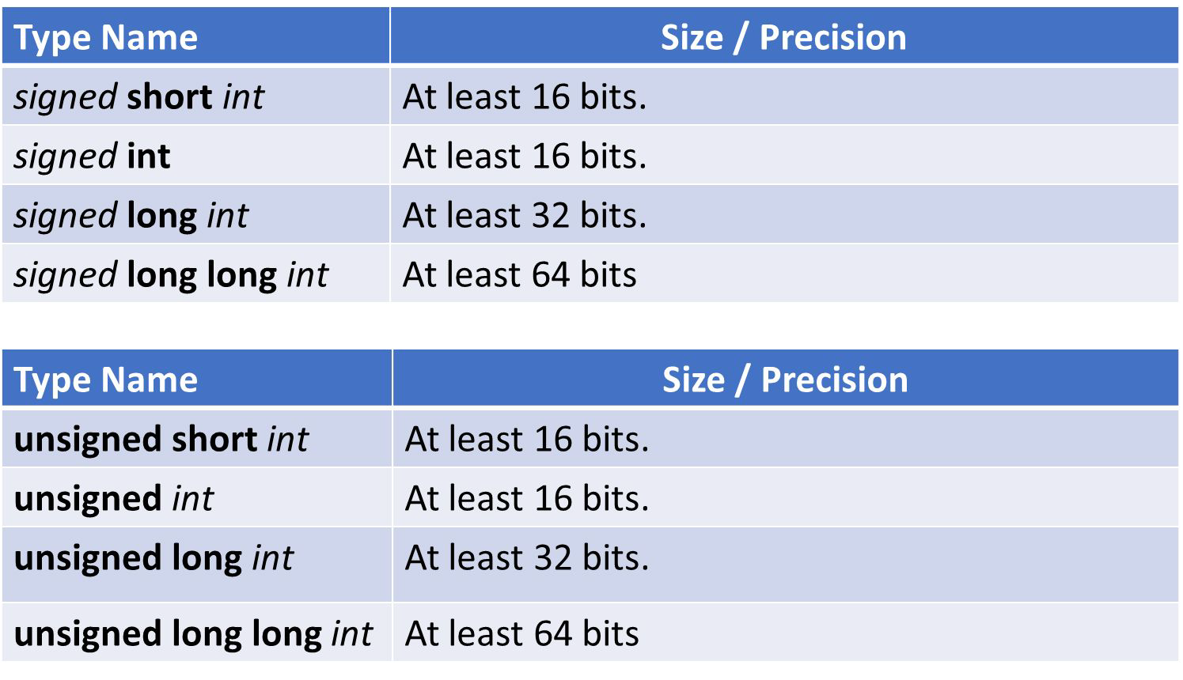

Floating-point Type

* Used to represent non-integer numbers
* Represented by mantissa and exponent (scientiﬁc notation)
* Precision is the number of digits in the mantissa
* Precision and size are compiler dependent

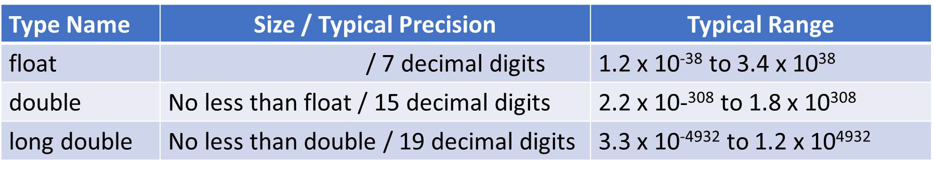

Boolean Type

* Used to represent true and false
* Zero is false.
* Non-zero is true.

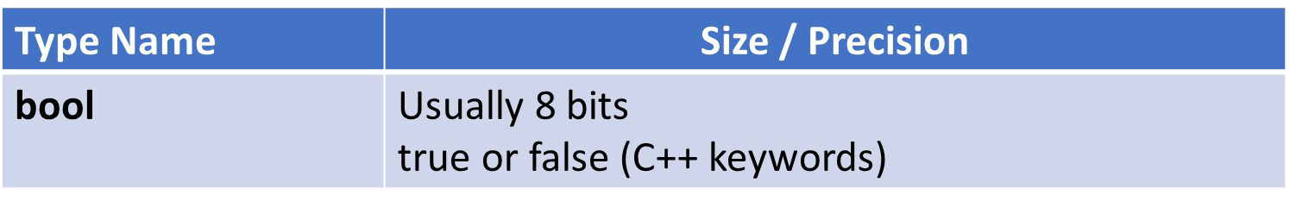

* The sizeof operator
  + determines the size in bytes of a type or variable
* Examples:

sizeof(int) sizeof(double)

sizeof(some_variable) sizeof some_variable

<climits> and <cfloat>

* The climits and cfloat include ﬁles contain size and precision information about your implementation of C++

INT_MAX INT_MIN LONG_MIN LONG_MAX FLT_MIN FLT_MAX

. . .

## What is a constant?

* Like C++ variables
  + Have names
  + Occupy storage
  + Are usually typed

However, their value cannot change once declared!

* Literal constants
* Declared constants
  + const keyword
* Constant expressions
  + constexpr keyword
* Enumerated constants
  + enum keyword
* Deﬁned constants
  + #define

Literal constants

* The most obvious kind of constant x = 12;

y = 1.56;

name = “Frank”; middle_initial = ‘J’;

Literal constants

* Integer Literal Constants

1. - an integer

12U - an unsigned integer 12L - a long integer

12LL - a long long integer

Literal constants

* Floating-point Literal Constants
  1. - a double
  2. F - a ﬂoat
  3. L - a long double

Literal constants

* Character Literal Constants (escape codes)

\n - newline

\r - return

\t - tab

\b - backspace

\’ - single quote

\” - double quote

\\ - backslash

cout << “Hello**\t**there**\n**my friend**\n**”;

Hello there my friend

Declared constants

* Constants declared using the const keyword **const** double pi {3.1415926}; **const** int months_in_year {12};

pi = 2.5; **// Compiler error**

Deﬁned constants

* Constants declared using the const keyword

#define pi 3.1415926

Don’t use deﬁned constants in Modern C++

### Section Overview

Arrays and Vectors

* Arrays
  + What they are
  + Why we use arrays
  + Declaration and initialization
  + Accessing array elements
* Multi-dimensional arrays
* Vectors
  + What they are
  + Advantages vs. arrays
  + Declaration and initialization

What is an array?

* Compound data type or data structure
  + Collection of elements
* All elements are of the same type
* Each element can be accessed directly

|  |  |  |
| --- | --- | --- |
| int | test_score_1 | {0}; |
| int | test_score_2 | {0}; |
| int | test_score_3 | {0}; |

|  |  |  |
| --- | --- | --- |
| int | test_score_1 | {0}; |
| int | test_score_2 | {0}; |
| int | test_score_3 | {0}; |
| int | test_score_4 | {0}; |
| int | test_score_5 | {0}; |

. . .

int test_score_100 {0};

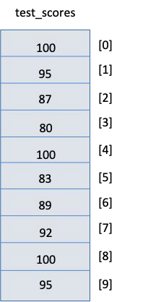

Characteristics

* Fixed size
* Elements are all the same type
* Stored contiguously in memory
* Individual elements can be accessed by
* their position or index
* First element is at index 0
* Last element is at index size-1
* No checking to see if you are out of bounds
* Always initialize arrays
* Very efficient
* Iteration (looping) is often used to process

Declaring

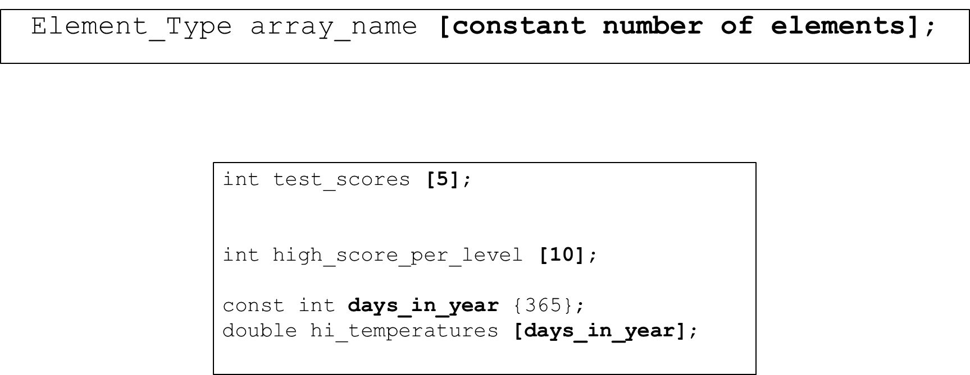

Initialization

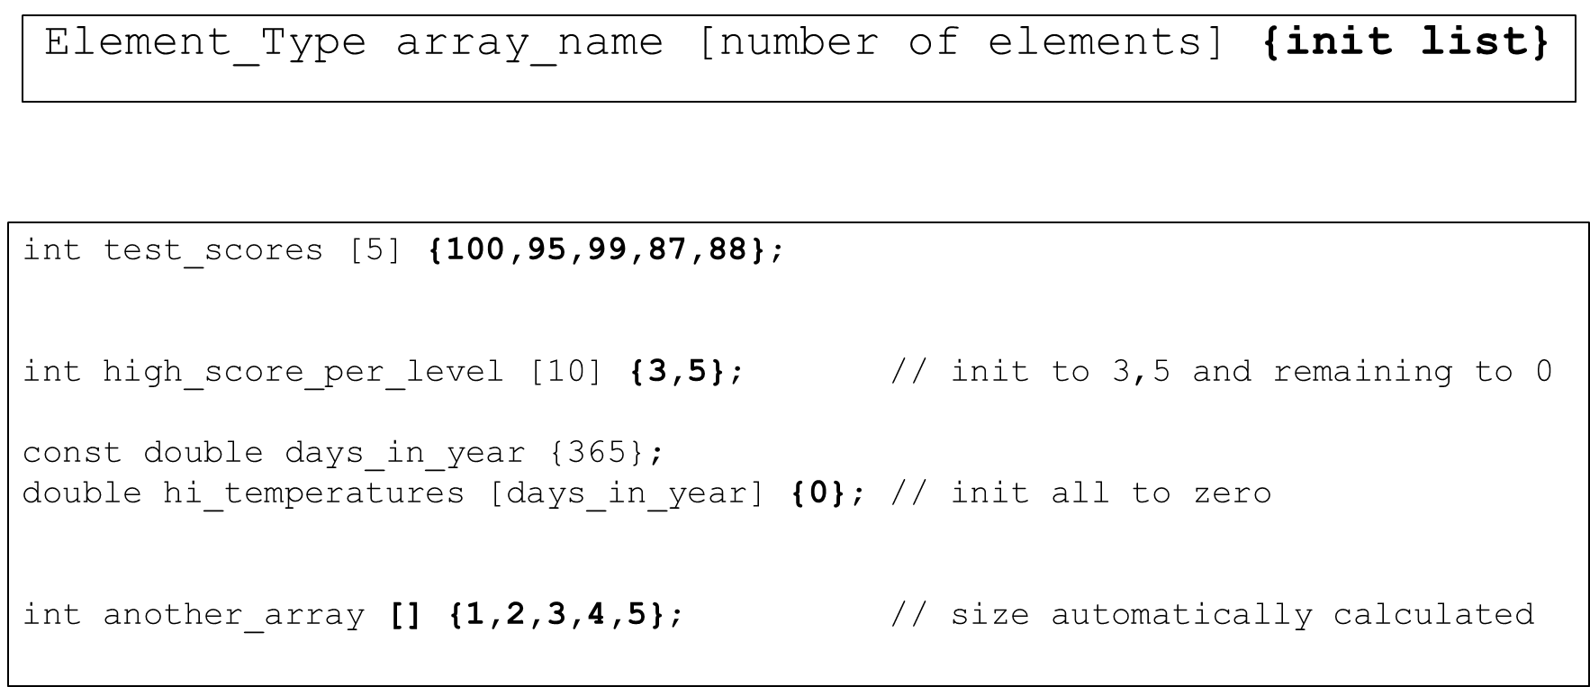

Accessing array elements

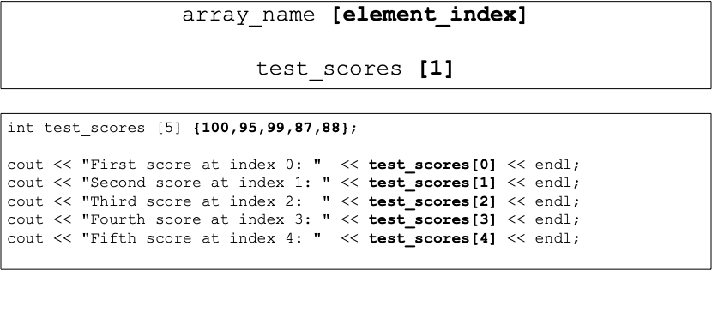

BEGINNING C++ PROGRAMMING

Accessing Array Elements

ARRAYS AND VECTORS

S07-CPP-0080-1

Changing the contents of array elements

BEGINNING C++ PROGRAMMING

Accessing Array Elements

ARRAYS AND VECTORS

S07-CPP-0080-2

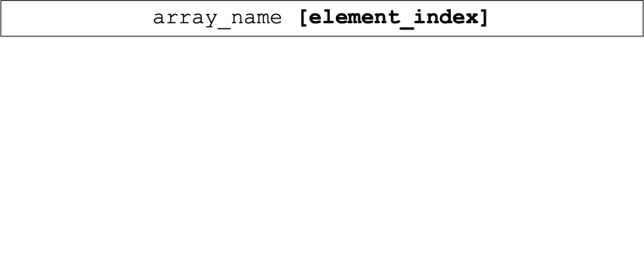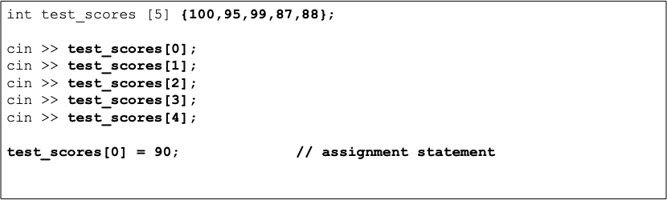

How does it work?

* The name of the array represent the location of the first element in the array (index 0)
* The [index] represents the offset from the beginning of the array
* C++ simply performs a calculation to find the correct element
* Remember – no bounds checking!

Declaring multi-dimensional arrays

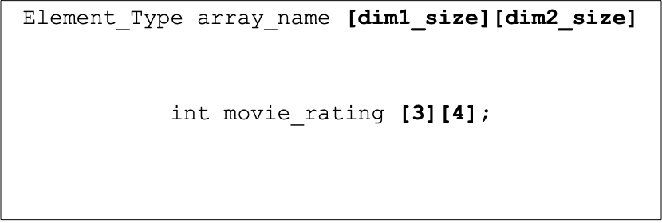

Multi-dimensional arrays

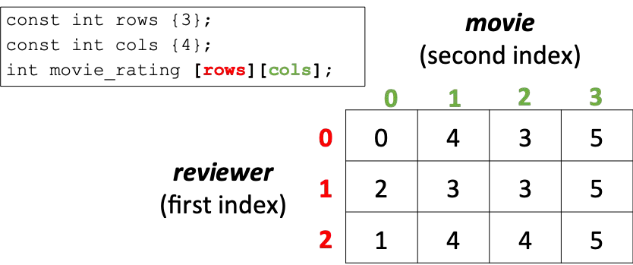

Accessing array elements in multi-dimensional arrays

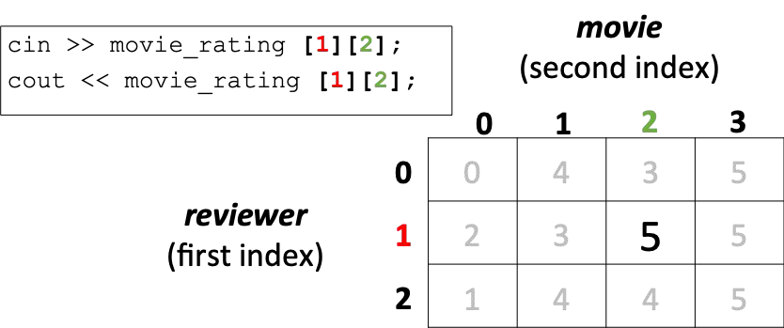

Initializing multi-dimensional arrays

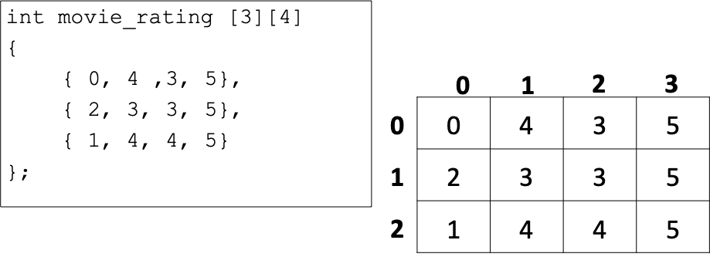

* Suppose we want to store test scores for my school
* I have no way of knowing how many students will register next year
* Options:
  + Pick a size that you are not likely to exceed and use static arrays
  + Use a dynamic array such as vector

What is a vector?

* Container in the C++ Standard Template Library
* An array that can grow and shrink in size at execution time
* Provides similar semantics and syntax as arrays
* Very efficient
* Can provide bounds checking
* Can use lots of cool functions like sort, reverse, find, and more.

Declaring

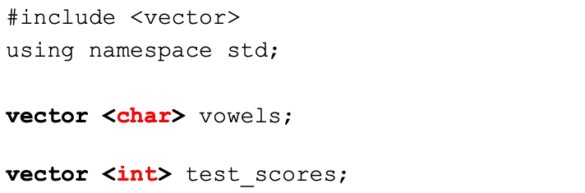

Declaring

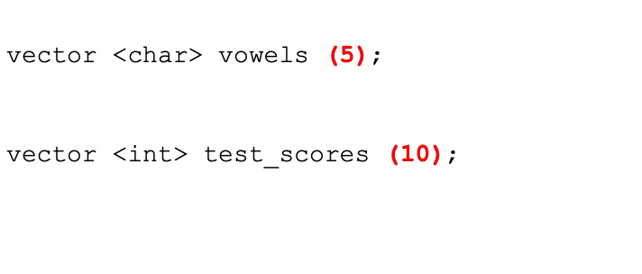

Initializing

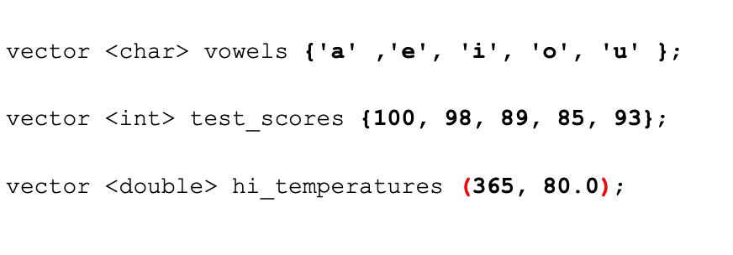

Characteristics

* Dynamic size
* Elements are all the same type
* Stored contiguously in memory
* Individual elements can be accessed by
* their position or index
* First element is at index 0
* Last element is at index size-1
* [ ] - no checking to see if you are out of bounds
* Provides many useful function that do bounds check
* Elements initialized to zero
* Very efficient
* Iteration (looping) is often used to process

Accessing vector elements – array syntax

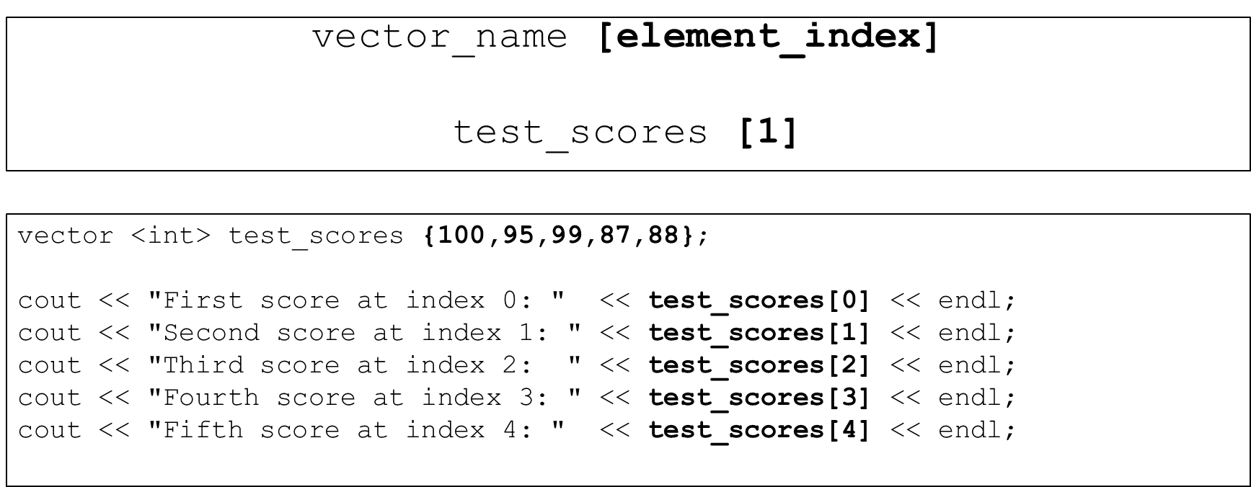

Accessing vector elements – vector syntax

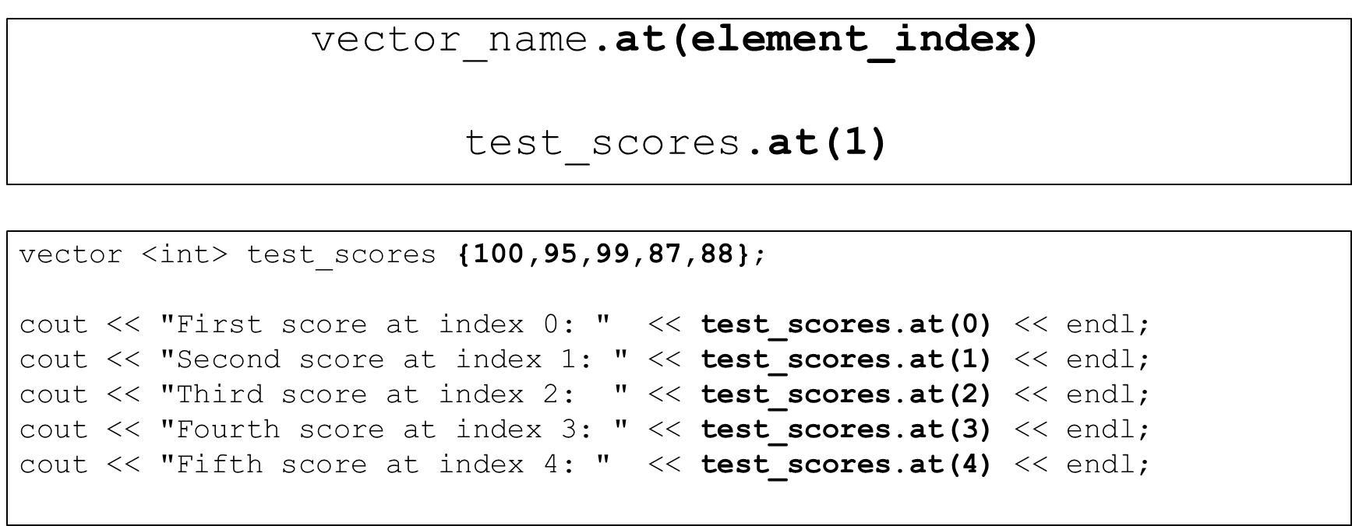

Changing the contents of vector elements – vector syntax

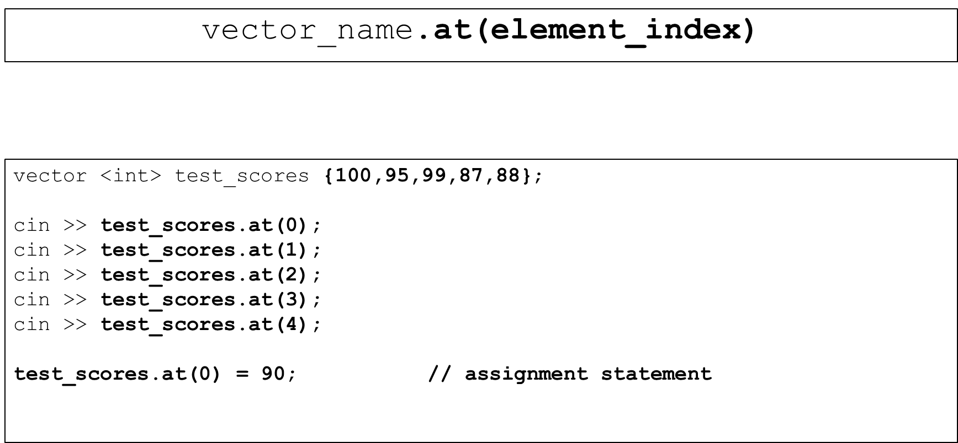

So, when do they grow as needed?

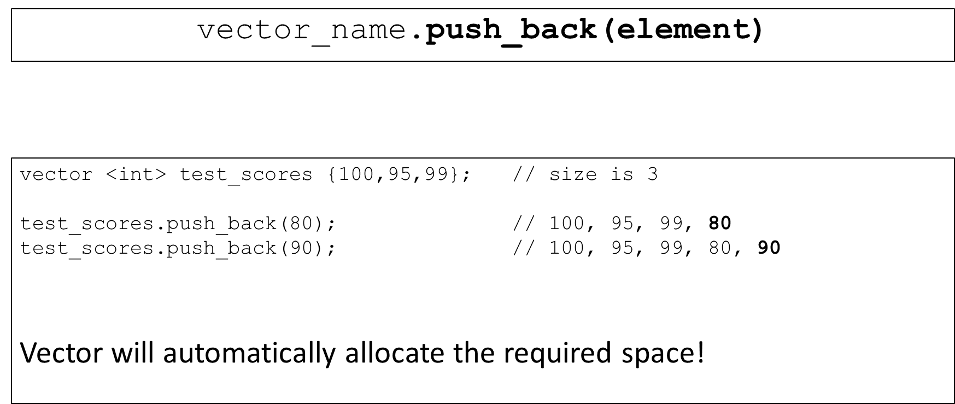

What if you are out of bounds?

* Arrays never do bounds checking
* Many vector methods provide bounds checking
* An exception and error message is generated

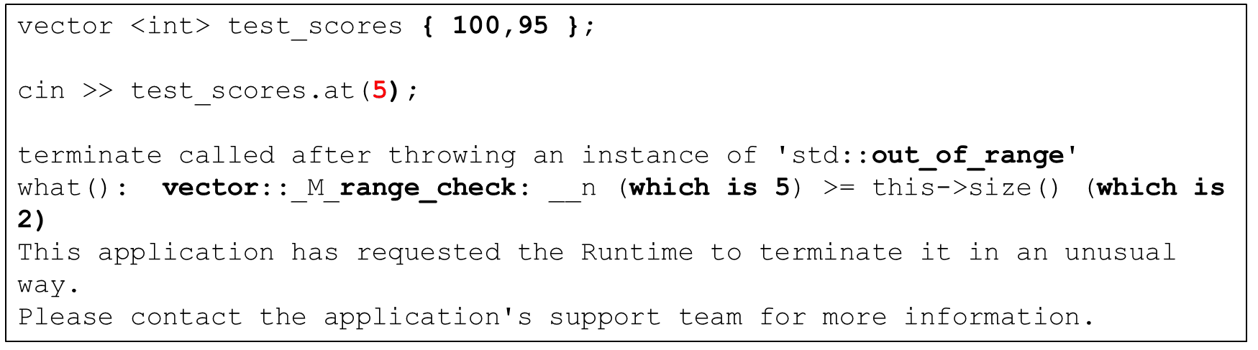

### Section Overview

Expressions, Statements and Operators

* Expressions
* Statements and block statements
* Operators
  + Assignment
  + Arithmetic
  + Increment and decrement
  + Equality
  + Relational
  + Logical
  + Compound assignment
  + Precedence

Expressions

An expression is:

* The most basic building block of a program
* “a sequence of operators and operands that specifies a computation”
* Computes a value from a number of operands
* There is much, much more to expressions – not necessary at this level

Expressions - examples

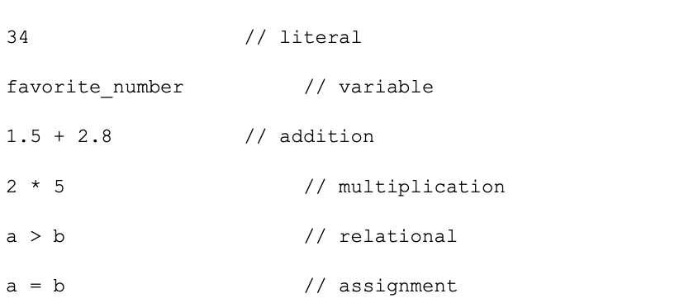

Statements

A statement is:

* A complete line of code that performs some action
* Usually terminated with a semi-colon
* Usually contain expressions
* C++ has many types of statements
  + expression, null, compound, selection, iteration,
  + declaration, jump, try blocks, and others.

Statements - examples

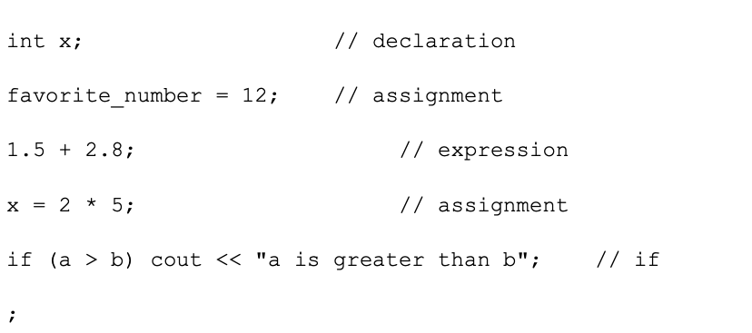

### Using Operators

* C++ has a rich set of operators
  + unary, binary, ternary
* Common operators can be grouped as follows:
  + assignment
  + arithmetic
  + increment/decrement
  + relational
  + logical
  + member access
  + other

### Assignment Operator (=)

lhs = rhs

* rhs is an expression that is evaluated to a value
* The value of the rhs is stored to the lhs
* The value of the rhs must be type compatible with the lhs
* The lhs must be assignable
* Assignment expression is evaluated to what was just assigned
* More than one variable can be assigned in a single statement
* C++ operations occur on same type operands
* If operands are of different types, C++ will convert one
* Important! since it could affect calculation results
* C++ will attempt to automatically convert types (coercion). If it can’t, a compiler error will occur

Conversions

* Higher vs. Lower types are based on the size of the values the type can hold
  + long double,double,float,unsigned long,long,unsigned int,int
  + short and char types are always converted to int
* Type Coercion: conversion of one operand to another data type
* Promotion: conversion to a higher type
  + Used in mathematical expressions
* Demotion: conversion to a lower type
  + Used with assignment to lower type

Examples

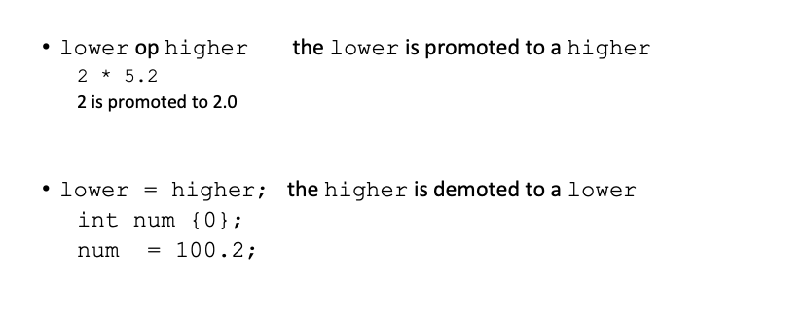

Explicit Type Casting – static_cast<type>

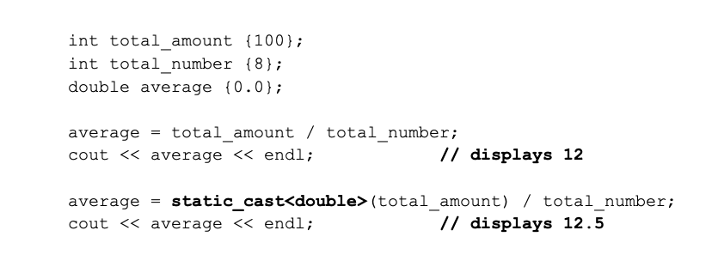

The == and != operators

* Compares the values of 2 expressions
* Evaluates to a Boolean (True or False, 1 or 0)
* Commonly used in control flow statements

|  |  |  |
| --- | --- | --- |
| expr1 | == | expr2 |
| expr1 | != | expr2 |

100 == 200

num1 != num2

The == and != operators

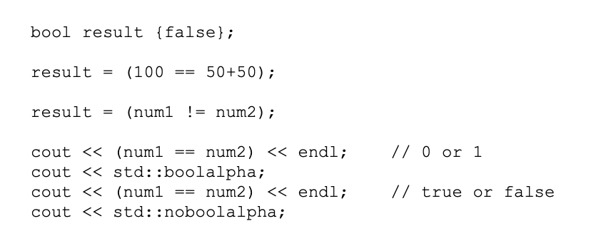

### Relational Operators

expr1 op expr2

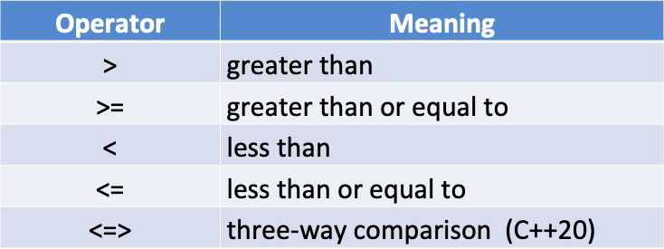

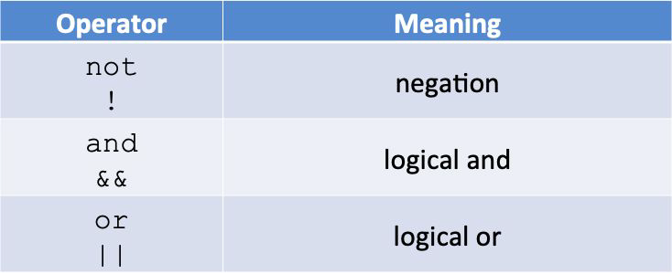

not (!)

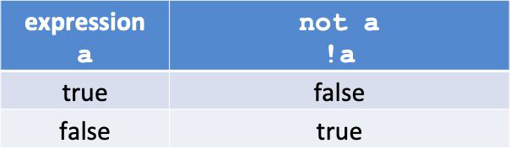

and (&&)

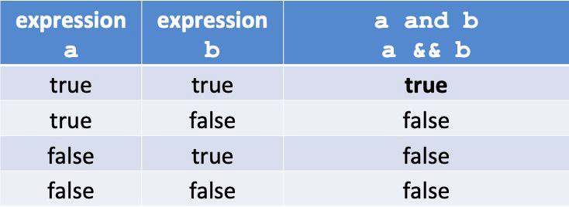

or (||)

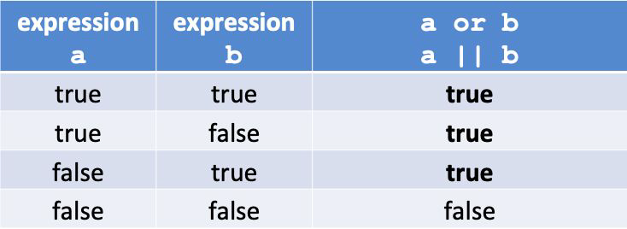

Precedence

* not has higher precedence than and
* and has higher precedence than or
* not is a unary operator
* and and or are binary operators

Examples

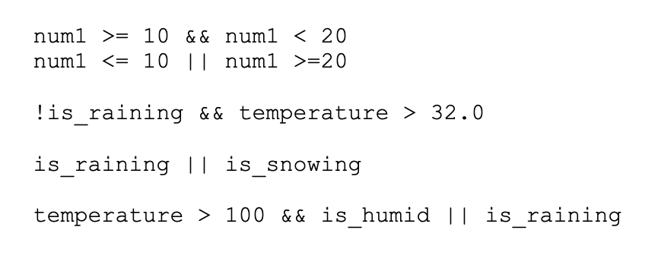

Short-Circuit Evaluation

* When evaluating a logical expression C++ stops as soon as the result is known

|  |  |  |  |  |
| --- | --- | --- | --- | --- |
| expr1 | && | expr2 | && | expr3 |
| expr1 | || | expr2 | || | expr3 |

### Compound Assignment

op=

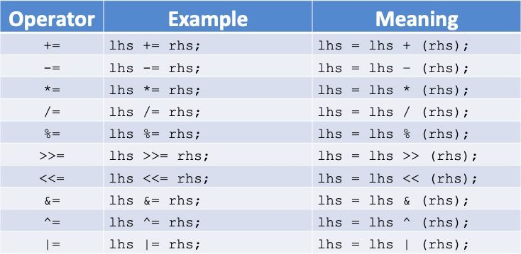

### Logical Operators

Examples

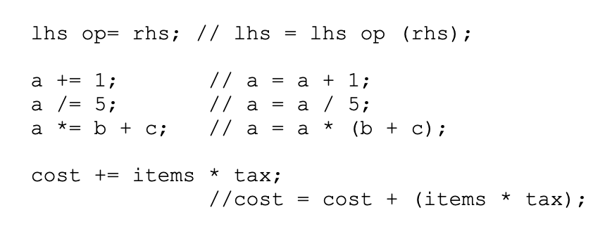

### Operator Precedence (not a complete list)

Higher to lower

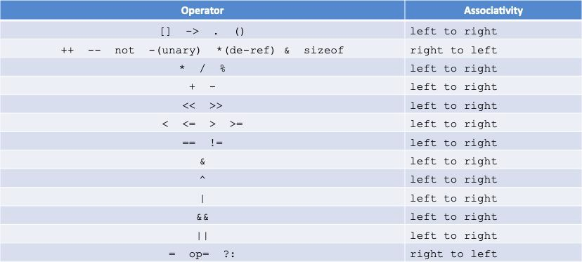

What is associativity?

* Use precedence rules when adjacent operators are different

expr1 **op1** expr2 **op2** expr3 // precedence

* Use associativity rules when adjacent operators have the same precedence

expr1 **op1** expr2 **op1** expr3 // associativity

* Use parenthesis to absolutely remove any doubt

Example

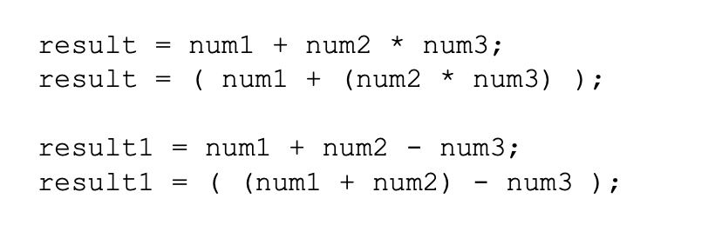

## Section Overview

Controlling Program Flow

* + Sequence
    - Ordering statements sequentially
  + Selection
    - Making decisions
  + Iteration
    - Looping or repeating

## Selection – Decision Making

* + if statement
  + if-else statement
  + Nested if statements
  + switch statement
  + Conditional operator ?:

## Iteration - Looping

* + for loop
  + Range-based for loop
  + while loop
  + do-while loop
  + continue and break
  + Inﬁnite loops
  + Nested loops

if (expr) statement;

* + If the expression is true then execute the statement
  + If the expression is false then skip the statement

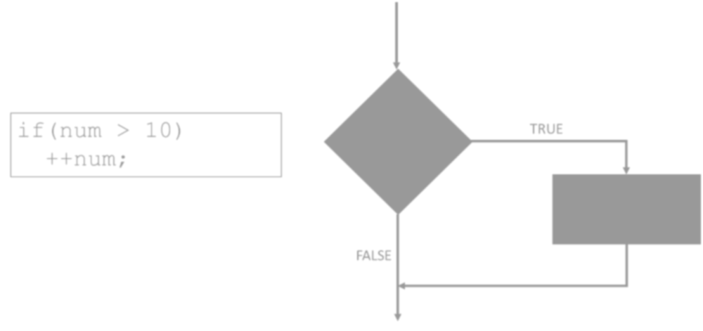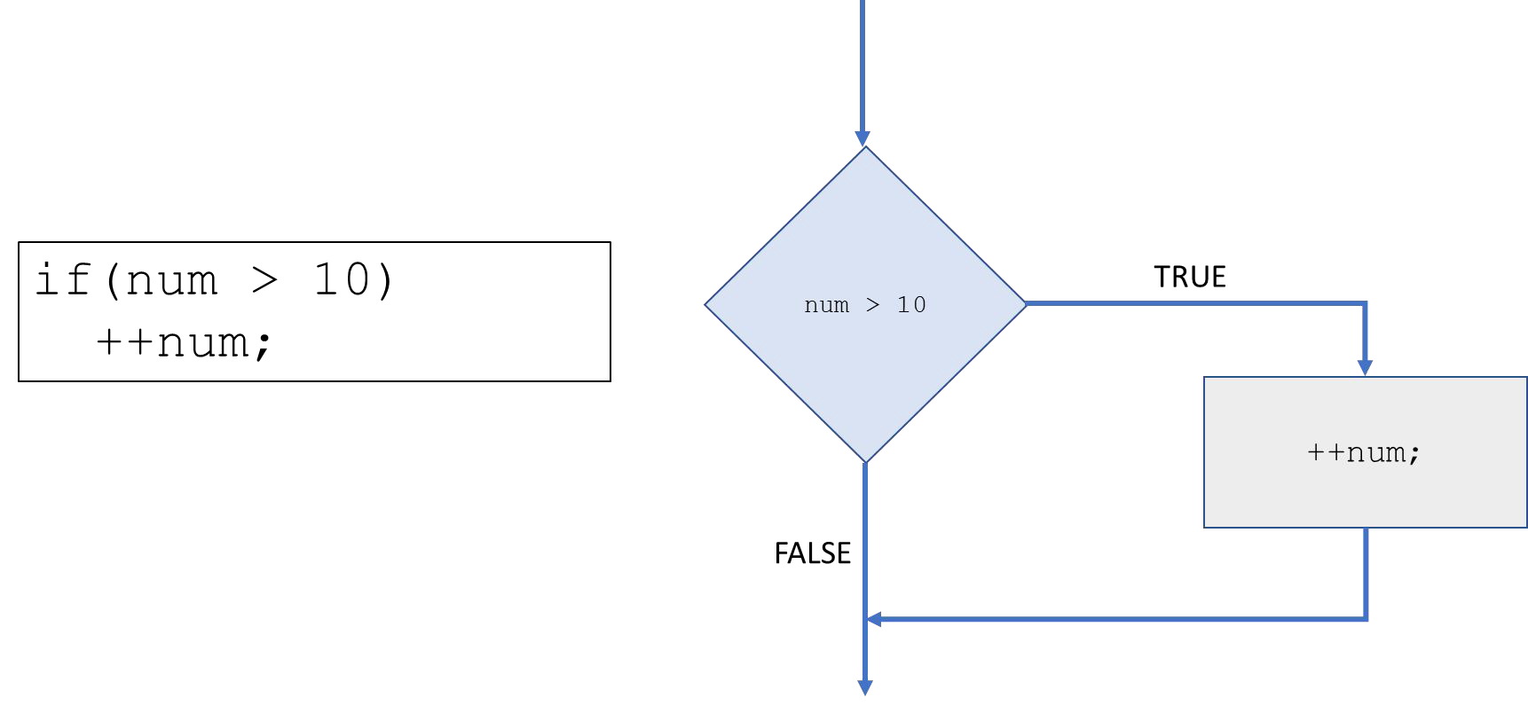

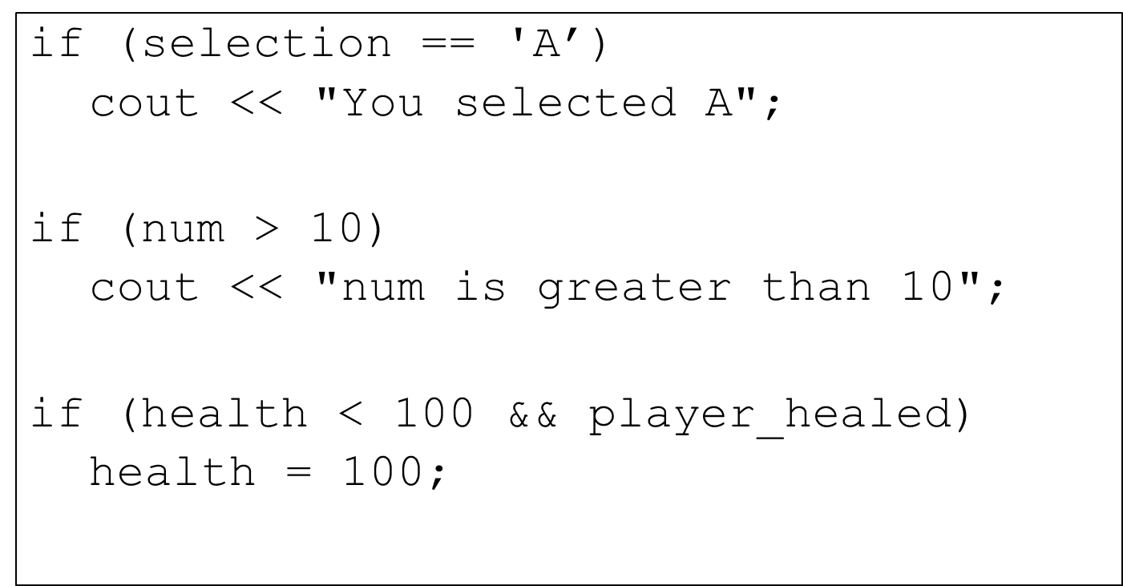

block statement

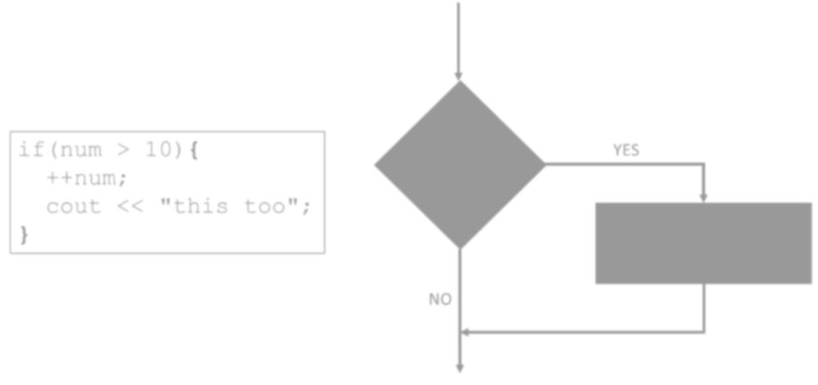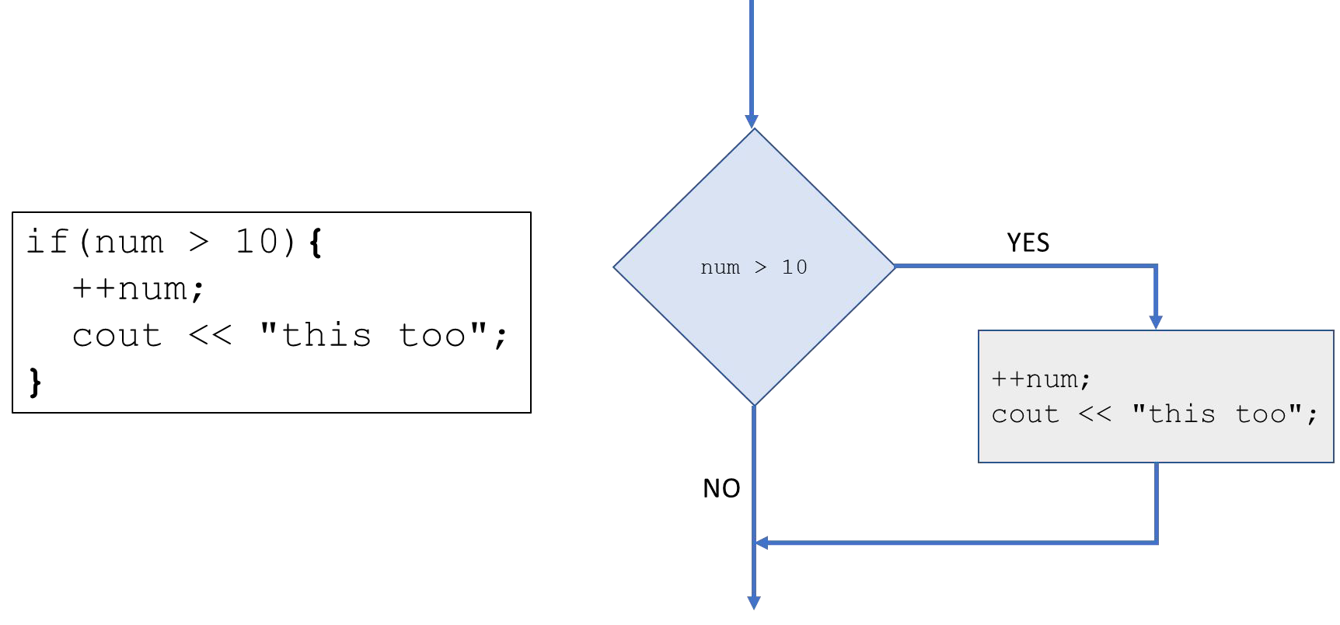

## Block statement

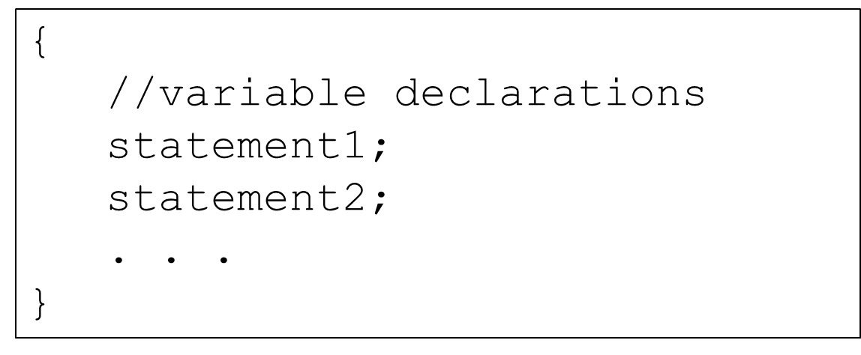

* Create a block of code by including more than one statement in code block { }
* Blocks can also contain variable declarations
* These variables are visible only within the block – local scope

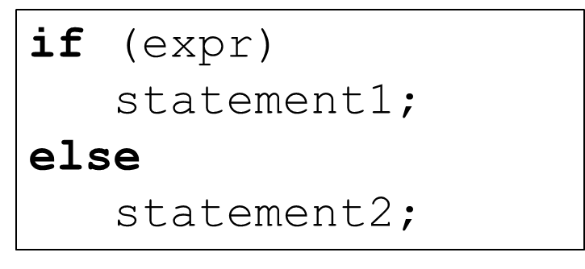

* If the expression is true then execute statement1
* If the expression is false then execute statement2

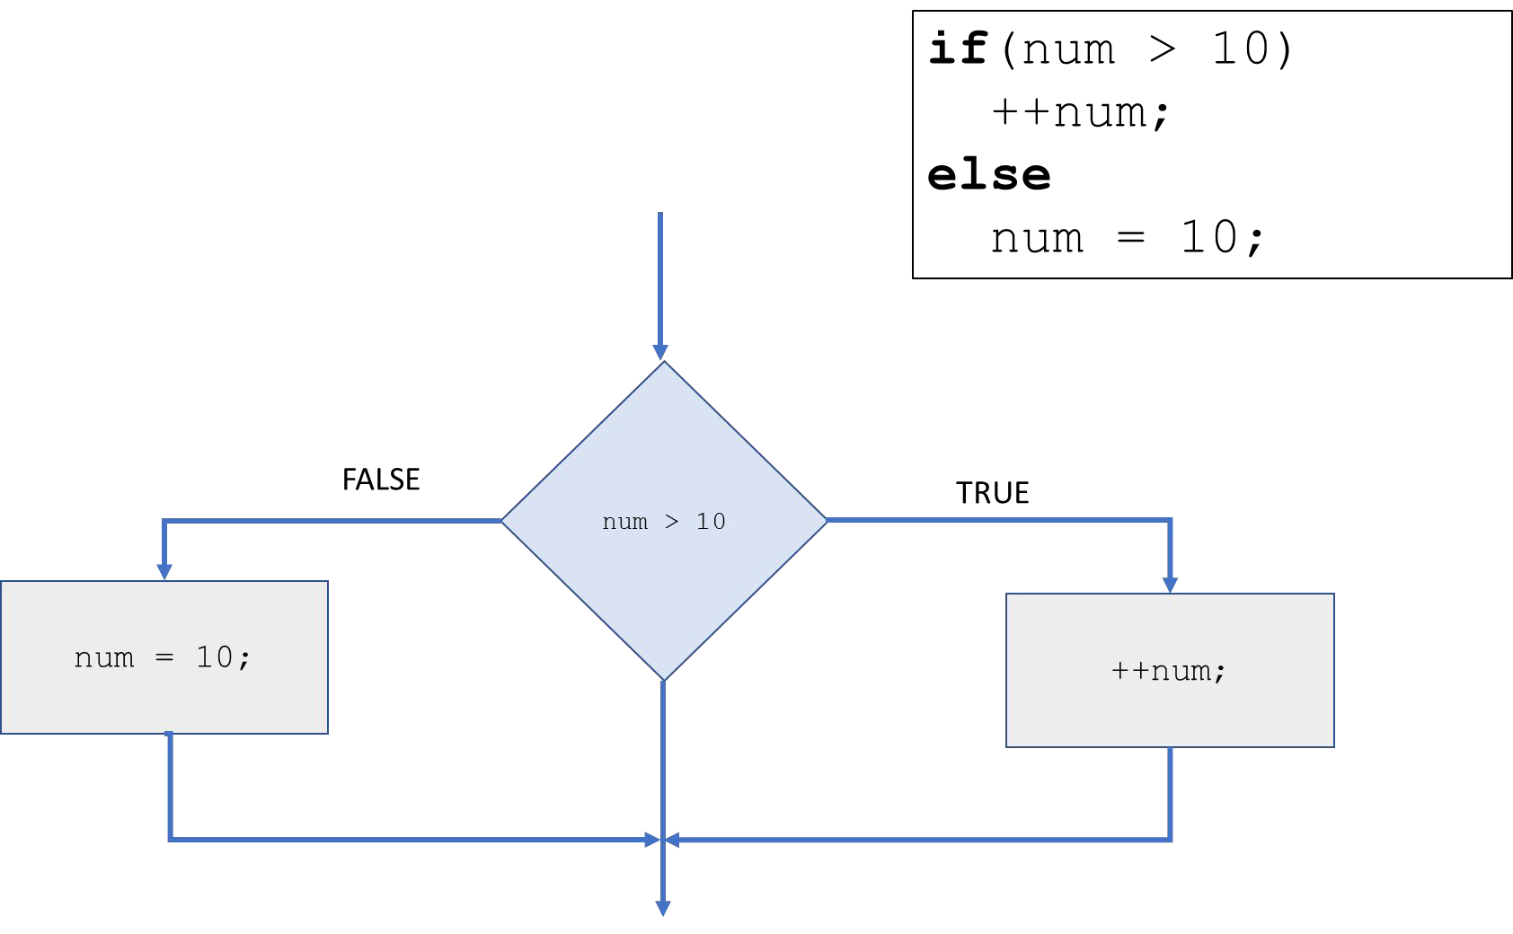

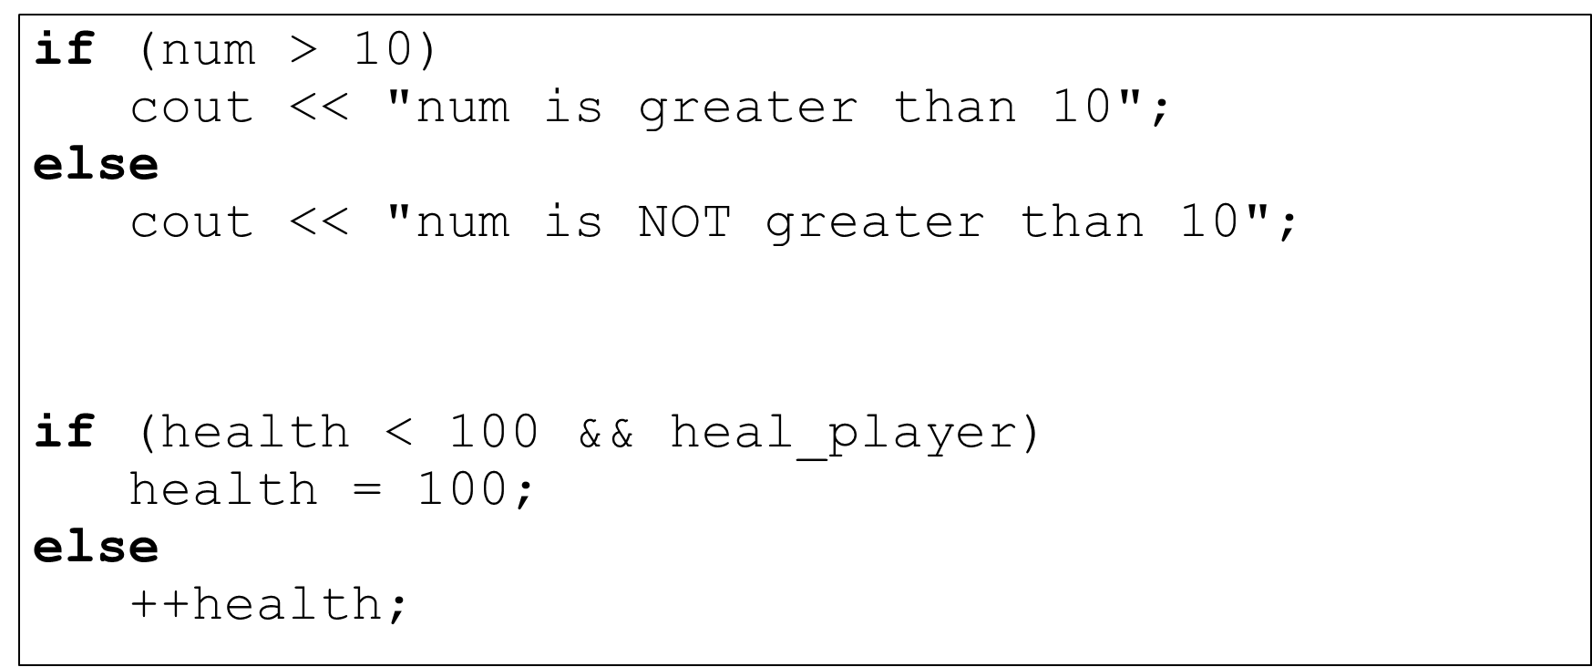

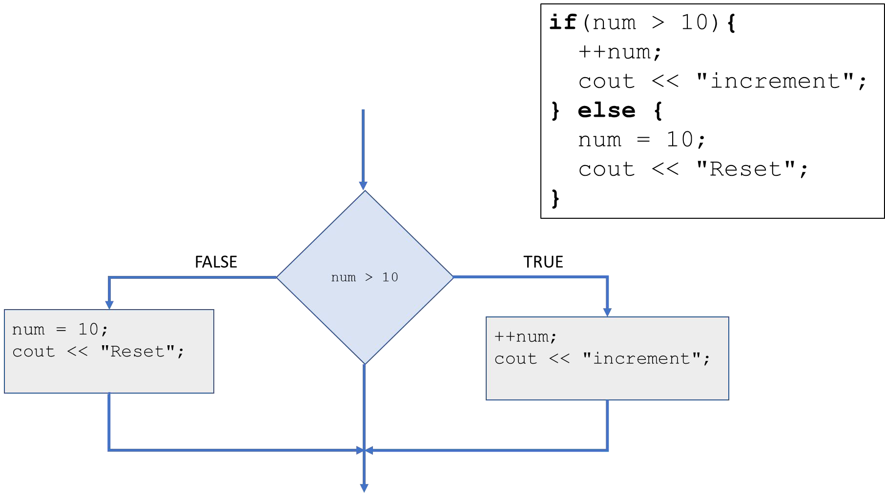block statement

## if-else-if construct

block statement

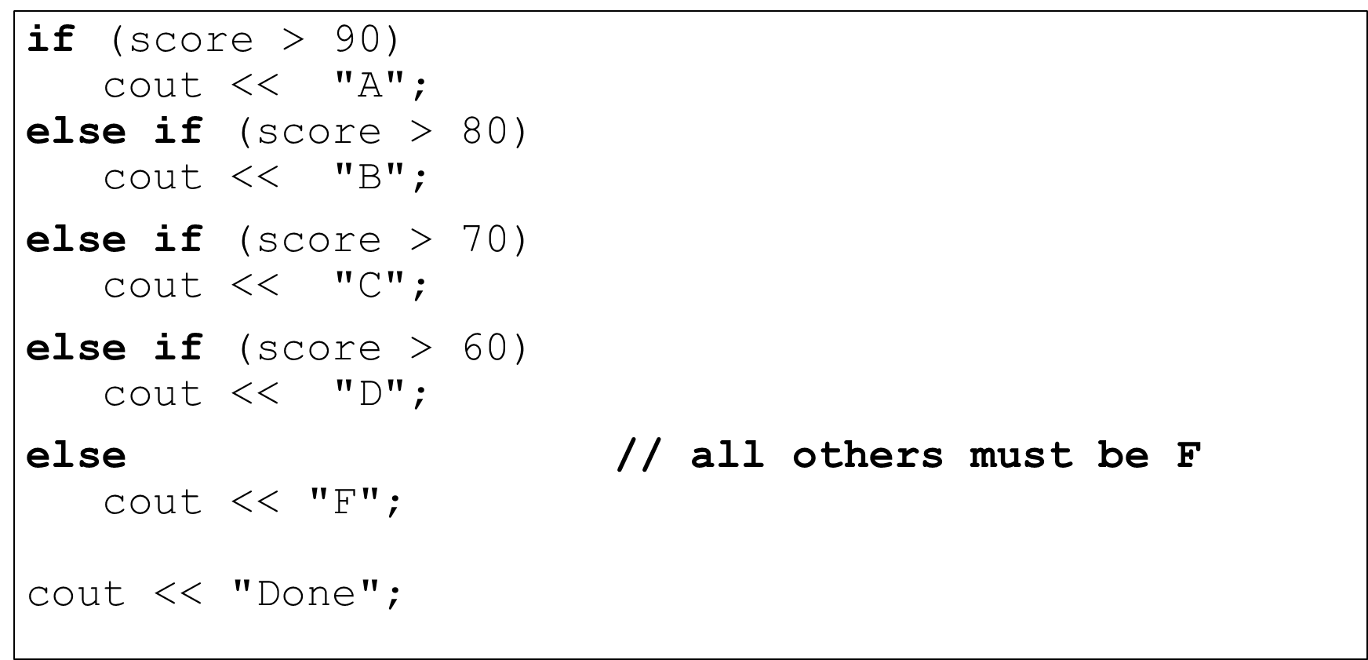

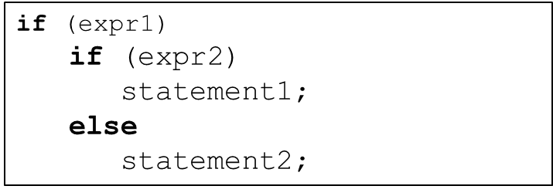

* **if** statement is nested within another
* Allows testing of multiple conditions
* **else** belongs to the closest **if**

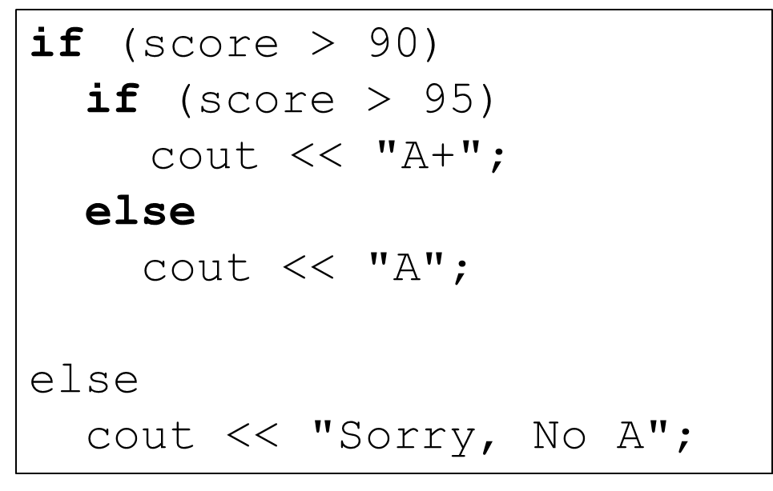

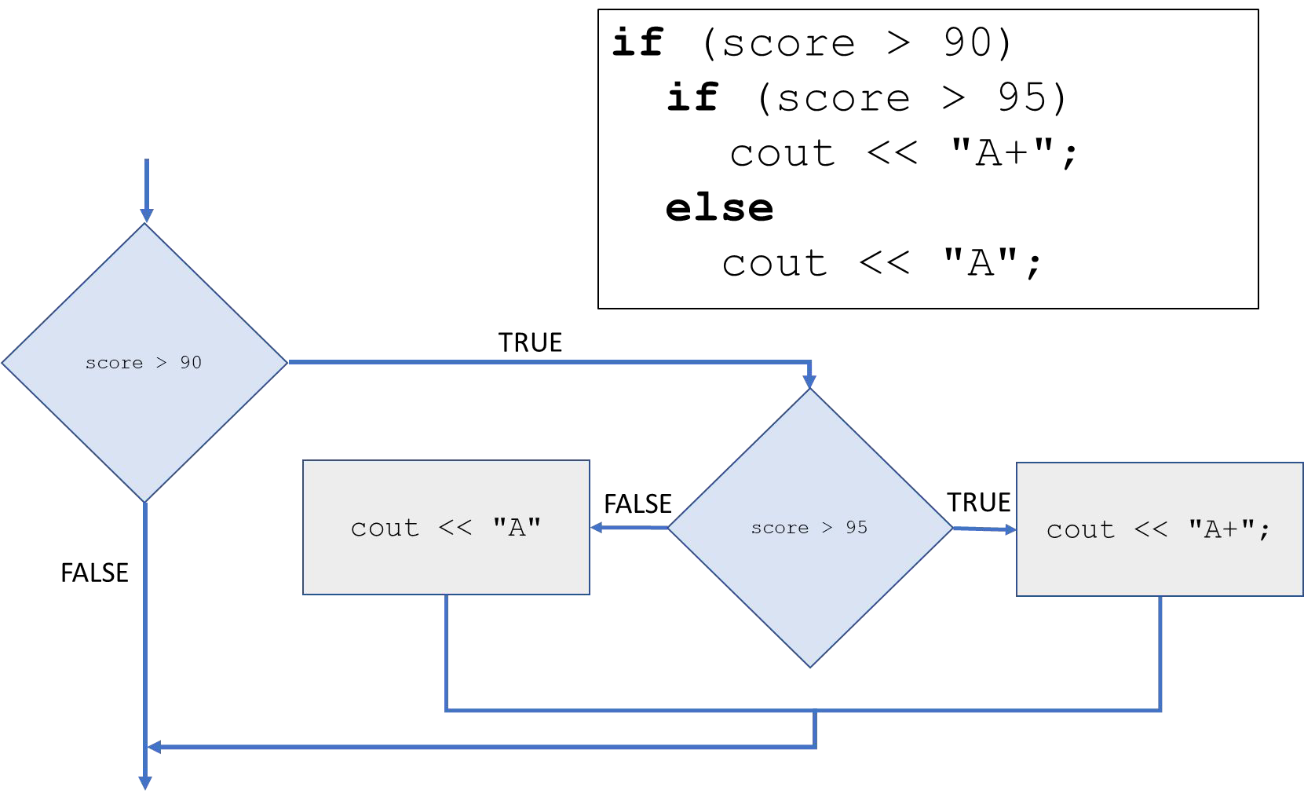

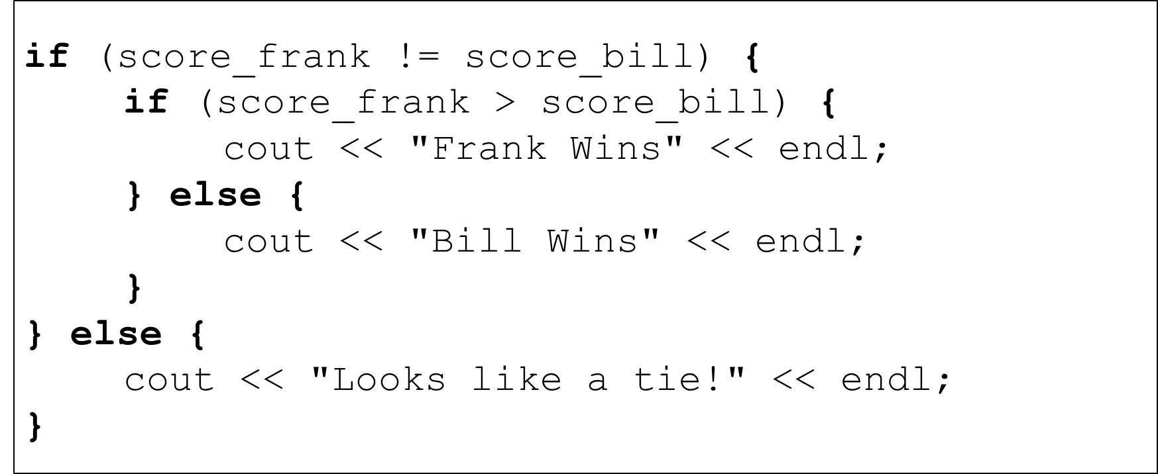

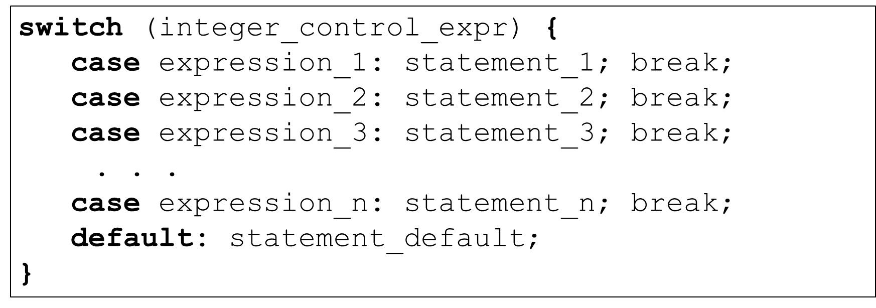

example

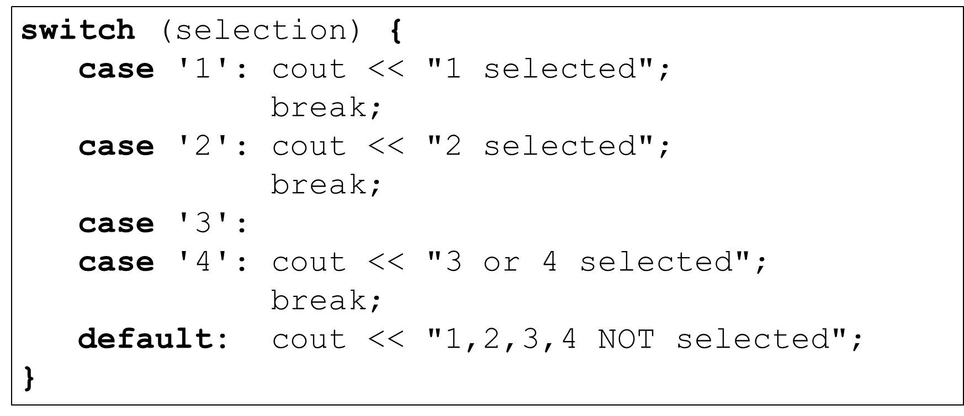

fall-through example

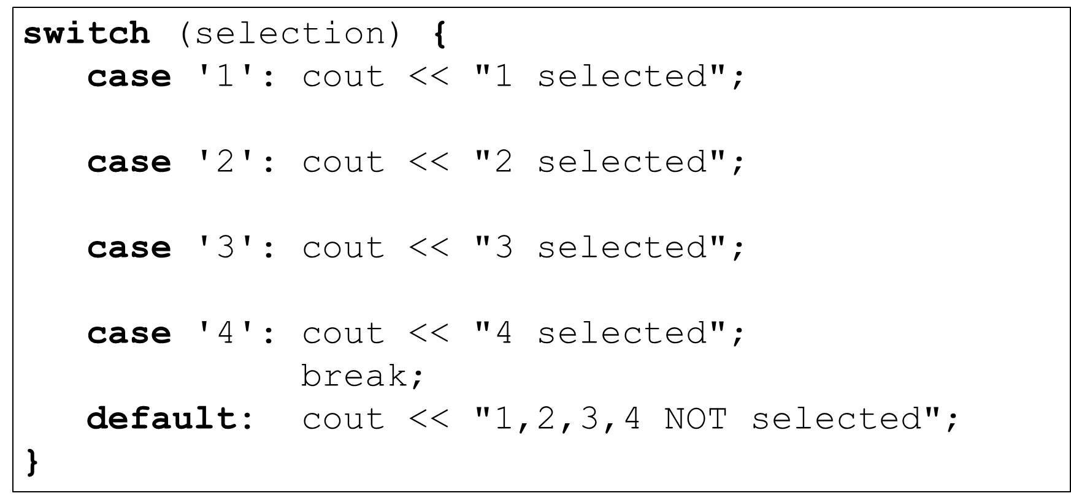

with an enumeration

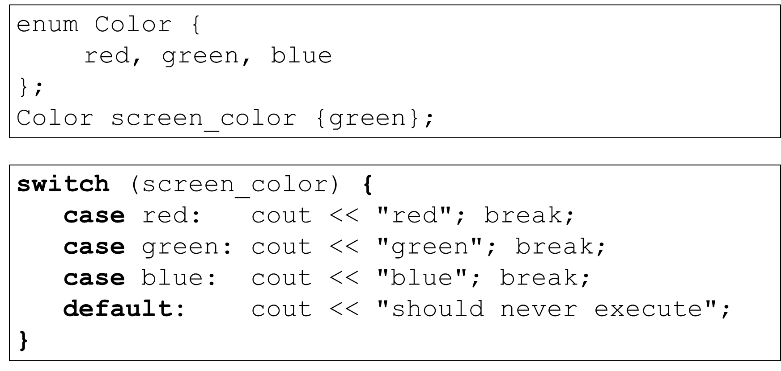

* The control expression must evaluate to an integer type
* The case expressions must be constant expressions that evaluate to integer or integers literals
* Once a match occurs all following case sections are executes UNTIL a

break is reached the switch complete

* Best practice – provide break statement for each case
* Best practice – default is optional, but should be handled

?:

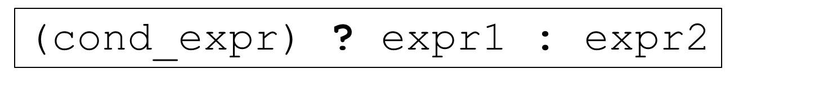

* cond_expr evaluates to a boolean expression
  + If cond_expr is true then the value of expr1 is returned
  + If cond_expr is false then the value of expr2 is returned
* Similar to if-else construct
* Ternary operator
* Very useful when used inline
* Very easy to abuse!

example

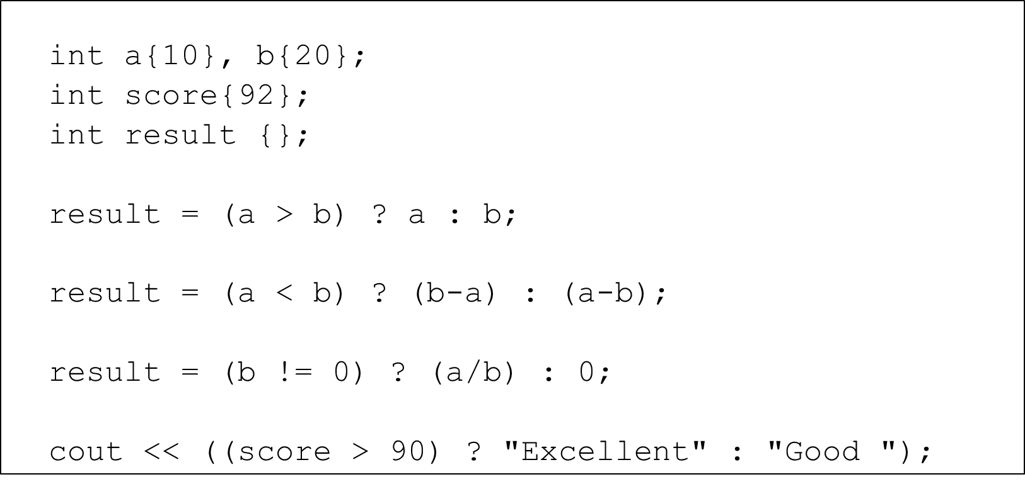

iteration

* The third basic building block of programming
  + sequence, selection, iteration
* Iteration or repetition
* Allows the execution of a statement or block of statements repeatedly
* Loops are made up a loop condition and the body which contains the statements to repeat

Some typical use-cases

Execute a loop:

* + a speciﬁc number of times
  + for each element in a collection
  + while a speciﬁc condition remains true
  + until a speciﬁc condition becomes false
  + until we reach the end of some input stream
  + forever
  + many, many more

## C++ Looping Constructs

* for loop
  + iterate a speciﬁc number of times
* Range-based for loop
  + one iteration for each element in a range or collection
* while loop
  + iterate while a condition remains true
  + stop when the condition becomes false
  + check the condition at the beginning of every iteration
* do-while loop
  + iterate while a condition remains true
  + stop when the condition becomes false
  + check the condition at the end of every iteration

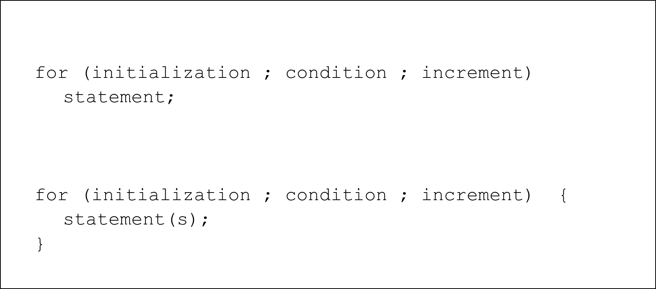

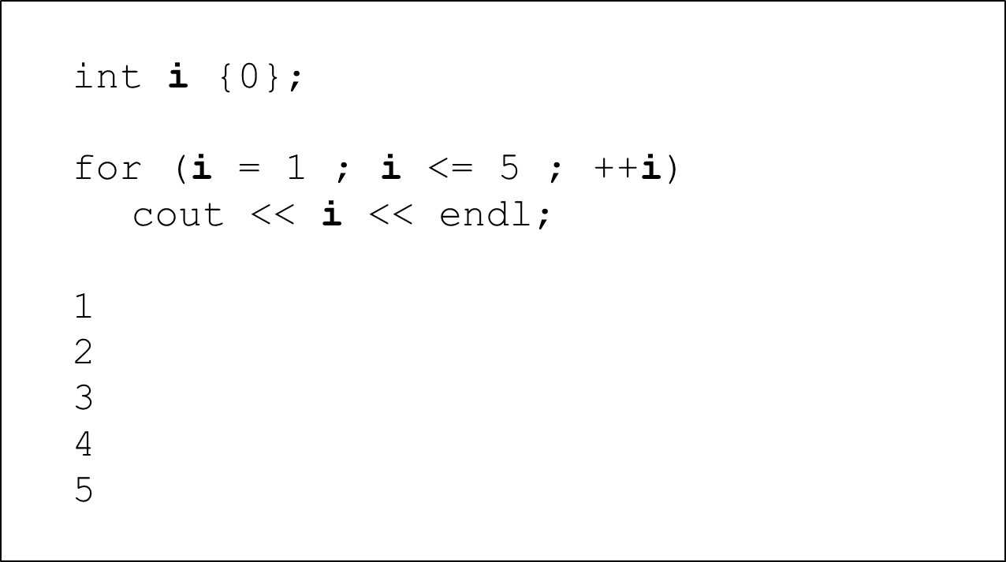

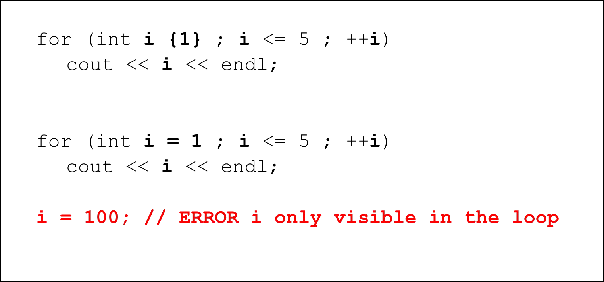

display even numbers

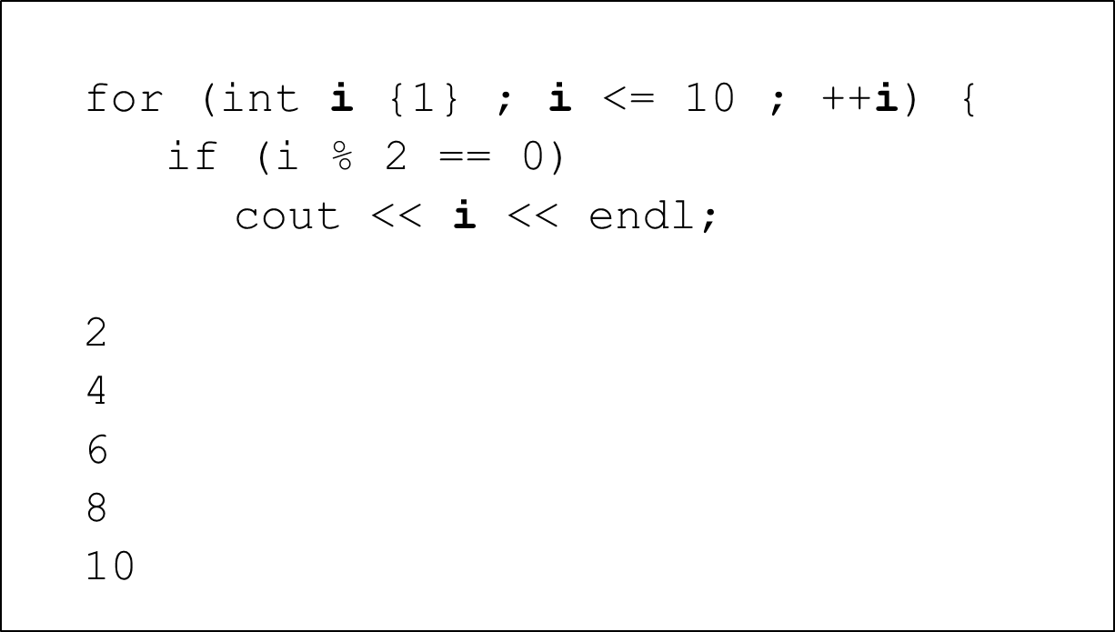

array example

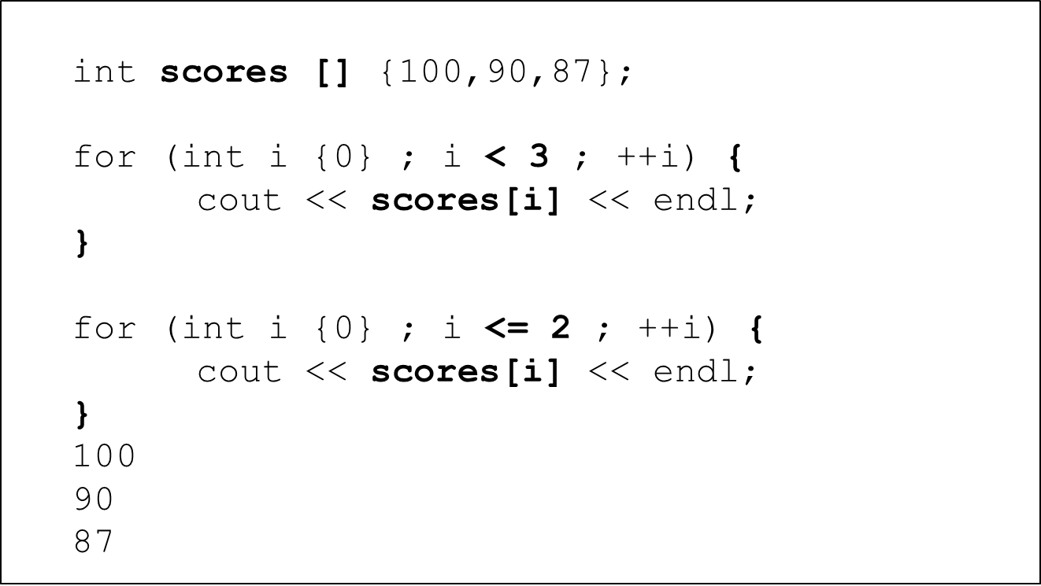

comma operator

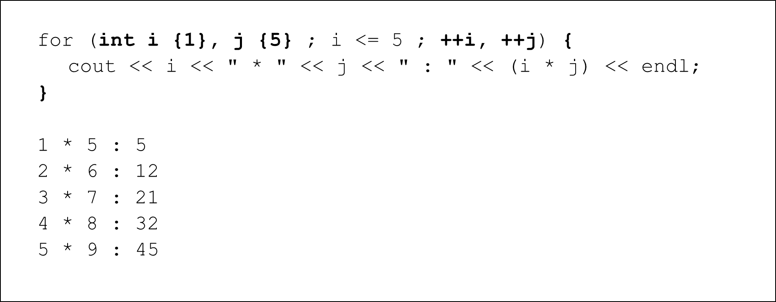

some other details…

* The basic for loop is very clear and concise
* Since the for loop’s expressions are all optional, it is possible to have
  + no initialization
  + no test
  + no increment

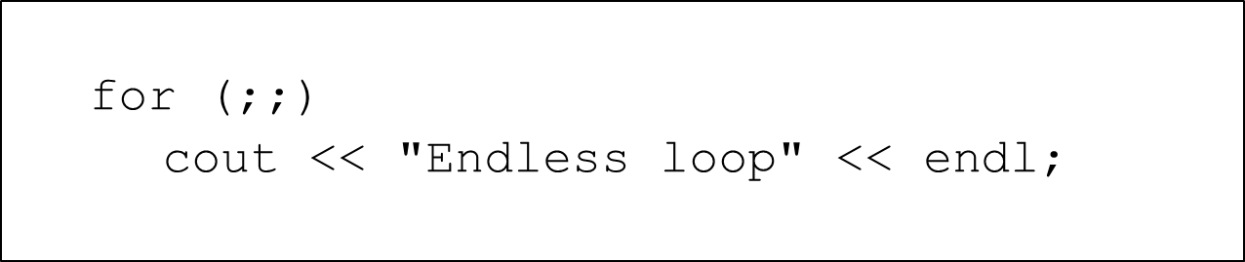

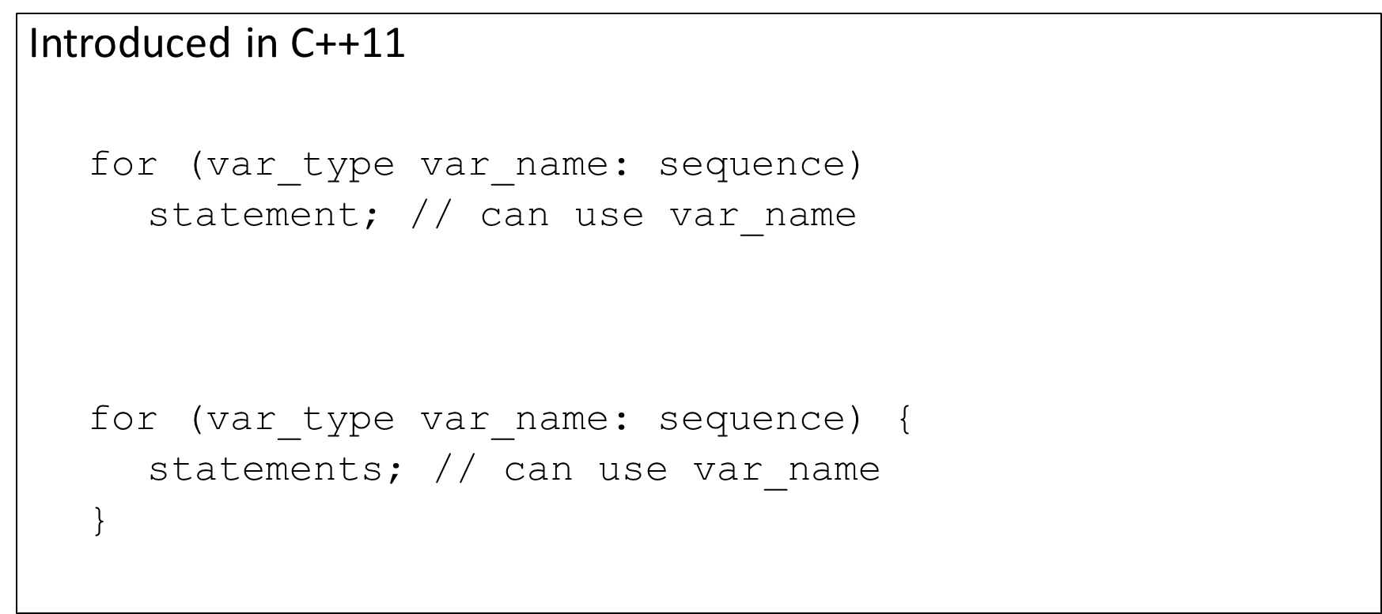

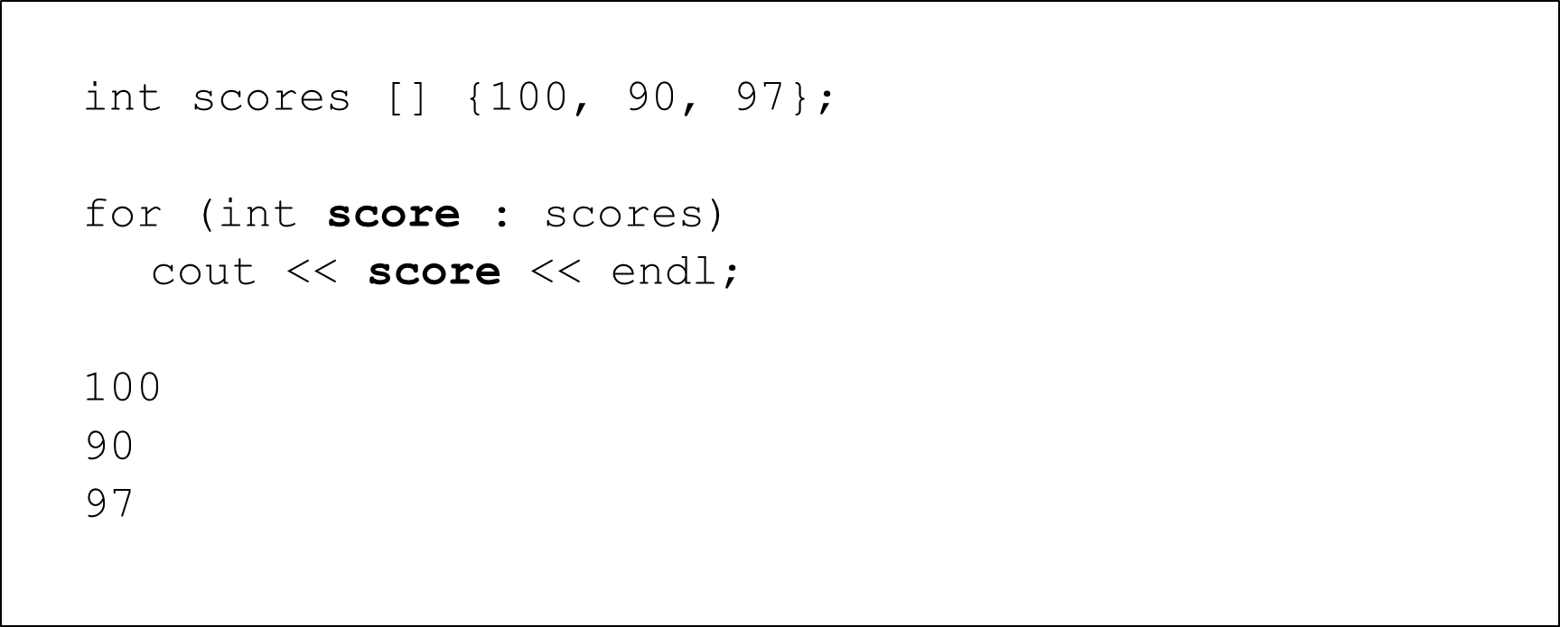

auto

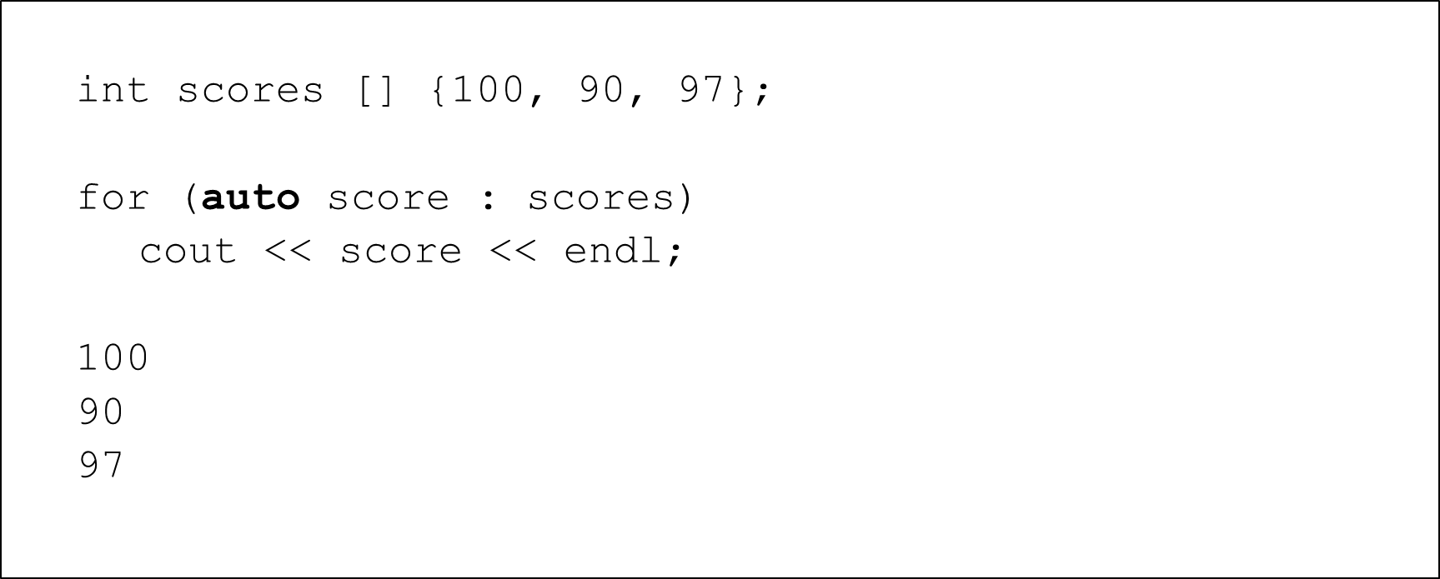

vector

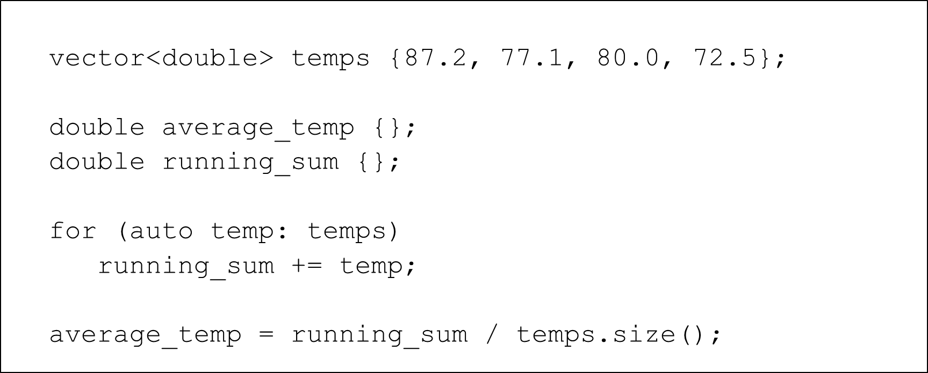

initializer list

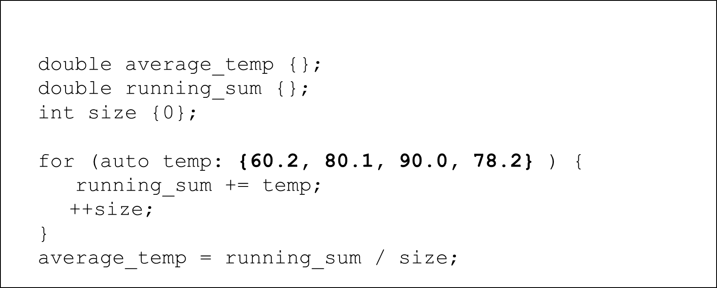

string

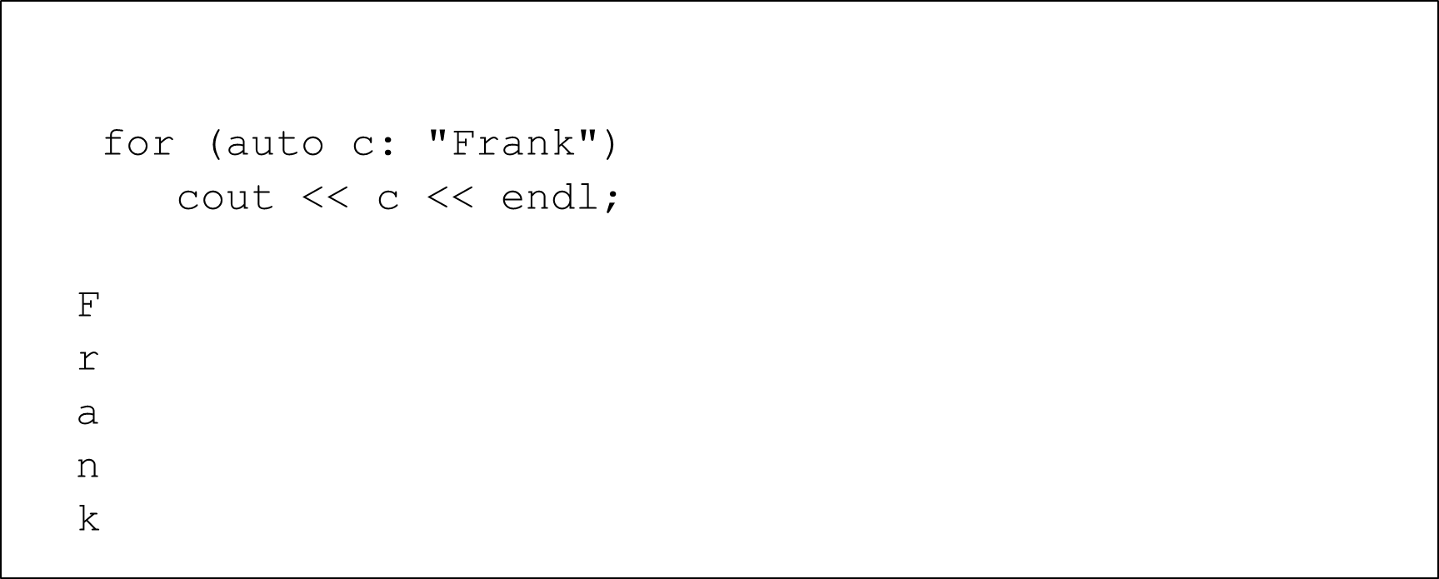

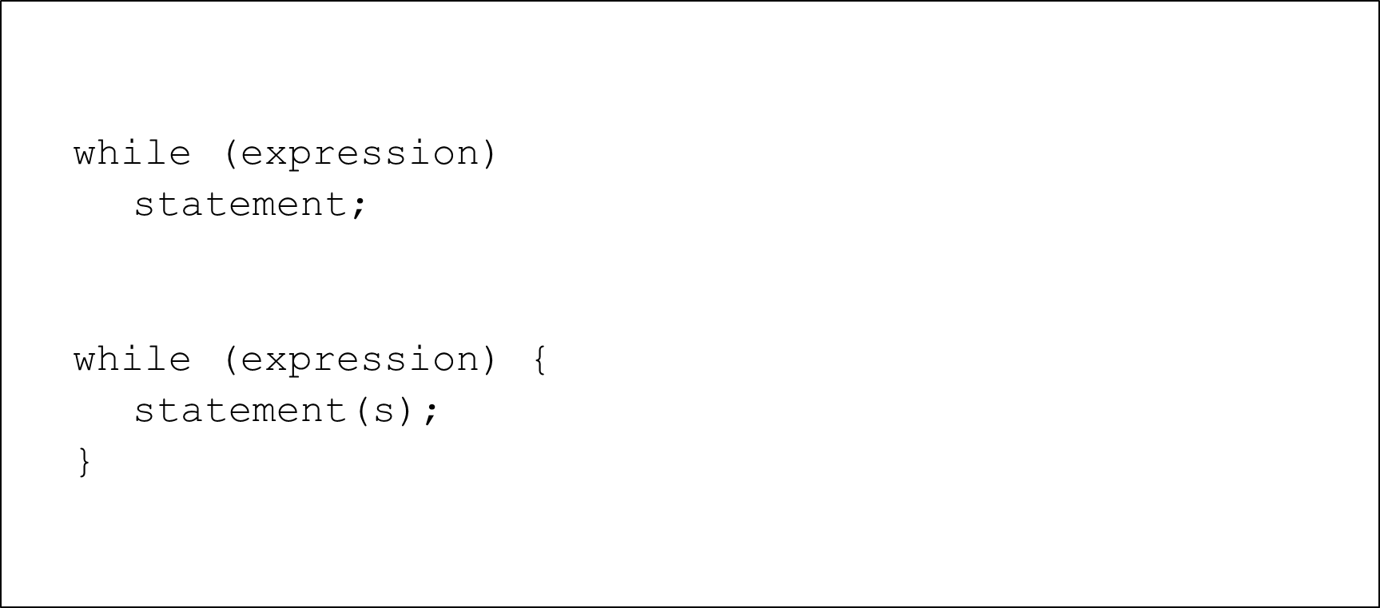

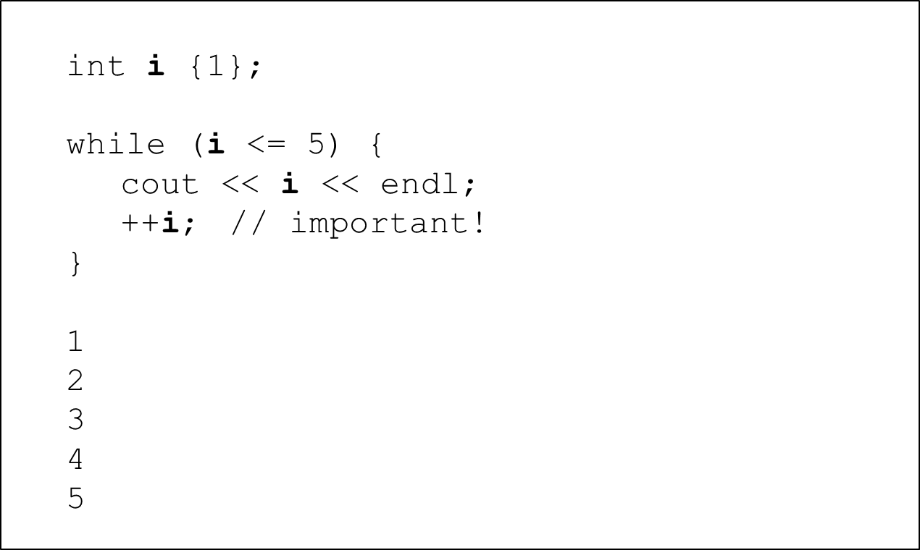

even numbers

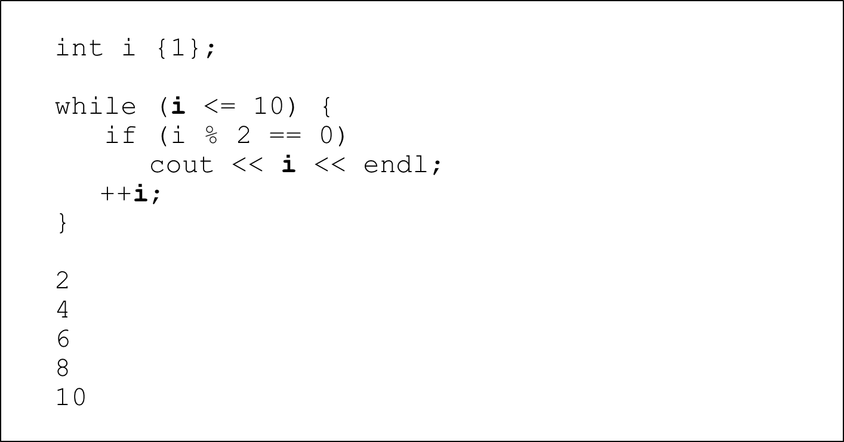

array example

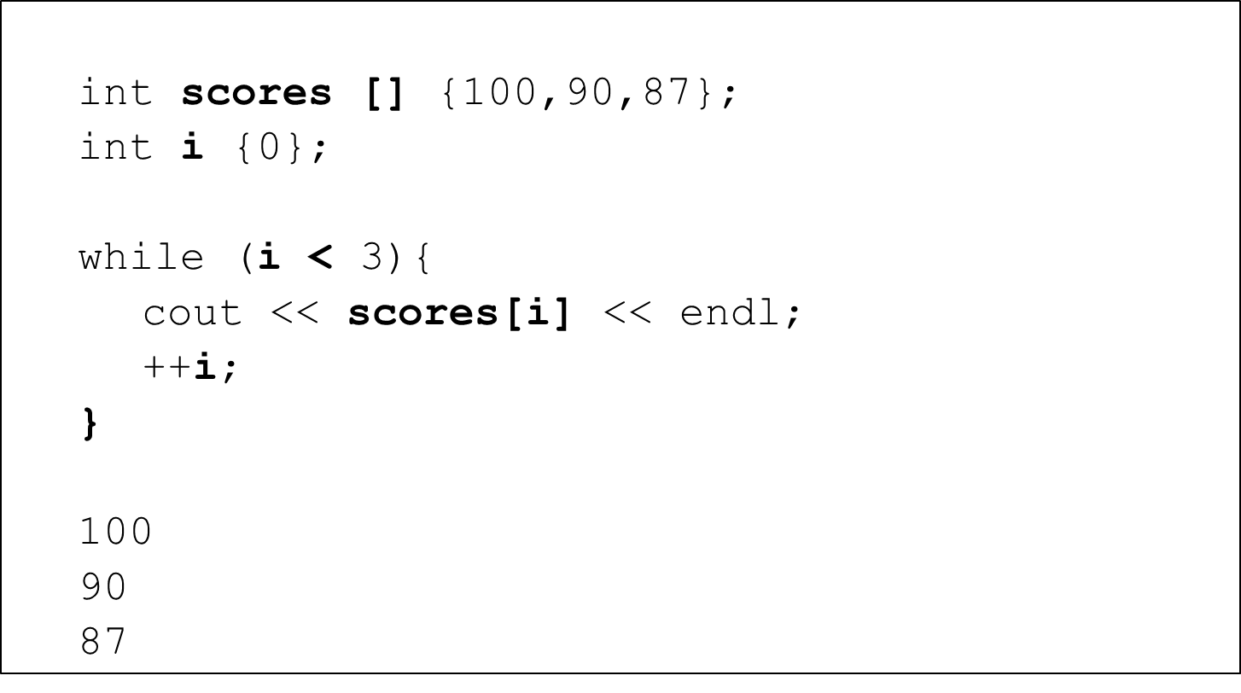

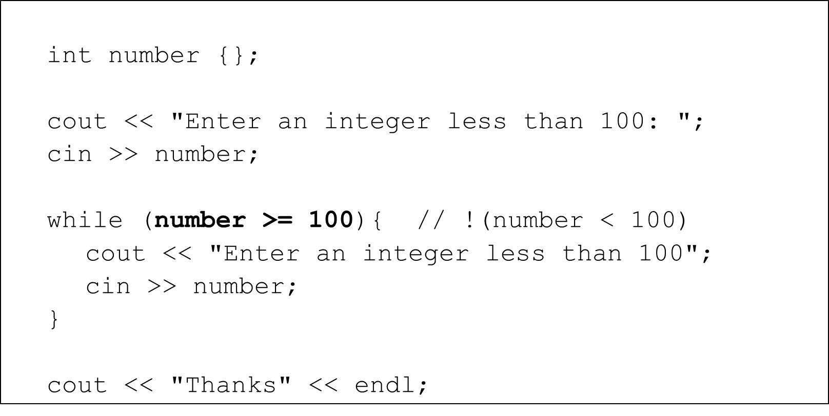

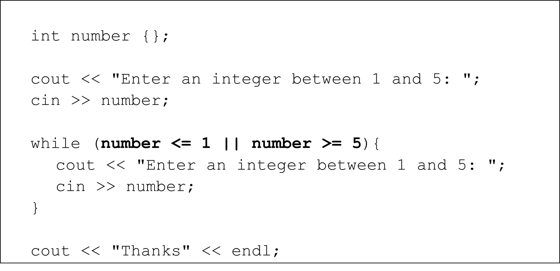

input validation – boolean ﬂag

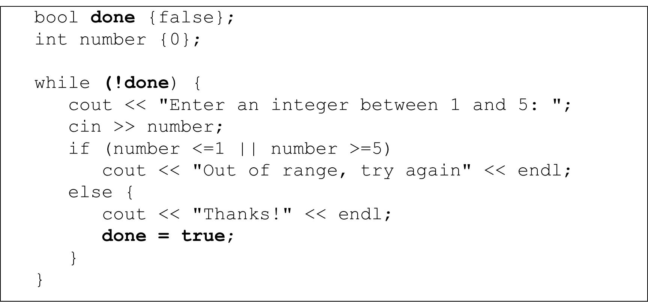

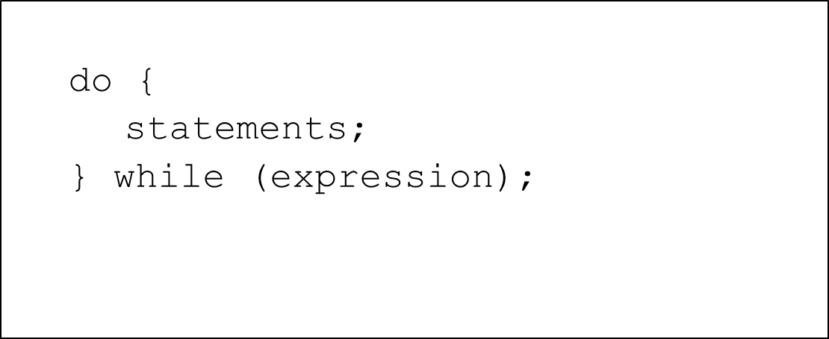

input validation

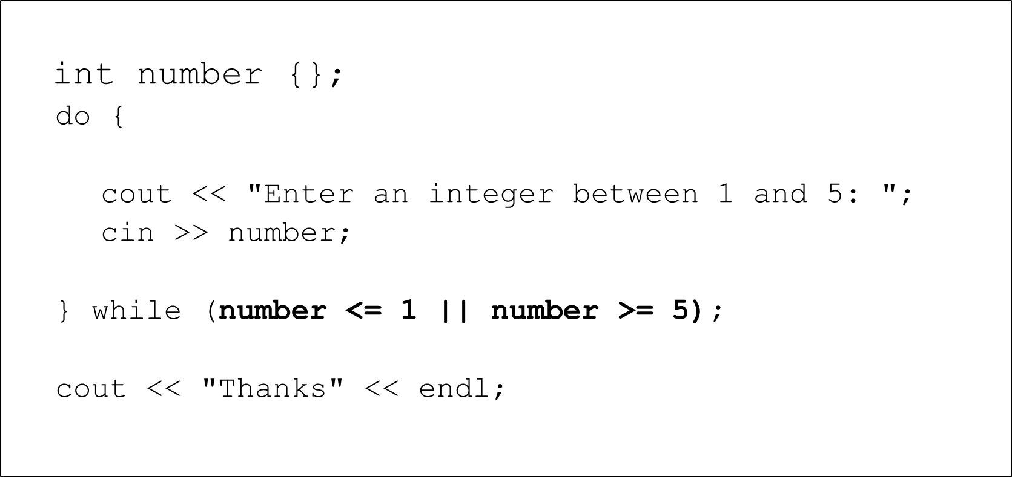

area calculation with calculate another

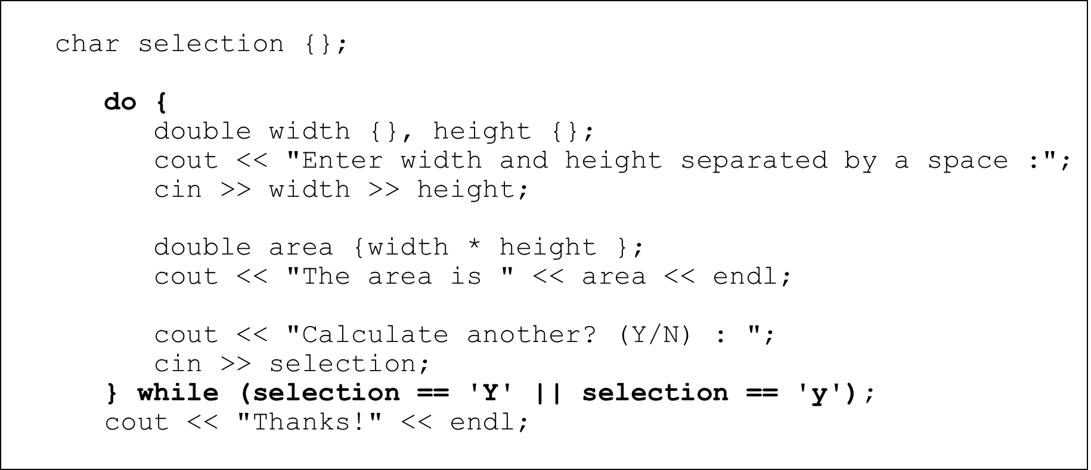

* continue
  + no further statements in the body of the loop are executed
  + control immediately goes directly to the beginning of the loop for the next iteration
* break
  + no further statements in the body of the loop are executed
  + loop is immediately terminated
  + Control immediately goes to the statement following the loop construct

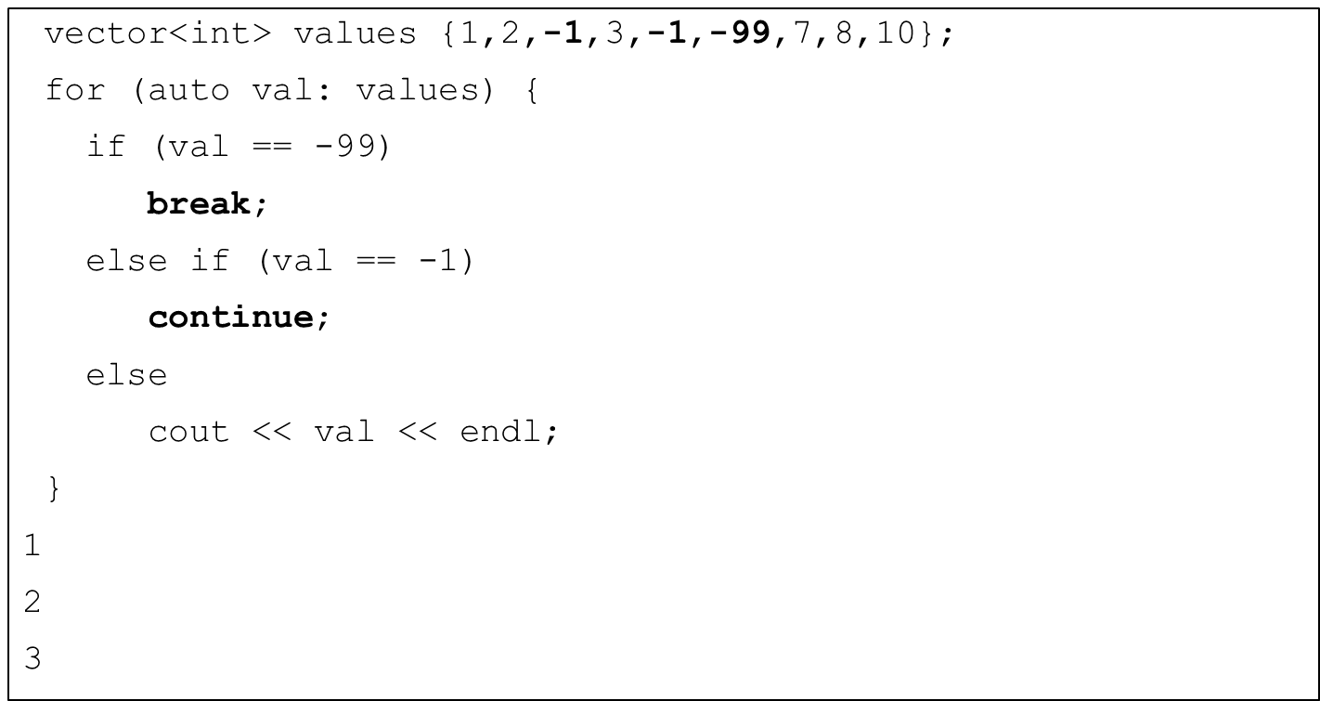

## Inﬁnite Loops

* Loops whose condition expression always evaluate to true
* Usually this is unintended and a programmer error
* Sometimes programmers use inﬁnite loops and include and break statements in the body to control them
* Sometimes inﬁnite loops are exactly what we need
  + Event loop in an event-driven program
  + Operating system

Inﬁnite for Loops

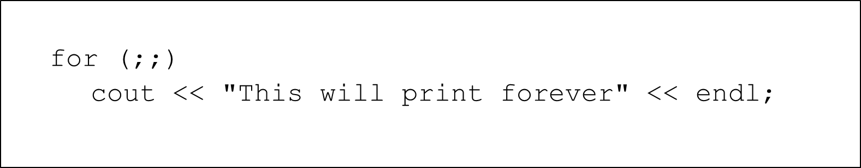

Inﬁnite while Loops

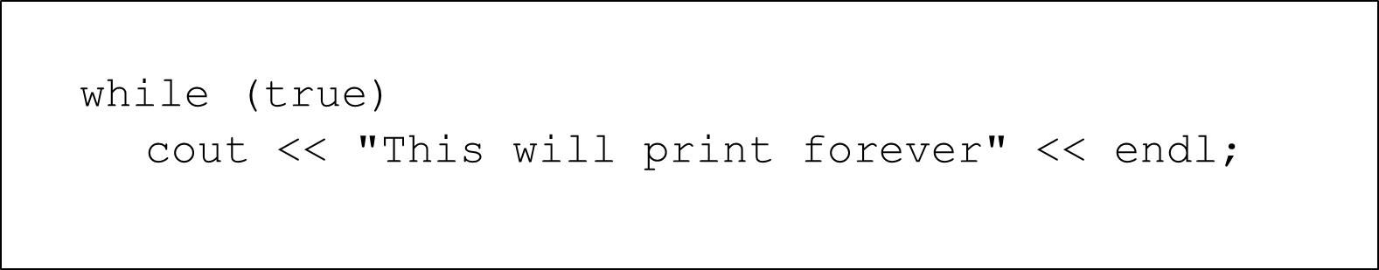

Inﬁnite do-while Loops

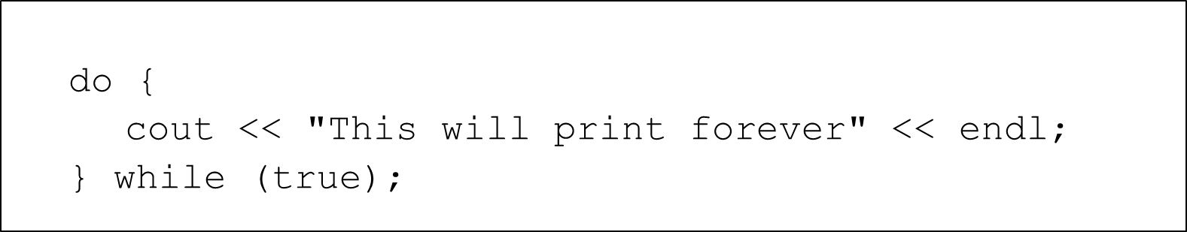

Inﬁnite while Loops

example

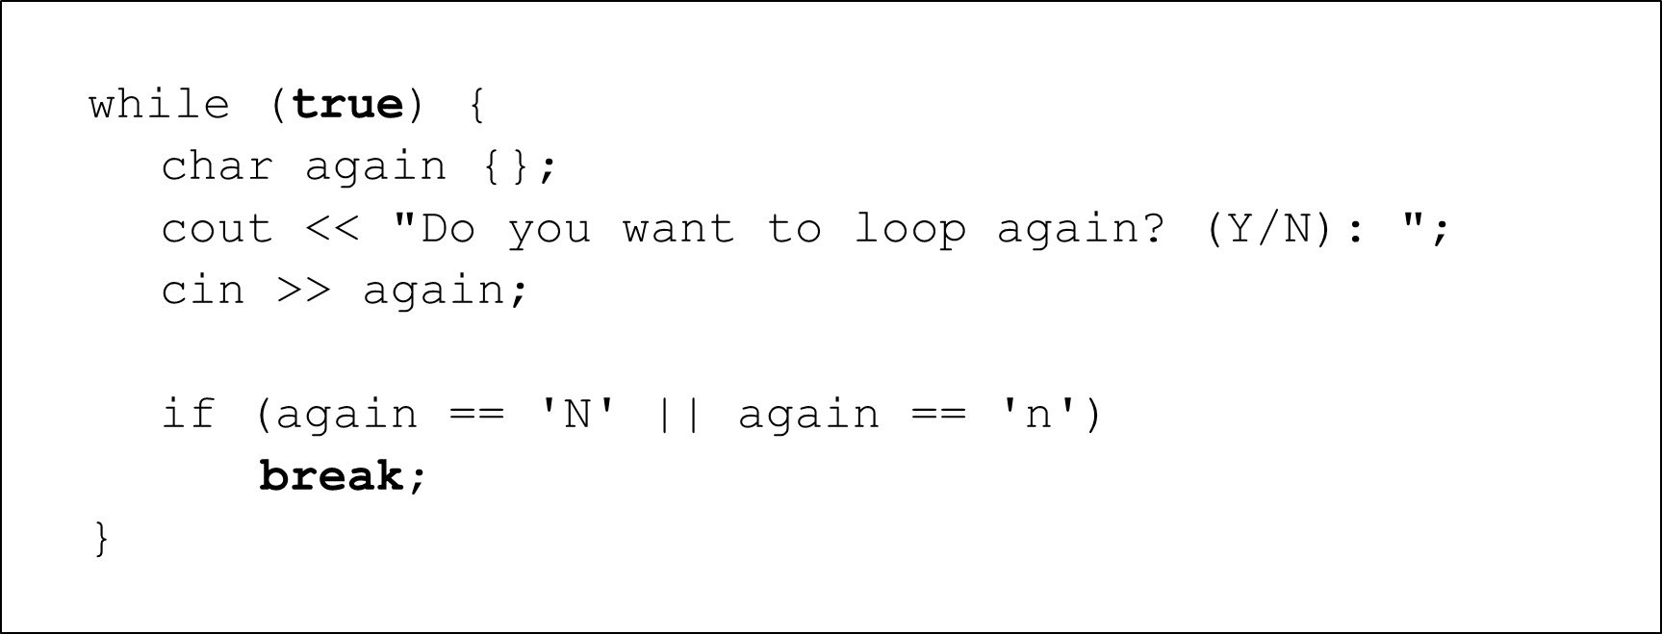

* Loop nested within another loop
* Can be many as many levels deep as the program needs
* Very useful with multi-dimensional data structures
* Outer loop vs. Inner loop

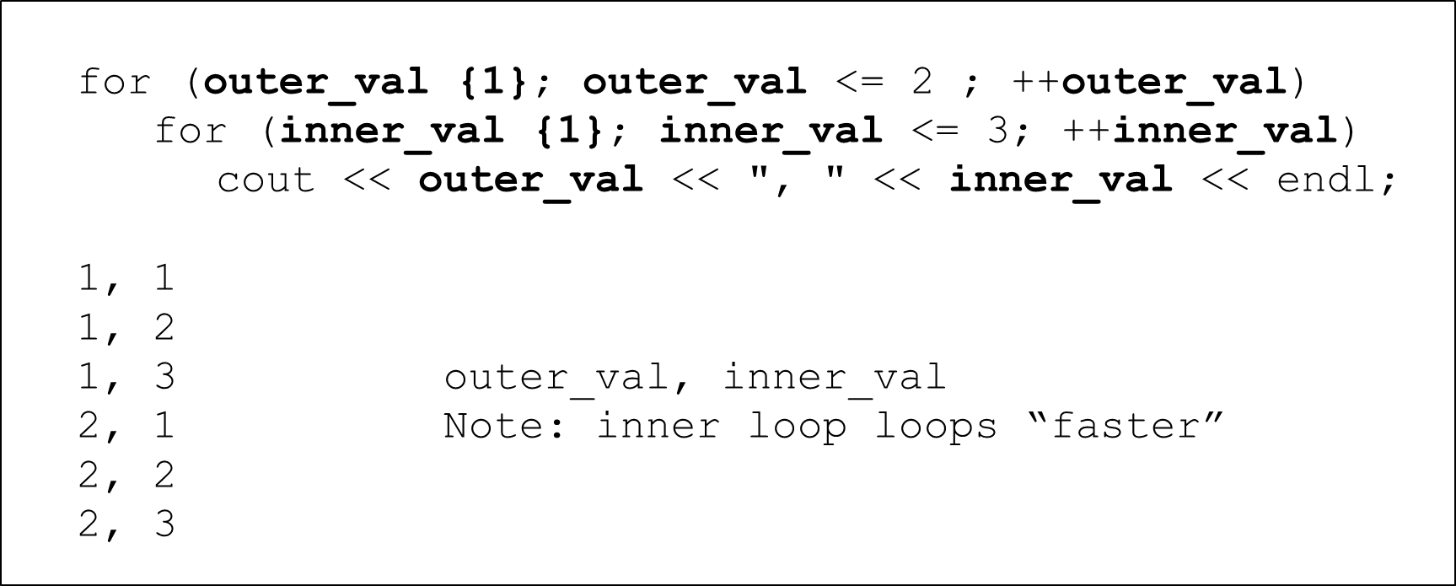

Multiplication Table

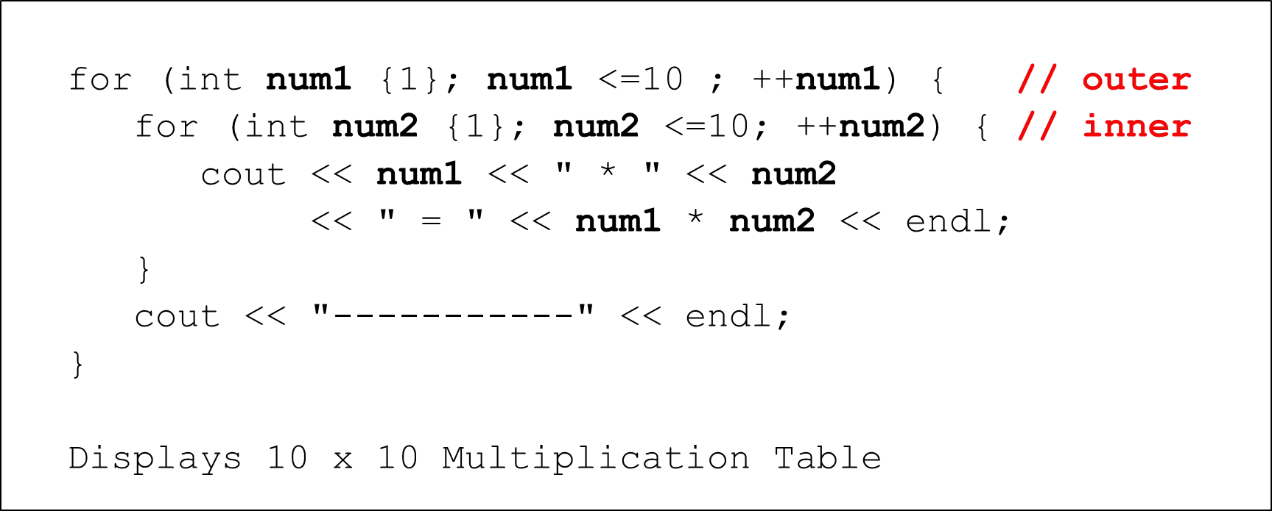

2D Arrays – set all elements to 1000

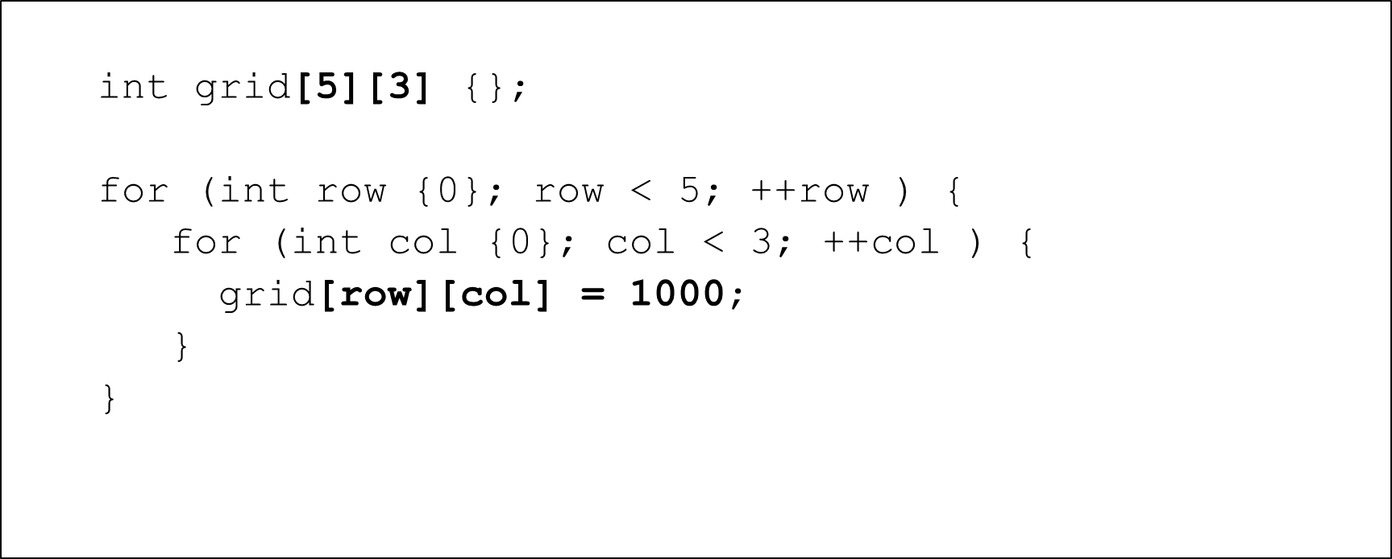

2D Arrays – display elements

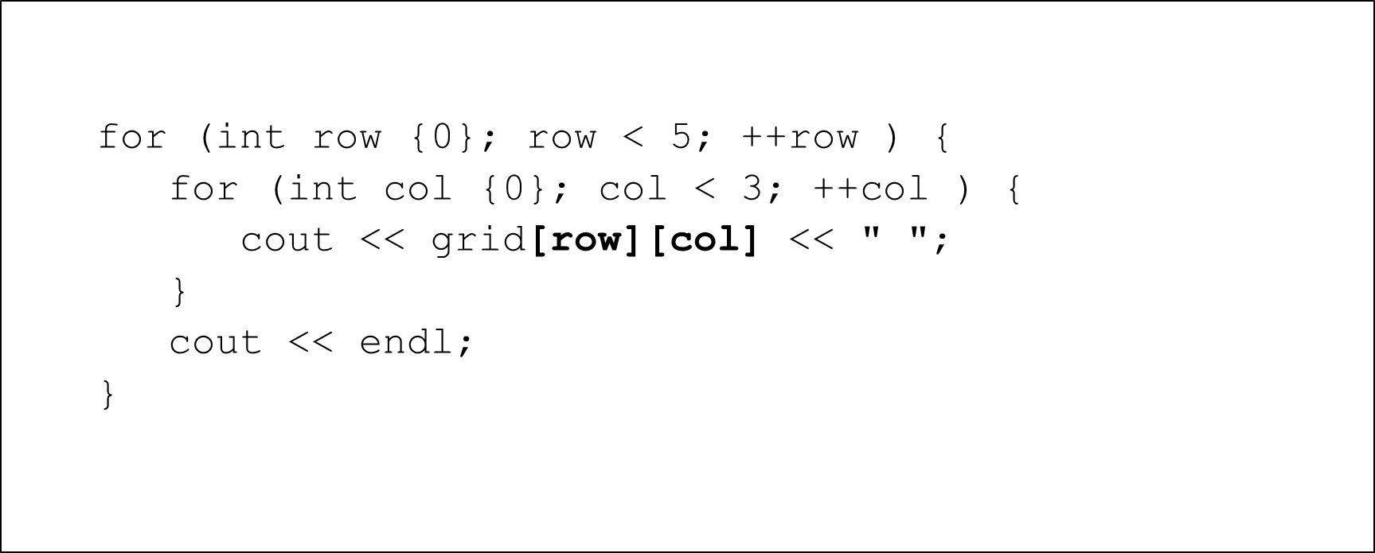

2D Vector – display elements

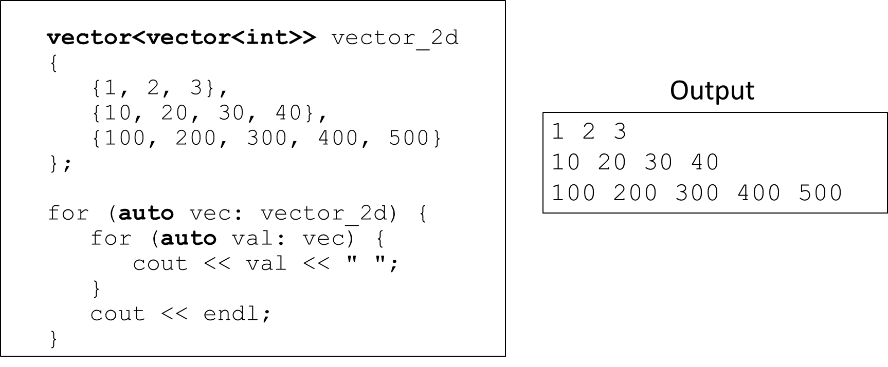

## Section Overview

Characters and Strings

* Character functions
* C-style Strings
* Working with C-style Strings
* C++ Strings
* Working with C++ Strings

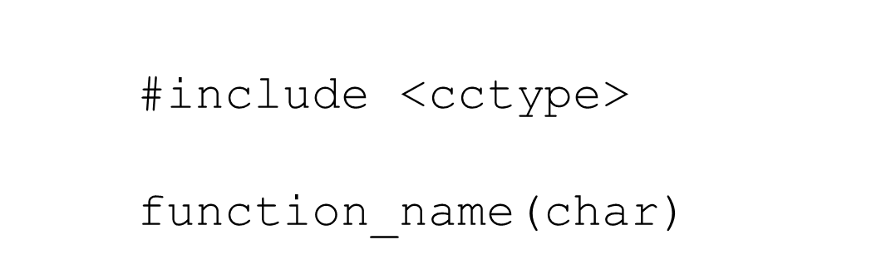#include <cctype>

* Functions for testing characters
* Functions for converting character case

Testing characters

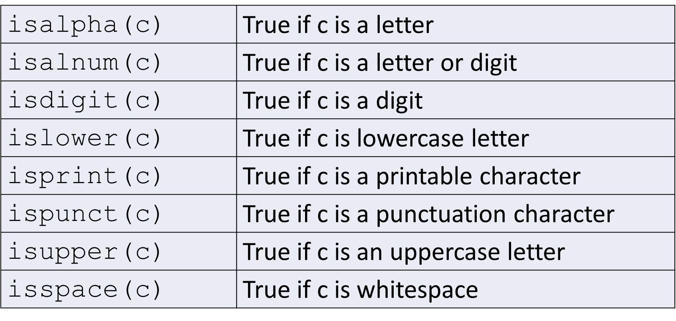

Converting characters

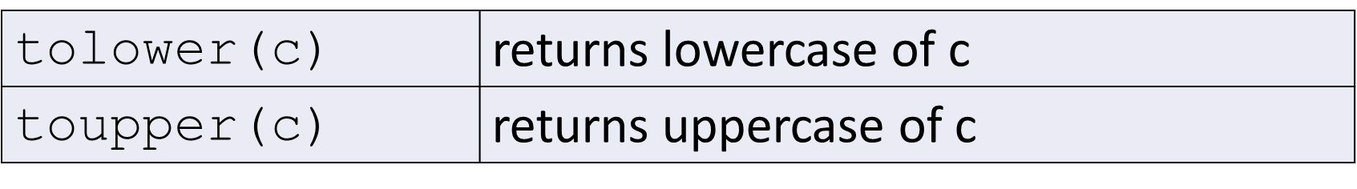

* Sequence of characters
  + contiguous in memory
  + implemented as an array of characters
  + terminated by a null character (null)
    - null – character with a value of zero
  + Referred to as zero or null terminated strings
* String literal
  + sequence of characters in double quotes, e.g. “Frank”
  + constant
  + terminated with null character

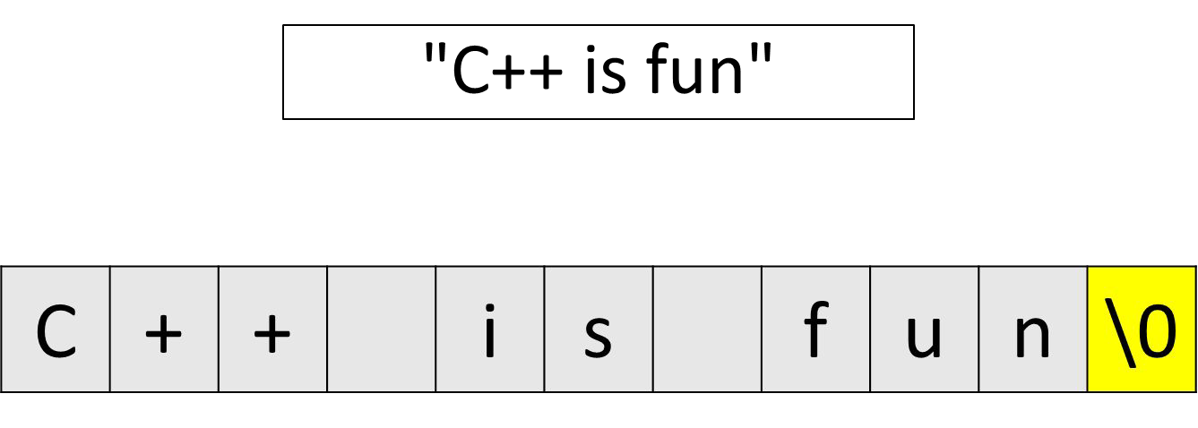

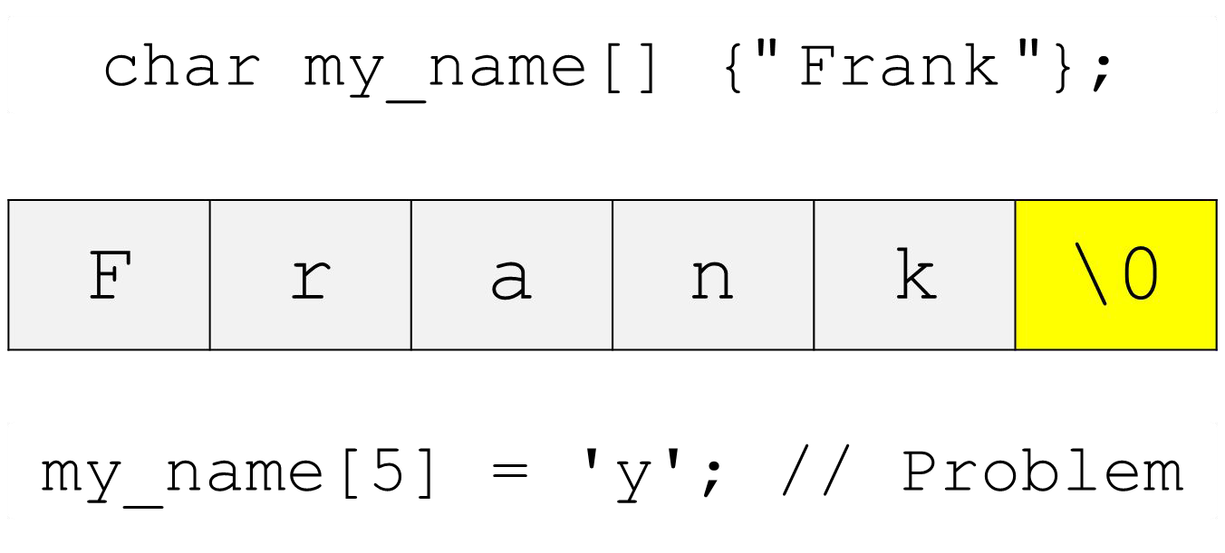

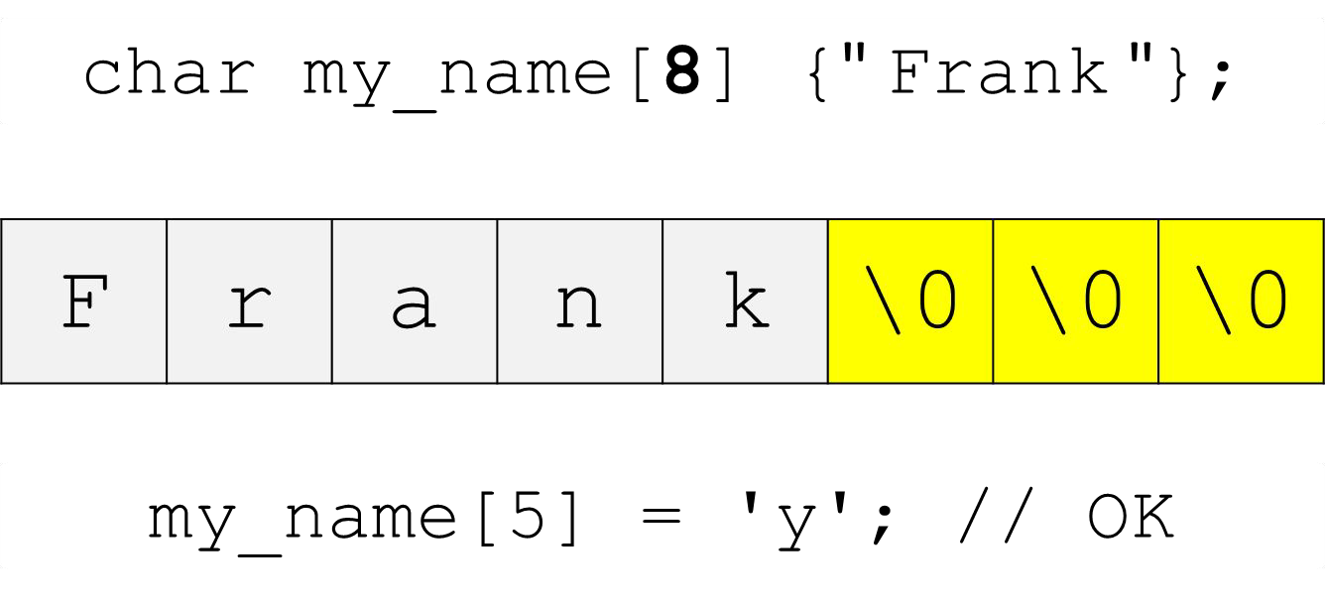

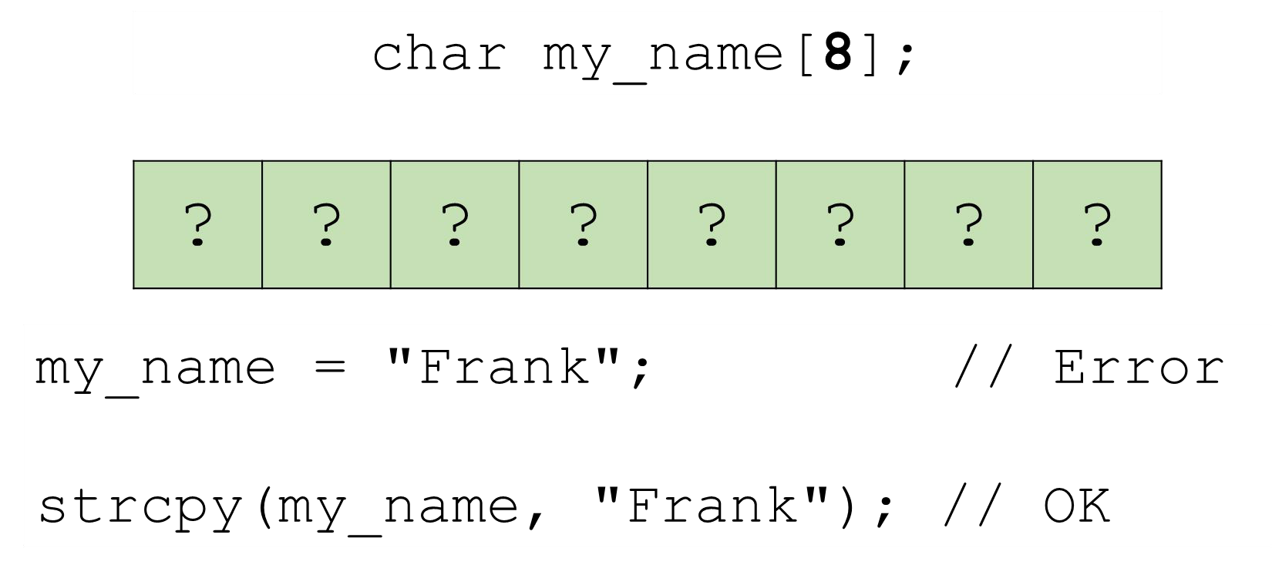

Functions that work with C-style Strings

* Copying
* Concatenation
* Comparison
* Searching
* and others

A few examples

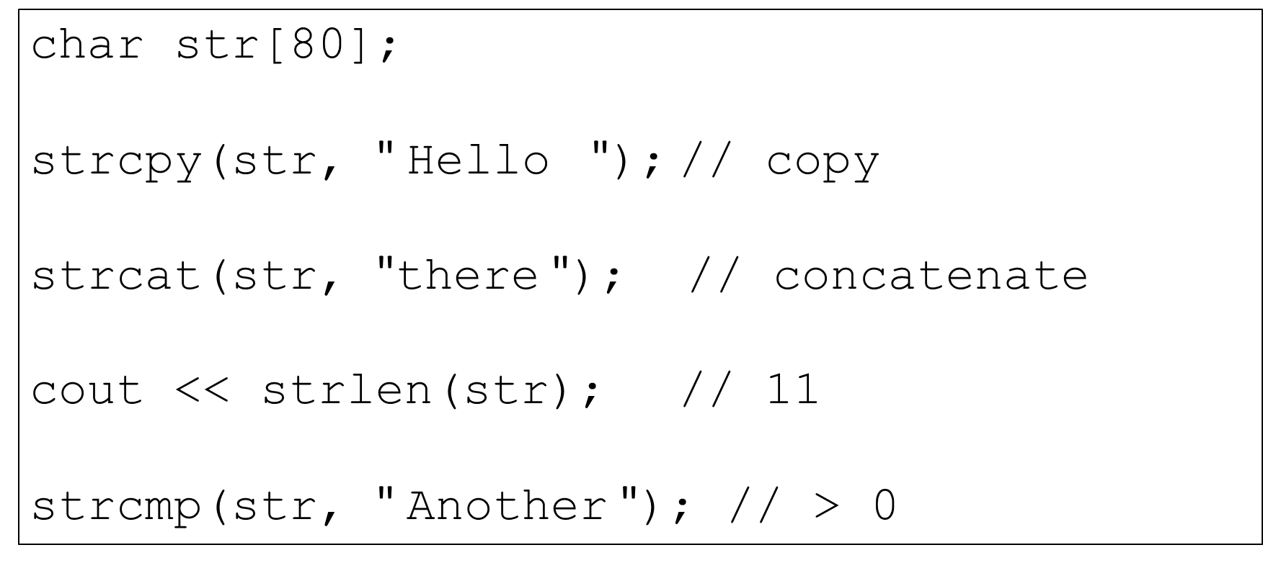

## #include <cstdlib>

General purpose functions

* Includes functions to convert C-style Strings to
  + integer
  + ﬂoat
  + long
  + etc.
* std::string is a Class in the Standard Template Library
  + #include <string>
  + std namespace
  + contiguous in memory
  + dynamic size
  + work with input and output streams
  + lots of useful member functions
  + our familiar operators can be used (+, = , < , <=, >, >=, +=, ==, !=, []…)
  + can be easily converted to C-style Strings if needed
  + safer

Declaring and initializing

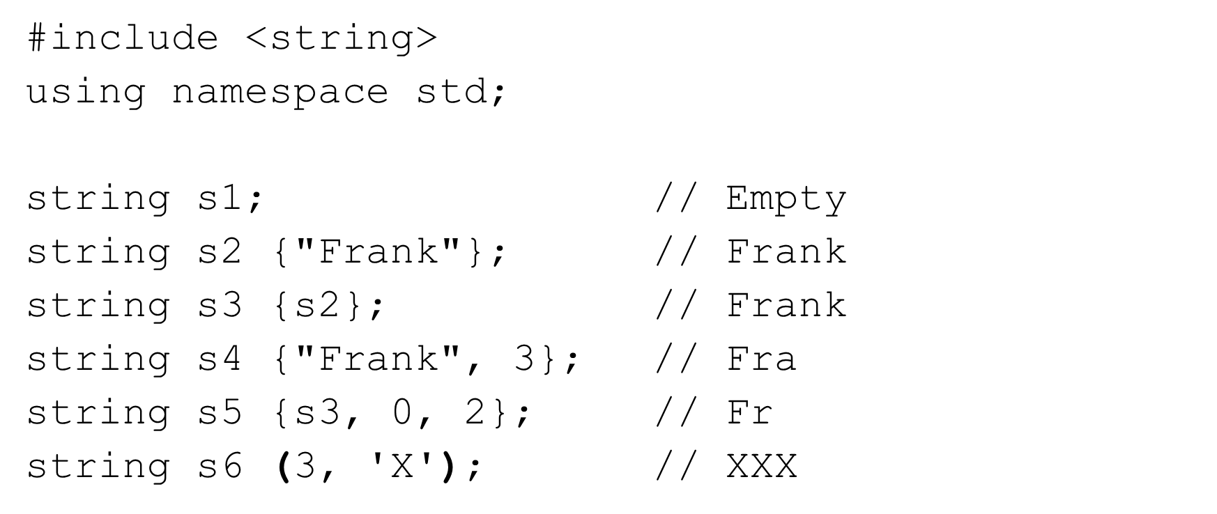

Assignment =

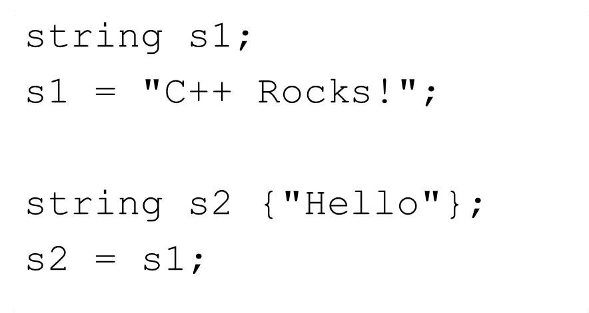

Concatenation

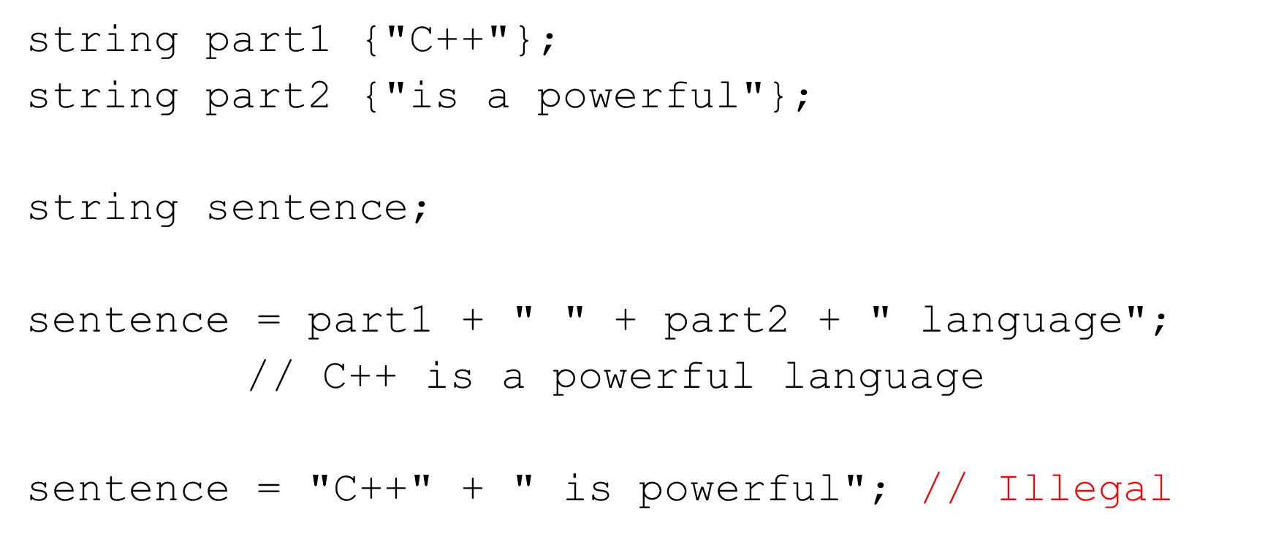

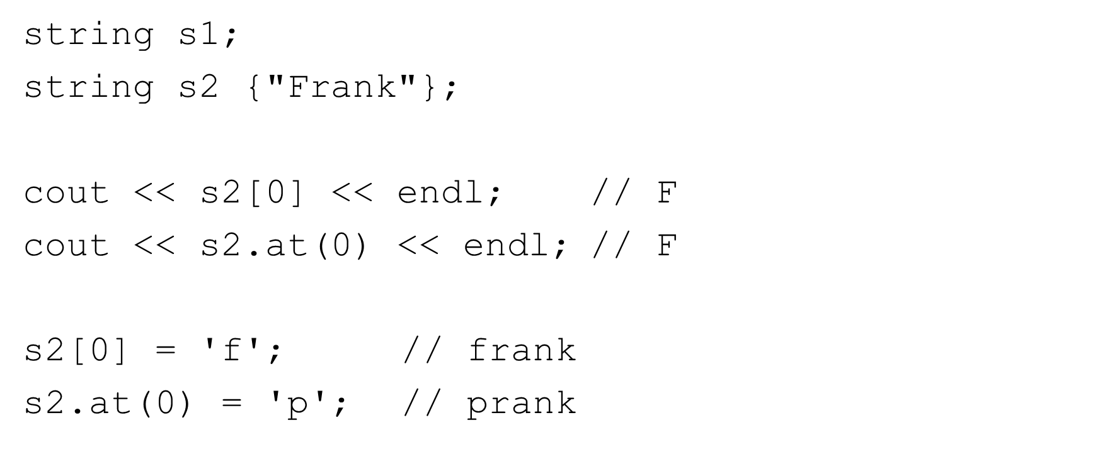

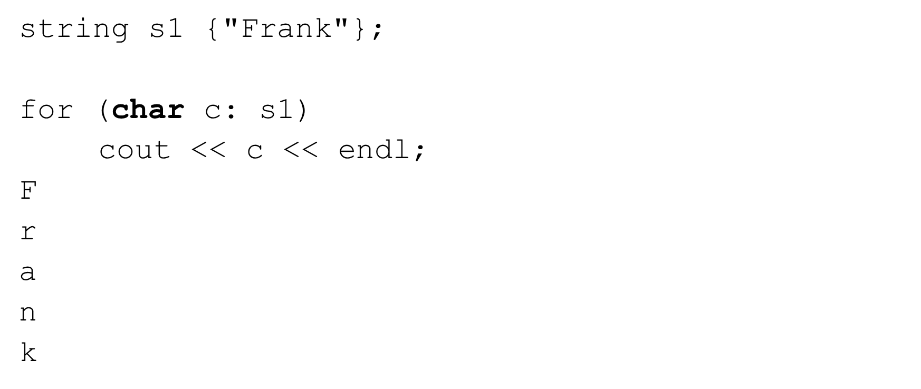

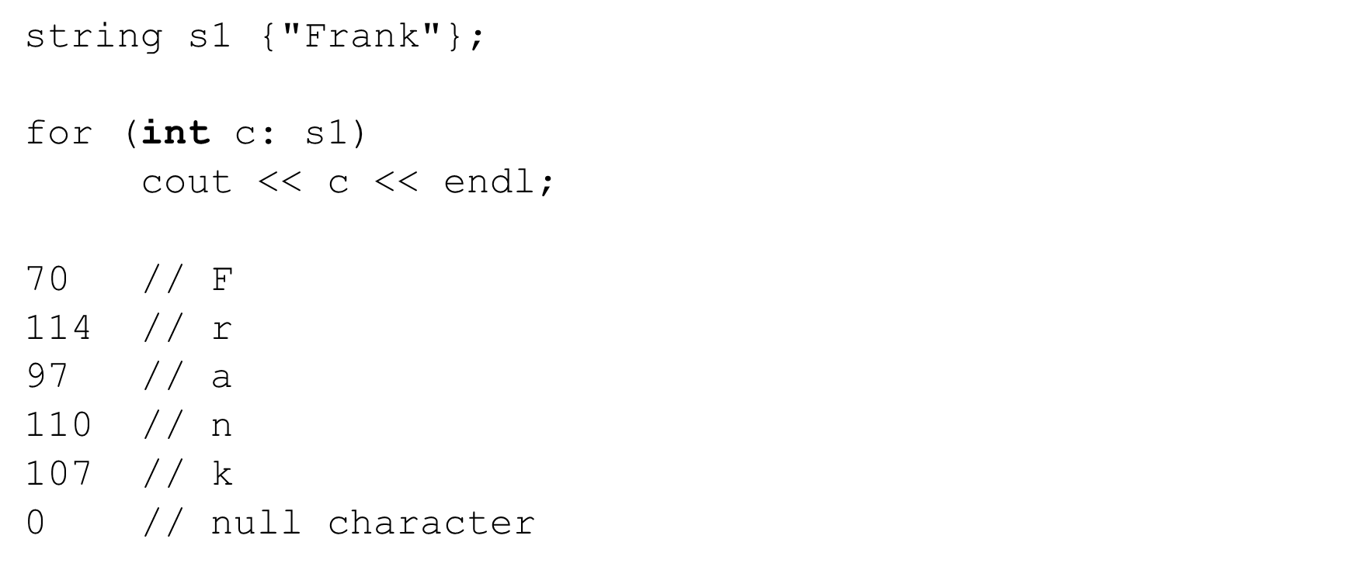

== != > >= < <=

The objects are compared character by character lexically.

Can compare:

two std::string objects

std::string object and C-syle string literal

std::string object and C-style string variable

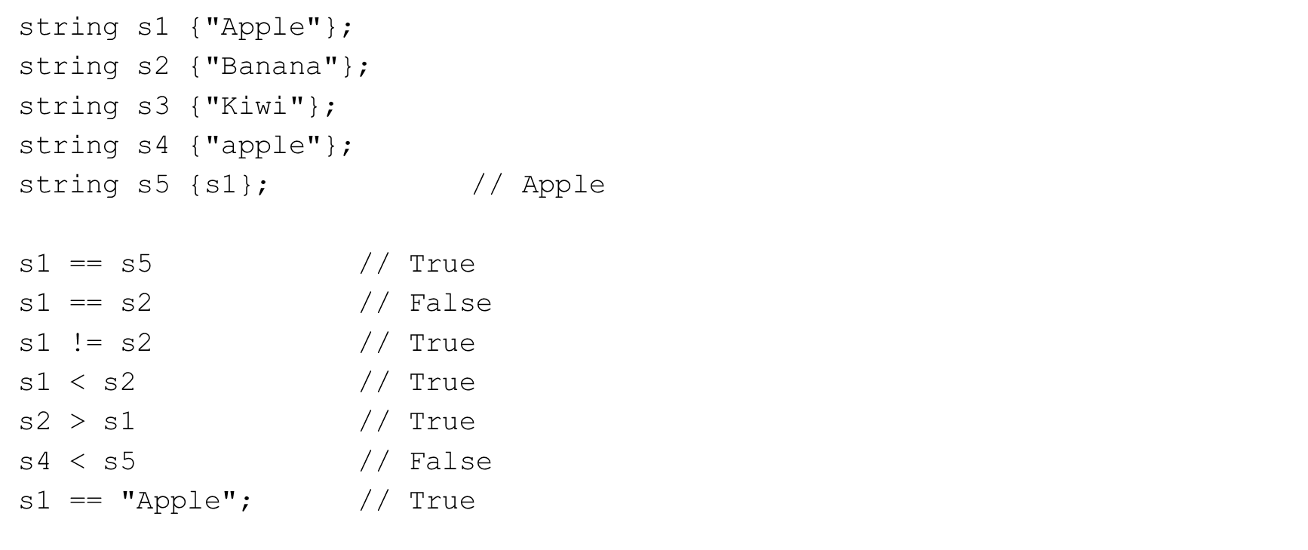

Substrings – substr()

Extracts a substring from a std::string

object.substr(start_index, length)

|  |  |  |  |  |  |  |
| --- | --- | --- | --- | --- | --- | --- |
| string | | s1 | {"This | is | a | test"}; |
| cout | << | s1.substr(0,4); // This | | | | |
| cout | << | s1.substr(5,2); // is | | | | |
| cout | << | s1.substr(10,4); // test | | | | |

Searching – find()

Returns the index of a substring in a std::string

object.find(search_string) string s1 {"This is a test"};

cout << s1.find("This"); // 0 cout << s1.find("is"); // 2 cout << s1.find("test"); // 10 cout << s1.find('e'); // 11 cout << s1.find("is", 4); // 5

cout << s1.find("XX"); // string::npos

Removing characters – erase() and clear()

Removes a substring of characters from a std::string

object.erase(start_index, length) string s1 {"This is a test"};

|  |  |  |  |  |  |  |
| --- | --- | --- | --- | --- | --- | --- |
| cout | << | s1.erase(0,5); | // | is | a | test |
| cout | << | s1.erase(5,4); | // | is | a |  |

s1.clear(); // empties string s1

Other useful methods

string s1 {"Frank"};

cout << s1.**length()** << endl; // 5 s1 += " James";

cout << s1 << endl; // Frank James

Many more…

Input >> and getline()

Reading std::string from cin

string s1;

cin >> s1; // Hello there

// Only accepts up to the first space cout << s1 << endl; // Hello

getline(cin, s1); // Read entire line until \n cout << s1 << end; // Hello there

getline(cin, s1, 'x'); // this isx cout << s1 << endl; // this is

## Functions

* Function
  + deﬁnition
  + prototype
  + Parameters and pass-by-value
  + return statement
  + default parameter values
  + overloading
  + passing arrays to function
  + pass-by-reference
  + inline functions
  + auto return type
  + recursive functions

BEGINNING C++ PROGRAMMING

Section Overview

FUNCTIONS

S11-CPP-0020-1

* C++ programs
  + C++ Standard Libraries (functions and classes)
  + Third-party libraries (functions and classes)
  + Our own functions and classes
* Functions allow the modularization of a program
  + Separate code into logical self-contained units
  + These units can be reused

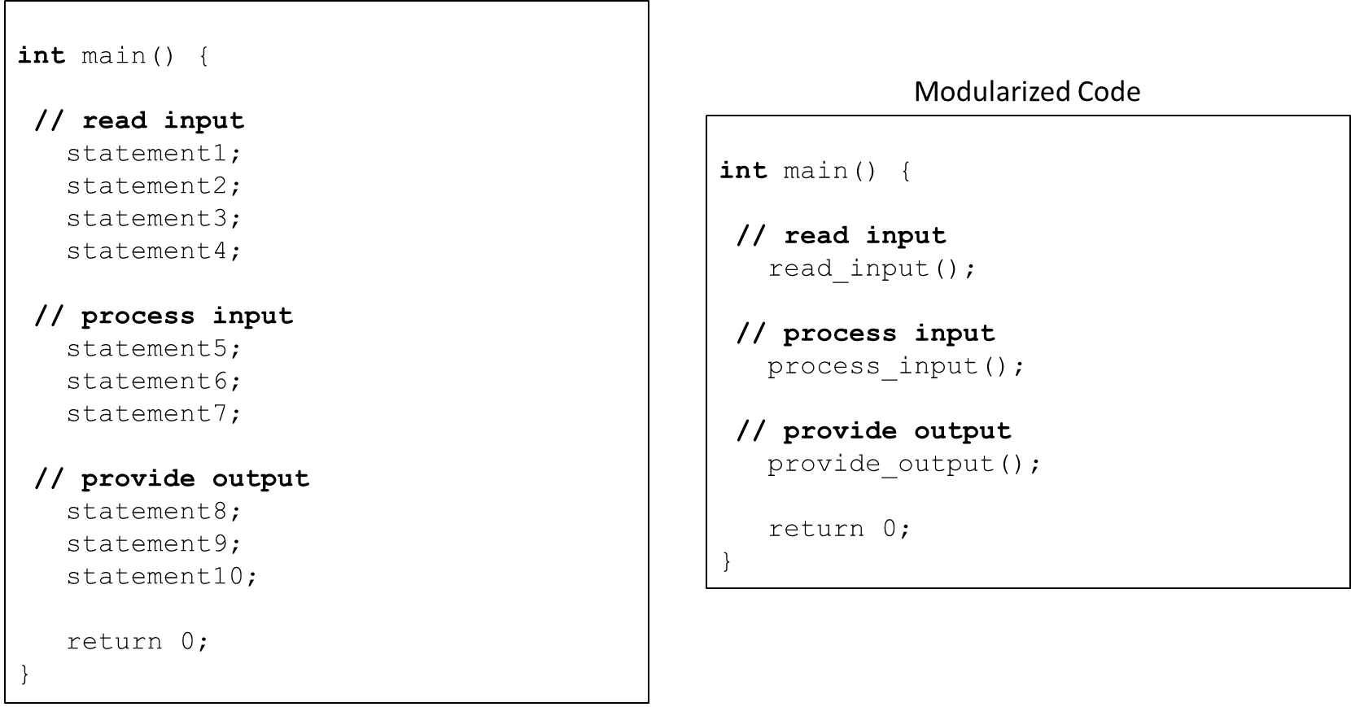

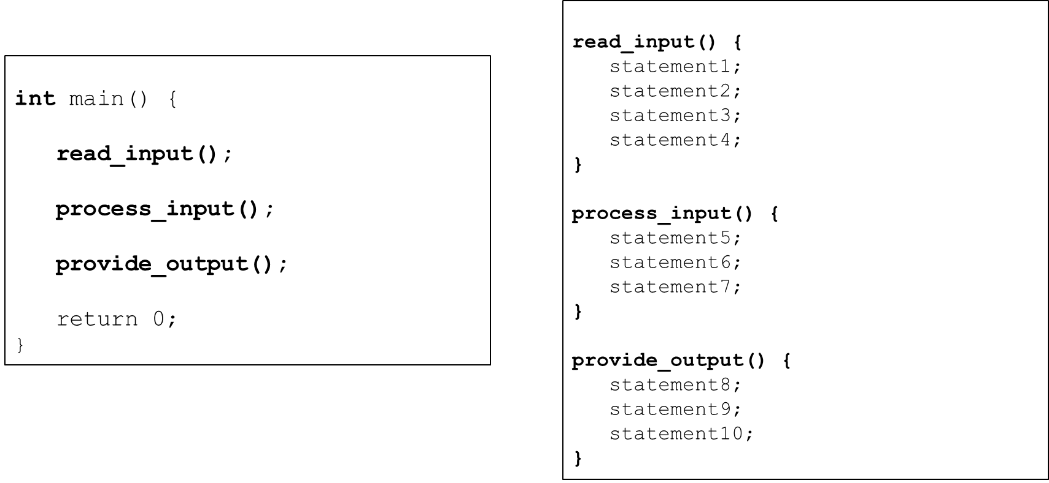

Boss/Worker analogy

* Write your code to the function speciﬁcation
* Understand what the function does
* Understand what information the function needs
* Understand what the function returns
* Understand any errors the function may produce
* Understand any performance constraints
* Don’t worry about HOW the function works internally
  + Unless you are the one writing the function!

Example <cmath>

* Common mathematical calculations
* Global functions called as:

function_name(argument); function_name(argument1, argument2, …);

|  |  |  |  |  |  |  |  |  |
| --- | --- | --- | --- | --- | --- | --- | --- | --- |
| cout | << | **sqrt**(400.0) | | << | endl; | // | | 20.0 |
| double | | result; |  | |  | |  | |
| result | | = **pow**(2.0, | 3.0); | | // | | 2.0^3.0 | |

User-deﬁned functions

* We can deﬁne our own functions
* Here is a preview

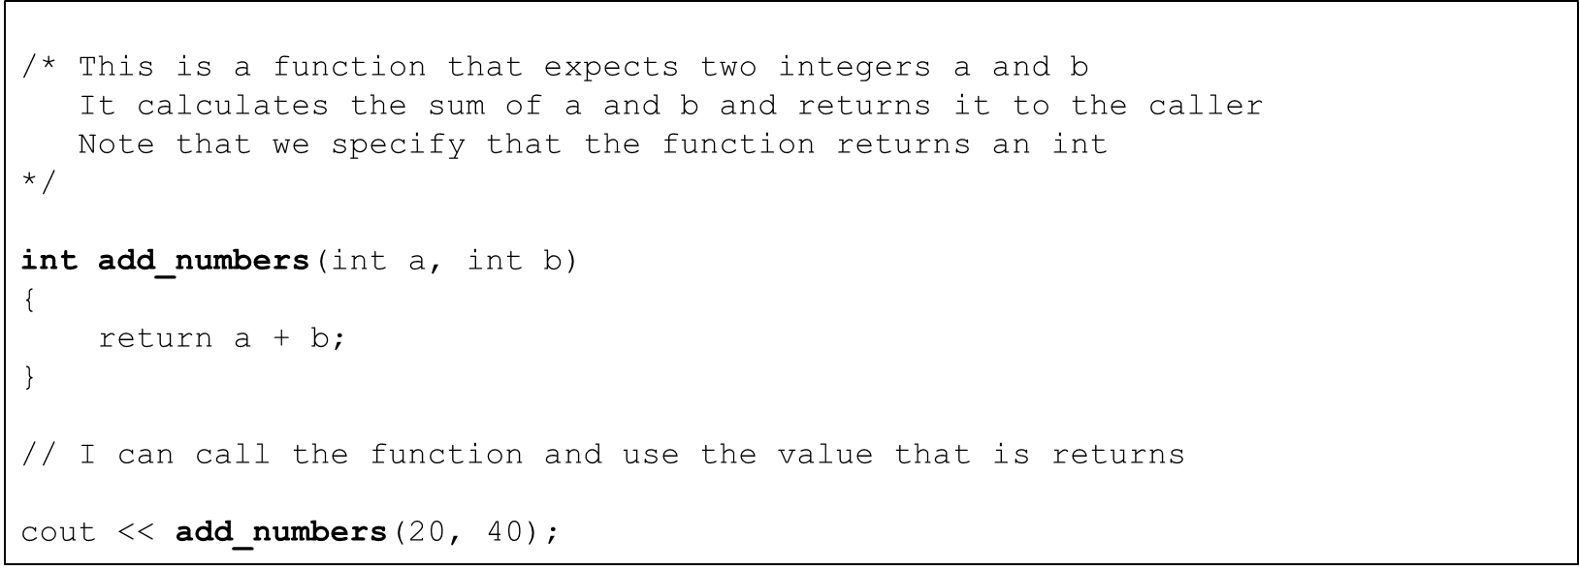

User-deﬁned functions

* Return zero if any of the arguments are negative

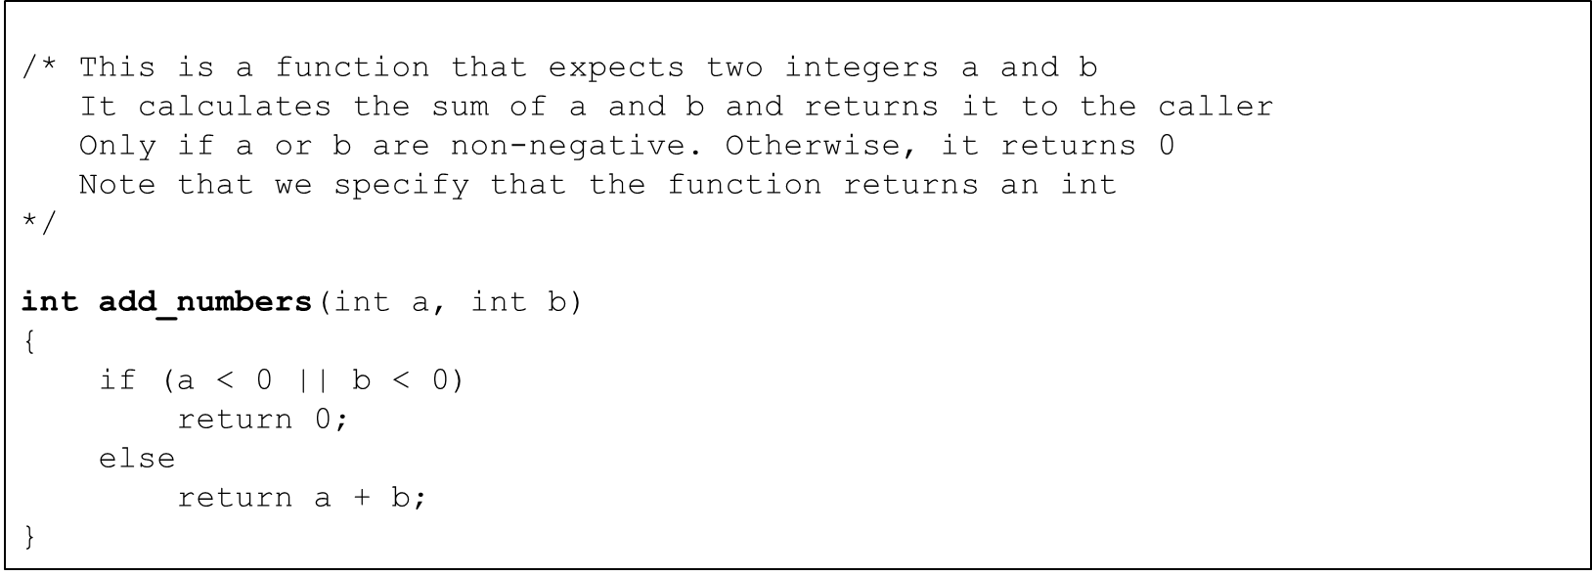

* name
  + the name of the function
  + same rules as for variables
  + should be meaningful
  + usually a verb or verb phrase
* parameter list
  + the variables passed into the function
  + their types must be speciﬁed
* return type
  + the type of the data that is returned from the function
* body
  + the statements that are executed when the function is called
  + in curly braces {}

Example with no parameters

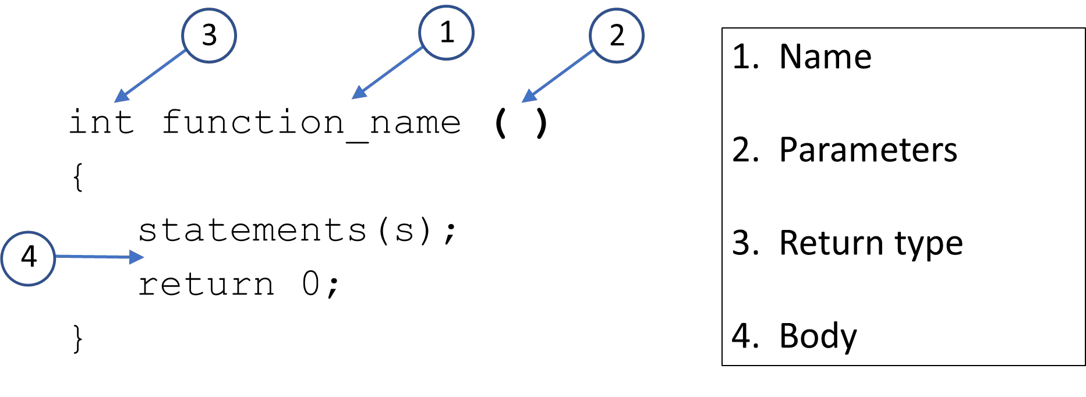

Example with 1 parameter

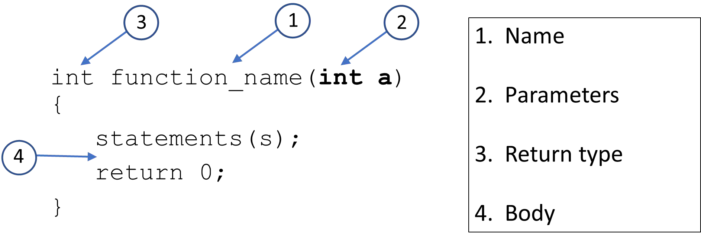

Example with no return type (void)

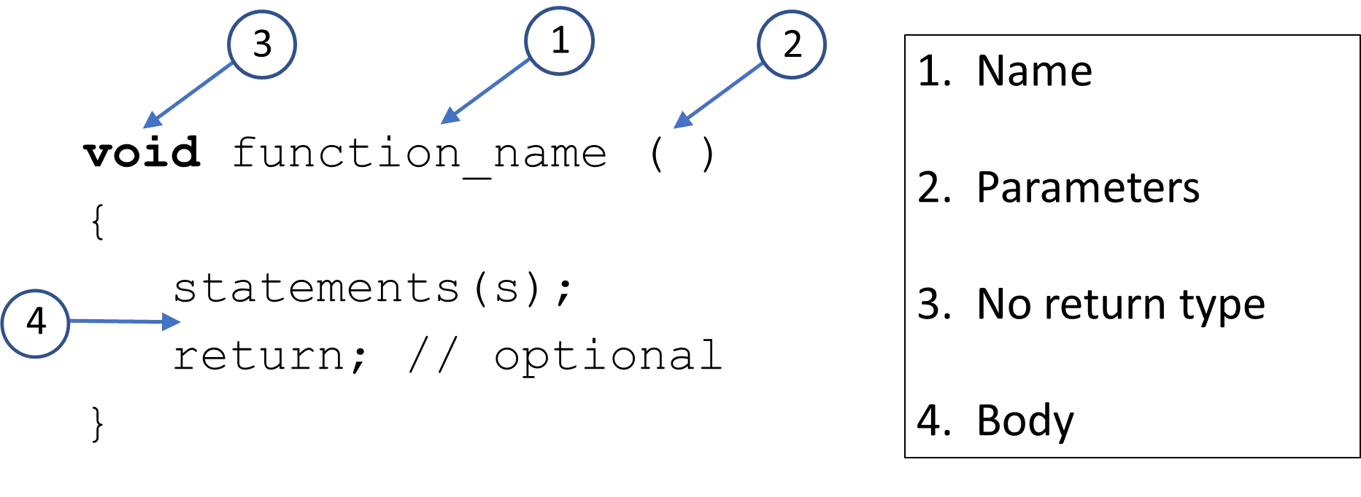

Example with multiple parameters

void function_name**(int a, std::string b)**

{

statements(s); return; // optional

}

A function with no return type and no parameters

**void** say_hello () {

cout << "Hello" << endl;

}

void say_hello () {

cout << "Hello" << endl;

}

int main() { **say_hello();** return 0;

}

void **say_hello** () {

cout << "Hello" << endl;

}

int main() {

for (int i{1} i<=10; ++i)

##### say_hello();

return 0;

}

void **say_world** () {

cout << " World" << endl;

}

void **say_hello** () {

cout << "Hello" << endl;

**say_world();**

}

int main() { **say_hello();** return 0;

}

void **say_world** () {

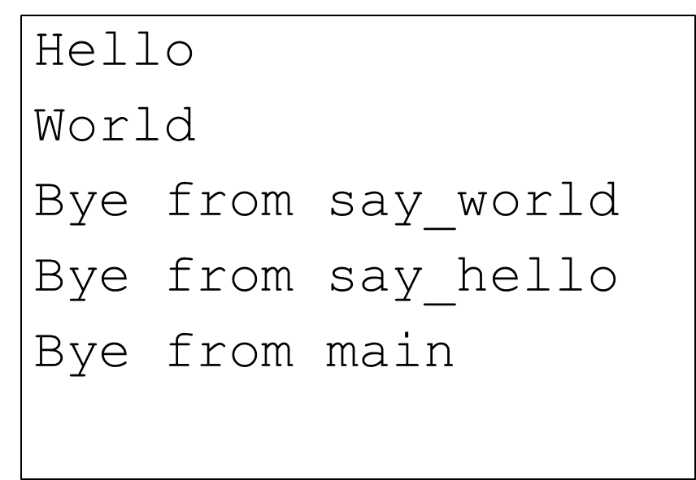cout << " World" << endl;

cout << " Bye from say_world" << endl;

}

void **say_hello** () {

cout << "Hello" << endl;

**say_world();**

cout << " Bye from say_hello" << endl;

}

int main() {

**say_hello();**

cout << " Bye from main" << endl; return 0;

}

## Calling functions

* Functions can call other functions
* Compiler must know the function details BEFORE it is called!

int main() {

**say_hello();** // called **BEFORE** it is defined ERROR return 0;

}

void say_hello ()

{

cout << "Hello" << endl;

}

## Function Prototypes

* The compiler must ‘know’ about a function before it is used
  + Deﬁne functions before calling them
    - OK for small programs
    - Not a practical solution for larger programs
  + Use function prototypes
    - Tells the compiler what it needs to know without a full function deﬁnition
    - Also called forward declarations
    - Placed at the beginning of the program
    - Also used in our own header ﬁles (.h) – more about this later

**int function_name();** // prototype

##### int function_name()

{

statements(s); return 0;

}

|  |  |  |
| --- | --- | --- |
| int | **function_name**(**int**); // | prototype |
|  | // **or** |  |
| int | **function_name**(**int a**); // | prototype |

int **function_name**(**int a**) { statements(s);

return 0;

}

**void function_name**(); // prototype

##### void function_name()

{

statements(s); return; // optional

}

void **function_name**(int a, std::string b);

// or

void **function_name**(int, std::string);

void **function_name**(int a, std::string b)

{

statements(s); return; // optional

}

## A function with no return type and no parameters

void **say_hello**();

void **say_hello**() {

#### cout << "Hello" << endl;

}

## Calling a function

void **say_hello**();

int main() {

**say_hello**(); // OK

**say_hello**(100); // Error

|  |  |  |  |  |  |
| --- | --- | --- | --- | --- | --- |
| cout | << | **say_hello**(); | // | Error |  |
|  |  | // | No | return | **value** |

return 0;

}

## Example

|  |  |  |  |
| --- | --- | --- | --- |
| **void** | **say_hello();** | // | prototype |
| **void** | **say_world();** | // | prototype |

void **say_world** () {

cout << " World" << endl;

cout << " Bye from say_world“ << endl;

int main() {

**say_hello**();

cout << " Bye from main" << endl; return 0;

}

}

void **say_hello** () {

cout << "Hello" << endl;

**say_world**();

cout << " Bye from say_hello" << endl;

}

## Function Parameters

* When we call a function we can pass in data to that function
* In the function call they are called arguments
* In the function deﬁnition they are called parameters
* They must match in number, order, and in type

int add_numbers(**int, int**); // prototype

int main() {

int result {0};

result = add_numbers(**100,200**); // call return 0;

}

int add_numbers(**int a, int b**) { // definition return a + b;

}

void say_hello(**std::string name**) { cout << "Hello " << name << endl;

}

say_hello**("Frank"**);

std::string my_dog {"Buster"}; say_hello(**my_dog**);

## Pass-by-value

* When you pass data into a function it is passed-by-value
* A copy of the data is passed to the function
* Whatever changes you make to the parameter in the function does NOT aﬀect the argument that was passed in.
* Formal vs. Actual parameters
  + Formal parameters – the parameters deﬁned in the function header
  + Actual parameters – the parameter used in the function call, the arguments

## Example

|  |  |  |  |  |  |  |  |  |  |  |
| --- | --- | --- | --- | --- | --- | --- | --- | --- | --- | --- |
| void param_test(int | **formal**) | { |  | // | formal | is | a | copy | of | actual |
| cout << **formal** << | endl; |  | / | 50 |  |  |  |  |  |  |

**formal** = **100**; // only changes the local copy cout << **formal** << endl; // 100

}

int main() {

int **actual** {**50**};

cout << **actual** << endl; // 50

param_test(**actual**); // pass in 50 to param_test cout << **actual** << endl; // 50 - did not change return 0

}

## Function Return Statement

* If a function returns a value then it must use a return statement that returns a value
* If a function does not return a value (void) then the return statement is optional
* return statement can occur anywhere in the body of the function
* return statement immediately exits the function
* We can have multiple return statements in a function
  + Avoid many return statements in a function
* The return value is the result of the function call
* When a function is called, all arguments must be supplied
* Sometimes some of the arguments have the same values most of the time
* We can tell the compiler to use default values if the arguments are not supplied
* Default values can be in the prototype or deﬁnition, not both
  + best practice – in the prototype
  + must appear at the tail end of the parameter list
* Can have multiple default values
  + must appear consecutively at the tail end of the parameter list

Example – no default arguments

double calc_cost(double base_cost, **double tax_rate**);

double calc_cost(double base_cost, **double tax_rate**) { return base_cost += (base_cost * tax_rate);

}

int main() { double cost {0};

cost = calc_cost(100.0, **0.06**); return 0;

}

Example – single default argument

double calc_cost(double base_cost, **double tax_rate = 0.06**);

double calc_cost(double base_cost, double tax_rate) { return base_cost += (base_cost * tax_rate);

}

int main() { double cost {0};

cost = calc_cost(200.0); // will use the default tax

cost = calc_cost (100.0, **0.08**); // will use 0.08 not the defauly return 0;

}

Example – multiple default arguments

double calc_cost(double base_cost, **double tax_rate = 0.06, double shipping = 3.50**);

double calc_cost(double base_cost, double tax_rate, double shipping) { return base_cost += (base_cost * tax_rate) + shipping;

}

int main() { double cost {0};

cost = calc_cost (100.0, 0.08, 4.25); // will use no defaults cost = calc_cost(100.0, 0.08); // will use default shipping cost = calc_cost(200.0); // will use default tax and shipping

return 0;

}

* We can have functions that have diﬀerent parameter lists that have the same name
* Abstraction mechanism since we can just think ‘print’ for example
* A type of polymorphism
  + We can have the same name work with diﬀerent data types to execute similar behavior
* The compiler must be able to tell the functions apart based on the parameter lists and argument supplied

int **add_numbers**(**int, int**); // add ints

double **add_numbers**(**double**, **double**); // add doubles

|  |  |  |  |  |
| --- | --- | --- | --- | --- |
| int main() | { |  | | |
| cout << | **add_numbers**(**10,20**) | << endl; | // | integer |
| cout << | **add_numbers**(**10.0,** | **20.0**) << | endl; | // double |
| return 0; |  |  |  |  |

}

int **add_numbers**(**int a, int b**) { return a + b;

}

double **add_numbers**(**double a**, **double b) {**

return a + b;

}

Example

void **display**(int n); void **display**(double d);

void **display**(std::string s);

void **display**(std::string s, std::string t); void **display**(std::vector<int> v);

void **display**(std::vector<std::string> v);

Return type is not considered

int **get_value();**

double **get_value**();

// Error

cout << **get_value()** << endl; // which one?

## Passing Arrays To Functions

* We can pass an array to a function by providing square brackets in the formal parameter description

void print_array(**int numbers []**);

* The array elements are NOT copied
* Since the array name evaluates to the location of the array in memory – this address is what is copied
* So the function has no idea how many elements are in the array since all it knows is the location of the ﬁrst element (the name of the array)

void **print_array**(int numbers **[]**);

int main() {

int my_numbers[] {1,2,3,4,5}; **print_array(my_numbers)**; return 0;

}

void **print_array**(int numbers **[]**) {

// Doesn’t know how many elements are in the array???

**// we need to pass in the size!!**

}

void **print_array**(int numbers [], **size_t size**);

int main() {

int my_numbers[] {1,2,3,4,5};

**print_array(my_numbers, 5)**; / 1 2 3 4 5

return 0;

}

void **print_array**(int numbers [], **size_t size**) { for (size_t i{0}; i < **size**; ++i )

cout << **numbers[i]** << endl;

}

* Since we are passing the location of the array
  + The function can modify the actual array!

void **zero_array**(int numbers [], **size_t size**) { for (size_t i{0}; i < **size**; ++i )

**numbers[i] = 0; // zero out array element**

}

int main() {

int my_numbers[] {1,2,3,4,5};

**zero_array(my_numbers, 5)**; // my_numbers is now zeroes! print_array(my_numbers, 5); // 0 0 0 0 0

return 0;

}

## const parameters

* We can tell the compiler that function parameters are const (read-only)
* This could be useful in the print_array function since it should NOT modify the array

void print_array(**const** int numbers [], size_t size) { for (size_t i{0}; i < size; ++i )

cout << numbers[i] << endl;

numbers[i] = 0; // any attempt to modify the array

**// will result in a compiler error**

}

## Pass by Reference

* Sometimes we want to be able to change the actual parameter from within the function body
* In order to achieve this we need the location or address of the actual parameter
* We saw how this is the eﬀect with array, but what about other variable types?
* We can use reference parameters to tell the compiler to pass in a reference to the actual parameter.
* The formal parameter will now be an alias for the actual parameter

void scale_number(int **&num**); // prototype

int main() {

int number {1000}; scale_number(number); // call cout << number << endl; // 100 return 0;

}

void scale_number(int **&num**) { // definition if (num > 100)

num = 100;

}

void swap(int **&a**, int **&b**);

int main() {

int x{10}, y{20};

cout << x << " " << y << endl; // 10 20 swap(x, y);

cout << x << " " << y << endl; // 20 10

return 0;

}

void swap(int **&a**, int **&b**) { int temp = a;

a = b;

b = temp;

}

## vector example – pass by value

void print(std::vector<int> v);

int main() {

std::vector<int> data {1,2,3,4,5};

print(data); // 1 2 3 4 5

return 0;

}

void print(std::vector<int> v) { for (auto num: v)

cout << num << endl;

}

## vector example – pass by reference

void print(std::vector<int> **&v**);

int main() {

std::vector<int> data {1,2,3,4,5};

print(data); // 1 2 3 4 5

return 0;

}

void print(std::vector<int> **&v**) { for (auto num: v)

cout << num << endl;

}

## vector example – pass by const reference

void print(**const** std::vector<int> **&v**);

int main() {

std::vector<int> data {1,2,3,4,5};

print(data); // 1 2 3 4 5

return 0;

}

void print(**const** std::vector<int> **&v**) {

v.at(0) = 200; // ERROR

for (auto num: v)

cout << num << endl;

}

## Scope Rules

* C++ uses scope rules to determine where an identiﬁer can be used
* C++ uses static or lexical scoping
* Local or Block scope
* Global scope

## Local or Block scope

* Identiﬁers declared in a block { }
* Function parameters have block scope
* Only visible within the block { } where declared
* Function local variables are only active while the function is executing
* Local variables are NOT preserved between function calls
* With nested blocks inner blocks can ‘see’ but outer blocks cannot ‘see’ in

## Static local variables

* Declared with static qualiﬁer

static int value {10};

* Value IS preserved between function calls
* Only initialized the ﬁrst time the function is called

## Global scope

* Identiﬁer declared outside any function or class
* Visible to all parts of the program after the global identiﬁer has been declared
* Global constants are OK
* Best practice – don’t use global variables

## How do Function Calls Work?

* Functions use the ‘function call stack’
  + Analogous to a stack of books
  + LIFO – Last In First Out
  + push and pop
* Stack Frame or Activation Record
  + Functions must return control to function that called it
  + Each time a function is called we create an new activation record and push it on stack
  + When a function terminates we pop the activation record and return
  + Local variables and function parameters are allocated on the stack
* Stack size is ﬁnite – Stack Overﬂow

## Inline Functions

* Function calls have a certain amount of overhead
* You saw what happens on the call stack
* Sometimes we have simple functions
* We can suggest to the compiler to compile them ‘inline’
  + avoid function call overhead
  + generate inline assembly code
  + faster
  + could cause code bloat
* Compilers optimizations are very sophisticated
  + will likely inline even without your suggestion

## Example

**inline** int add_numbers(int a, int b) { // definition return a + b;

}

int main() {

int result {0};

result = add_numbers(100,200); // call return 0;

}

## Recursive Functions

* A recursive function is a function that calls itself
  + Either directly or indirectly through another function
* Recursive problem solving
  + Base case
  + Divide the rest of problem into subproblem and do recursive call
* There are many problems that lend themselves to recursive solutions
* Mathematic – factorial, Fibonacci, fractals,…
* Searching and sorting – binary search, search trees, …

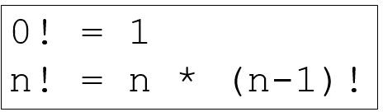

* Base case:
  + factorial(0) = 1
* Recursive case:
  + factorial(n) = n * factorial(n-1)

unsigned long long **factorial**(unsigned long long n) { if (n == 0)

return 1; // base case

return n * **factorial**(n-1); // recursive case

}

int main() {

cout << **factorial**(8) << endl; // **40320**

return 0;

}

## Example - Fibonacci

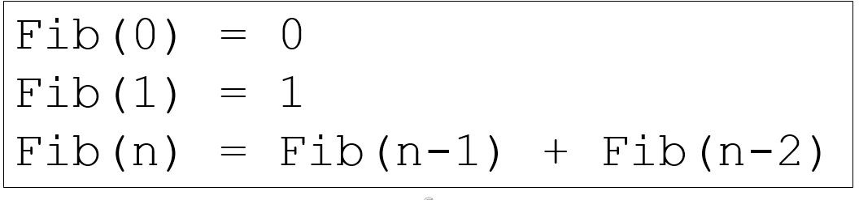

* Base case:
  + Fib(0) = 0
  + Fib(1) = 1
* Recursive case:
  + Fib(n) = Fib(n-1) + Fib(n-2)

## Example - Factorial

unsigned long long **fibonacci**(unsigned long long n) { if (n <= 1)

return n; // base cases

return **fibonacci**(n-1) + **fibonacci**(n-2); // recursion

}

int main() {

cout << **fibonacci**(30) << endl; // 832040

return 0;

}

## Important notes

* If recursion doesn’t eventually stop you will have inﬁnite recursion
* Recursion can be resource intensive
* Remember the base case(s)
  + It terminates the recursion
* Only use recursive solutions when it makes sense
* Anything that can be done recursively can be done iteratively
  + Stack overﬂow error

## Overview

* What is a pointer?
* Declaring pointers
* Storing addresses in pointers
* Dereferencing pointers
* Dynamic memory allocation
* Pointer arithmetic
* Pointers and arrays
* Pass-by-reference with pointers
* const and pointers
* Using pointers to functions
* Potential pointer pitfalls
* What is a reference?
* Review passing references to functions
* const and references
* Reference variables in range-based for loops
* Potential reference pitfalls
* Raw vs. Smart pointers

## What is a Pointer?

* + A variable
    - whose value is an address
  + What can be at that address?
    - Another variable
    - A function
  + Pointers point to variables or functions?
  + If x is an integer variable and its value is 10 then I can declare a pointer that points to it
  + To use the data that the pointer is pointing to you must know its type

## Why use Pointers?

Can’t I just use the variable or function itself?

Yes, but not always

* + Inside functions, pointers can be used to access data that are deﬁned outside the function. Those variables may not be in scope so you can’t access them by their name
  + Pointers can be used to operate on arrays very eﬃciently
  + We can allocate memory dynamically on the heap or free store.
    - This memory doesn’t even have a variable name.
    - The only way to get to it is via a pointer
  + With OO. pointers are how polymorphism works!
  + Can access speciﬁc addresses in memory
    - useful in embedded and systems applications

## Declaring Pointers

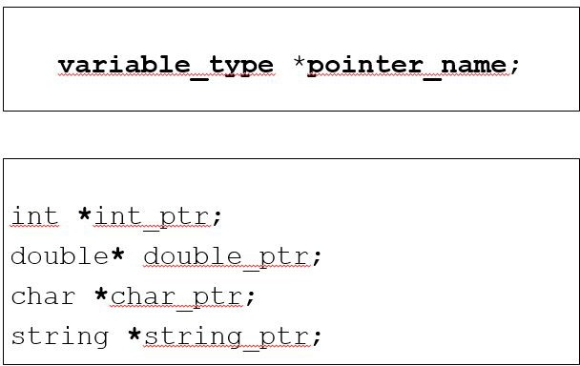

Declaring Pointers

Initializing pointer variables to ‘point nowhere’

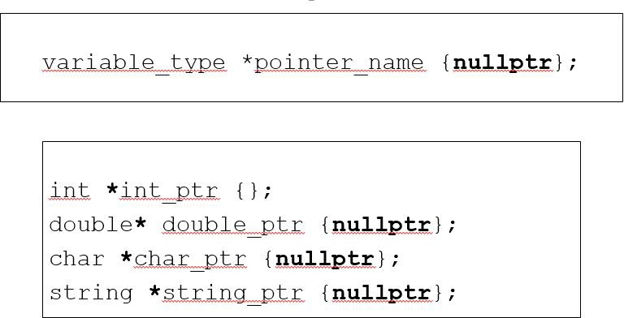

## Declaring Pointers

Initializing pointer variables to ‘point nowhere’

* + Always initialize pointers
  + Uninitialized pointers contain garbage data and can ‘point anywhere’
  + Initializing to zero or nullptr (C++ 11) represents address zero
    - implies that the pointer is ‘pointing nowhere’
  + If you don’t initialize a pointer to point to a variable or function then you should initialize it to nullptr to ‘make it null’

**&** the address operator

* + Variables are stored in unique addresses
  + Unary operator
  + Evaluates to the address of its operand
    - Operand cannot be a constant or expression that evaluates to temp values

int num{10};

cout << "Value of num is: " << **num** << endl; // **10**

cout << "sizeof of num is: " << **sizeof num** << endl; // **4**

cout << "Address of num is: " << **&num** << endl; // **0x61ff1c**

**&** the address operator - example

|  |  |  |  |  |  |  |  |  |  |  |  |  |  |  |  |  |  |  |
| --- | --- | --- | --- | --- | --- | --- | --- | --- | --- | --- | --- | --- | --- | --- | --- | --- | --- | --- |
| int | *p; |  | | | | | | | | | | | | | | | | |
| cout | << | "Value | of | p | is: | | " | << | **p** | << | endl; | | **//** | **0x61ff60** | | | | **- garbage** |
| cout | << | "Address | | of | p | is: | | " | << | **&p** | << | endl; | | **//** | **0x61ff18** | | | |
| cout | << | "sizeof | of | | p | is: | " | << | | **sizeof** | | **p** | << | endl; | | **//** | **4** | |

p = **nullptr**;// set p to point nowhere

cout << "Value of p is: " << **p** << endl; **// 0**

## Accessing Pointer Addresses?

sizeof a pointer variable

* + Don’t confuse the size of a pointer and the size of what it points to
  + All pointers in a program have the same size
  + They may be pointing to very large or very small types

int **\*p1** {nullptr}; double **\*p2** {nullptr};

unsigned long long **\*p3** {nullptr}; vector<string> **\*p4** {nullptr}; string **\*p5** {nullptr};

## Storing an Address in Pointer Variable?

Typed pointers

#### The compiler will make sure that the address stored in a pointer variable is of the correct type

int score {10};

double high_temp {100.7}; int *score_ptr **{nullptr**}; score_ptr = &score; // OK

score_ptr = &high_temp; // Compiler Error

## Storing an Address in Pointer Variable?

**&** the address operator

* + Pointers are variables so they can change
  + Pointers can be null
  + Pointers can be uninitialized

double high_temp {100.7};

double low_temp {37.2}; double *temp_ptr;

temp_ptr = &high_temp; // points to high_temp temp_ptr = &low_temp; // now points to low_temp

temp_ptr = nullptr;

Access the data we’re pointing to – dereferencing a pointer

* + If score_ptr is a pointer and has a valid address
  + Then you can access the data at the address contained in the score_ptr

using the dereferencing operator **\***

int score {100};

int *score_ptr {&score};

cout << **\*score_ptr** << endl; // 100

*score_ptr = 200;

cout << **\*score_ptr** << endl; // 200 cout << **score** << endl; // 200

double high_temp {100.7};

double low_temp {37.4};

double **\*temp_ptr** {&high_temp};

cout << \***temp_ptr** << endl; // 100.7 temp_ptr = &low_temp;

cout << \***temp_ptr** << endl; // 37.4

string name {"Frank"}; string **\*string_ptr** {&name};

cout << **\*string_ptr** << endl; // Frank name = "James";

cout << **\*string_ptr** << endl; // James

Allocating storage from the heap at runtime

* We often don’t know how much storage we need until we need it
* We can allocate storage for a variable at run time
* Recall C++ arrays
  + We had to explicitly provide the size and it was ﬁxed
  + But vectors grow and shrink dynamically
* We can use pointers to access newly allocated heap storage

using **new** to allocate storage

int *int_ptr {nullptr};

int_ptr = **new int**; // allocate an integer on the heap cout << int_ptr << endl; // 0x2747f28

cout << *int_ptr << endl; // 41188048 - garbage

*int_ptr = 100;

cout << *int_ptr << endl; // 100

using **delete** to deallocate storage

int *int_ptr {nullptr};

int_ptr = **new int**; // allocate an integer on the heap

. . .

**delete int_ptr;** // frees the allocated storage

using **new[]** to allocate storage for an array

int *array_ptr {nullptr}; int size {};

|  |  |  |  |  |  |  |  |  |  |
| --- | --- | --- | --- | --- | --- | --- | --- | --- | --- |
| cout | << | "How | big | do | you | want | the | array? | "; |
| cin | >> | size; |  |  |  |  |  |  |  |

array_ptr = **new int[size];** // allocate array on the heap

// We can access the array here

// we’ll see how in a few slides

using **delete[]** to deallocate storage for an array

int *array_ptr {nullptr}; int size {};

|  |  |  |  |  |  |  |  |  |
| --- | --- | --- | --- | --- | --- | --- | --- | --- |
| cout | << | “How | big | do | you | want | the | array?”; |
| cin | >> | size; |  |  |  |  |  |  |

array_ptr = **new int[size];** // allocate array on the heap

. . .

**delete [] array_ptr;** // free allocated storage

* The value of an array name is the address of the ﬁrst element in the array
* The value of a pointer variable is an address
* If the pointer points to the same data type as the array element then the pointer and array name can be used interchangeably (almost)

|  |  |  |  |  |  |  |  |  |
| --- | --- | --- | --- | --- | --- | --- | --- | --- |
| int | scores[] | | {100, | | 95, | 89}; | | |
| cout | << | scores | | << | endl; | | // | 0x61fec8 |
| cout | << | *scores | | << | endl; | | // | 100 |

int *score_ptr {scores};

cout << score_ptr << endl; // 0x61fec8 cout << *score_ptr << endl; // 100

|  |  |  |  |  |  |  |  |
| --- | --- | --- | --- | --- | --- | --- | --- |
| int | scores[] | {100, | 95, | 89}; | | | |
| int | *score_ptr {scores}; | | | |  |  |  |
| cout | << score_ptr[0] << | | | | endl; | // | 100 |
| cout | << score_ptr[1] << | | | | endl; | // | 95 |
| cout | << score_ptr[2] << | | | | endl; | // | 89 |

int scores[] {100, 95, 89}; int *score_ptr {scores};

|  |  |  |  |  |  |
| --- | --- | --- | --- | --- | --- |
| cout | << | score_ptr | << | endl; | // **0x61ff10** |
| cout | << | **(score_ptr** | **+** | **1)** << | endl; // **0x61ff14** |
| cout | << | **(score_ptr** | **+** | **2)** << | endl; // **0x61ff18** |

int scores[] {100, 95, 89}; int *score_ptr {scores};

|  |  |  |  |  |  |  |
| --- | --- | --- | --- | --- | --- | --- |
| cout | << | *score_ptr | << | endl; | // **100** |  |
| cout | << | \***(score_ptr** | **+** | **1)** << | endl; // | **95** |
| cout | << | \***(score_ptr** | **+** | **2)** << | endl; // | **89** |

## Subscript and Oﬀset notation equivalence

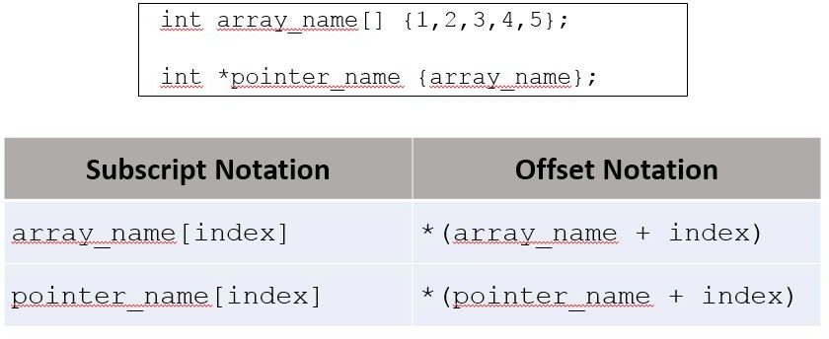

Pointer Arithmetic

* Pointers can be used in
  + Assignment expressions
  + Arithmetic expressions
  + Comparison expressions
* C++ allows pointer arithmetic
* Pointer arithmetic only makes sense with raw arrays

## ++ and --

* (++) increments a pointer to point to the next array element

int_ptr++;

* (--) decrements a pointer to point to the previous array element

**int_ptr--;**

## + and -

* (+) increment pointer by n * sizeof(type)

int_ptr += n; or int_ptr = int_ptr + n;

* (-) decrement pointer by n * sizeof(type)

**int_ptr -= n; or int_ptr = int_ptr - n;**

## Subtracting two pointers

* Determine the number of elements between the pointers
* Both pointers must point to the same data type

int n = **int_ptr2 – int_ptr1;**

## Comparing two pointers == and !=

Determine if two pointers point to the same location

* does NOT compare the data where they point!

|  |  |  |
| --- | --- | --- |
| string  string | s1  s2 | {"Frank"};  {"Frank"}; |
| string | *p1 | {&s1}; |
| string | *p2 | {&s2}; |
| string | *p3 | {&s1}; |

|  |  |  |  |  |  |  |  |  |
| --- | --- | --- | --- | --- | --- | --- | --- | --- |
| cout | << | **(p1** | **==** | **p2)** | << | endl; | // | **false** |
| cout | << | **(p1** | **==** | **p3)** | << | endl; | // | **true** |

## Comparing the data pointers point to

Determine if two pointers point to the same data

* you must compare the referenced pointers

|  |  |  |
| --- | --- | --- |
| string  string | s1  s2 | {"Frank"};  {"Frank"}; |
| string | *p1 | {&s1}; |
| string | *p2 | {&s2}; |
| string | *p3 | {&s1}; |

|  |  |  |  |  |  |  |  |  |
| --- | --- | --- | --- | --- | --- | --- | --- | --- |
| cout | << | **(*p1** | **==** | **\*p2)** | << | endl; | // | **true** |
| cout | << | **(*p1** | **==** | **\*p3)** | << | endl; | // | **true** |

## Passing pointers to a function

const and Pointers

* There are several ways to qualify pointers using const
  + Pointers to constants
  + Constant pointers
  + Constant pointers to constants

## Pointers to constants

* The data pointed to by the pointers is constant and cannot be changed.
* The pointer itself can change and point somewhere else.

int high_score {100}; int low_score { 65};

**const int *score_ptr** { &high_score };

*score_ptr = 86; // ERROR score_ptr = &low_score; // OK

## Constant pointers

* The data pointed to by the pointers can be changed.
* The pointer itself cannot change and point somewhere else

int high_score {100}; int low_score { 65};

int **\*const score_ptr** { &high_score };

*score_ptr = 86; // OK score_ptr = &low_score; // ERROR

## Constant pointers to constants

* The data pointed to by the pointer is constant and cannot be changed.
* The pointer itself cannot change and point somewhere else.

int high_score {100}; int low_score { 65};

**const int *const score_ptr** { &high_score };

*score_ptr = 86; // ERROR score_ptr = &low_score; // ERROR

* Pass-by-reference with pointer parameters
* We can use pointers and the dereference operator to achieve pass-by-reference
* The function parameter is a pointer
* The actual parameter can be a pointer or address of a variable

Pass-by-reference with pointers – deﬁning the function

void double_data(int **\*int_ptr);**

void double_data(int **\*int_ptr)** {

*int_ptr *= 2;

**// *int_ptr = *int_ptr * 2;**

}

Pass-by-reference with pointers – calling the function

int main() {

int value {10};

cout << value << endl; // 10 double_data( **&value**);

cout << value << endl; // 20

}

## Returning a Pointer from a Function

* Functions can also return pointers

**type \***function();

* Should return pointers to
  + Memory dynamically allocated in the function
  + To data that was passed in
* Never return a pointer to a local function variable!

**int \***largest_int(int **\*int_ptr1, int *int_ptr2) {**

###### if (*int_ptr1 > *int_ptr2) return int_ptr1;

else

###### return int_ptr2;

}

int main() { int a{100}; int b{200};

int *largest_ptr {nullptr}; **largest_ptr = largest_int(&a, &b);** cout << *largest_ptr << endl; // 200 return 0;

}

**int \***create_array(size_t size, int init_value = 0) { int *new_storage {nullptr};

new_storage = **new int[size];**

for (size_t i{0}; i < size; ++i)

*(new_storage + i) = init_value; return new_storage;

}

int main() {

**int *my_array;** // will be allocated by the function

**my_array = create_array(100,20);** // create the array

// use it

**delete [] my_array**; / / be sure to free the storage return 0;

}

## Never return a pointer to a local variable!!

**int** *dont_do_this () { int size {};

. . .

return &size;

}

**int** *or_this () { int size {};

int *int_ptr {&size};

. . .

return int_ptr;

}

## Potential Pointer Pitfalls

* Uninitialized pointers
* Dangling Pointers
* Not checking if new failed to allocate memory
* Leaking memory

## Uninitialized pointers

int *int_ptr; // pointing anywhere

. . .

*int_ptr = 100; // Hopefully a crash

## Dangling pointer

* Pointer that is pointing to released memory
  + For example, 2 pointers point to the same data
  + 1 pointer releases the data with delete
  + The other pointer accesses the release data
* Pointer that points to memory that is invalid
  + We saw this when we returned a pointer to a function local variable

## Not checking if new failed

* If new fails an exception is thrown
* We can use exception handling to catch exceptions
* Dereferencing a null pointer will cause your program to crash

## Leaking memory

* Forgetting to release allocated memory with delete
* If you lose your pointer to the storage allocated on the heap you have not way to get to that storage again
* The memory is orphaned or leaked
* One of the most common pointer problems

## What is a Reference?

* An alias for a variable
* Must be initialized to a variable when declared
* Cannot be null
* Once initialized cannot be made to refer to a diﬀerent variable
* Very useful as function parameters
* Might be helpful to think of a reference as a constant pointer that is automatically dereferenced

vector<string> stooges {"Larry", "Moe", "Curly"}; for (**auto str**: stooges)

**str = "Funny";** // changes the copy

for (auto str:stooges)

cout << str << endl; // Larry, Moe, Curly

vector<string> stooges {"Larry", "Moe", "Curly"}; for (**auto &str**: stooges)

str = "Funny"; // changes the actual

for (auto str:stooges)

cout << str << endl; // Funny, Funny, Funny

vector<string> stooges {"Larry", "Moe", "Curly"};

|  |  |  |  |  |
| --- | --- | --- | --- | --- |
| for | (auto | **const &str**: | stooges) |  |
|  | str | = "Funny"; | // compiler | error |

vector<string> stooges {"Larry", "Moe", "Curly"}; for (auto **const &str**:stooges)

cout << str << endl; // Larry, Moe, Curly

Passing references to functions

* Please refer to the section 11 videos and examples
* l-values
  + values that have names and are addressable
  + modiﬁable if they are not constants

int **x** {100}; // **x** is an l-value x = 1000;

x = 1000 + 20;

string **name**; // **name** is an l-value name = "Frank";

* l-values
  + values that have names and are addressable
  + modiﬁable if they are not constants

**100** = x; // **100** is **NOT** an l-value

**(1000 + 20)** = x; // **(1000 + 20)** is **NOT** an l-value

string name; name = "Frank";

**"Frank"** = name; // **"Frank"** is **NOT** an l-value

* r-value (non-addressable and non-assignable)
  + A value that’s not an l-value
    - on the right-hand side of an assignment expression
    - a literal
    - a temporary which is intended to be non-modiﬁable

|  |  |  |  |  |  |  |  |  |  |  |  |
| --- | --- | --- | --- | --- | --- | --- | --- | --- | --- | --- | --- |
| int  int | x  y | {**100**};  = **x + 200**; | | | //  // | | **100** is an  **(x+200)**is | | r-value  an r-value | | |
| string name = | | name;  **"Frank";** | | | // | **"Frank"** | | is | an | r-value | |
| int | max_num | | **=** | **max(20,30)**; | // | **max(20,30)** | | | is | an | r-value |

* r-values can be assigned to l-values explicitly

|  |  |  |
| --- | --- | --- |
| int | x | {100}; |
| int | y | {0}; |

y = 100; // r-value **100** assigned to l-value **y**

x = x + y; // r-value **(x+y)** assigned to l-value **x**

* The references we’ve used are l-value references
  + Because we are referencing l-values

|  |  |  |  |  |  |  |  |
| --- | --- | --- | --- | --- | --- | --- | --- |
| int | x | {100}; | | | | | |
| int ref1 | &**ref1** =  = 1000; | | x; | // | ref1 is reference | to | l-value |

int &**ref2** = 100; // Error 100 is an r-value

* The same when we pass-by-reference

int square(int &**n**) { return n*n;

}

int num {10}; square(**num**); // OK

square(**5**); // Error – can’t reference r-value 5

## When to use pointers vs. references parameters

* Pass-by-value
  + when the function does not modify the actual parameter, and
  + the parameter is small and eﬃcient to copy like simple types (int, char,

double, etc.)

## When to use pointers vs. references parameters

* Pass-by-reference using a pointer
  + when the function does modify the actual parameter, and
  + the parameter is expensive to copy, and
  + Its OK to the pointer is allowed a nullptr value

## When to use pointers vs. references parameters

* Pass-by-reference using a pointer to const
  + when the function does not modify the actual parameter, and
  + the parameter is expensive to copy, and
  + Its OK to the pointer is allowed a nullptr value

## When to use pointers vs. references parameters

* Pass-by-reference using a const pointer to const
  + when the function does not modify the actual parameter, and
  + the parameter is expensive to copy, and
  + Its OK to the pointer is allowed a nullptr value, and
  + You don’t want to modify the pointer itself

## When to use pointers vs. references parameters

* Pass-by-reference using a reference
  + when the function does modify the actual parameter, and
  + the parameter is expensive to copy, and
  + The parameter will never be nullptr

## When to use pointers vs. references parameters

* Pass-by-reference using a const reference
  + when the function does not modify the actual parameter, and
  + the parameter is expensive to copy, and
  + The parameter will never be nullptr

## Object-Oriented Programming – Classes and Objects

* What is Object-Oriented Programming?
* What are Classes and Objects?
* Declaring Classes and creating Objects
* Dot and pointer operators
* public and private access modiﬁers
* Methods, Constructors and Destructors
  + class methods
  + default and overloaded constructors
  + copy and move constructors
  + shallow vs. deep copying
  + this pointer
* static class members
* struct vs. class
* friend of a class

## What is Object-Oriented Programming?

* Procedural Programming
* Procedural Programming limitations
* OO Programming concepts and their advantages
* OO Programming limitations

## Procedural programming

* Focus is on processes or actions that a program takes
* Programs are typically a collection of functions
* Data is declared separately
* Data is passed as arguments into functions
* Fairly easy to learn

## Procedural programming - Limitations

* Functions need to know the structure of the data.
  + if the structure of the data changes many functions must be changed
* As programs get larger they become more:
  + diﬃcult to understand
  + diﬃcult to maintain
  + diﬃcult to extend
  + diﬃcult to debug
  + diﬃcult to reuse code
  + fragile and easier to break
* Classes and Objects
  + focus is on classes that model real-world domain entities
  + allows developers to think at a higher level of abstraction
  + used successfully in very large programs
* Encapsulation
  + objects contain data AND operations that work on that data
  + Abstract Data Type (ADT)
* Information-hiding
  + implementation-speciﬁc logic can be hidden
  + users of the class code to the interface since they don’t need to know the implementation
  + more abstraction
  + easier to test, debug, maintain and extend
* Reusability
  + easier to reuse classes in other applications
  + faster development
  + higher quality
* Inheritance
  + can create new classes in term of existing classes
  + reusability
  + polymorphic classes
* Polymorphism and more…

## Limitations

* Not a panacea
  + OO Programming won’t make bad code better
  + not suitable for all types of problems
  + not everything decomposes to a class
* Learning curve
  + usually a steeper leaning curve, especially for C++
  + many OO languages, many variations of OO concepts
* Design
  + usually more up-front design is necessary to create good models and hierarchies
* Programs can be:
  + larger in size
  + slower
  + more complex
* Classes
  + blueprint from which objects are created
  + a user-deﬁned data-type
  + has attributes (data)
  + has methods (functions)
  + can hide data and methods
  + provides a public interface
* Example classes
  + Account
  + Employee
  + Image
  + std::vector
  + std::string
* Objects
  + created from a class
  + represents a speciﬁc instance of a class
  + can create many, many objects
  + each has its own identity
  + each can use the deﬁned class methods
* Example Account objects
  + Frank’s account is an instance of an Account
  + Jim’s account is an instance of an Account
  + Each has its own balance, can make deposits, withdrawals, etc.

int high_score; int low_score;

Account frank_account; Account jim_account;

std::vector<int> scores; std::string name;

## Declaring a Class

class Class_Name

{

// declaration(s);

};

## Player

class **Player**

{

**// attributes** std::string name; int health;

int xp;

// methods

void talk(std::string text_to_say); bool is_dead();

};

## Creating objects

**Player** frank;

**Player** hero;

**Player \***enemy = new **Player**(); delete enemy;

## Account

BEGINNING C++ PROGRAMMING

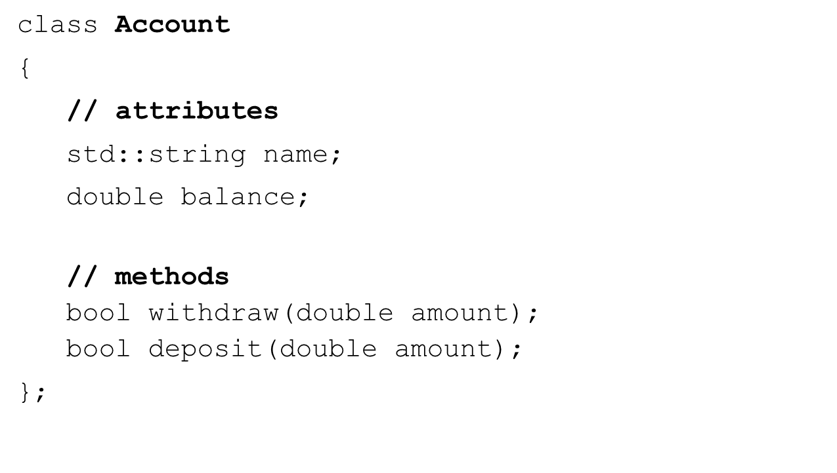

Declaring Classes And Objects

OOP - CLASSES AND OBJECTS

S13-CPP-0080-4

**Account** frank_account;

**Account** jim_account;

**Account \***mary_account = new **Account**(); delete mary_account;

**Account** frank_account;

**Account** jim_account;

**Account** accounts[] {frank_account, jim_account};

std::vector**<Account>** accounts1 {frank_account}; accounts1.push_back(jim_account);

* We can access
  + class attributes
  + class methods
* Some class members will not be accessible (more on that later)
* We need an object to access instance variables

If we have an object (dot operator)

* Using the dot operator

Account frank_account;

frank_account**.**balance; frank_account**.**deposit(1000.00);

If we have a pointer to an object (member of pointer operator)

* Dereference the pointer then use the dot operator.

Account *frank_account = new Account();

**(*frank_account).**balance; **(*frank_account).**deposit(1000.00);

* Or use the member of pointer operator (arrow operator)

Account *frank_account = new Account(); frank_account**->**balance;

frank_account**->**deposit(1000.00);

public, private, and protected

* + public
    - accessible everywhere
  + private
    - accessible only by members or friends of the class
  + protected
    - used with inheritance – we’ll talk about it in the next section

public

class Class_Name

{

###### public:

// declaration(s);

};

private

class Class_Name

{

###### private:

// declaration(s);

};

protected

class Class_Name

{

###### protected:

// declaration(s);

};

## Declaring a Class

Player

class Player

{

private:

std::string name; int health;

int xp;

public:

void talk(std::string text_to_say); bool is_dead();

};

## Creating objects

Player frank;

frank.name = "Frank"; // Compiler error frank.health = 1000; // Compiler error frank.talk("Ready to battle"); // OK

Player **\***enemy = new Player();

enemy->xp = 100; // Compiler error enemy->talk("I will hunt you down"); // OK

delete enemy;

## Declaring a Class

Account

class Account

{

private:

std::string name; double balance;

public:

bool withdraw(double amount); bool deposit(double amount);

};

## Creating objects

Account frank_account;

frank_account.balance = 10000000.00; // Compiler error frank_account.deposit(10000000.0); // OK frank_account.name = "Frank’s Account"; // Compiler error

Account *mary_account = new Account();

mary_account->balance = 10000.0; // Compiler error mary_account->withdraw(10000.0); // OK

delete mary_account;

* Very similar to how we implemented functions
* Member methods have access to member attributes
  + So you don’t need to pass them as arguments!
* Can be implemented inside the class declaration
  + Implicitly inline
* Can be implemented outside the class declaration
  + Need to use Class_name::method_name
* Can separate speciﬁcation from implementation
  + .h ﬁle for the class declaration
  + .cpp ﬁle for the class implementation

Inside the class declaration

class Account {

private:

double balance; public:

**void set_balance(double bal) { balance = bal;**

**}**

**double get_balance() { return balance;**

**}**

};

Outside the class declaration

class Account {

private:

double balance; public:

**void set_balance(double bal); double get_balance();**

};

**void Account::set_balance(double bal) { balance = bal;**

**}**

**double Account::get_balance() { return balance;**

**}**

Account.h

class Account {

private:

double balance; public:

void set_balance(double bal); double get_balance();

};

Include Guards

###### #ifndef _ACCOUNT_H_ #define _ACCOUNT_H_

// Account class declaration

###### #endif

Account.h

**#ifndef _ACCOUNT_H_ #define _ACCOUNT_H_**

class Account {

private:

double balance; public:

void set_balance(double bal); double get_balance();

};

**#endif**

Account.h - #pragma once

###### #pragma once

class Account { private:

double balance; public:

void set_balance(double bal); double get_balance();

};

Account.cpp

###### #include "Account.h"

void **Account::set_balance**(double bal) { balance = bal;

}

double **Account::get_balance**() { return balance;

}

main.cpp

#include <iostream>

#include "Account.h"

int main() {

Account frank_account; frank_account.set_balance(1000.00); double bal = frank_account.get_balance();

std::cout << bal << std::endl; // 1000 return 0;

}

## Constructors

* Special member method
* Invoked during object creation
* Useful for initialization
* Same name as the class
* No return type is speciﬁed
* Can be overloaded

## Player Constructors

class **Player**

{

private:

std::string name; int health;

int xp; public:

**// Overloaded Constructors Player**(); **Player**(std::string name);

**Player**(std::string name, int health, int xp);

};

## Account Constructors

class **Account**

{

private:

std::string name; double balance;

public:

// Constructors Account();

**Account**(std::string name, double balance);

**Account**(std::string name);

**Account**(double balance);

};

## Destructors

* Special member method
* Same name as the class proceeded with a tilde (~)
* Invoked automatically when an object is destroyed
* No return type and no parameters
* Only 1 destructor is allowed per class – cannot be overloaded!
* Useful to release memory and other resources

## Player Destructor

class **Player**

{

private:

std::string name; int health;

int xp; public:

Player(); Player(std::string name);

Player(std::string name, int health, int xp);

// Destructor

**~Player();**

};

## Account Destructor

class **Account**

{

private:

std::string name; double balance;

public:

Account();

Account(std::string name, double balance); Account(std::string name);

Account(double balance);

**// Destructor**

**~Account();**

};

## Creating objects

{

Player slayer;

Player frank {"Frank", 100, 4 }; Player hero {"Hero"};

Player villain {"Villain"};

// use the objects

} // 4 destructors called

Player *enemy = new Player("Enemy", 1000, 0); delete enemy; // destructor called

## The Default Constructor

* Does not expect any arguments
  + Also called the no-args constructor
* If your write no constructors at all for a class
  + C++ will generate a Default Constructor that does nothing
* Called when you instantiate a new object with no arguments

|  |  |  |  |  |
| --- | --- | --- | --- | --- |
| Player | frank; |  | | |
| Player | *enemy | = | new | Player; |

## Declaring a Class

Account – using default constructor

class **Account**

{

private:

std::string name; double balance;

public:

bool withdraw(double amount); bool deposit(double amount);

};

## Creating objects

Using the default constructor

**Account** frank_account;

**Account** jim_account;

**Account \***mary_account = new **Account**; delete mary_account;

Account – user-deﬁned no-args constructor

class **Account**

{

private:

std::string name; double balance;

public:

**Account() {**

**name = "None"; balance = 0.0;**

**}**

bool withdraw(double amount); bool deposit(double amount);

};

Account – no default constructor

class **Account**

{

private:

std::string name; double balance;

public:

**Account(std::string name_val, double bal) { name = name_val;**

**balance = bal;**

**}**

bool withdraw(double amount); bool deposit(double amount);

};

## Creating objects

Using the default constructor

|  |  |  |  |  |  |  |
| --- | --- | --- | --- | --- | --- | --- |
| **Account Account** | frank_account; jim_account; |  |  |  | //  // | Error Error |
| **Account**  delete | **\***mary_account mary_account; | = | new | **Account**; | // | Error |

**Account** bill_account {**"**Bill**"**, 15000.0}; // OK

## Overloading Constructors

* Classes can have as many constructors as necessary
* Each must have a unique signature
* Default constructor is no longer compiler-generated once another constructor is declared

class **Player**

{

private:

std::string name; int health;

int xp; public:

// Overloaded Constructors Player();

**Player**(std::string name_val);

**Player**(std::string name_val, int health_val, int xp_val);

};

**Player::Player**() { name = "None"; health = 0;

xp = 0;

}

**Player::Player**(std::string name_val) { name = name_val;

health = 0;

xp = 0;

}

Overloaded Constructors

**Player::Player**(std::string name_val, int health_val, int xp_val) {

name = name_val; health = health_val; xp = xp_val;

}

## Creating objects

|  |  |  |  |  |  |  |  |  |  |  |  |  |  |  |  |  |
| --- | --- | --- | --- | --- | --- | --- | --- | --- | --- | --- | --- | --- | --- | --- | --- | --- |
| Player | empty; | | | | | // | | | None, | | | 0, | 0 | | | |
| Player | hero **{"Hero"}**; | | | | | // | | | | Hero, 0, | | | | 0 |  | |
| Player | villain **{"Villain"}**; | | | | | // | | | | Villain, | | | | 0, | 0 | |
| Player | frank | **{"Frank",** | | | **100,** | **4}**; | // | | Frank, | | | | 100, | | 4 | |
| Player delete | *enemy enemy; | = | new | Player**("Enemy",** | | | **1000,** | **0)**; | // | | Enemy, | | | 1000, | | 0 |

* So far, all data member values have been set in the constructor body
* Constructor initialization lists
  + are more eﬃcient
  + initialization list immediately follows the parameter list
  + initializes the data members as the object is created!
  + order of initialization is the order of declaration in the class

class **Player**

{

private:

std::string name; int health;

int xp; public:

// Overloaded Constructors Player();

**Player**(std::string name_val);

**Player**(std::string name_val, int health_val, int xp_val);

};

Player()

Previous way:

Player::Player() {

name = "None"; // assignment not initialization health = 0;

xp = 0;

}

Better way:

Player::Player()

: name{"None"}, health{0}, xp{0} {

}

Player(std::string)

Previous way:

Player::Player(std::string name_val) {

name = name_val; // assignment not initialization health = 0;

xp = 0;

}

Better way:

Player::Player(std::string name_val)

: name{name_val}, health{0}, xp{0} {

}

Player(std::string, int, int)

**Previous way:**

Player::Player(std::string name_val, int health_val, int xp_val) { name = name_val; // assignment not initialization health = health_val;

xp = xp_val;

}

**Better way:**

Player::Player(std::string name_val, int health_val, int xp_val)

: **name{name_val}, health{health_val}, xp{xp_val}** {

}

Player::Player()

: name{"None"}, health{0}, xp{0} {

}

Player::Player(std::string name_val)

: name{name_val}, health{0}, xp{0} {

}

Player::Player(std::string name_val, int health_val, int xp_val)

: name{name_val}, health{health_val}, xp{xp_val} {

}

* Often the code for constructors is very similar
* Duplicated code can lead to errors
* C++ allows delegating constructors
  + code for one constructor can call another in the initialization list
  + avoids duplicating code

class **Player**

{

private:

std::string name; int health;

int xp; public:

// Overloaded Constructors Player();

**Player**(std::string name_val);

**Player**(std::string name_val, int health_val, int xp_val);

};

Player::Player()

: name{"None"}, health{0}, xp{0} {

}

Player::Player(std::string name_val)

: name{name_val}, health{0}, xp{0} {

}

Player::Player(std::string name_val, int health_val, int xp_val)

: name{name_val}, health{health_val}, xp{xp_val} {

}

Player::Player(std::string name_val, int health_val, int xp_val)

: **name{name_val}, health{health_val}, xp{xp_val}** {

}

Player::Player()

: **Player {"None", 0, 0}** {

}

Player::Player(std::string name_val)

: **Player { name_val, 0, 0}** {

}

* Can often simplify our code and reduce the number of overloaded constructors
* Same rules apply as we learned with non-member functions

class **Player**

{

private:

std::string name; int health;

int xp; public:

**// Constructor with default parameter values**

Player(**std::string name_val = "None", int health_val = 0,**

**int xp_val = 0**);

};

Player::Player(std::string name_val, int health_val, int xp_val)

: name {name_val}, health {health_val}, xp {xp_val} {

|  |  |  |  |  |  |  |  |  |  |
| --- | --- | --- | --- | --- | --- | --- | --- | --- | --- |
| } |  | | | | | | | | |
| Player | empty; | | |  | // None, 0, 0 | | |  |  |
| Player | frank {"Frank"}; | | |  | // Frank, 0, | | | 0 |  |
| Player | villain {"Villain", | | | 100, | 55}; // Villain, | | | 100, | 55 |
| **Player** | **hero** | **{**"**Hero**"**,** | **100};** | **//** | | **Hero,** | **100,** | **0** | |

// Note what happens if you declare a no-args constructor

## Copy Constructor

* When objects are copied C++ must create a new object from an existing object
* When is a copy of an object made?
  + passing object by value as a parameter
  + returning an object from a function by value
  + constructing one object based on another of the same class
* C++ must have a way of accomplishing this so it provides a compiler-deﬁned copy constructor if you don’t

## Pass object by-value

Player **hero** {"Hero", 100, 20};

void display_player(**Player p**) {

// p is a **COPY** of hero in this example

// use p

// Destructor for p will be called

}

display_player(**hero**);

## Return object by value

**Player** enemy;

**Player** create_super_enemy() {

Player an_enemy{"Super Enemy", 1000, 1000};

return an_enemy; // A **COPY** of an_enemy is returned

}

**enemy** = create_super_enemy();

## Construct one object based on another

Player **hero** {"Hero", 100, 100};

Player **another_hero** {**hero**}; // A COPY of hero is made

## Copy Constructor

* If you don’t provide your own way of copying objects by value then the compiler provides a default way of copying objects
* Copies the values of each data member to the new object
  + default memberwise copy
* Perfectly ﬁne in many cases
* Beware if you have a pointer data member
  + Pointer will be copied
  + Not what it is pointing to
  + Shallow vs. Deep copy – more in the next video

## Best practices

* Provide a copy constructor when your class has raw pointer members
* Provide the copy constructor with a const reference parameter
* Use STL classes as they already provide copy constructors
* Avoid using raw pointer data members if possible

## Declaring the Copy Constructor

Type::Type(**const** Type **&**source);

Player::Player(**const** Player **&**source); Account::Account(**const** Account **&**source);

Type::Type(**const** Type **&**source) {

// code or initialization list to copy the object

}

Player

Player::Player(**const** Player **&source**)

: name{**source**.name}, health {**source**.health}, xp {**source**.xp} {

}

Account

Account::Account(**const** Account **&source**)

: name{**source**.name},

balance {**source**.balance} {

}

## Shallow vs. Deep Copying

* Consider a class that contains a pointer as a data member
* Constructor allocates storage dynamically and initializes the pointer
* Destructor releases the memory allocated by the constructor
* What happens in the default copy constructor?

## Default copy constructor

* memberwise copy
* Each data member is copied from the source object
* The pointer is copied NOT what it points to (shallow copy)
* Problem: when we release the storage in the destructor, the other object still refers to the released storage!

Shallow

class Shallow {

|  |  |  |  |  |
| --- | --- | --- | --- | --- |
| private: |  | | | |
| int *data; | **//** | | | **POINTER** |
| public: |  | | |  |
| Shallow(int d); |  | **//** | **Constructor** | |
| Shallow(const Shallow | &source); |  | **// Copy** | |

Constructor

~Shallow(); **// Destructor**

};

|  |  |  |  |
| --- | --- | --- | --- |
| Shallow constructor |  | | |
| Shallow::Shallow(int data = new int; | d)  **//** | {  **allocate** | **storage** |

*data = d;

}

Shallow destructor

Shallow::~Shallow() {

delete data; **// free storage**

cout << "Destructor freeing data" << endl;

}

Shallow copy constructor

Shallow::Shallow(const Shallow &source)

: data(source.data) {

cout << "Copy constructor - shallow"

<< endl;

}

Shallow copy - only the pointer is copied - not what it is pointing to!

Problem: source and the newly created object BOTH point to the SAME data area!

Shallow – a simple method that expects a copy

Shallow::Shallow(const Shallow &source)

###### : data(source.data) {

cout << "Copy constructor - shallow"

<< endl;

}

Shallow copy - only the pointer is copied - not what it is pointing to!

**Problem**: source and the newly created object BOTH point to the SAME data area!

Sample main – will likely crash

int main() {

Shallow obj1 {100}; display_shallow(obj1);

**// obj1’s data has been released!**

obj1.set_data_value(1000); Shallow obj2 {obj1};

cout << "Hello world" << endl;

return 0;

}

## User-provided copy constructor

* Create a copy of the pointed-to data
* Each copy will have a pointer to unique storage in the heap
* Deep copy when you have a raw pointer as a class data member

Deep

class Deep { private:

int *data; **// POINTER**

public:

Deep(int d); **// Constructor**

Deep(const Deep &source); **// Copy Constructor**

~Deep(); **// Destructor**

};

Deep constructor

Deep::Deep(int d) {

data = new int; **// allocate storage**

*data = d;

}

Deep constructor

Deep::~Deep() {

delete data; **// free storage**

cout << "Destructor freeing data" << endl;

}

Deep constructor

Deep::Deep(const Deep &source)

{

data = new int; **// allocate storage**

*data = *source.data;

cout << "Copy constructor - deep"

<< endl;

}

Deep copy – create new storage and copy values

Deep copy constructor – delegating constructor

Deep::Deep(const Deep &source)

: Deep{*source.data} {

cout << "Copy constructor - deep"

<< endl;

}

Delegate to Deep(int) and pass in the int (*source.data)source is pointing to

Deep – a simple method that expects a copy

void display_deep(**Deep s**) {

cout << s.get_data_value() << endl;

}

When s goes out of scope the destructor is called and releases data.

No Problem: since the storage being releases is unique to s

Sample main – will not crash

int main() {

Deep obj1 {100}; display_deep(obj1);

obj1.set_data_value(1000); Deep obj2 {obj1};

return 0;

}

## Move Constructor

* Sometimes when we execute code the compiler creates unnamed temporary values

int total {0};

total = **100 + 200**;

* + 100 + 200 is evaluated and 300 stored in an unnamed temp value
  + the 300 is then stored in the variable total
  + then the temp value is discarded
* The same happens with objects as well

## When is it useful?

* Sometimes copy constructors are called many times automatically due to the copy semantics of C++
* Copy constructors doing deep copying can have a signiﬁcant performance bottleneck
* C++11 introduced move semantics and the move constructor
* Move constructor moves an object rather than copy it
* Optional but recommended when you have a raw pointer
* Copy elision – C++ may optimize copying away completely (RVO-Return Value Optimization)
* Used in moving semantics and perfect forwarding
* Move semantics is all about r-value references
* Used by move constructor and move assignment operator to eﬃciently move an object rather than copy it
* R-value reference operator (&&)

int x {100}

int **&**l_ref = x; // l-value reference l_ref = 10; // change x to 10

|  |  |  |  |  |  |  |  |  |  |
| --- | --- | --- | --- | --- | --- | --- | --- | --- | --- |
| int **&&**r_ref | | = | 200; | | // r-value | | | ref |  |
| r_ref = 300; | |  | // | | change r_ref | | | to | 300 |
| int | **&&**x_ref | = | x; | // | | Compiler | error | | |

## l-value reference parameters

int x {100}; // **x** is an l-value void func(int **&**num); // **A**

func(**x**); // calls **A** – **x** is an l-value func(**200**); // **Error** – **200** is an r-value

error: cannot bind non-const lvalue reference of type 'int&' to an rvalue of type 'int'

## r-value reference parameters

int x {100}; // x is an l-value void func(int **&&**num); // **B**

func(**200**); // calls **B** – **200** is an r-value func(**x**); // **ERROR** - x is an l-value

error: cannot bind rvalue reference of type 'int&&' to lvalue of type 'int'

## l-value and r-value reference parameters

int x {100}; // x is an l-value

|  |  |  |  |  |
| --- | --- | --- | --- | --- |
| void | func(int | **&**num); | // | **A** |
| void | func(int | **&&**num); | // | **B** |

func(**x**); // calls **A** – **x** is an l-value func(**200**); // calls **B** - **200** is an r-value

## Example - Move class

class **Move** { private:

int *data; // raw pointer public:

void set_data_value(int d) { *data = d; } int get_data_value() { return *data; } Move(int d); // Constructor

Move(const Move &source); // Copy Constructor

~Move(); // Destructor

};

## Move class copy constructor

Move::Move(const Move &source) { data = new int;

*data = *source.data;

}

Allocate storage and copy

Vector<Move> vec;

vec.push_back(Move{10}); vec.push_back(Move{20});

Copy Constructors will be called to copy the temps

|  |  |  |  |
| --- | --- | --- | --- |
| Constructor for: 10 |  | | |
| Constructor for: 10 |
| Copy constructor - deep | copy | for: | 10 |
| Destructor freeing data | for: | 10 |  |
| Constructor for: 20 |  |  |  |
| Constructor for: 20 |  |  |  |
| Copy constructor - deep | copy | for: | 20 |
| Constructor for: 10 |  |  |  |
| Copy constructor - deep | copy | for: | 10 |
| Destructor freeing data | for: | 10 |  |
| Destructor freeing data | for: | 20 |  |

## What does it do?

* Instead of making a deep copy of the move constrictor
  + ‘moves’ the resource
  + Simply copies the address of the resource from source to the current object
  + And, nulls out the pointer in the source pointer
* Very eﬃcient

## syntax - r-value reference

Type::Type(Type **&&**source); Player::Player(Player **&&**source); Move::Move(Move **&&**source);

## Move class with move constructor

class **Move** { private:

int *data; // raw pointer

public:

void set_data_value(int d) { *data = d; } int get_data_value() { return *data; } Move(int d); // Constructor

Move(const Move &source);// Copy Constructor

**Move(Move &&source); // Move Constructor**

~Move(); // Destructor

};

## Move class move constructor

Move::Move(Move **&&**source)

: data{source.data} {

source.data = nullptr;

}

‘Steal’ the data and then null out the source pointer

Vector<Move> vec;

vec.push_back(Move{10}); vec.push_back(Move{20});

Move Constructors will be called for the temp r-values

|  |  |  |  |
| --- | --- | --- | --- |
| Constructor for: | 10 |  | |
| Move constructor | - moving | resource: | 10 |

|  |  |  |  |  |
| --- | --- | --- | --- | --- |
| Destructor | freeing | data | for | nullptr |
| Constructor | for: 20 |  |  |  |

|  |  |  |  |  |
| --- | --- | --- | --- | --- |
| Move | constructor | - moving | resource: | 20 |
| Move | constructor | - moving | resource: | 10 |

|  |  |  |  |  |
| --- | --- | --- | --- | --- |
| Destructor | freeing | data | for | nullptr |
| Destructor | freeing | data | for | nullptr |
| Destructor | freeing | data | for: | 10 |
| Destructor | freeing | data | for: | 20 |

* this is a reserved keyword
* Contains the address of the object - so it’s a pointer to the object
* Can only be used in class scope
* All member access is done via the this pointer
* Can be used by the programmer
  + To access data member and methods
  + To determine if two objects are the same (more in the next section)
  + Can be dereferenced (*this) to yield the current object

void Account::set_balance(double bal) { balance = bal; // this->balance is implied

}

To disambiguate identiﬁer use

void Account::set_balance(double balance) {

balance = balance; // which balance? The parameter

}

void Account::set_balance(double balance) {

**this->**balance = balance; // Unambiguous

}

To determine object identity

* Sometimes its useful to know if two objects are the same object

int Account::compare_balance(const Account &other) { if (**this == &other**)

std::cout << "The same objects" << std::endl;

...

}

frank_account.compare_balance(frank_account);

* We’ll use the this pointer again when we overload the assignment operator

## Using const with classes

* Pass arguments to class member methods as const
* We can also create const objects
* What happens if we call member functions on const objects?
* const-correctness

## Creating a const object

* villain is a const object so it’s attributes cannot change

**const** Player villain {"Villain", 100, 55};

What happens when we call member methods on a const object?

const Player villain {"Villain", 100, 55}; villain.set_name("Nice guy"); **// ERROR** std::cout << villain.get_name() << std::endl; **// ERROR**

What happens when we call member methods on a const object?

**const** Player villain {"Villain", 100, 55}; void display_player_name(**const** Player &p) {

cout << p.get_name() << endl;

}

display_player_name(villain); **// ERROR**

const methods

class Player { private:

. . .

public:

std::string get_name() **const**;

. . .

};

const-correctness

const Player villain {"Villain", 100, 55}; villain.set_name("Nice guy"); **// ERROR** std::cout << villain.get_name() << std::endl; **// OK**

const methods

class Player { private:

. . .

public:

std::string get_name() **const;**

**// ERROR** if code in get_name modifies this object

. . .

};

## Static Class Members

* Class data members can be declared as static
  + A single data member that belongs to the class, not the objects
  + Useful to store class-wide information
* Class functions can be declared as static
  + Independent of any objects
  + Can be called using the class name

## Player class -static members

class Player { private:

static int num_players;

public:

static int get_num_players();

. . .

};

## Player class – initialize the static data

Typically in Player.cpp

#include "Player.h"

int Player::num_players = 0;

## Player class – implement static method

int Player::get_num_players() { return num_players;

}

## Player class –update the constructor

Player::Player(std::string name_val, int health_val, int xp_val)

: name{name_val}, health{health_val}, xp{xp_val} {

###### ++num_players;

}

## Player class - Destructor

Player::~Player() {

--num_players;

}

## main.cpp

void display_active_players() { cout << "Active players: "

<< **Player::get_num_players()** << endl;

}

int main() {

display_active_players();

Player obj1 {"Frank"};

display_active_players();

. . .

## Structs vs Classes

* In addition to deﬁne a class we can declare a struct
* struct comes from the C programming language
* Essentially the same as a class expect
  + members are public by default

## class

**class** Person { std::string name; std::string get_name();

};

Person p;

p.name = "Frank"; **// compiler error - private**

std::cout << p.get_name(); **// compiler error - private**

## struct

**struct** Person { std::string name;

std::string get_name(); **// Why if name is public?**

};

|  |  |  |  |  |  |
| --- | --- | --- | --- | --- | --- |
| Person | p; |  | | | |
| p.name | = | "Frank"; | **//** | **OK** | **- public** |

std::cout << p.get_name(); **// OK - public**

## Some general guidelines

* struct
  + Use struct for passive objects with public access
  + Don’t declare methods in struct
* class
  + Use class for active objects with private access
  + Implement getters/setters as needed
  + Implement member methods as needed
* Friend
  + A function or class that has access to private class member
  + And, that function of or class is NOT a member of the class it is accessing
* Function
  + Can be regular non-member functions
  + Can be member methods of another class
* Class
  + Another class can have access to private class members
* Friendship must be granted NOT taken
  + Declared explicitly in the class that is granting friendship
  + Declared in the function prototype with the keyword friend
* Friendship is not symmetric
  + Must be explicitly granted
    - if A is a friend of B
    - B is NOT a friend of A
* Friendship is not transitive
  + Must be explicitly granted
    - if A is a friend of B AND
    - B is a friend of C
    - then A is NOT a friend of C

class Player {

friend void display_player(Player &p);

std::string name; int health;

int xp;

public:

. . .

};

void display_player(Player &p) { std::cout << **p.name** << std::endl; std::cout << **p.health** << std::endl; std::cout << **p.xp** << std::endl;

}

display_player may also change private data members

class Player {

friend void Other_class::display_player(Player &p);

std::string name; int health;

int xp;

public:

. . .

};

class Other_class {

. . .

public:

**void display_player(Player &p) {** std::cout << **p.name** << std::endl; std::cout << **p.health** << std::endl; std::cout << **p.xp** << std::endl;

}

};

## Another class as a friend

class Player {

friend class Other_class;

std::string name; int health;

int xp;

public:

. . .

};

## Section Overview

Operator Overloading

* What is Operator Overloading?
* Overloading the assignment operator (=)
  + Copy semantics
  + Move semantics
* Overloading operators as member functions
* Overloading operators as global functions
* Overloading stream insertion (<<) and extraction operators (>>)
* Using traditional operators such as +, =, *, etc. with user-deﬁned types
* Allows user deﬁned types to behave similar to built-in types
* Can make code more readable and writable
* Not done automatically (except for the assignment operator) They must be explicitly deﬁned

Suppose we have a Number class that models any number

* Using functions:

Number result = multiply(add(a,b),divide(c,d));

* Using member methods:

Number result = (a.add(b)).multiply(c.divide(d));

What is Operator Overloading?

Suppose we have a Number class that models any number

* Using overloaded operators

Number result = (a+b)*(c/d);

What operators can be overloaded?

* 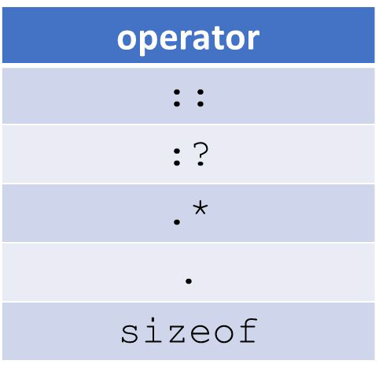The majority of C++’s operators can be overloaded
* The following operators cannot be overload

Some basic rules

* Precedence and Associativity cannot be changed
* ‘arity’ cannot be changed (i.e. can’t make the division operator unary)
* Can’t overload operators for primitive type (e.g. int, double, etc.)
* Can’t create new operators
* **[]**, **()**, **->**, and the assignment operator (=) must be declared as member methods
* Other operators can be declared as member methods or global functions

Some examples

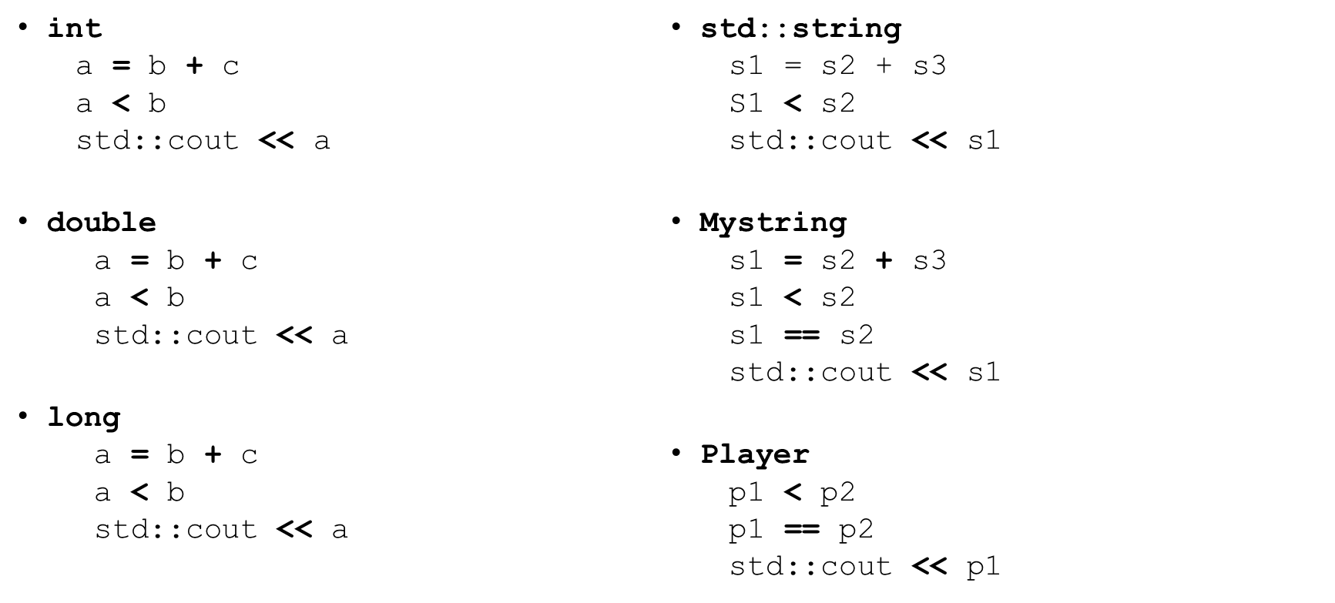

Mystring class declaration

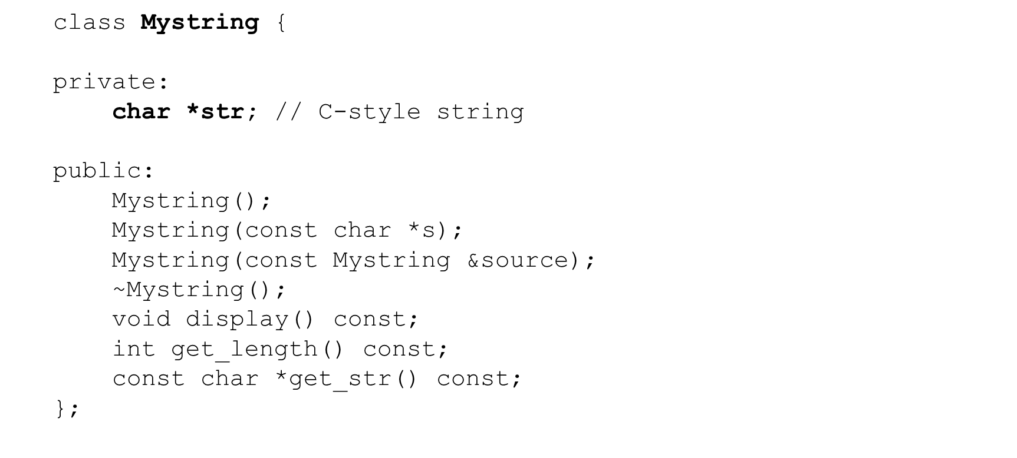

Copy assignment operator (=)

* C++ provides a default assignment operator used for assigning one object to another

|  |  |  |
| --- | --- | --- |
| Mystring | s1 | {"Frank"}; |
| Mystring | s2 | = s1; // **NOT** assignment |
|  | // | same as Mystring s2{s1}; |

s2 = s1; // **assignment**

* Default is memberwise assignment (shallow copy)
  + If we have raw pointer data member we must deep copy

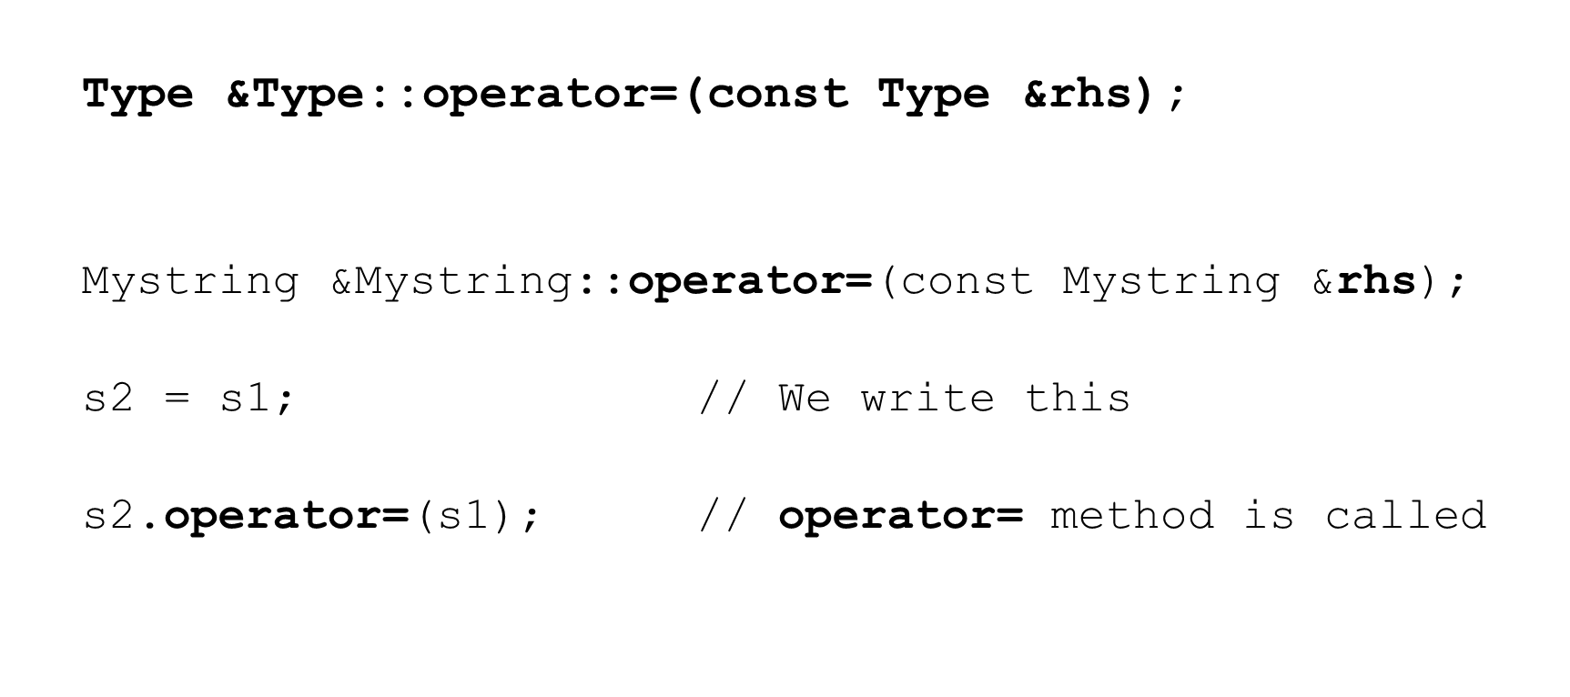

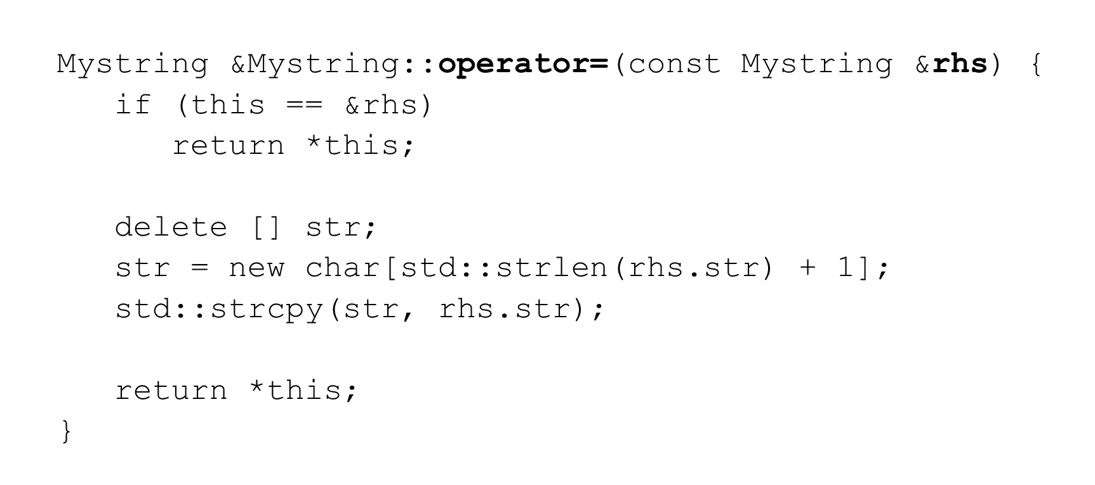

* + Check for self assignment

if (this == &rhs) // p1 = p1;

return *this; // return current object

* + Deallocate storage for this->str since we are overwriting it

delete [] str;

* + Allocate storage for the deep copy

str = new char[std::strlen(rhs.str) + 1];

Overloading the copy assignment operator – steps for deep copy

* + Perform the copy

std::strcpy(str, rhs.str);

* + Return the current by reference to allow chain assignment

return *this;

// s1 = s2 = s3;

Move assignment operator (=)

* You can choose to overload the move assignment operator
  + C++ will use the copy assignment operator if necessary

Mystring s1;

s1 = Mystring {"Frank"}; // move assignment

* If we have raw pointer we should overload the move assignment operator for eﬃciency

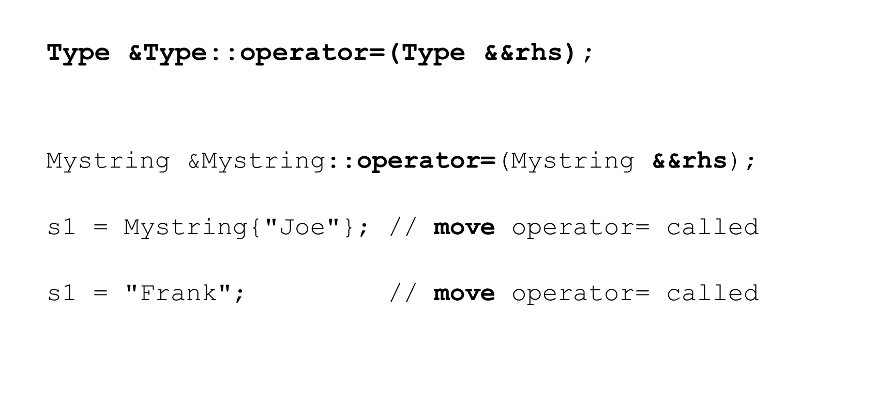

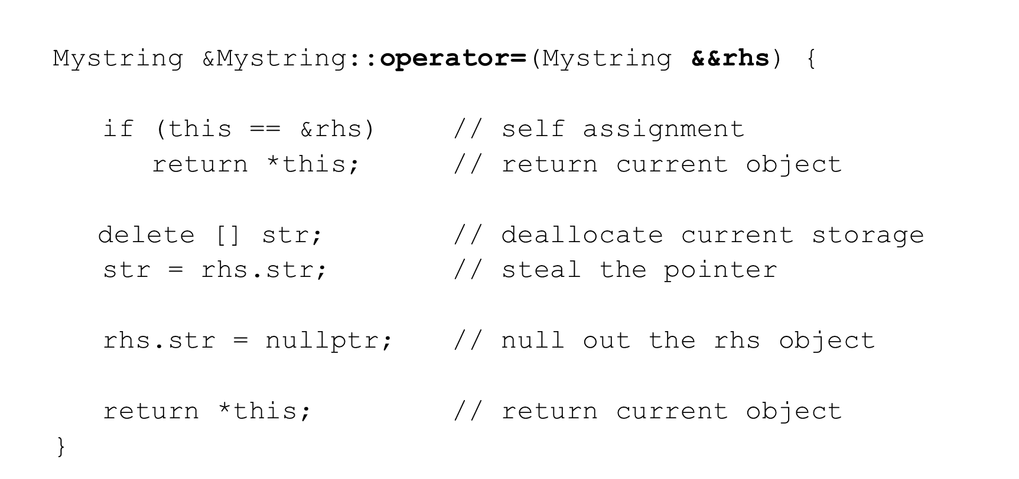

Overloading the Move assignment operator – steps

* + Check for self assignment

if (this == &rhs)

return *this; // return current object

* + Deallocate storage for this->str since we are overwriting it

delete [] str;

Overloading the Move assignment operator – steps for deep copy

* + Steal the pointer from the rhs object and assign it to this->str

str = rhs.str;

* + Null out the rhs pointer

rhs.str = nullptr;

* + Return the current object by reference to allow chain assignment

return *this;

Unary operators as member methods (++, --, -, !)

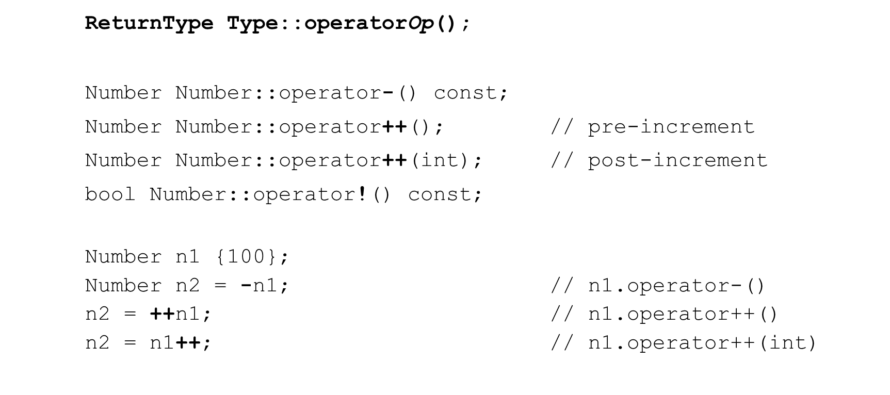

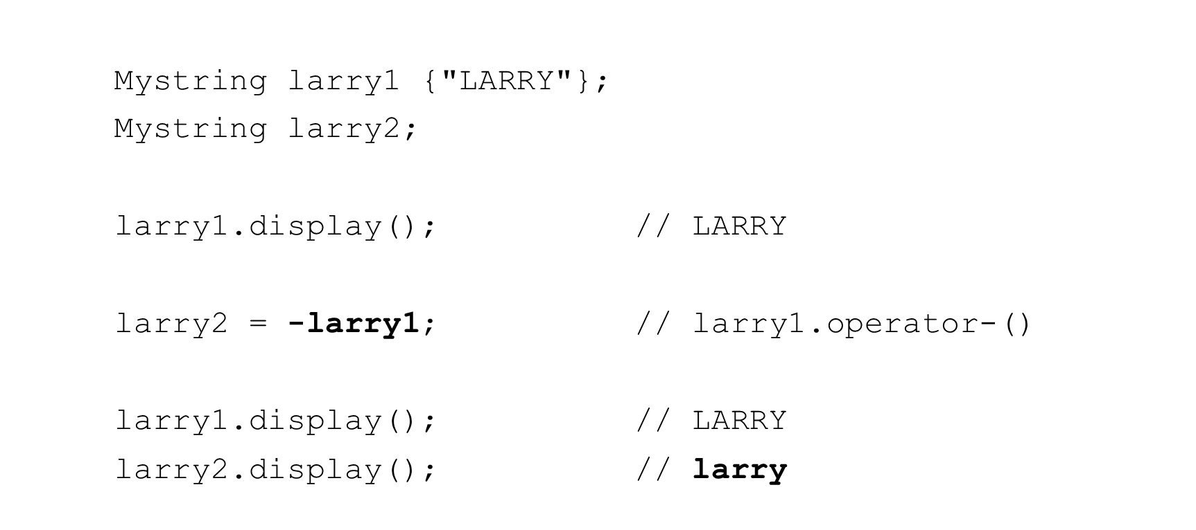

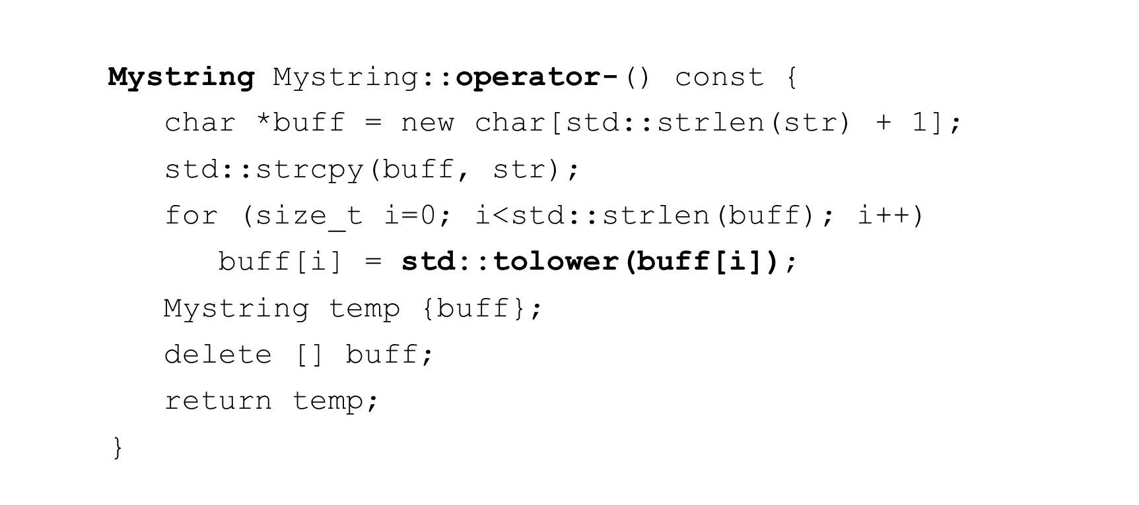

Binary operators as member methods (+,-,==,!=,<,>, etc.)

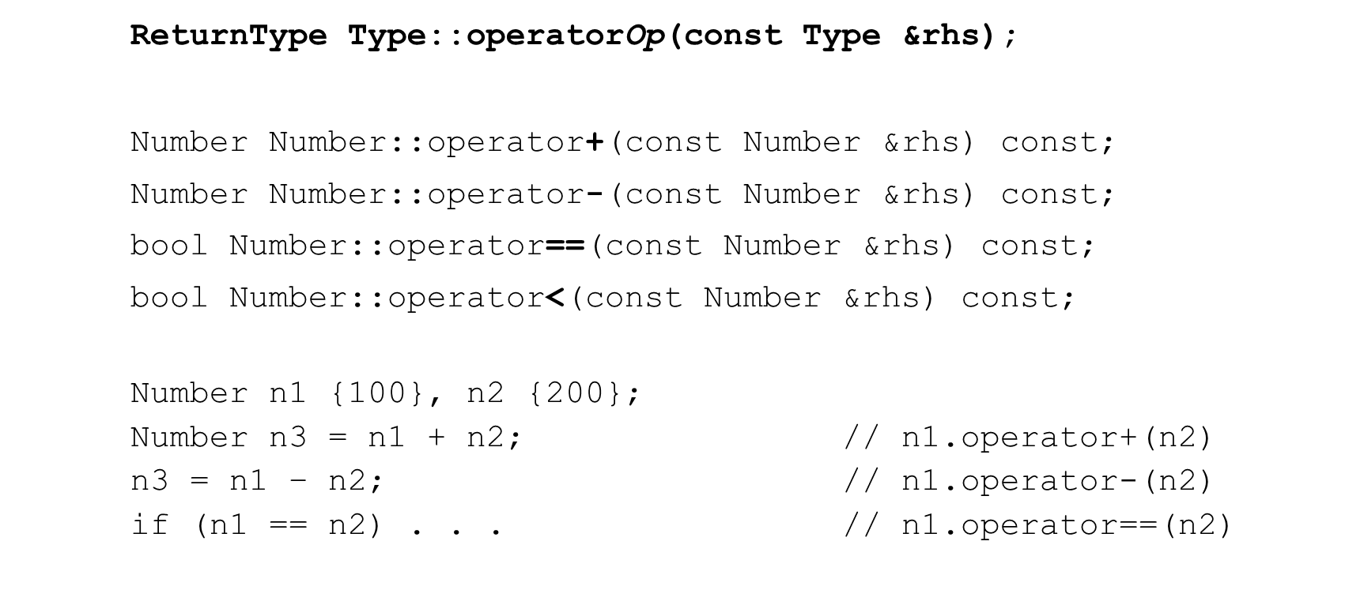

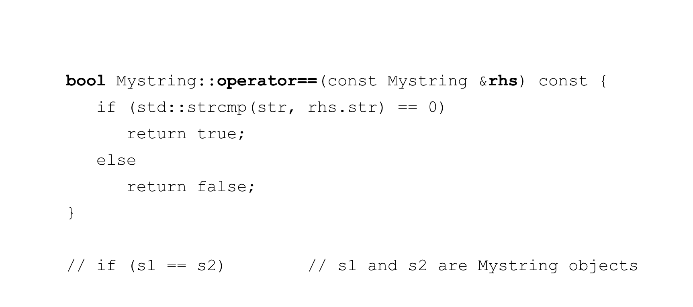Mystring operator==

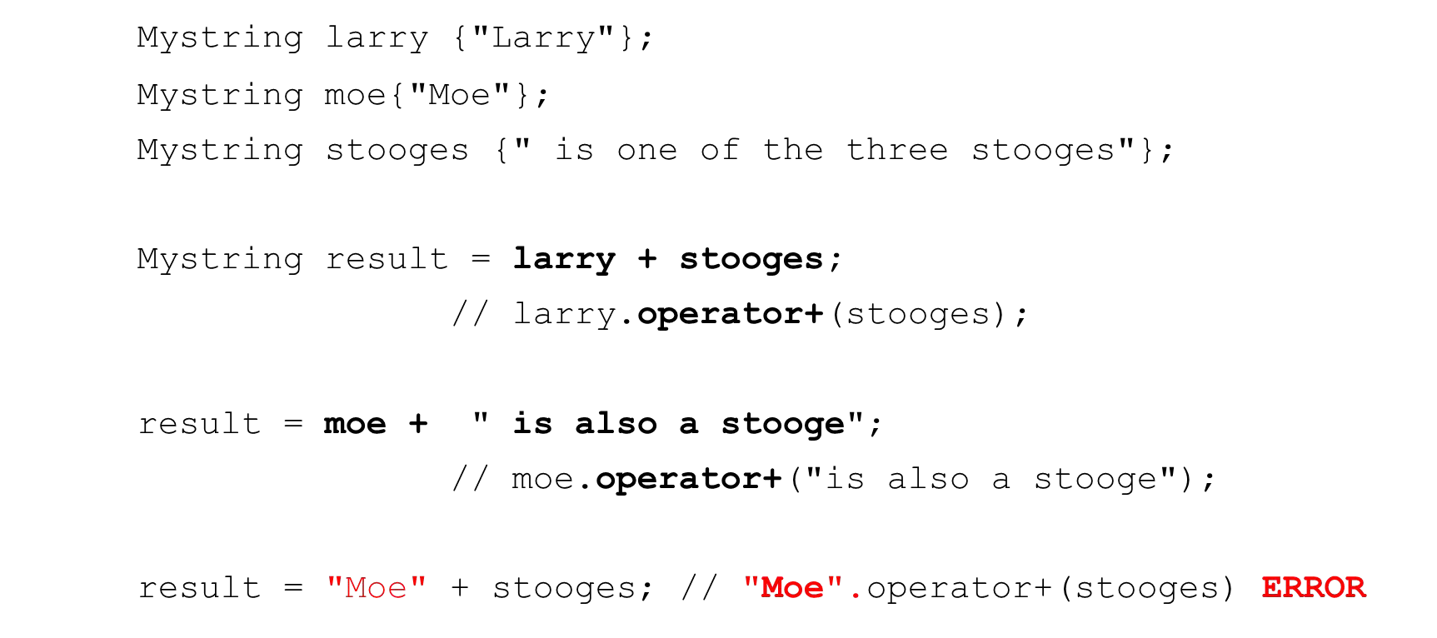

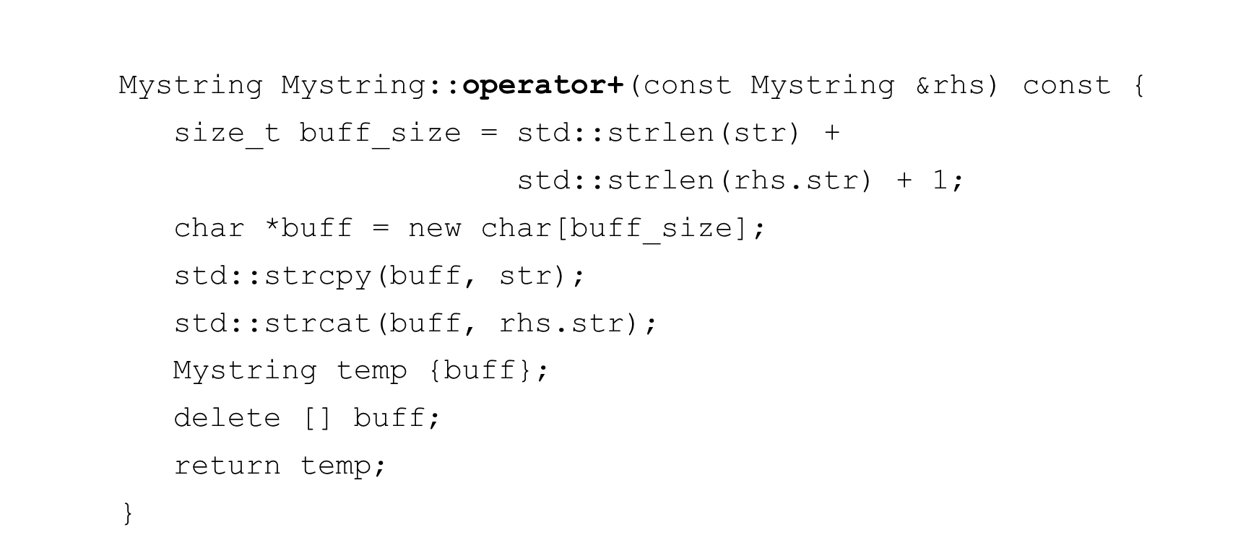

Unary operators as global functions (++, --, -, !)

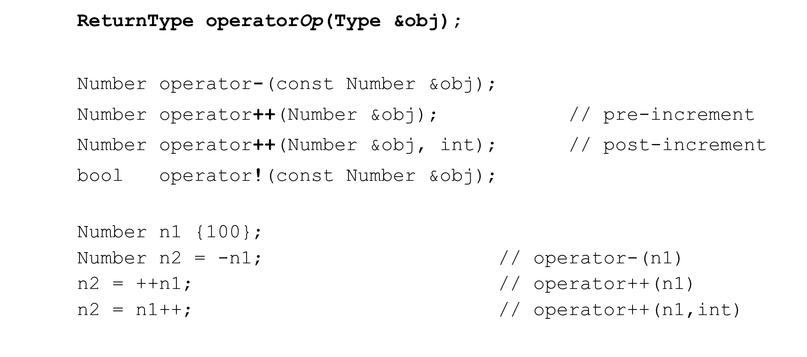

Mystring operator- make lowercase

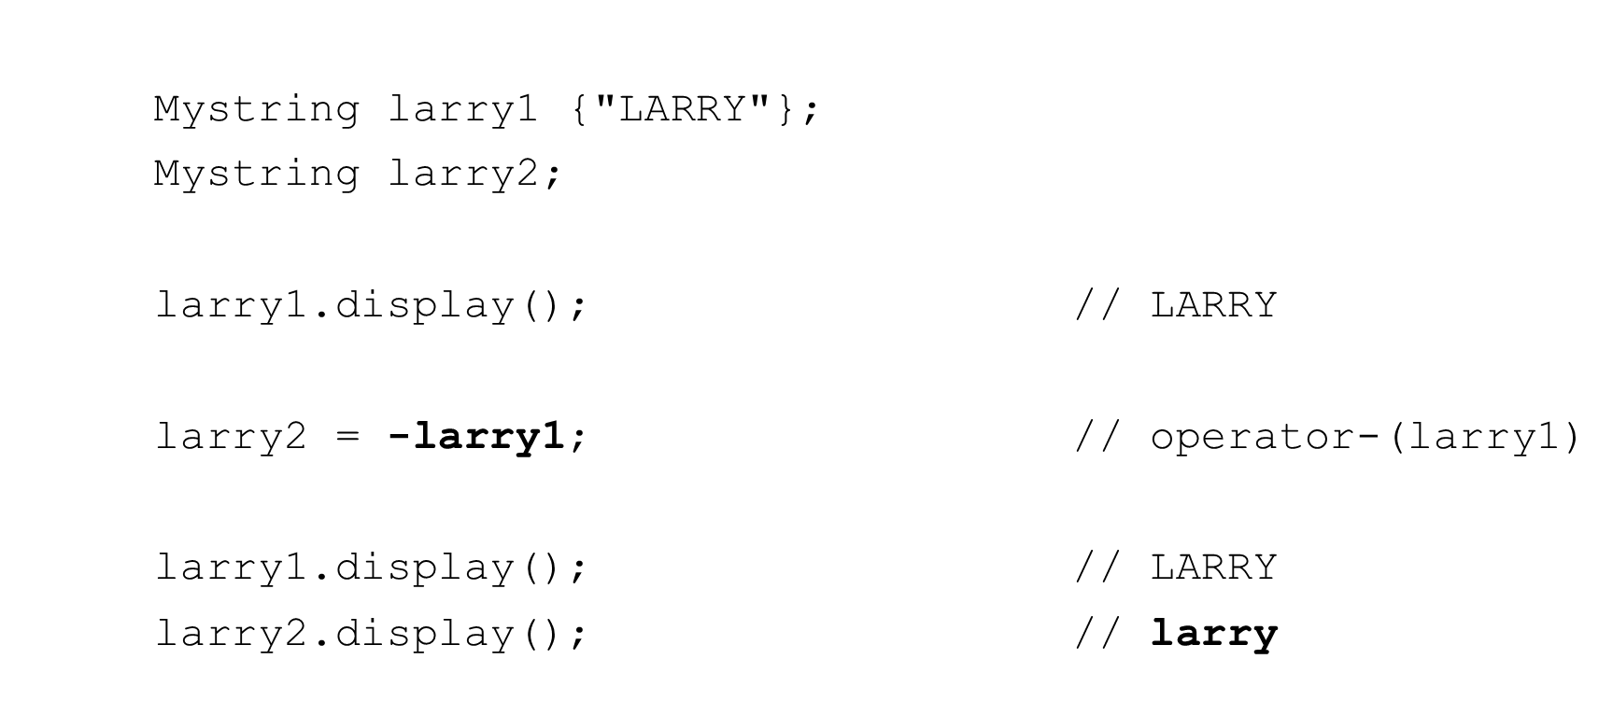

Mystring operator-

* Often declared as friend functions in the class declaration

Mystring **operator-**(const Mystring &**obj**) {

char *buff = new char[std::strlen(**obj.str**) + 1]; std::strcpy(buff, **obj.str**);

for (size_t i=0; i<std::strlen(buff); i++) buff[i] = std::tolower(buff[i]);

Mystring temp {buff}; delete [] buff; return temp;

}

Binary operators as global functions (+,-,==,!=,<,>, etc.)

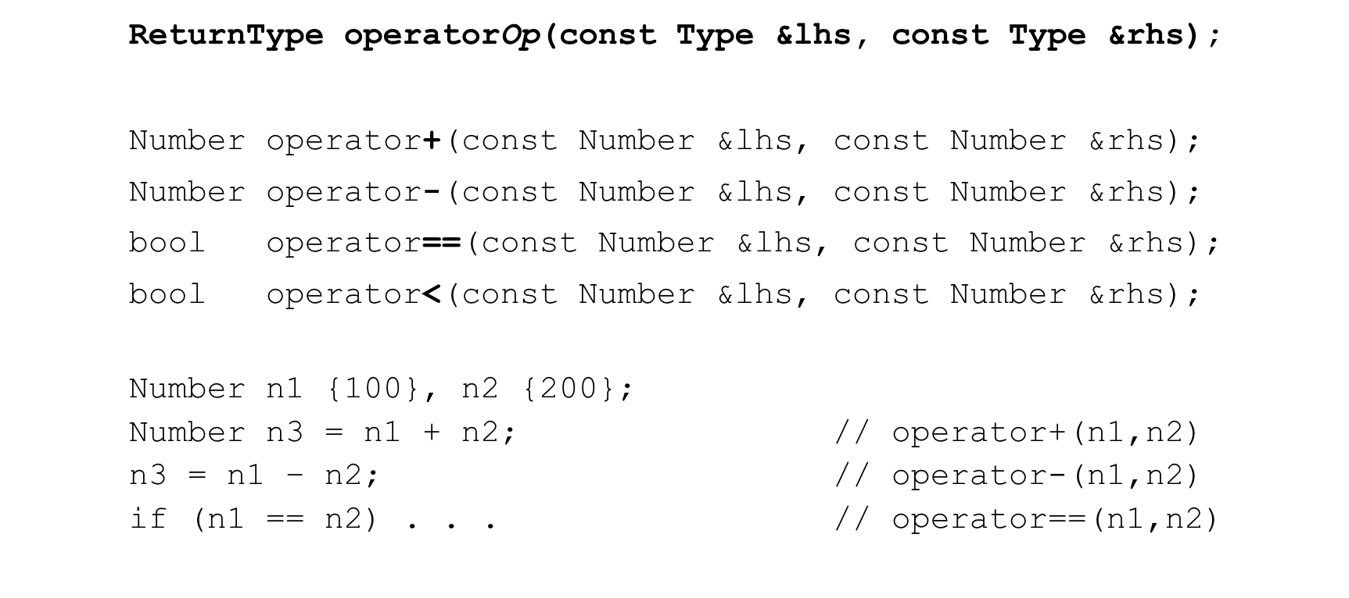

Mystring operator==

bool **operator==**(const Mystring &**lhs**, const Mystring &**rhs**){ if (std::strcmp(**lhs.str**, **rhs.str**) == 0)

return true; else

return false;

}

* If declared as a friend of Mystring can access private str attribute
* Otherwise we must use getter methods

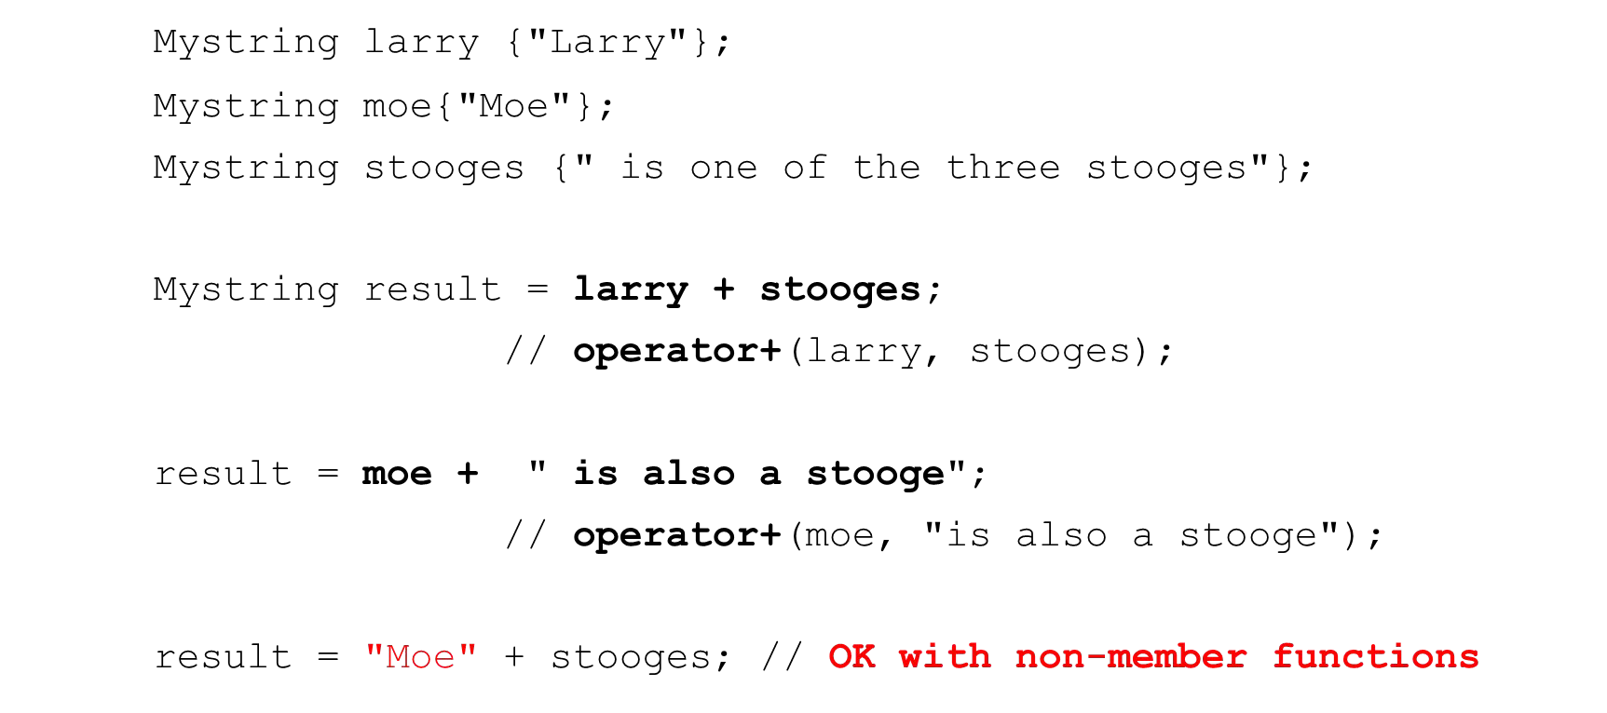

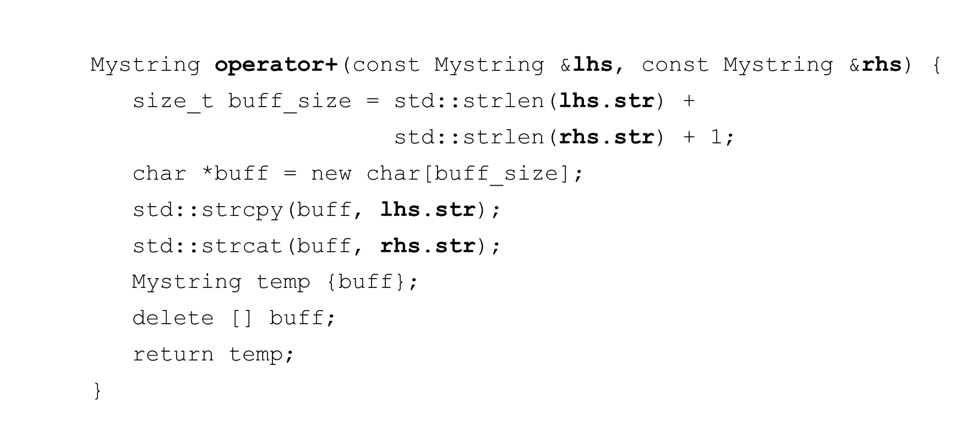

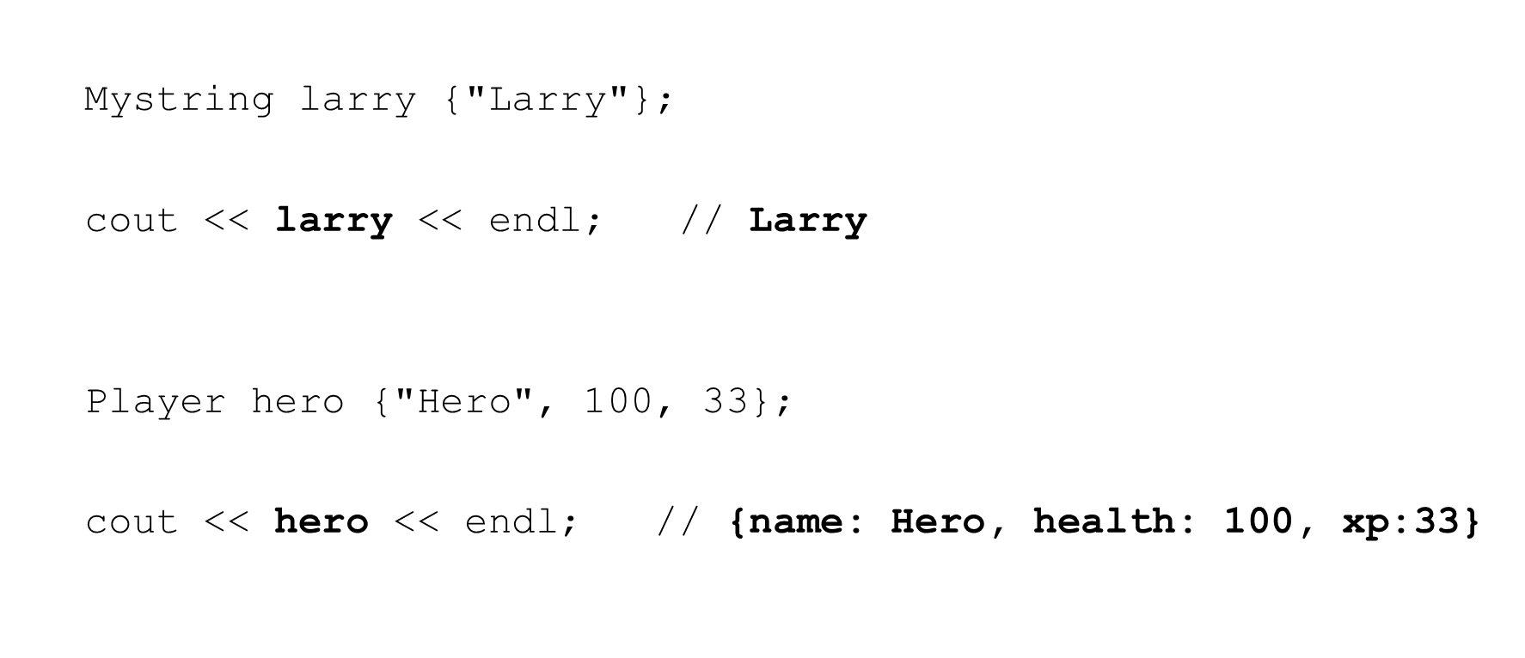

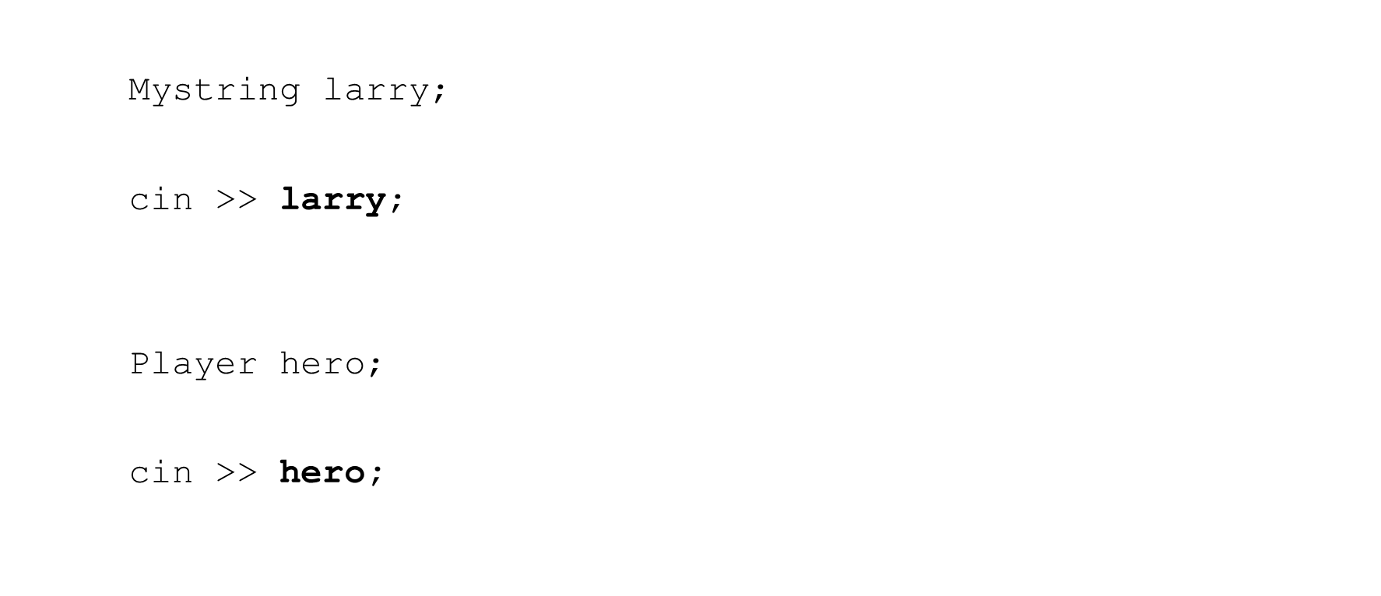

* Doesn’t make sense to implement as member methods
  + Left operand must be a user-deﬁned class
  + Not the way we normally use these operators

Mystring larry;

**larry** << cout; **// huh?**

Player hero;

**hero** >> cin**; // huh?**

stream insertion operator (<<)

std::ostream &operator<<(std::**ostream** &os, const **Mystring** &obj) { os << obj.str; // if friend function

// os << obj.get_str(); // if not friend function return os;

}

* Return a reference to the ostream so we can keep inserting
* Don’t return ostream by value!

stream extraction operator (>>)

std::istream &operator>>(std::**istream** &is, **Mystring** &obj) { char *buff = new char[1000];

is >> buff;

obj = Mystring{buff}; // If you have copy or move assignment delete [] buff;

return is;

}

* Return a reference to the istream so we can keep inserting
* Update the object passed in

## Section Overview

Inheritance

* What is Inheritance?
  + Why is it useful?
* Terminology and Notation
* Inheritance vs. Composition
* Deriving classes from existing classes
  + Types of inheritance
* Protected members and class access
* Constructors and Destructors
  + Passing arguments to base class constructors
  + Order of constructor and destructors calls
* Redeﬁning base class methods
* Class Hierarchies
* Multiple Inheritance

What is it and why is it used?

* Provides a method for creating new classes from existing classes
* The new class contains the data and behaviors of the existing class
* Allow for reuse of existing classes
* Allows us to focus on the common attributes among a set of classes
* Allows new classes to modify behaviors of existing classes to make it unique
  + Without actually modifying the original class

Related classes

* Player, Enemy, Level Boss, Hero, Super Player, etc.
* Account, Savings Account, Checking Account, Trust Account, etc.
* Shape, Line, Oval, Circle, Square, etc.
* Person, Employee, Student, Faculty, Staﬀ, Administrator, etc.

Accounts

* Account
  + balance, deposit, withdraw, . . .
* Savings Account
  + balance, deposit, withdraw, interest rate, . . .
* Checking Account
  + balance, deposit, withdraw, minimum balance, per check fee, . . .
* Trust Account
  + balance, deposit, withdraw, interest rate, . . .

Accounts – without inheritance – code duplication

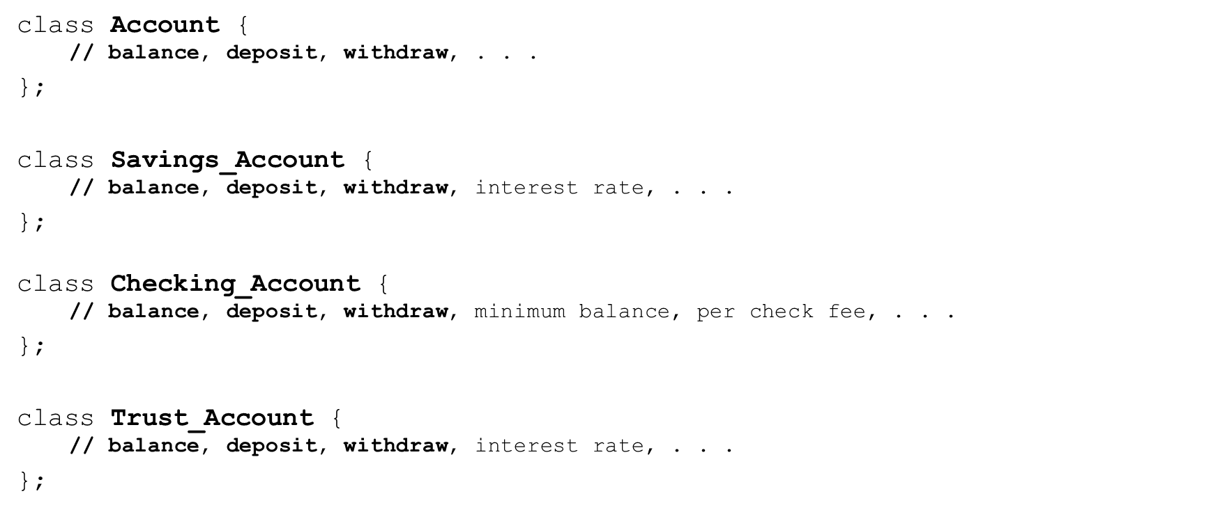

Accounts – with inheritance – code reuse

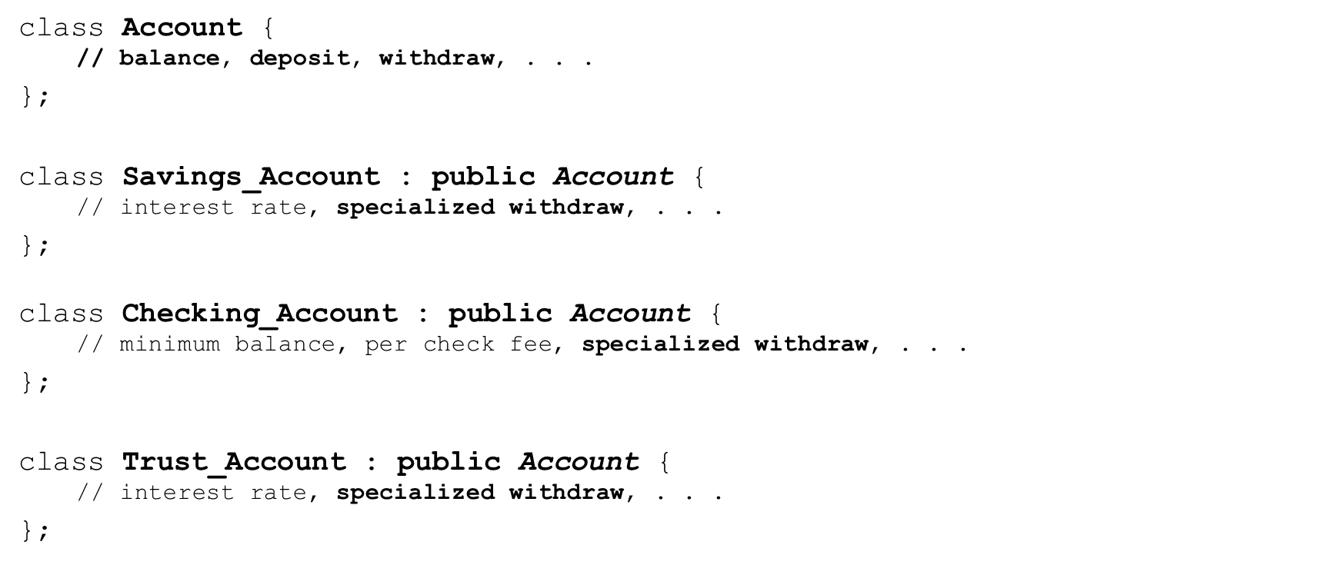

* Inheritance
  + Process of creating new classes from existing classes
  + Reuse mechanism
* Single Inheritance
  + A new class is created from another ‘single’ class
* Multiple Inheritance
  + A new class is created from two (or more) other classes
* Base class (parent class, super class)

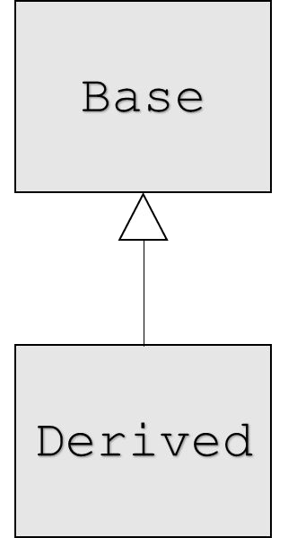

* + The class being extended or inherited from
* Derived class (child class, sub class)
  + The class being created from the Base class
  + Will inherit attributes and operations from Base class

Terminology

* “Is-A” relationship
  + Public inheritance
  + Derived classes are sub-types of their Base classes
  + Can use a derived class object wherever we use a base class object
* Generalization
  + Combining similar classes into a single, more general class based on common attributes
* Specialization
  + Creating new classes from existing classes proving more specialized attributes or operations
* Inheritance or Class Hierarchies
  + Organization of our inheritance relationships

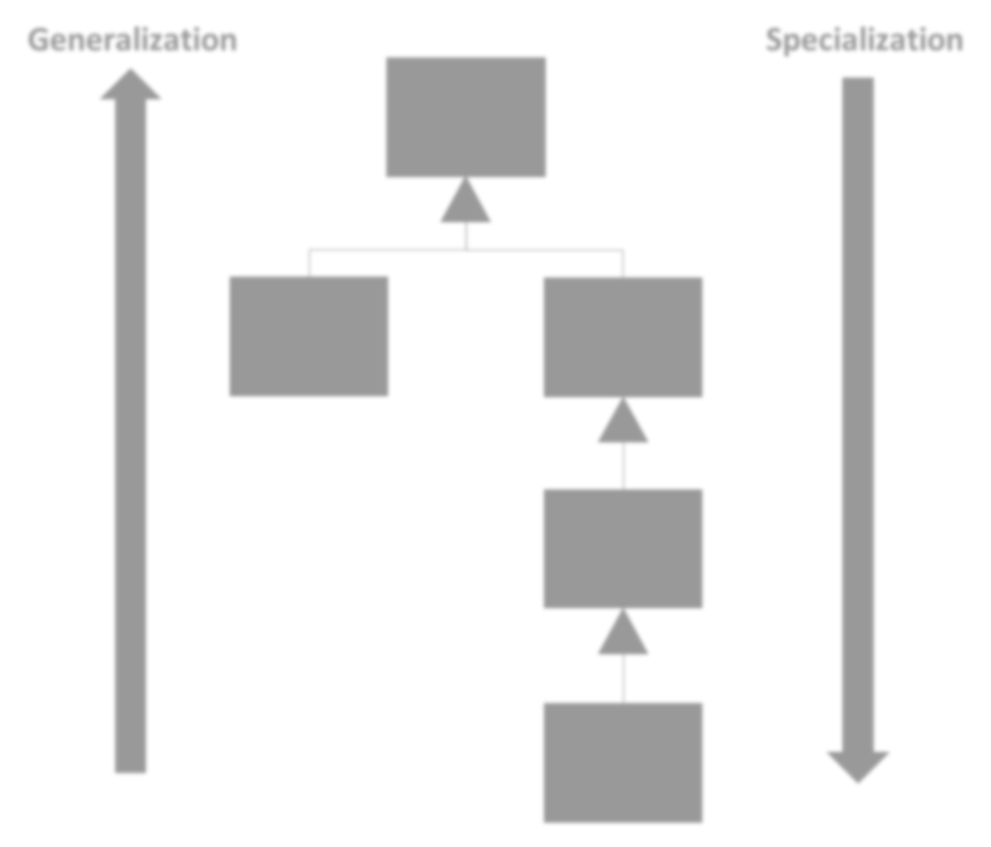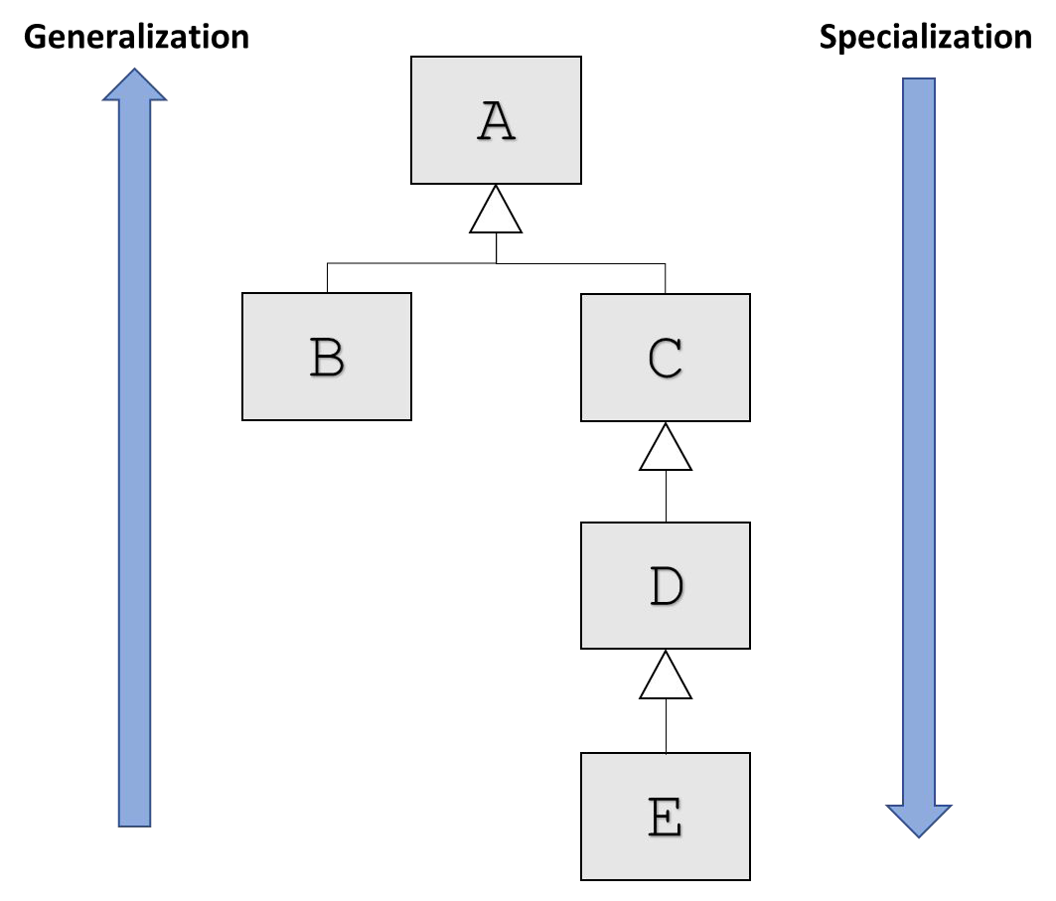

Classes:

* + A
  + B is derived from A
  + C is derived from A
  + D is derived from C
  + E is derived from D

Classes:

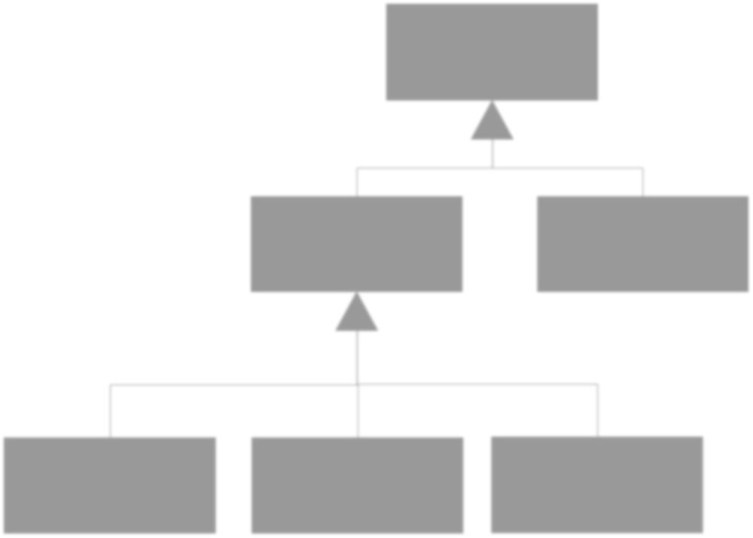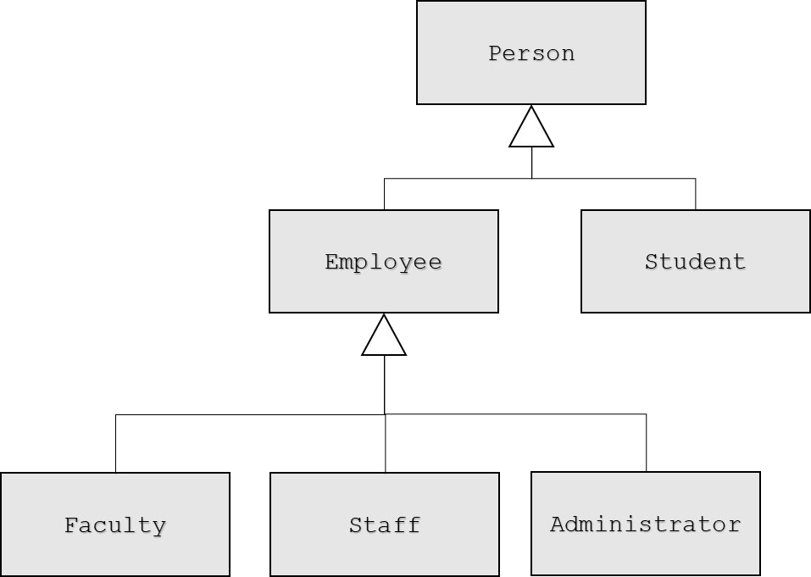

* + Person
  + Employee is derived from Person
  + Student is derived from Person
  + Faculty is derived from Employee
  + Staﬀ is derived from Employee
  + Administrator is derived from Employee

Public Inheritance vs. Composition

* Both allow reuse of existing classes
* Public Inheritance
  + “is-a” relationship
    - Employee ‘is-a’ Person
    - Checking Account ‘is-a’ Account
    - Circle “is-a” Shape
* Composition
  + “has-a” relationship
    - Person “has a” Account
    - Player “has-a” Special Attack
    - Circle “has-a” Location

|  |  |  |
| --- | --- | --- |
| Person | has | Account |
|  |

Student

Employee

Administrator

Staff

Faculty

class Person { private:

std::string name; // **has-a** name

Account account; // **has-a** account

};

C++ derivation syntax

class **Base** {

// Base class members . . .

};

class **Derived**: **access-specifier Base** {

// Derived class members . . .

};

Access-speciﬁer can be: public, private, or protected

Types of inheritance in C++

* public
  + Most common
  + Establishes ‘is-a’ relationship between Derived and Base classes
* private and protected
  + Establishes “derived class has a base class” relationship
  + “Is implemented in terms of” relationship
  + Diﬀerent from composition

C++ derivation syntax

class **Account** {

// Account class members . . .

};

class **Savings_Account**: **public Account** {

// Savings_Account class members . . .

};

Savings_Account ‘is-a’ Account

**Account** account {};

**Account** *p_account = new **Account**();

account.deposit(1000.0); p_account->withdraw(200.0);

delete p_account;

**Savings_Account** sav_account {};

**Savings_Account** *p_sav_account = new **Savings_Account**();

sav_account.deposit(1000.0); p_sav_account->withdraw(200.0);

delete p_sav_account;

class **Base** {

###### protected:

// protected Base class members . . .

};

* Accessible from the Base class itself
* Accessible from classes Derived from Base
* Not accessible by objects of Base or Derived

class **Base** { public:

int **a**; // public Base class members . . .

**protected**:

int **b**; // protected Base class members . . .

private:

int **c**; // private Base class members . . .

};

Access with **public** inheritance

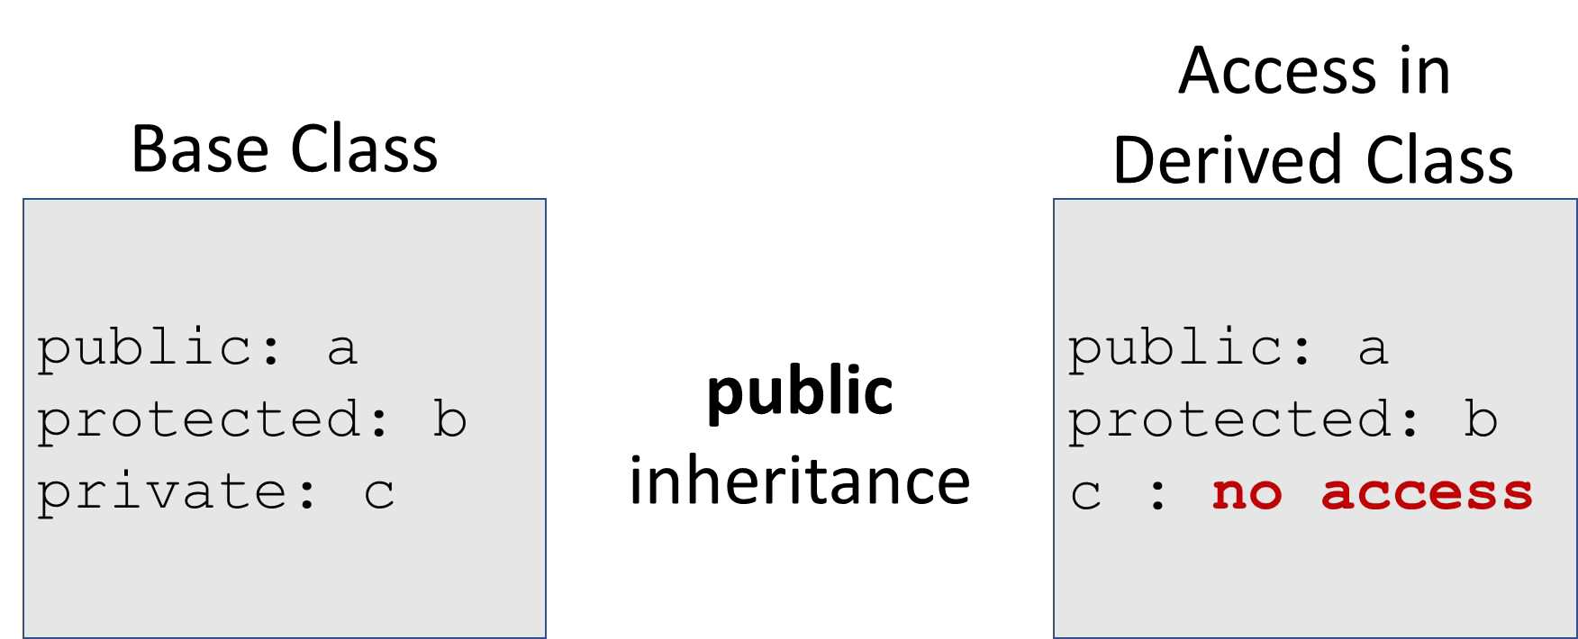

Access with **protected** inheritance

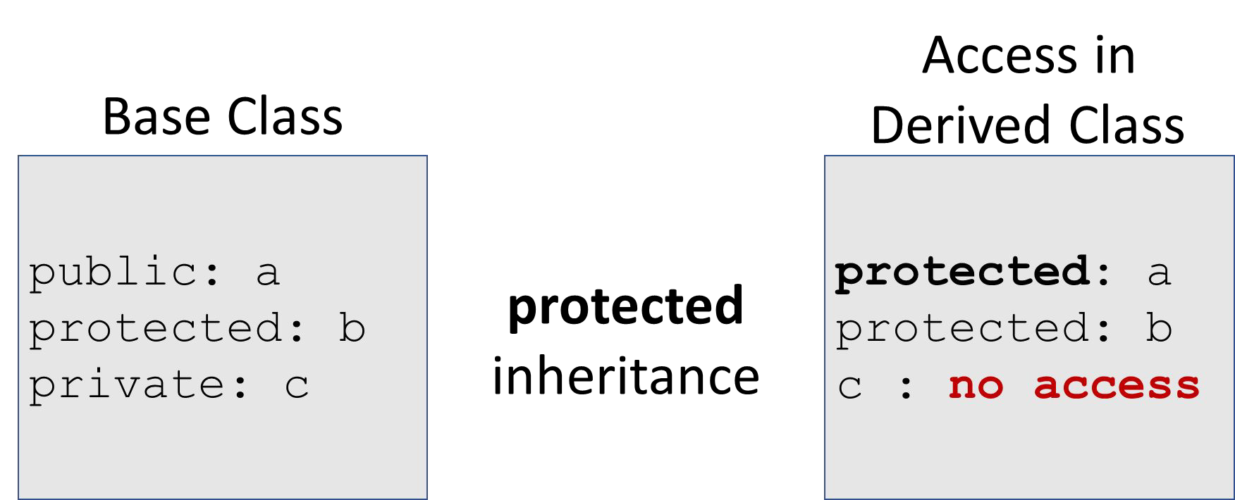

Access with **private** inheritance

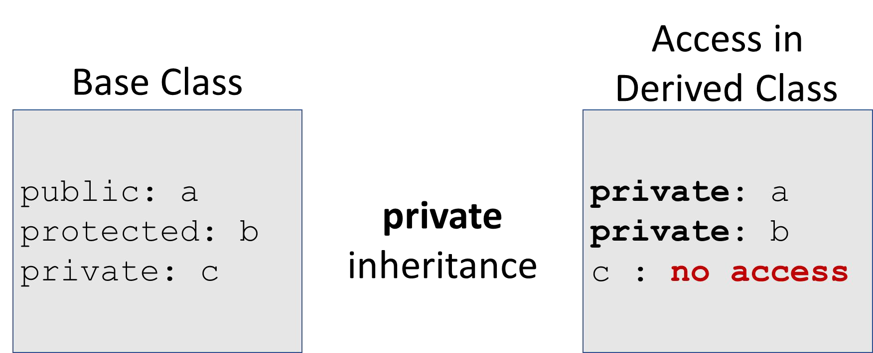

* A Derived class inherits from its Base class
* The Base part of the Derived class MUST be initialized BEFORE the Derived class is initialized
* When a Derived object is created
  + Base class constructor executes then
  + Derived class constructor executes

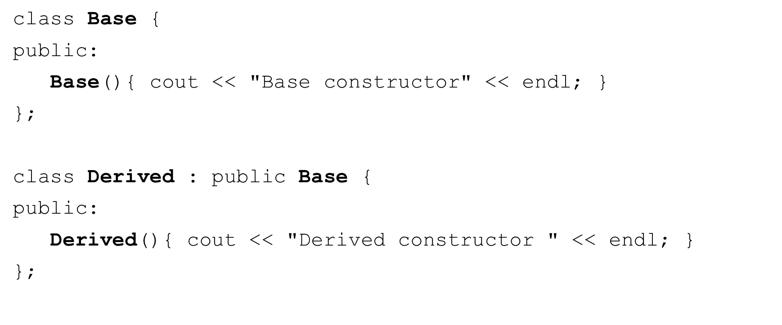

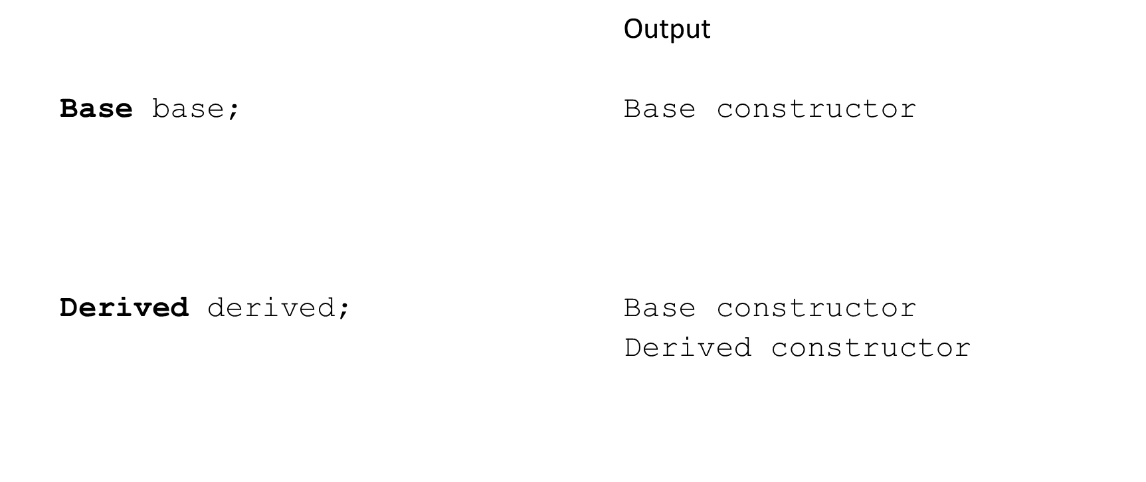

* Class destructors are invoked in the reverse order as constructors
* The Derived part of the Derived class MUST be destroyed BEFORE the Base class destructor is invoked
* When a Derived object is destroyed
  + Derived class destructor executes then
  + Base class destructor executes
  + Each destructor should free resources allocated in it’s own constructors

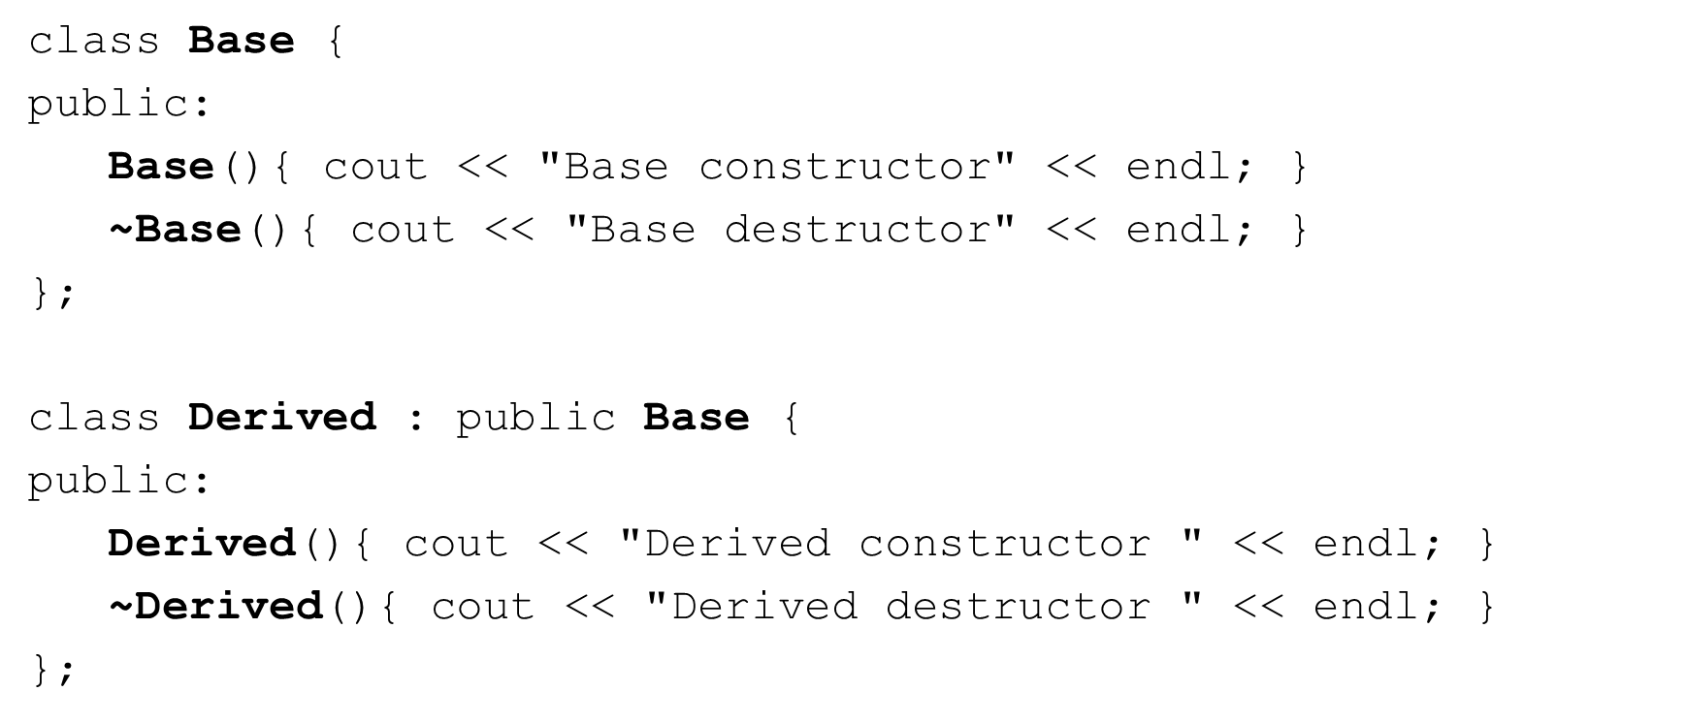

Destructors and class initialization

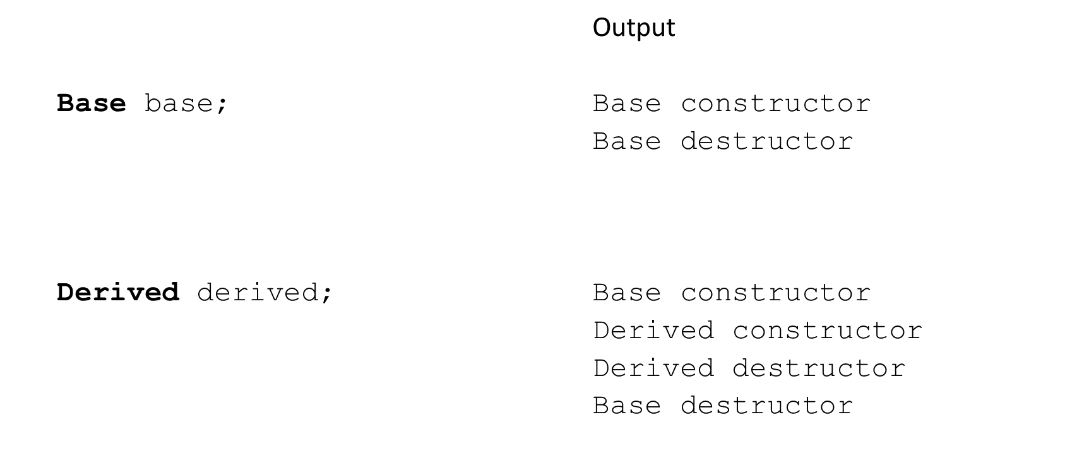

Constructors and class initialization

* A Derived class does NOT inherit
  + Base class constructors
  + Base class destructor
  + Base class overloaded assignment operators
  + Base class friend functions
* However, the derived class constructors, destructors, and overloaded assignment operators can invoke the base-class versions
* C++11 allows explicit inheritance of base ‘non-special’ constructors with
  + using Base::Base; anywhere in the derived class declaration
  + Lots of rules involved, often better to deﬁne constructors yourself
* The Base part of a Derived class must be initialized ﬁrst
* How can we control exactly which Base class constructor is used during initialization?
* We can invoke the whichever Base class constructor we wish in the initialization list of the Derived class

class Base { public:

Base();

**Base(int)**;

. . .

};

Derived::Derived(int x)

: **Base(x)**, *{optional initializers for Derived}* {

// code

}

class **Base** { int **value**;

public:

**Base**(): **value**{0} {

cout << "Base no-args constructor" << endl;

}

**Base**(int x) : **value**{x} {

cout << "int Base constructor" << endl;

}

};

class **Derived** : public **Base** { int **doubled_value**;

public:

**Derived**(): **Base**{}, **doubled_value**{0} {

cout << "Derived no-args constructor " << endl;

}

**Derived**(int x) : **Base**{x}, **doubled_value** {x*2} { cout << "int Derived constructor " << endl;

}

};

Constructors and class initialization

**Base** base;

**Base** base{100};

**Derived** derived;

**Derived** derived{100};

Output

**Base** no-args constructor int **Base** constructor

**Base** no-args constructor

**Derived** no-args constructor

int **Base** constructor int **Derived** constructor

Copy/Move constructors and overloaded operator=

* Not inherited from the Base class
* You may not need to provide your own
  + Compiler-provided versions may be just ﬁne
* We can explicitly invoke the Base class versions from the Derived class

Copy constructor

* Can invoke Base copy constructor explicitly
  + Derived object ‘*other*’ will be sliced

**Derived**::**Derived**(const **Derived** &*other*)

: **Base(other)**, {Derived initialization list}

{

// code

}

class **Base** { int **value**;

public:

// Same constructors as previous example

**Base(**const **Base** &other**) :value{other.value} {**

cout << "Base copy constructor" << endl;

}

};

class **Derived** : public **Base** { int **doubled_value**;

public:

// Same constructors as previous example

**Derived**(const **Derived** &other)

: **Base**(other), doubled_value {other.doubled_value } { cout << "Derived copy constructor " << endl;

}

};

class **Base** { int **value**;

public:

// Same constructors as previous example

**Base** &**operator=**(const **Base** &rhs) { if (this != &rhs) {

**value = rhs.value;** // assign

}

return *this;

}

};

class **Derived** : public **Base** { int **doubled_value**;

public:

// Same constructors as previous example

**Derived** &**operator=**(const **Derived** &rhs) { if (this != &rhs) {

**Base::operator=(rhs);** // Assign **Base** part

**doubled_value = rhs.doubled_value;** // Assign **Derived** part

}

return *this;

}

};

Copy/Move constructors and overloaded operator=

* Often you do not need to provide your own
* If you DO NOT not deﬁne them in Derived
  + then the compiler will create them and automatically and call the base class’s version
* If you DO provide Derived versions
  + then YOU must invoke the Base versions explicitly yourself
* Be careful with raw pointers
  + Especially if Base and Derived each have raw pointers
  + Provide them with deep copy semantics
* Derived class can directly invoke Base class methods
* Derived class can override or redeﬁne Base class methods
* Very powerful in the context of polymorphism (next section)

class **Account** { public:

void **deposit**(double amount) { balance += amount; }

};

class **Savings_Account:** public **Account** { public:

void **deposit**(double amount) { // **Redefine** Base class method amount += some_interest;

**Account::deposit(amount)**; // **invoke** call Base class method

}

};

* Binding of which method to use is done at compile time
  + Default binding for C++ is static
  + Derived class objects will use Derived::deposit
  + But, we can explicitly invoke Base::deposit from Derived::deposit
  + OK, but limited – much more powerful approach is dynamic binding which we will see in the next section

**Base** b;

b.deposit(1000.0); // **Base**::deposit

**Derived** d;

d.deposit(1000.0); // **Derived**::deposit

**Base** *ptr = new **Derived**();

ptr->deposit(1000.0); // **Base**::deposit ????

Student

Employee

Person

Staff

Department Chair

Administrator

Faculty

* + A derived class inherits from two or more Base classes at the same time
  + The Base classes may belong to unrelated class hierarchies
  + A Department Chair
    - Is-A Faculty and
    - Is-A Administrator

C++ Syntax

class **Department_Chair:**

public **Faculty,** public **Administrator** {

. . .

};

* Beyond the scope of this course
* Some compelling use-cases
* Easily misused
* Can be very complex
* What is Polymorphism?
* Using base class pointers
* Static vs. dynamic binding
* Virtual functions
* Virtual destructors
* The override and ﬁnal speciﬁers
* Using base class references
* Pure virtual functions and abstract classes
* Abstract classes as interfaces

BEGINNING C++ PROGRAMMING INHERITANCE

* What is Polymorphism?
* Using base class pointers
* Static vs. dynamic binding
* Virtual functions
* Virtual destructors
* The override and ﬁnal speciﬁers
* Using base class references
* Pure virtual functions and abstract classes
* Abstract classes as interfaces

BEGINNING C++ PROGRAMMING POLYMORPHISM

What is Polymorphism?

* Fundamental to Object-Oriented Programming
* Polymorphism
  + Compile-time / early binding / static binding
  + Run-time / late binding / dynamic binding
* Runtime polymorphism
  + Being able to assign diﬀerent meanings to the same function at run-time
* Allows us to program more abstractly
  + Think general vs. speciﬁc
  + Let C++ ﬁgure out which function to call at run-time
* Not the default in C++, run-time polymorphism is achieved via
  + Inheritance
  + Base class pointers or references
  + virtual functions

Types of Polymorphism in C++?

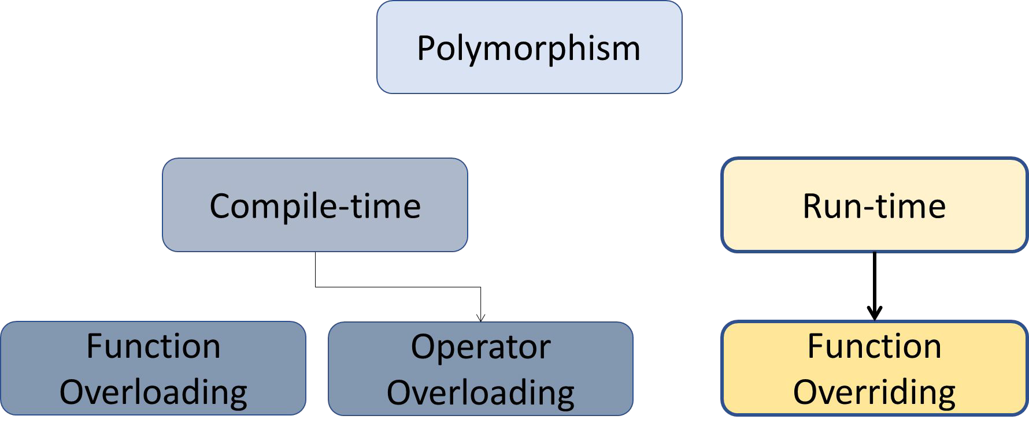

An non-polymorphic example – Static Binding

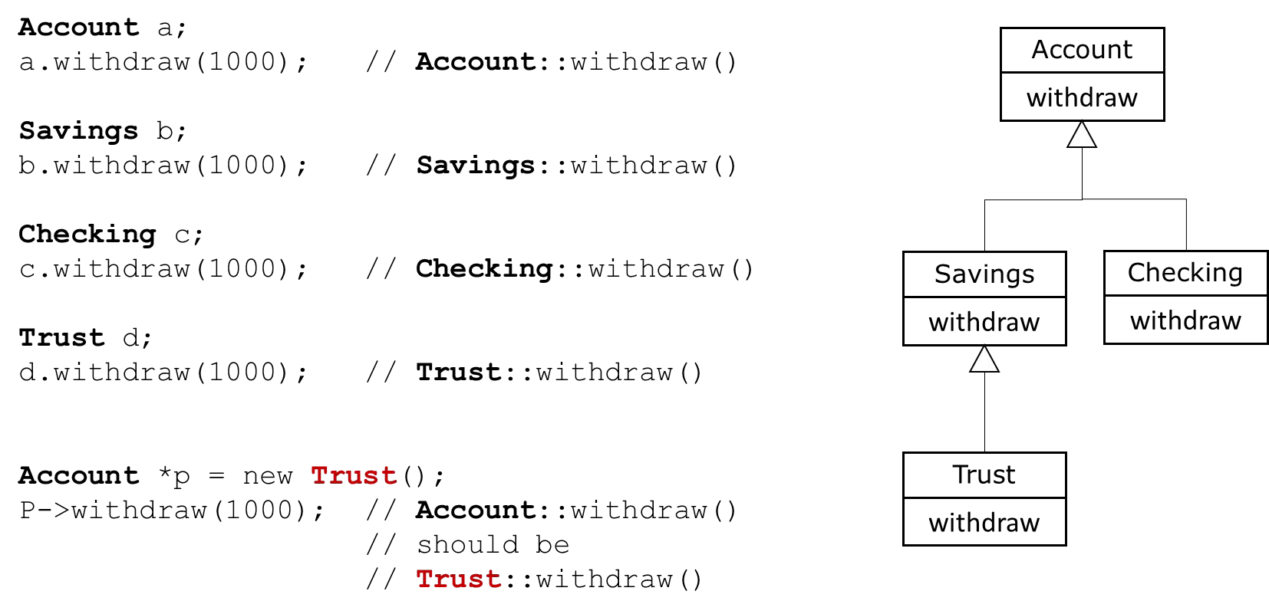

An non-polymorphic example – Static Binding

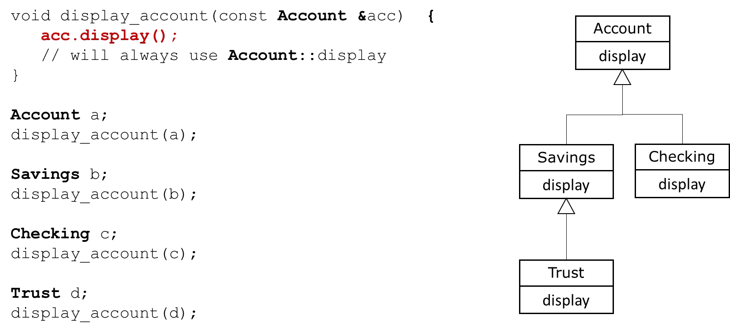

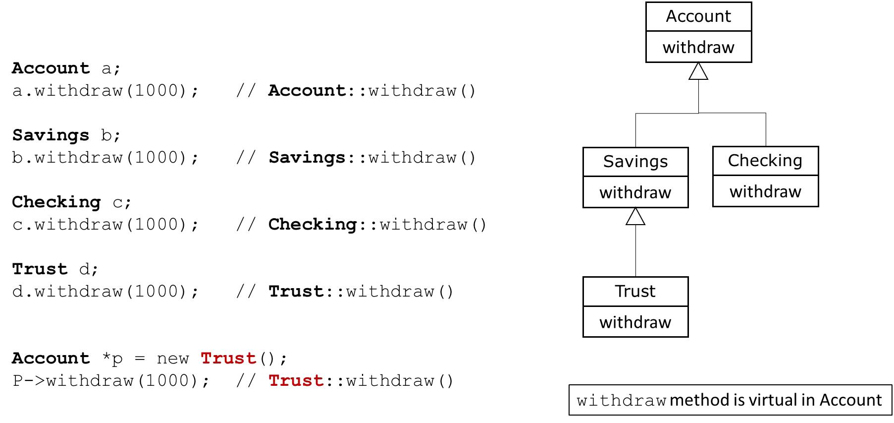A polymorphic example – Dynamic Binding

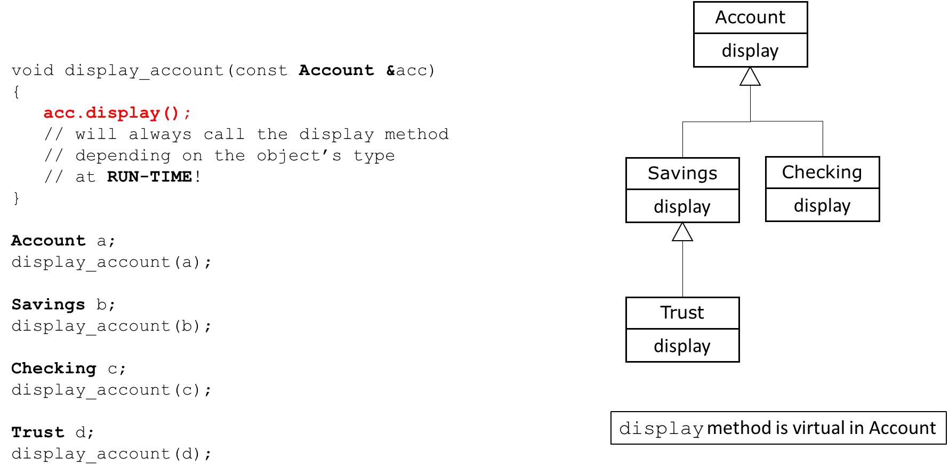A polymorphic example – Dynamic Binding

Using a Base class pointer

* For dynamic polymorphism we must have:
  + Inheritance
  + Base class pointer or Base class reference
  + virtual functions

Using a Base class pointer

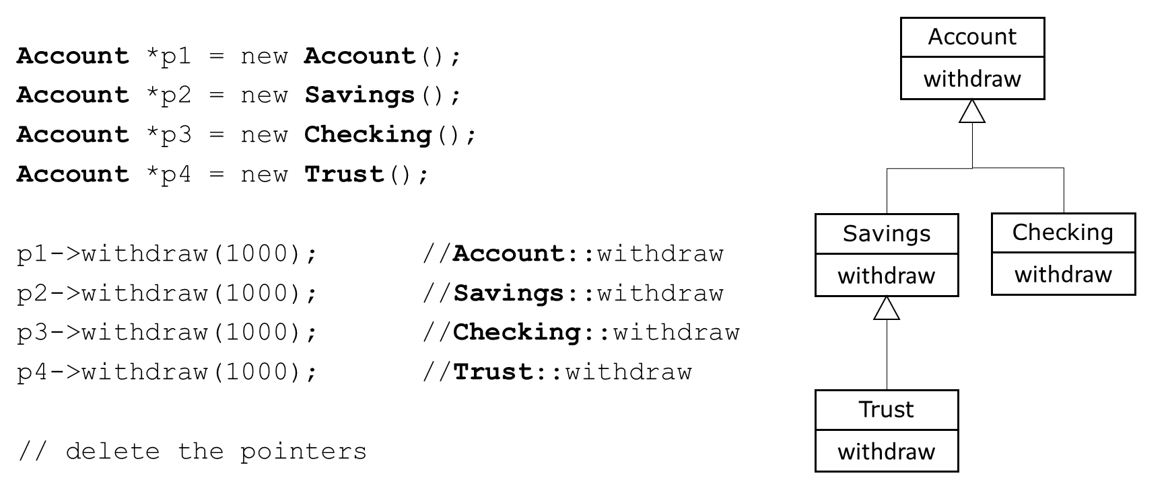

Using a Base class pointer

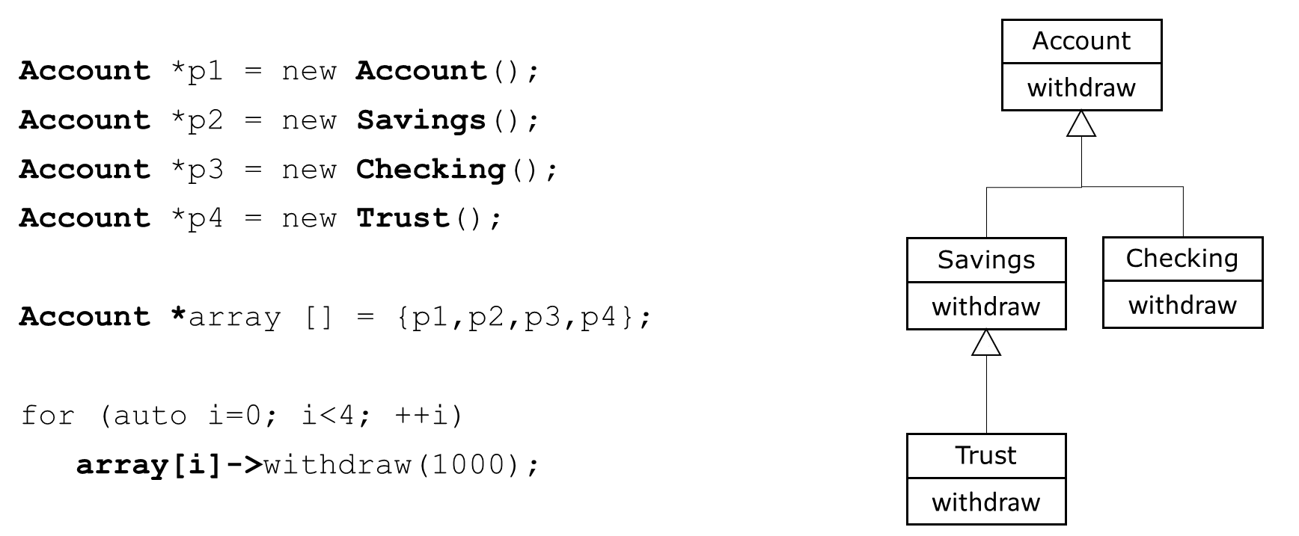

Using a Base class pointer

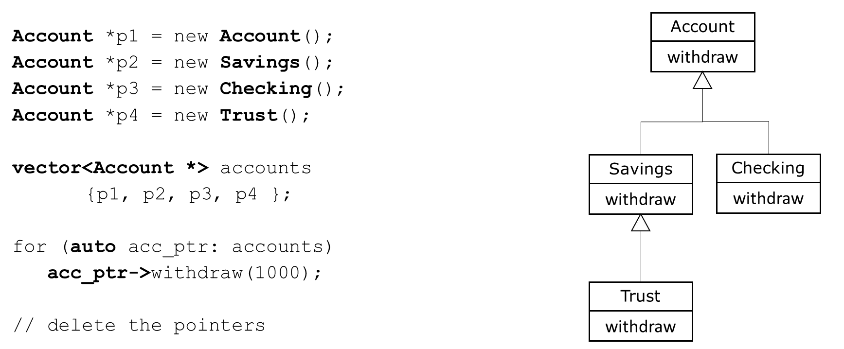

Virtual functions

* Redeﬁned functions are bound statically
* Overridden functions are bound dynamically
* Virtual functions are overridden
* Allow us to treat all objects generally as objects of the Base class

Declaring virtual functions

* Declare the function you want to override as virtual in the Base class
* Virtual functions are virtual all the way down the hierarchy from this point
* Dynamic polymorphism only via Account class pointer or reference

class **Account** { public:

**virtual** void withdraw(double amount);

. . .

};

Declaring virtual functions

* Override the function in the Derived classes
* Function signature and return type must match EXACTLY
* Virtual keyword not required but is best practice
* If you don’t provide an overridden version it is inherited from it’s base class

class **Checking :** public **Account** { public:

**virtual** void withdraw(double amount);

. . .

};

Virtual Destructors

* Problems can happen when we destroy polymorphic objects
* If a derived class is destroyed by deleting its storage via the base class pointer and the class a non-virtual destructor. Then the behavior is undeﬁned in the C++ standard.
* Derived objects must be destroyed in the correct order starting at the correct destructor

Virtual Destructors

* Solution/Rule:
  + If a class has virtual functions
  + ALWAYS provide a public virtual destructor
  + If base class destructor is virtual then all derived class destructors are also virtual

class **Account** { public:

**virtual** void withdraw(double amount);

**virtual ~Account()**;

. . .

};

The override speciﬁer

* We can override Base class virtual functions
* The function signature and return must be EXACTLY the same
* If they are diﬀerent then we have redeﬁnition NOT overriding
* Redeﬁnition is statically bound
* Overriding is dynamically bound
* C++11 provides an override speciﬁer to have the compiler ensure overriding

The override speciﬁer

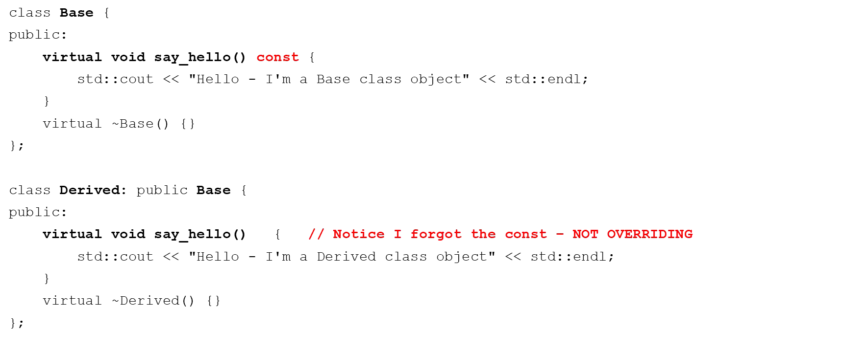

The override speciﬁer

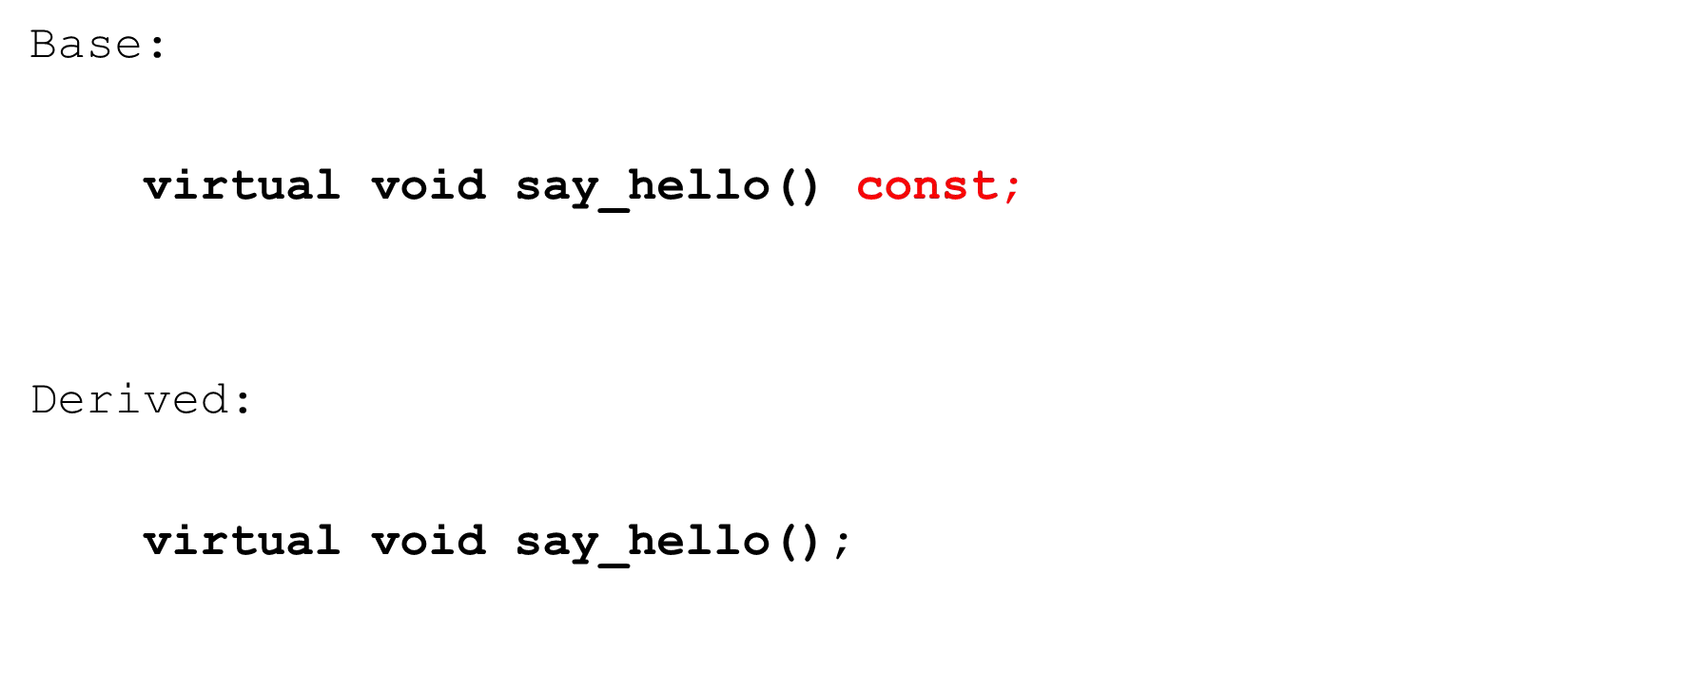

The override speciﬁer

**Base** *p1 = new **Base**();

p1->say_hello(); // "Hello - I'm a Base class object"

**Base** *p2 = new **Derived**();

p2->say_hello(); // "Hello - I'm a Base class object"

* Not what we expected
* say_hello method signatures are diﬀerent
* So Derived redeﬁnes say_hello instead of overriding it!

The override speciﬁer

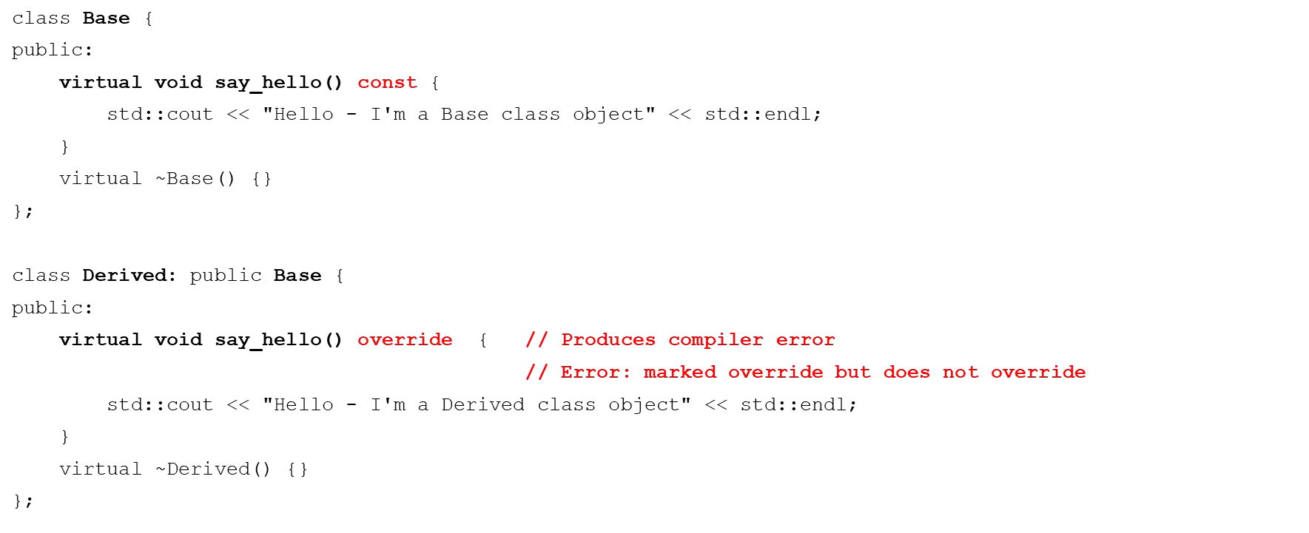

The final speciﬁer

* C++11 provides the ﬁnal speciﬁer
  + When used at the class level
  + Prevents a class from being derived from
  + When used at the method level
  + Prevents virtual method from being overridden in derived classes

final class

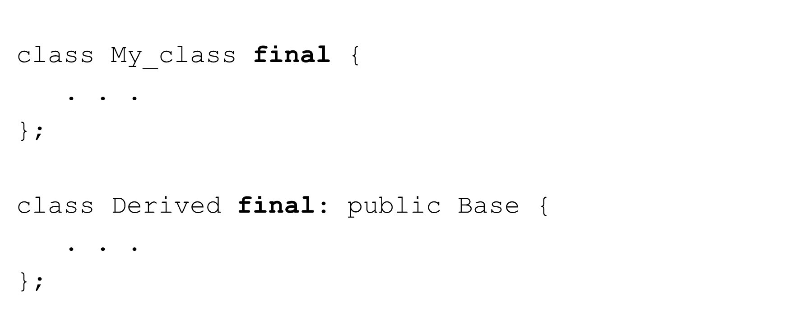

final method

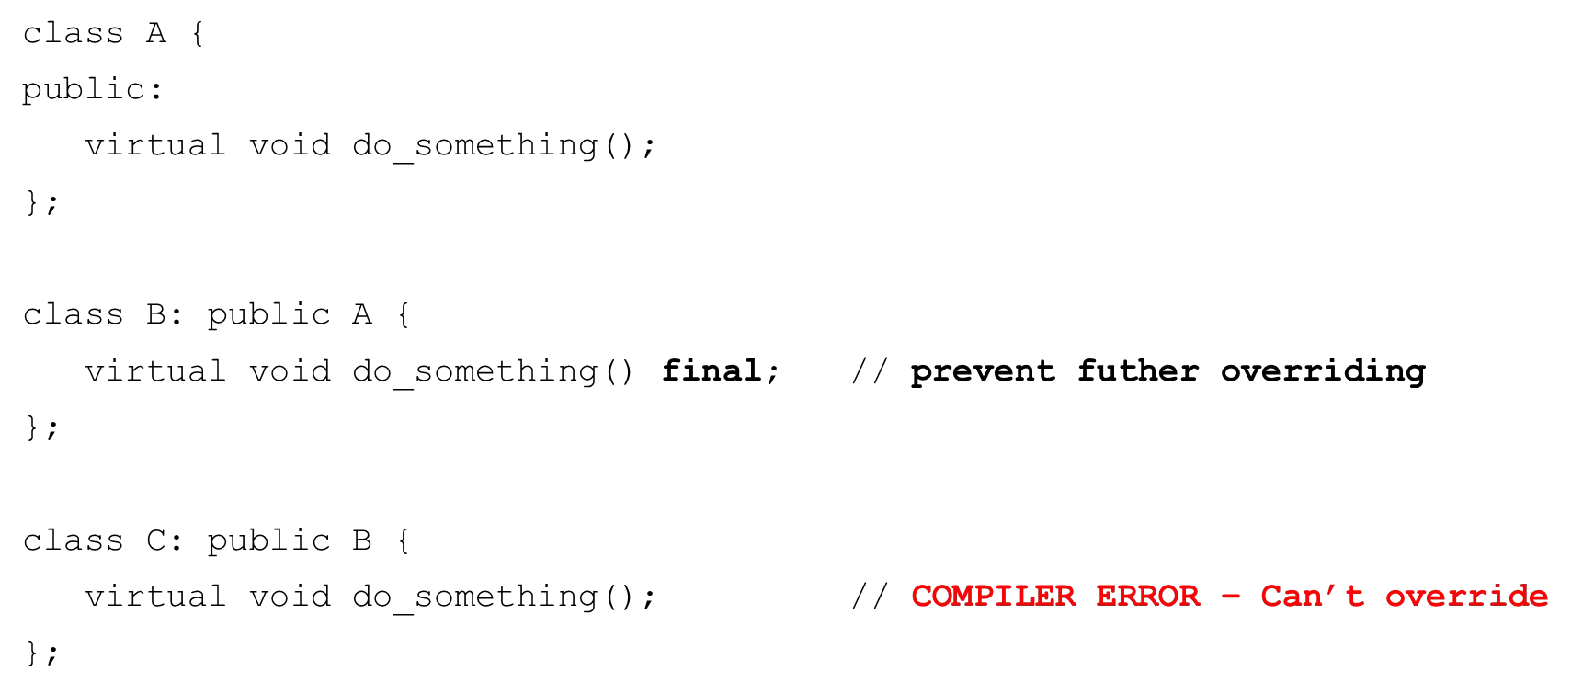

Using Base class references

* We can also use Base class references with dynamic polymorphism
* Useful when we pass objects to functions that expect a Base class reference

Using Base class references

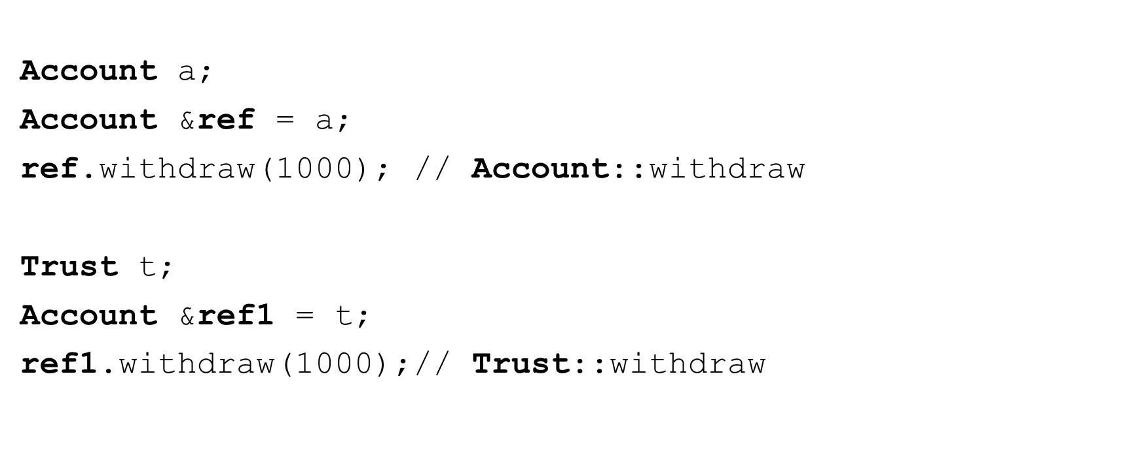

Using Base class references

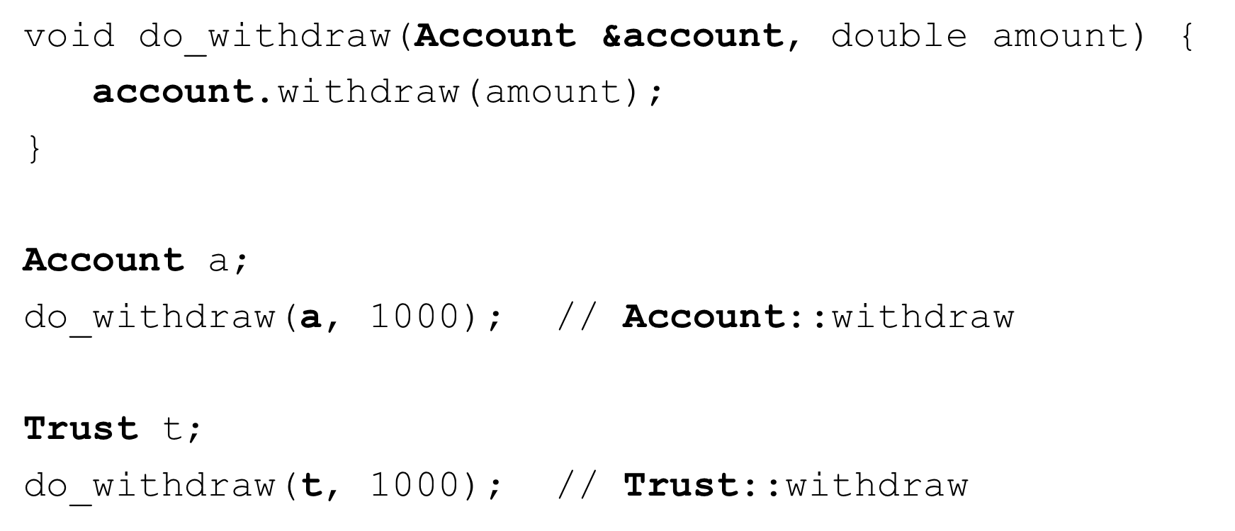

Pure virtual functions and abstract classes

* Abstract class
  + Cannot instantiate objects
  + These classes are used as base classes in inheritance hierarchies
  + Often referred to as Abstract Base Classes
* Concrete class
  + Used to instantiate objects from
  + All their member functions are deﬁned
    - Checking Account, Savings Account
    - Faculty, Staff
    - Enemy, Level Boss

Pure virtual functions and abstract classes

* Abstract base class
  + Too generic to create objects from
    - Shape, Employee, Account, Player
  + Serves as parent to Derived classes that may have objects
  + Contains at least one pure virtual function

Pure virtual functions and abstract classes

* Pure virtual function
  + Used to make a class abstract
  + Speciﬁed with “=0” in its declaration

virtual void function() **= 0**; // pure virtual function

* + Typically do not provide implementations

Pure virtual functions and abstract classes

* Pure virtual function
  + Derived classes MUST override the base class
  + If the Derived class does not override then the Derived class is also abstract
  + Used when it doesn't make sense for a base class to have an implementation
    - But concrete classes must implement it

virtual void draw() = 0; // Shape virtual void defend() = 0; // Player

Pure virtual functions and abstract classes

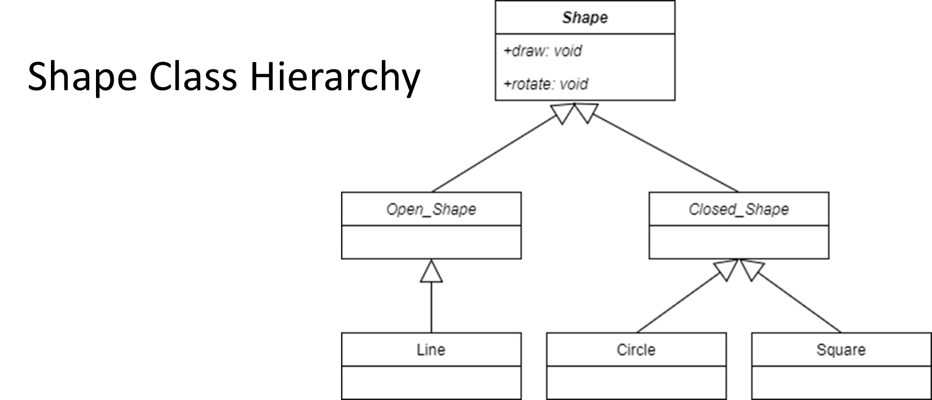

Pure virtual functions and abstract classes

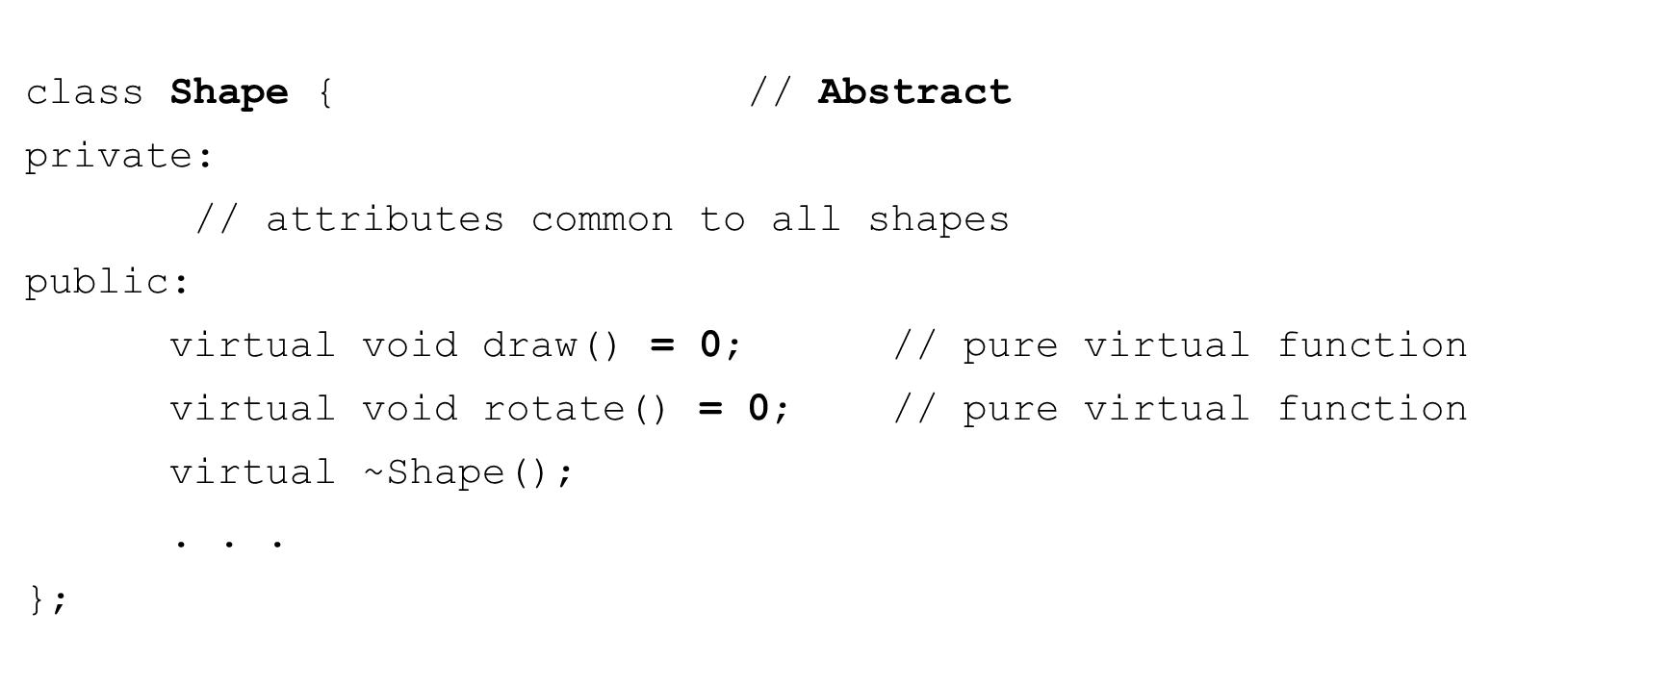

Pure virtual functions and abstract classes

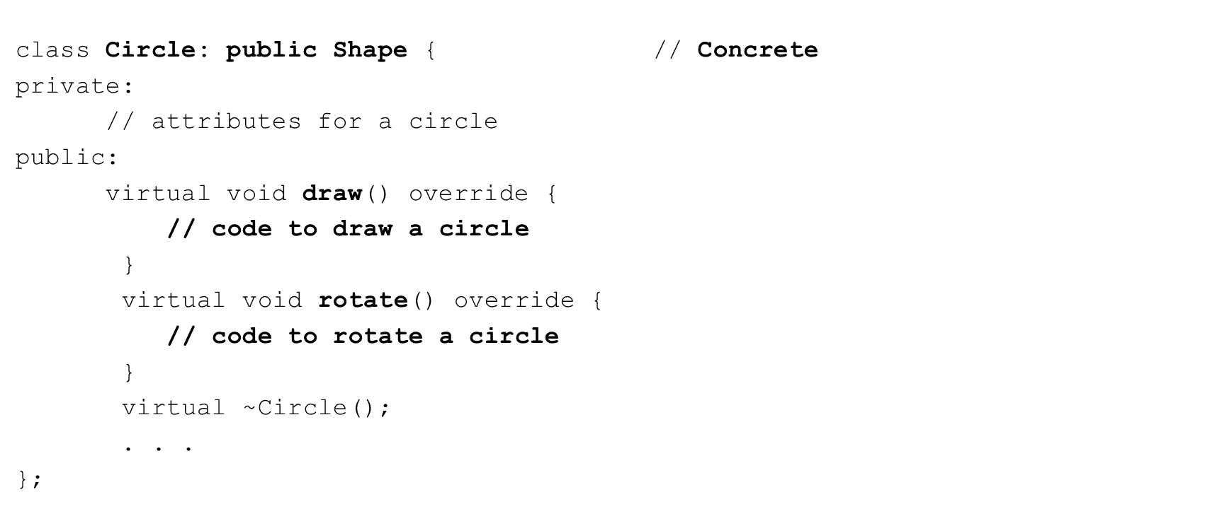

Pure virtual functions and abstract classes Abstract Base class

* Cannot be instantiated

Shape shape; // Error

Shape *ptr = new **Shape**(); // Error

* We can use pointers and references to dynamically refer to concrete classes derived from them

**Shape** *ptr = new **Circle**(); ptr->**draw**();

ptr->**rotate**();

What is using a class as an interface?

* An abstract class that has only pure virtual functions
* These functions provide a general set of services to the user of the class
* Provided as public
* Each subclass is free to implement these services as needed
* Every service (method) must be implemented
* The service type information is strictly enforced

A Printable example

* C++ does not provide true interfaces
* We use abstract classes and pure virtual functions to achieve it
* Suppose we want to be able to provide Printable support for any object we wish without knowing it’s implementation at compile time

std::cout << **any_object** << std::endl;

* + any_object must conform to the Printable interface

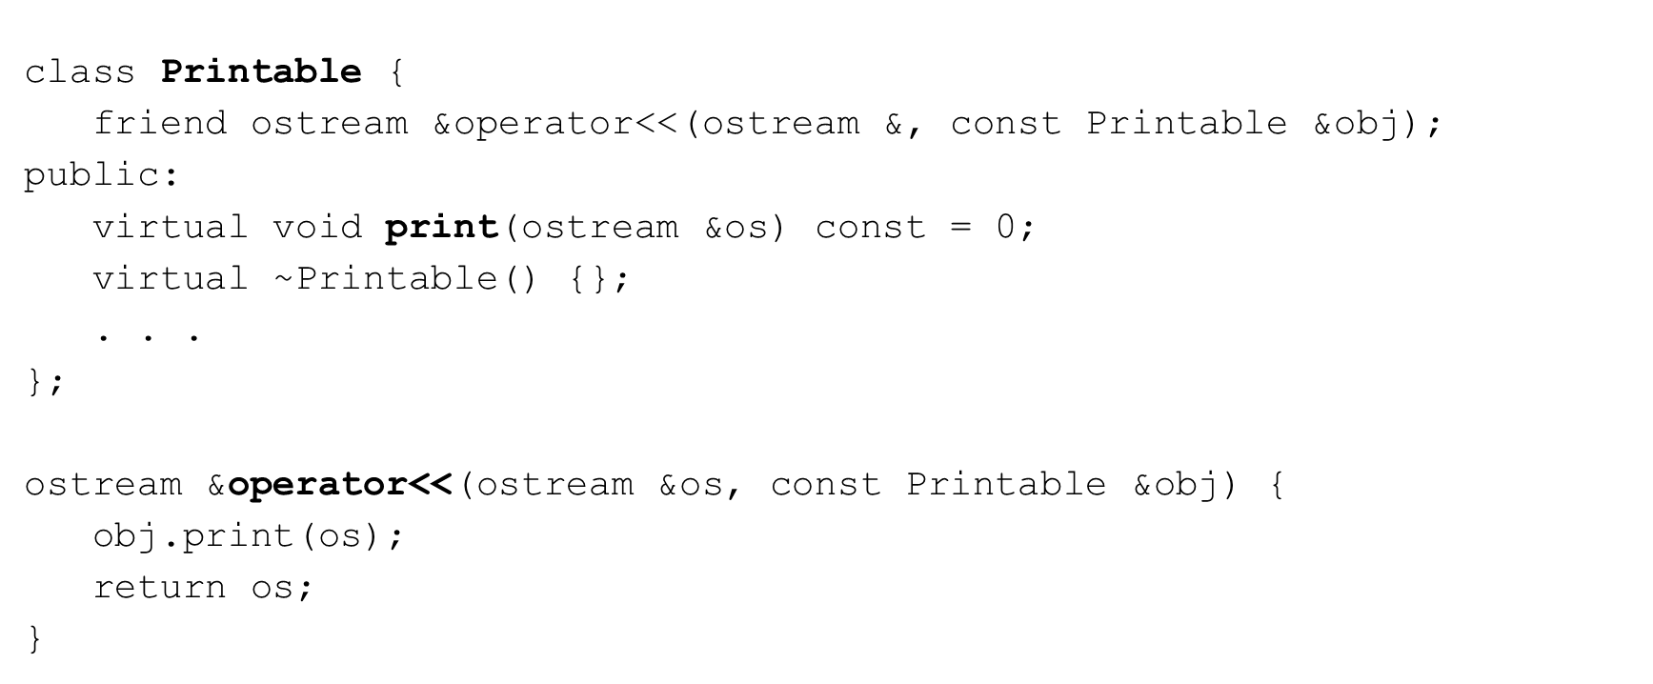An Printable example

An Printable example

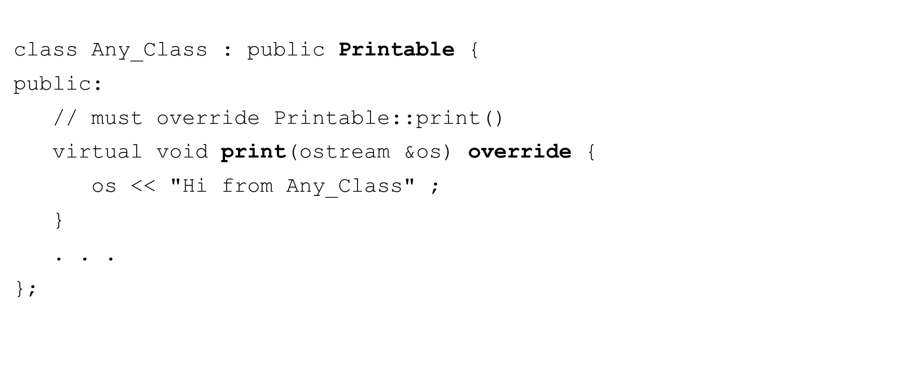

An Printable example

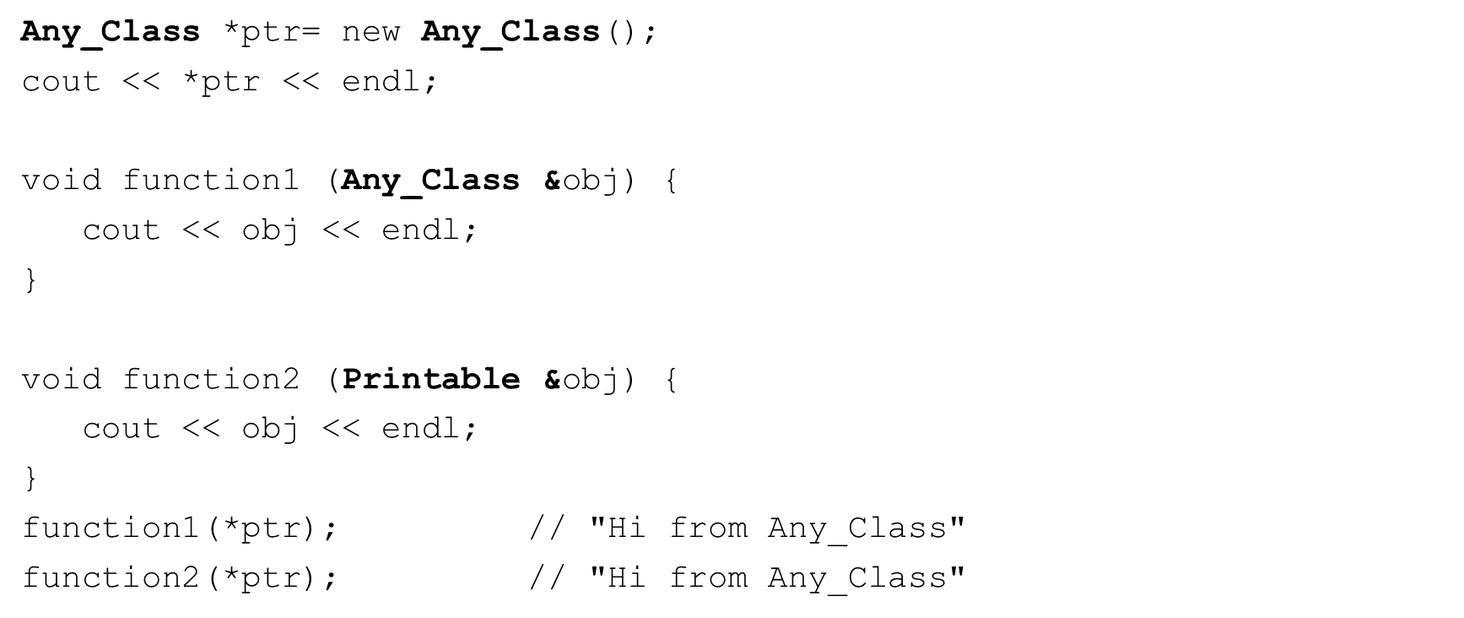

A Shapes example

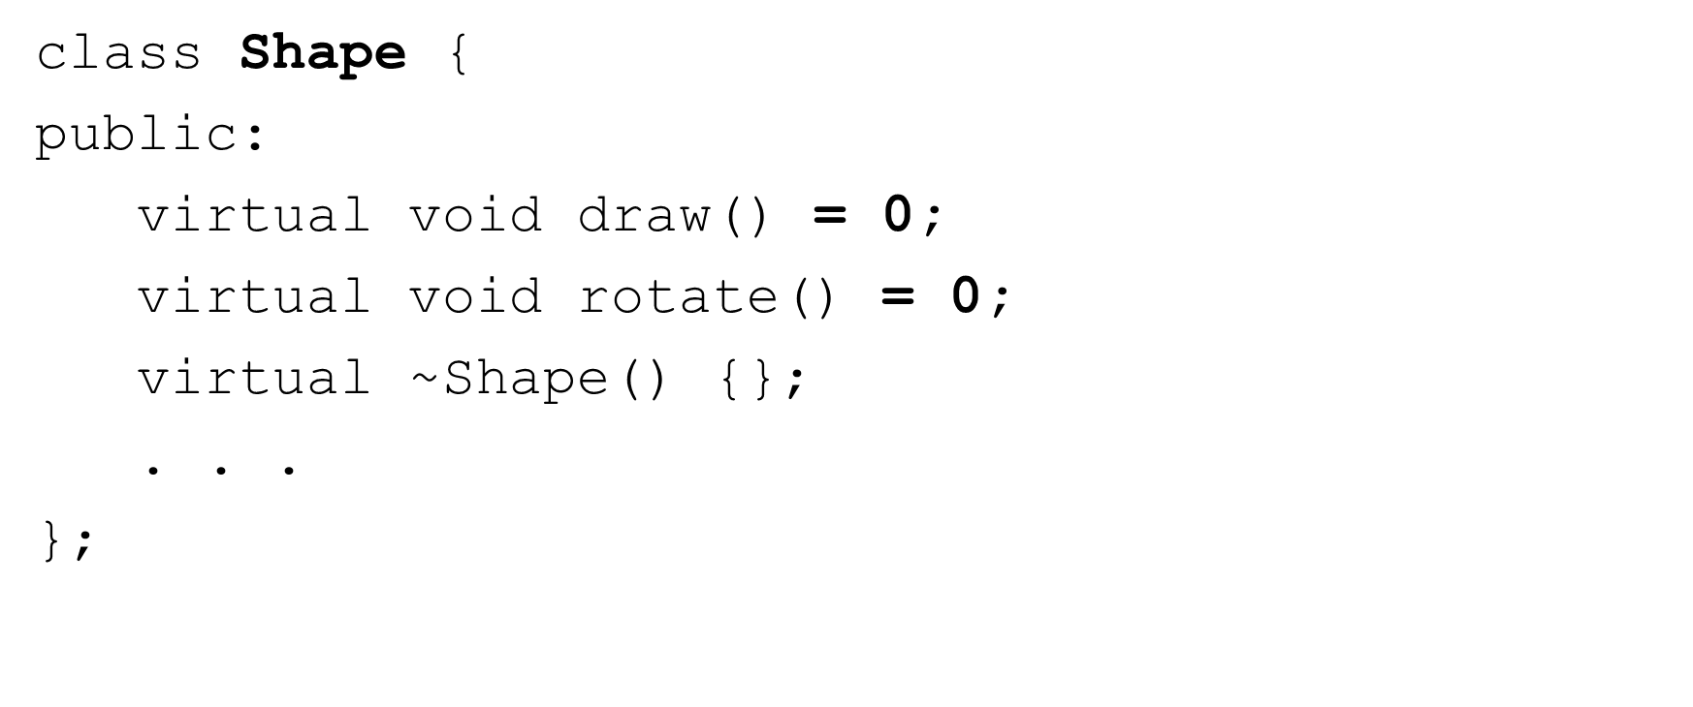

A Shapes example

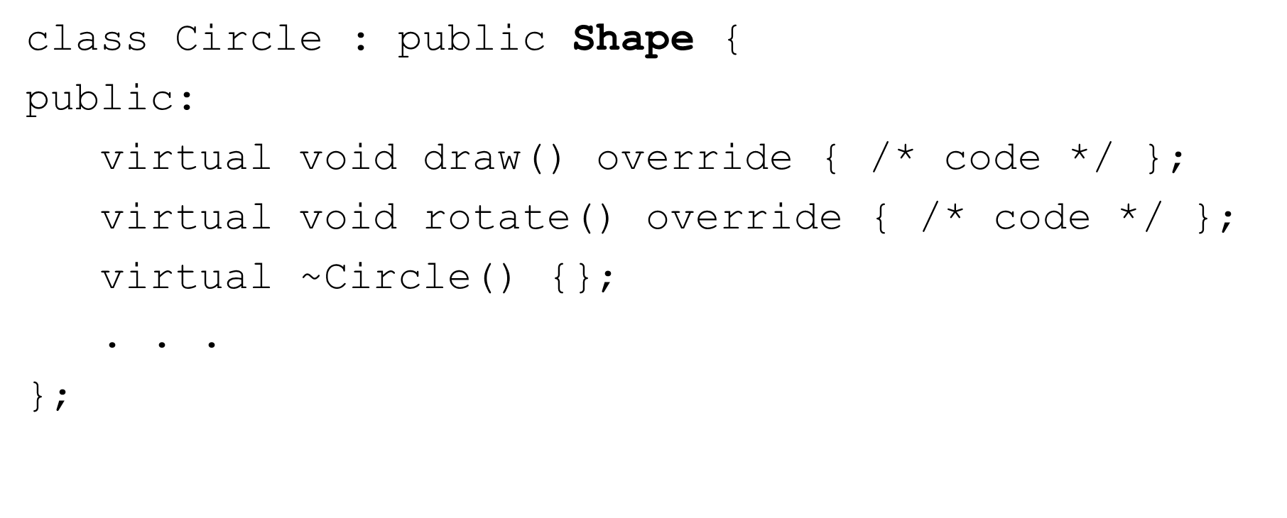

A Shapes example

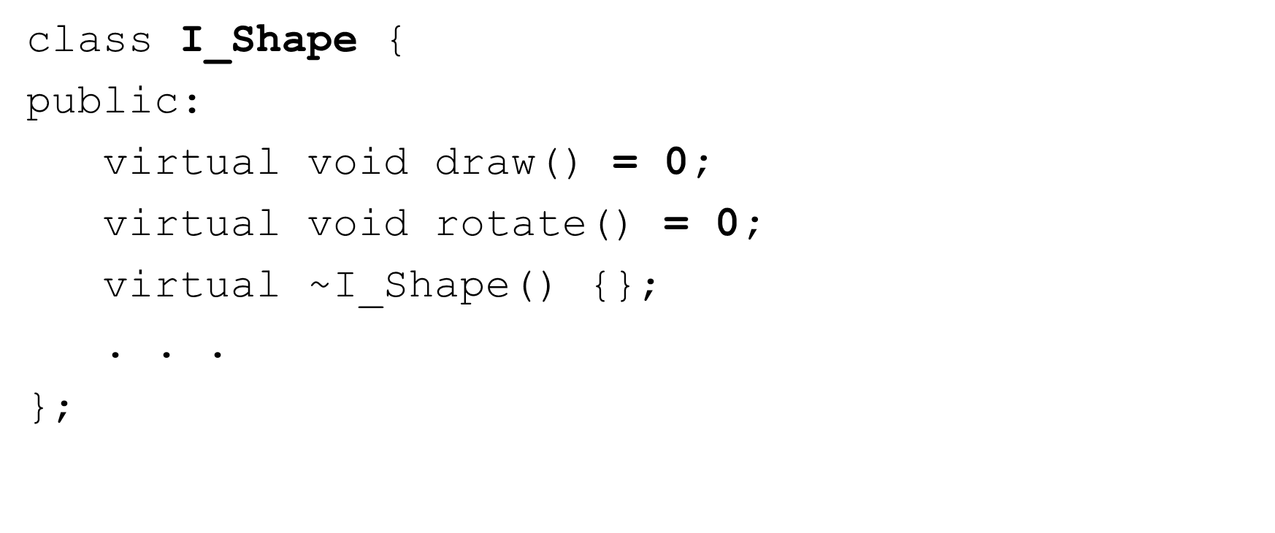

A Shapes example

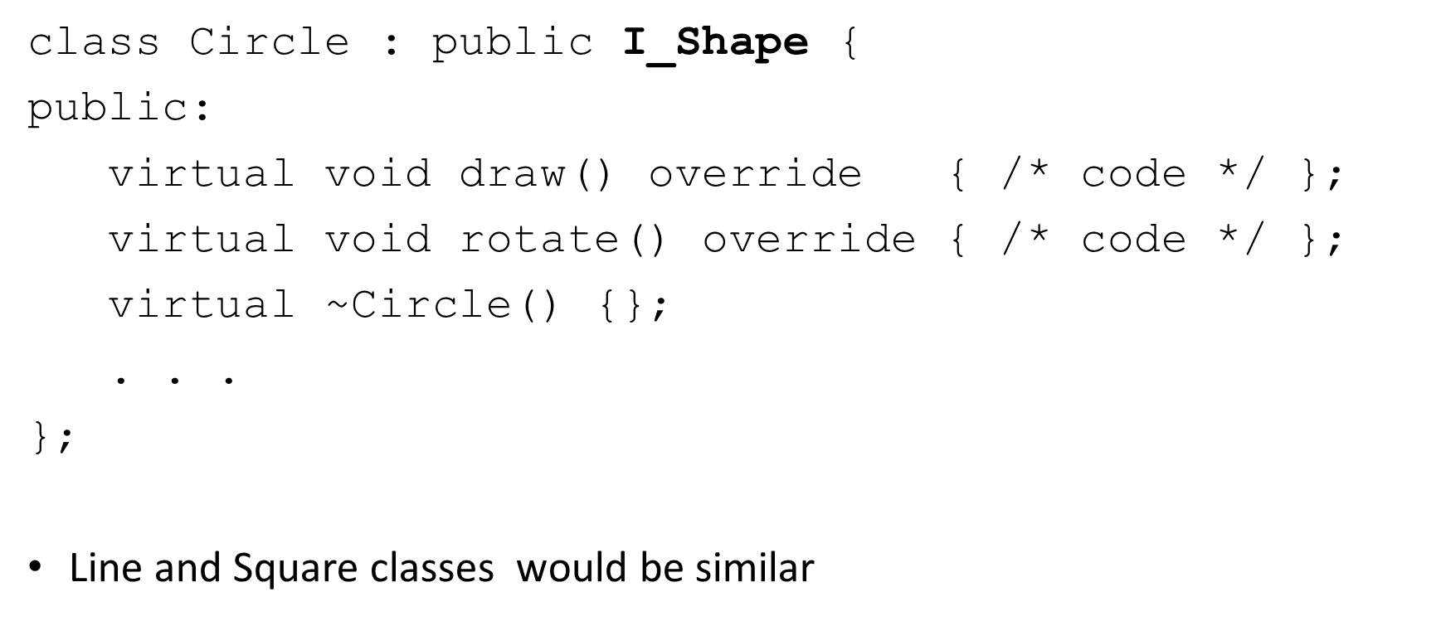

A Shapes example

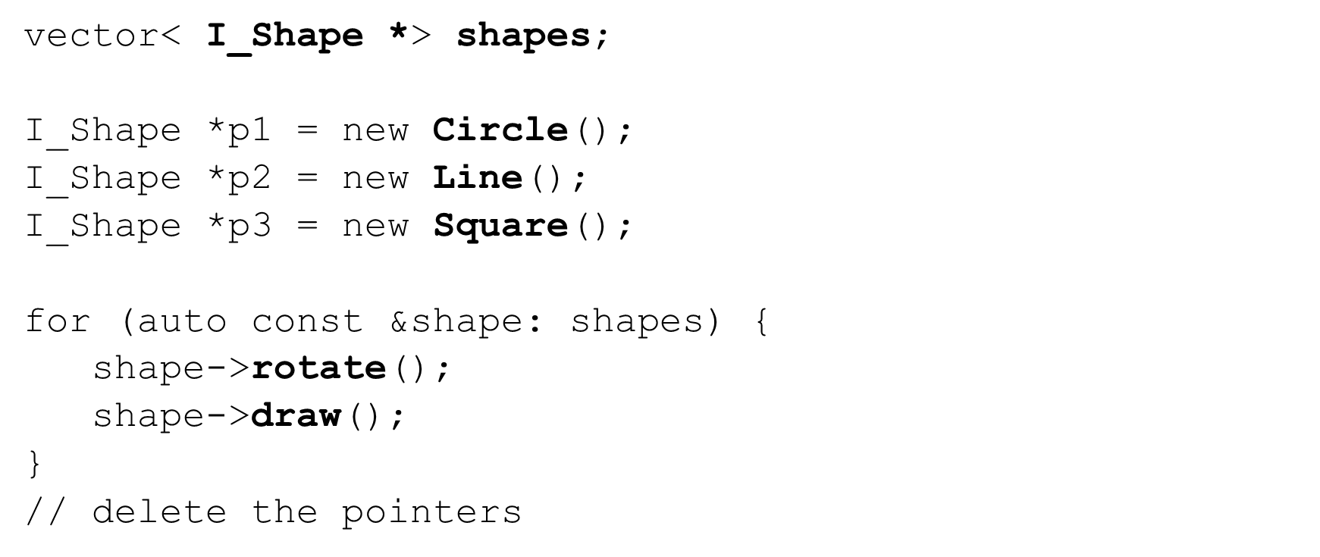

## Section Overview

Smart Pointers

* Issues with raw pointers
* What are smart pointers?
* Concept of ownership and RAII
* C++ Smart Pointers
  + Unique pointers (unique_ptr)
  + Shared pointers (shared_ptr)
  + Weak pointers (weak_ptr)
* Custom deleters

Issues with Raw Pointers

* C++ provides absolute ﬂexibility with memory management
  + Allocation
  + Deallocation
  + Lifetime management
* Some potentially serious problems
  + Uninitialized (wild) pointers
  + Memory leaks
  + Dangling pointers
  + Not exception safe
* Ownership?
  + Who owns the pointer?
  + When should a pointer be deleted?

What are they?

* Objects
* Can only point to heap-allocated memory
* Automatically call delete when no longer needed
* Adhere to RAII principles
* C++ Smart Pointers
  + Unique pointers (unique_ptr)
  + Shared pointers (shared_ptr)
  + Weak pointers (weak_ptr)
  + Auto pointers (auto_ptr) Deprecated – we will not discuss

What are they?

* #include <memory>
* Deﬁned by class templates
  + Wrapper around a raw pointer
  + Overloaded operators
    - Dereference (*)
    - Member selection (->)
    - Pointer arithmetic not supported (++, --, etc.)
  + Can have custom deleters

A simple example

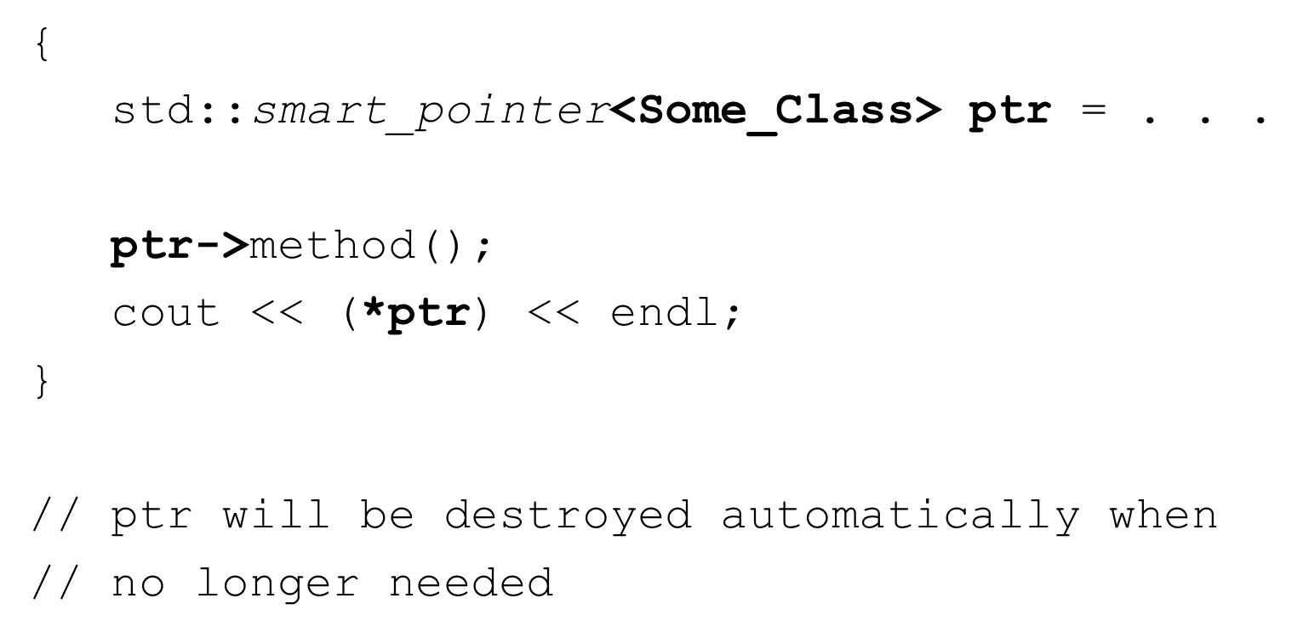

RAII – Resource Acquisition Is Initialization

* Common idiom or pattern used in software design based on container object lifetime
* RAII objects are allocated on the stack
* Resource Acquisition
  + Open a ﬁle
  + Allocate memory
  + Acquire a lock
* Is Initialization
  + The resource is acquired in a constructor
* Resource relinquishing
  + Happens in the destructor
    - Close the ﬁle
    - Deallocate the memory
    - Release the lock

unique_ptr

* Simple smart pointer – very eﬃcient!
* unique_ptr<T>
  + Points to an object of type T on the heap
  + It is unique – there can only be one unique_ptr<T> pointing to the object on the heap
  + Owns what it points to
  + Cannot be assigned or copied
  + CAN be moved
  + When the pointer is destroyed, what it points to is automatically destroyed

unique_ptr – creating, initializing and using

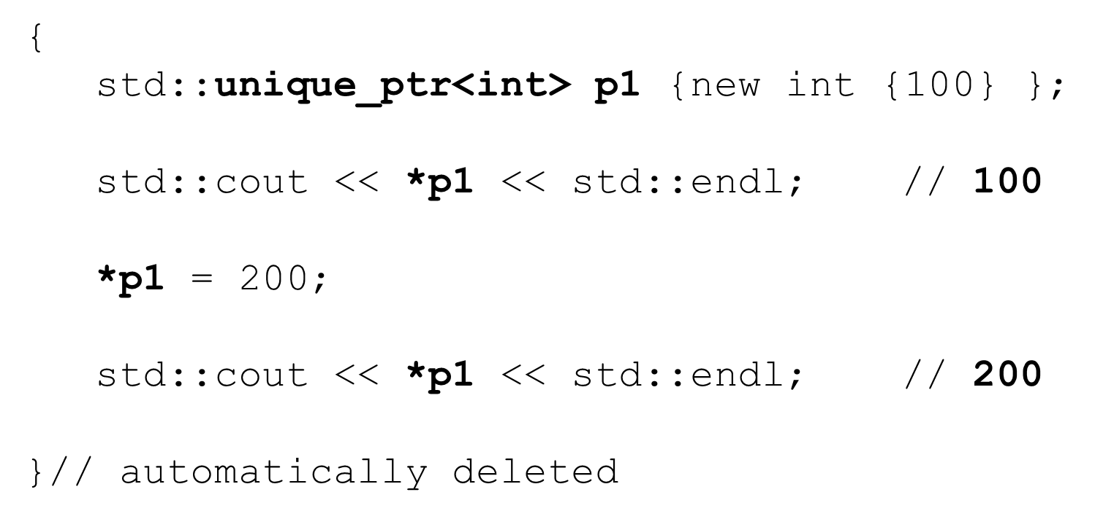

unique_ptr – some other useful methods

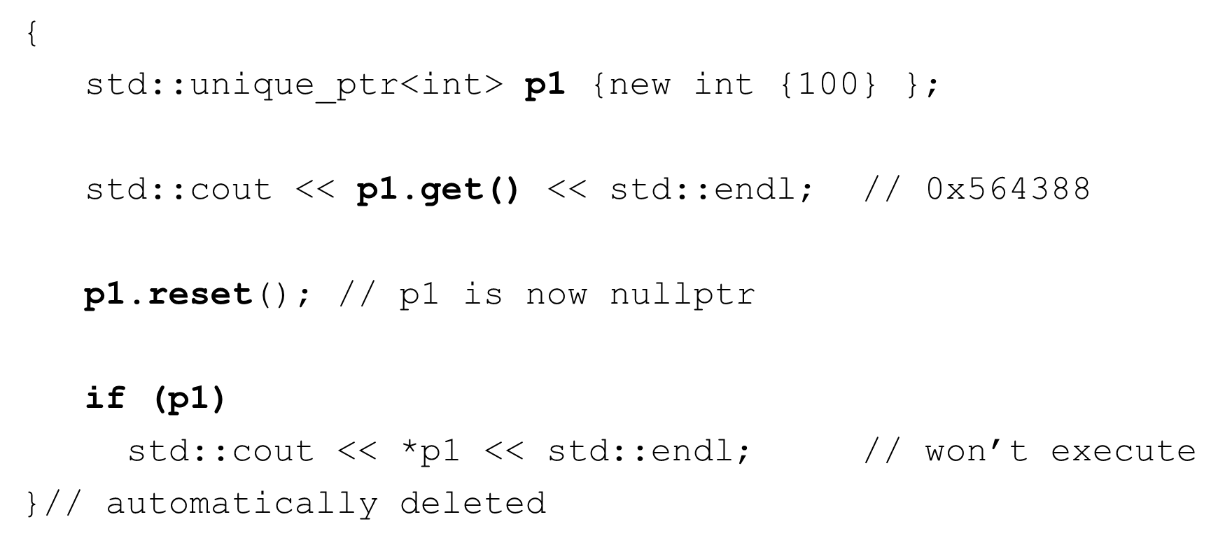

unique_ptr – user deﬁned classes

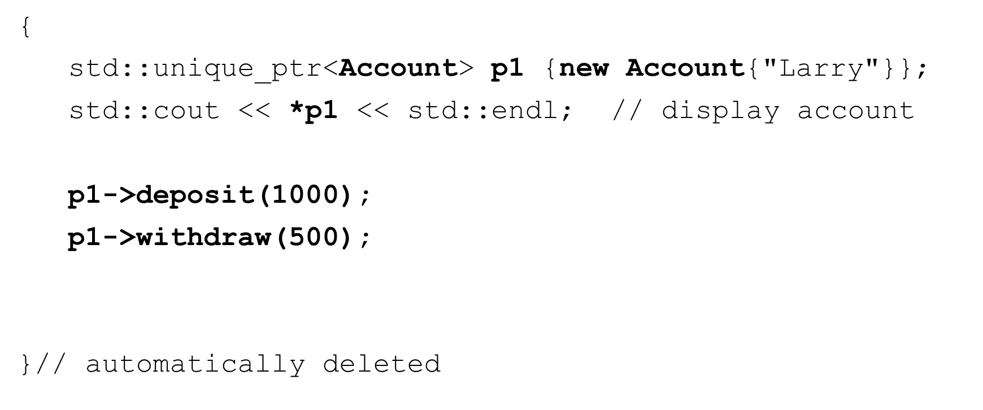

unique_ptr – vectors and move

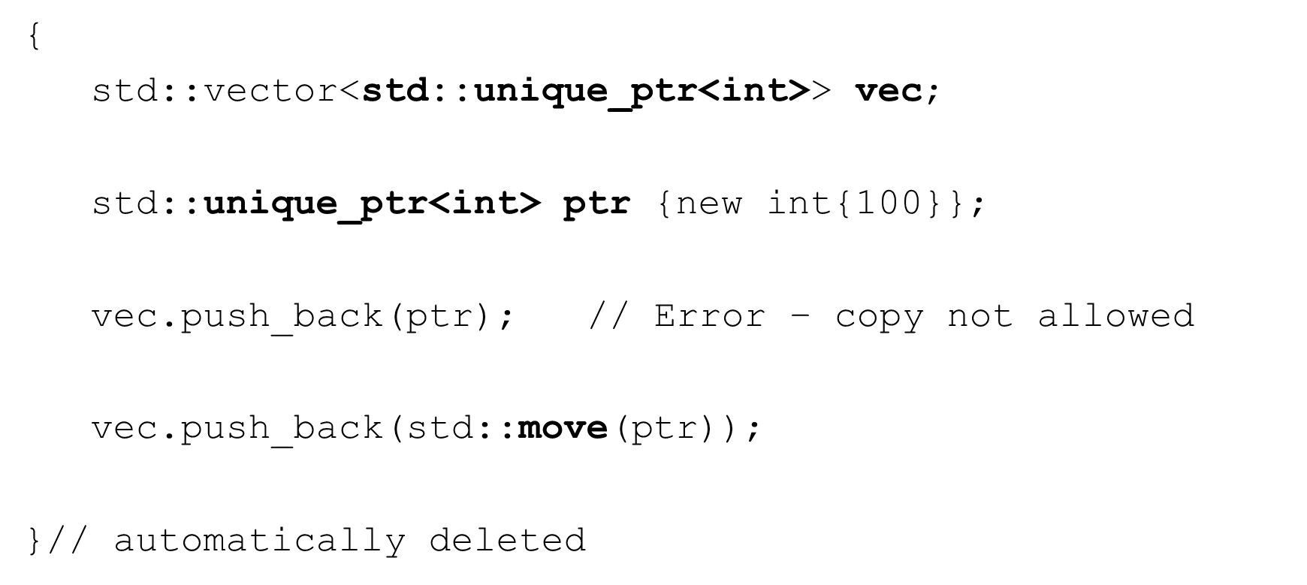

unique_ptr – make_unique (C++14)

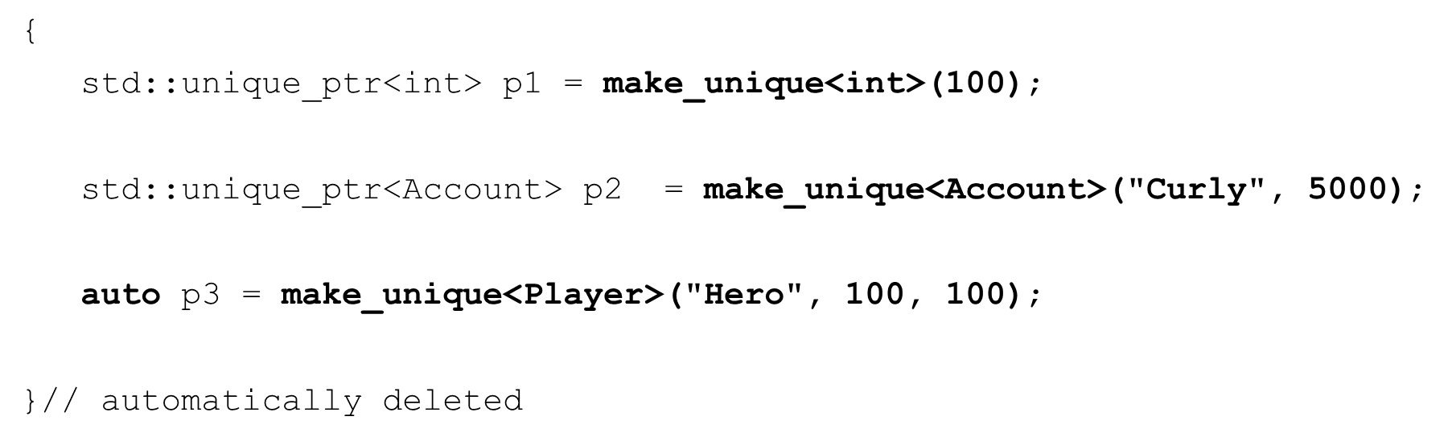

More eﬃcient – no calls to new or delete

shared_ptr

* Provides shared ownership of heap objects
* shared_ptr<T>
  + Points to an object of type T on the heap
  + It is not unique – there can many shared_ptrs pointing to the same object on the heap
  + Establishes shared ownership relationship
  + CAN be assigned and copied
  + CAN be moved
  + Doesn’t support managing arrays by default
  + When the use count is zero, the managed object on the heap is destroyed

shared_ptr – creating, initializing and using

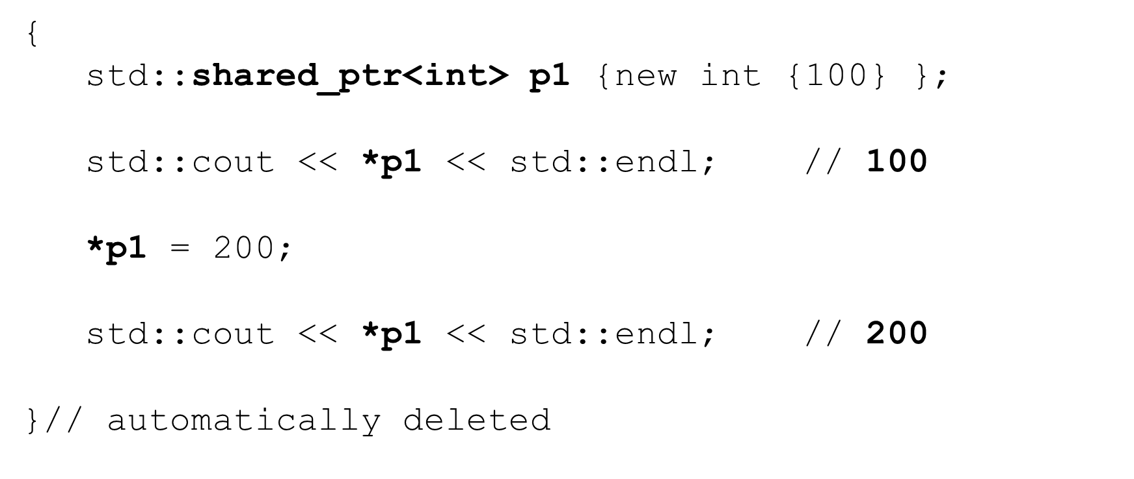

shared_ptr – some other useful methods

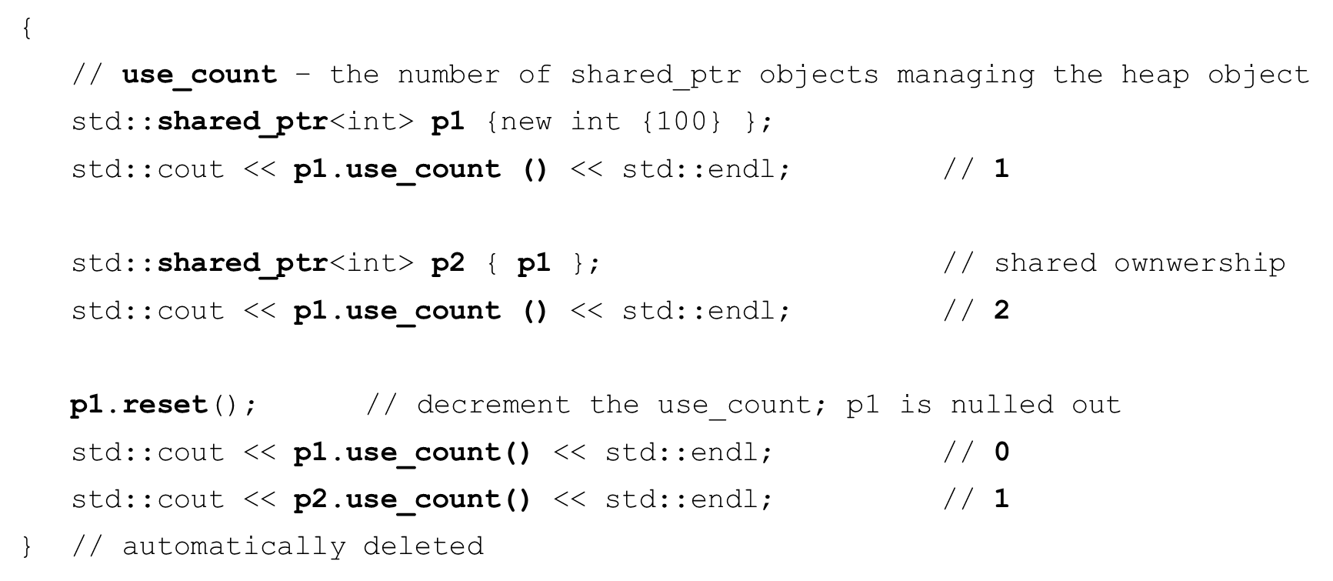

shared_ptr – user deﬁned classes

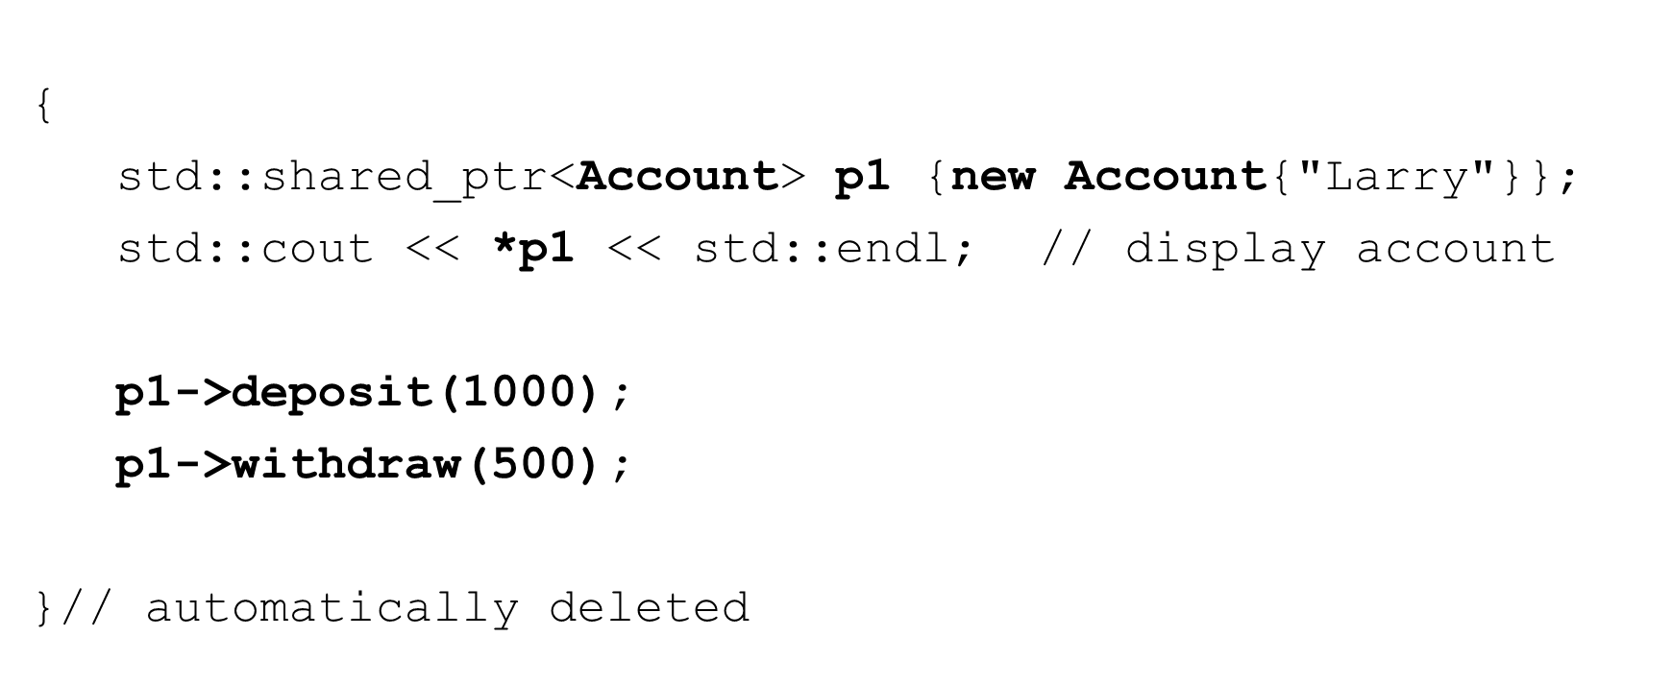

shared_ptr – vectors and move

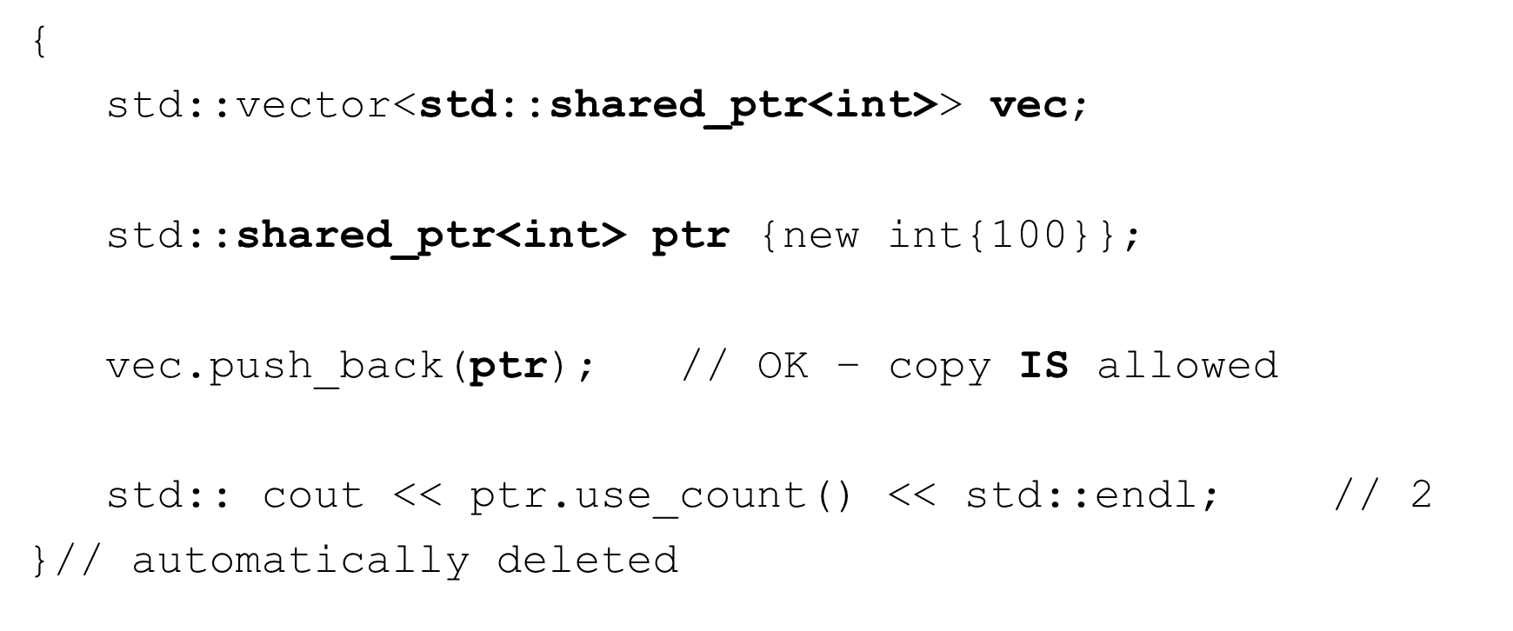

shared_ptr – make_shared (C++11)

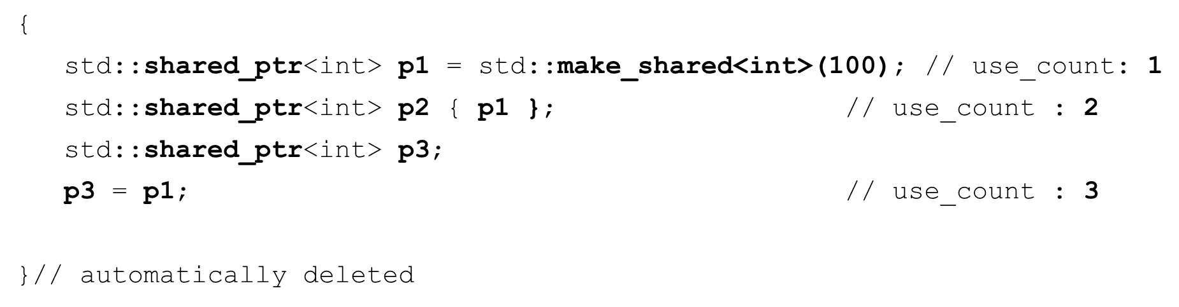

* Use std::make_shared – it’s more eﬃcient!
* All 3 pointers point to the SAME object on the heap!
* When the use_count becomes 0 the heap object is deallocated

weak_ptr

* Provides a non-owning “weak” reference
* weak_ptr<T>
  + Points to an object of type T on the heap
  + Does not participate in owning relationship
  + Always created from a shared_ptr
  + Does NOT increment or decrement reference use count
  + Used to prevent strong reference cycles which could prevent objects from being deleted

weak_ptr – circular or cyclic reference

* A refers to B
* B refers to A
* Shared strong ownership prevents heap deallocation

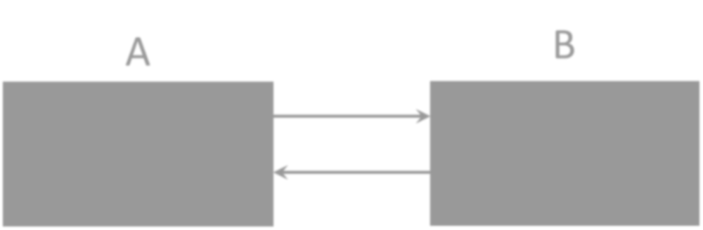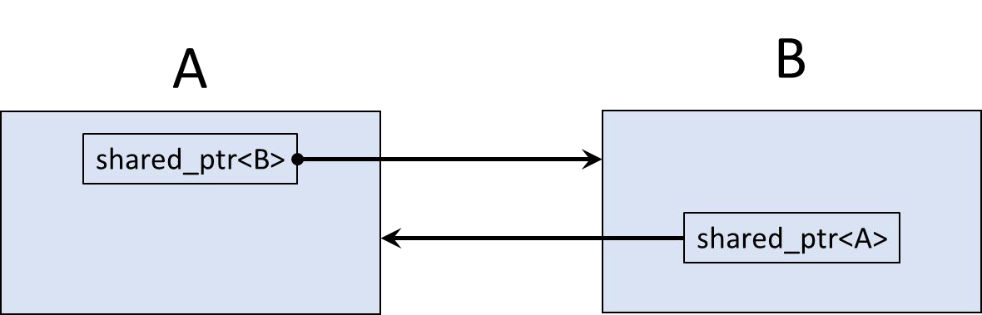

weak_ptr – circular or cyclic reference

* Solution – make one of the pointers non-owning or ‘weak’
* Now heap storage is deallocated properly

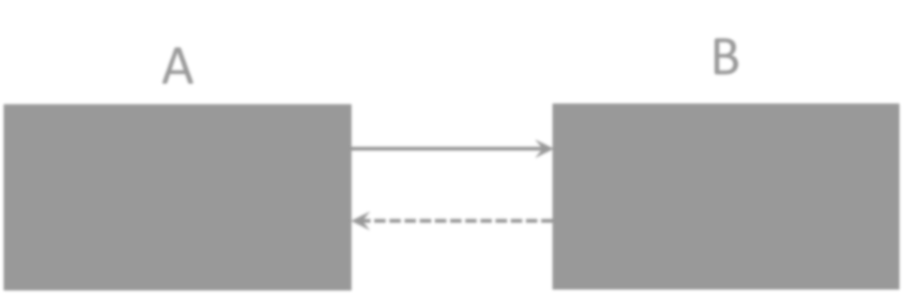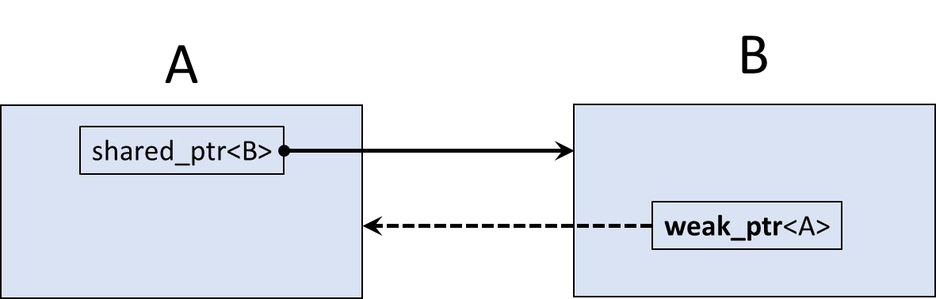

Custom deleters

* Sometimes when we destroy a smart pointer we need more than to just destroy the object on the heap
* These are special use-cases
* C++ smart pointers allow you to provide custom deleters
* Lots of way to achieve this
  + Functions
  + Lambdas
  + Others. . .

Custom deleters - function

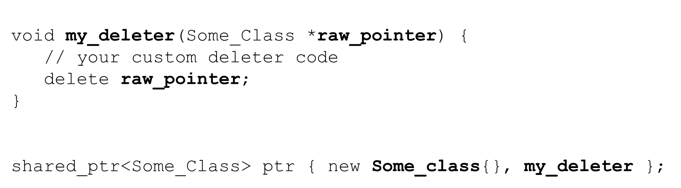

Custom deleters - function

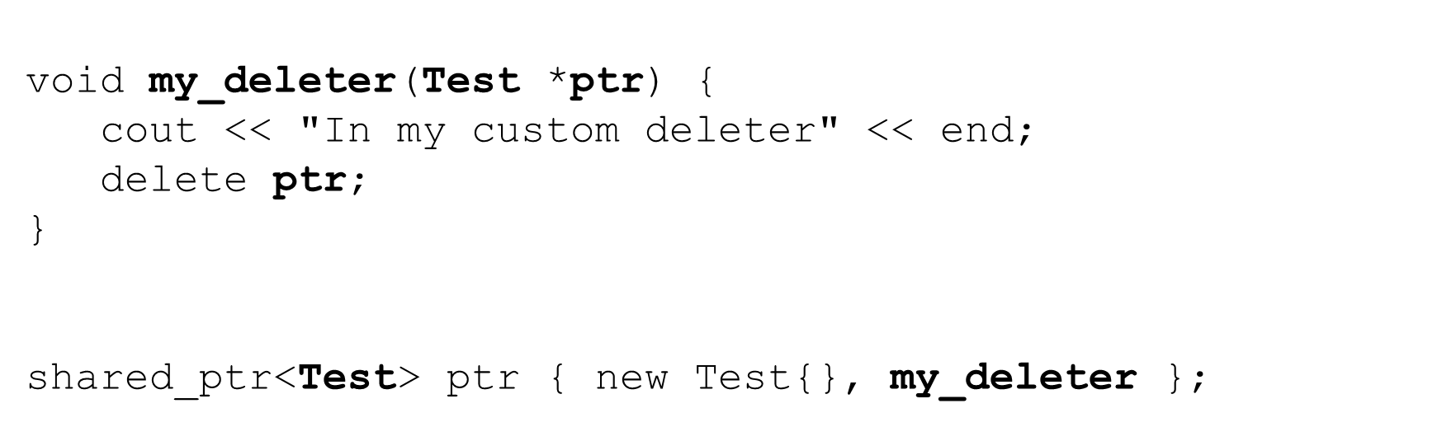

Custom deleters - lambda

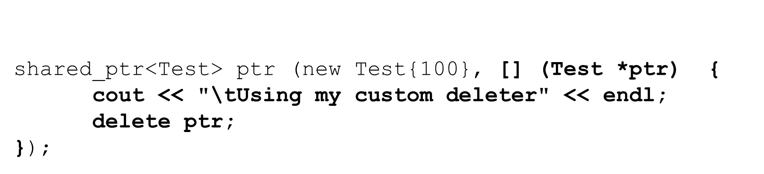

## Section Overview

Exception Handling

* What is an Exception?
* What is Exception Handling?
* What do we throw and catch exceptions?
* How does it aﬀect ﬂow of control?
* Deﬁning our own exception classes
* The Standard Library Exception Hierarchy
  + std::exception and what()

Basic concepts

* Exception handling
  + dealing with extraordinary situations
  + indicates that an extraordinary situation has been detected or has occurred
  + program can deal with the extraordinary situations in a suitable manner
* What causes exceptions?
  + insuﬃcient resources
  + missing resources
  + invalid operations
  + range violations
  + underﬂows and overﬂows
  + Illegal data and many others
* Exception safe
  + when your code handles exceptions

Terminology

* Exception
  + an object or primitive type that signals that an error has occurred
* Throwing an exception (raising an exception)
  + your code detects that an error has occurred or will occur
  + the place where the error occurred may not know how to handle the error
  + code can throw an exception describing the error to another part of the program that knows how to handle the error
* Catching an exception (handle the exception)
  + code that handles the exception
  + may or may not cause the program to terminate

C++ Syntax

* throw
  + throws an exception
  + followed by an argument
* try { code that may throw an exception }
  + you place code that may throw an exception in a try block
  + if the code throws an exception the try block is exited
  + the thrown exception is handled by a catch handler
  + if no catch handler exists the program terminates
* catch(Exception ex) { code to handle the exception }
  + code that handles the exception
  + can have multiple catch handlers
  + may or may not cause the program to terminate

Divide by zero example

* What happens if total is zero?
  + crash, overﬂow?
  + it depends

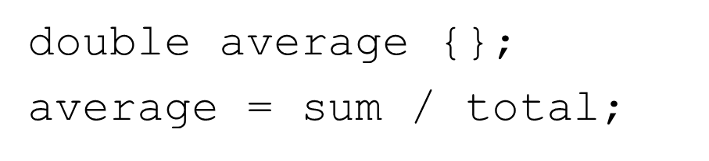

Divide by zero example

* What happens if total is zero?
  + crash, overﬂow?
  + it depends

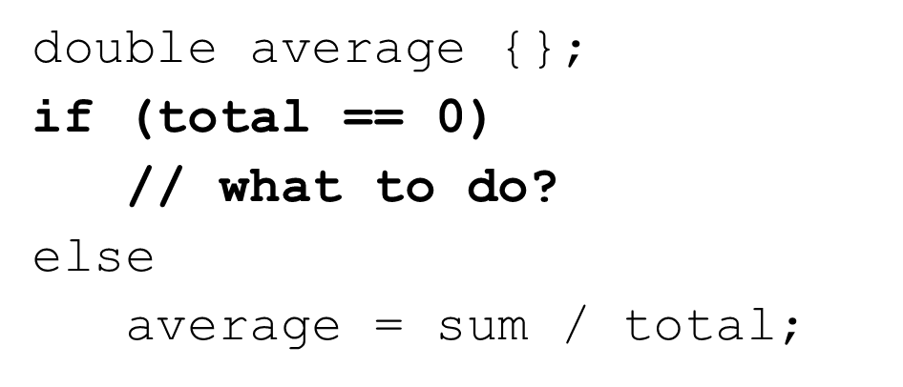

Divide by zero example

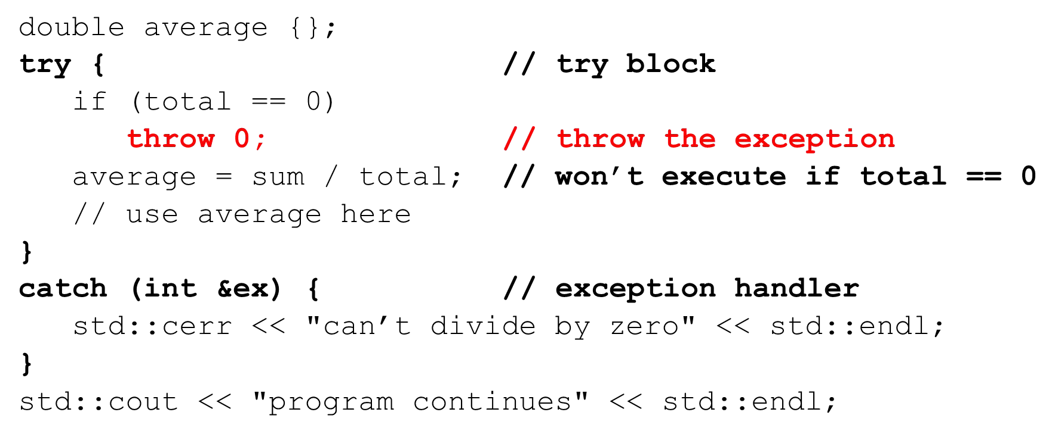

Throwing an exception from a function What do we return if total is zero?

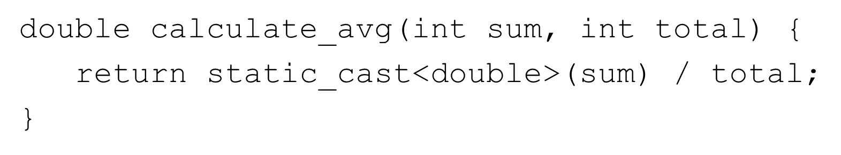

Throwing an exception from a function

Throw an exception if we can’t complete successfully

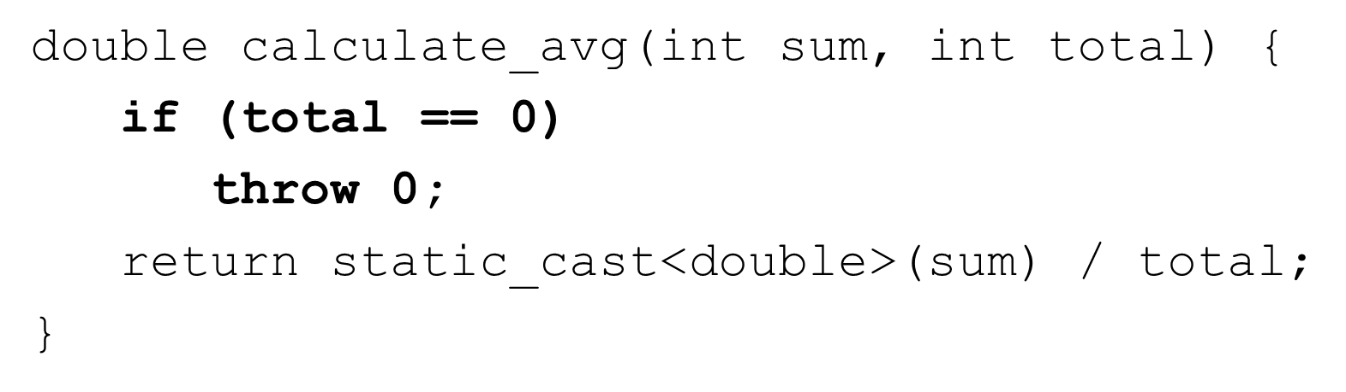

Catching an exception thrown from a function

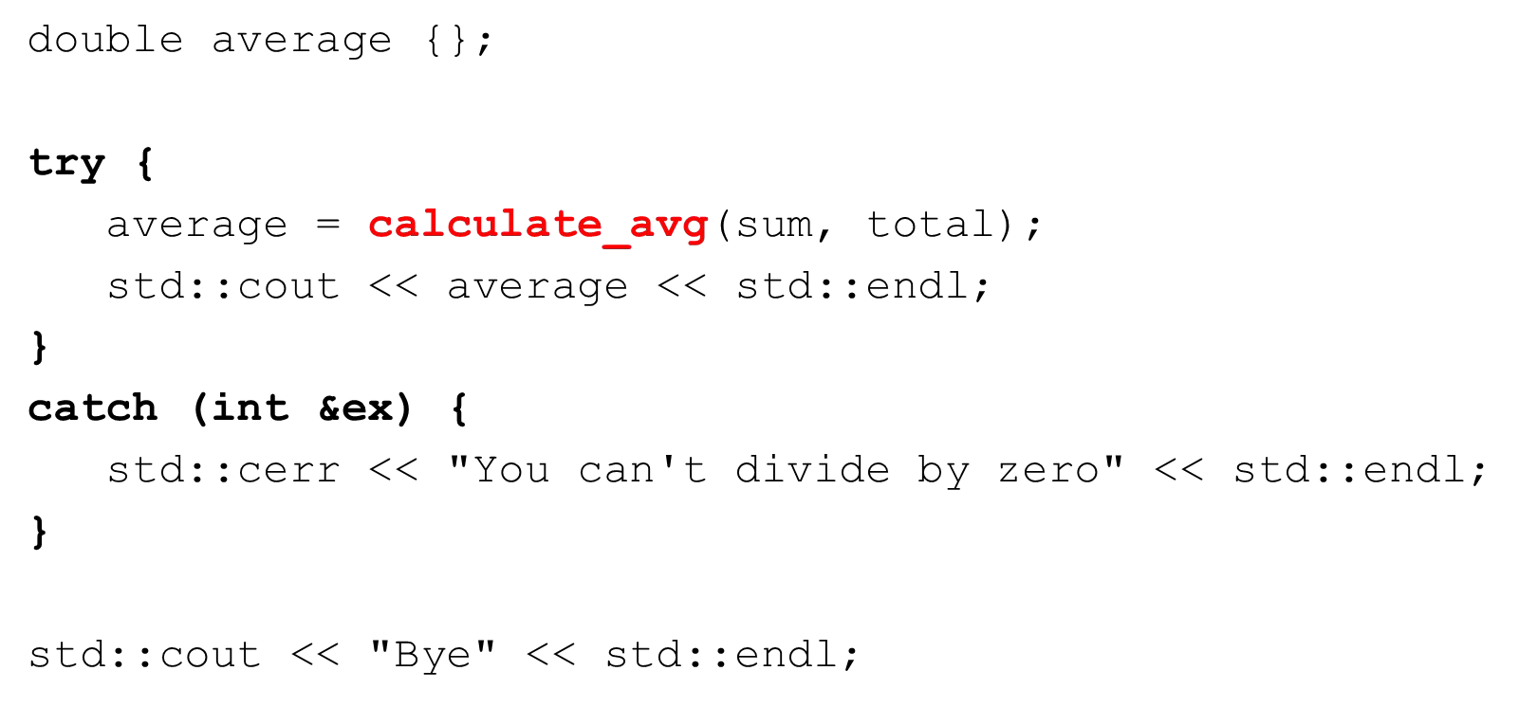

Throwing multiple exceptions from a function

What if a function can fail in several ways

* gallons is zero
* miles or gallons is negative

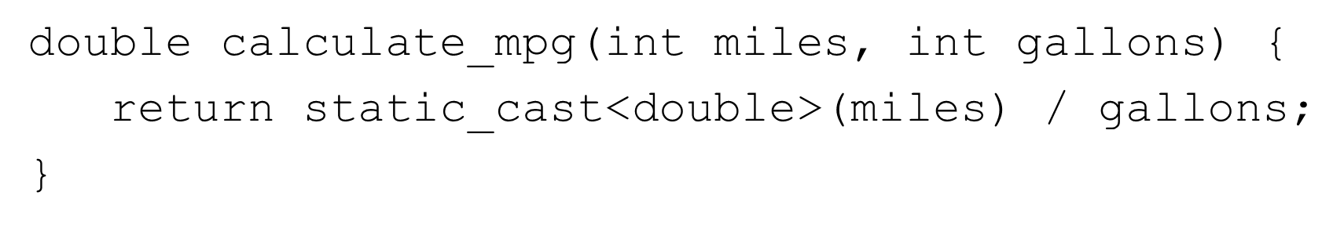

Throwing an exception from a function

Throw diﬀerent type exceptions for each condition

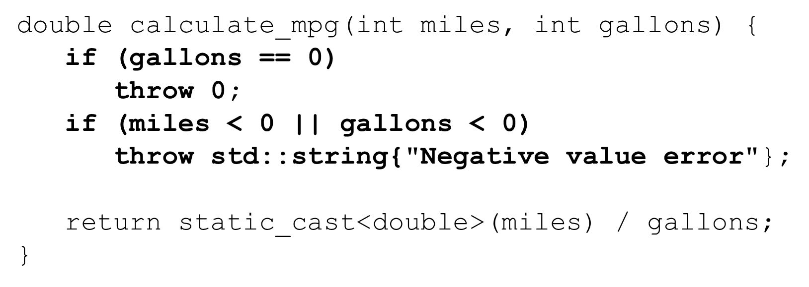

Catching an exception thrown from a function

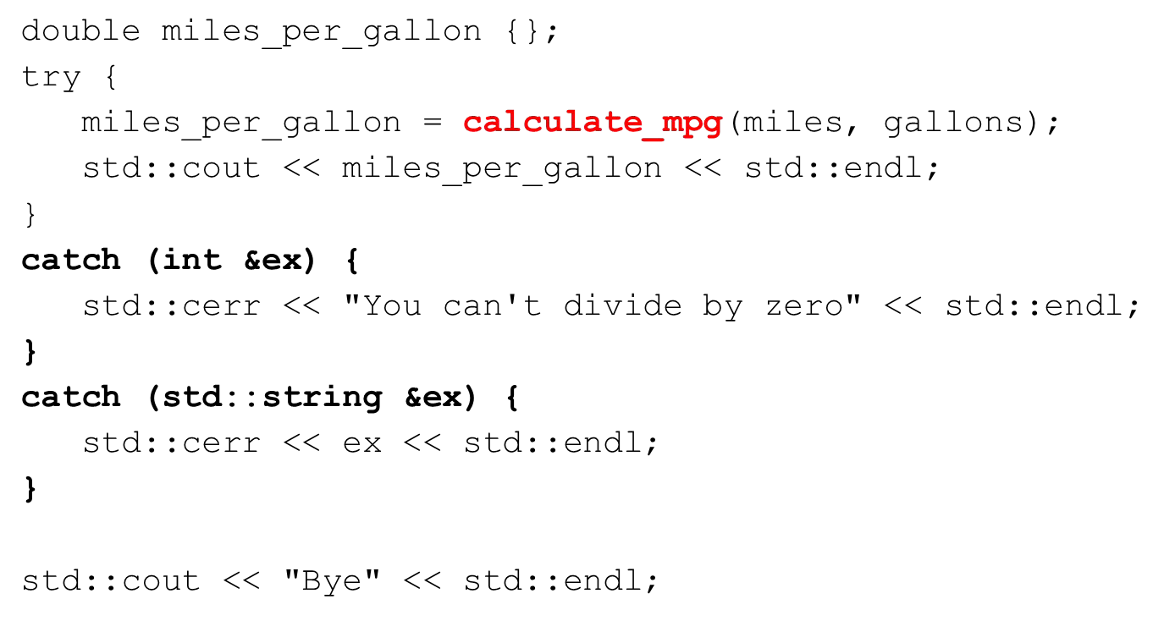

Catching any type of exception

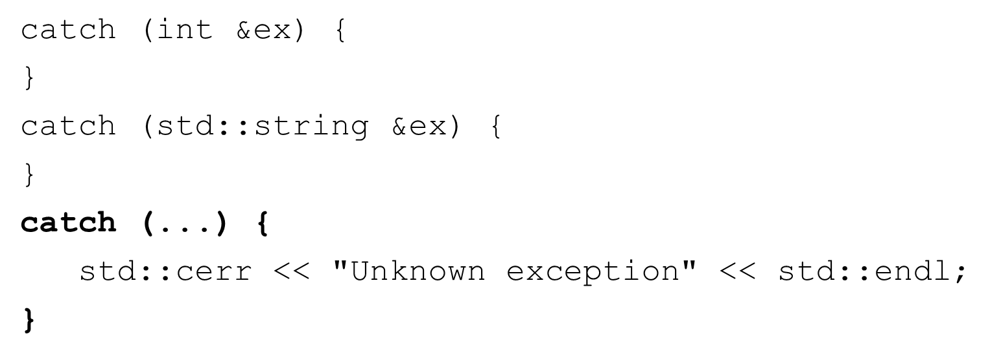

Stack unwinding

If an exception is thrown but not caught in the current scope

C++ tries to ﬁnd a handler for the exception by unwinding the stack

* Function in which the exception was not caught terminates and is removed from the call stack
* If a try block was used to then catch blocks are checked for a match
* If no try block was used or the catch handler doesn’t match stack unwinding occurs again
* If the stack is unwound back to main and no catch handler handles the exception the program terminates

User-deﬁned exceptions

We can create exception classes and throw instances of those classes

Best practice:

* + throw an object not a primitive type
  + throw an object by value
  + catch an object by reference (or const reference)

Creating exception classes

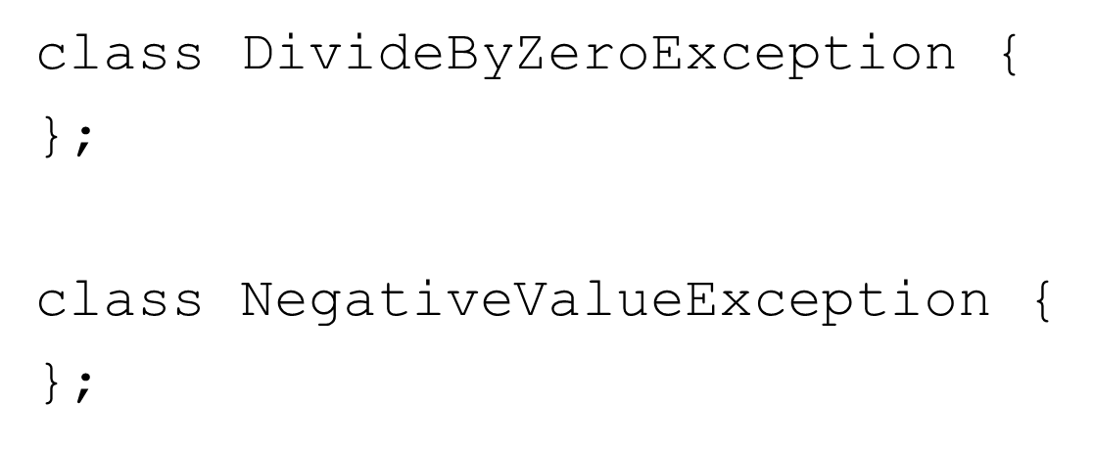

Throwing user-deﬁned exception classes

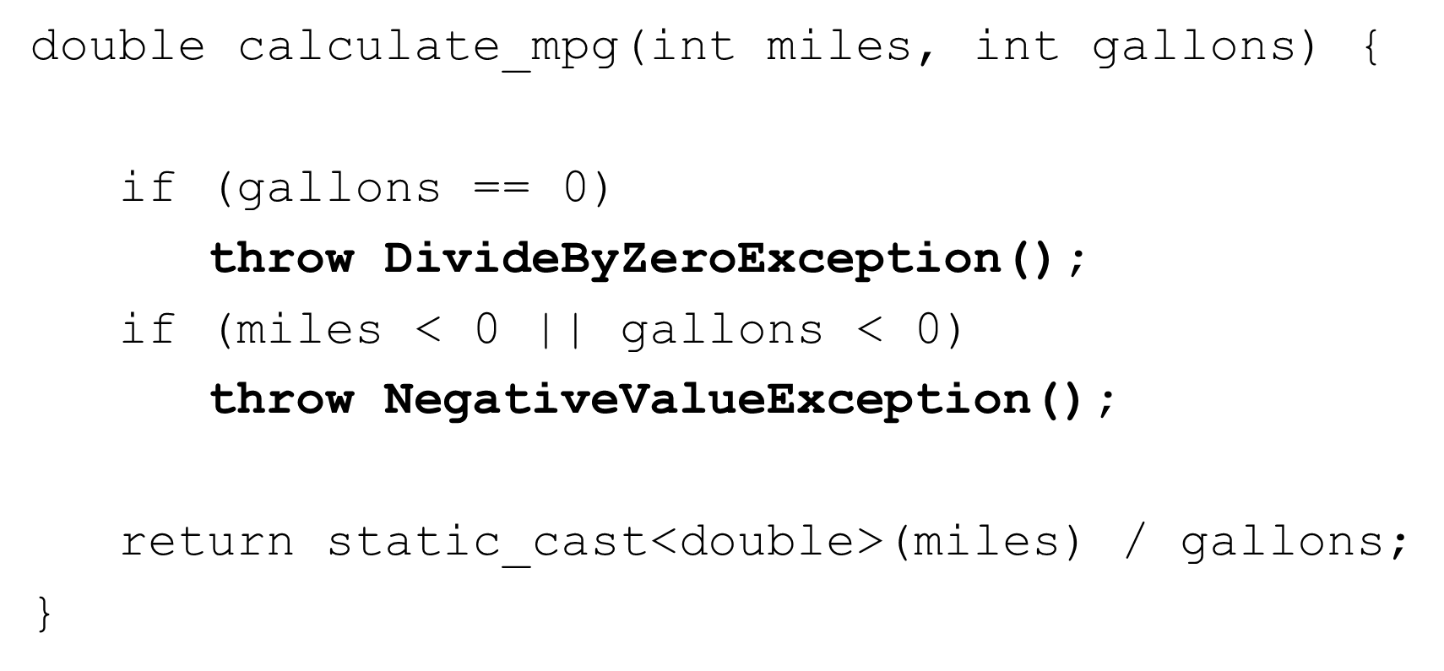

Catching user-deﬁned exceptions

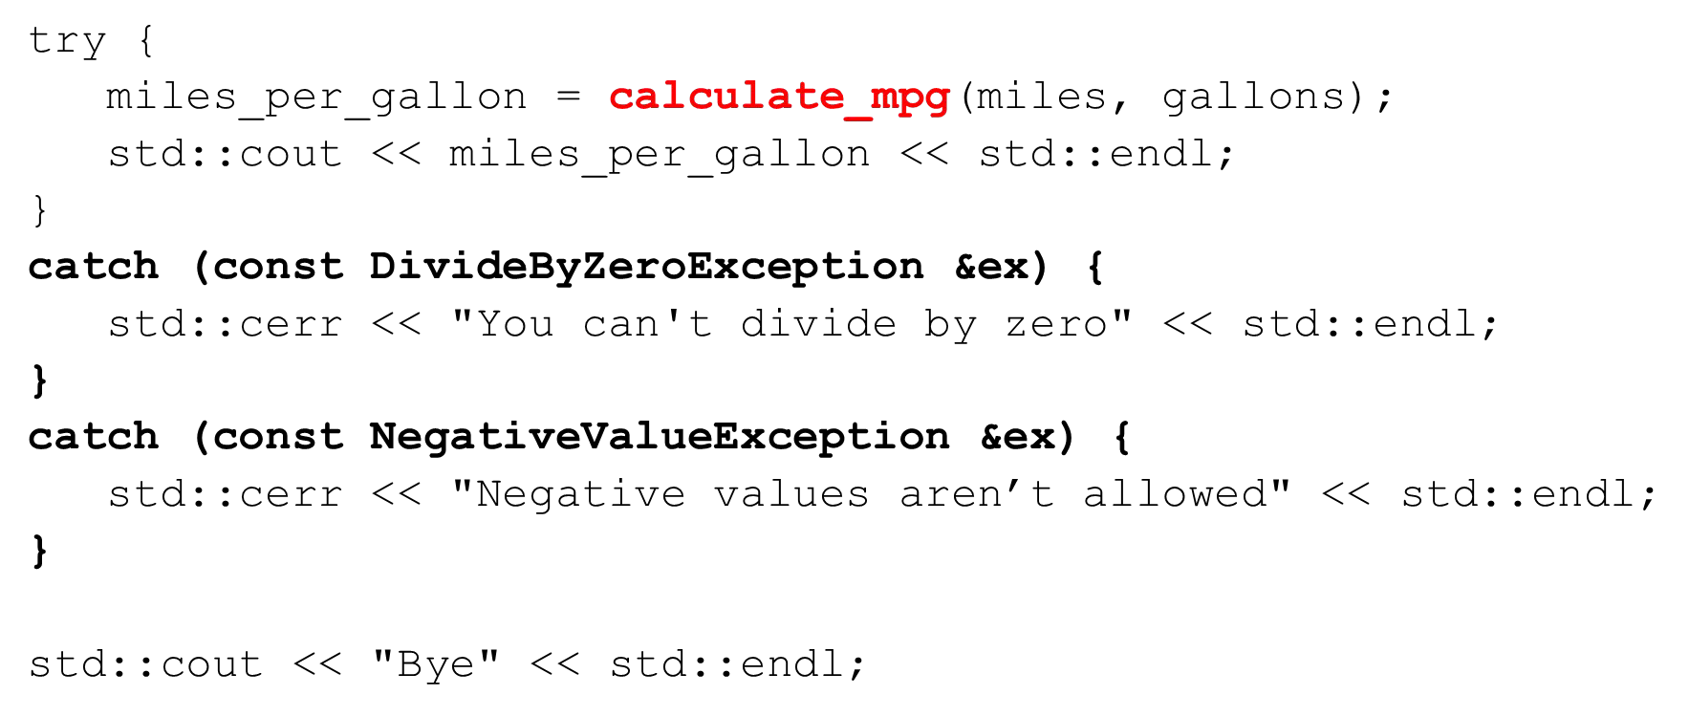

Class-level exceptions

Exceptions can also be thrown from within a class:

* Method
  + These work the same way as they do for functions as we’ve seen
* Constructor
  + Constructors may fail
  + Constructors do not return any value
  + Throw an exception in the constructor if you cannot initialize an object
* Destructor
  + Do NOT throw exceptions from your destructor

Class-level exceptions

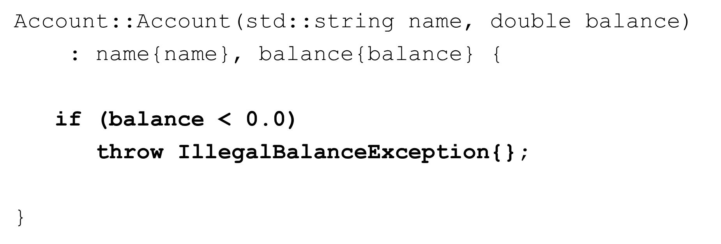

Class-level exceptions

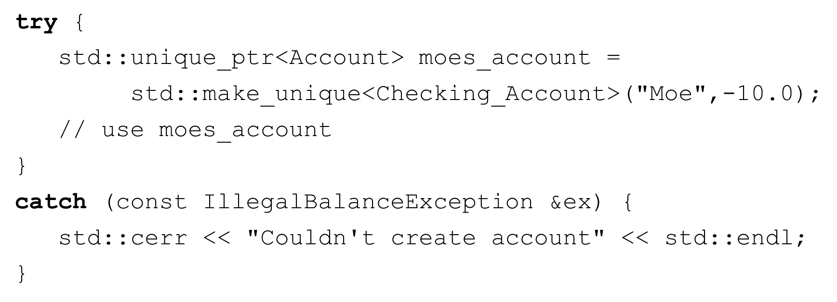

The C++ standard library exception class hierarchy

C++ provides a class hierarchy of exception classes

* + std::exception is the base class
  + all subclasses implement the what() virtual function
  + we can create our own user-deﬁned exception subclasses



The C++ standard library exception class hierarchy

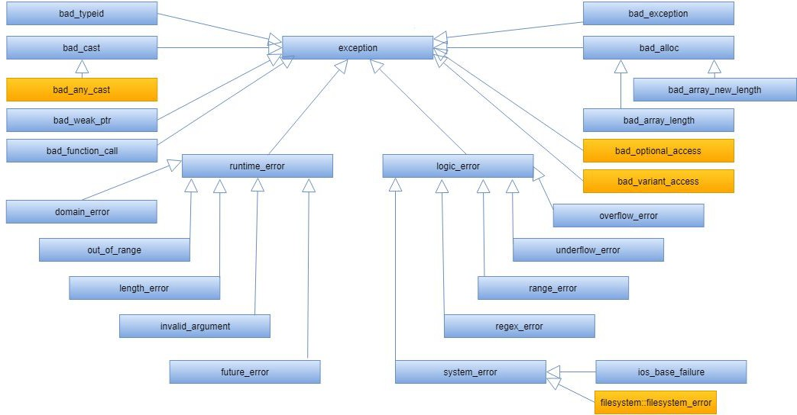

Deriving our class from std::exception

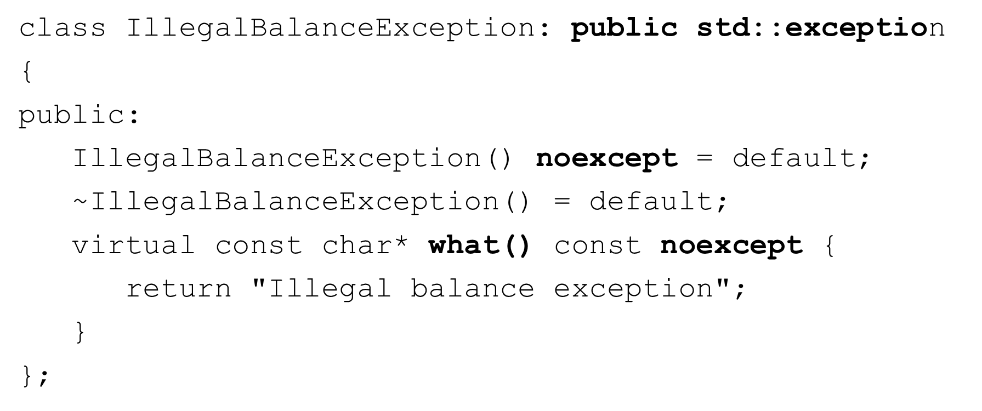

Our modiﬁed Account class constructor

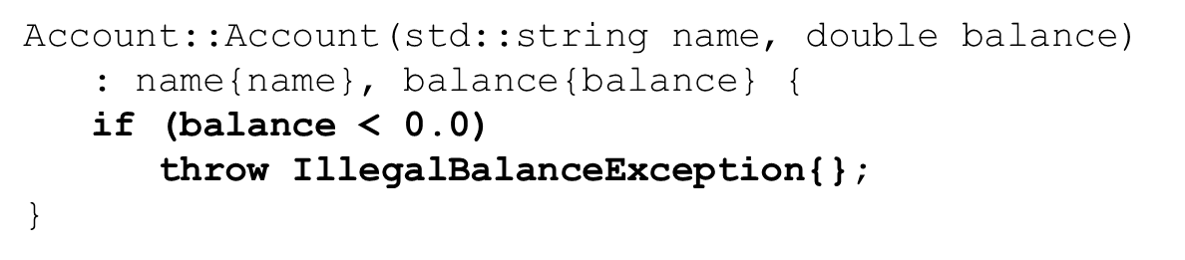

Creating an Account object

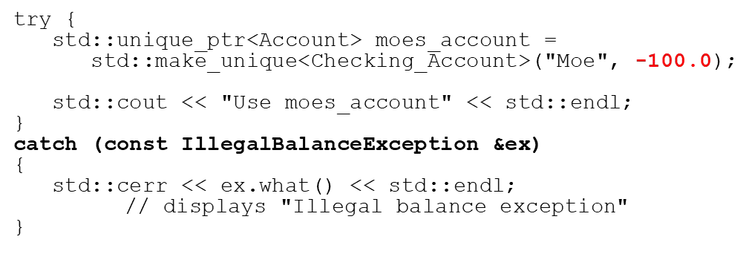

## Section Overview

I/O and Streams

* Streams and I/O
* Stream manipulators
* Reading and writing to a text ﬁle
* Using string streams
* C++ uses streams as an interface between the program and input and output devices
* Independent of the actual device
* Sequence of bytes
* Input stream provides data to the program
* Output stream receives data from the program

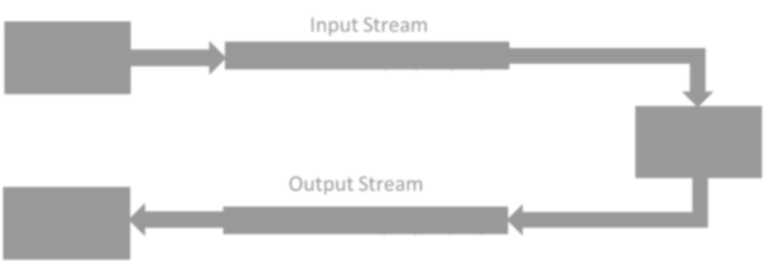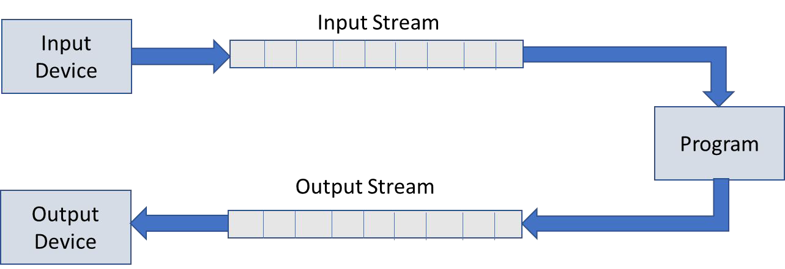

Common header ﬁles

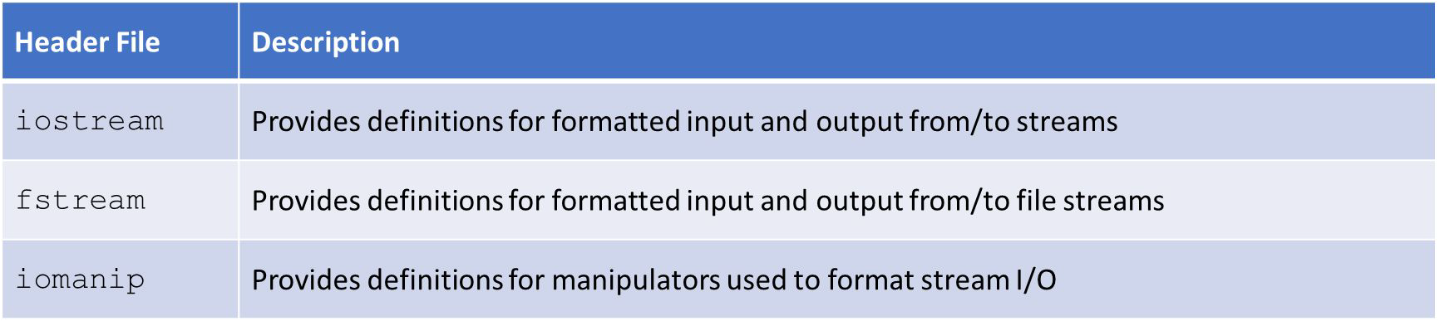

Commonly used stream classes

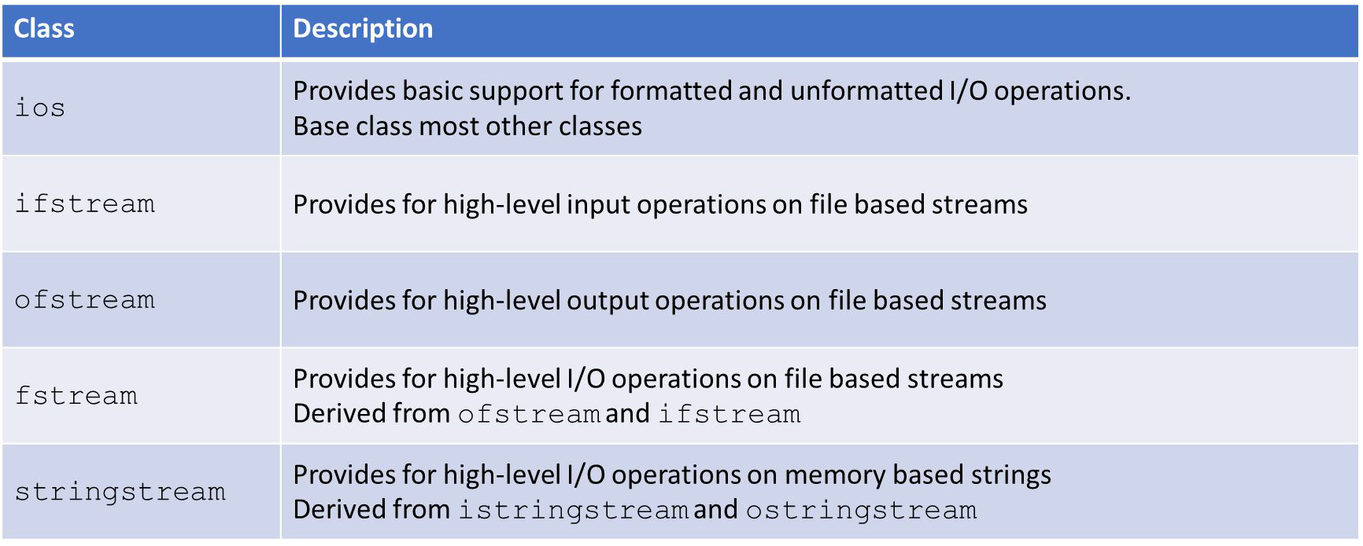

Global stream objects

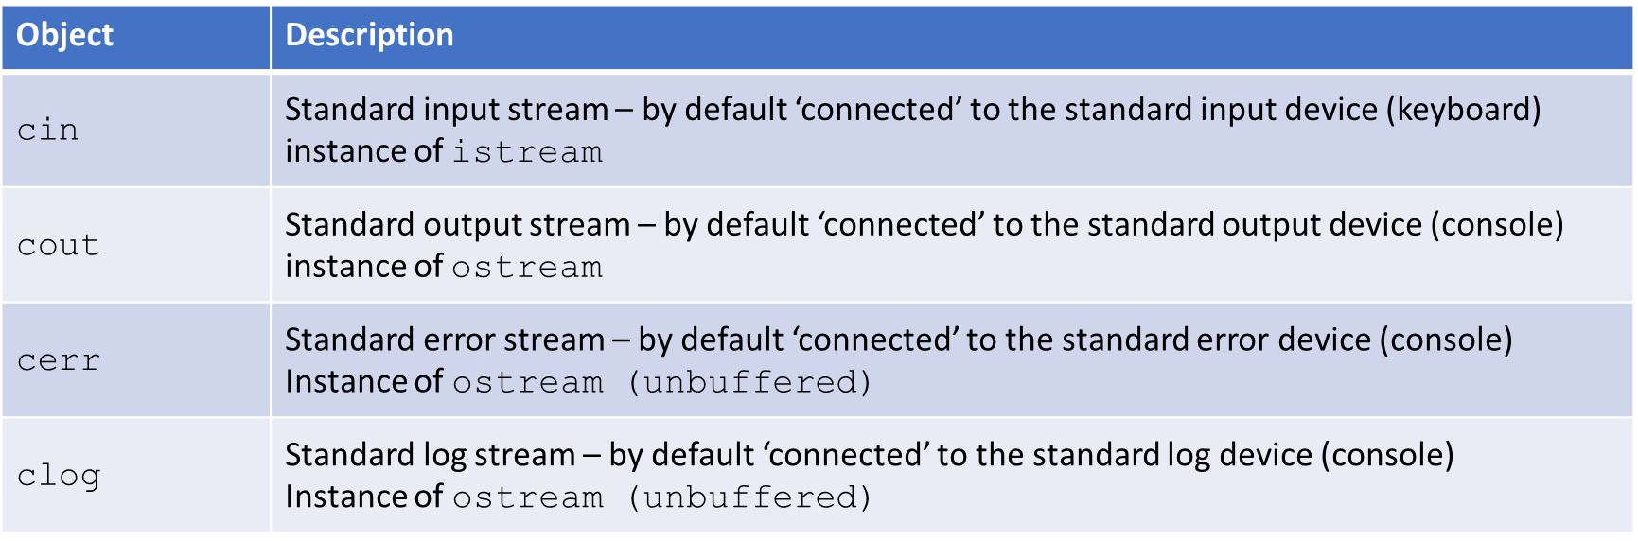

* Global objects – initialized before main executes
* Best practice is to use cerr for error messages and clog for log messages.

Stream manipulators

* Streams have useful member functions to control formatting
* Can be used on input and output streams
* The time of the eﬀect on the stream varies
* Can be used as member functions or as a manipulato

std::cout.width(10); // member function std::cout << std::setw(10); // manipulator

* We’ll focus on manipulator usage

Common stream manipulators

* Boolean
  + boolalpha , noboolalpha
* Integer
  + dec, hex, oct, showbase, noshowbase, showpos, noshowpos, uppercase, nouppercase
* Floating point
  + ﬁxed, scientiﬁc, setprecision, showpoint, noshowpoint, showpos, noshowpos
* Field width, justiﬁcation and ﬁll
  + setw, left, right, internal, setﬁll
* Others
  + endl, ﬂush, skipws, noskipws, ws

Formatting boolean types

* Default when displaying boolean values is 1 or 0
* Sometimes the strings true or false are more appropriate

Formatting boolean types

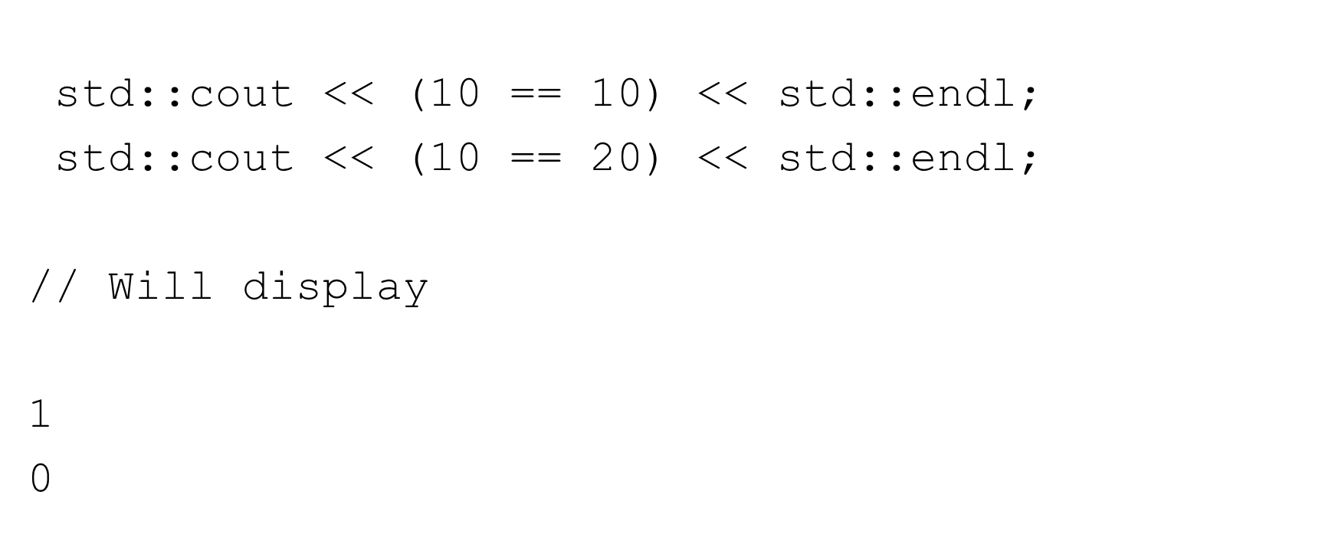

Formatting boolean types

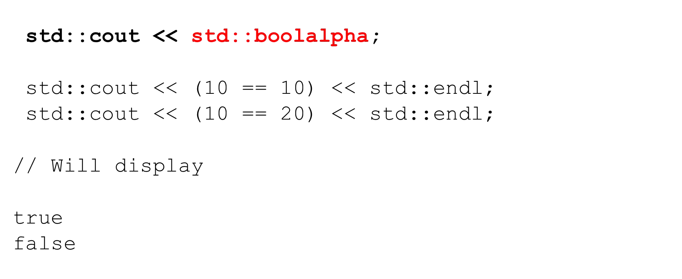

Formatting boolean types

* All further boolean output will be aﬀected

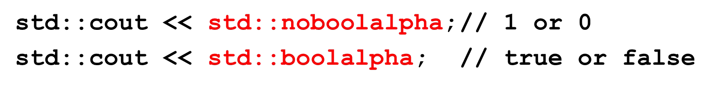

Formatting boolean types

* Method version

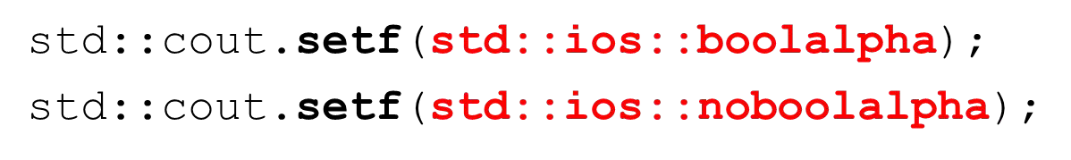

* Reset to default



Formatting integer types

* Default when displaying integer values is:
  + dec (base 10)
  + noshowbase - preﬁx used to show hexadecimal or octal
  + nouppercase - when displaying a preﬁx and hex values it will be lower case
  + noshowpos – no ‘+’ is displayed for positive numbers
* These manipulators aﬀect all further output to the stream

Formatting integer types - setting base

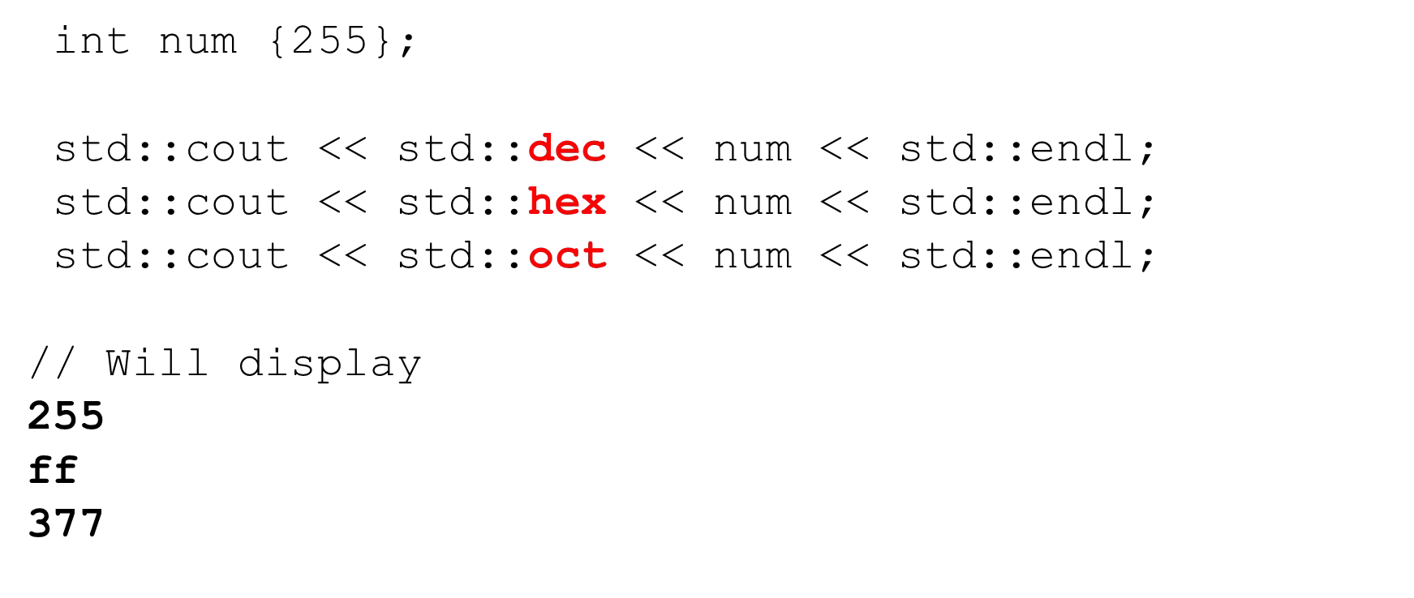

Formatting integer types - showing the base

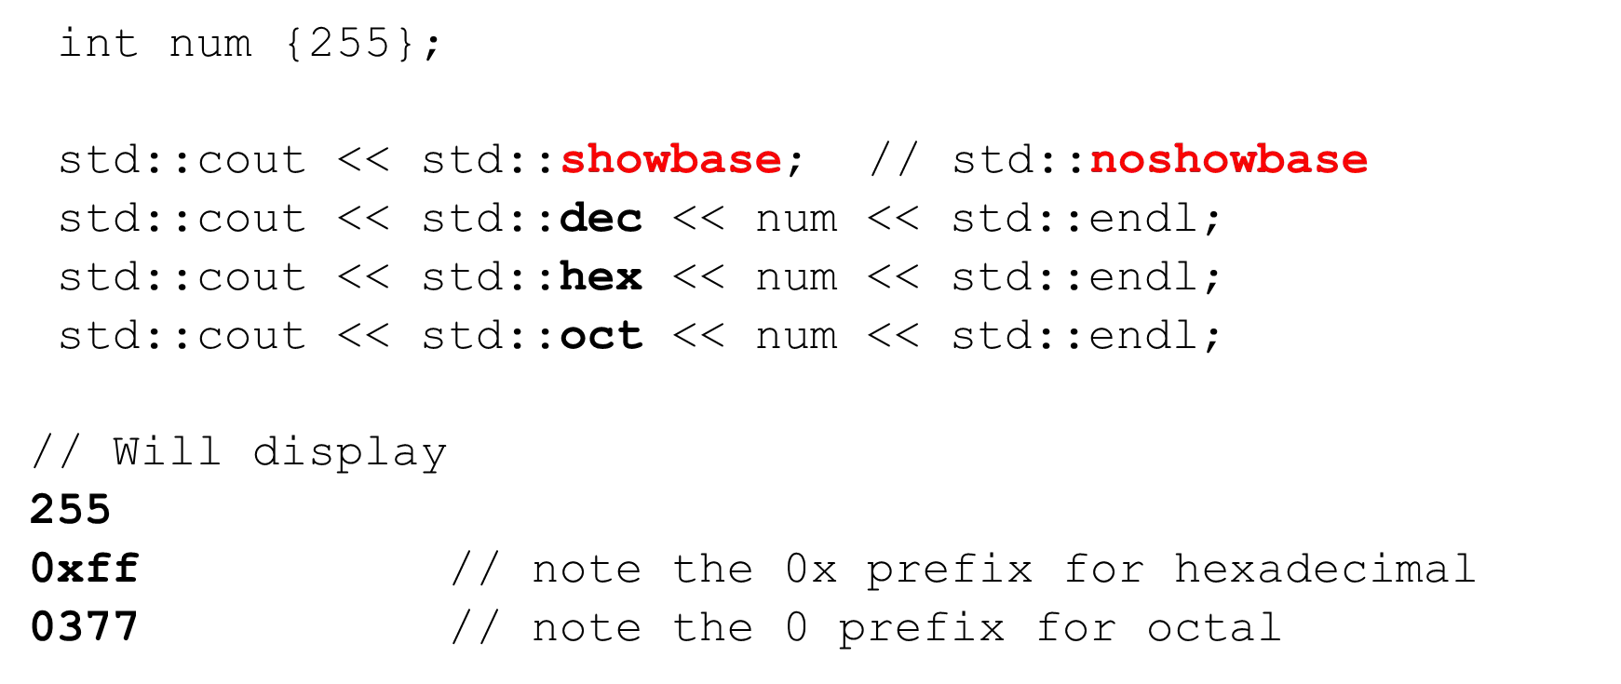

Formatting integer types - display hex in uppercase

BEGINNING C++ PROGRAMMING

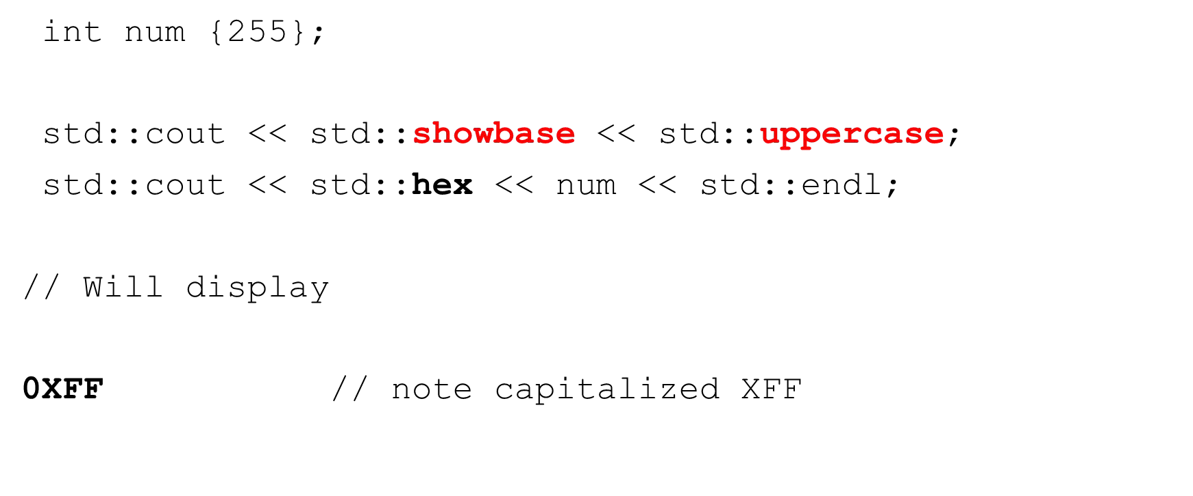

Manipulators Integer

I/O AND STREAMS

S19-CPP-0100-4

Formatting integer types - displaying the positive sign

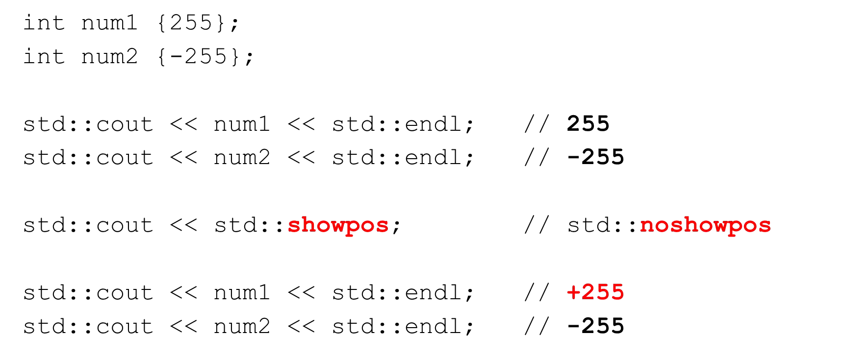

Setting/resetting integer types

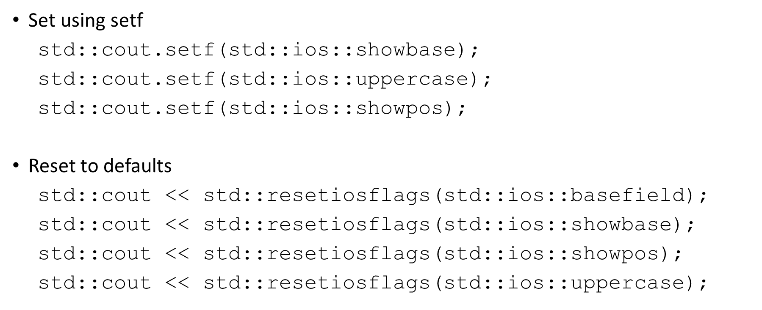

Formatting ﬂoating point types

* Default when displaying ﬂoating point values is:
  + setprecision – number of digits displayed (6)
  + ﬁxed – not ﬁxed to a speciﬁc number of digits after the decimal point
  + noshowpoint – trailing zeroes are not displayed
  + nouppercase - when displaying in scientiﬁc notation
  + noshowpos – no ‘+’ is displayed for positive numbers
* These manipulators aﬀect all further output to the stream

Formatting ﬂoating point types - precision

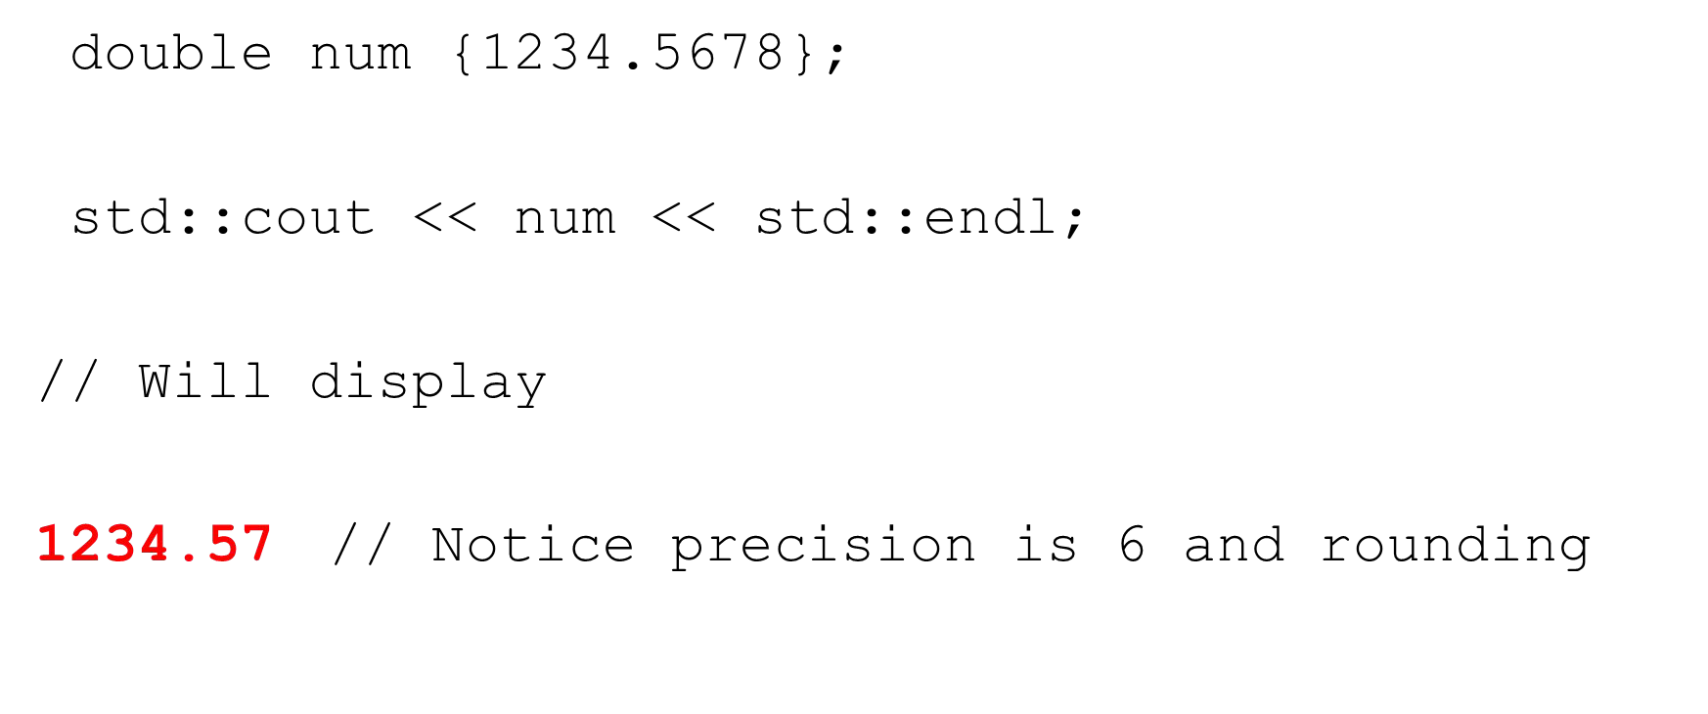

Formatting ﬂoating point types - precision

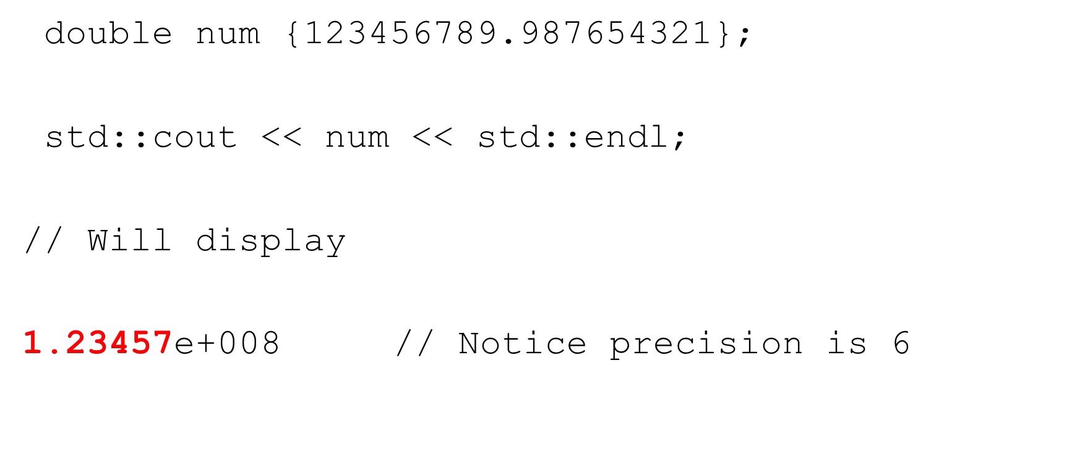

Formatting ﬂoating point types - precision

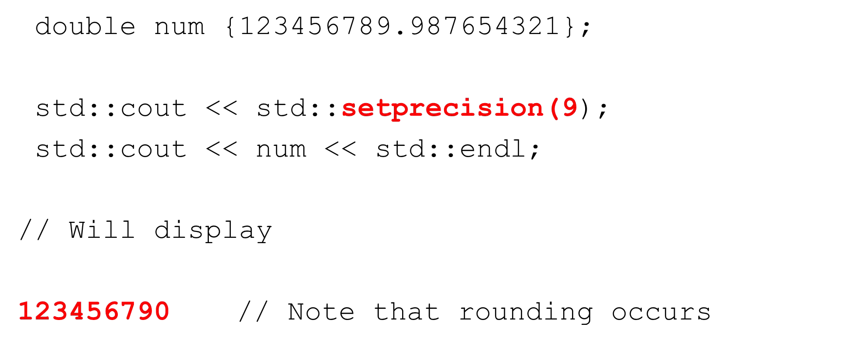

Formatting ﬂoating point types - ﬁxed

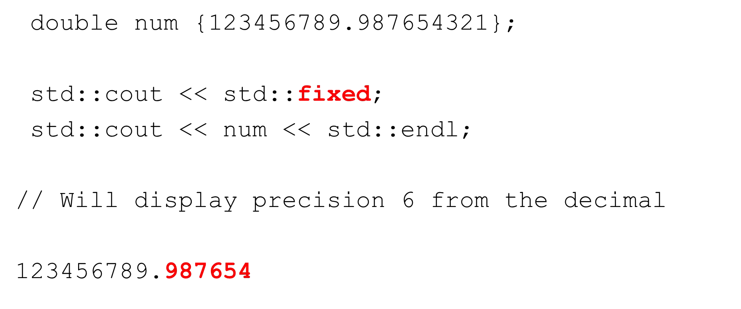

Formatting ﬂoating point types - ﬁxed

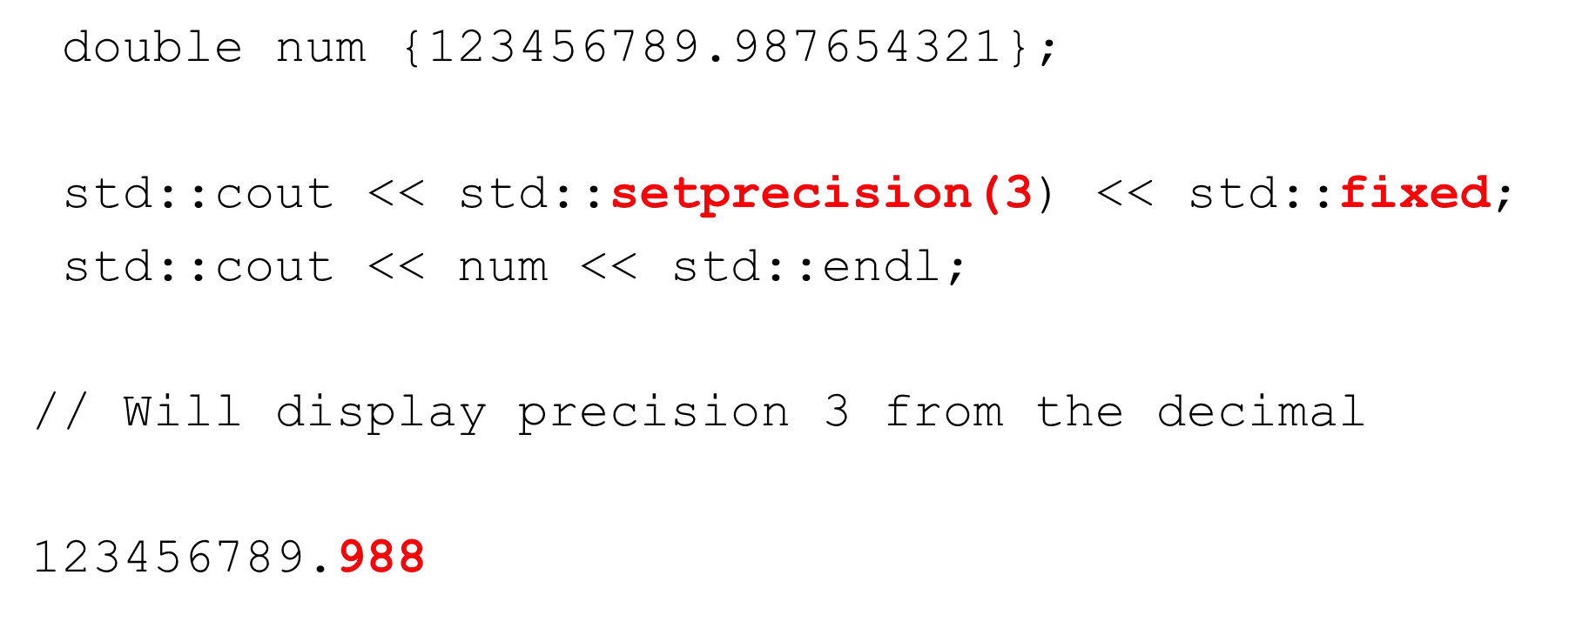

Formatting ﬂoating point types - scientiﬁc

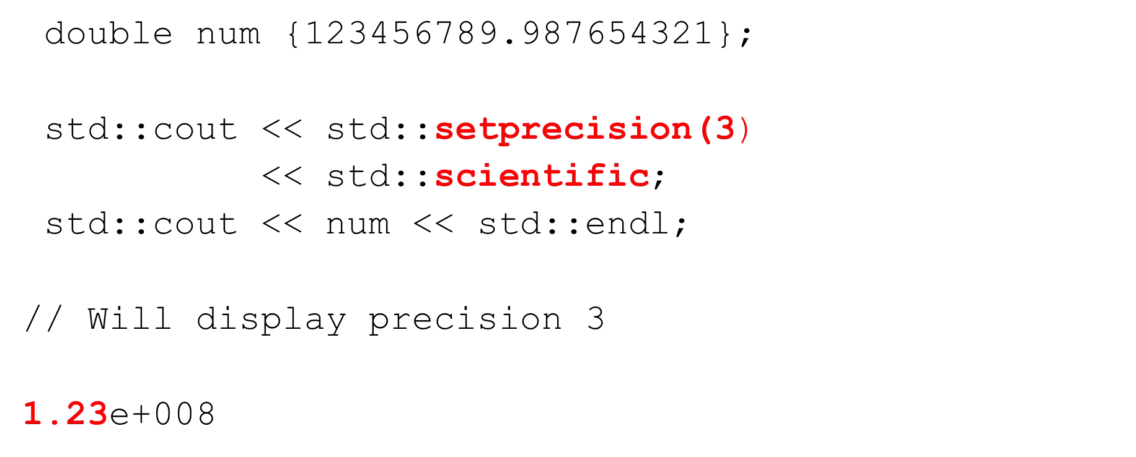

Formatting ﬂoating point types - scientiﬁc uppercase

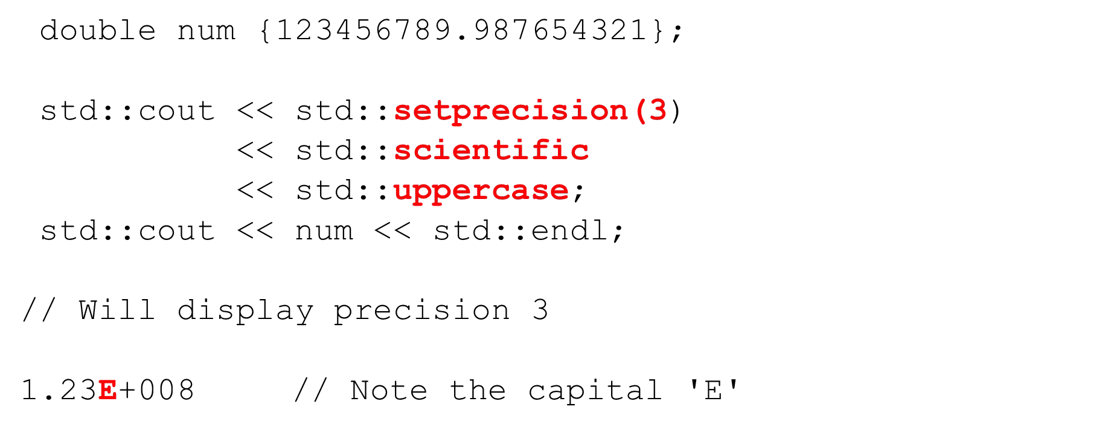

Formatting ﬂoating point types - displaying the positive sign

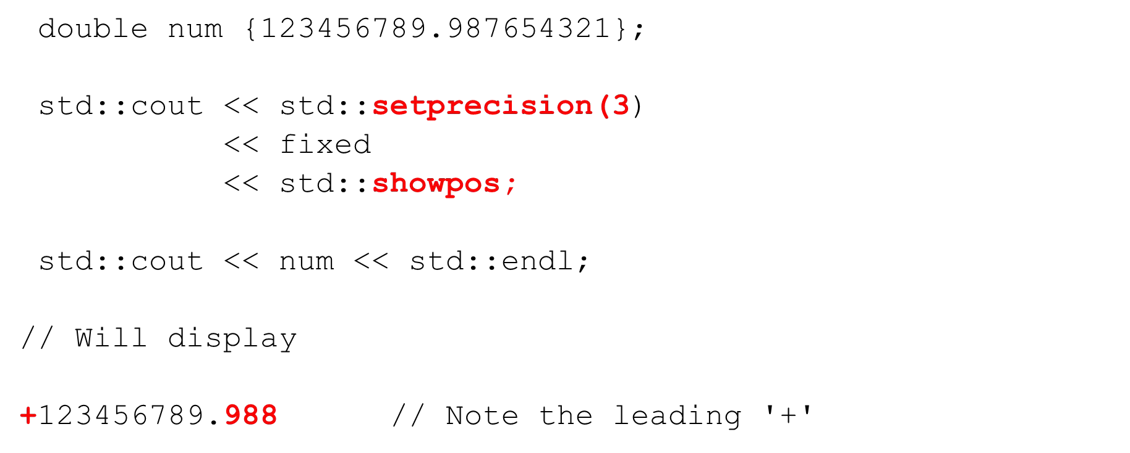

Formatting ﬂoating point types - trailing zeroes

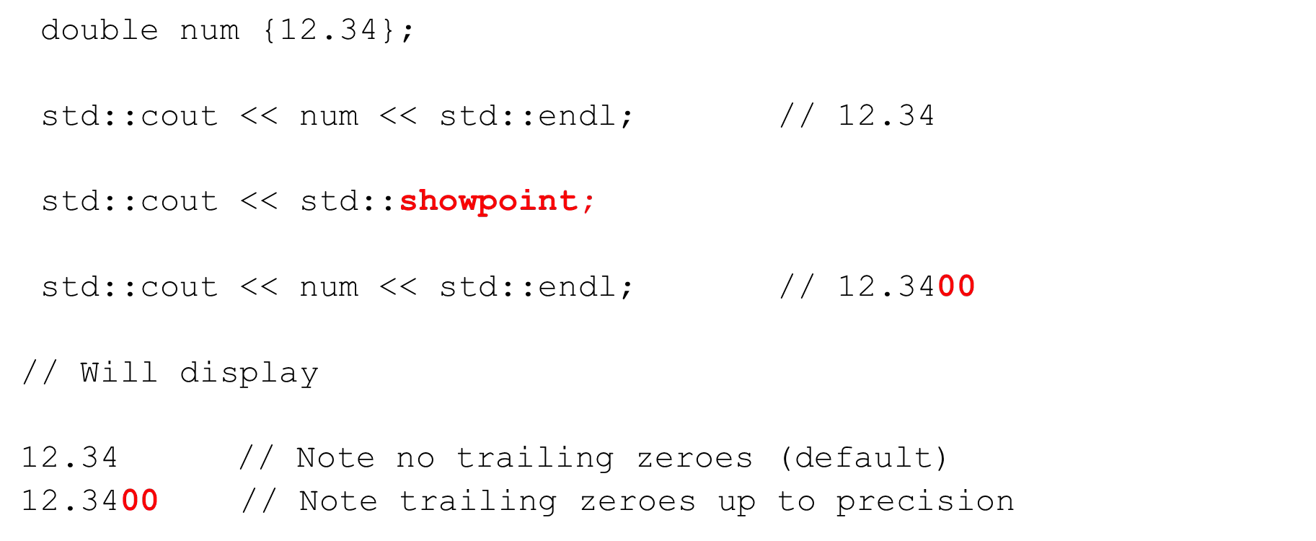

Returning to general settings

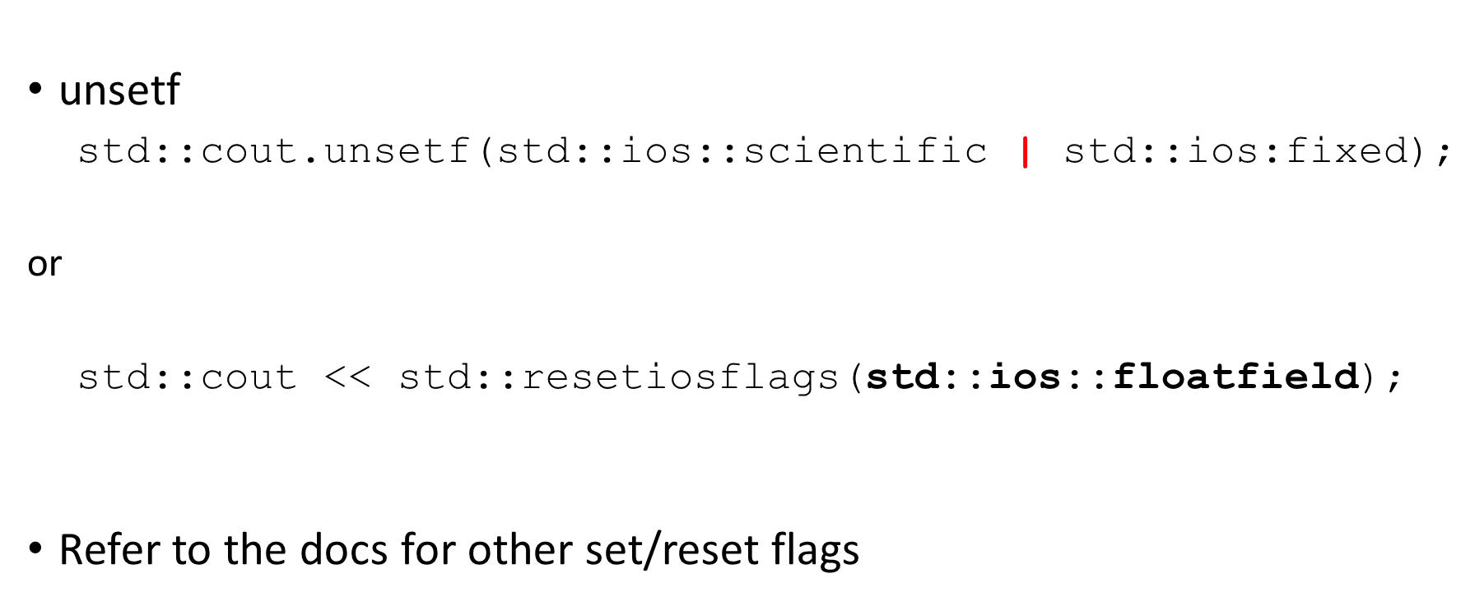

Field width, align and ﬁll

* Default when displaying ﬂoating point values is:
  + setw – not set by default
  + left – when no ﬁeld width, right - when using ﬁeld width
  + ﬁll – not set by default – blank space is used
* Some of these manipulators aﬀect only the next data element put on the stream

Defaults

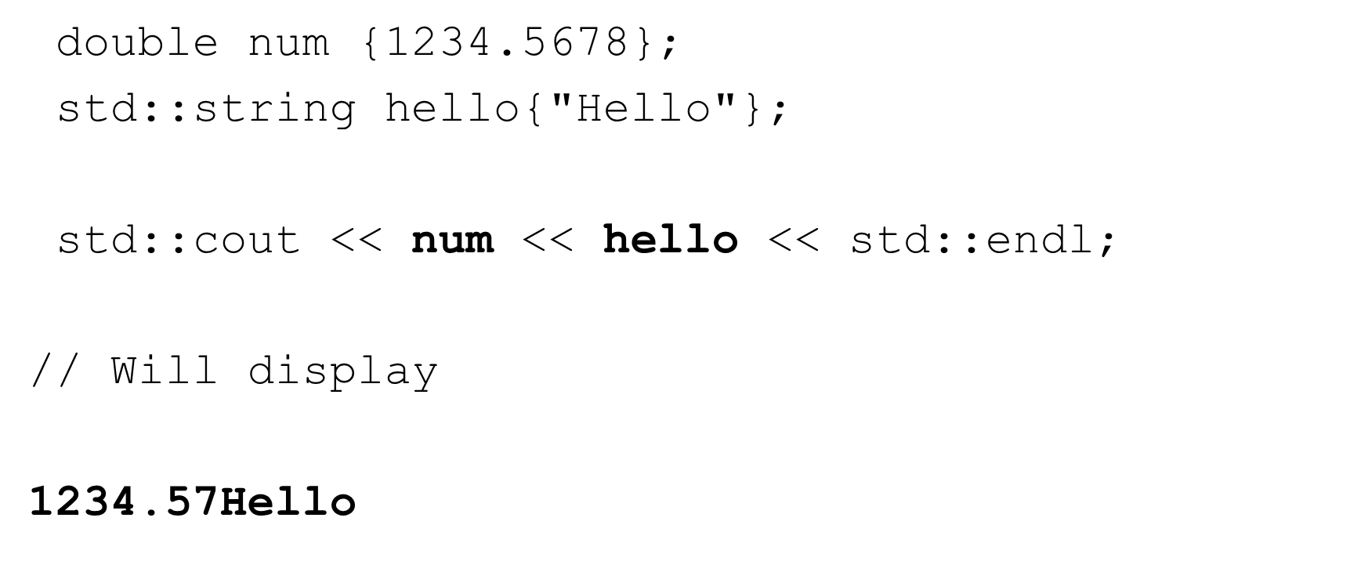

Defaults

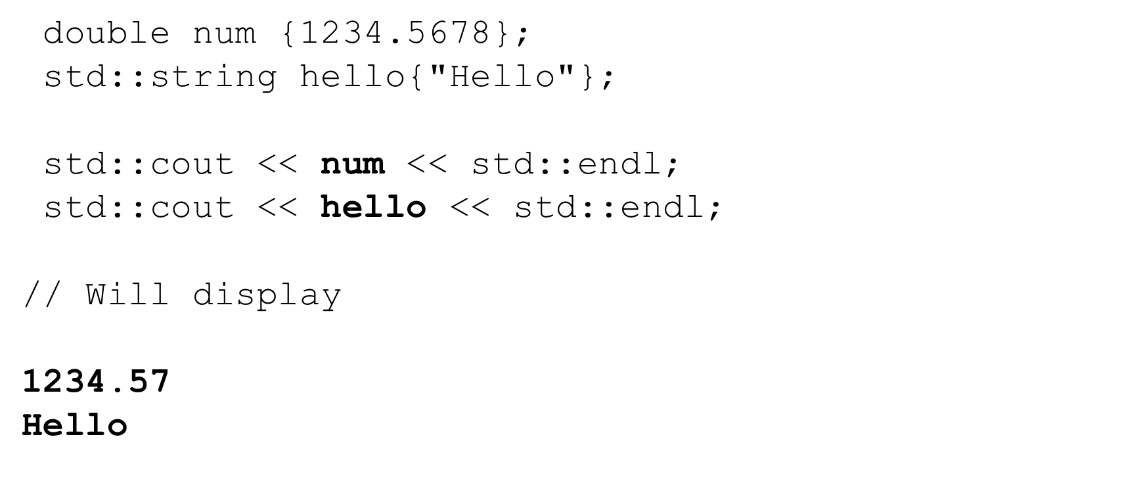

Field width - setw

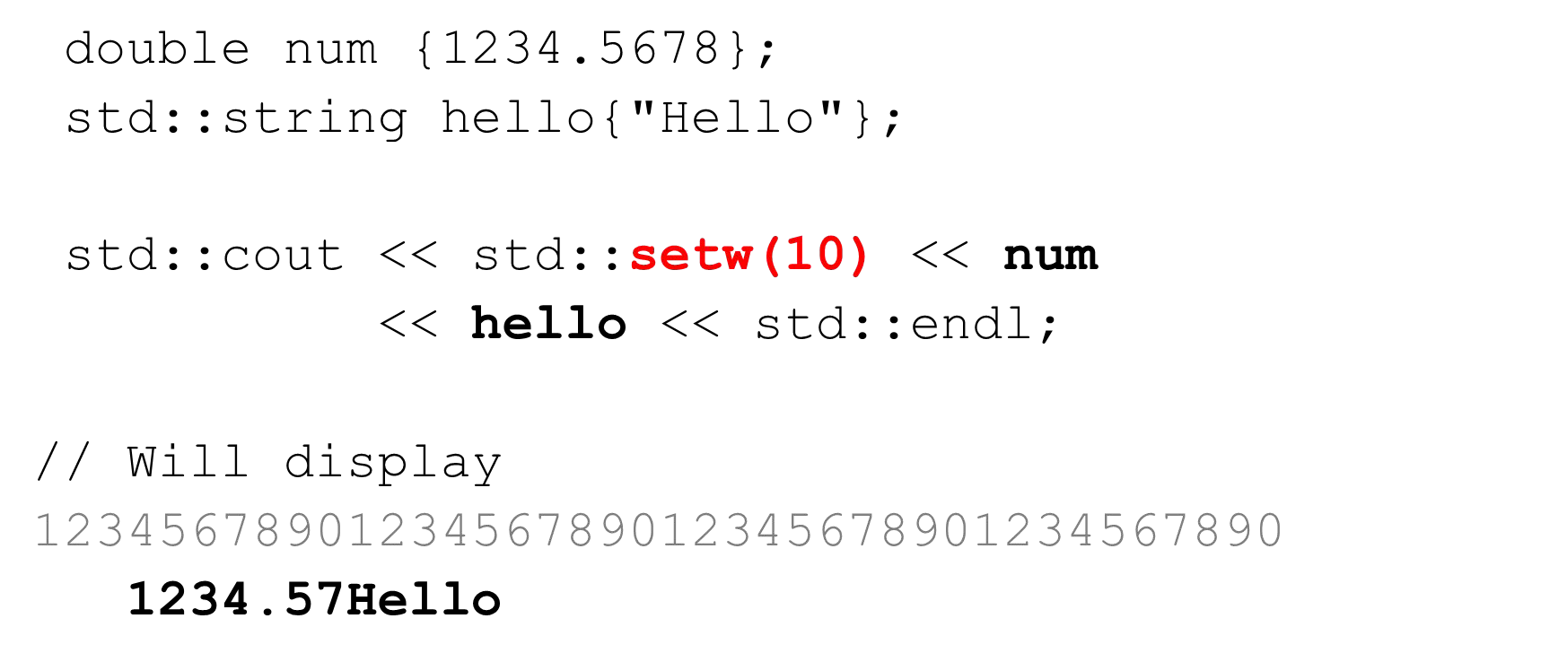

Field width - setw

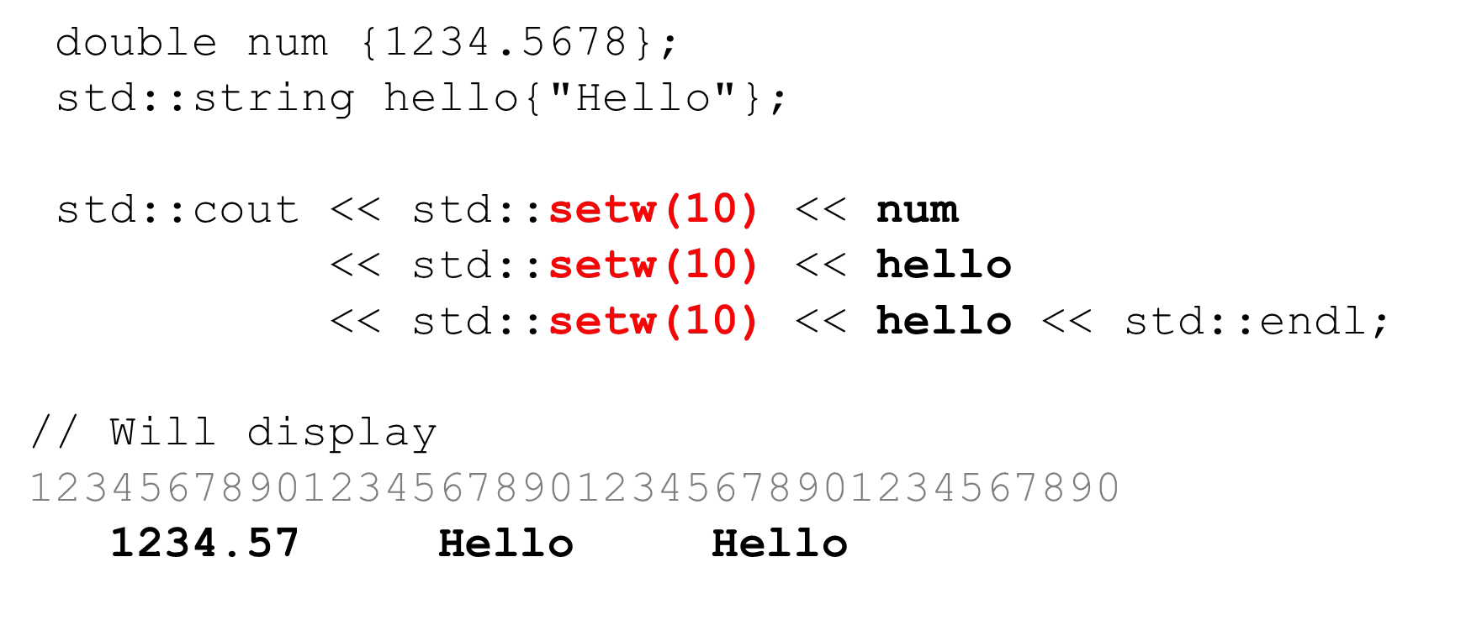

Field width - justiﬁcation

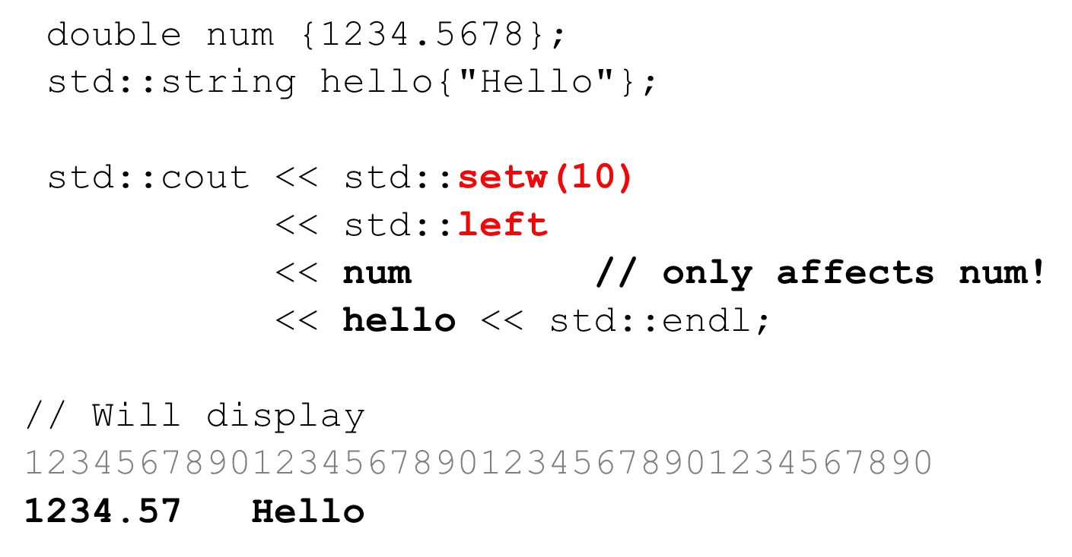

Field width - setw

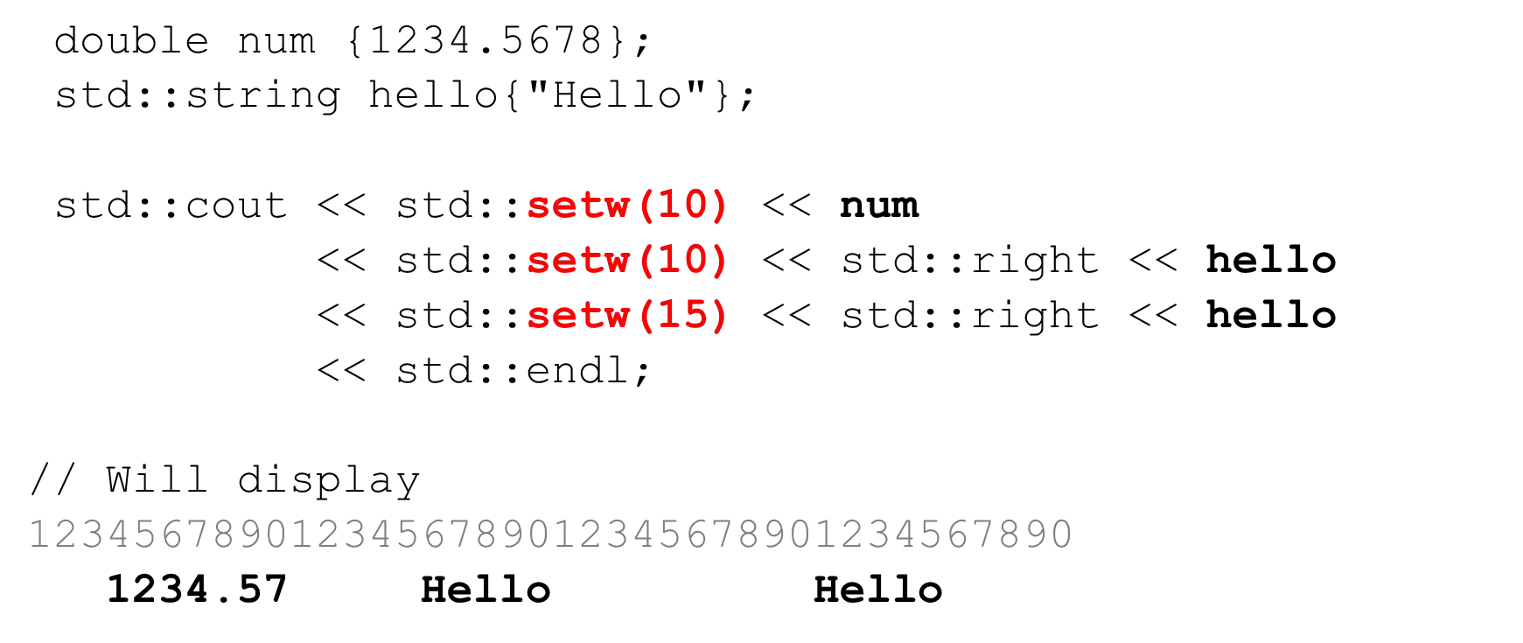

Filling ﬁxed width - setﬁll

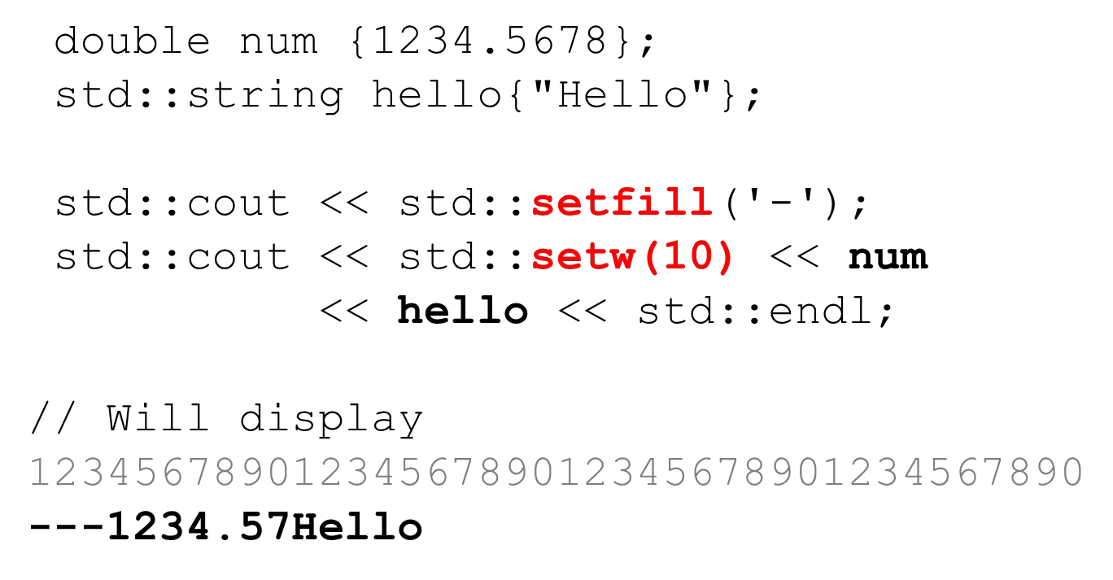

Field width - setw

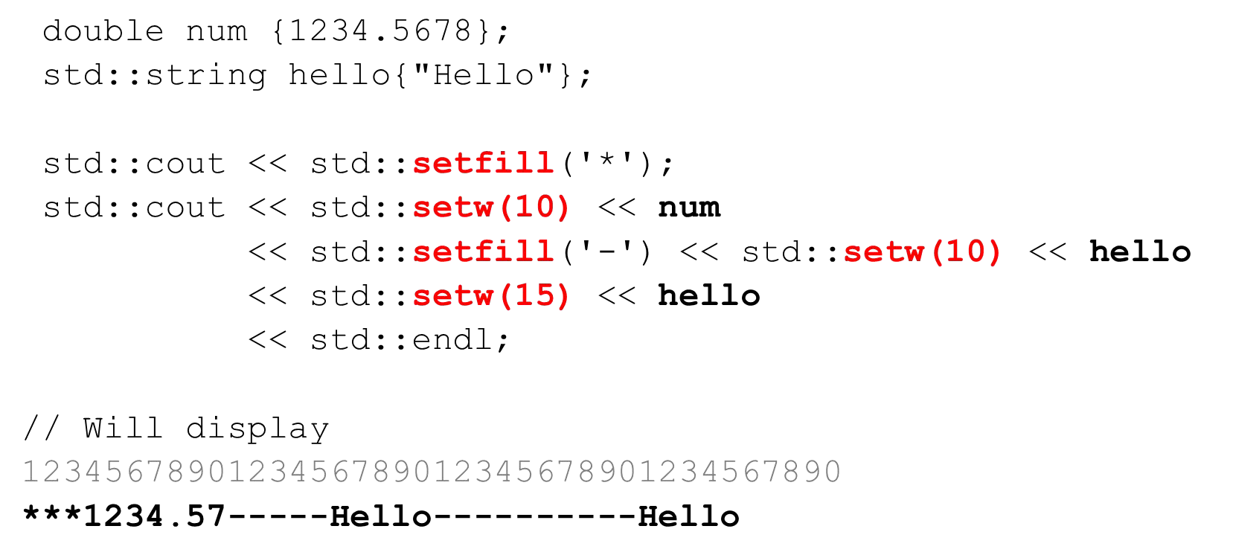

Input ﬁles (fstream and ifstream)

fstream and ifstream are commonly used for input ﬁles

1. #include <fstream>
2. Declare an fstream or ifstream object
3. Connect it to a ﬁle on your ﬁle system (opens it for reading)
4. Read data from the ﬁle via the stream
5. Close the stream

Opening a ﬁle for reading with (fstream)

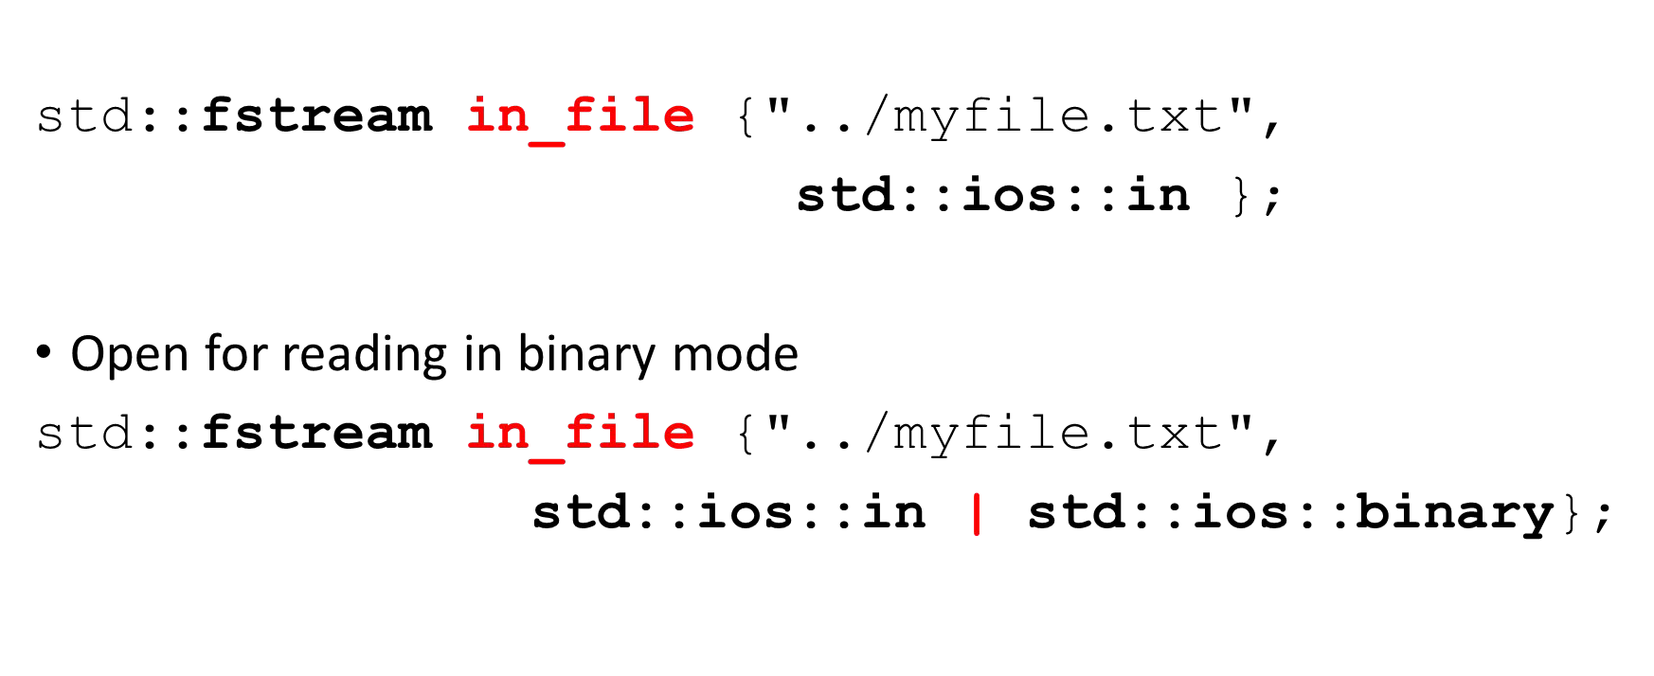

Opening a ﬁle for reading with (ifstream)

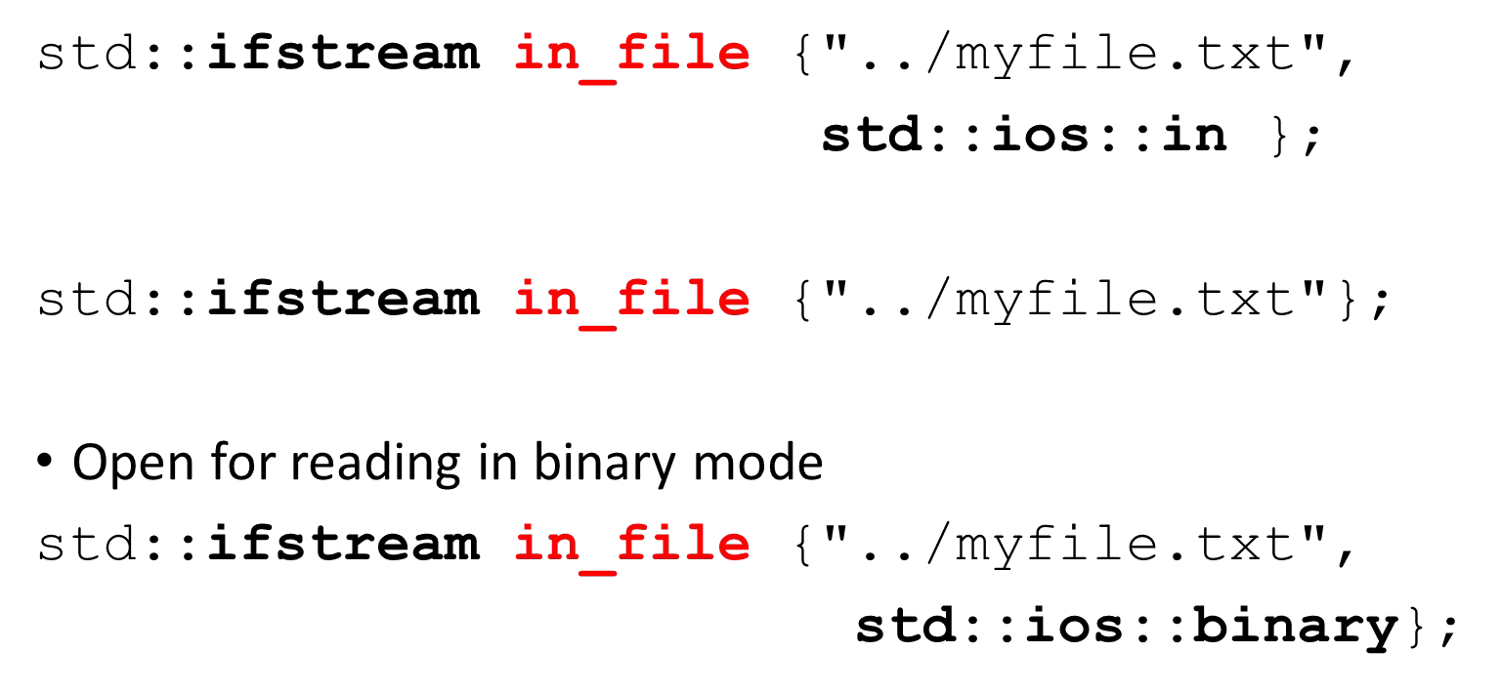

Opening a ﬁle for reading with open

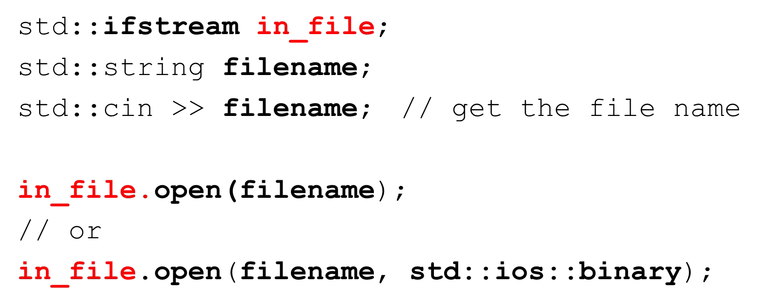

Check if ﬁle opened successfully (is_open)

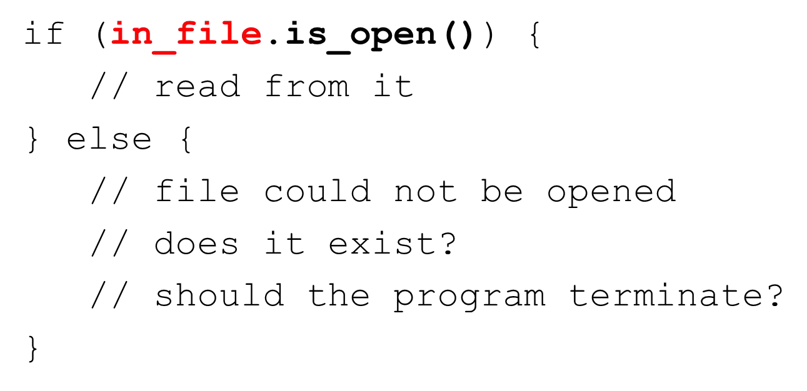

Check if ﬁle opened successfully – test the stream object

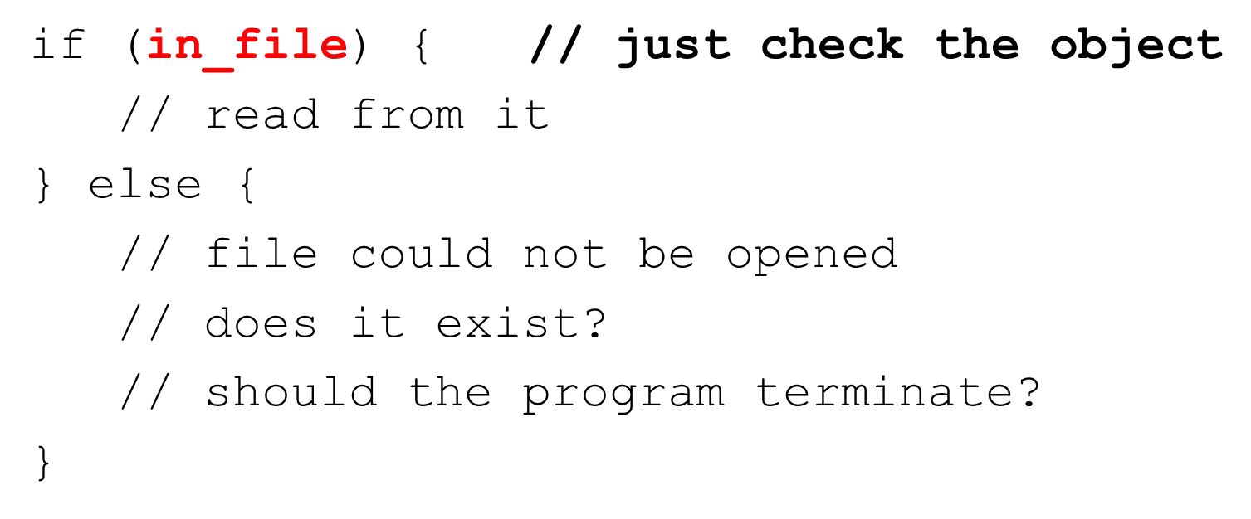

Closing a ﬁle

* Always close any open ﬁles to ﬂush out any unwritten data

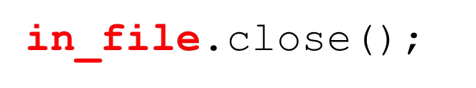

Reading from ﬁles using (>>)

* We can use the extraction operator for formatted read
* Same way we used it with cin

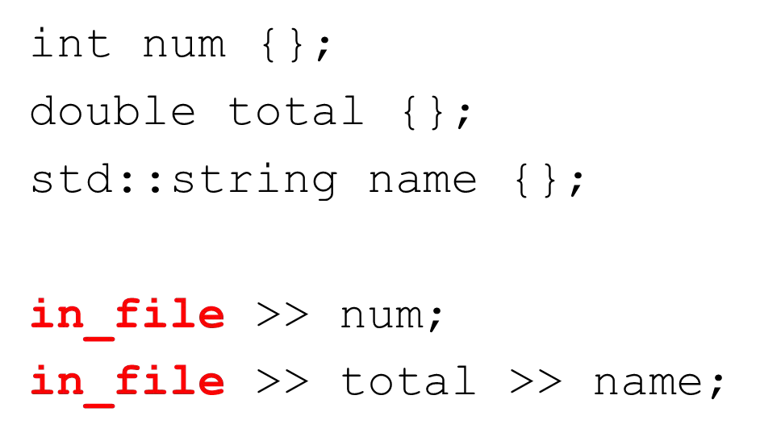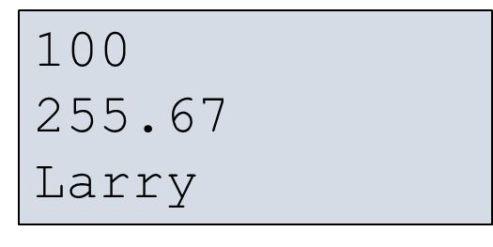

Reading from ﬁles using getline

* We can use getline to read the ﬁle one line at a time

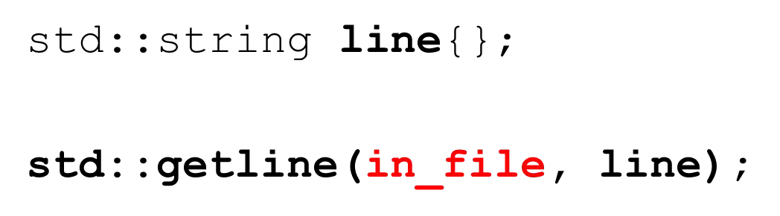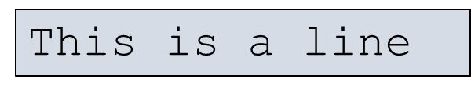

Reading text ﬁle one line at a time

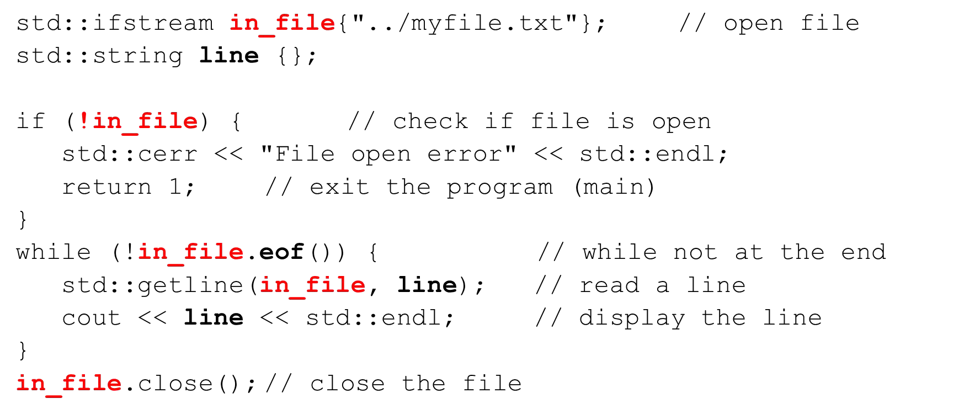

Reading text ﬁle one line at a time

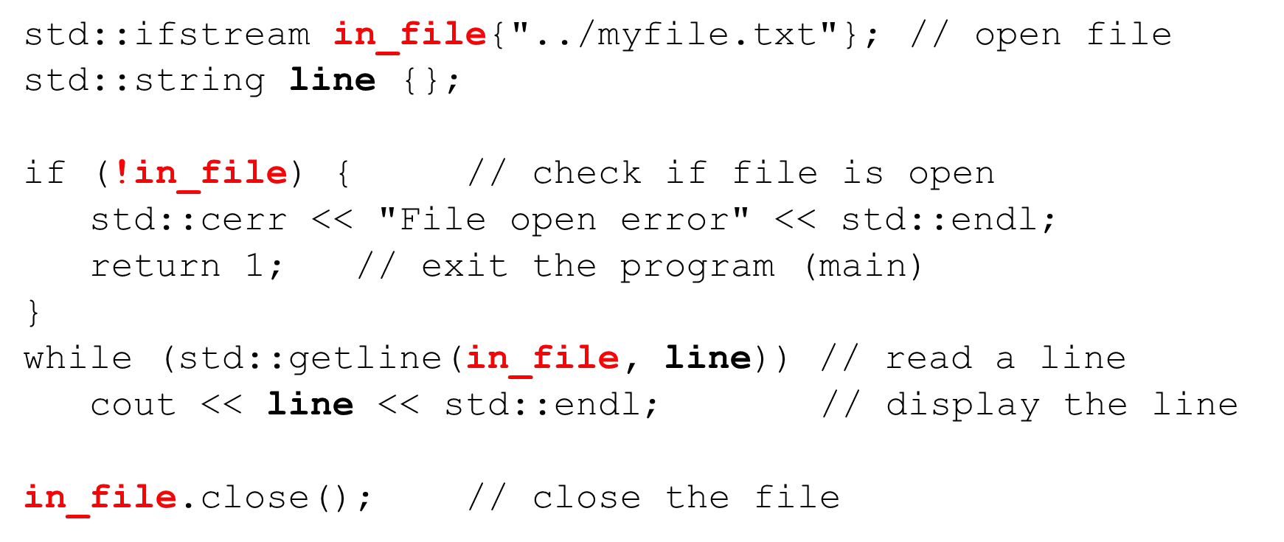

Reading text ﬁle one character at a time (get)

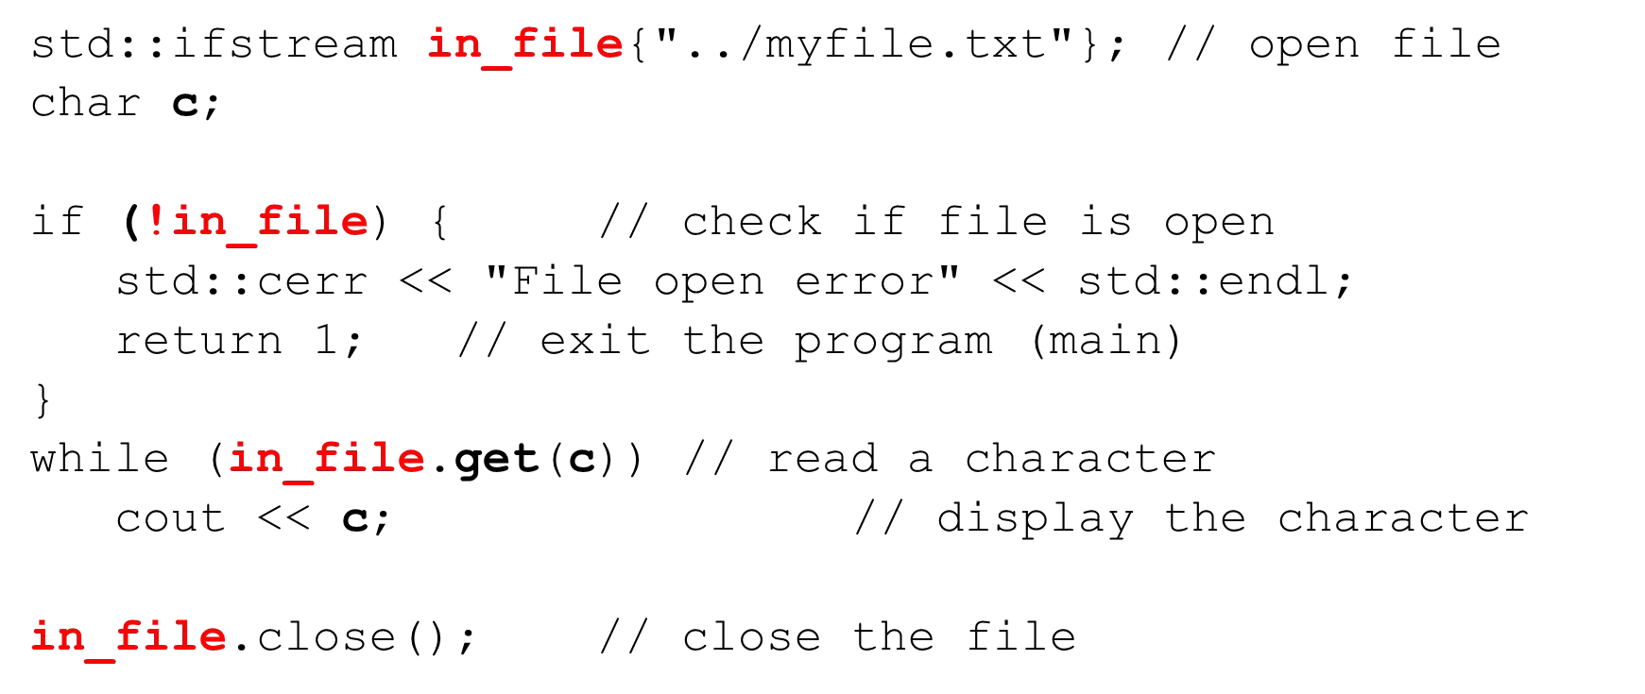

Output ﬁles (fstream and ofstream)

fstream and ofstream are commonly used for output ﬁles

1. #include <fstream>
2. Declare an fstream or ofstream object
3. Connect it to a ﬁle on your ﬁle system (opens it for writing)
4. Write data to the ﬁle via the stream
5. Close the stream

Output ﬁles (fstream and ofstream)

fstream and ofstream are commonly used for output ﬁles

* + Output ﬁles will be created if they don’t exist
  + Output ﬁles will be overwritten (truncated) by default
  + Can be opened so that new writes append
  + Can be open in text or binary modes

Opening a ﬁle for writing with (fstream)

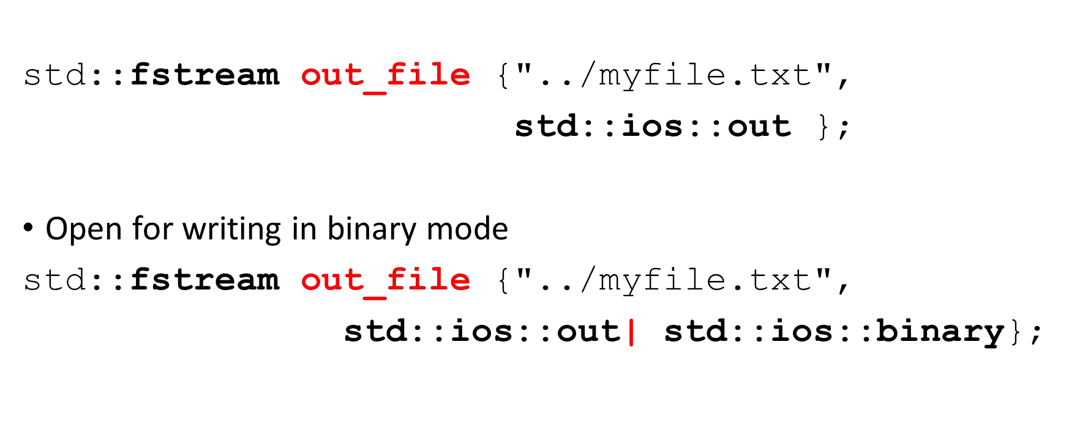

Opening a ﬁle for writing with (ofstream)

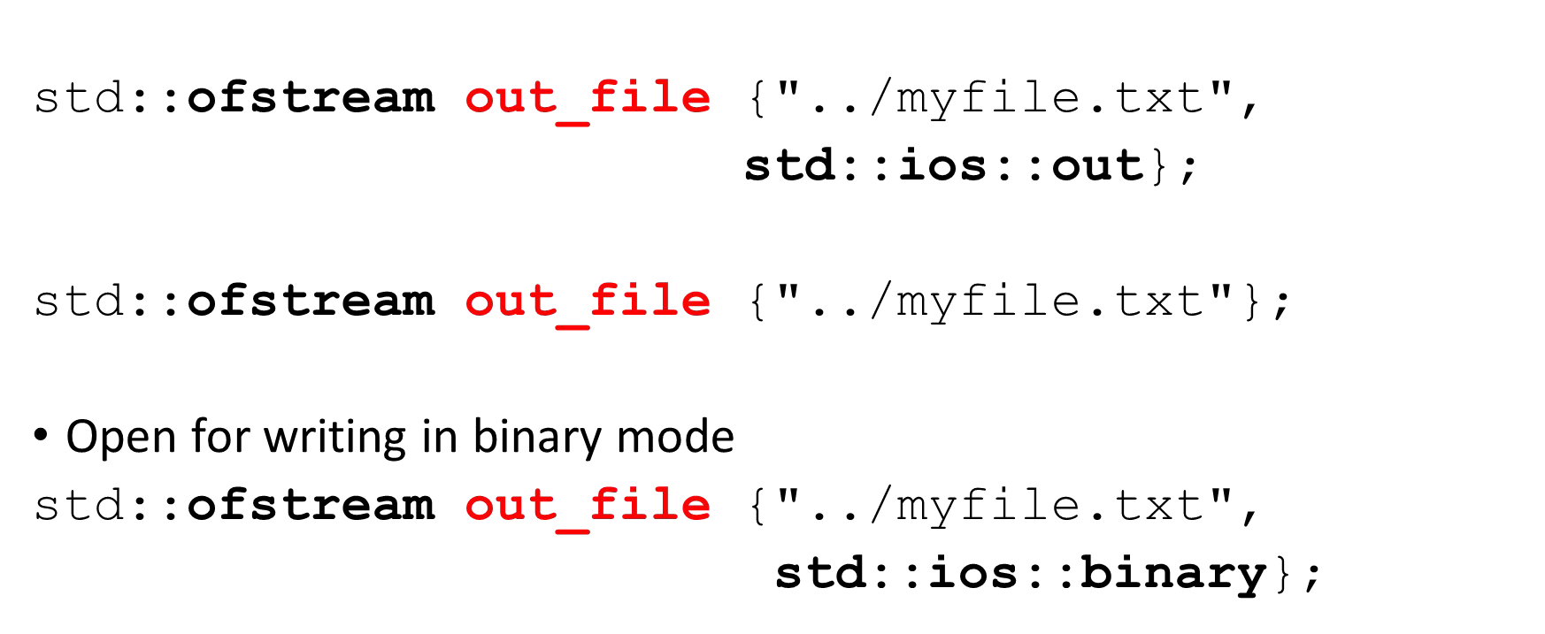

Opening a ﬁle for writing with (ofstream)

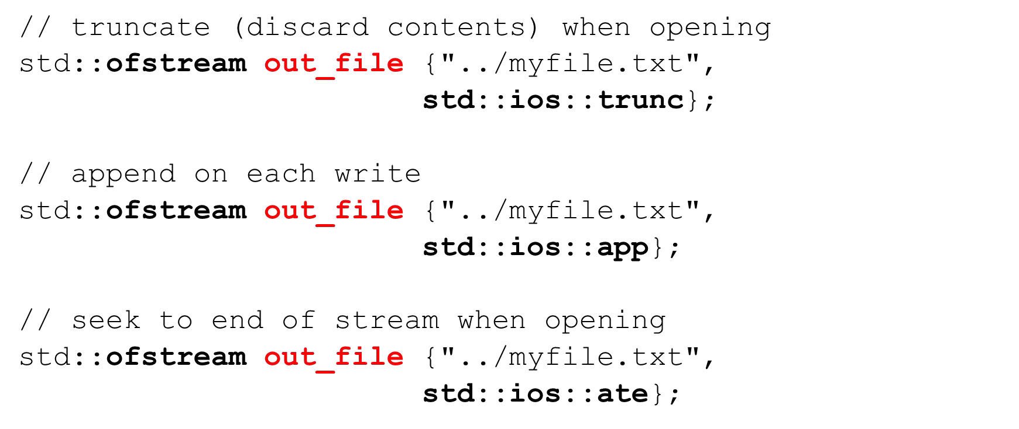

Opening a ﬁle for writing with open

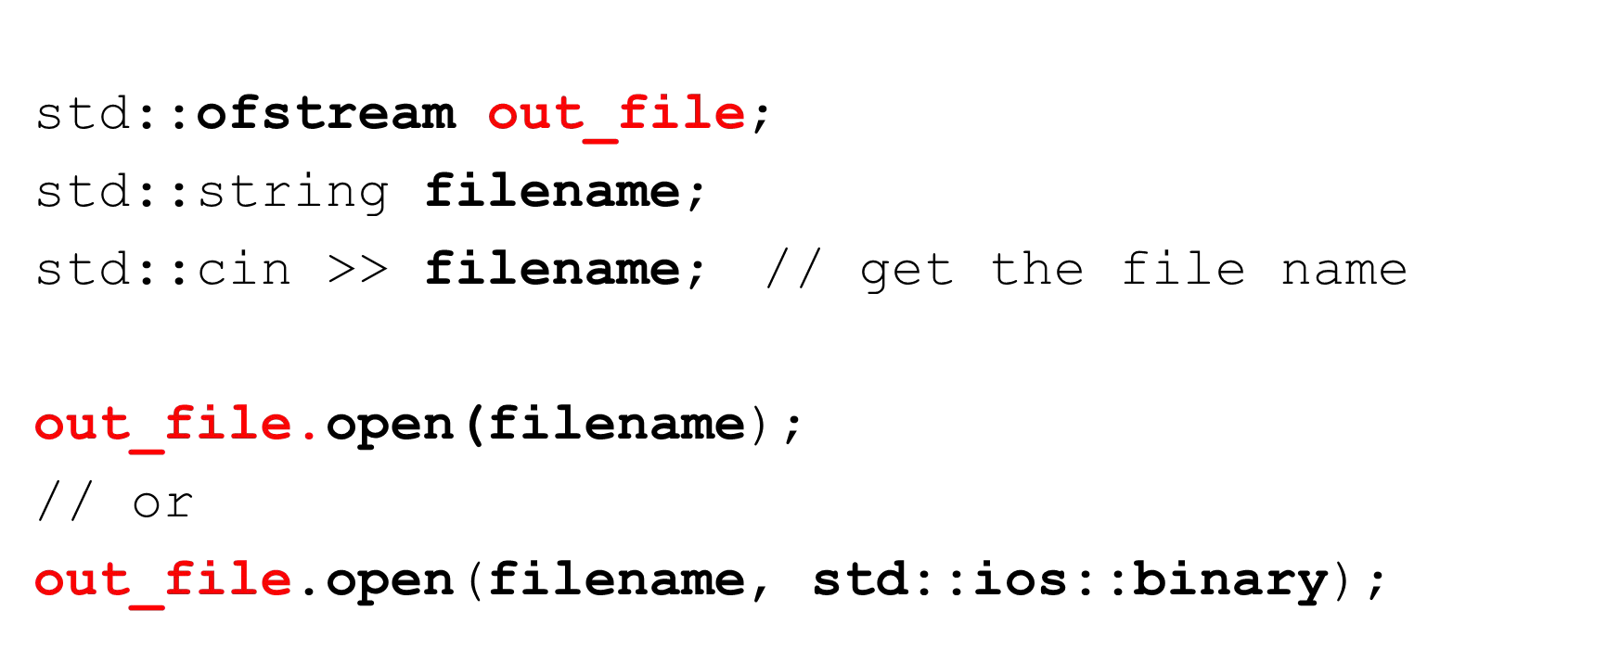

Check if ﬁle opened successfully (is_open)

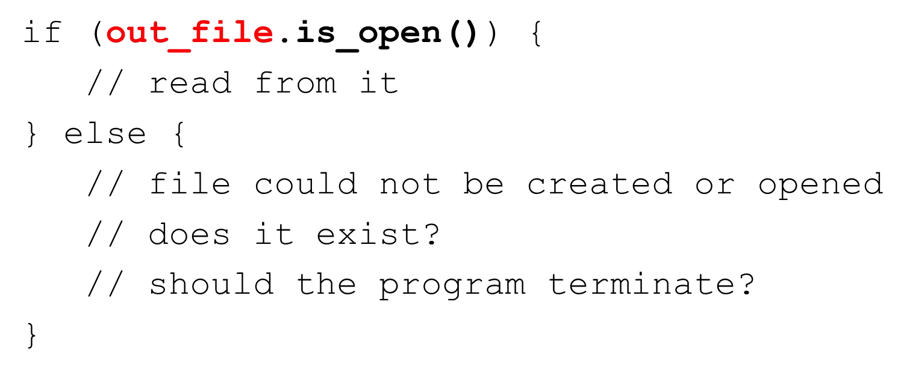

Check if ﬁle opened successfully – test the stream object

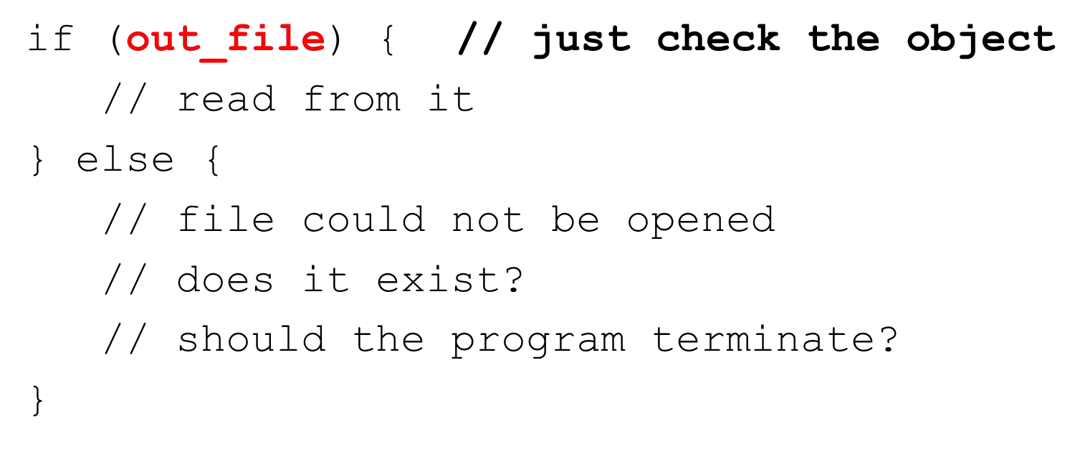

Closing a ﬁle

* Always close any open ﬁles to ﬂush out any unwritten data



Writing to ﬁles using (<<)

* We can use the insertion operator for formatted write
* Same way we used it with cout

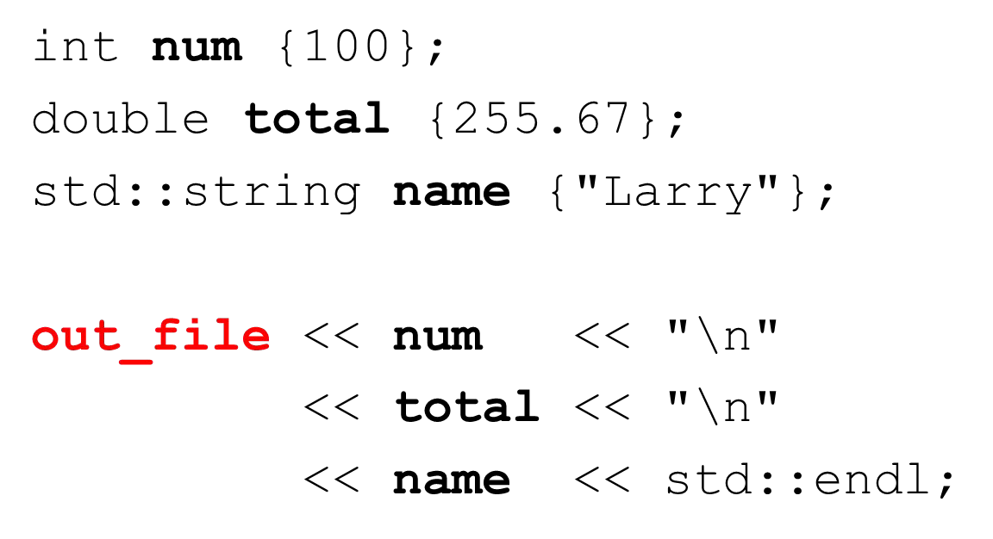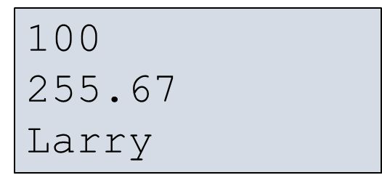

Copying a text ﬁle one line at a time

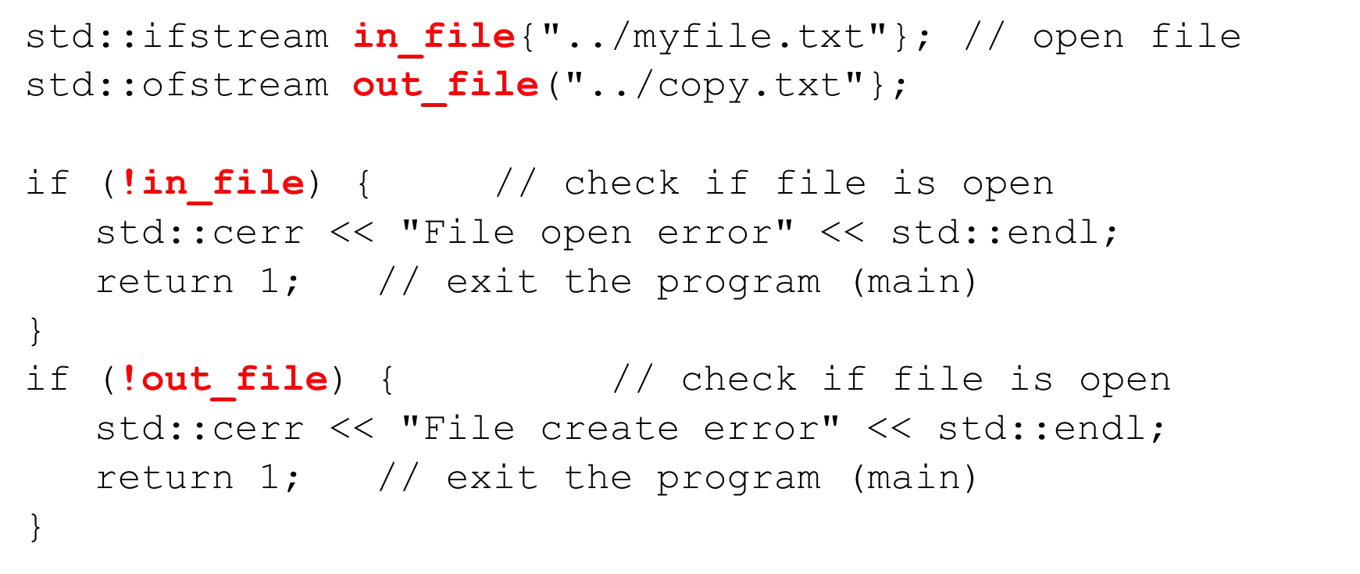

Copying a text ﬁle one line at a time

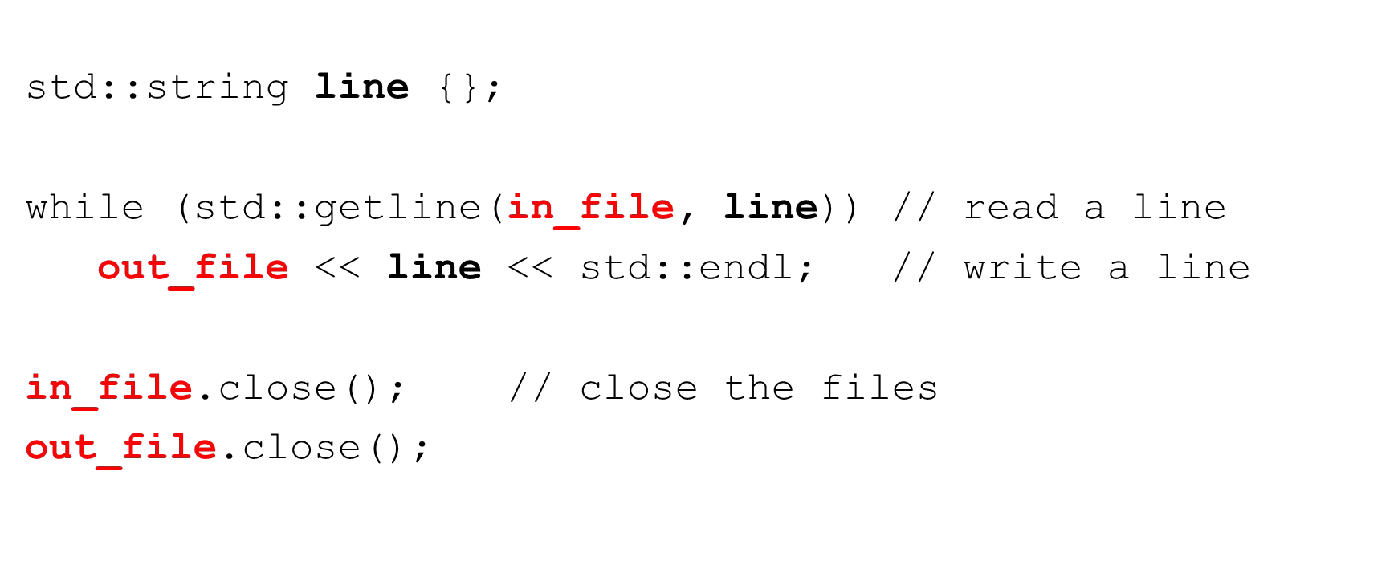

Copying a text ﬁle one character at a time (get/put)

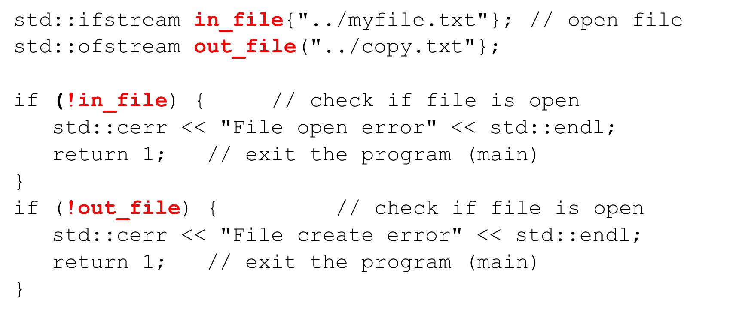

Copying a text ﬁle one character at a time (get/put)

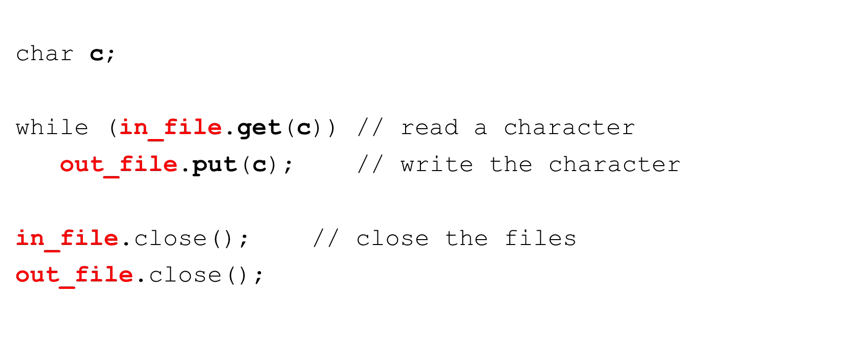

Using string streams

* Allow us to read or write from strings in memory much as we would read and write to ﬁles
* Very powerful
* Very useful for data validation

Using string streams

stringstream, istringstream and ostringstream

1. #include <sstream>
2. Declare an stringstream, istringstream or ostringstream object
3. Connect it to a std::string
4. Read/write data from/to the string stream using formatted I/O

Reading from a stringstream

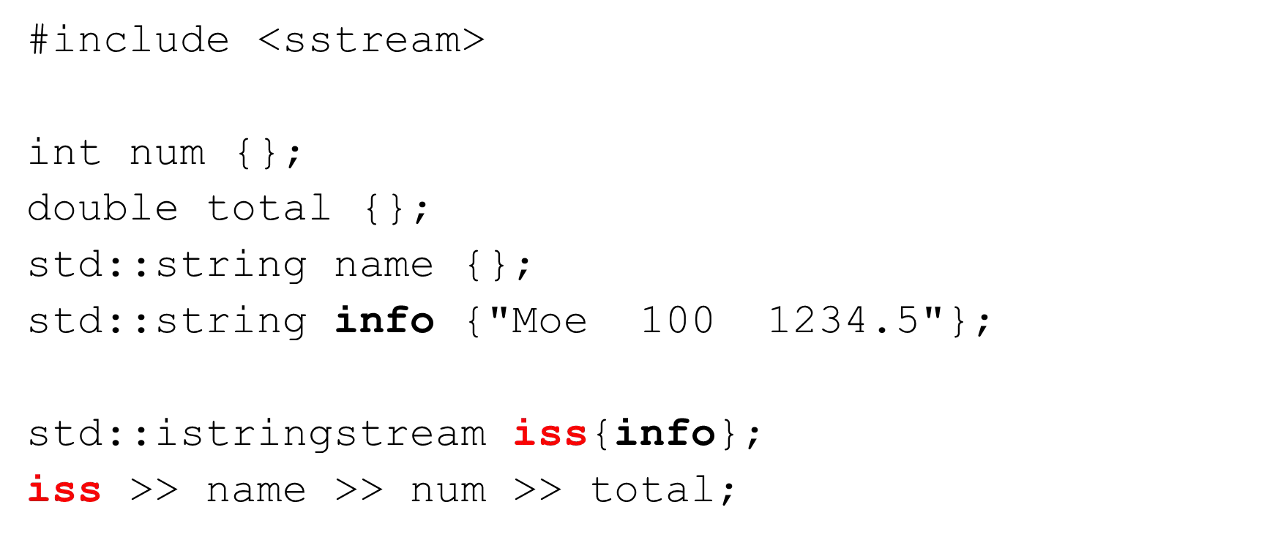

Writing to a stringstream

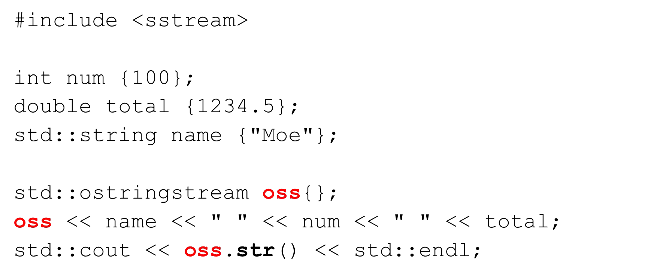

Validating input with stringstream

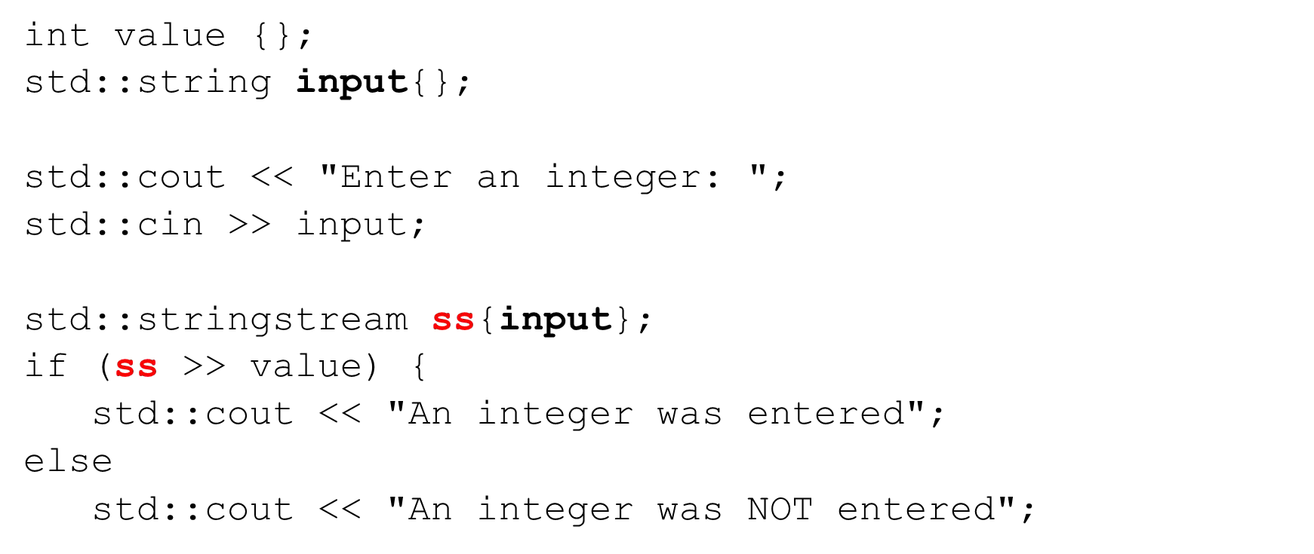

File Locations and IDEs

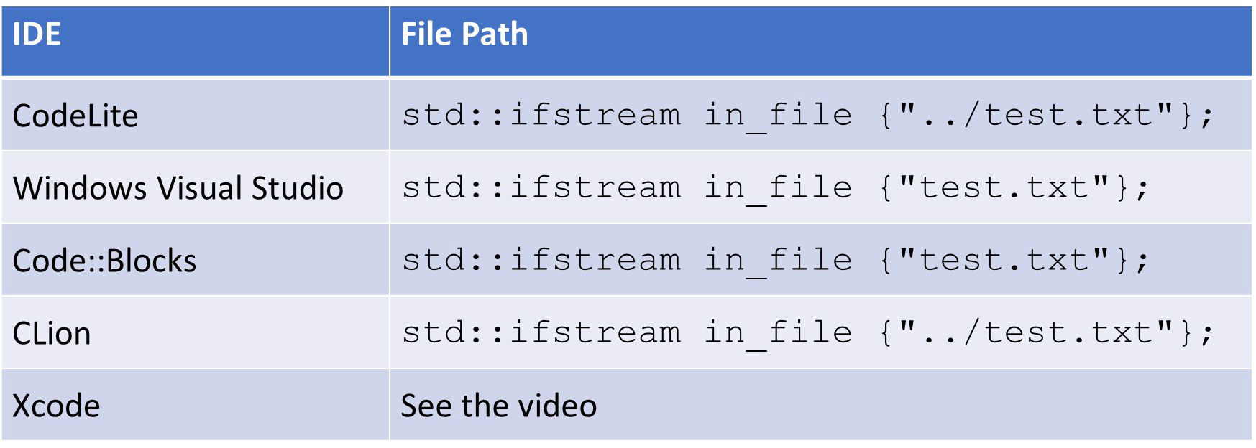

File Locations and IDEs

# Windows Visual Studio

File Locations and IDEs

# Code::Blocks

File Locations and IDEs

# CLion

File Locations and IDEs

# Xcode

## Section Overview

The Standard Template Library

* What is the STL
* Generic programming/ Meta-programming
  + Preprocessor macros
  + Function templates
  + Class templates
* STL Containers
* STL Iterators
* STL Algorithms
* Array
* Vector
* Deque
* List and Forward List
* Set and Multi Set
* Map and Multi Map
* Stack and Queue
* Priority Queue
* Algorithms

## What is the STL?

* + A library of powerful, reusable, adaptable, generic classes and functions
  + Implemented using C++ templates
  + Implements common data structures and algorithms
  + Huge class library!!
  + Alexander Stepanov (1994)

## Why use the STL?

* + Assortment of commonly used containers
  + Known time and size complexity
  + Tried and tested – Reusability!!!
  + Consistent, fast, and type-safe
  + Extensible
  + Containers
    - Collections of objects or primitive types (array, vector, deque, stack, set, map, etc.)
  + Algorithms
    - Functions for processing sequences of elements from containers (ﬁnd, max, count, accumulate, sort, etc.)
  + Iterators
    - Generate sequences of element from containers (forward, reverse, by value, by reference, constant, etc.)

A simple example

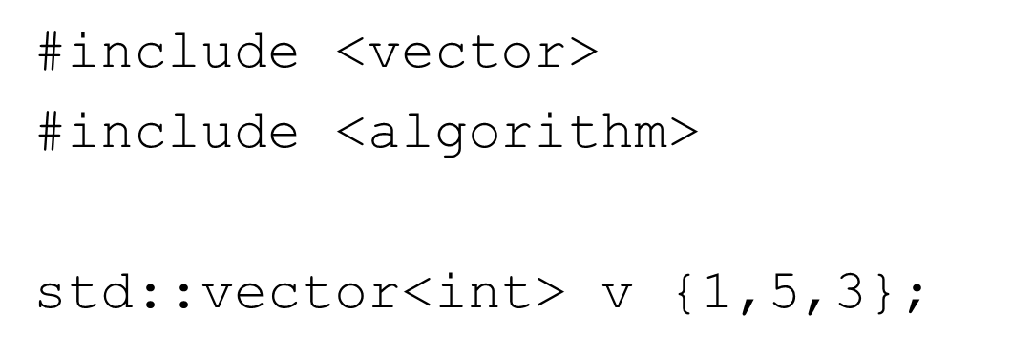

A simple example – sort a vector

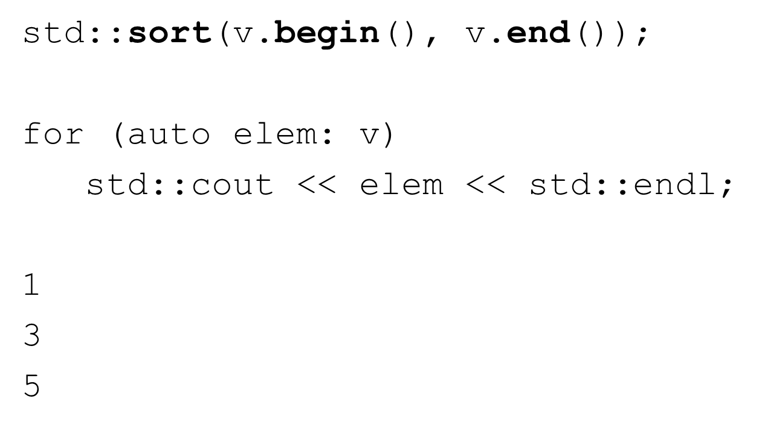

A simple example – reverse a vector

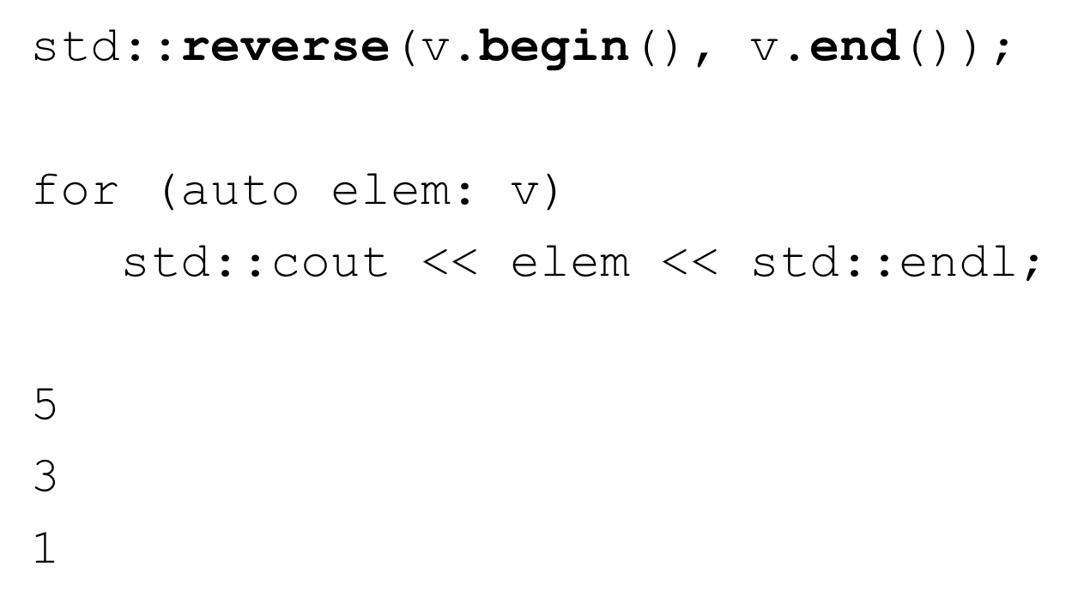

A simple example - accumulate

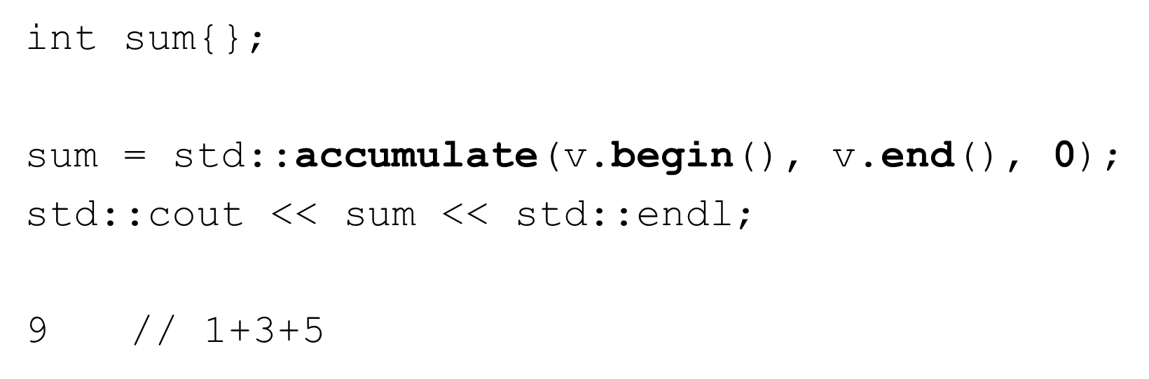

## Types of Containers

* Sequence containers
  + array, vector, list, forward_list, deque
* Associative containers
  + set, multi set, map, multi map
* Container adapters
  + stack, queue, priority queue

## Types of Iterators

* Input iterators – from the container to the program
* Output iterators – from the program to the container
* Forward iterators – navigate one item at a time in one direction
* Bi-directional iterators – navigate one item at a time both directions
* Random access iterators – directly access a container item

## Types of Algorithms

* About 60 algorithms in the STL
* Non-modifying
* Modifying

Generic Programming with macros

* Generic programming

“Writing code that works with a variety of types as arguments, as long as those argument types meet speciﬁc syntactic and semantic requirements”, Bjarne Stroustrup

* Macros*** beware ***
* Function templates
* Class templates

Macros (#define)

* C++ preprocessor directives
* No type information
* Simple substitution

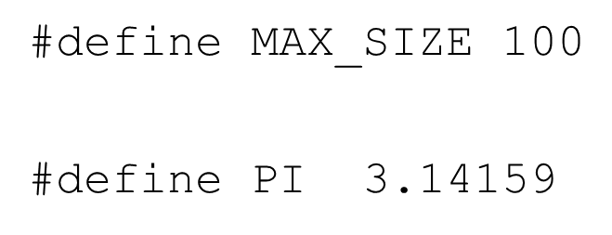

Macros (#define)

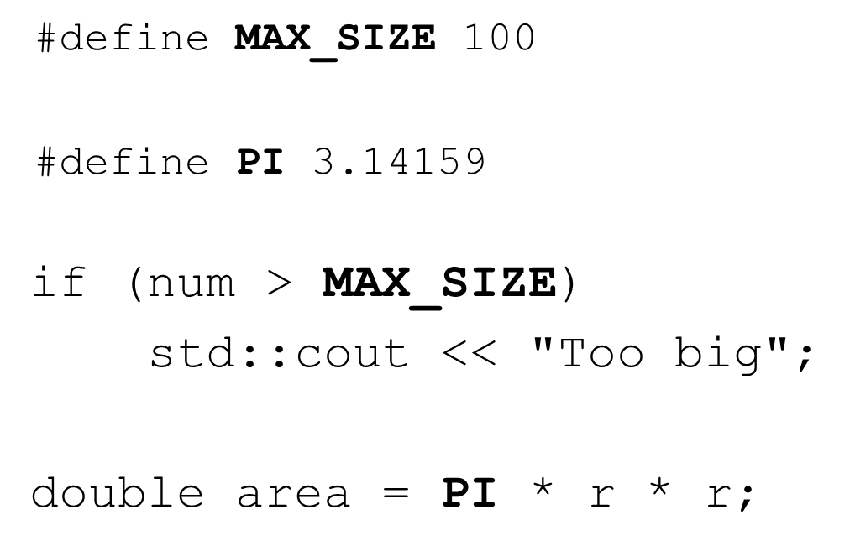

Macros (#define)

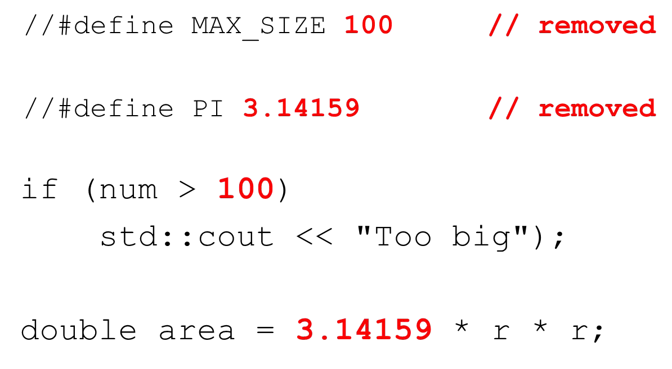

max function

* Suppose we need a function to determine the max of 2 integers

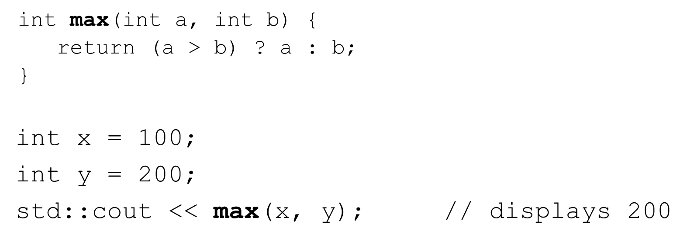

max function

* Now suppose we need to determine the max of 2 doubles, and 2 chars

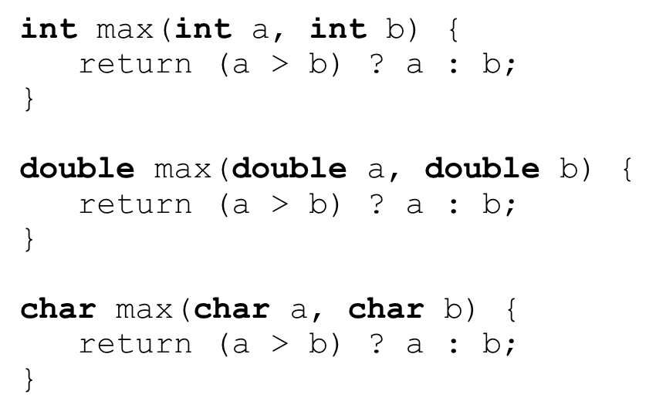

Macros with argument s (#define)

* We can write a generic macro with arguments instead

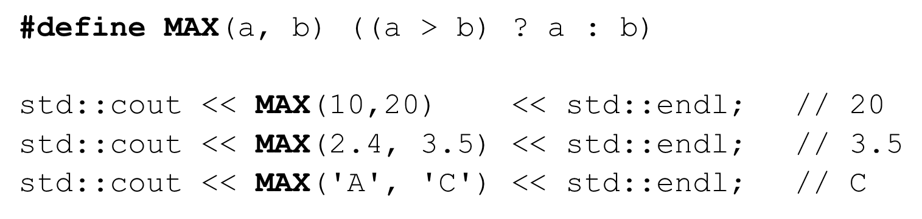

Macros with argument s (#define)

* We have to be careful with macros

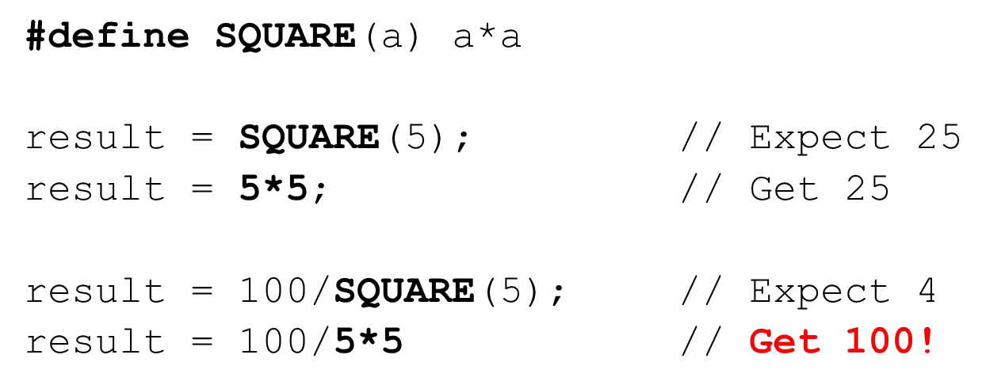

Macros with argument s (#define)

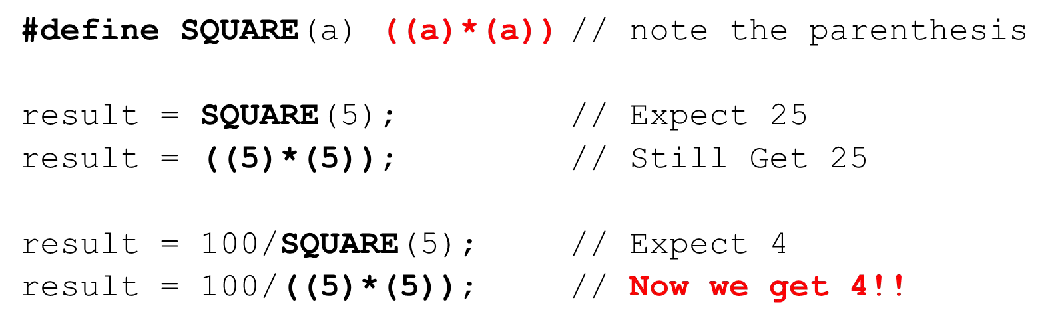

Generic Programming with function templates What is a C++ Template?

* Blueprint
* Function and class templates
* Allow plugging-in any data type
* Compiler generates the appropriate function/class from the blueprint
* Generic programming / meta-programming

Generic Programming with function templates

* Let’s revisit the max function from the last lecture

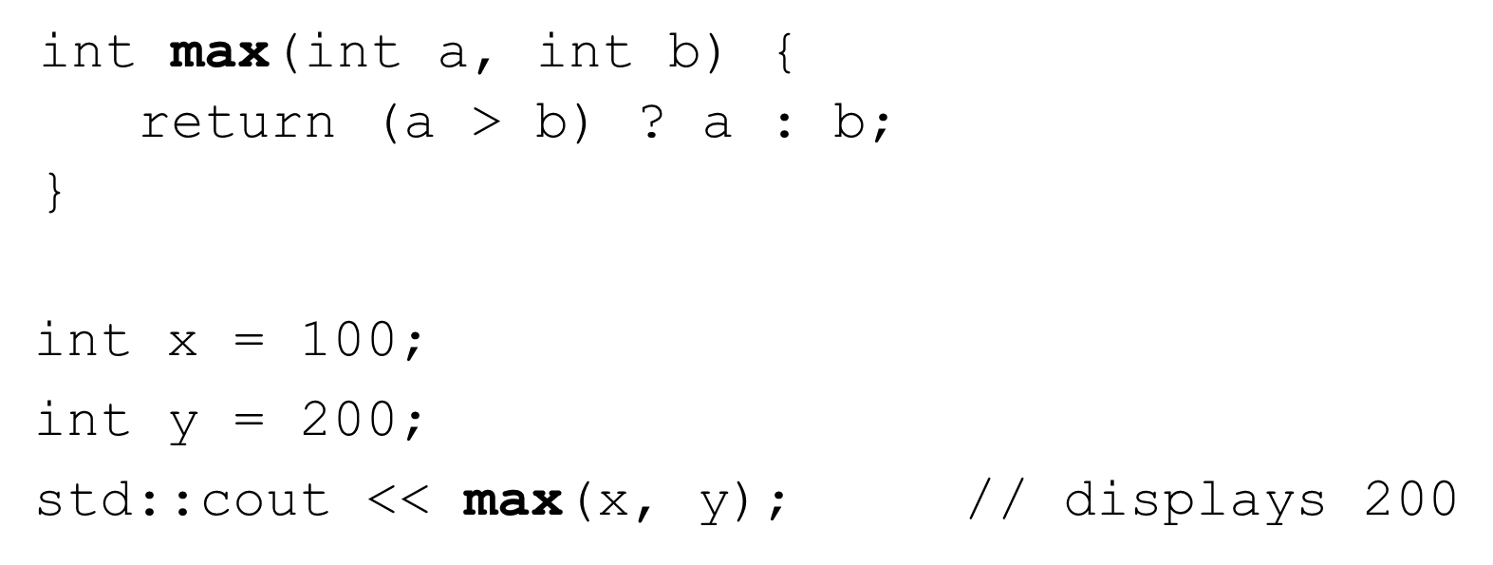

max function

* Now suppose we need to determine the max of 2 doubles, and 2 chars

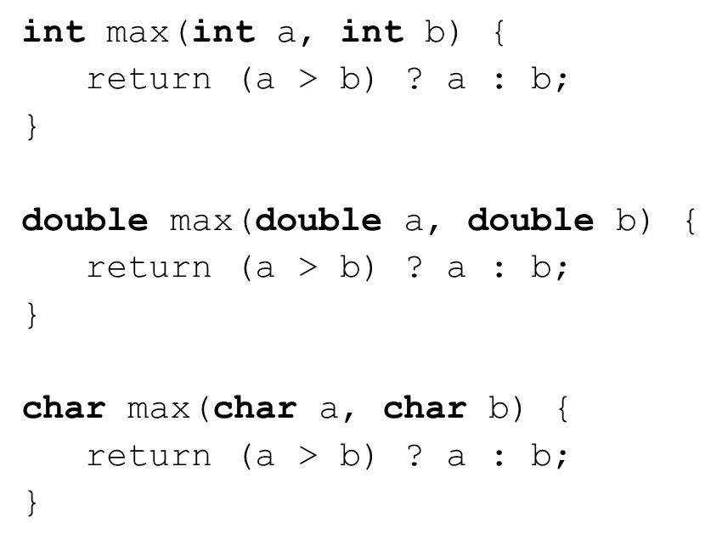

max function as a template function

* We can replace type we want to generalize with a name, say T
* But now this won’t compile

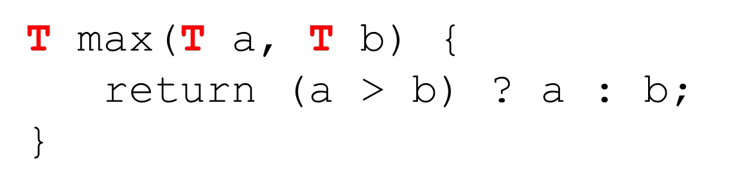

max function as a template function

* We need to tell the compiler this is a template function
* We also need to tell it that T is the template parameter

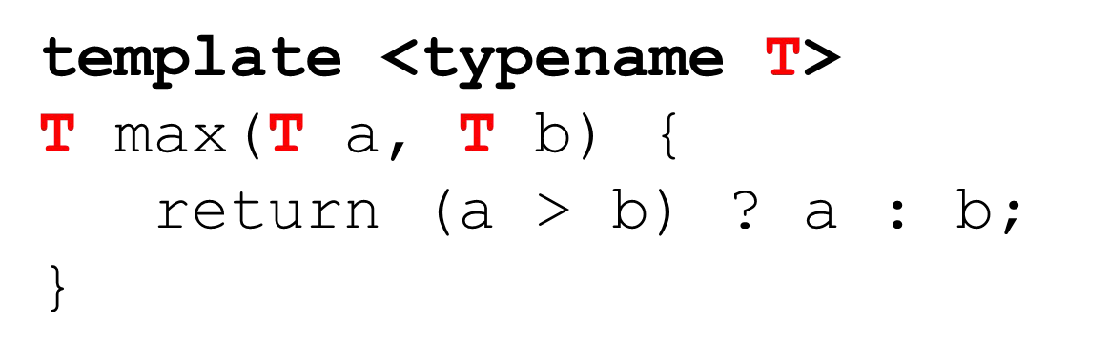

max function as a template function

* We may also use **class** instead of **typename**

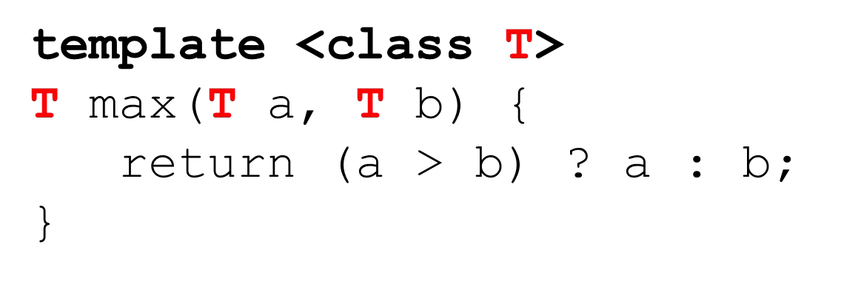

max function as a template function

* Now the compiler can generate the appropriate function from the template
* Note, this happens at compile-time!

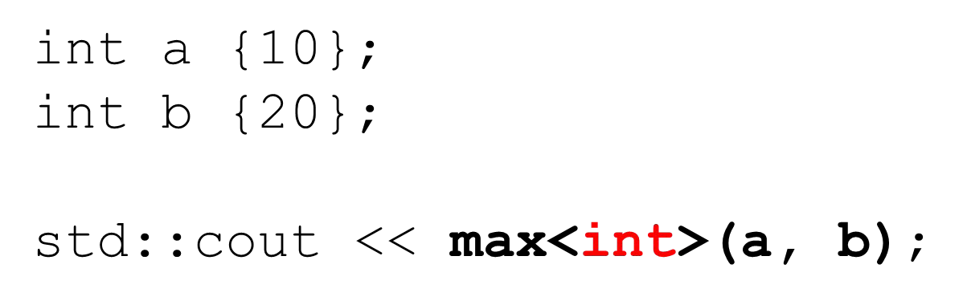

max function as a template function

* Many times the compiler can deduce the type and the template parameter is not needed
* Depending on the type of a and b, the compiler will ﬁgure it out

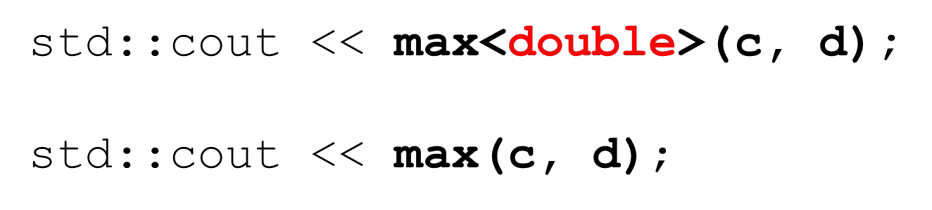

max function as a template function

* And we can use almost any type we need

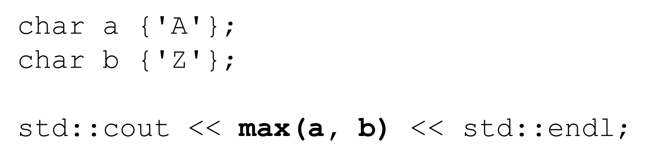

max function as a template function

* Notice the type MUST support the > operator either natively or as an overloaded operator (operator>)

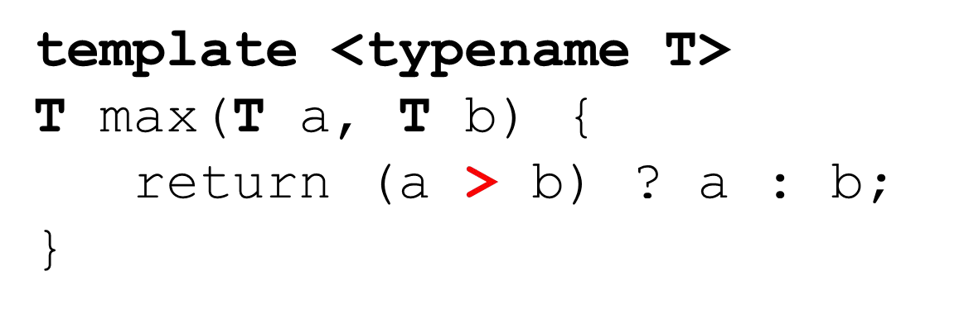

max function as a template function

* The following will not compile unless Player overloads operator>

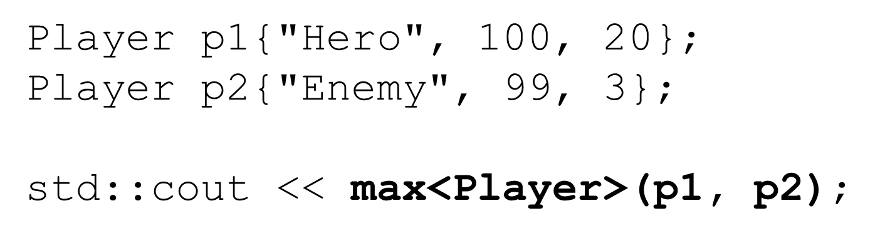

multiple types as template parameters

* We can have multiple template parameters
* And their types can be diﬀerent

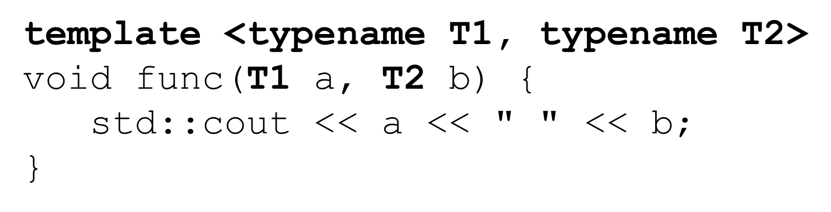

multiple types as template parameters

* When we use the function we provide the template parameters
* Often the compiler can deduce them

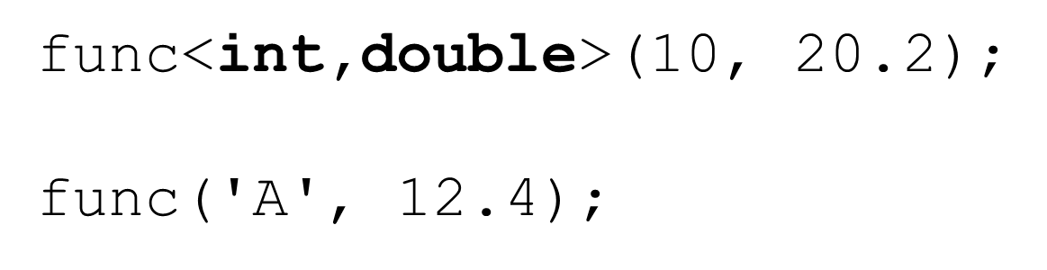

Generic Programming with class templates What is a C++ Class Template?

* Similar to function template, but at the class level
* Allows plugging-in any data type
* Compiler generates the appropriate class from the blueprint

Generic Programming with class templates

* Let’s say we want a class to hold Items where the item has a name and an integer

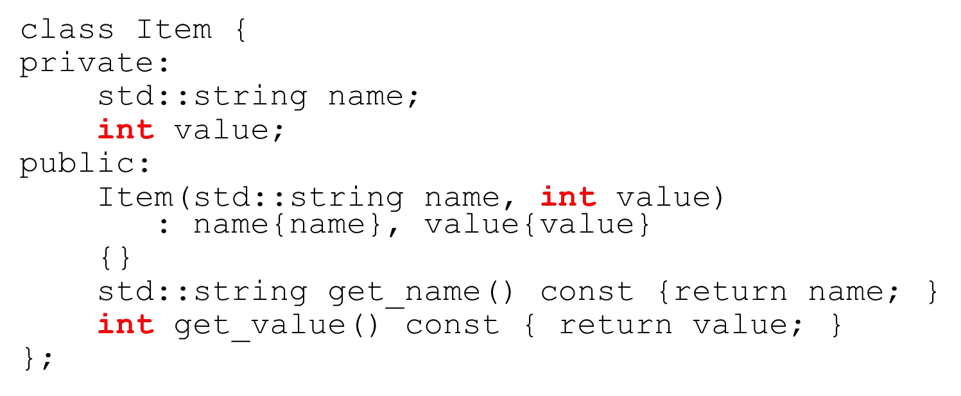

Generic Programming with class templates

* But we’d like our Item class to be able to hold any type of data in addition to the string
* We can’t overload class names
* We don’t want to use dynamic polymorphism

Generic Programming with class templates

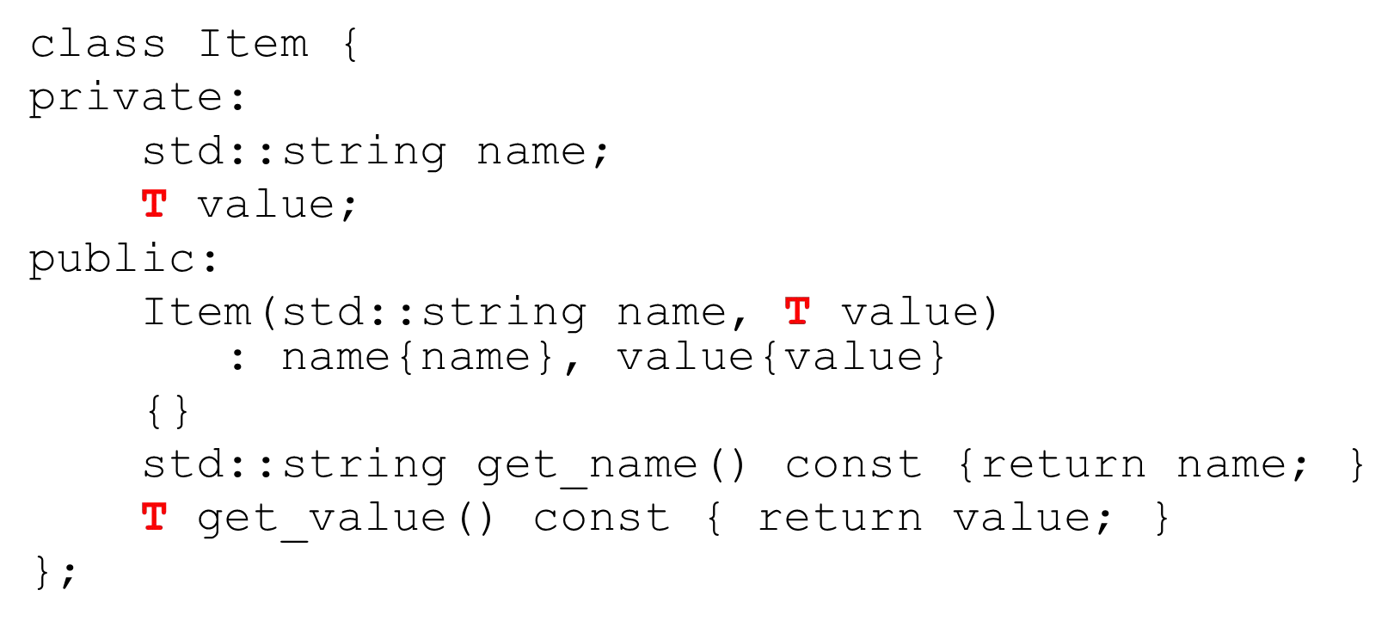

Generic Programming with class templates

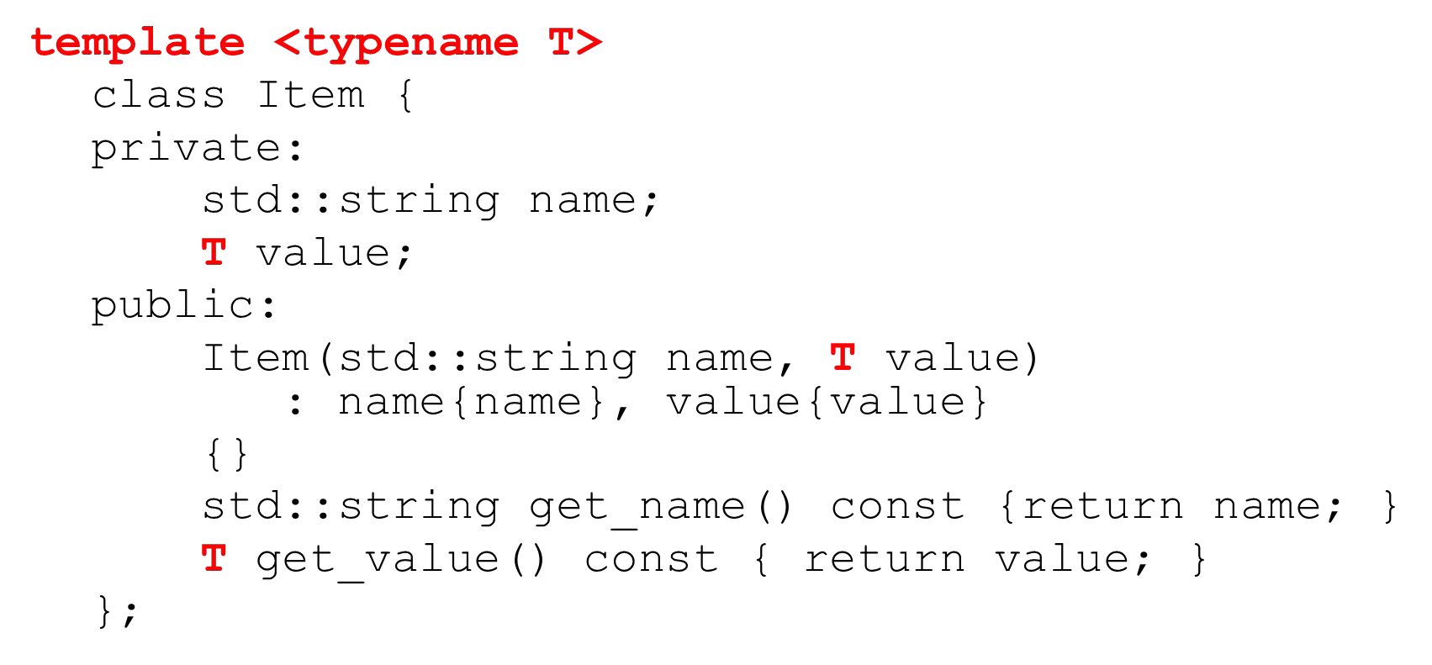

Generic Programming with class templates

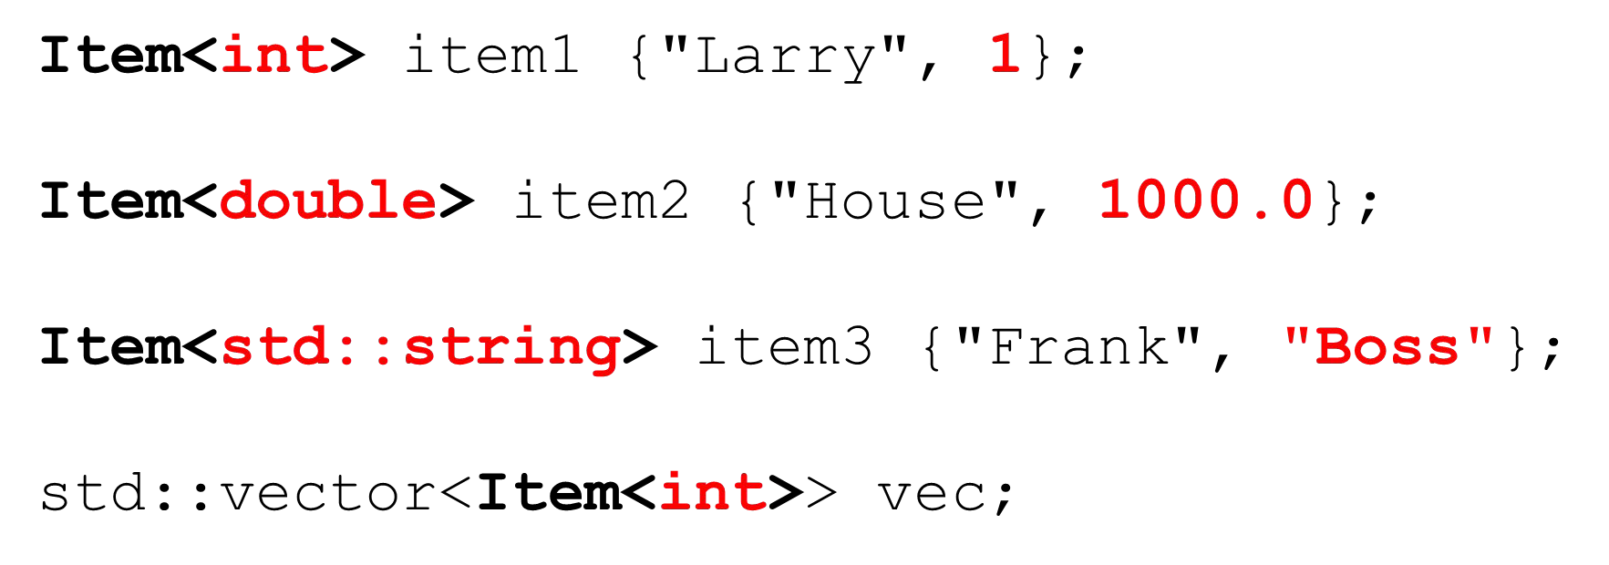

Multiple types as template parameters

* We can have multiple template parameters
* An their types can be diﬀerent

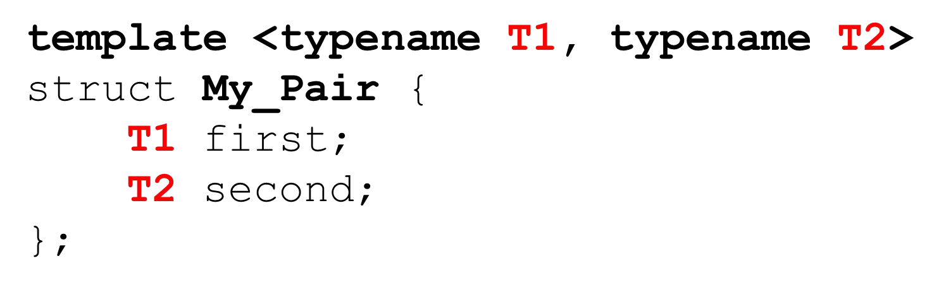

Multiple types as template parameters

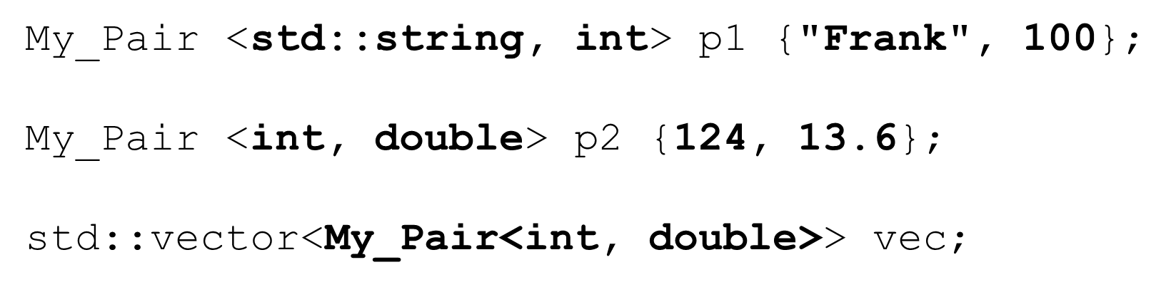

std::pair

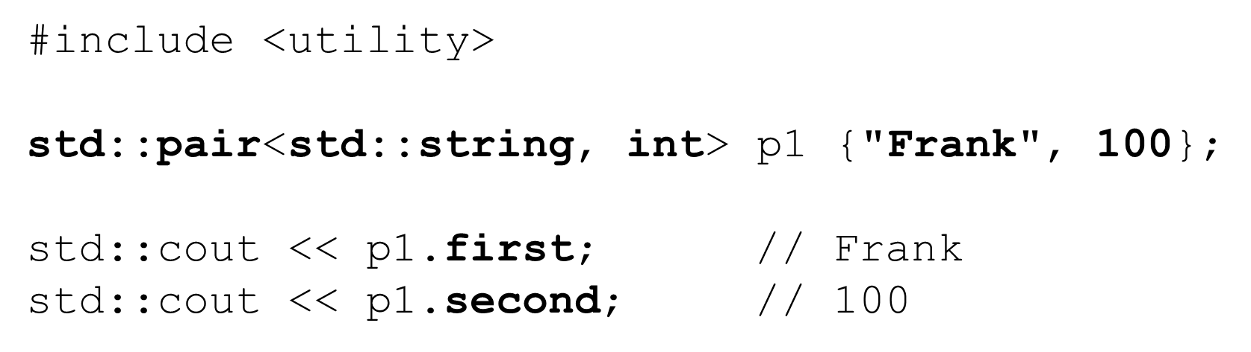

Containers

* Data structures that can store object of *almost* any type
  + Template-based classes
* Each container has member functions
  + Some are speciﬁc to the container
  + Others are available to all containers
* Each container has an associated header ﬁle
  + #include <*container_type*>

Containers – common

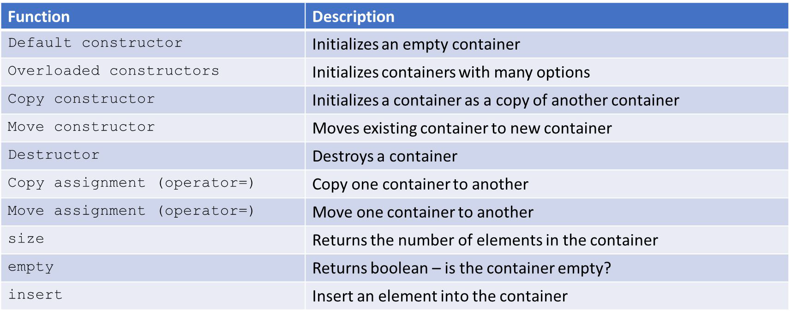

Containers – common

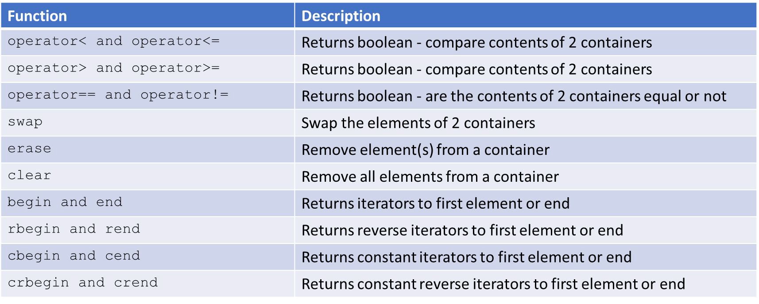

Container elements

What types of elements can we store in containers?

* A copy of the element will be stored in the container
  + All primitives OK
* Element should be
  + Copyable and assignable (copy constructor / copy assignment)
  + Moveable for eﬃciency (move Constructor / move Assignment)
* Ordered associative containers must be able to compare elements
  + operator<, operator==

Iterators

* Allows abstracting an arbitrary container as a sequence of elements
* They are objects that work like pointers by design
* Most container classes can be traversed with iterators

Declaring iterators

* Iterators must be declared based on the container type they will iterate over

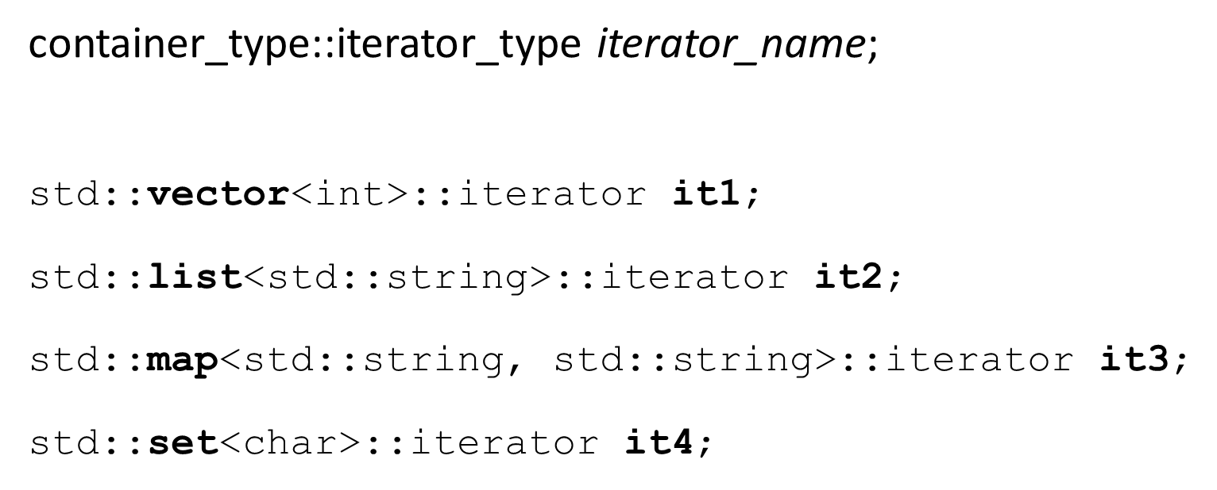

iterator begin and end methods

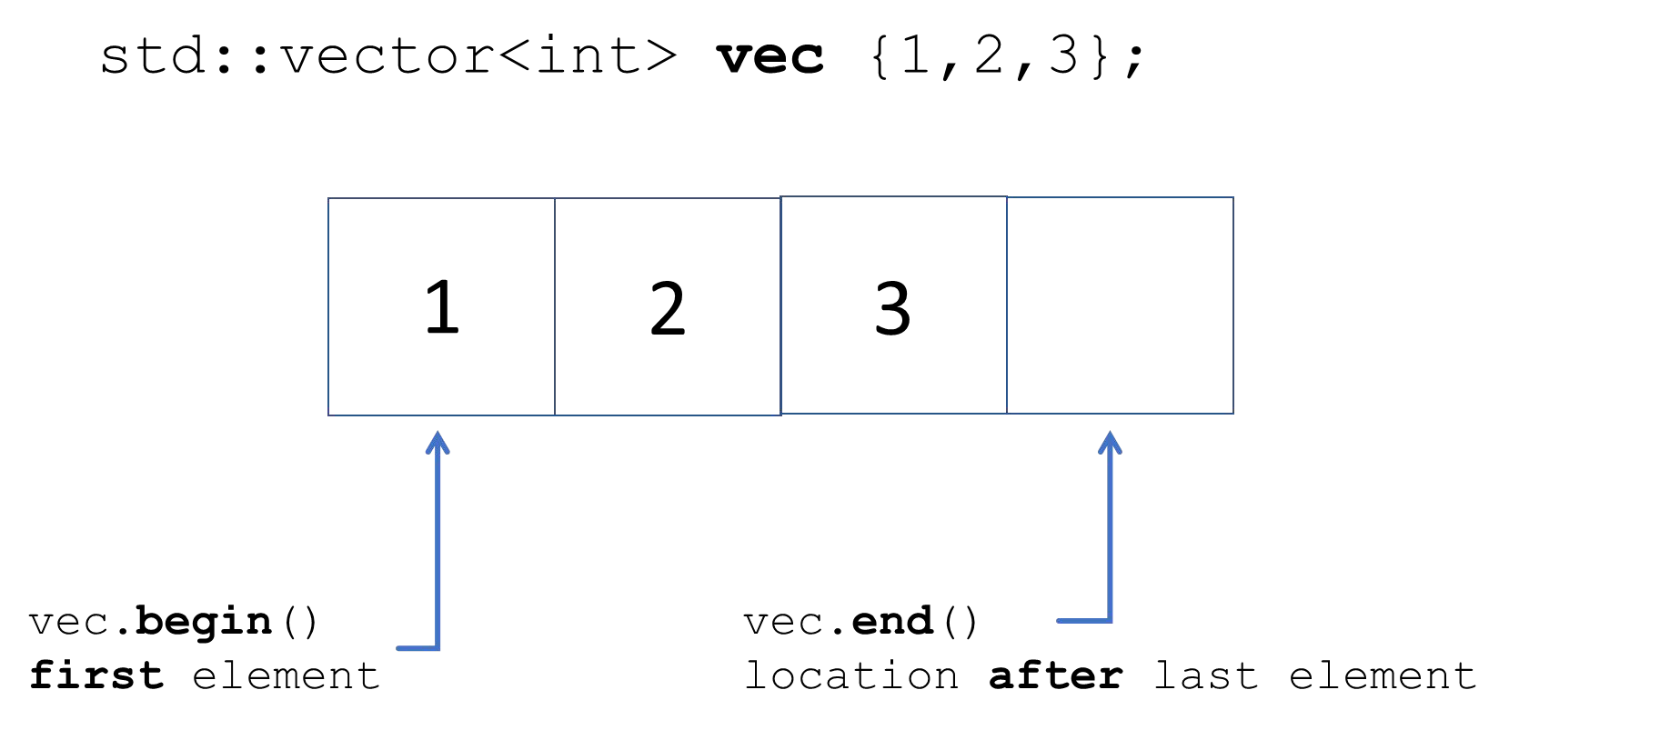

Declaring iterators

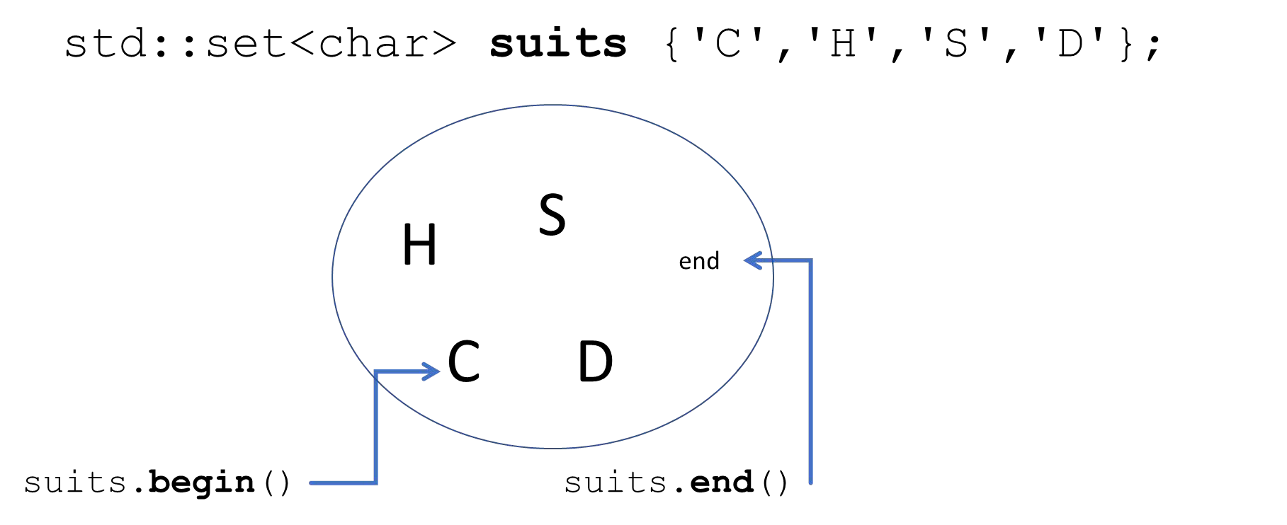

Initializing iterators

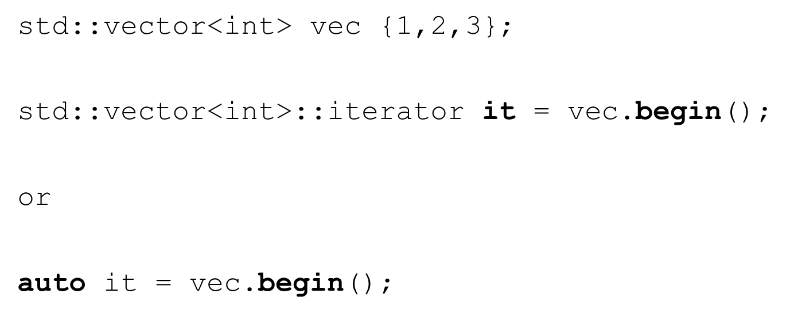

Operations with iterators (it)

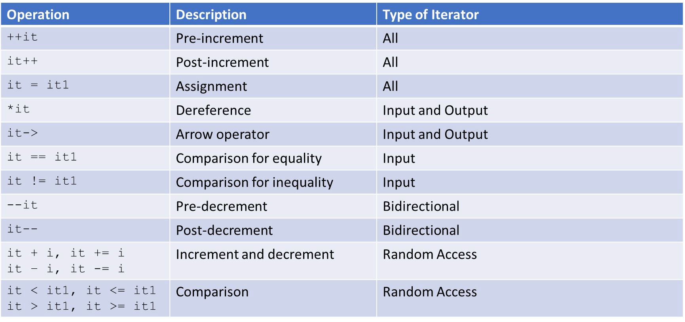

Using iterators – std::vector

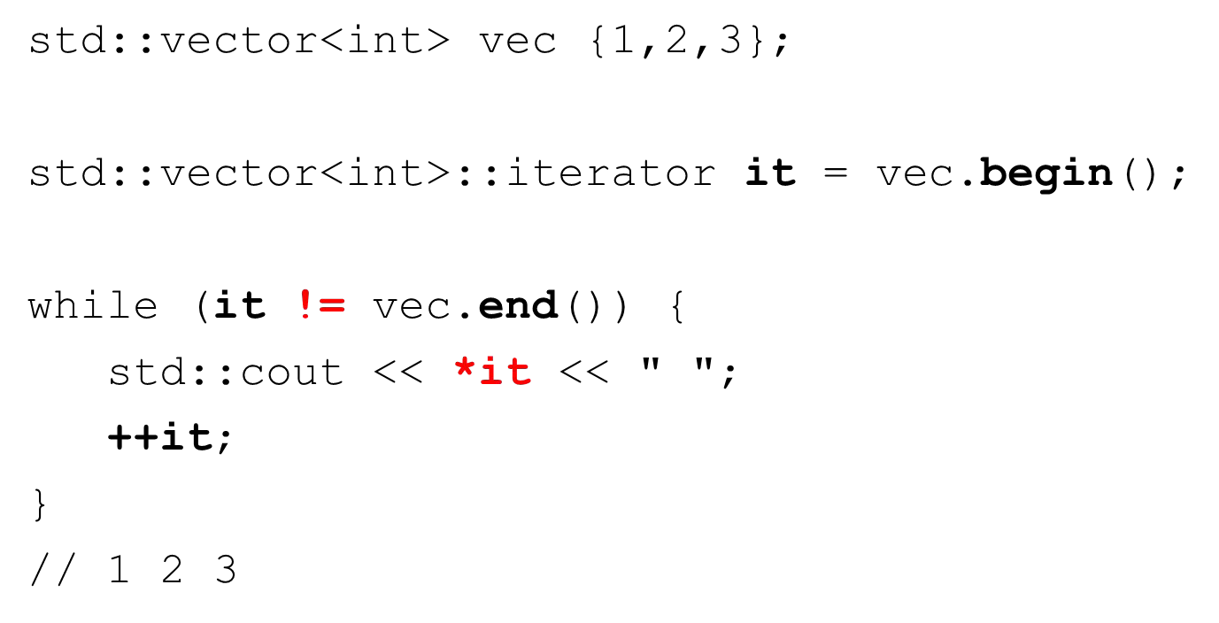

Using iterators – std::vector

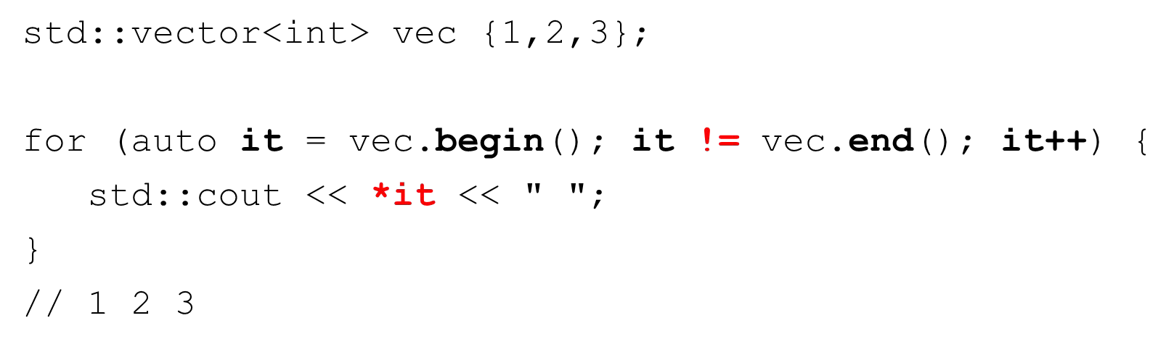

* This is how the range-based for loop works

Using iterators – std::set

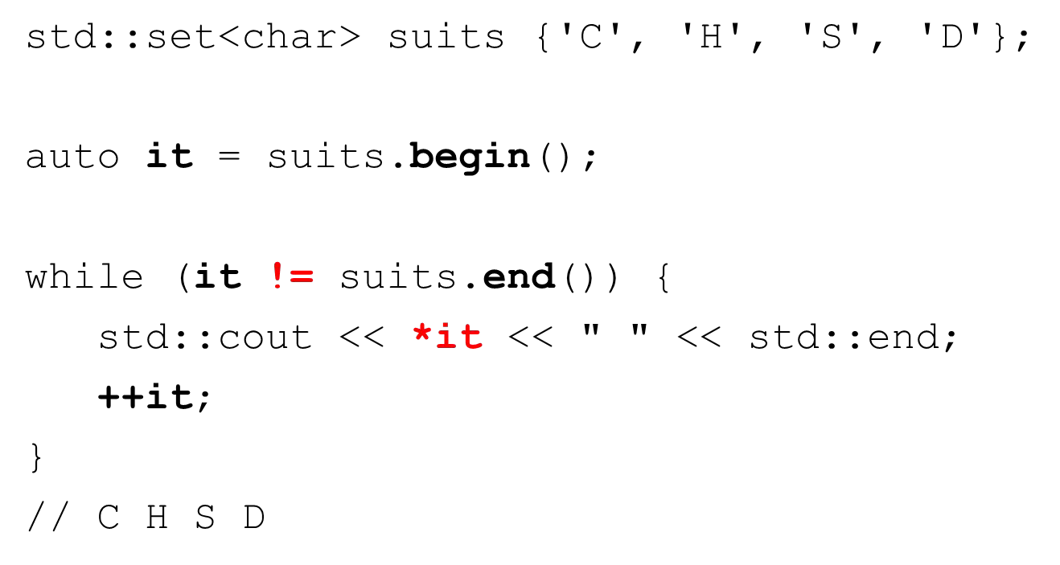

Reverse iterators

* Works in reverse
* Last element is the ﬁrst and ﬁrst is the last

•++ moves backward, -- moves forward

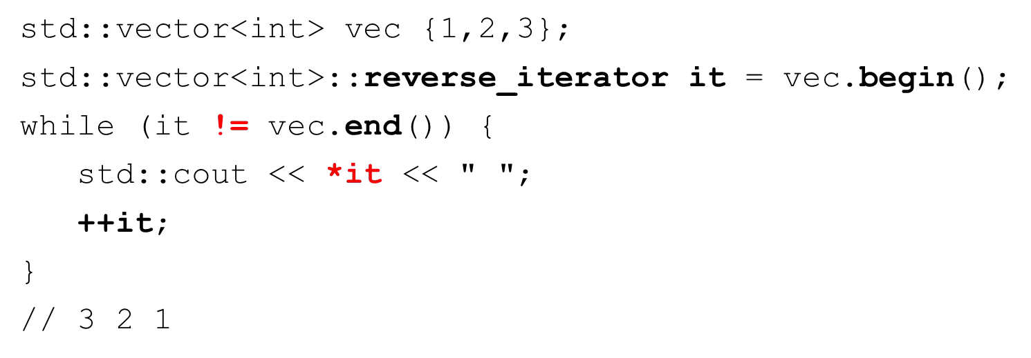

Other iterators

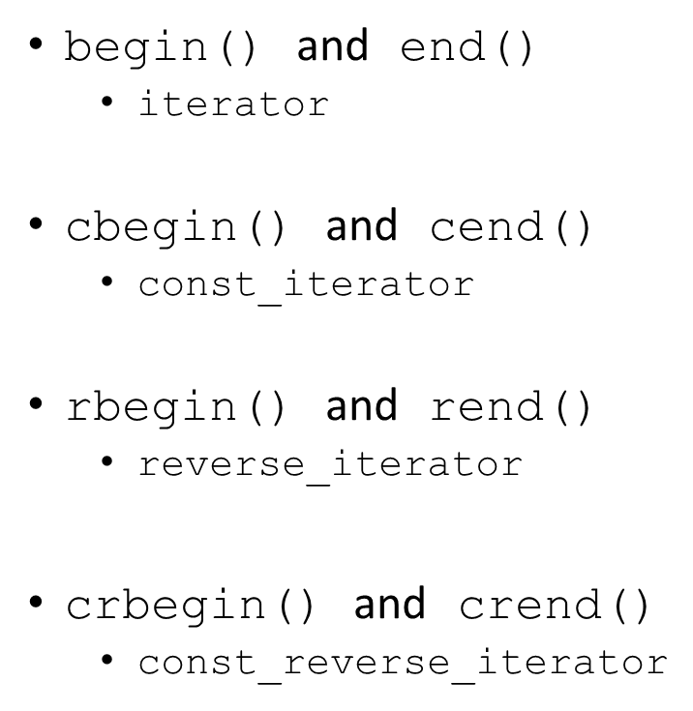

Algorithms

* STL algorithms work on sequences of container elements provided to them by an iterator
* STL has many common and useful algorithms
* Too many to describe in this section
  + <http://en.cppreference.com/w/cpp/algorithm>
* Many algorithms require extra information in order to do their work
  + Functors (function objects)
  + Function pointers
  + Lambda expressions (C++11)

Algorithms and iterators

* #include <algorithm>
* Diﬀerent containers support diﬀerent types of iterators
  + Determines the types of algorithms supported
* All STL algorithms expect iterators as arguments
  + Determines the sequence obtained from the container

Iterator invalidation

* Iterators point to container elements
* It’s possible iterators become invalid during processing
* Suppose we are iterating over a vector of 10 elements
  + And we clear() the vector while iterating? What happens?
  + Undeﬁned behavior – our iterators are pointing to invalid locations

Example algorithm – find with primitive types

* The find algorithm tries to locate the ﬁrst occurrence of an element in a container
* Lots of variations
* Returns an iterator pointing to the located element or end()

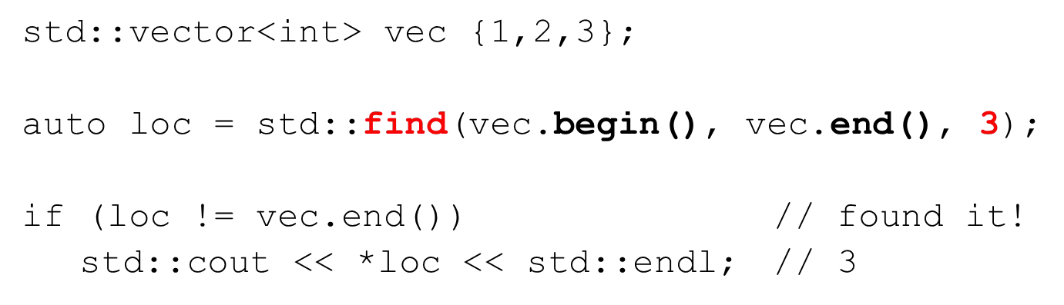

Example algorithm – find with user-deﬁned types

* Find needs to be able to compare object
* operator== is used and must be provided by your class

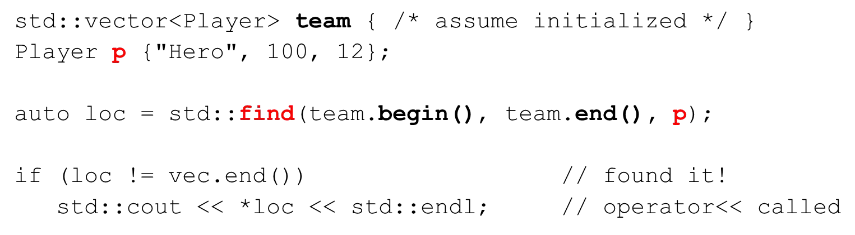

Example algorithm – for_each

* for_each algorithm applies a function to each element in the iterator sequence
* Function must be provided to the algorithm as:
  + Functor (function object)
  + Function pointer
  + Lambda expression (C++11)
* Let’s square each element

for_each - using a functor

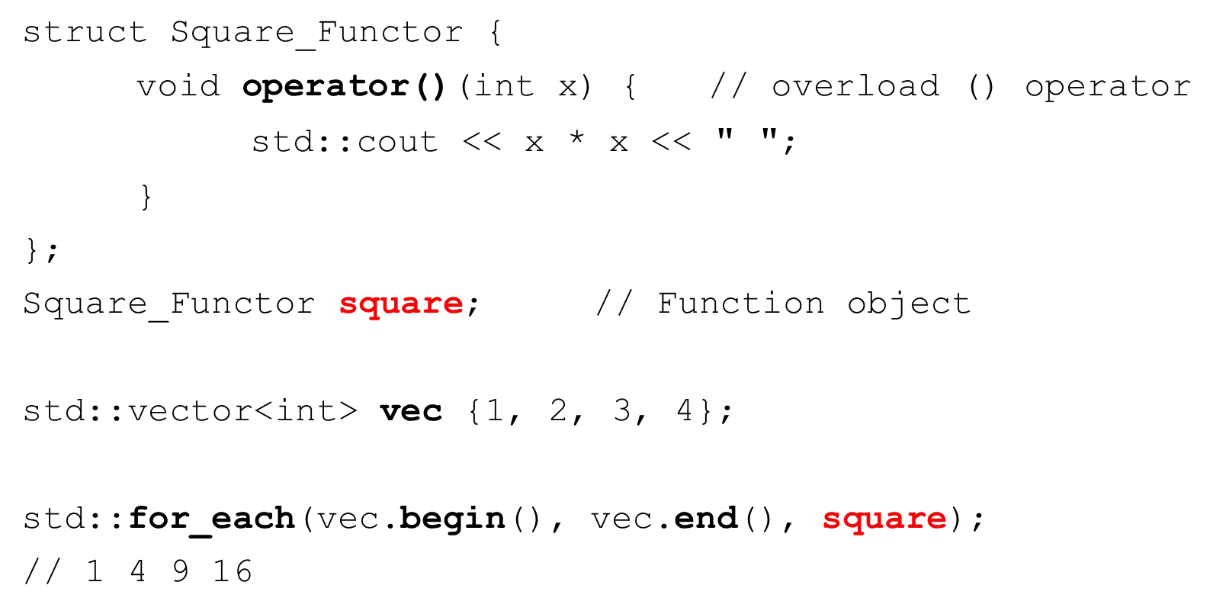

for_each - using a function pointer

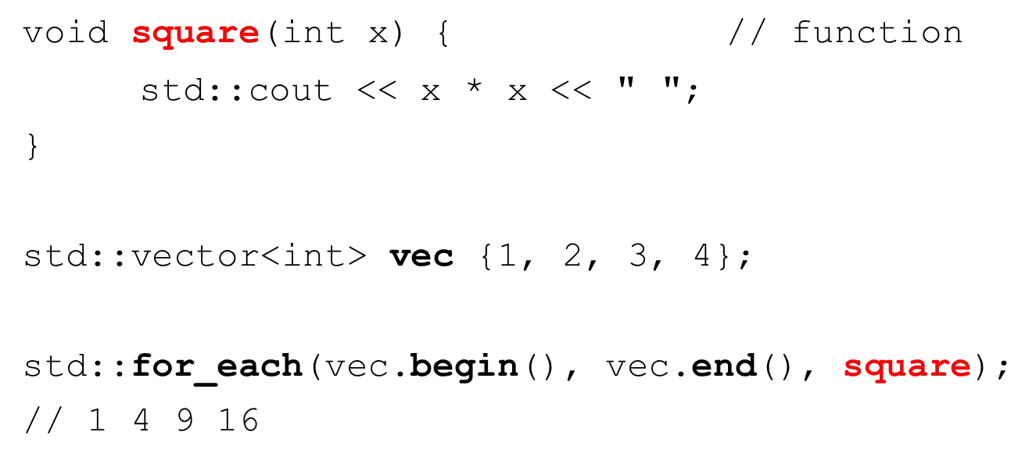

for_each - using a lambda expression

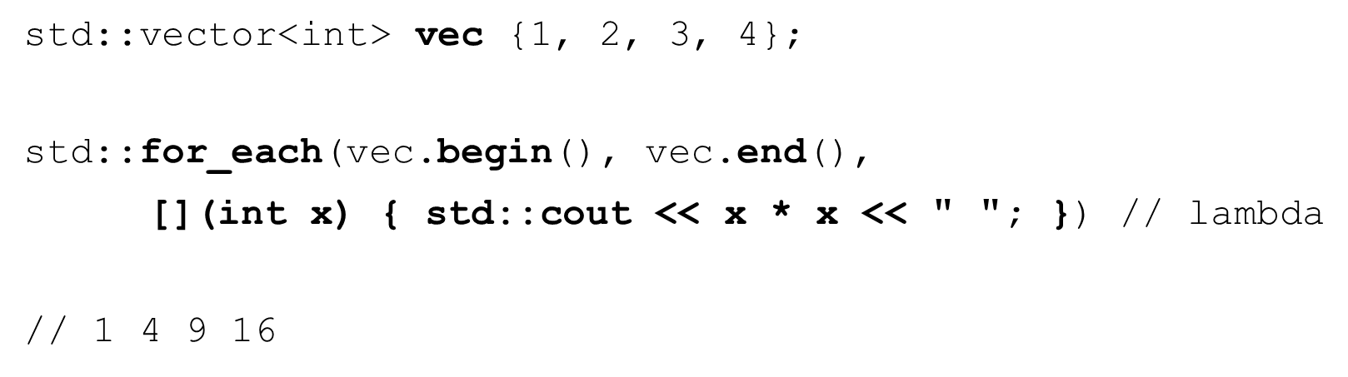

std::array (C++11)

#include <array>

* Fixed size
  + Size must be known at compile time
* Direct element access
* Provides access to the underlying raw array
* Use instead of raw arrays when possible
* All iterators available and do not invalidate

std::array – initialization and assignment

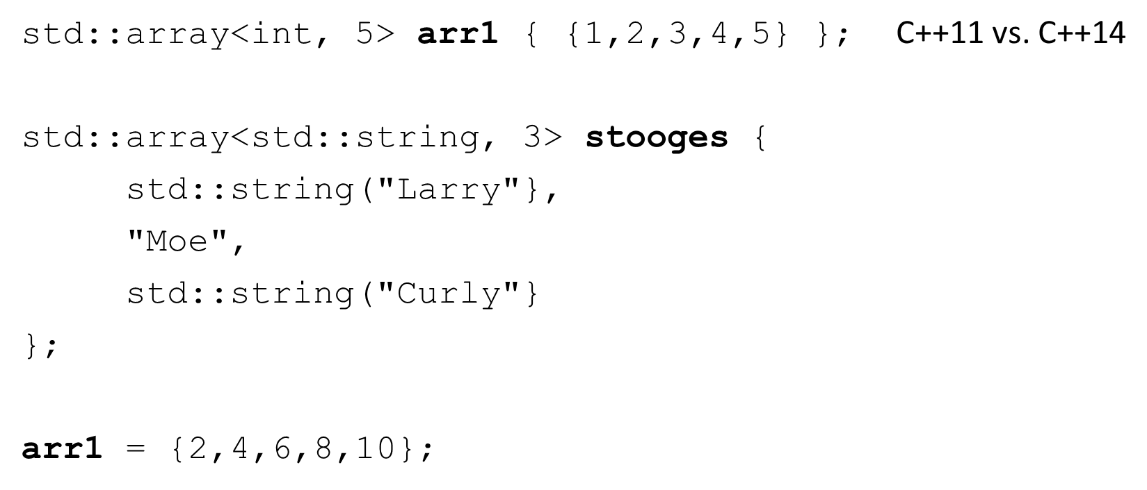

std::array – common methods

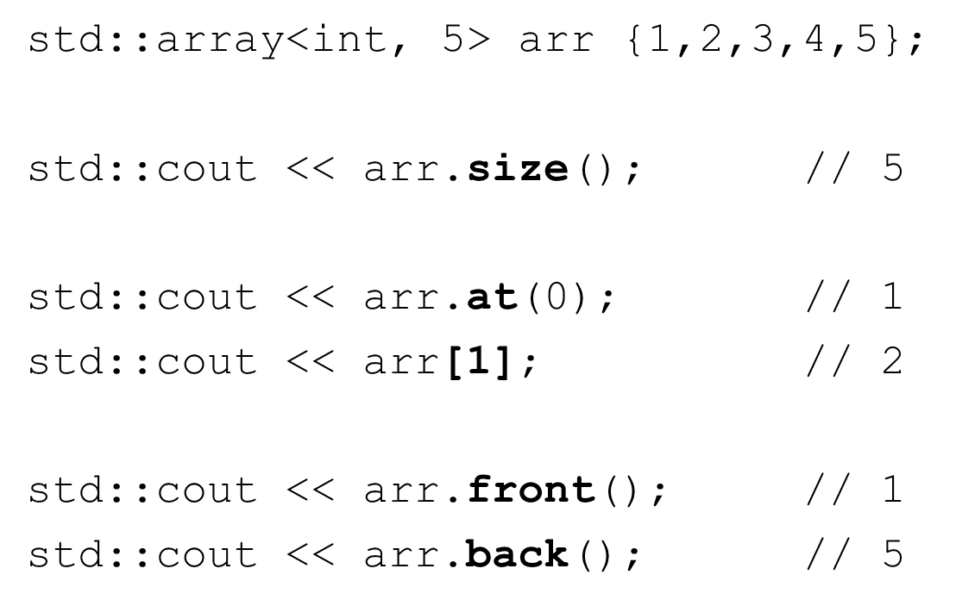

std::array – common methods

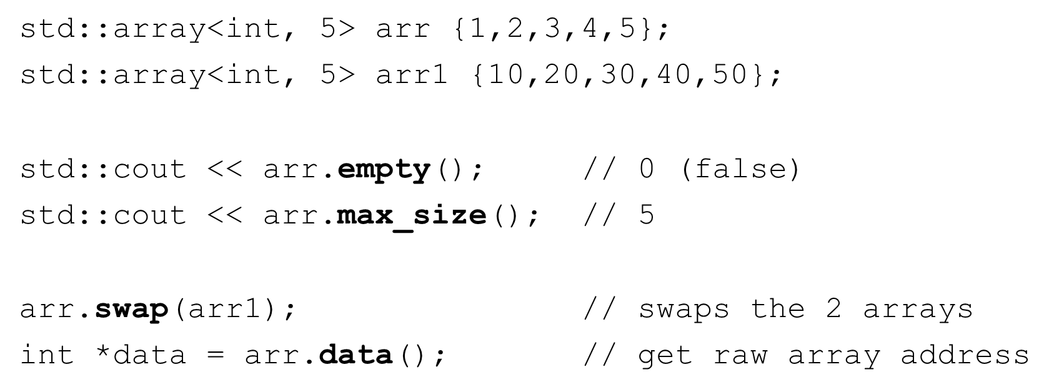

std::vector

#include <vector>

* Dynamic size
  + Handled automatically
  + Can expand and contract as needed
  + Elements are stored in contiguous memory as an array
* Direct element access (constant time)
* Rapid insertion and deletion at the back (constant time)
* Insertion or removal of elements (linear time)
* All iterators available and may invalidate

std::vector

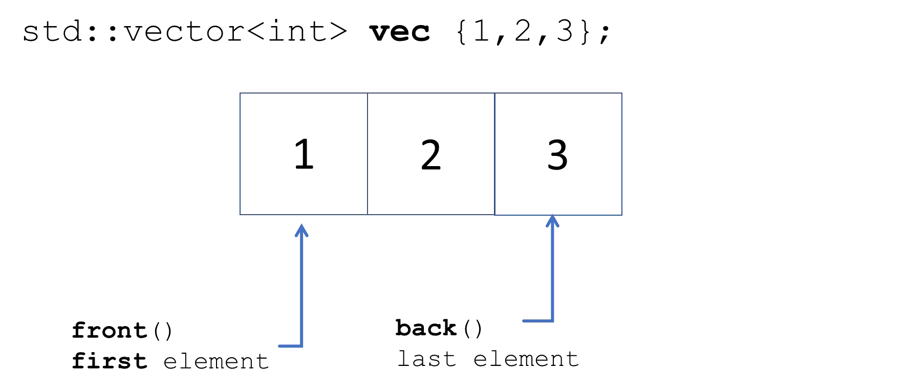

std::vector

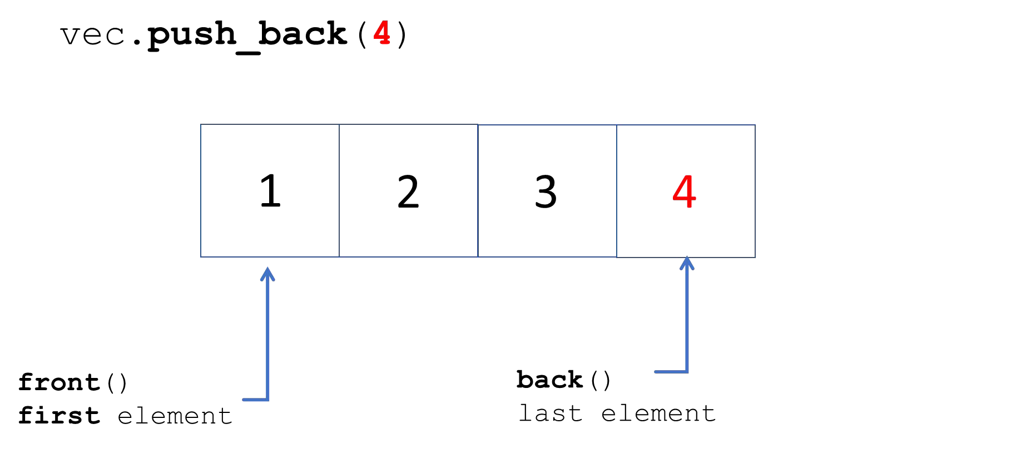

std::vector – initialization and assignment

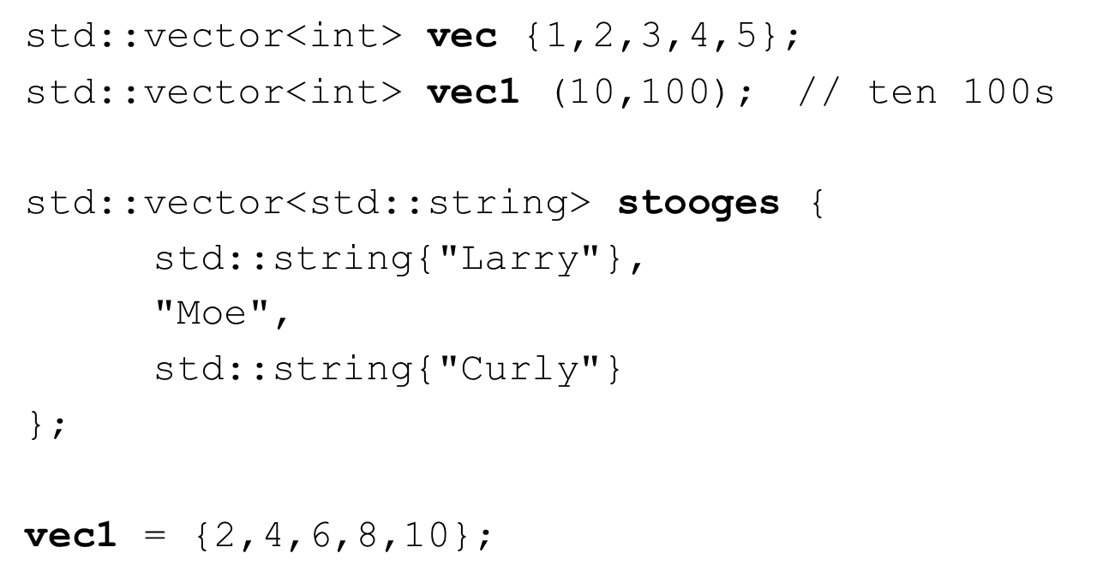

std::vector – common methods

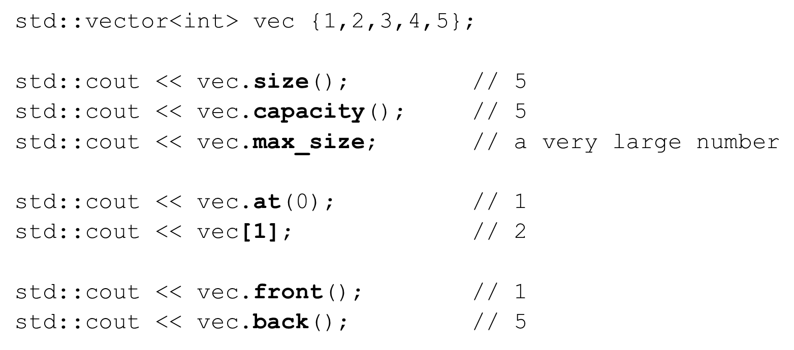

std::vector – common methods

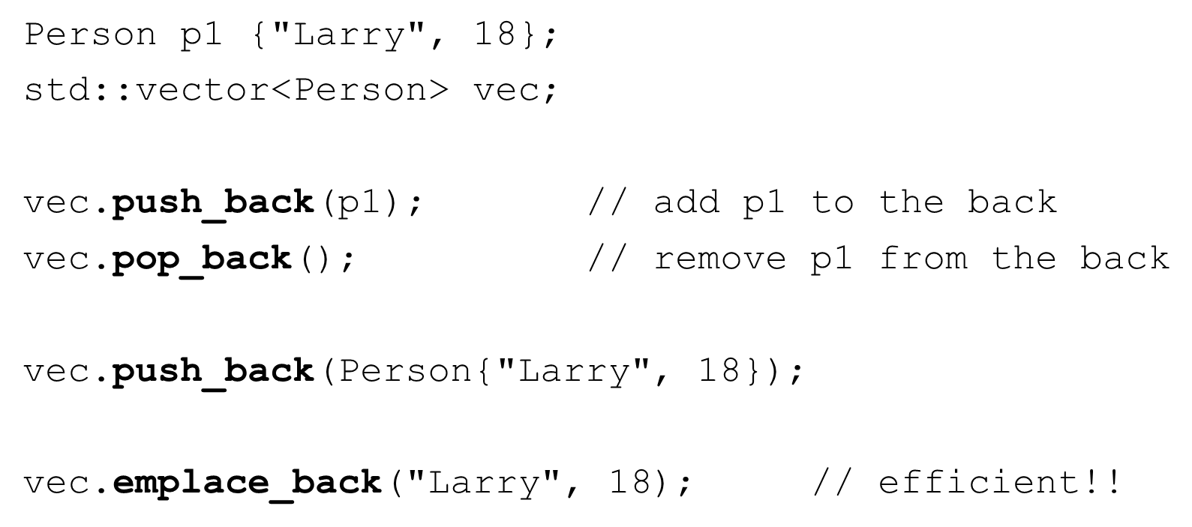

std::vector – common methods

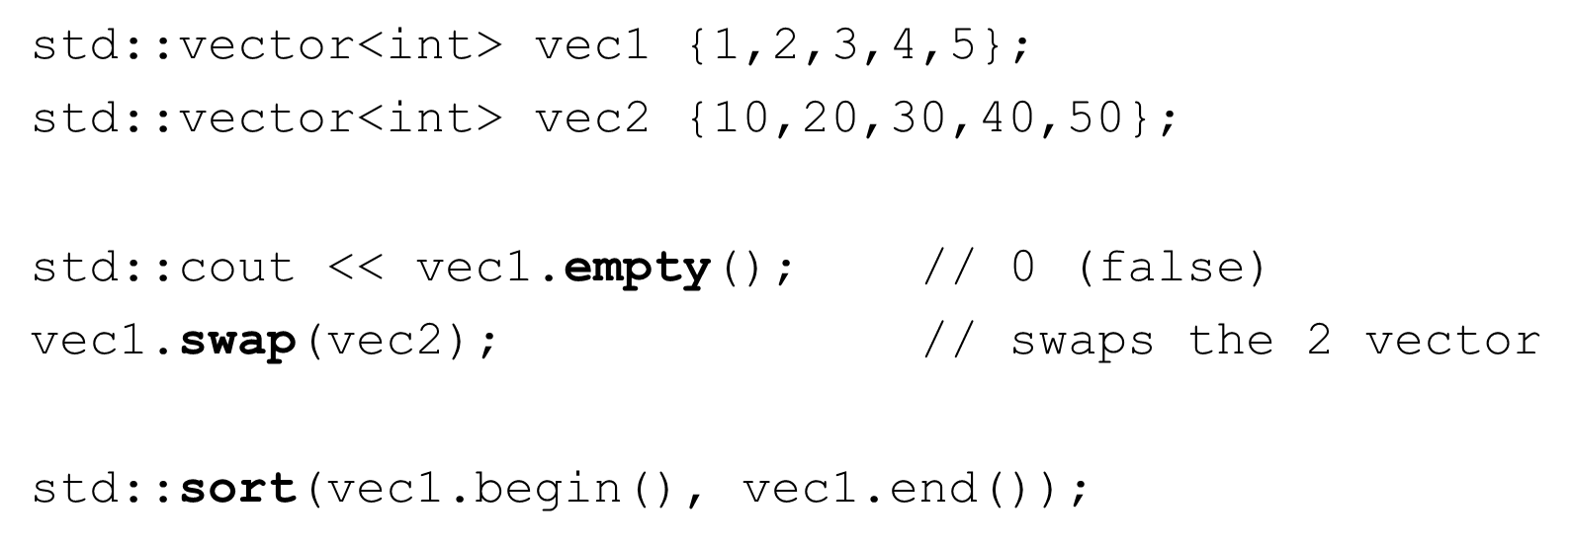

std::vector – common methods

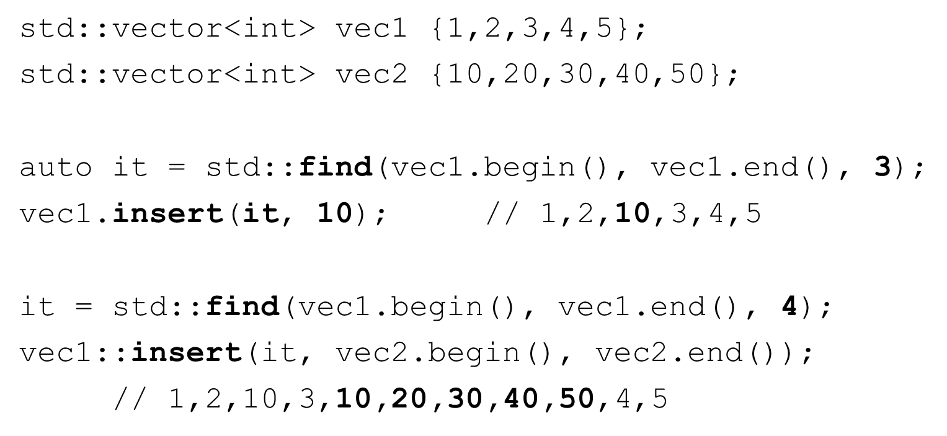

std::deque (double ended queue)

#include <deque>

* Dynamic size
  + Handled automatically
  + Can expand and contract as needed
  + Elements are NOT stored in contiguous memory
* Direct element access (constant time)
* Rapid insertion and deletion at the front and back (constant time)
* Insertion or removal of elements (linear time)
* All iterators available and may invalidate

std::deque – initialization and assignment

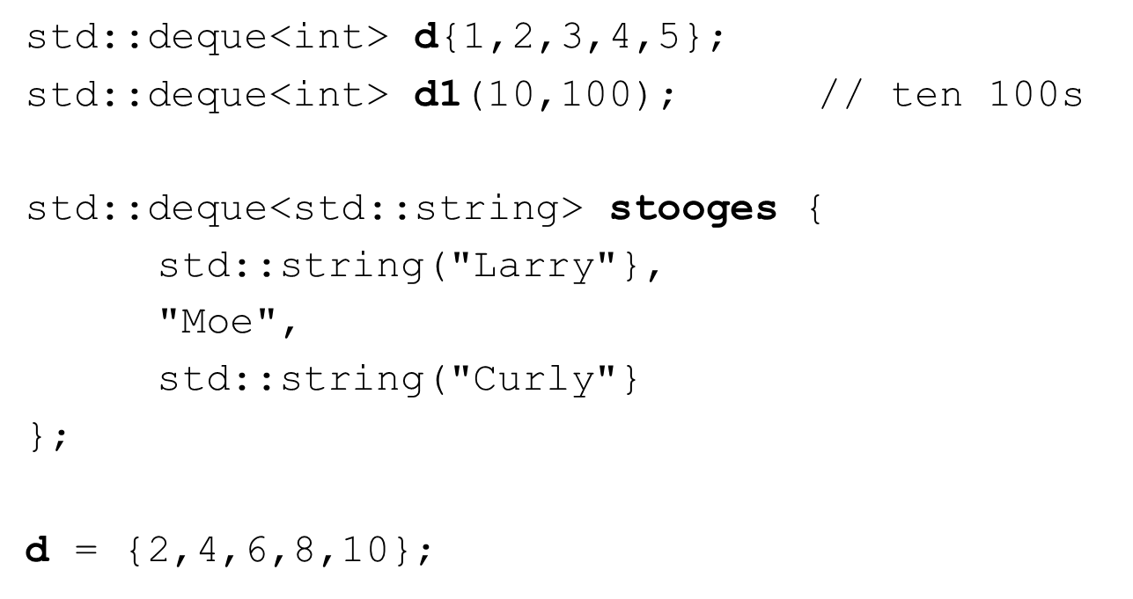

std::deque

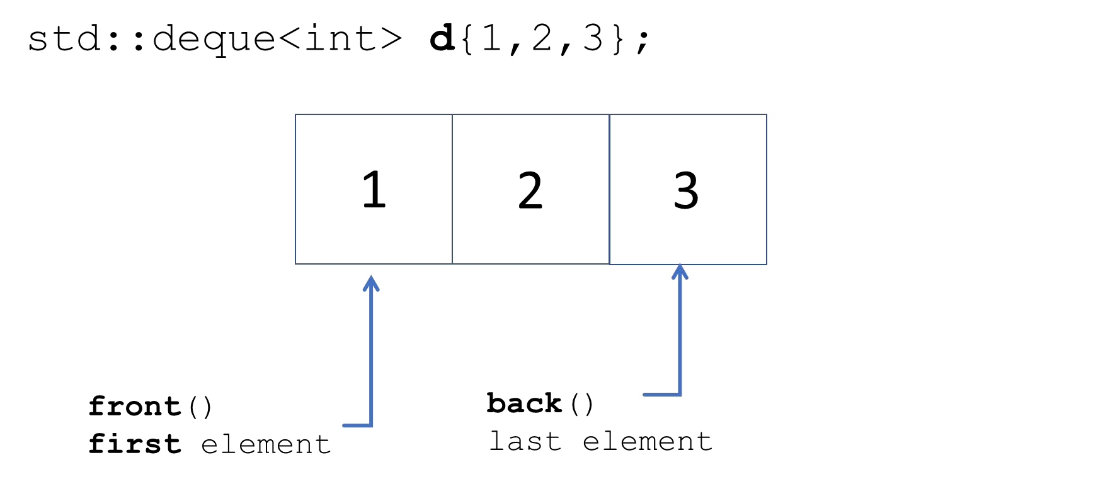

std::deque

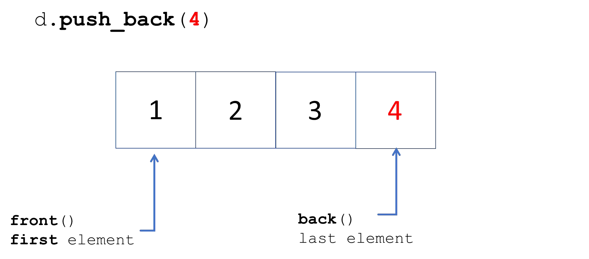

std::deque

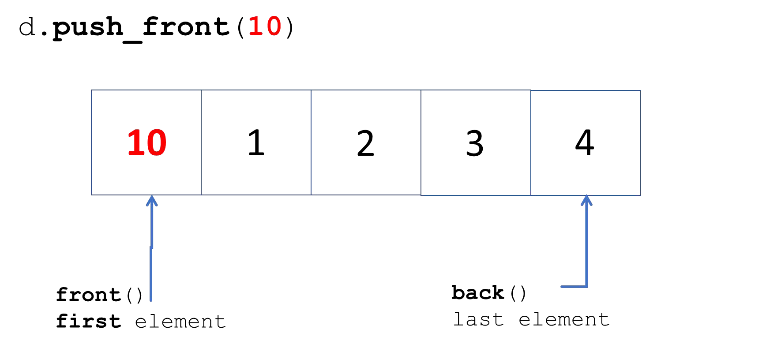

std::deque



std::deque – common methods

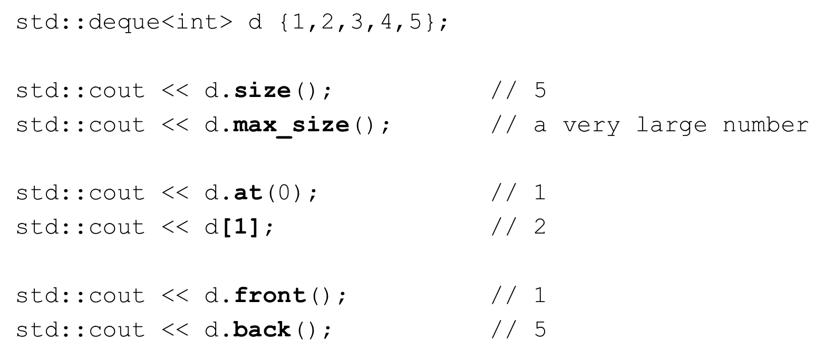

std::deque – common methods

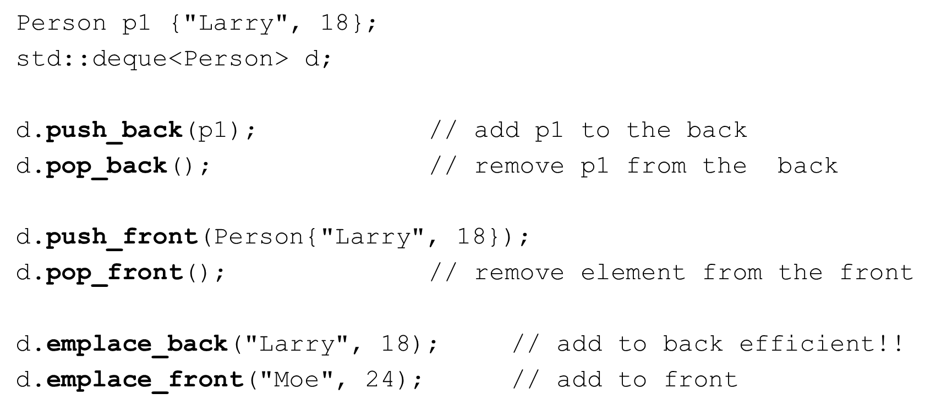

std::list and std::forward_list

* Sequence containers
* Non-contiguous in memory
* No direct access to elements
* Very eﬃcient for inserting and deleting elements once an element is found

std::list

#include <list>

* Dynamic size
  + Lists of elements
  + list is bidirectional (doubly-linked)
* Direct element access is NOT provided
* Rapid insertion and deletion of elements anywhere in the container (constant time)
* All iterators available and invalidate when corresponding element is deleted

std::list

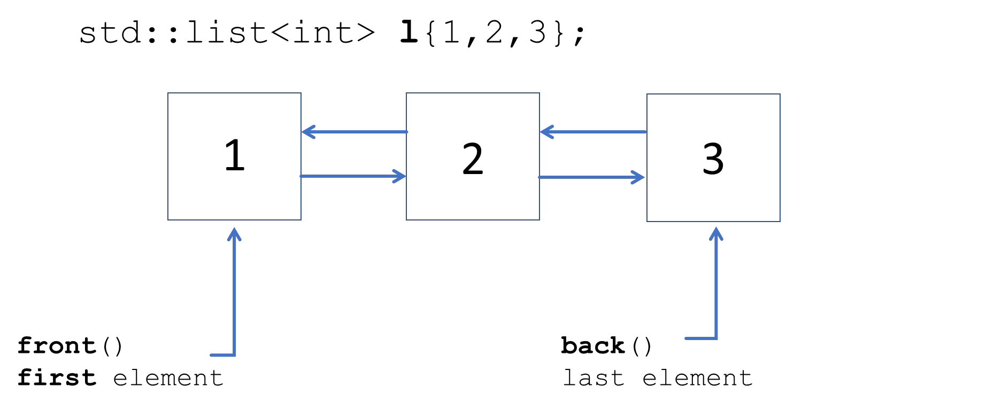

std::list – initialization and assignment

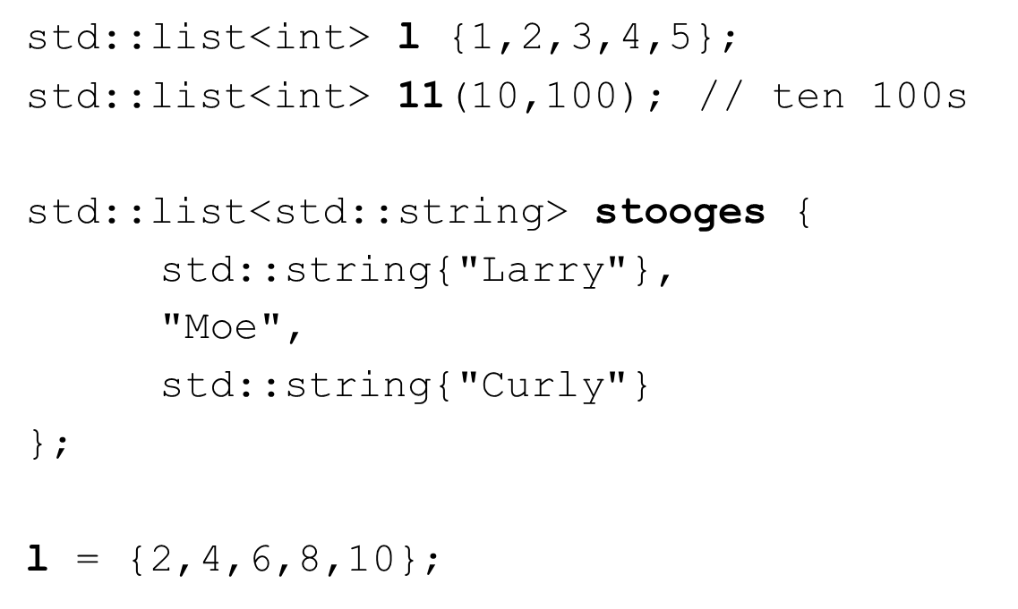

std::list – common methods

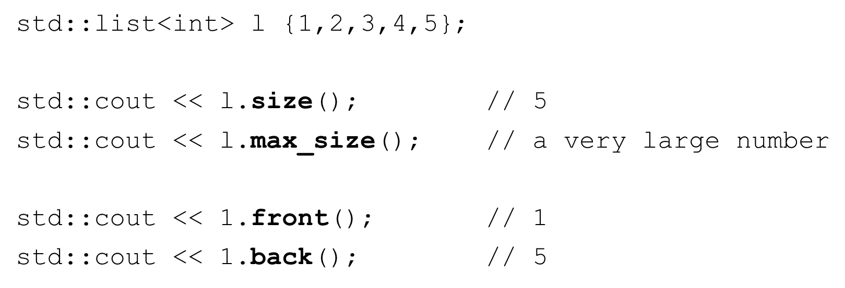

std::list – common methods

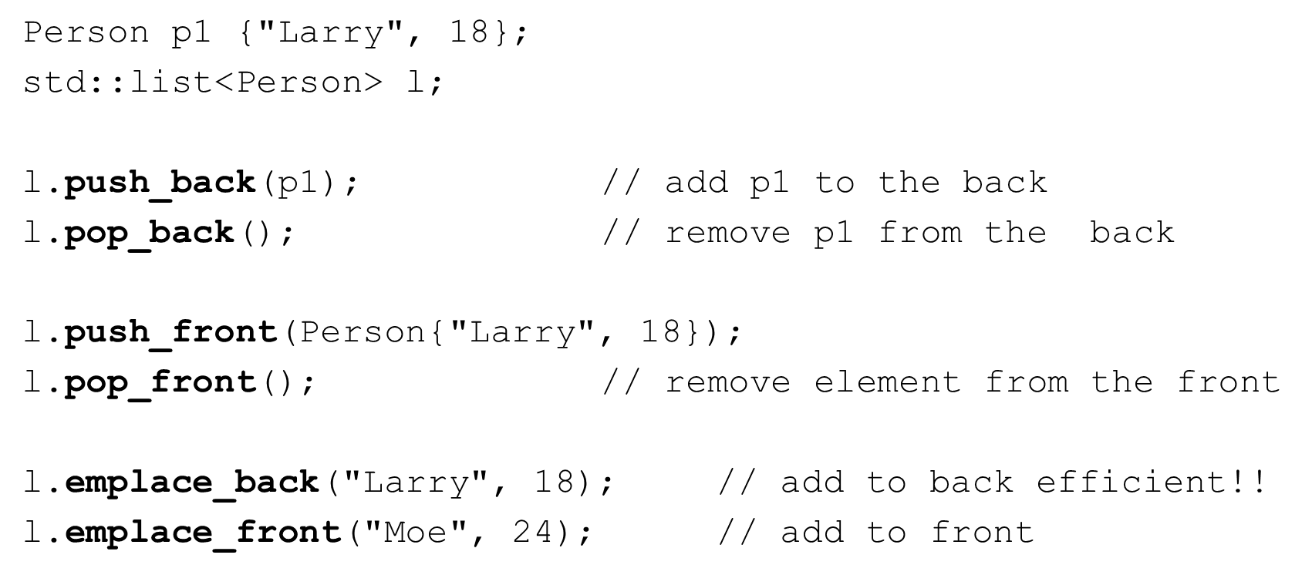

std::list – methods that use iterators

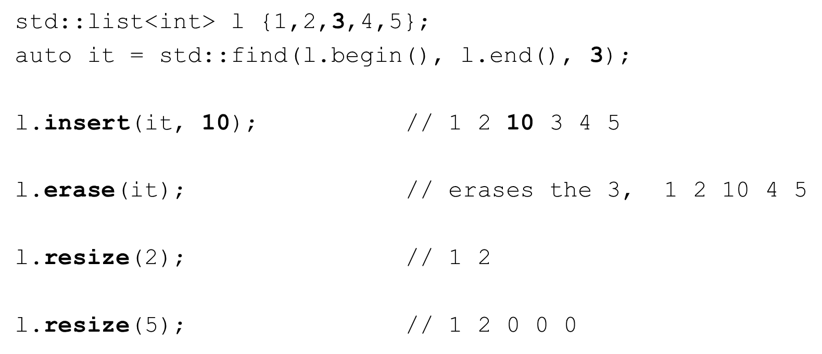

std::list – common methods

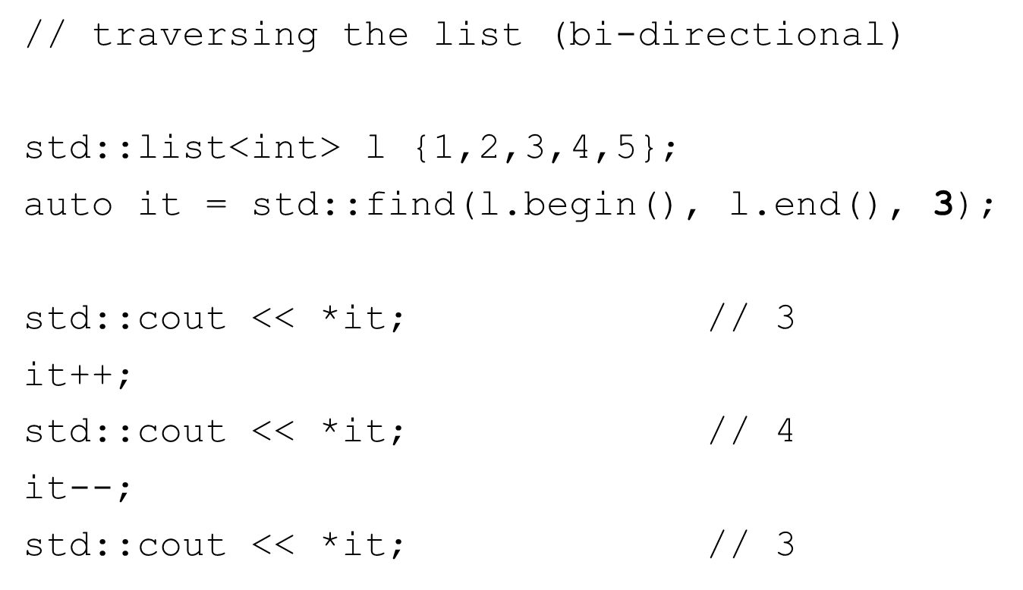

std::forward_list

#include <forward_list>

* Dynamic size
  + Lists of elements
  + list uni-directional (singly-linked)
  + Less overhed than a std::list
* Direct element access is NOT provided
* Rapid insertion and deletion of elements anywhere in the container (constant time)
* Reverse iterators not available. Iterators invalidate when corresponding element is deleted

std::forward_list

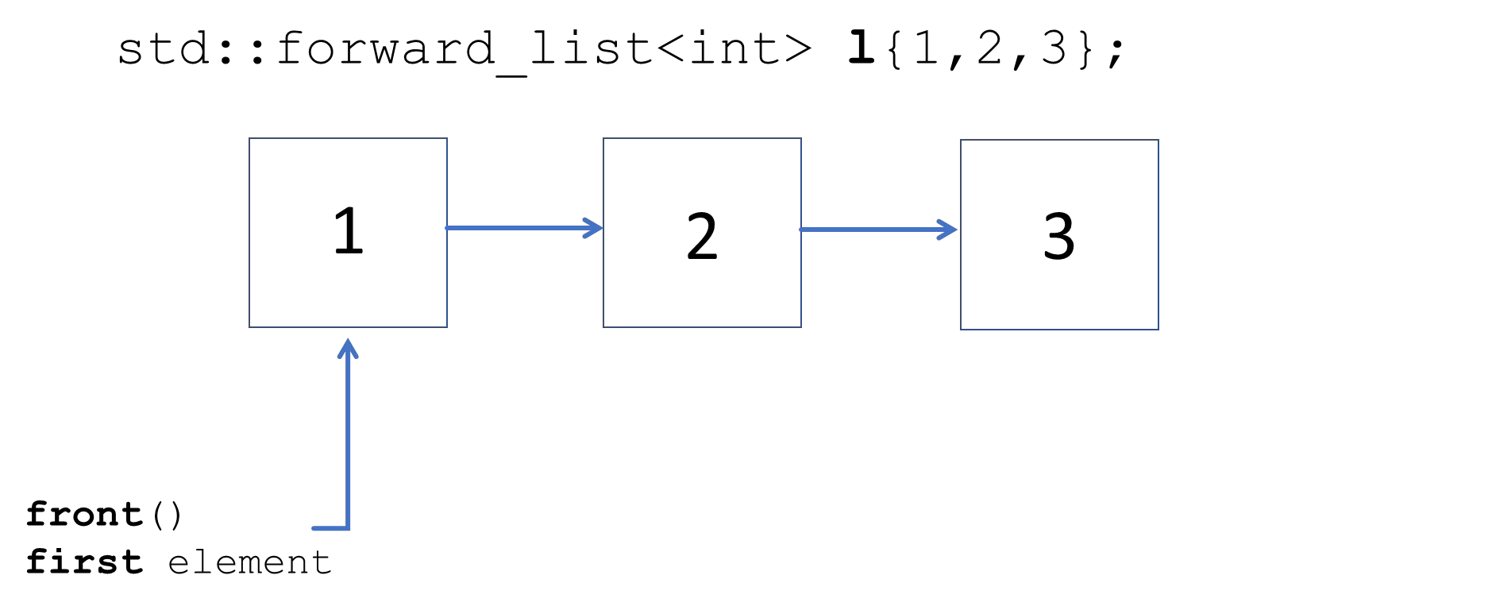

std::forward_list – common methods

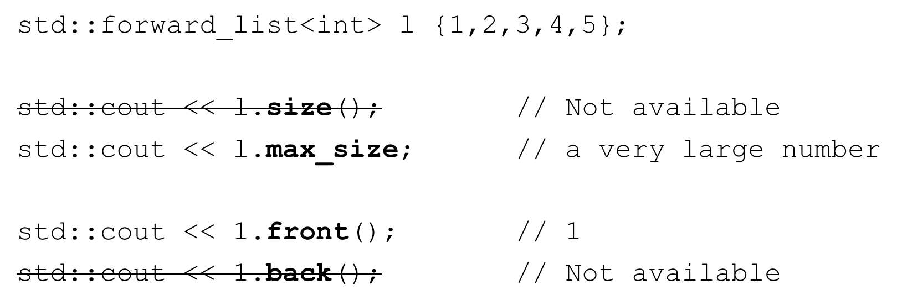

std::forward_list – common methods

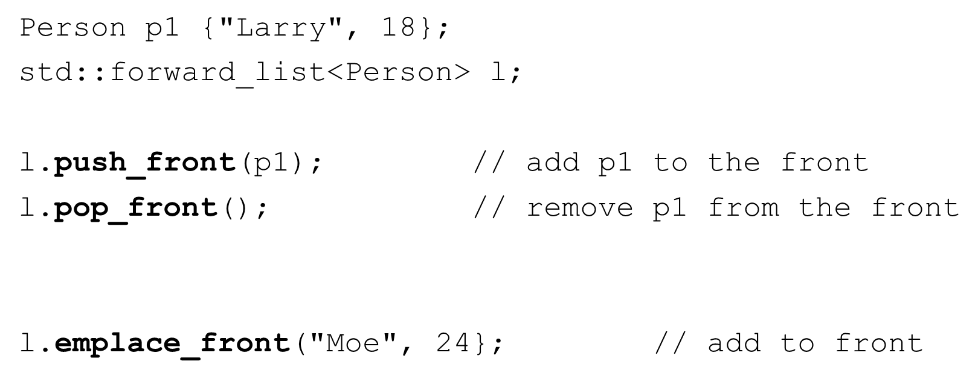

std::forward_list – methods that use iterators

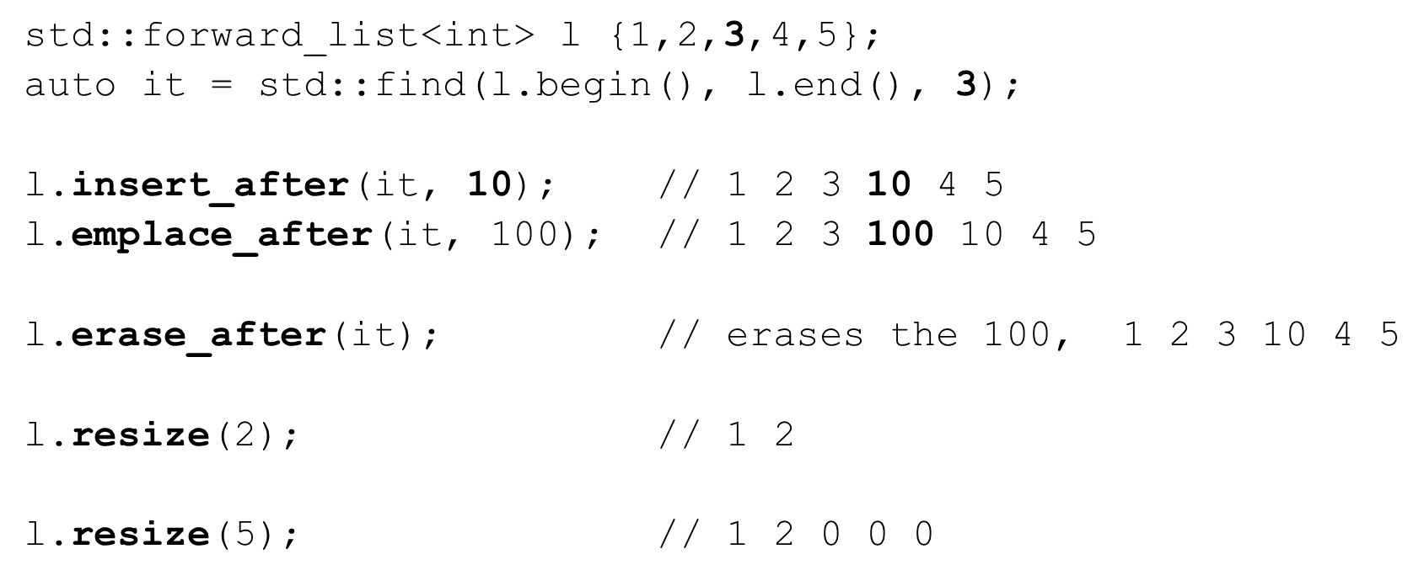

The STL Set containers

* Associative containers
  + Collection of stored objects that allow fast retrieval using a key
  + STL provides Sets and Maps
  + Usually implemented as a balanced binary tree or hashsets
  + Most operations are very eﬃcient
* Sets
  + std::set
  + std::unordered_set
  + std::multiset
  + std::unordered_multiset

std::set #include <set>

* Similar to a mathematical set
* Ordered by key
* No duplicate elements
* All iterators available and invalidate when corresponding element is deleted

std::set – initialization and assignment

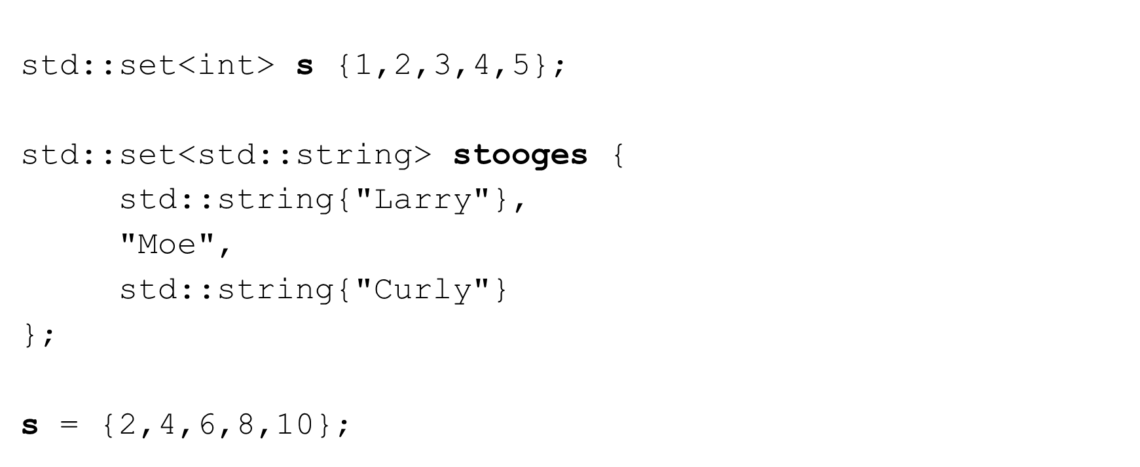

std::set – common methods

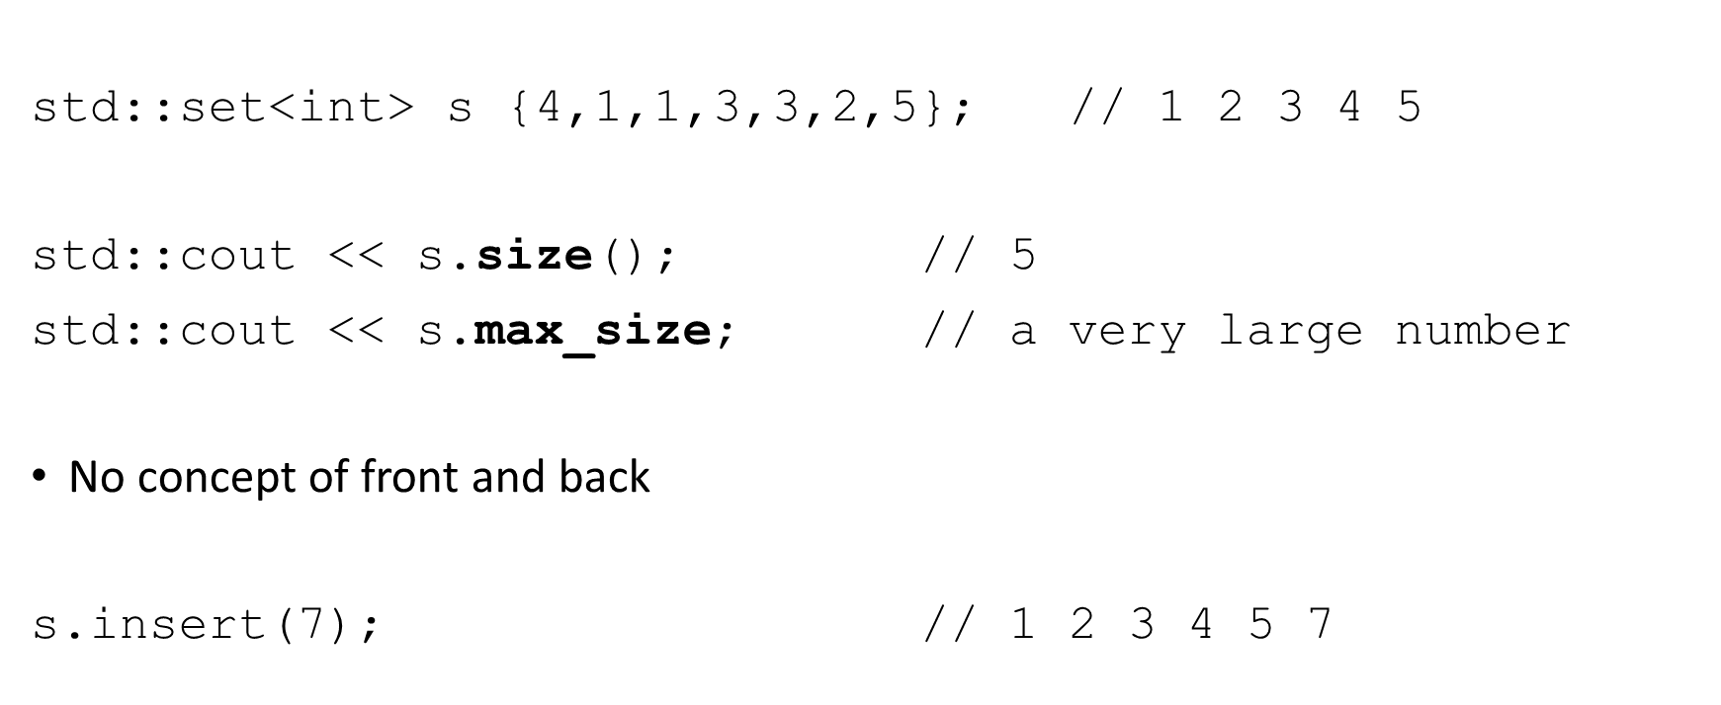

std::set – common methods

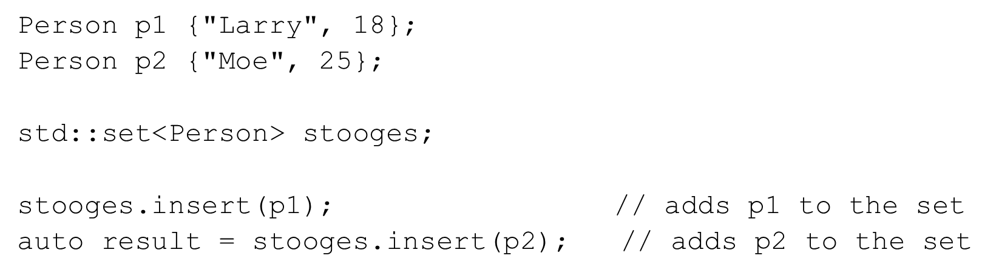

* uses operator< for ordering!
* returns a std::pair<iterator, bool>
  + first is an iterator to the inserted element or to the duplicate in the set
  + second is a boolean indicating success or failure

std::set – common methods

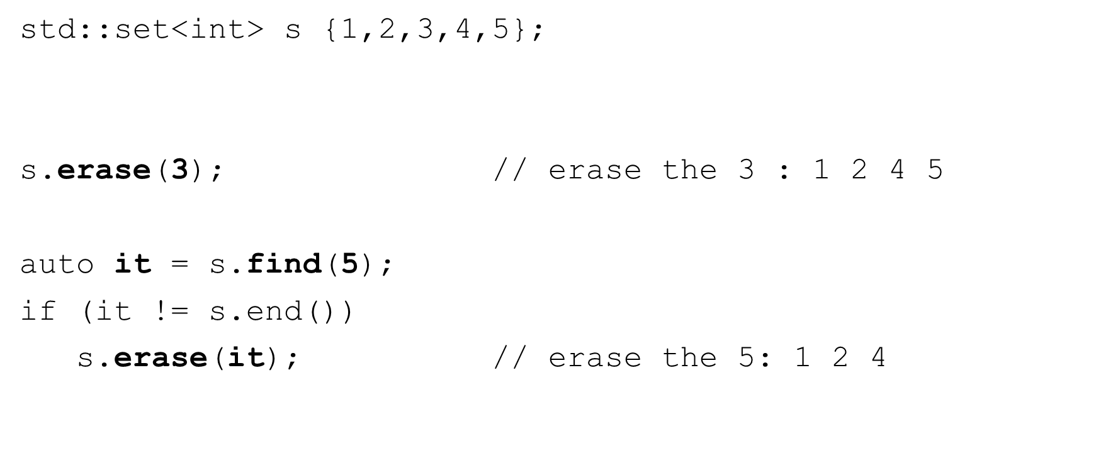

std::set – common methods

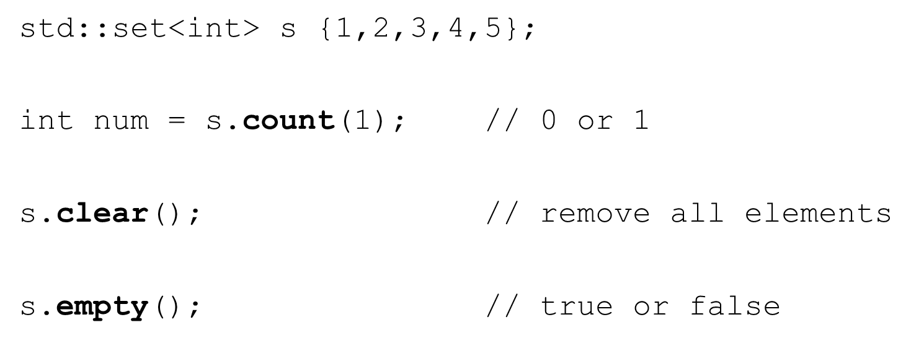

std::multi_set #include <set>

* Sorted by key
* Allows duplicate elements
* All iterators are available

std::unordered_set #include <unordered_set>

* Elements are unordered
* No duplicate elements allowed
* Elements cannot be modiﬁed
  + Must be erased and new element inserted
* No reverse iterators are allowed

std::unordered_multiset #include <unordered_set>

* Elements are unordered
* Allows duplicate elements
* No reverse iterators are allowed

The STL Map containers

* Associative containers
  + Collection of stored objects that allow fast retrieval using a key
  + STL provides Sets and Maps
  + Usually implemented as a balanced binary tree or hashsets
  + Most operations are very eﬃcient
* Maps
  + std::map
  + std::unordered_map
  + std::multimap
  + std::unordered_multimap

std::map

#include <map>

* Similar to a dictionary
* Elements are stored as Key, Value pairs (std::pair)
* Ordered by key
* No duplicate elements (keys are unique)
* Direct element access using the key
* All iterators available and invalidate when corresponding element is deleted

std::map – initialization and assignment

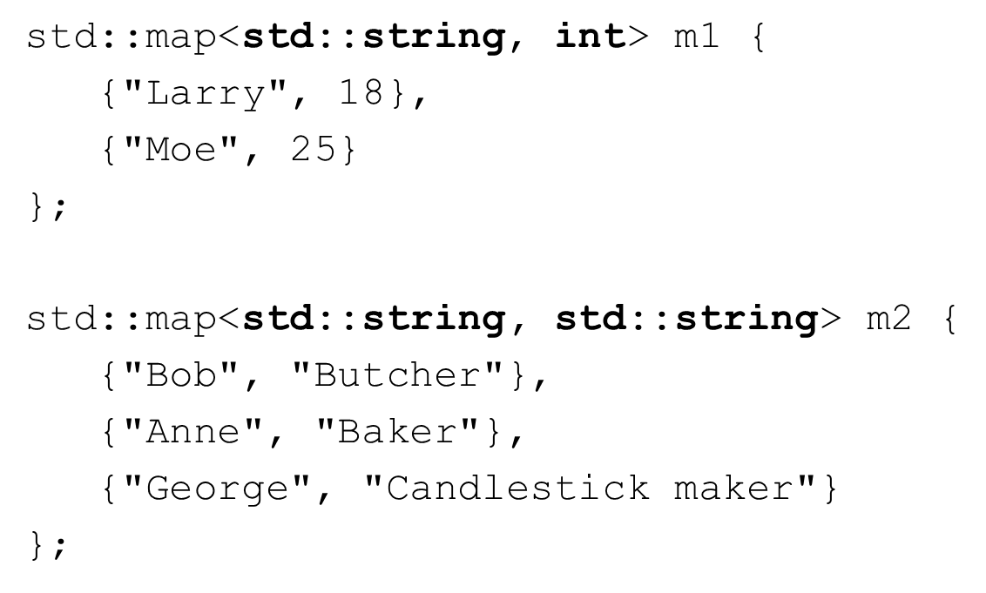

std::map – common methods

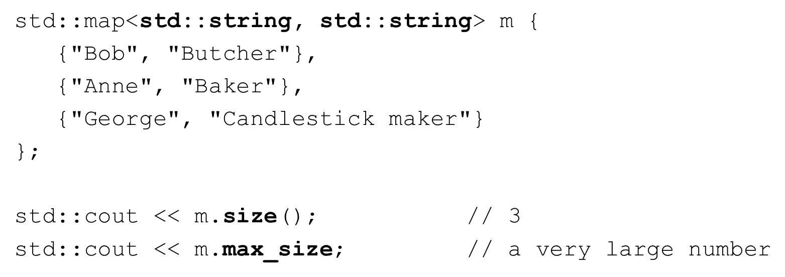

* No concept of front and back

std::map – common methods

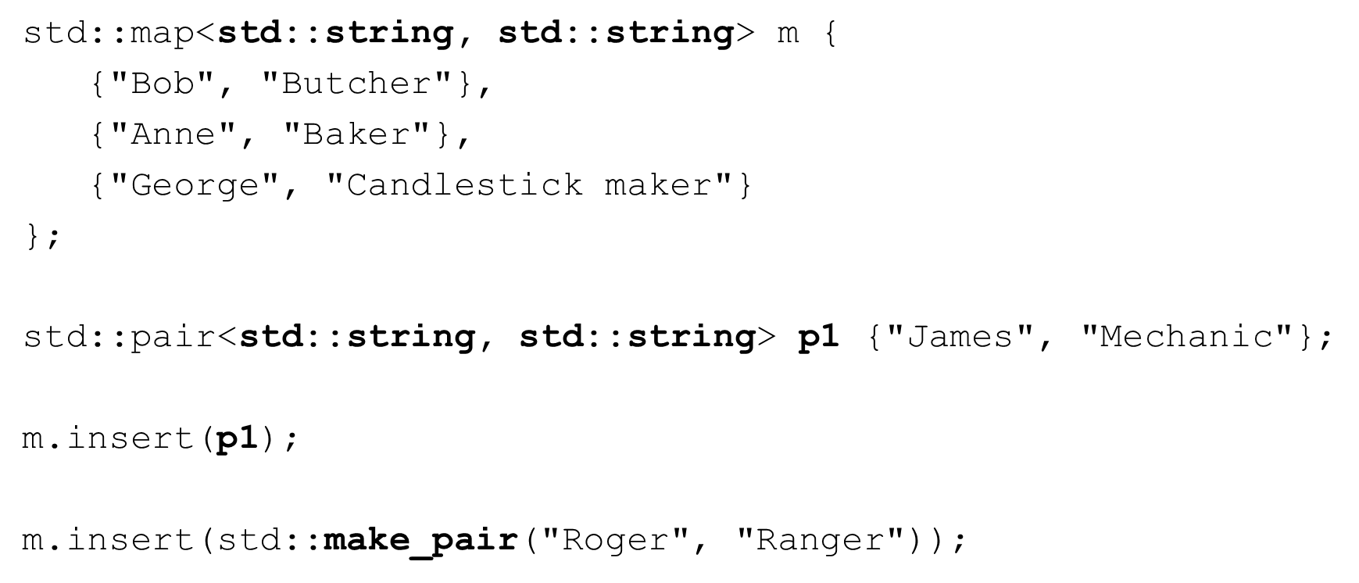

std::map – common methods

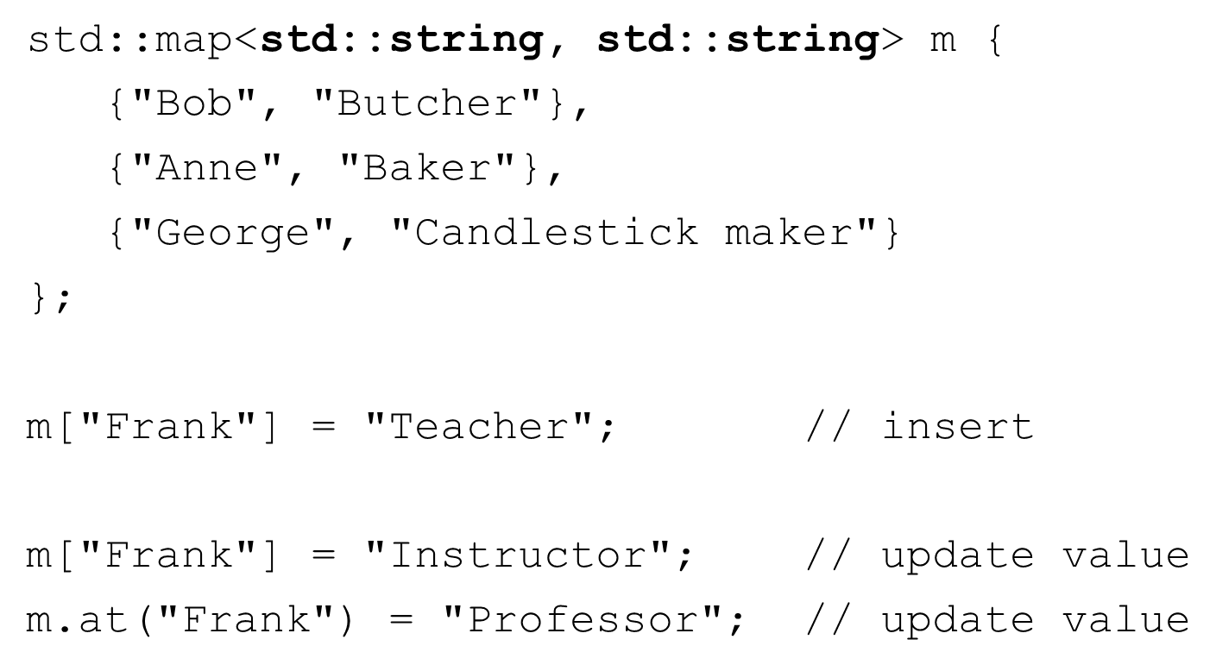

std::map – common methods

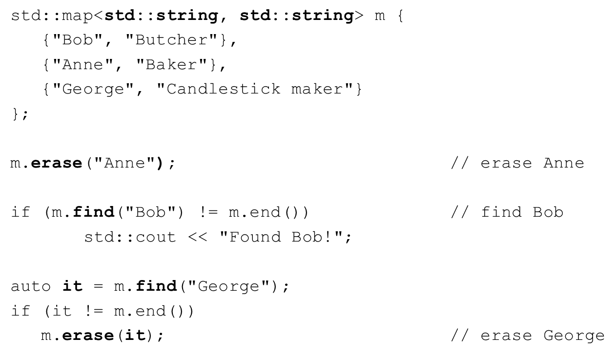

std::map – common methods

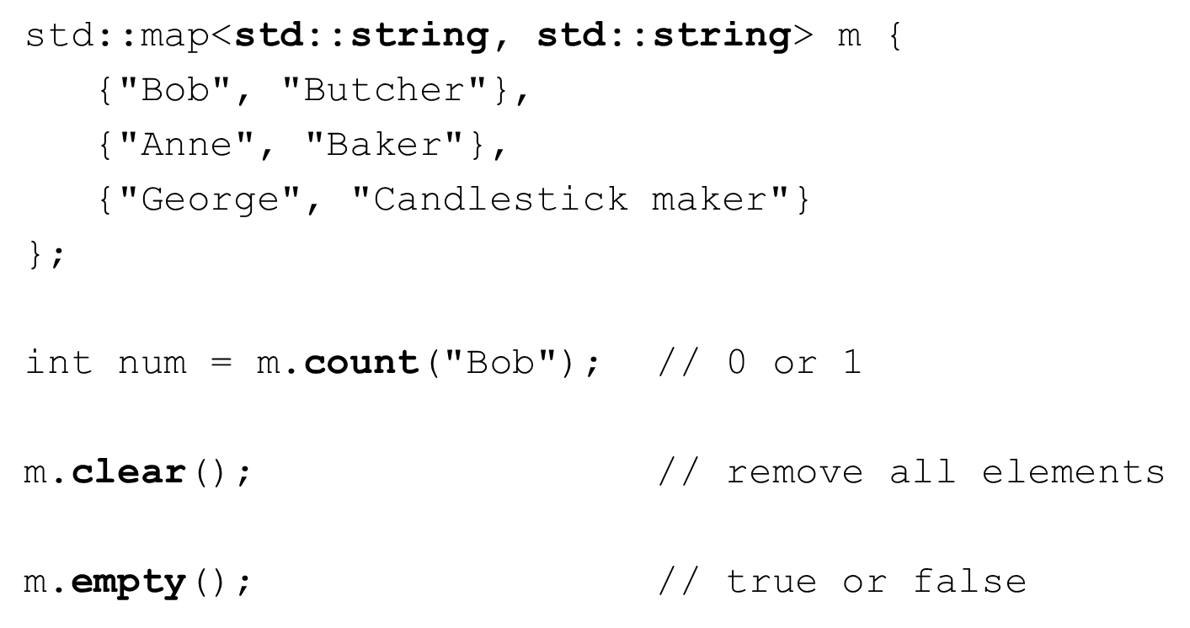

std::multi_map #include <map>

* Ordered by key
* Allows duplicate elements
* All iterators are available

std::unordered_map #include <unordered_map>

* Elements are unordered
* No duplicate elements allowed
* No reverse iterators are allowed

std::unordered_multimap #include <unordered_map>

* Elements are unordered
* Allows duplicate elements
* No reverse iterators are allowed

std::stack

* Last-in First-out (LIFO) data structure
* Implemented as an adapter over other STL container Can be implemented as a vector, list, or deque
* All operations occur on one end of the stack (top)
* No iterators are supported

std::stack #include <stack>

* push – insert an element at the top of the stack
* pop – remove an element from the top of the stack
* top – access the top element of the stack
* empty – is the stack empty?
* size – number of elements in the stack

std::stack – initialization

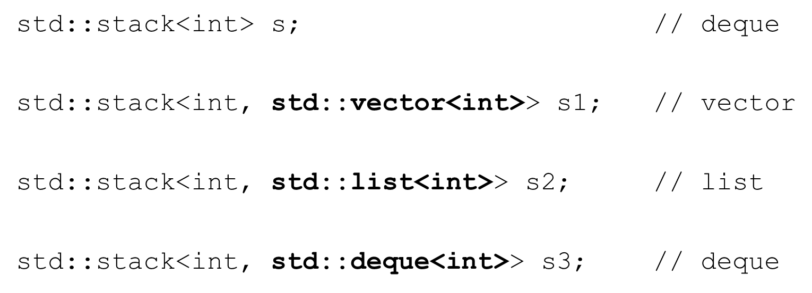

std::stack – common methods

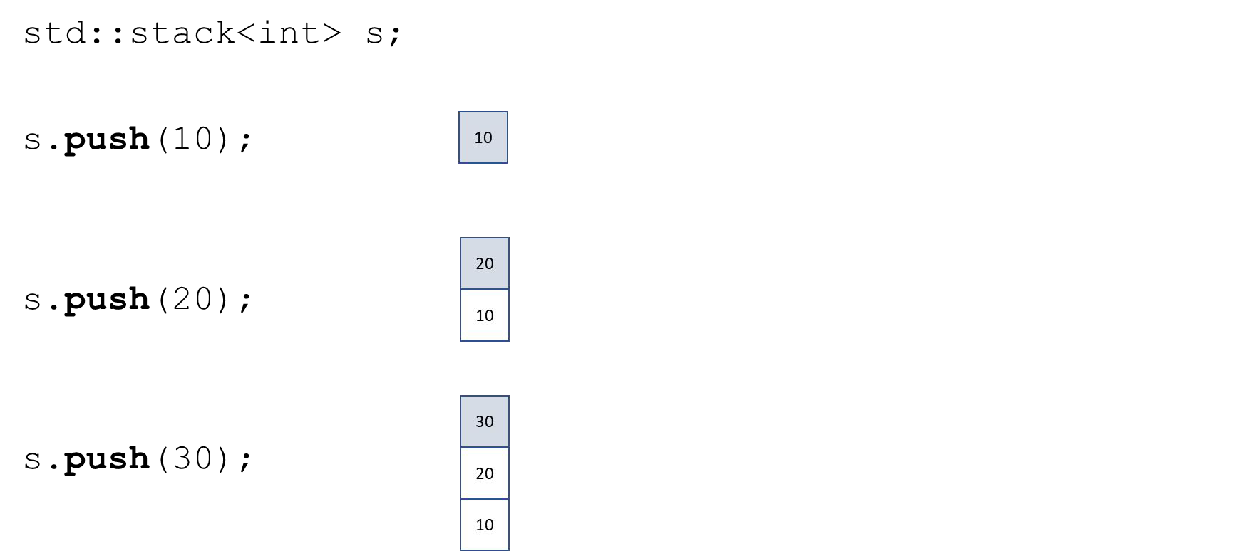

std::stack – common methods

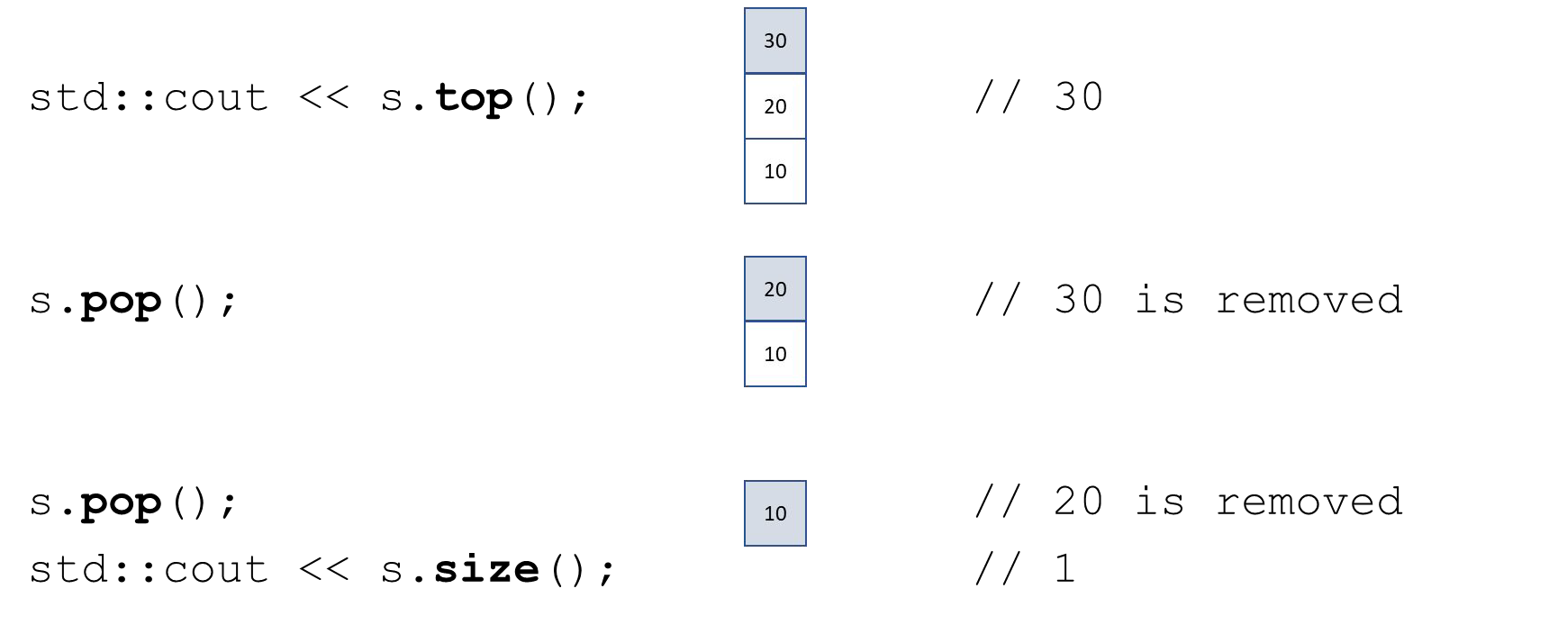

std::queue

* First-in First-out (FIFO) data structure
* Implemented as an adapter over other STL container Can be implemented as a list or deque
* Elements are pushed at the back and popped from the front
* No iterators are supported

std::queue #include <queue>

* push – insert an element at the back of the queue
* pop – remove an element from the front of the queue
* front – access the element at the front
* back – access the element at the back
* empty – is the queue empty?
* size – number of elements in the queue

std::queue – initialization

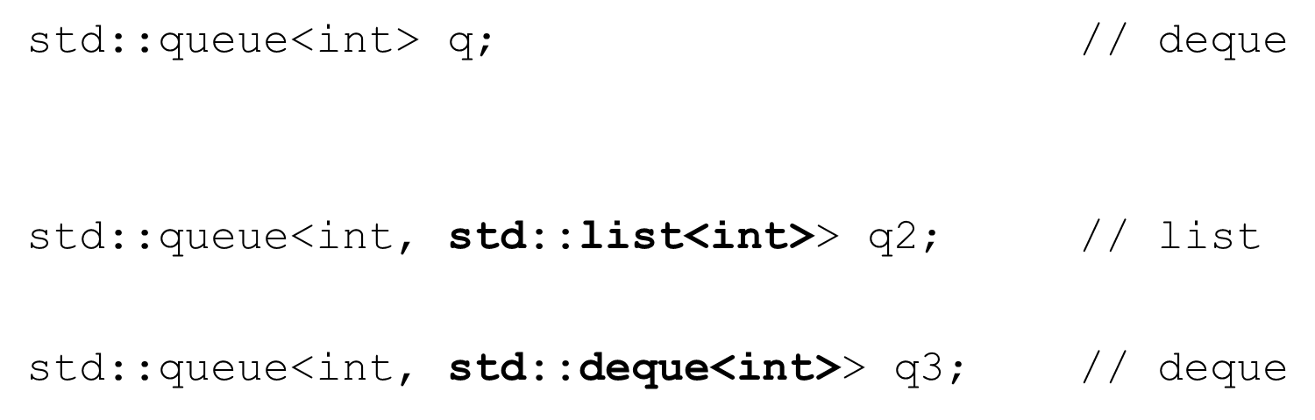

std::queue – common methods

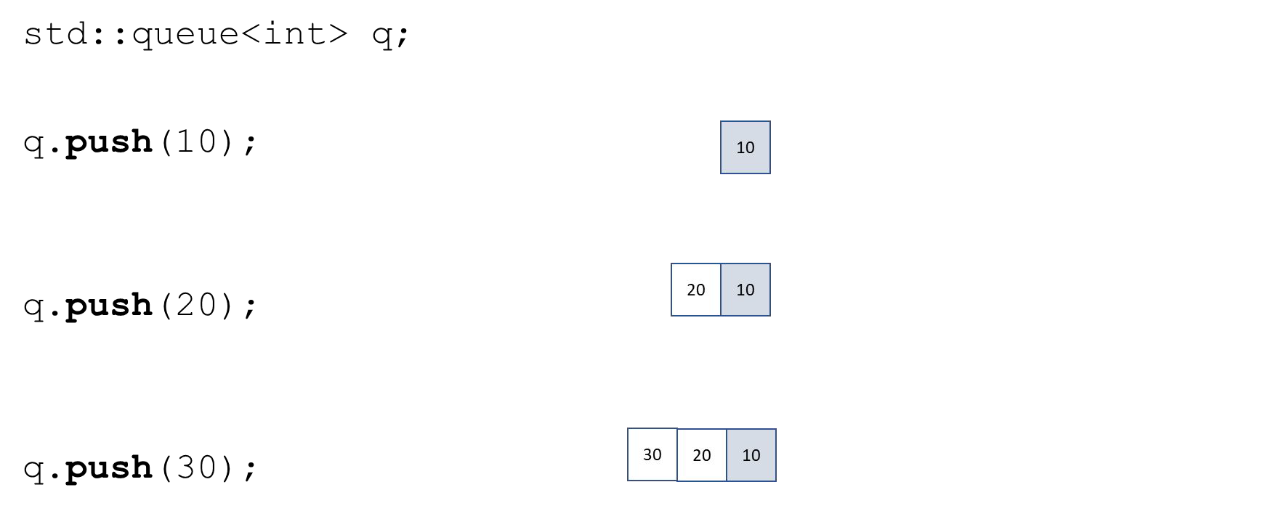

std::queue – common methods

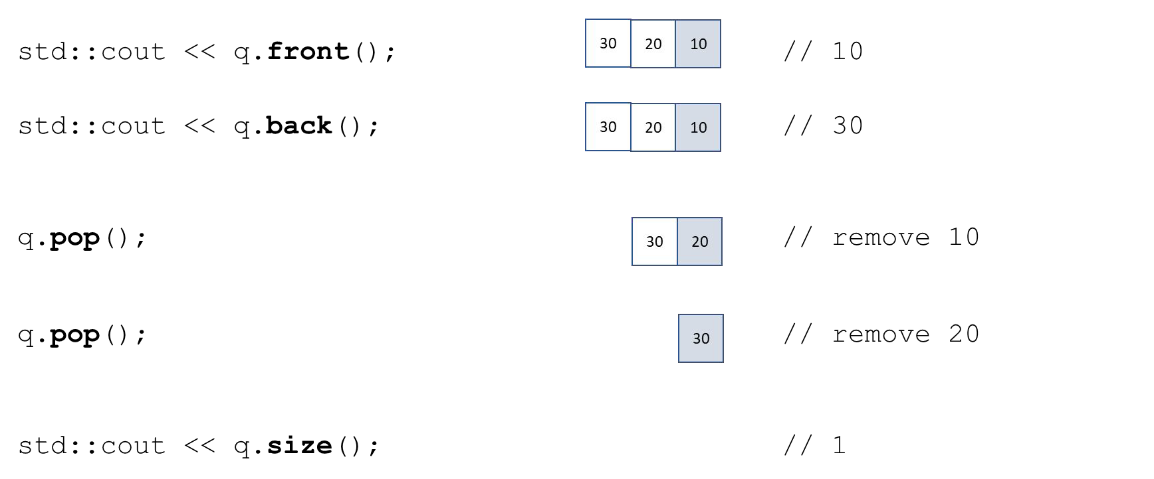

std::priority_queue

* Allows insertions and removal of elements in order from the front of the container
* Elements are stored internally as a vector by default
* Elements are inserted in ***priority*** order (largest value will always be at the front)
* No iterators are supported

std::priority_queue #include <queue>

* push – insert an element into sorted order
* pop – removes the top element (greatest)
* top – access the top element (greatest)
* empty – is the queue empty?
* size – number of elements in the queue

std::priority_queue – initialization

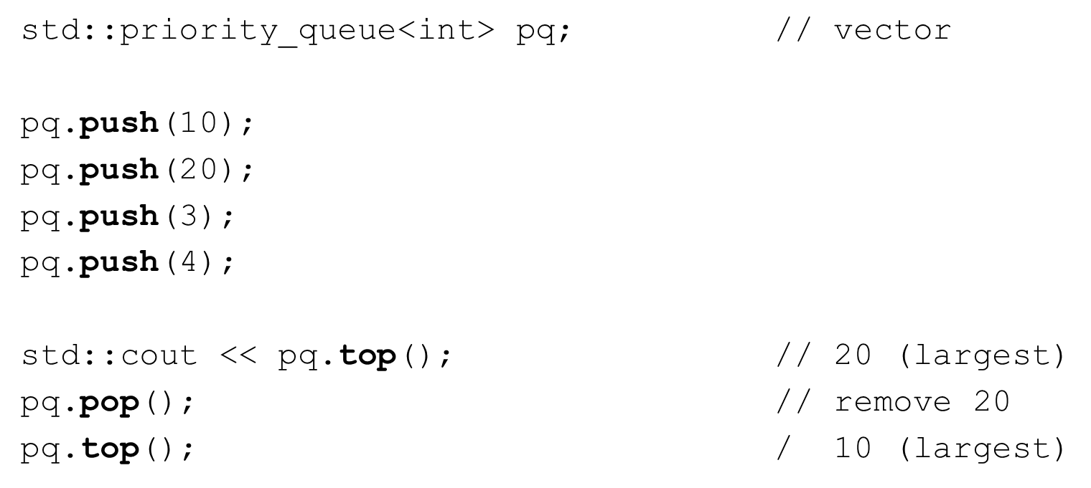

## Bonus Section Overview

C++ Lambda expressions

* What is a lambda expression?
  + Motivation
  + Review of function objects (functors)
  + Relation between lambdas and function objects
* Structure of a lambda expression
* Types of lambda expressions
  + Stateless lambda expression
  + Stateful lambda expression (capturing context)
* Lambdas and the STL

## C++ Lambda Expressions

Motivation

* Prior to C++ 11
  + Function objects
  + Function pointers
  + We often write many short functions that control algorithms
  + These short functions would be encapsulated in small classes to produce function objects
  + Many times the classes and functions are far removed from where they are used leading to modiﬁcation, maintenance, and testing issues
  + Compiler cannot eﬀectively inline these functions for eﬃciency.

Function objects

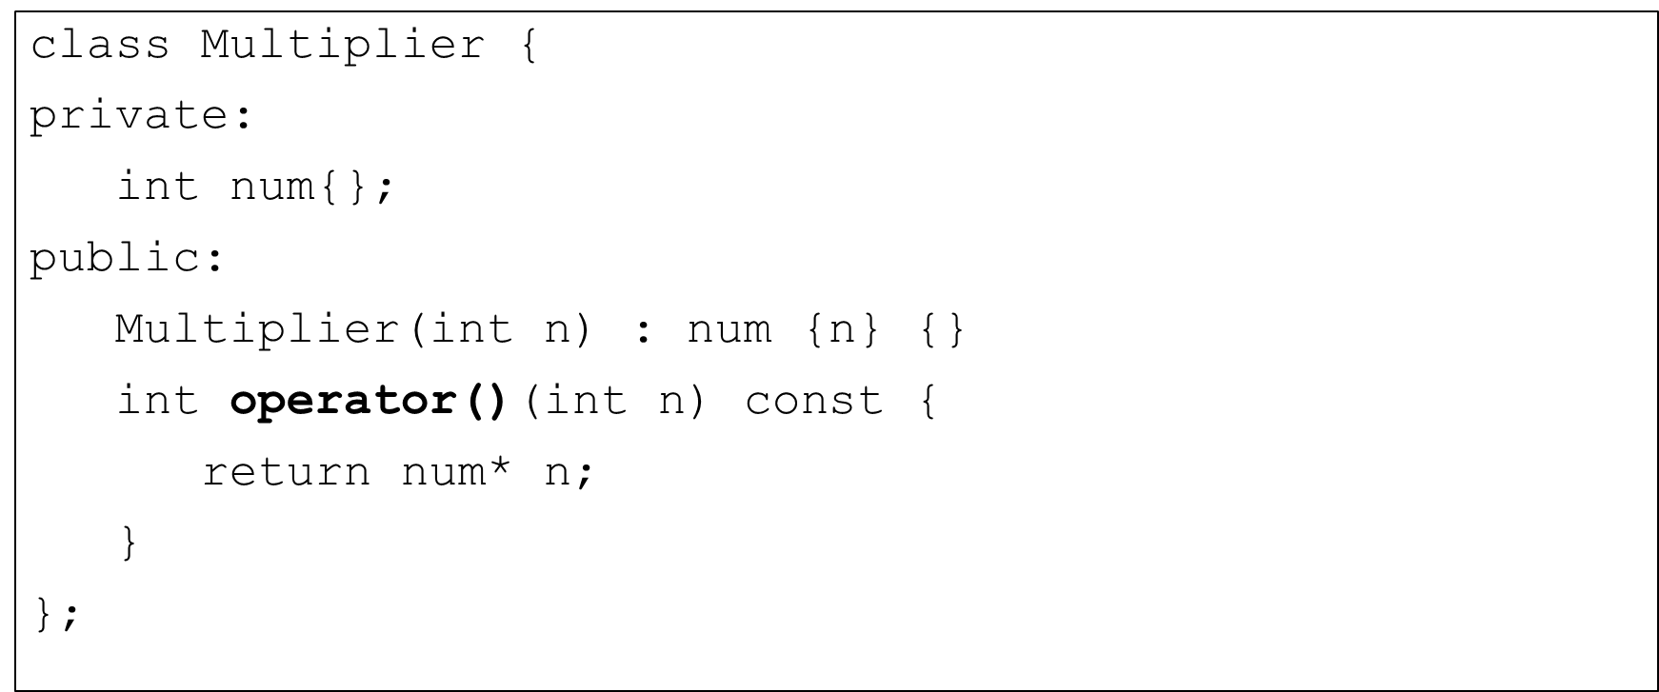

Function objects

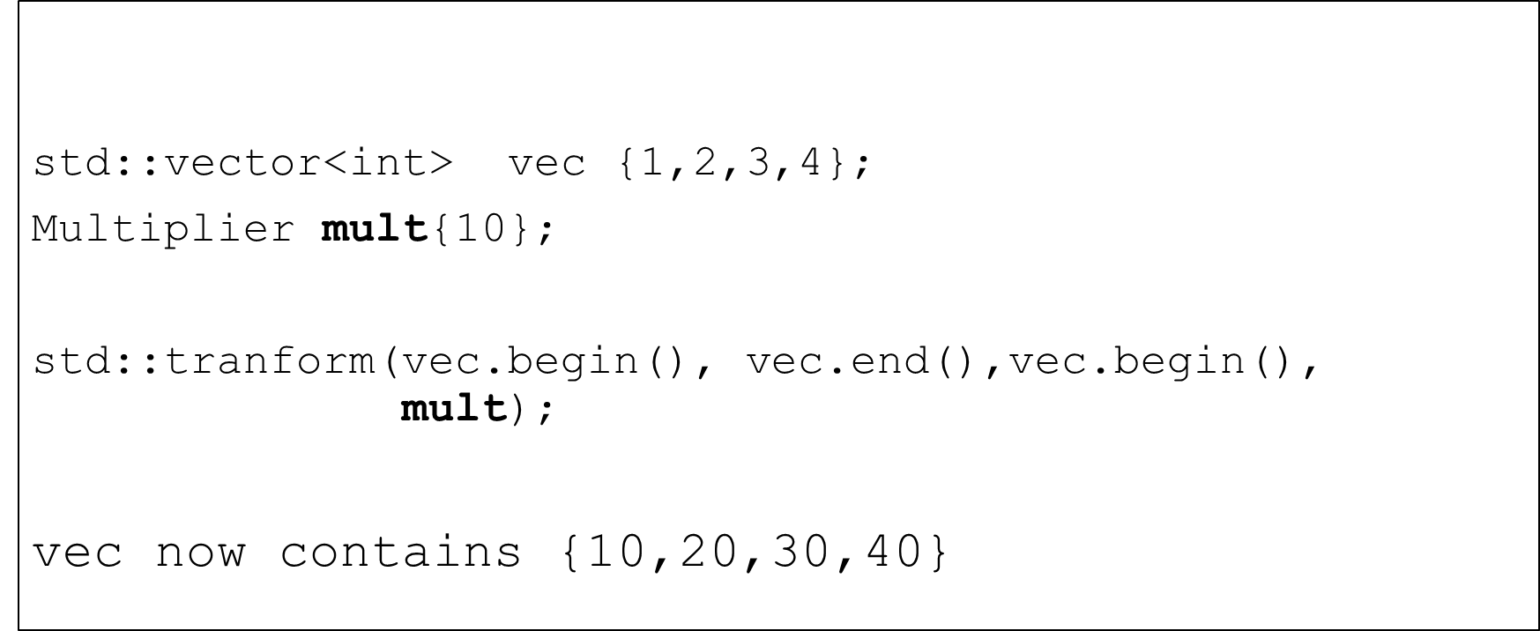

Function objects

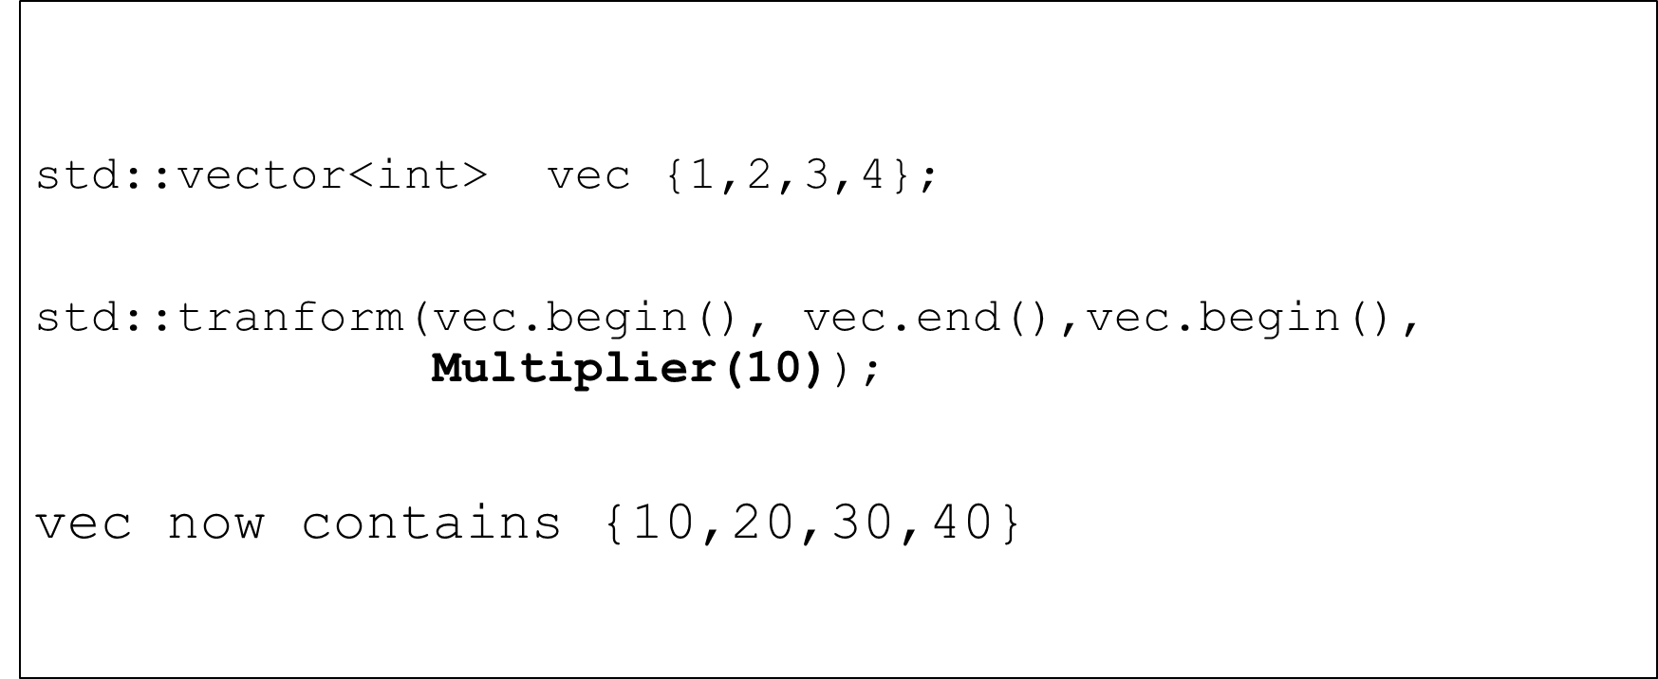

Generic function objects

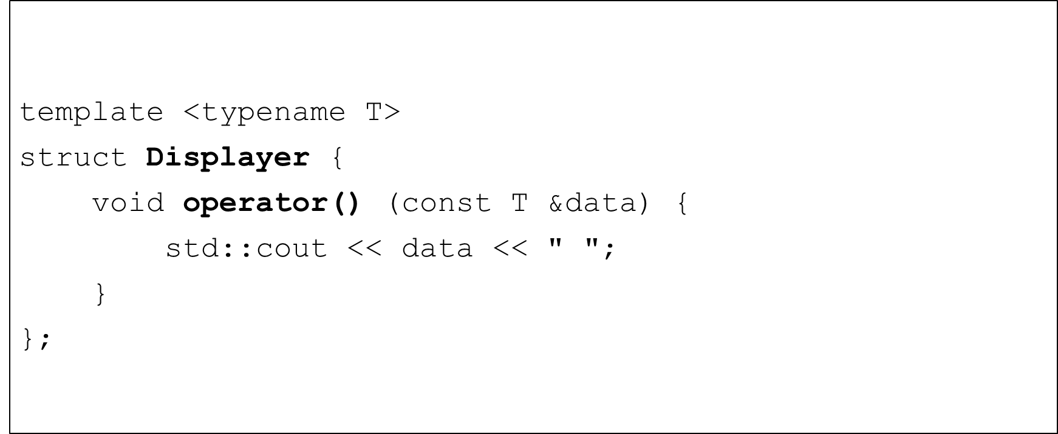

Generic function objects

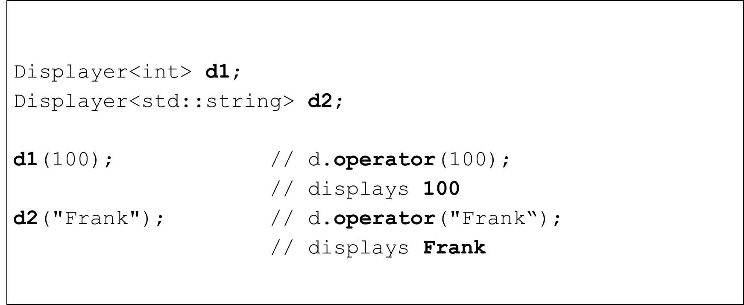

Generic function objects

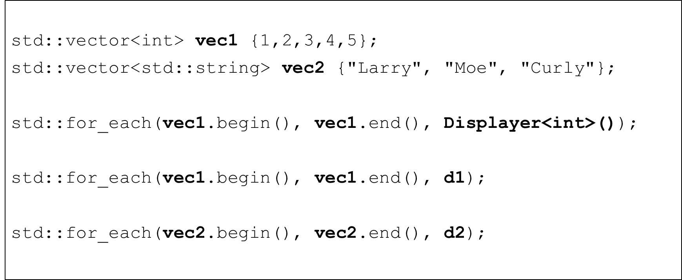

Using a lambda expression

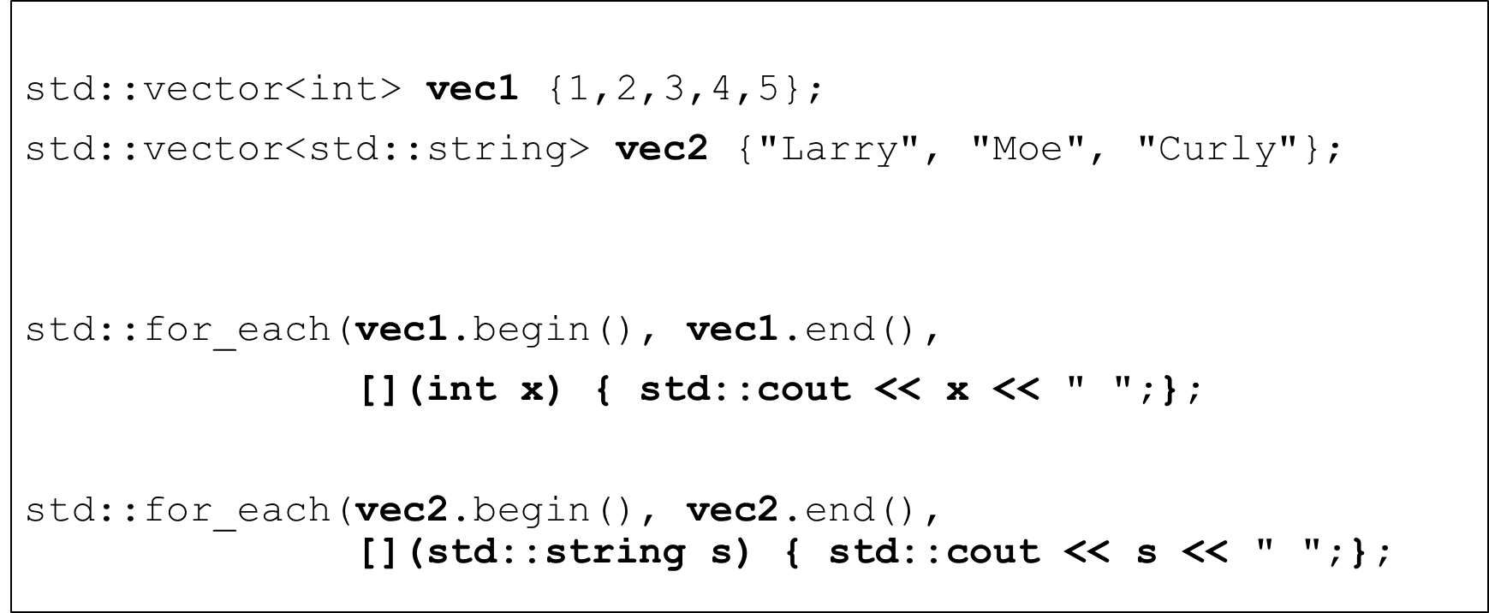

The Structure of a Lambda Expression

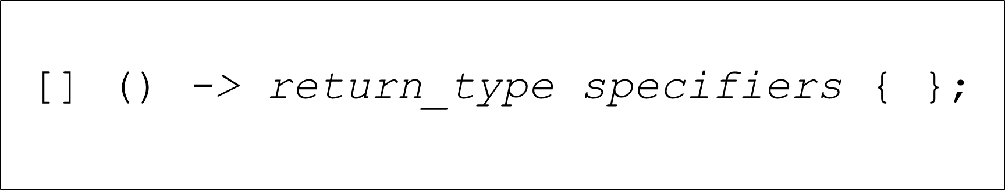

The Structure of a Lambda Expression

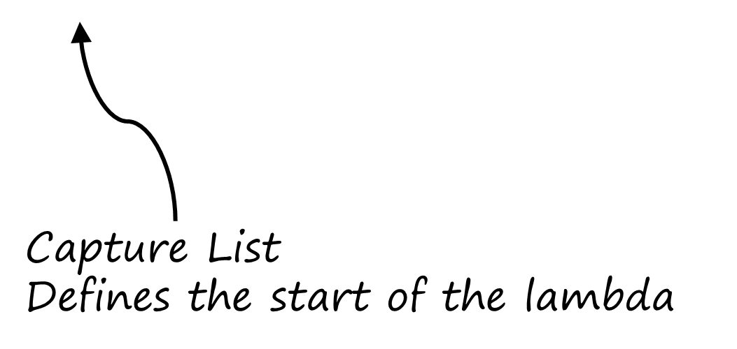

The Structure of a Lambda Expression

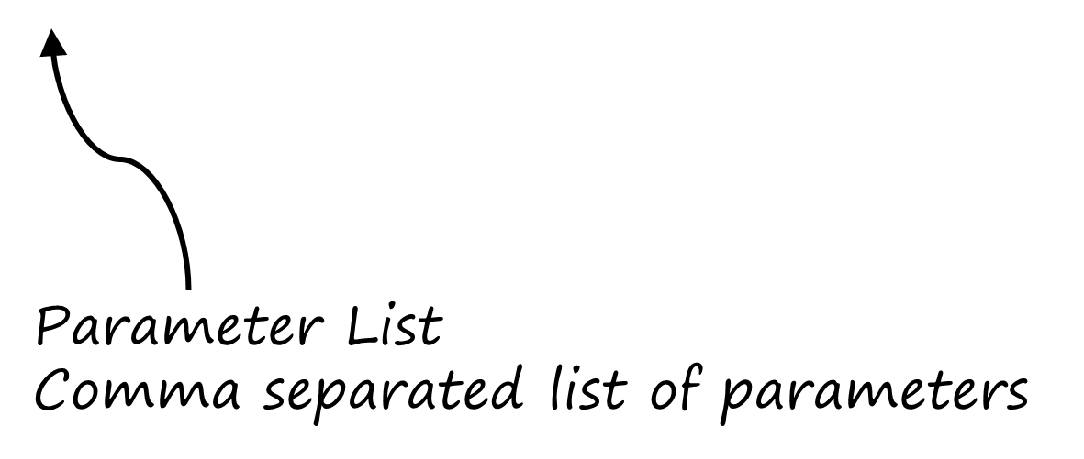

The Structure of a Lambda Expression

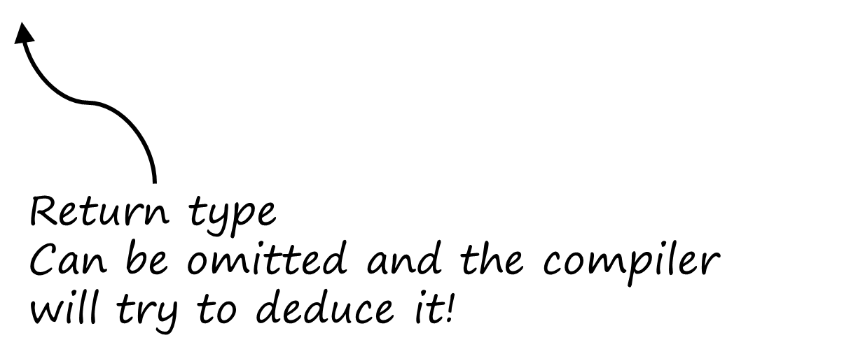

The Structure of a Lambda Expression

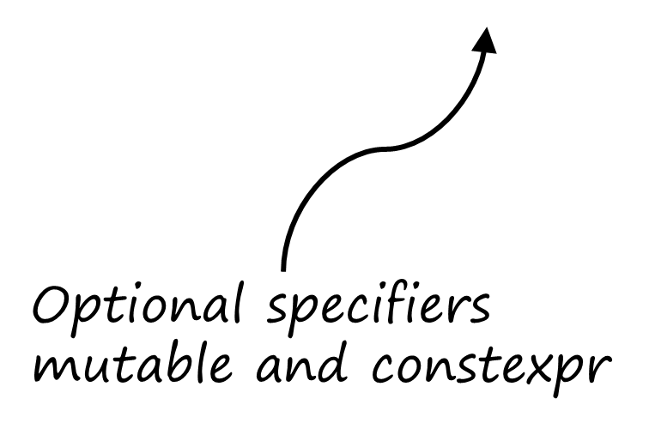

The Structure of a Lambda Expression

BEGINNING C++ PROGRAMMING

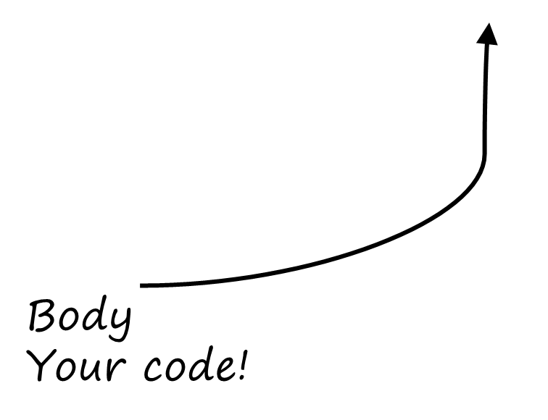

Structure of a Lambda Expression

LAMBDA EXPRESSIONS

S21-CPP-0060-6

A simple lambda expression

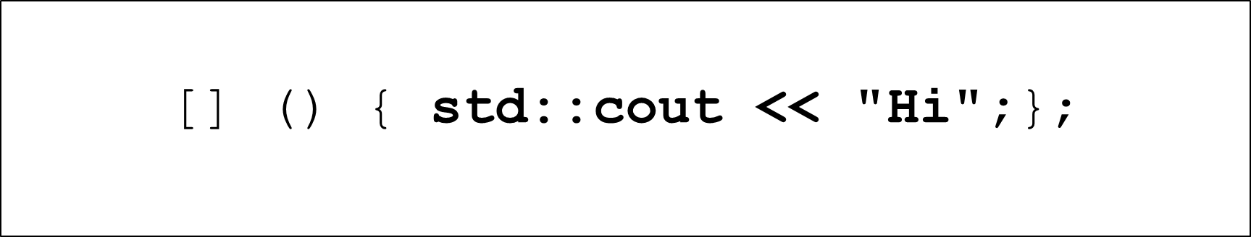

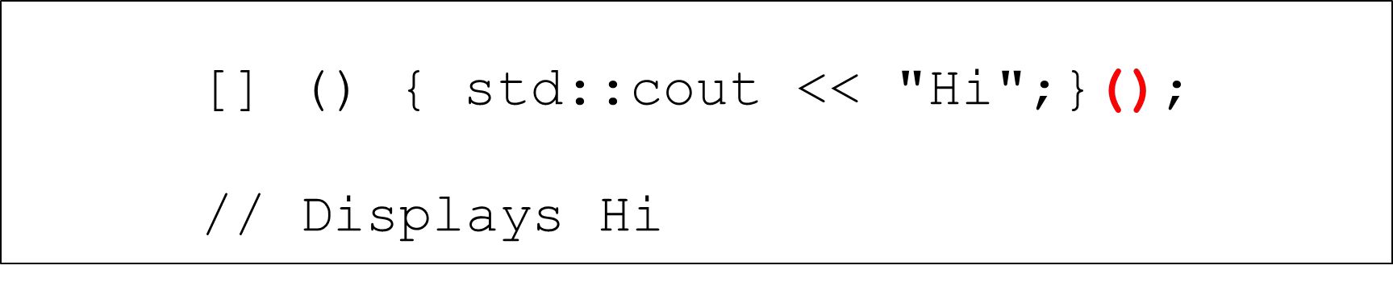

Parameters to lambda expressions

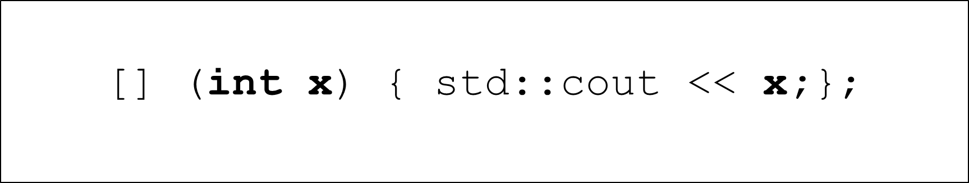

Parameters to lambda expressions

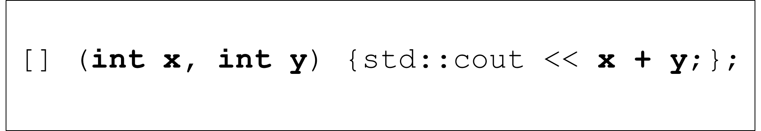

Assigning a lambda expression to a variable

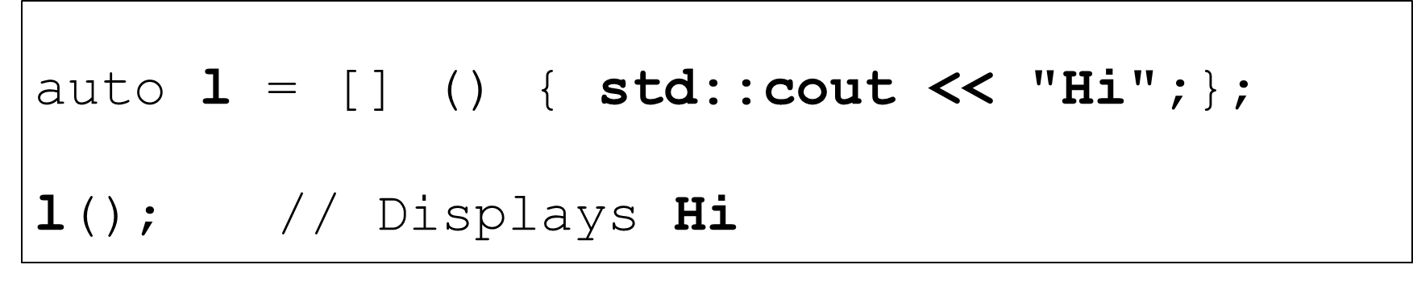

Assigning a lambda expression to a variable

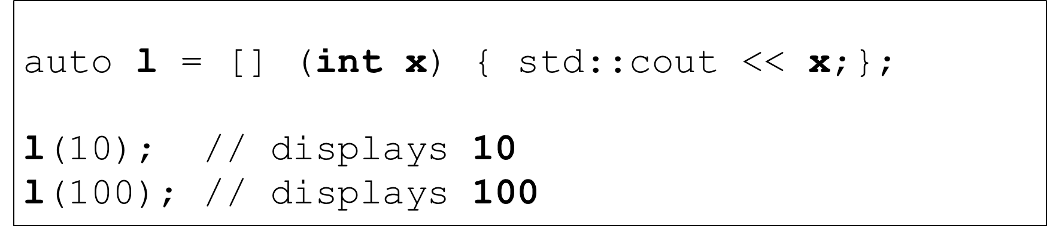

Returning a value from a lambda expression

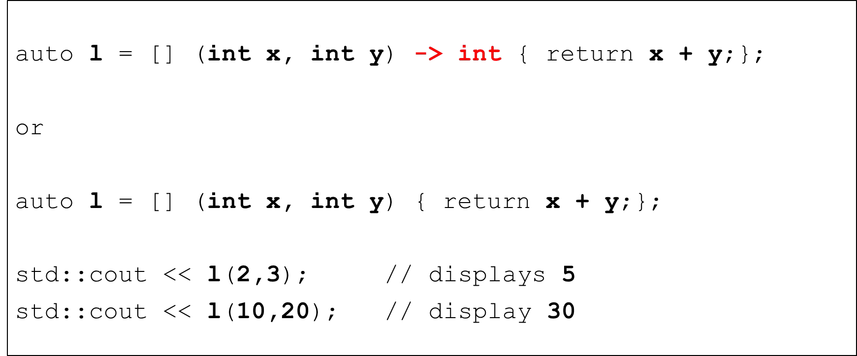



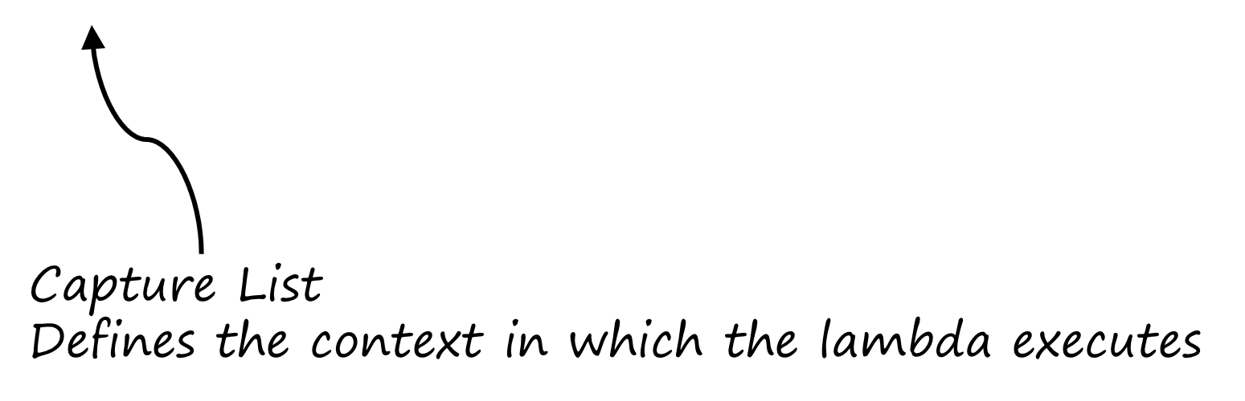

Simple stateless lambda expressions

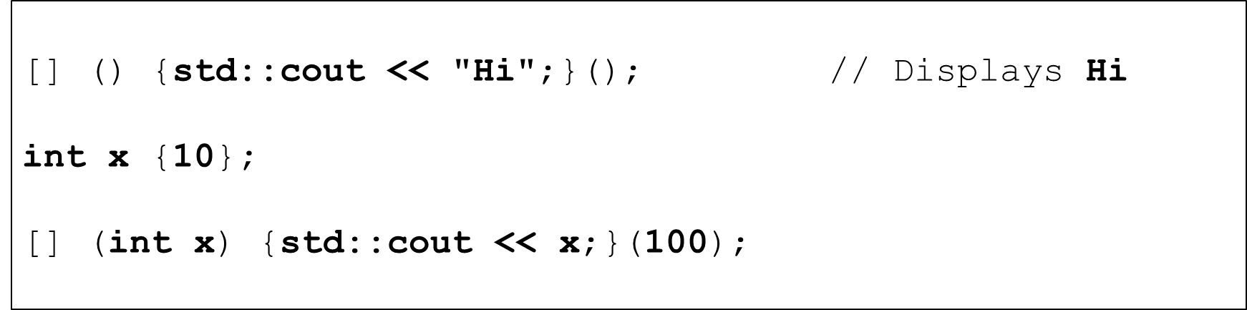

Simple stateless lambda expressions

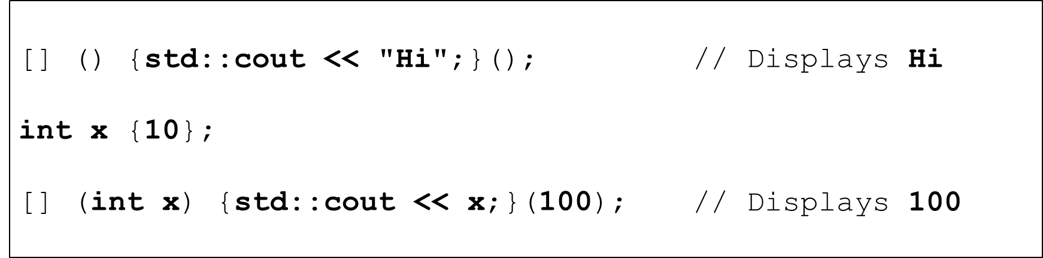

Simple stateless lambda expressions

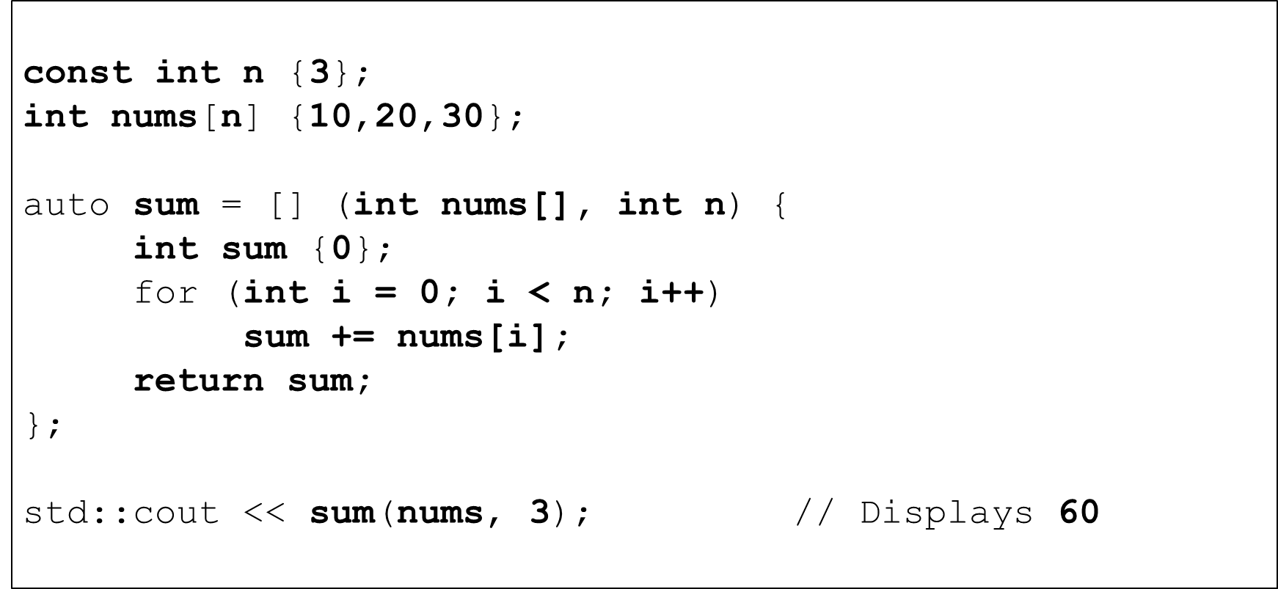

Using values and references as lambda parameters

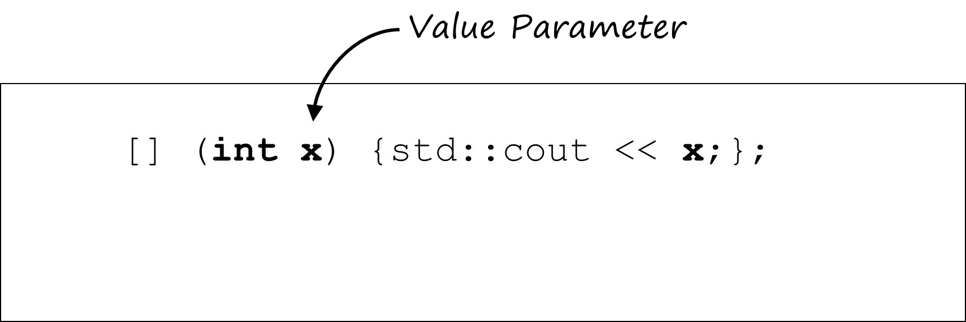

Using values and references as lambda parameters

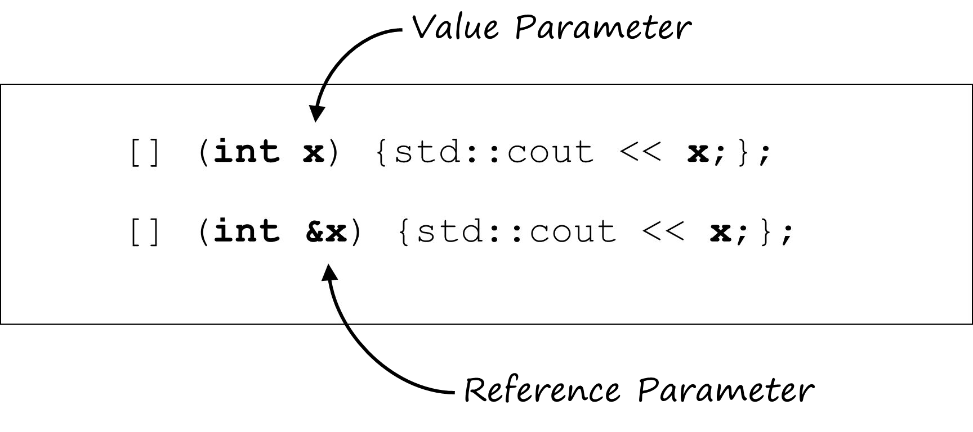

Using values and references as lambda parameters

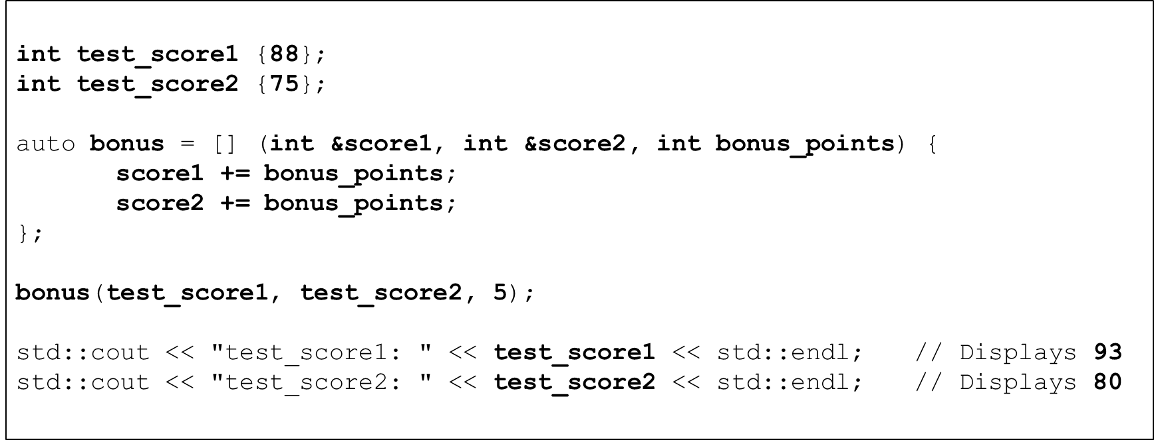

Using pointers as lambda parameters

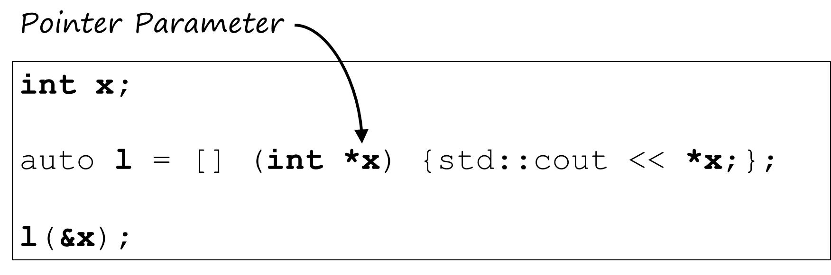

Using pointers as lambda parameters

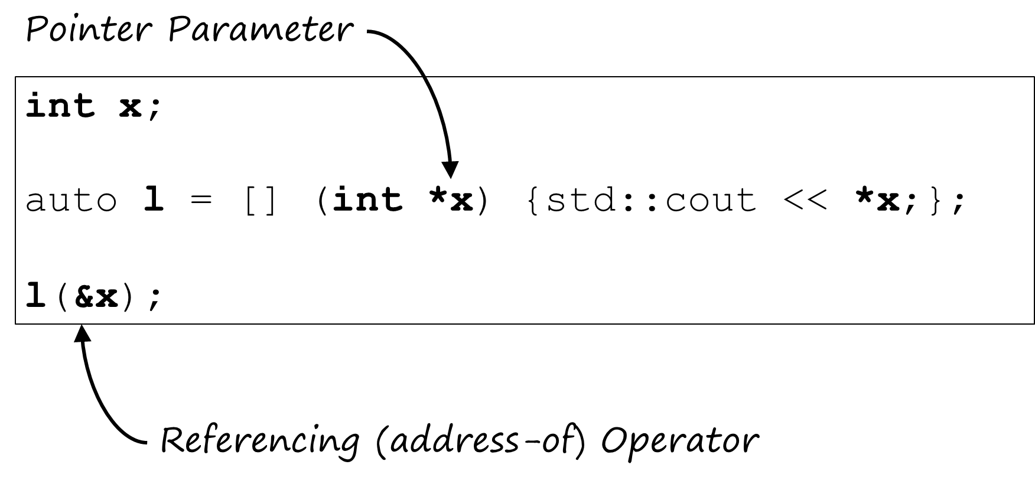

Using pointers as lambda parameters

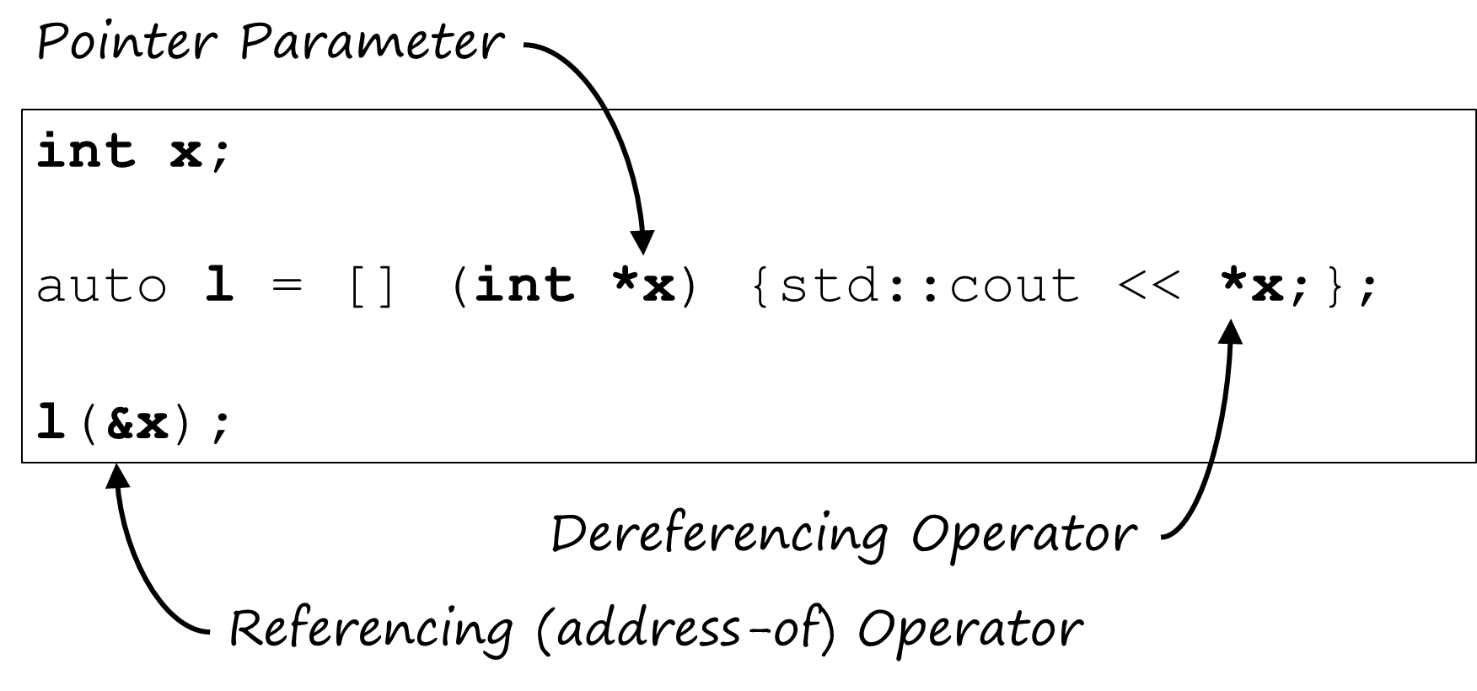

Using pointers as lambda parameters

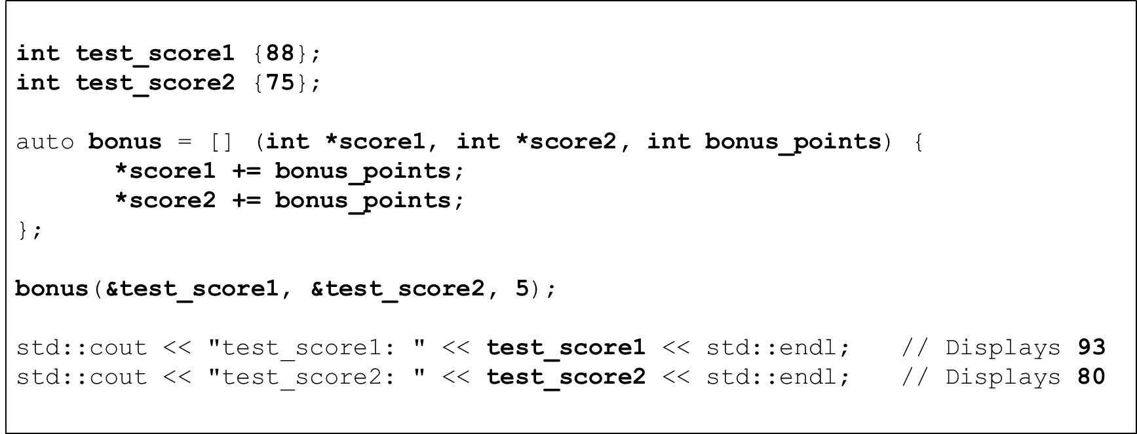

Using arrays and vectors as lambda reference parameters

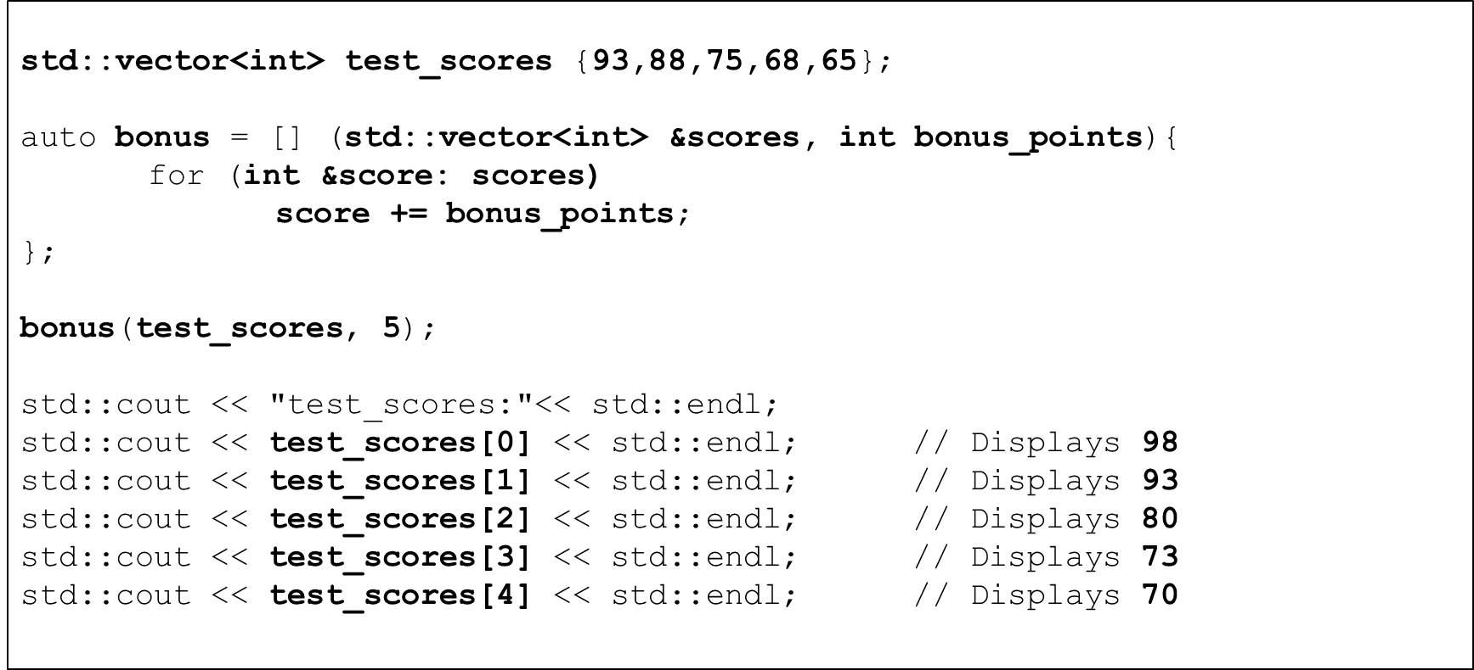

Using auto as lambda parameter type speciﬁers

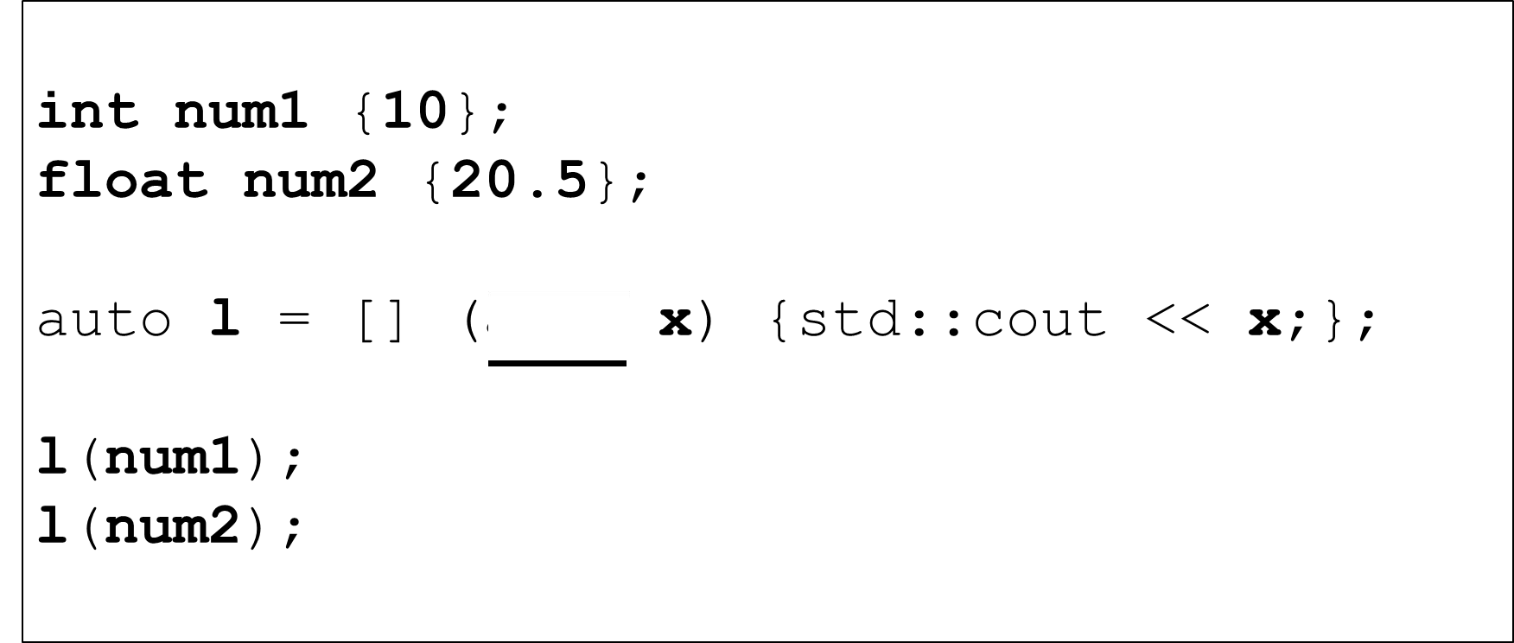

Using auto as lambda parameter type speciﬁers

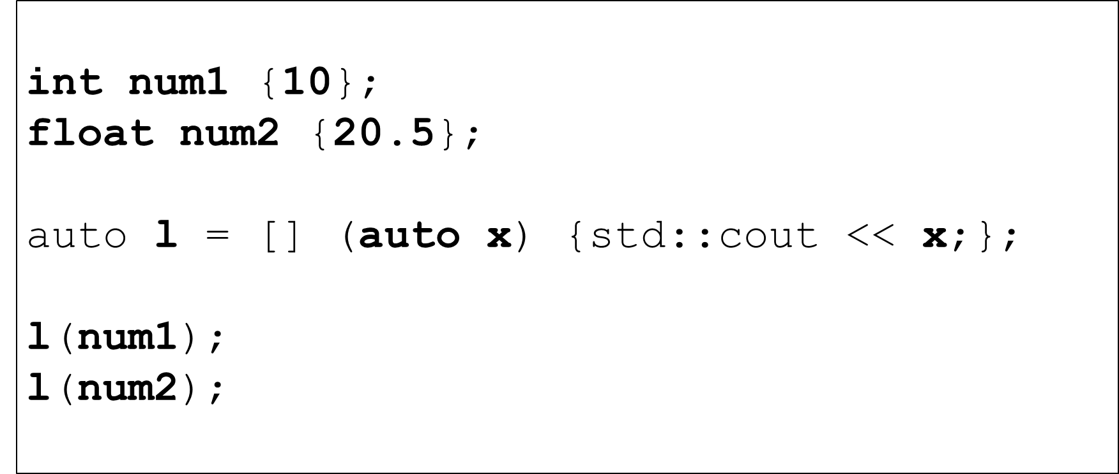

Using auto as lambda parameter type speciﬁers

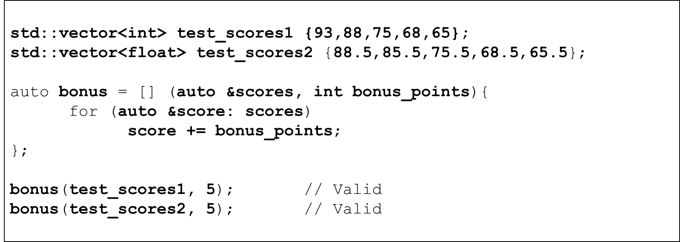

Using lambda expressions as function parameters

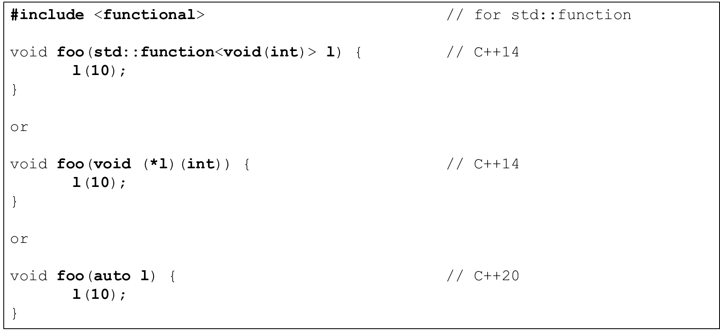

Using lambda expressions as function parameters

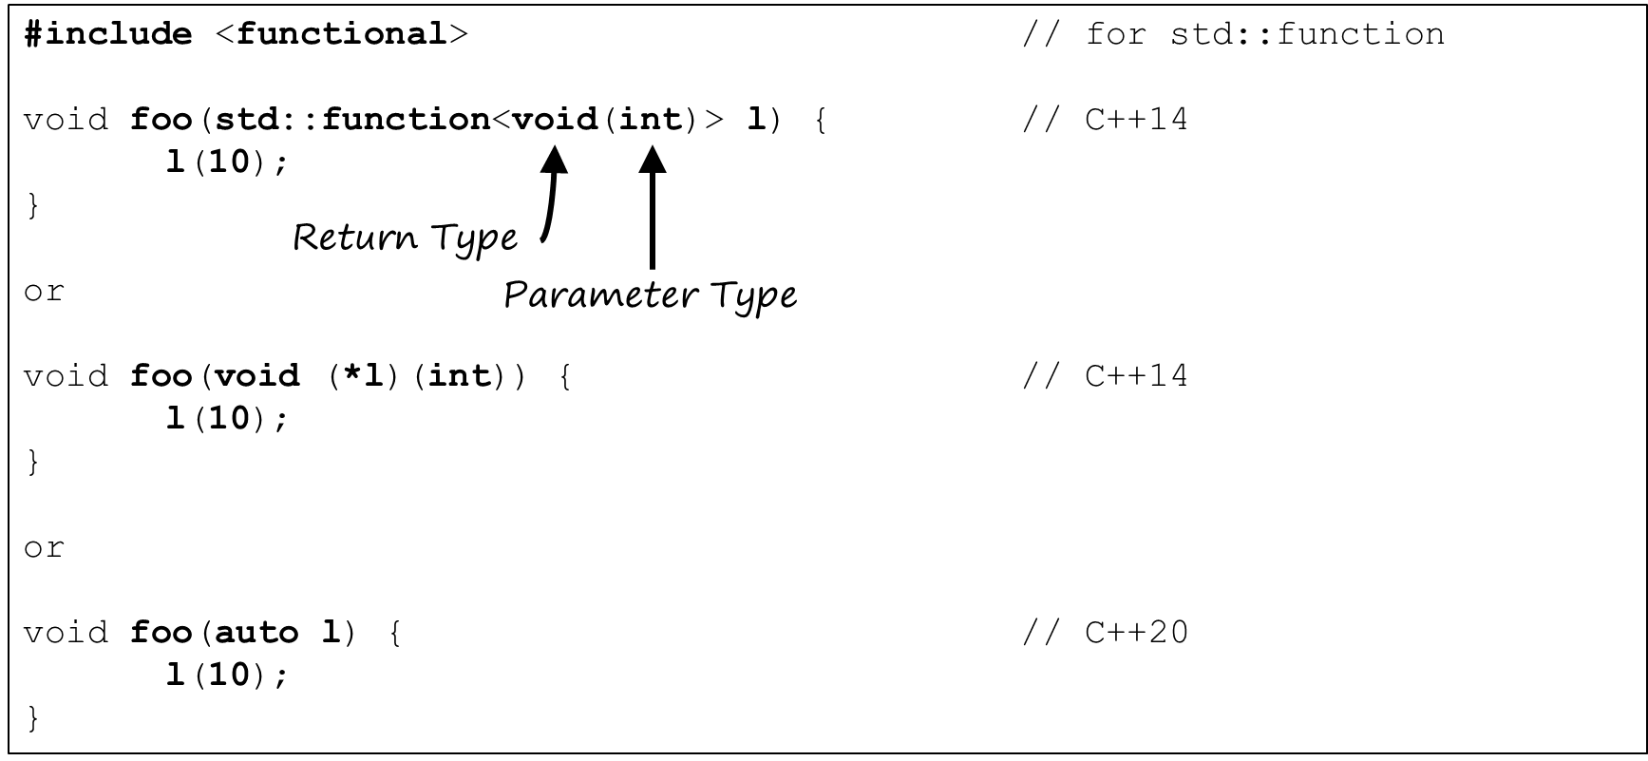

Using lambda expressions as function parameters

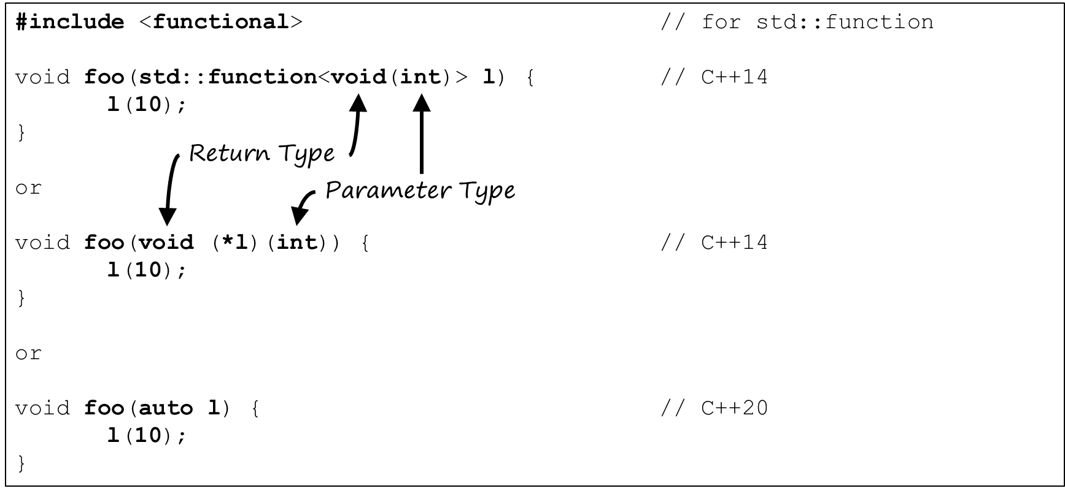

Returning lambda expressions from functions

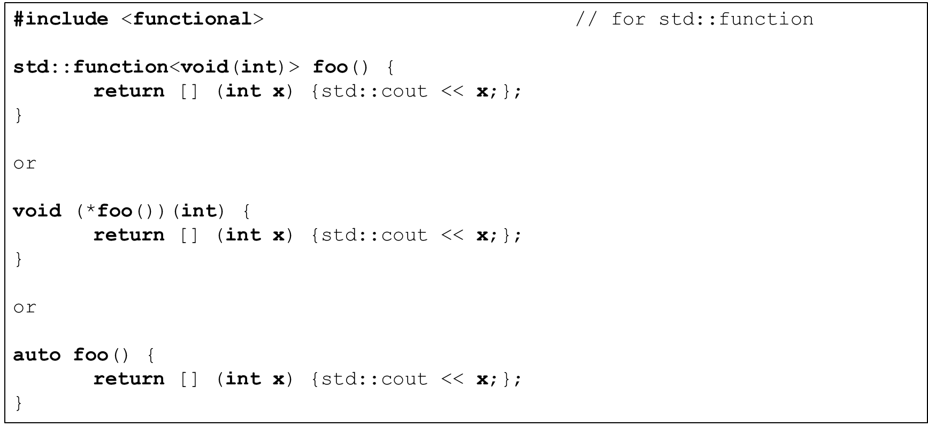

Returning lambda expressions from functions

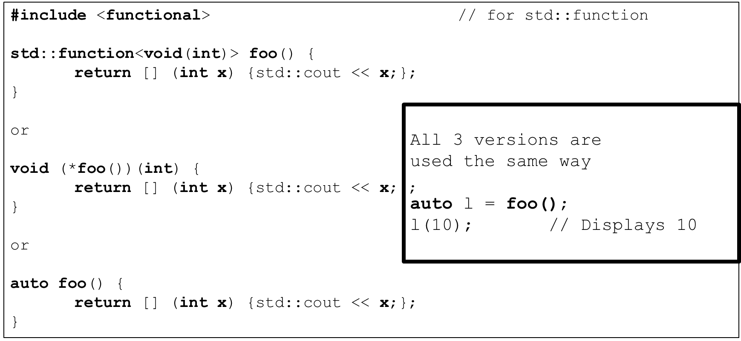

Using lambda expressions as function parameters

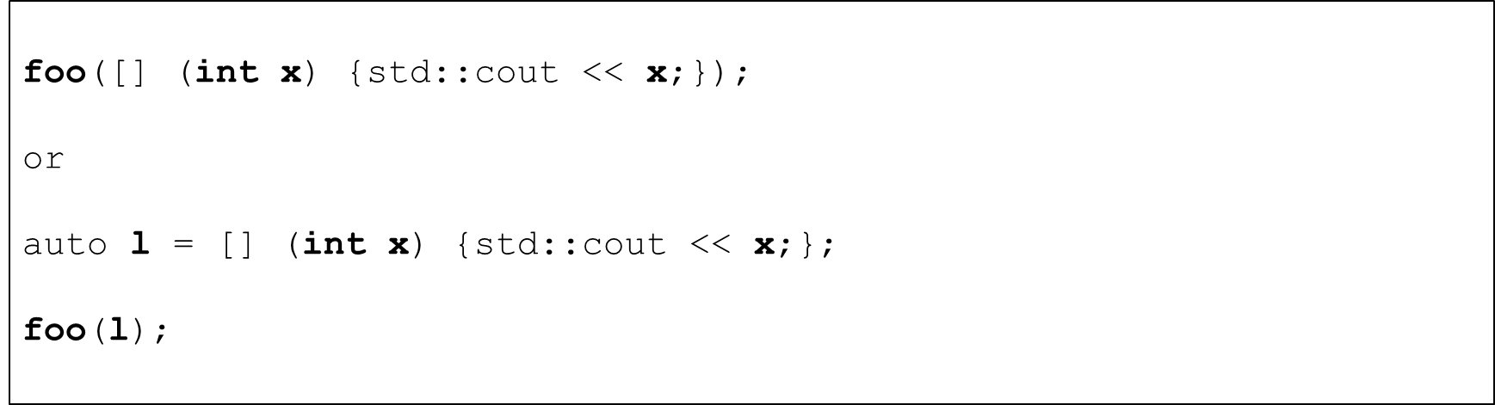

Using lambda expressions as predicates

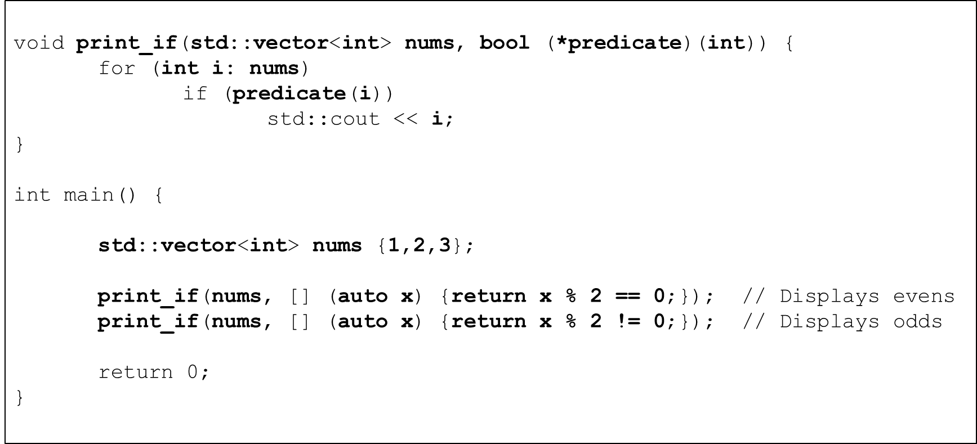

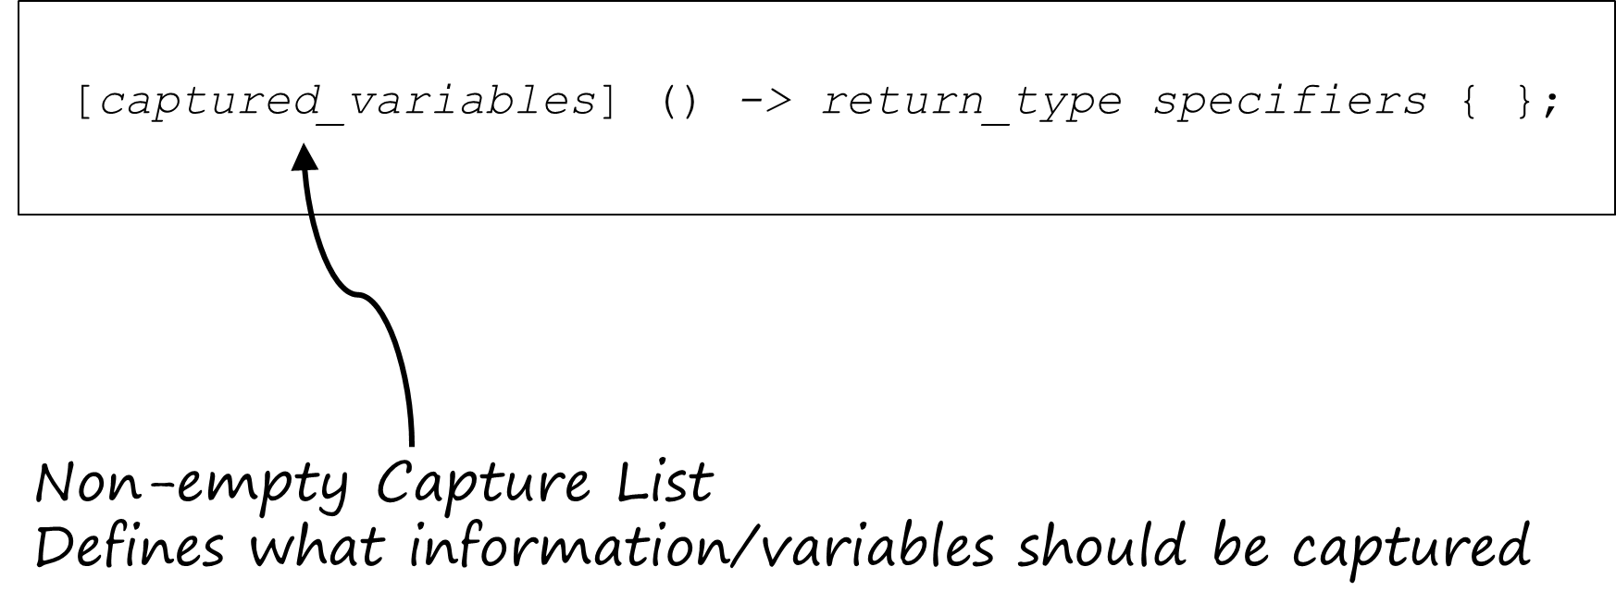

Compilation of stateless lambda expressions

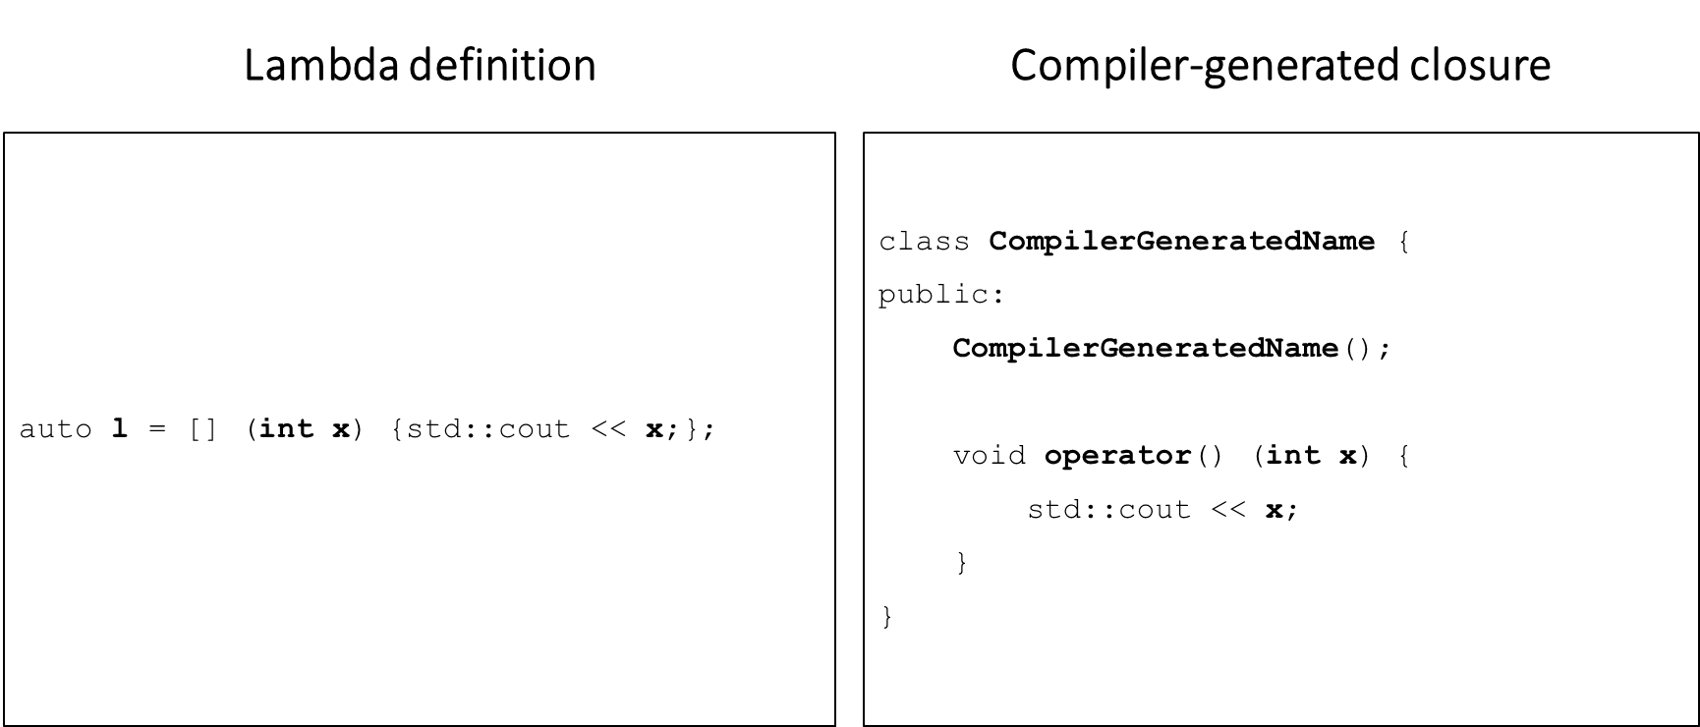

Compilation of stateful lambda expressions

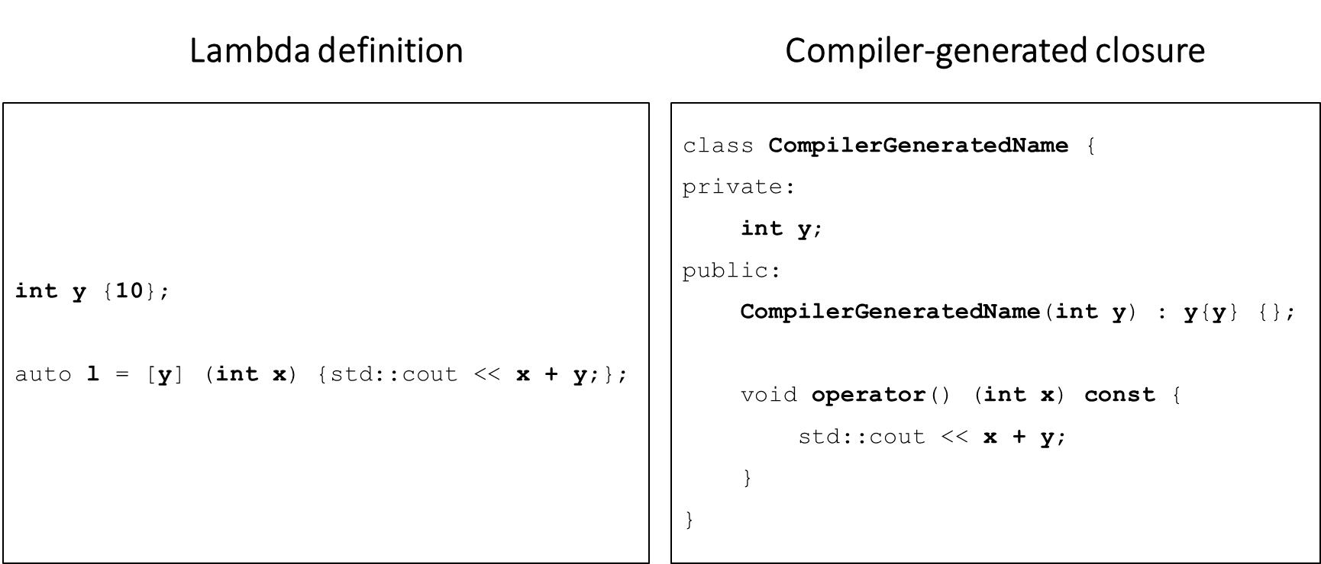

Capture by value

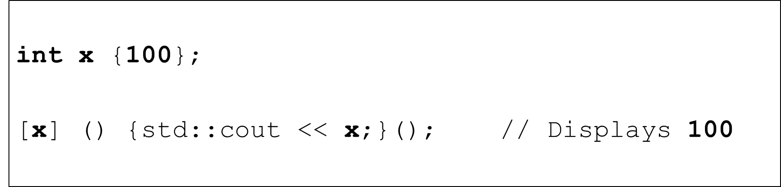

Using mutable to modify variables captured by value

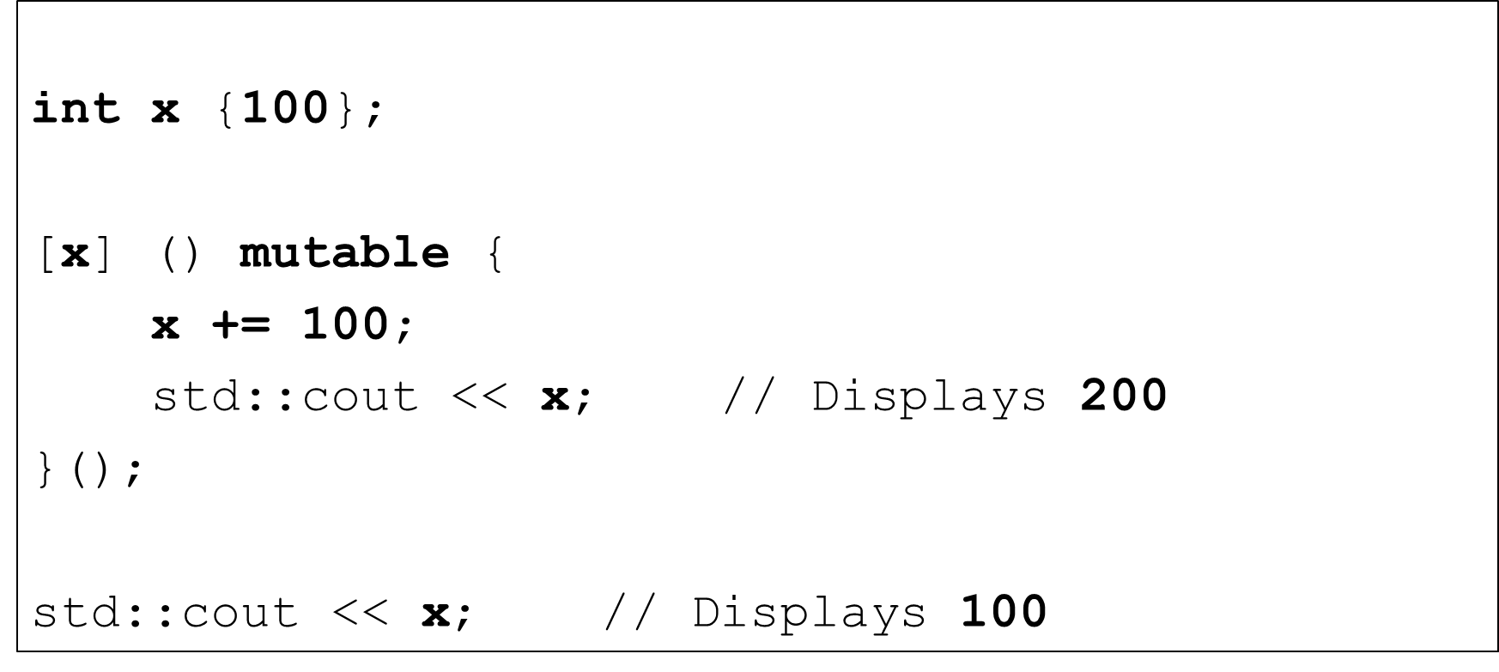

Capture by reference

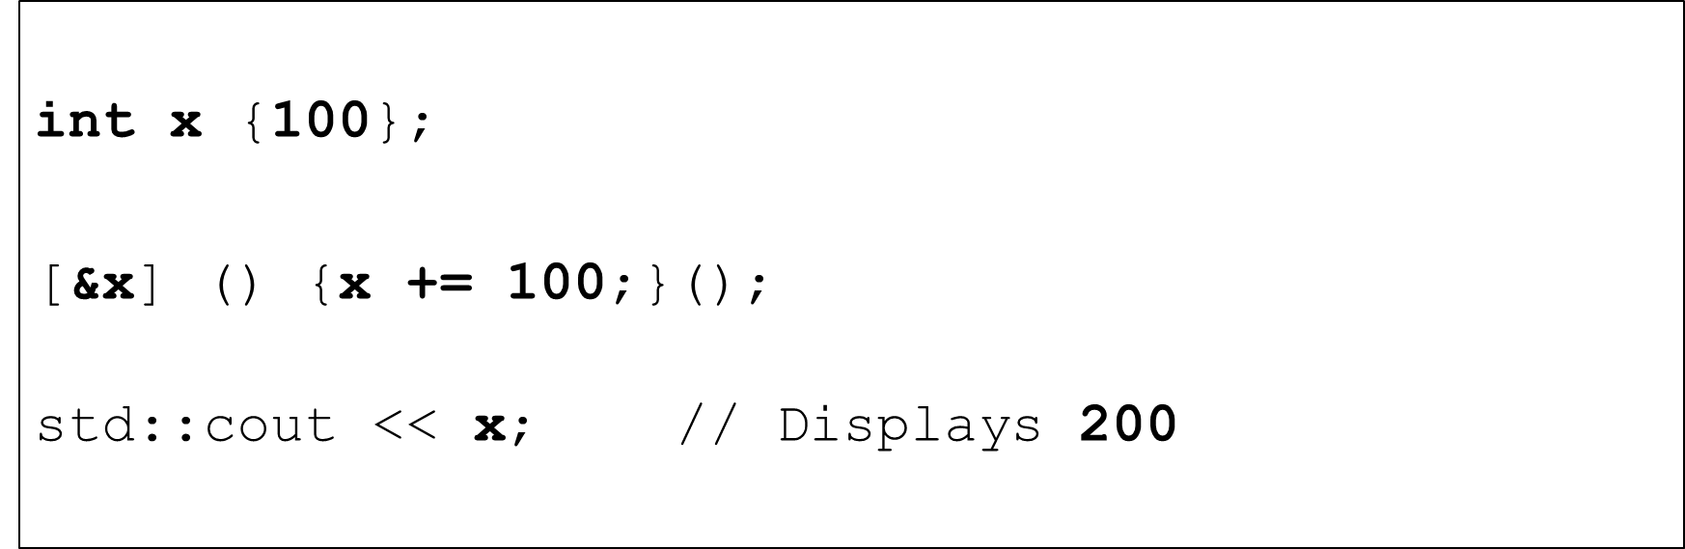

Capture by value and reference

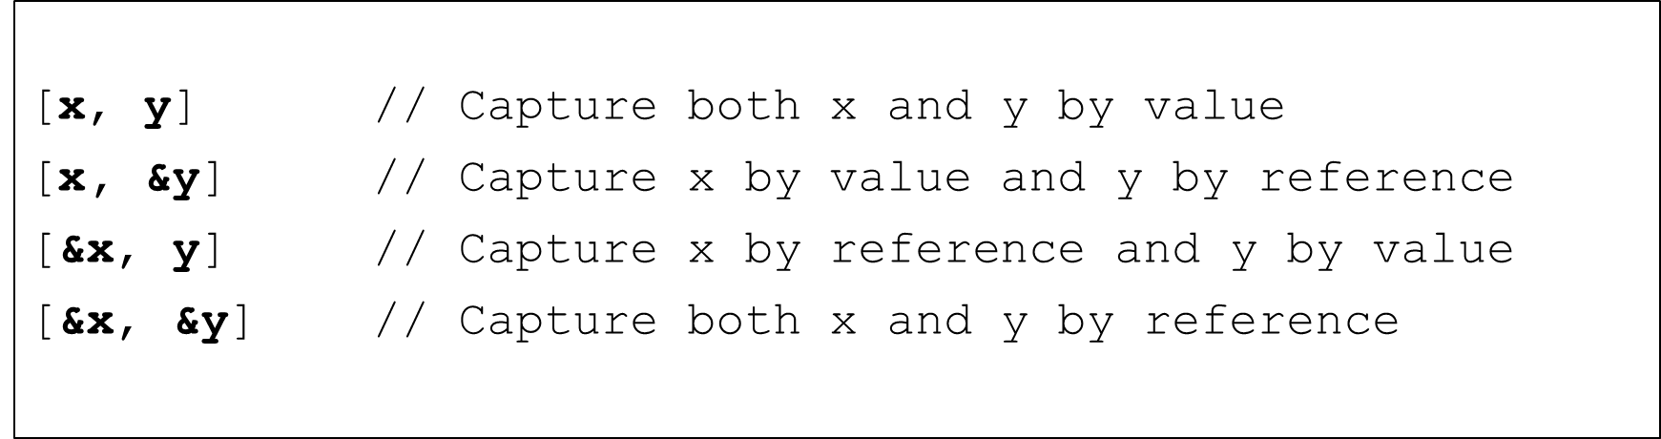

Default captures

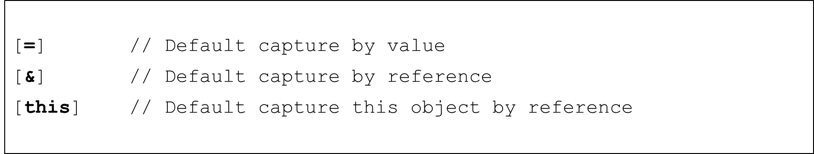

Using default and explicit captures

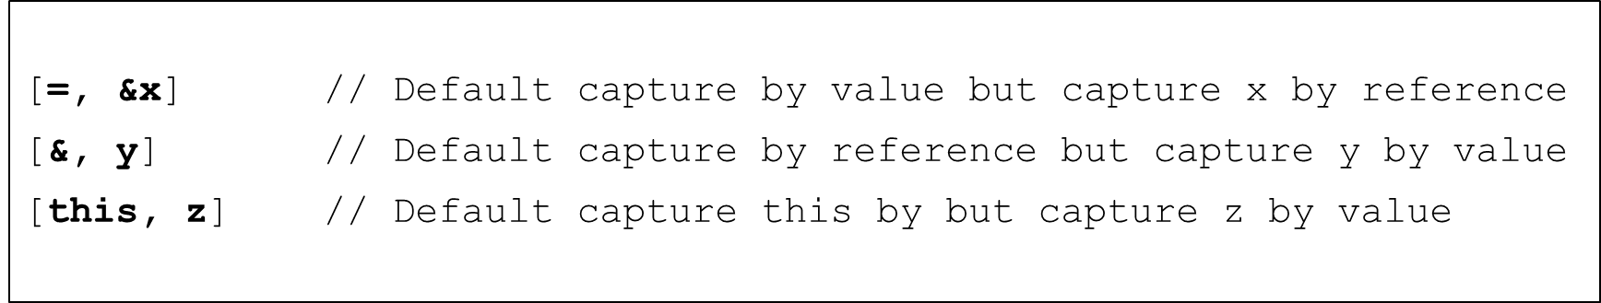

Using Visual Studio Code with C++

#### Visual Studio Code – VS Code

* Microsoft
* Free
* Cross-platform
* Cross-language
* Fast
* Small
* Powerful
* Extensible

Using Visual Studio Code with C++

* What we will do in this section
  + Install VS Code
  + Conﬁgure VS Code to work with C++
  + Setup a folder structure that allows us to use multiple projects
  + Build and run C++ projects
  + Build and debug C++ projects
  + How to use the source-code provided in the course
* We’ll do this for
  + Windows
  + Mac OSX
  + Linux (Ubuntu 20.04 LTS)

## Bonus Section Overview

C++ Enumerations

* What is an enumeration?
  + Motivation
* Structure of an enumeration
* Types of enumerations
  + Unscoped enumeration
  + Scoped enumeration
* Enumerations in use

What is an enumeration?

* + A user-defined type that models a set of constant integral values

What is an enumeration?

* + A user-defined type that models a set of constant integral values
    - The days of the week (Mon, Tue, Wed, . . .)
    - The months of the year (Jan, Feb, Mar, . . .)
    - The suits in a deck of cards (Clubs, Hearts, Spades, Diamonds)
    - The values in a deck of cards (Ace, Two, Three, . . .)
    - States of a system (Idle, Defense_Mode, Attack_Mode, . . .)
    - The directions on a compass (North, South, East, West)

Motivation

* Prior to enumerated types
  + Unnamed numerical constants
  + "Magic numbers"
  + These constants would be used as conditionals in control statements
  + Often, one would have no idea what an algorithm was doing
  + As a result, many algorithms suffered from low readability and high numbers of logic errors

Readability

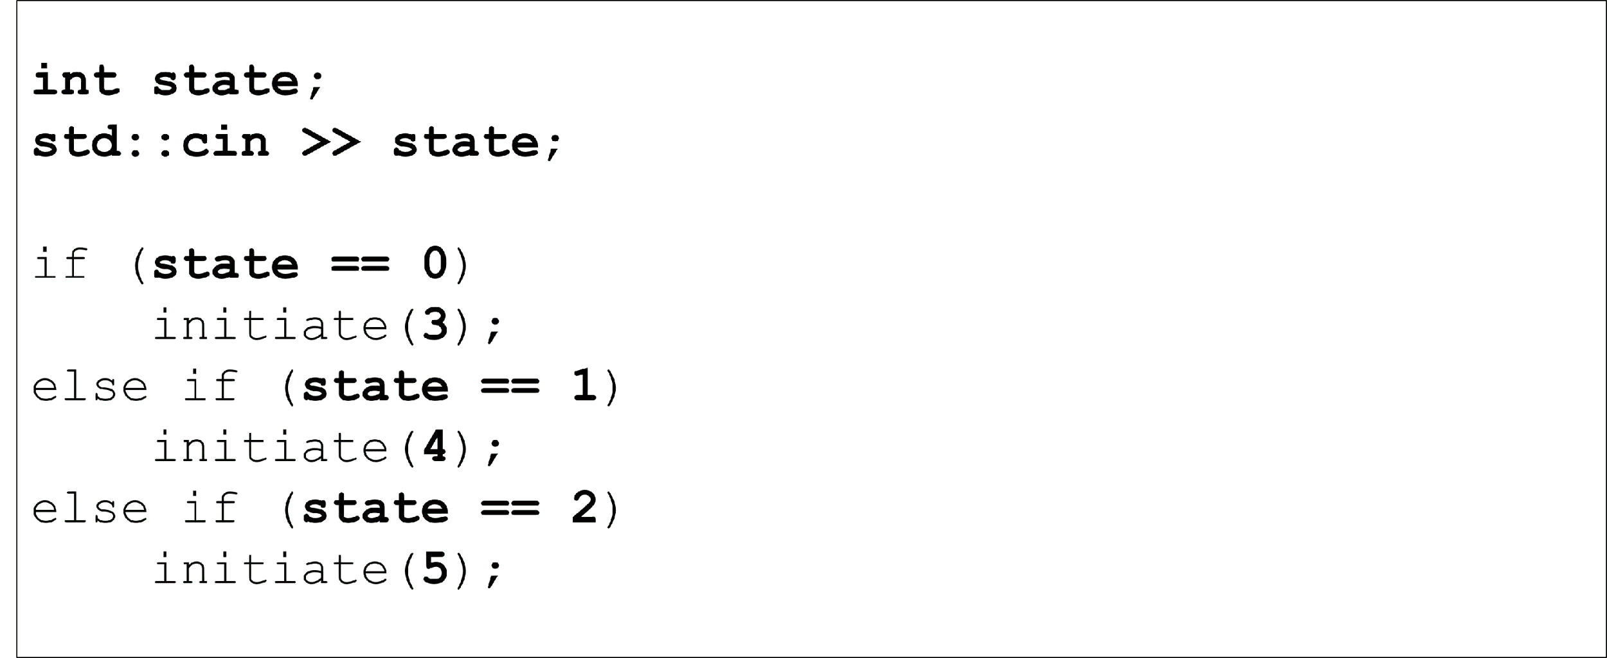

Readability

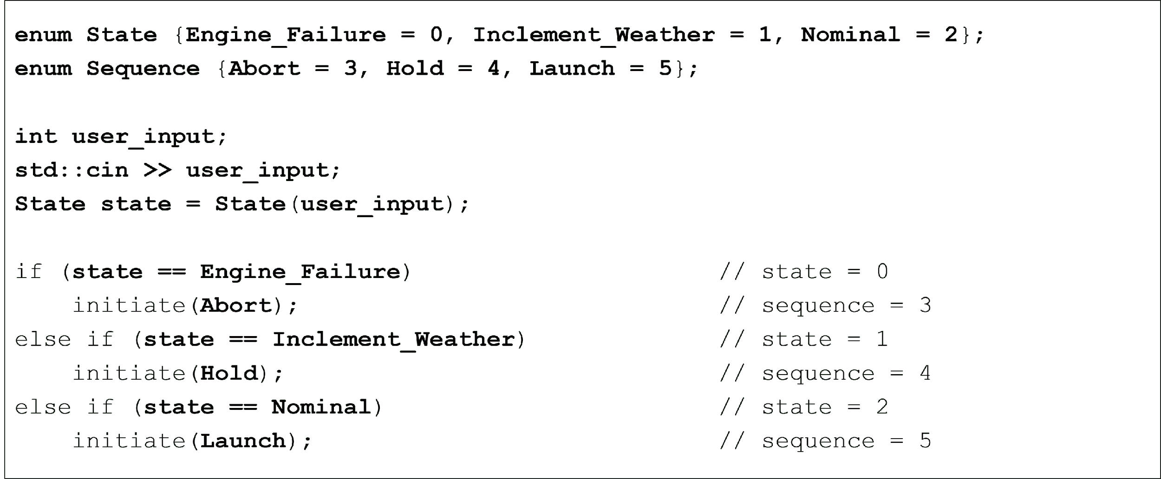

Algorithmic correctness

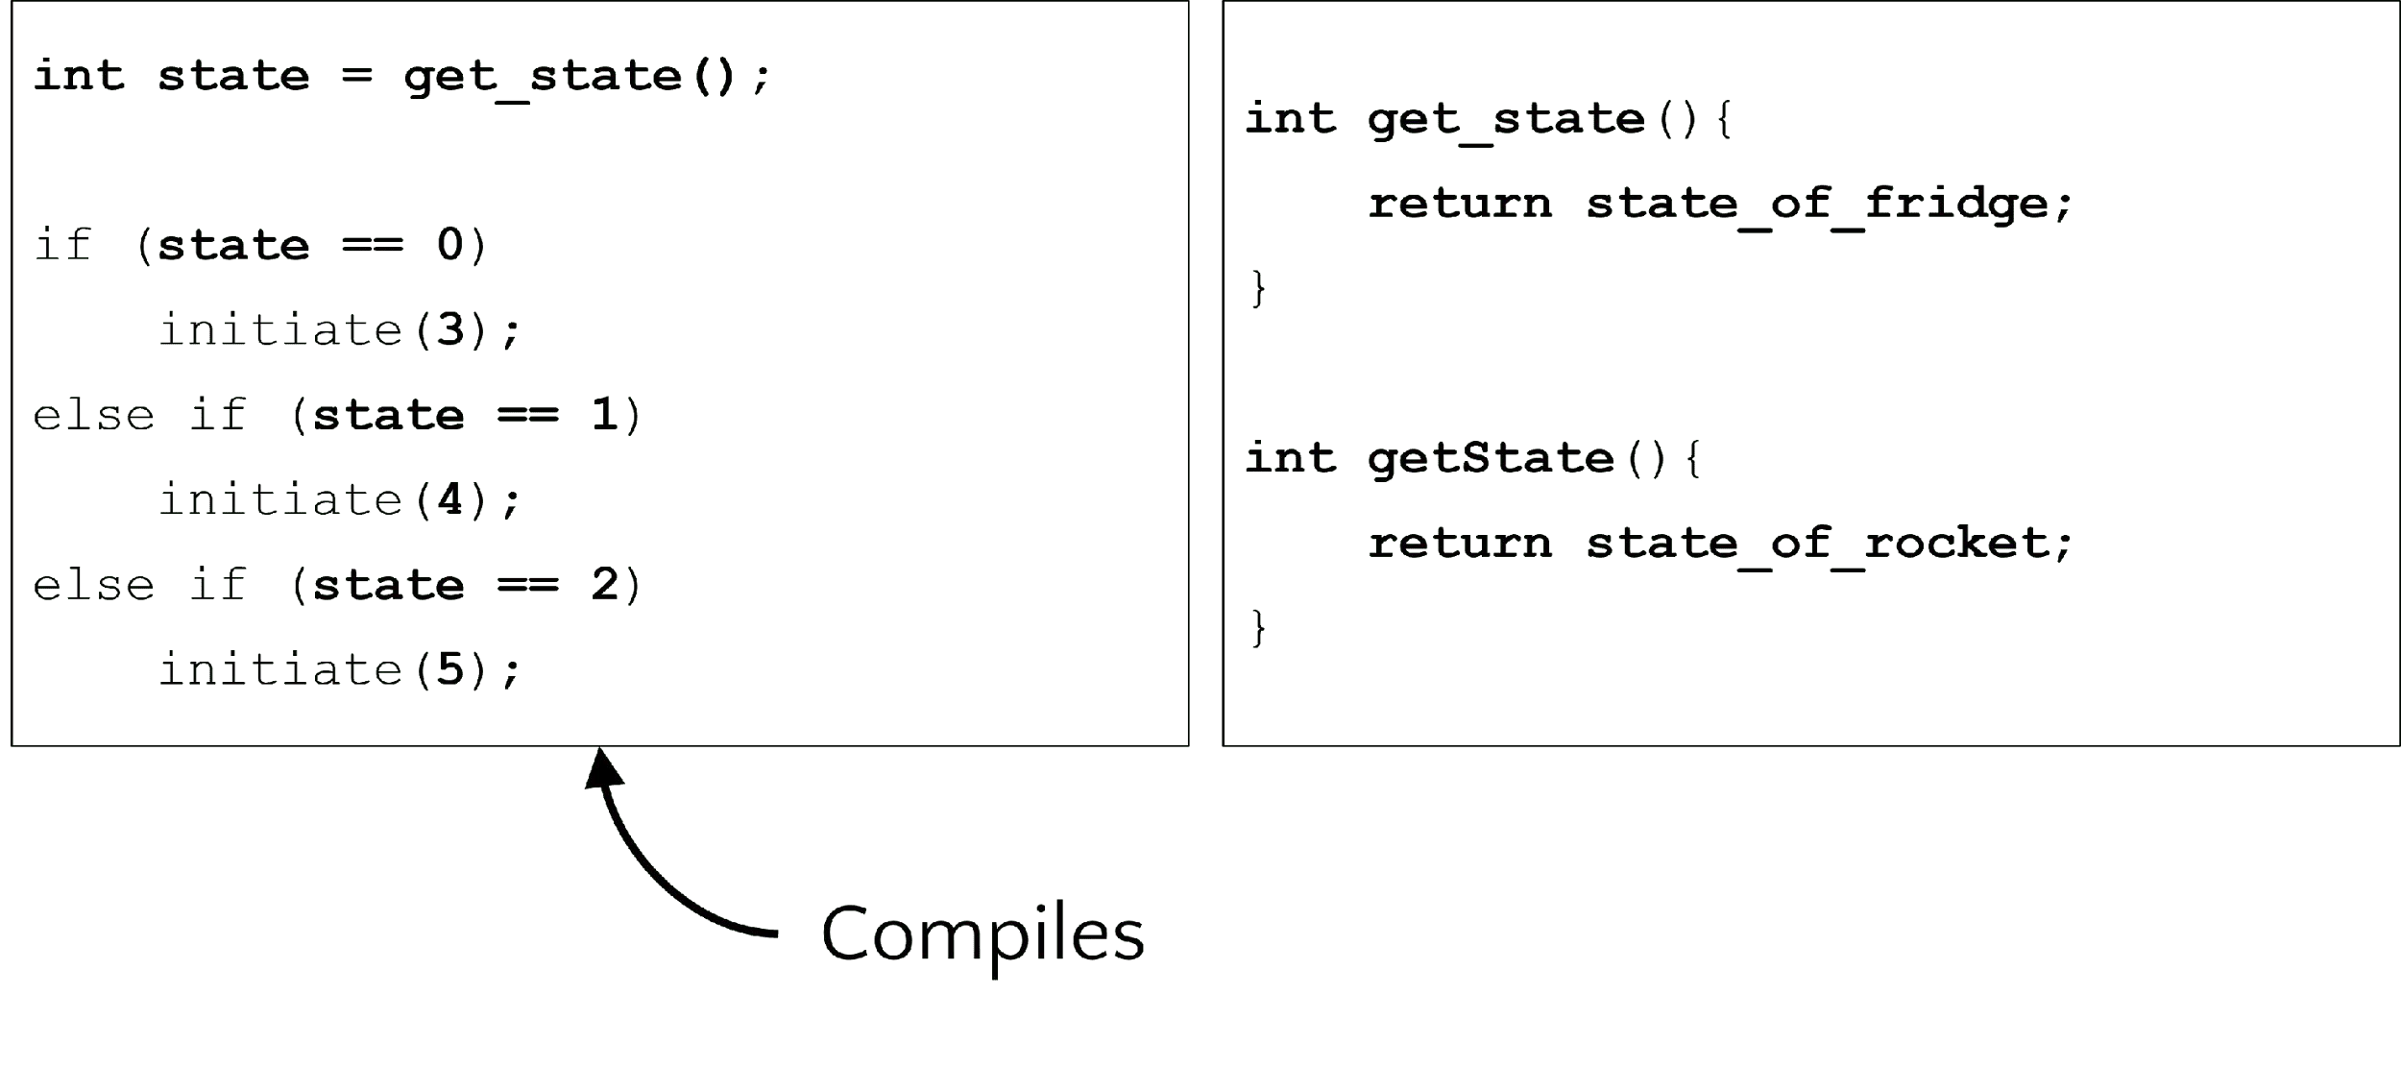

Algorithmic correctness

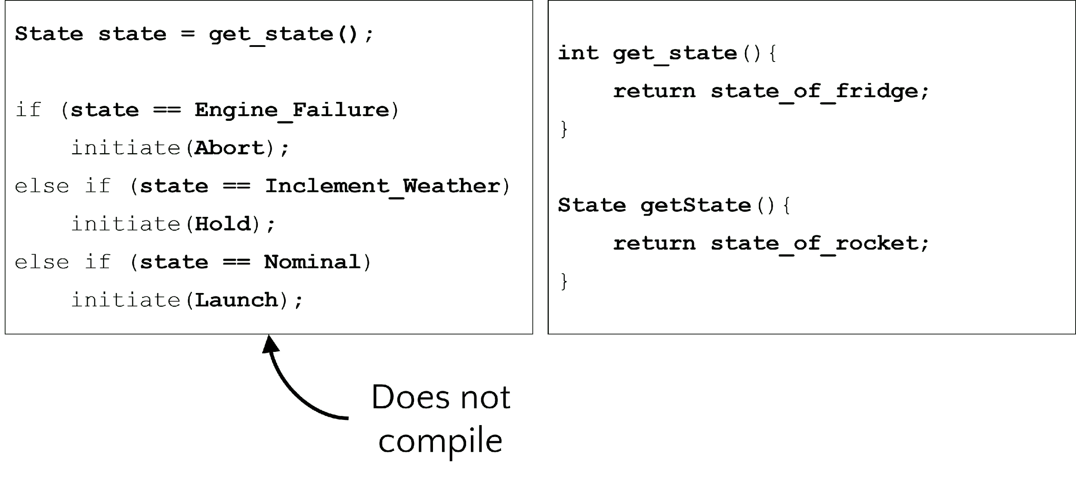

The Structure of an Enumeration

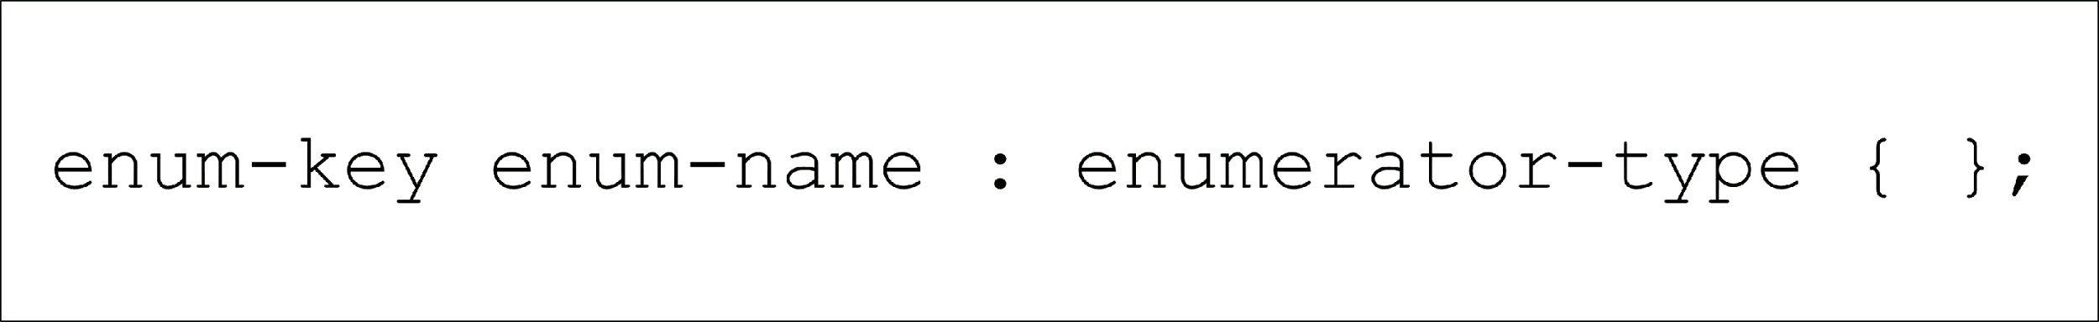

The Structure of an Enumeration

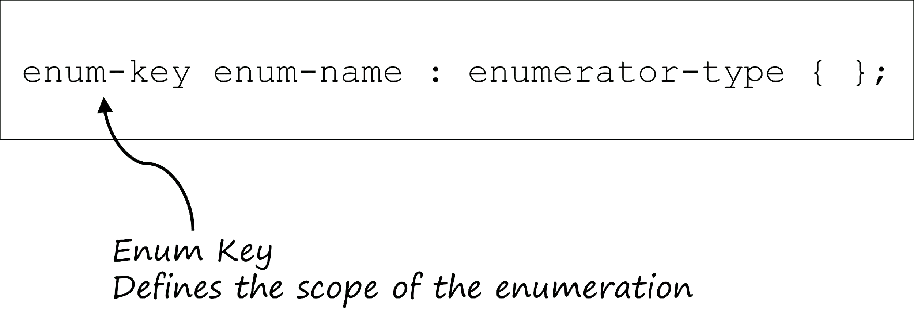

The Structure of an Enumeration

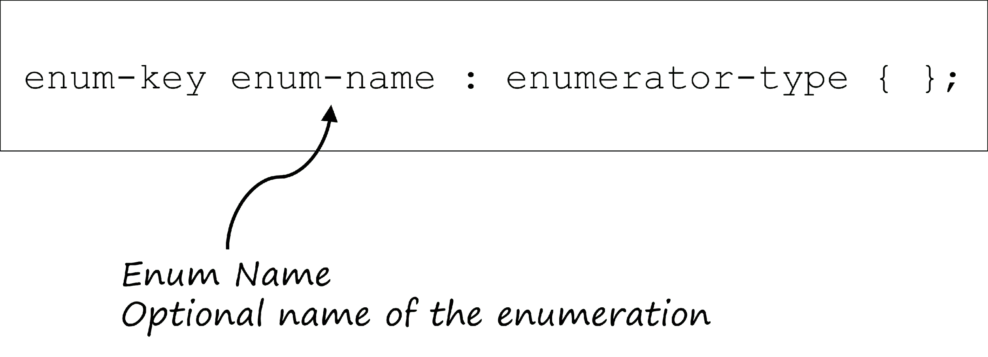

The Structure of an Enumeration

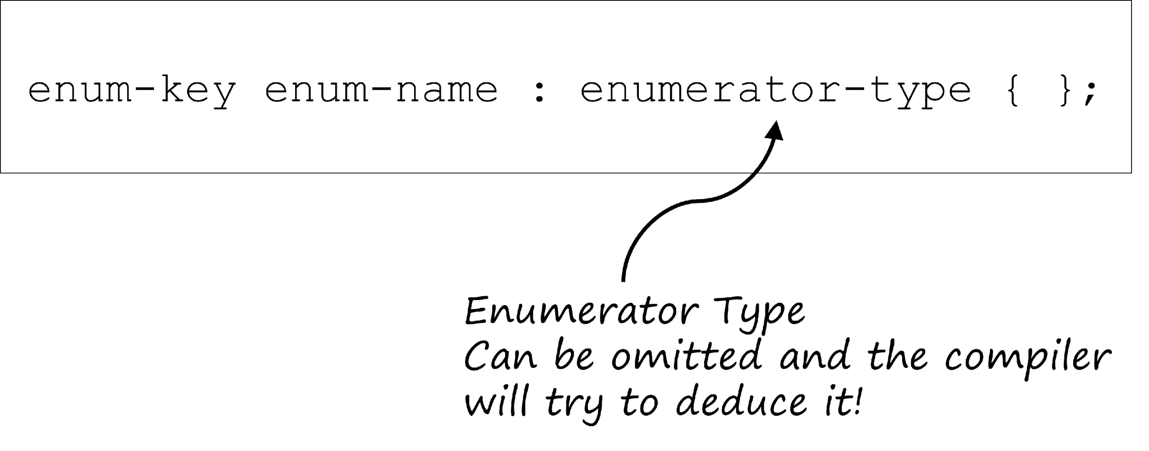

The Structure of an Enumeration

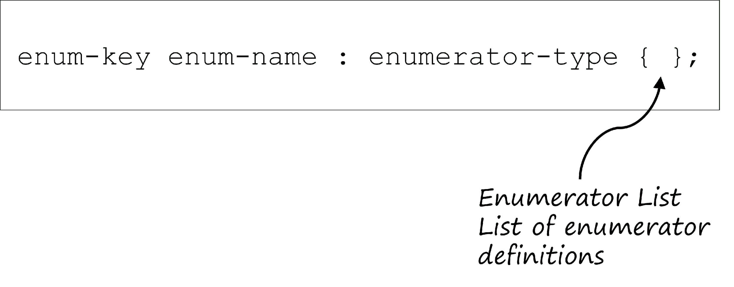

Enumerator list

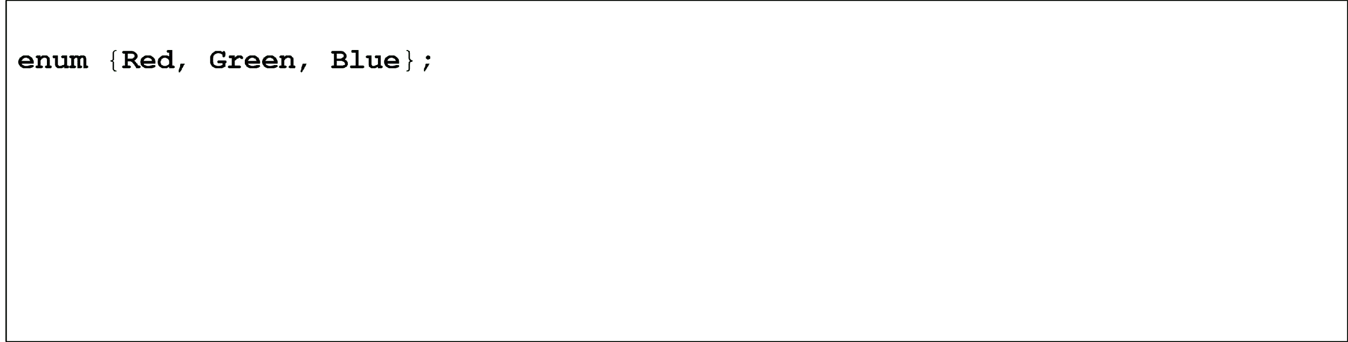

Enumerator list

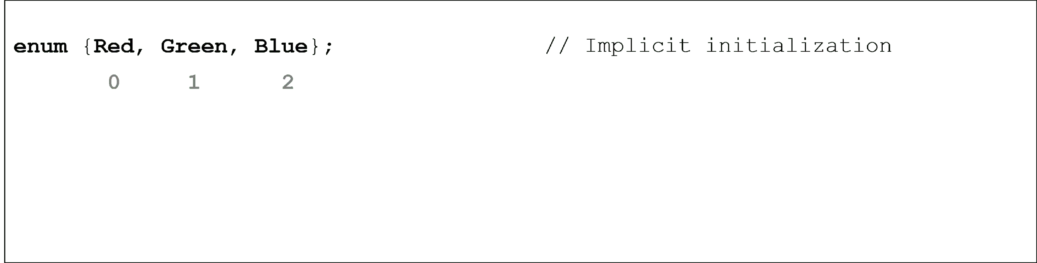

Enumerator list

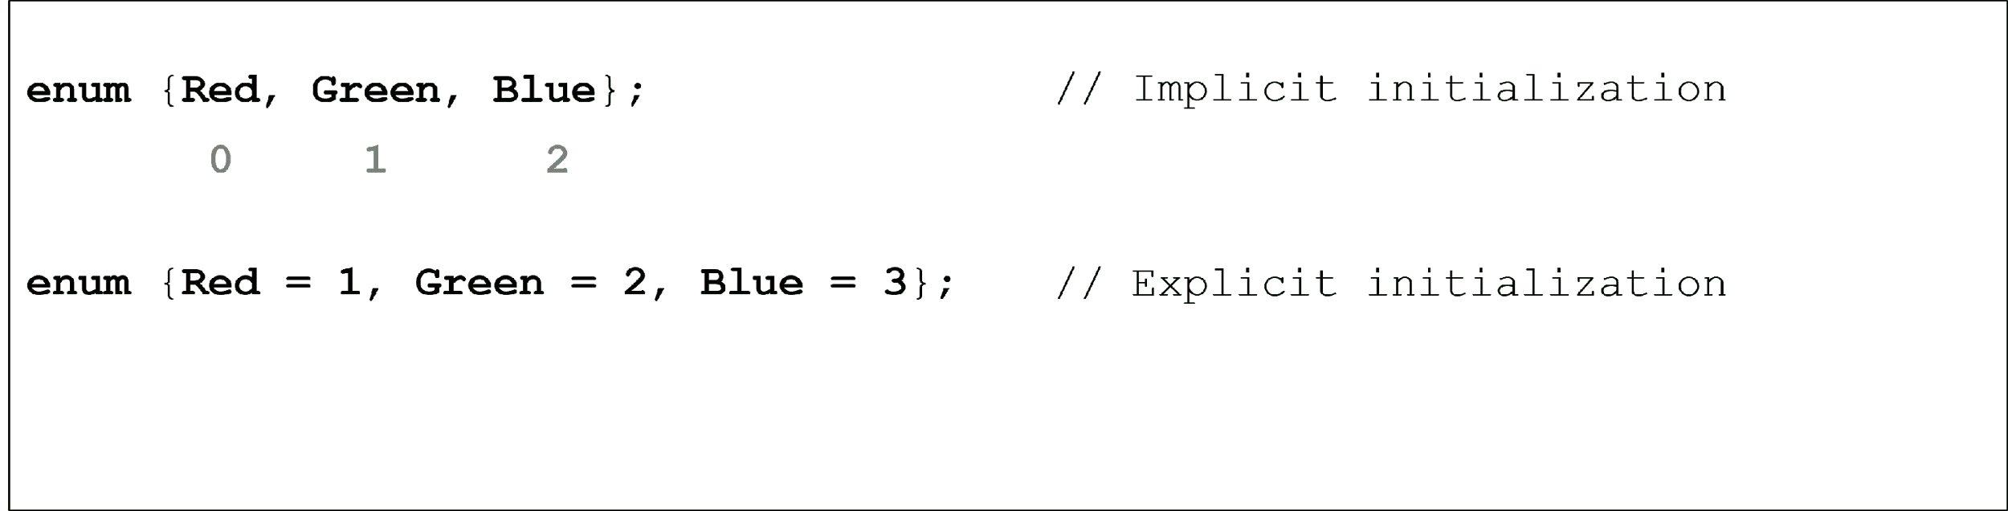

Enumerator list

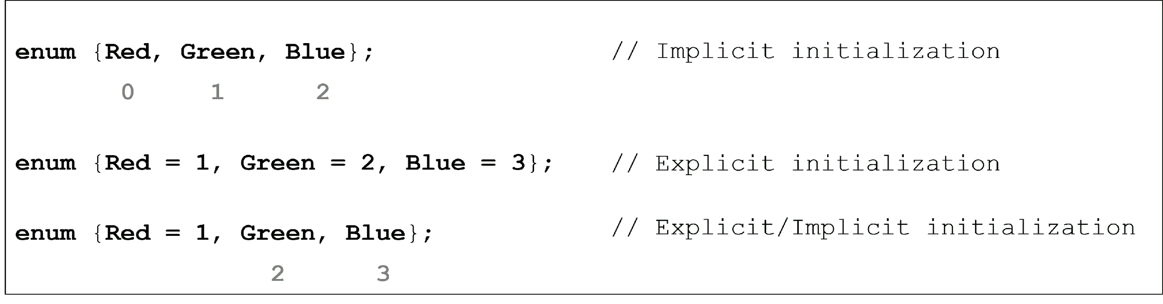

Enumerator type

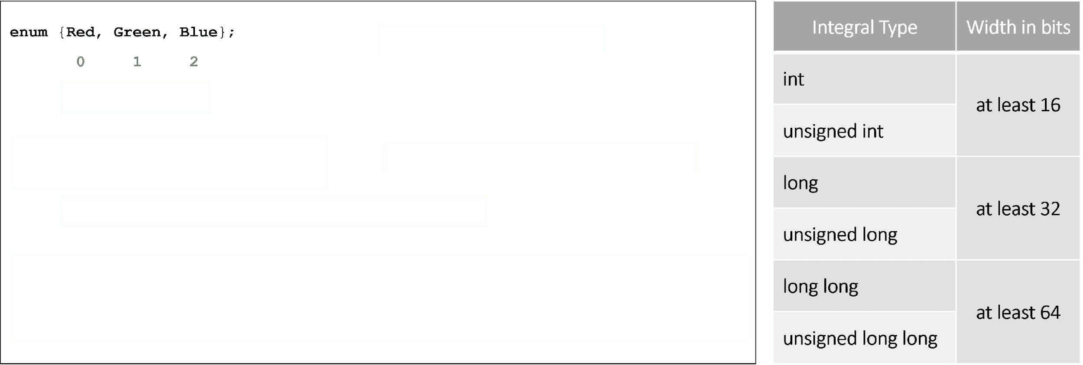

Enumerator type

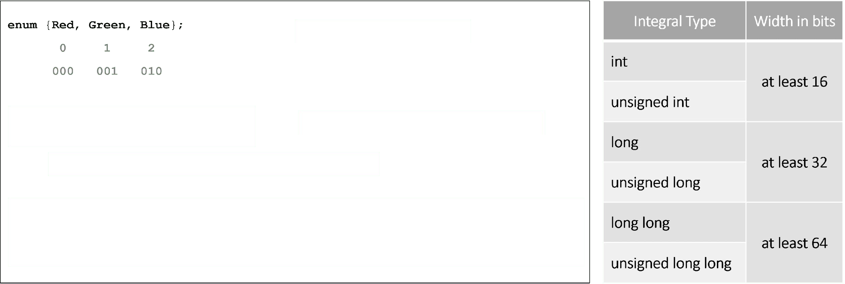

Enumerator type

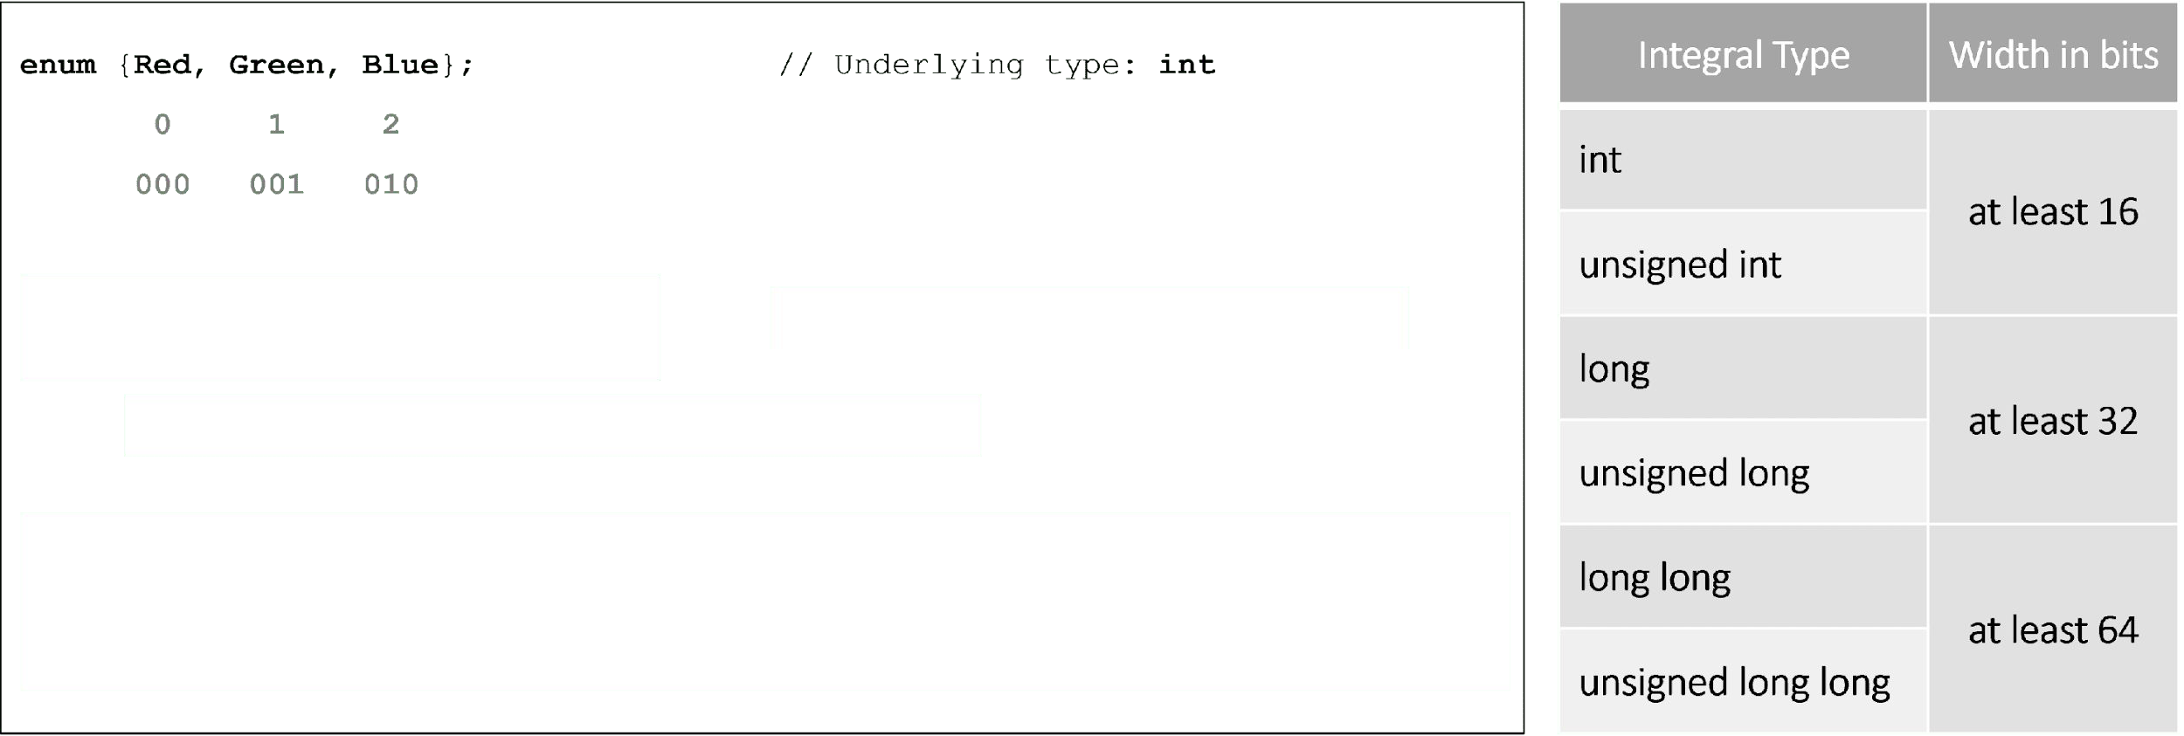

Enumerator type

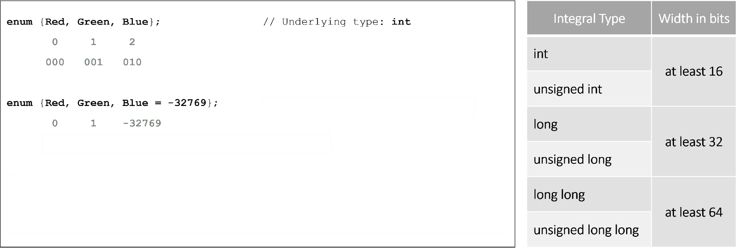

Enumerator type

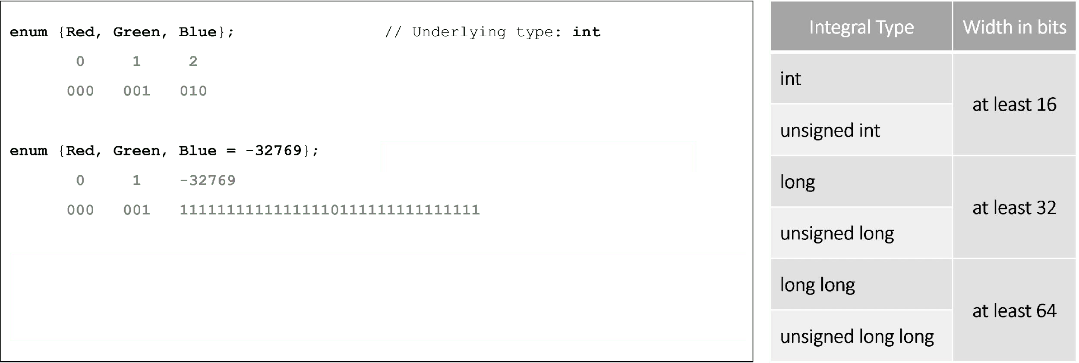

Enumerator type

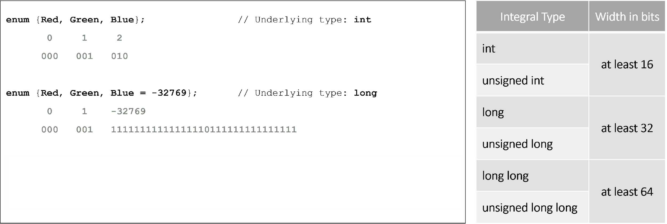

Enumerator type

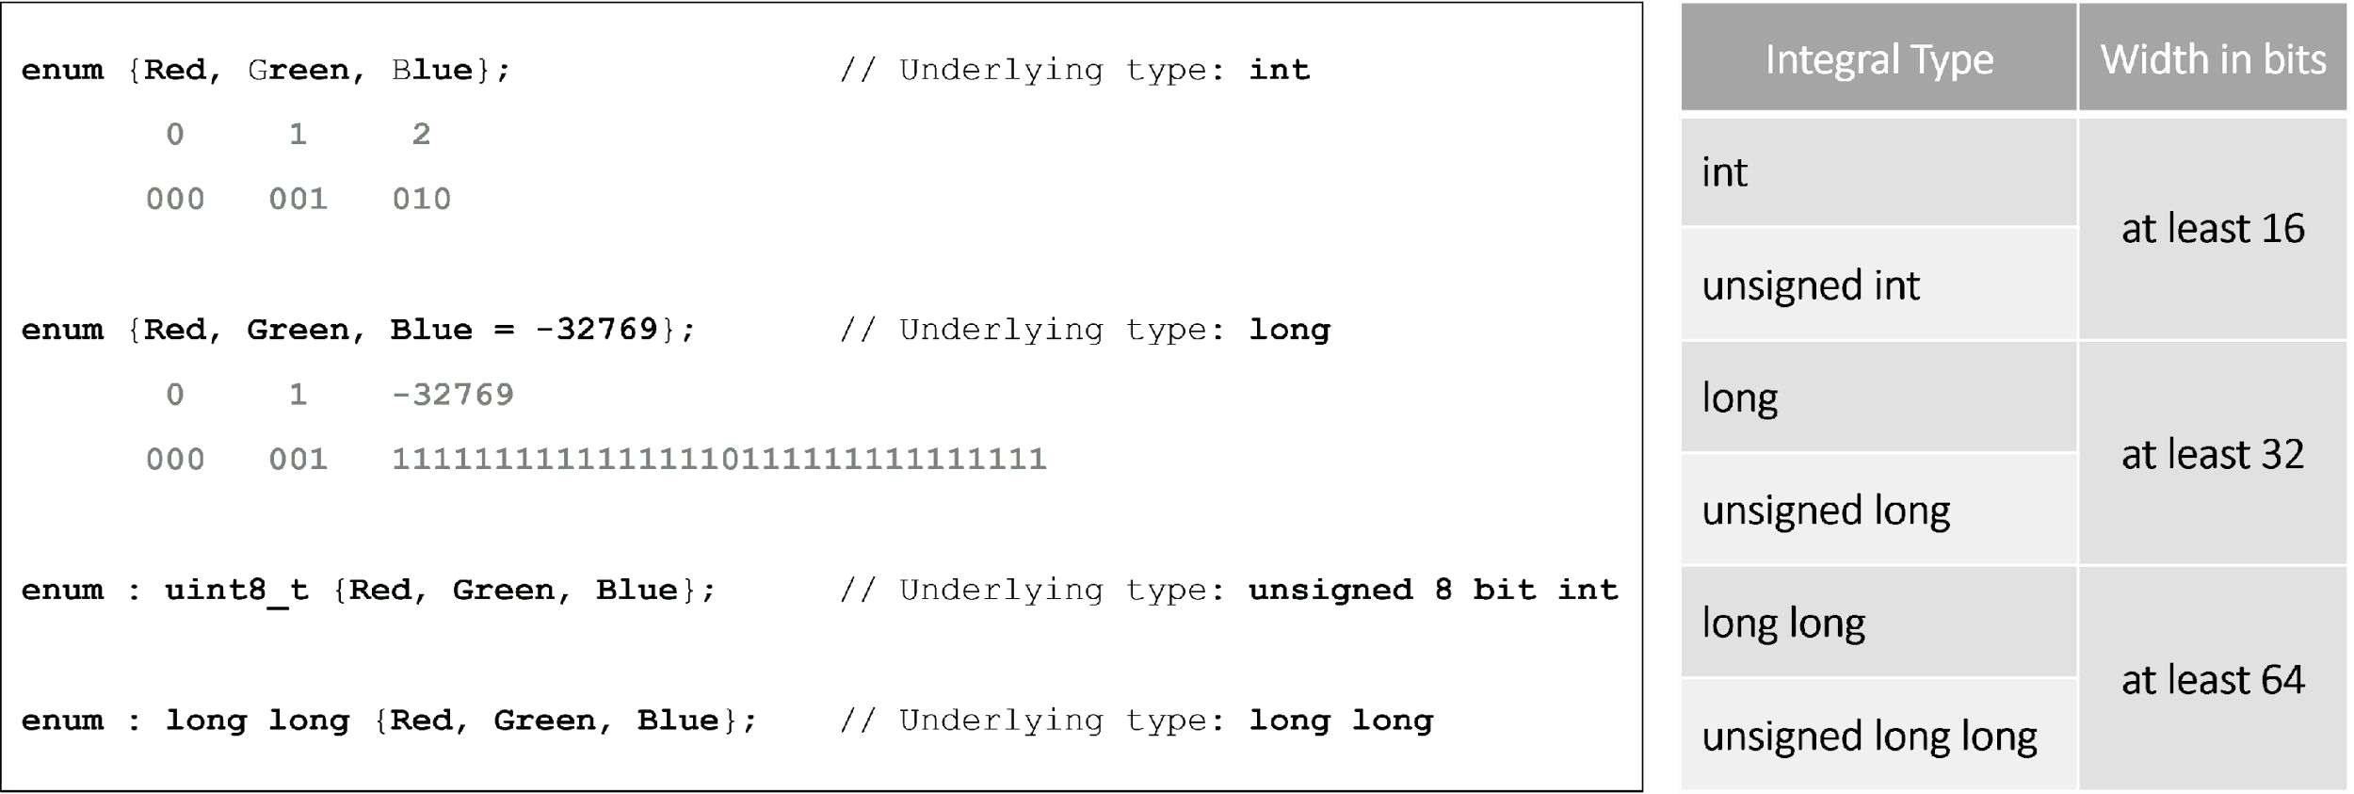

Enumeration name

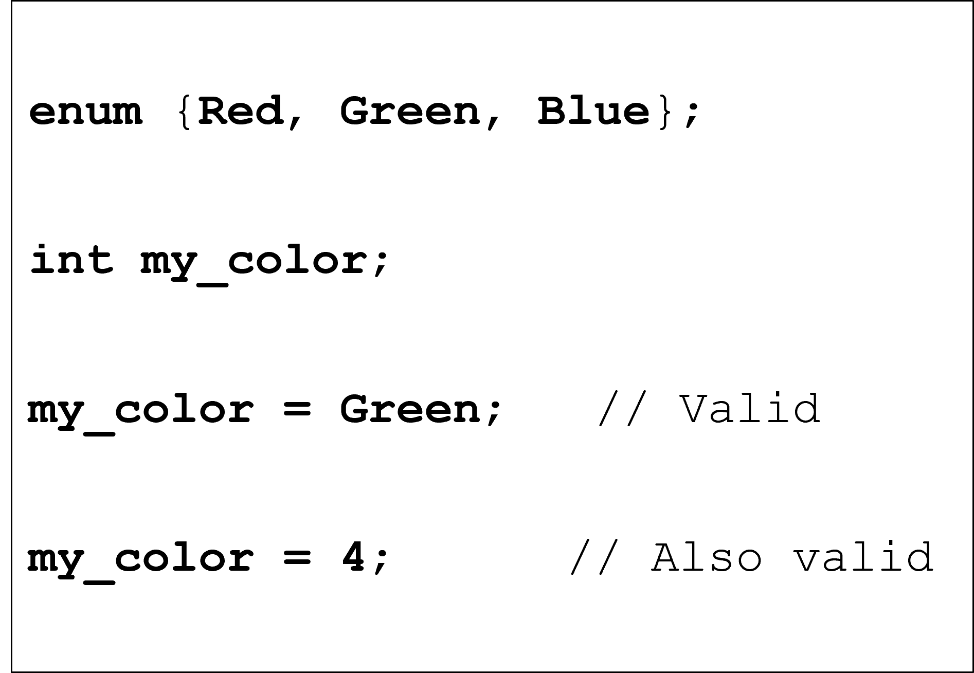

Enumeration name

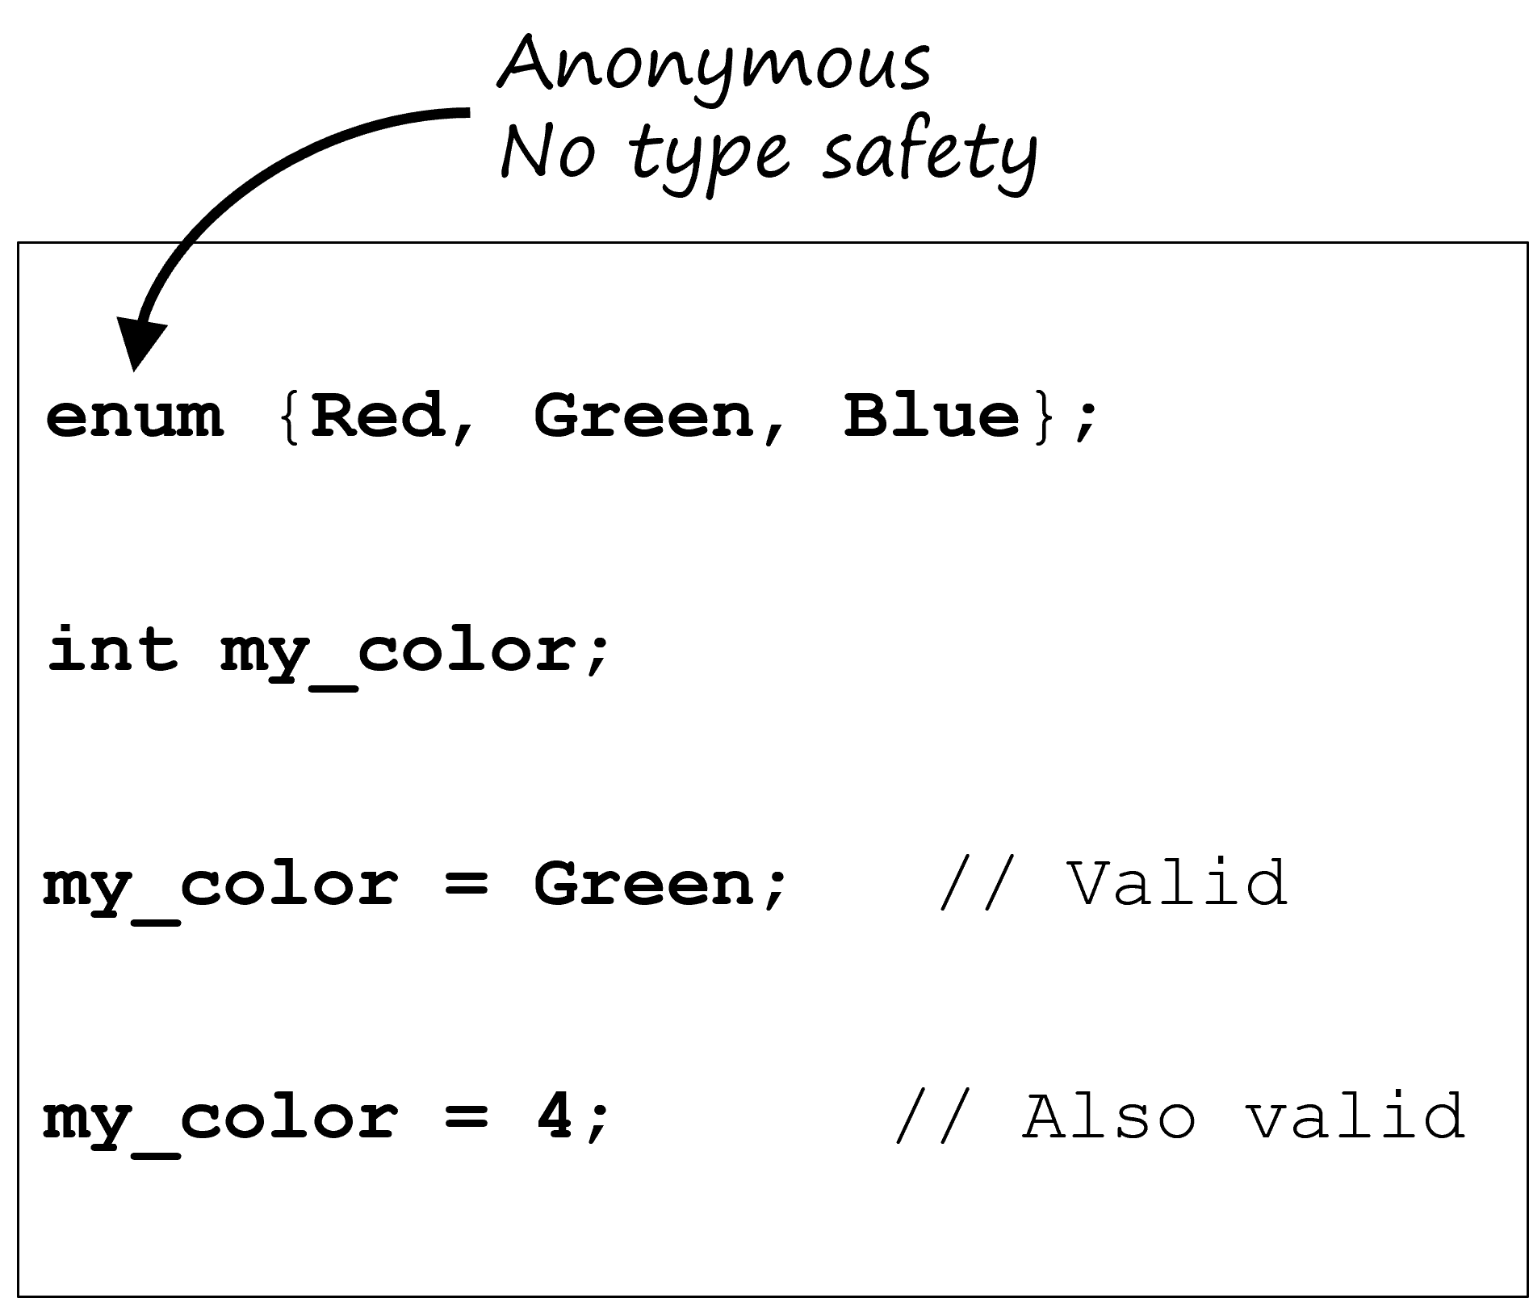

Enumeration name

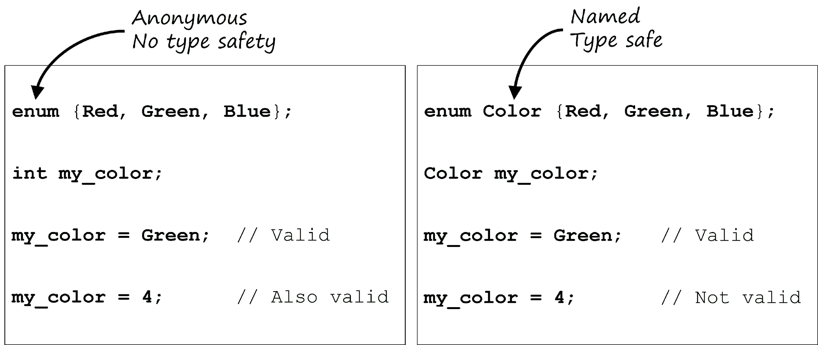





BEGINNING C++ PROGRAMMING

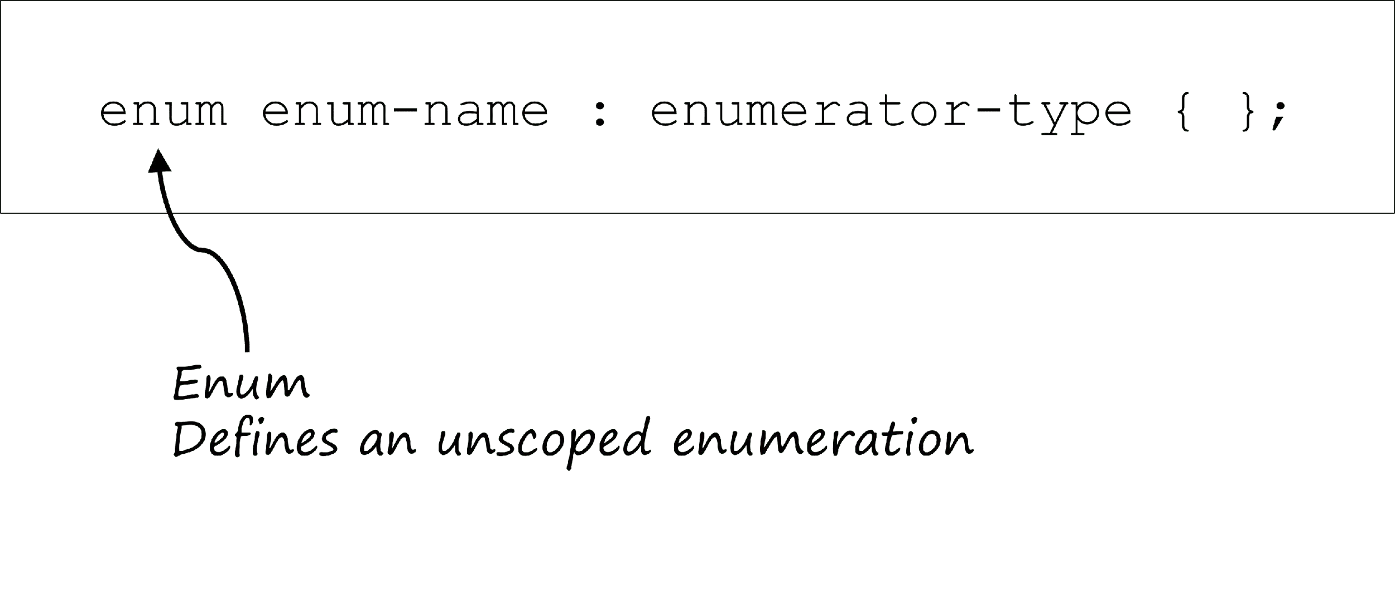

Unscoped Enumerations

BONUS SECTION - ENUMERATIONS

Enums-CPP-0080-3

Using if and switch statements with unscoped enumerations

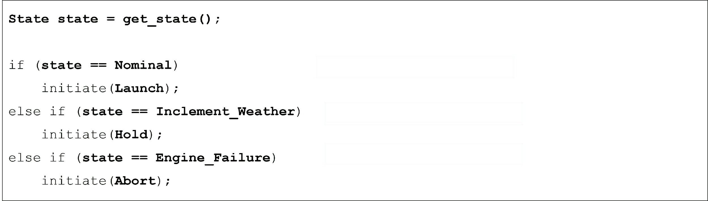

Using if and switch statements with unscoped enumerations

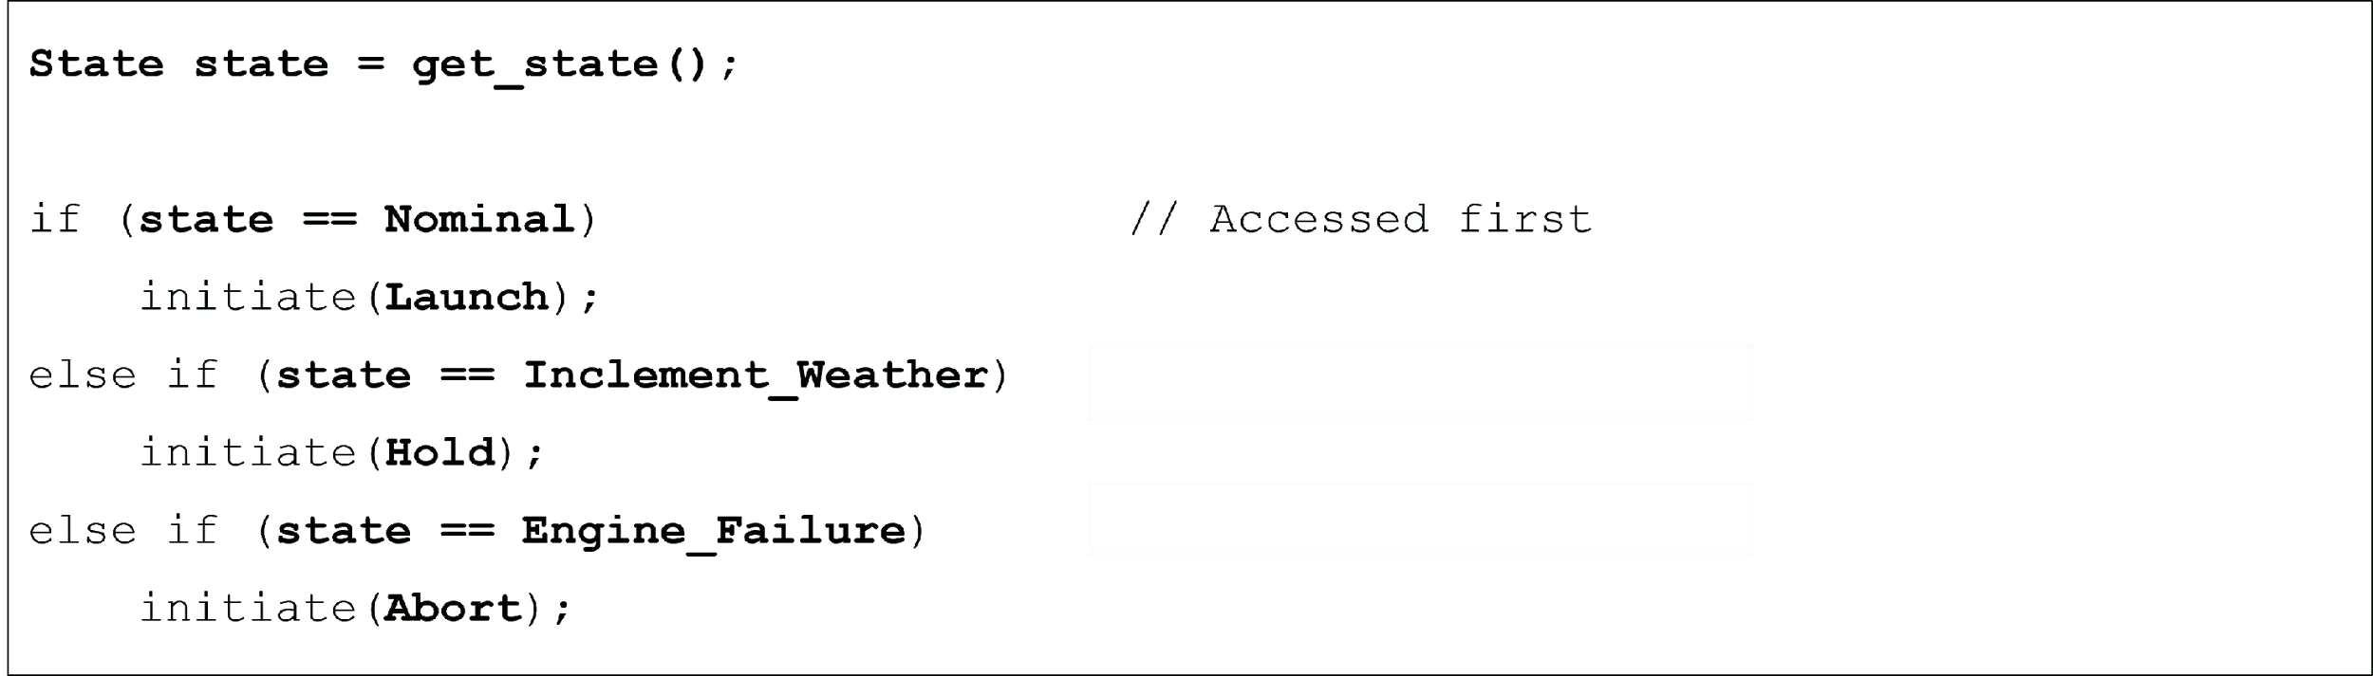

Using if and switch statements with unscoped enumerations

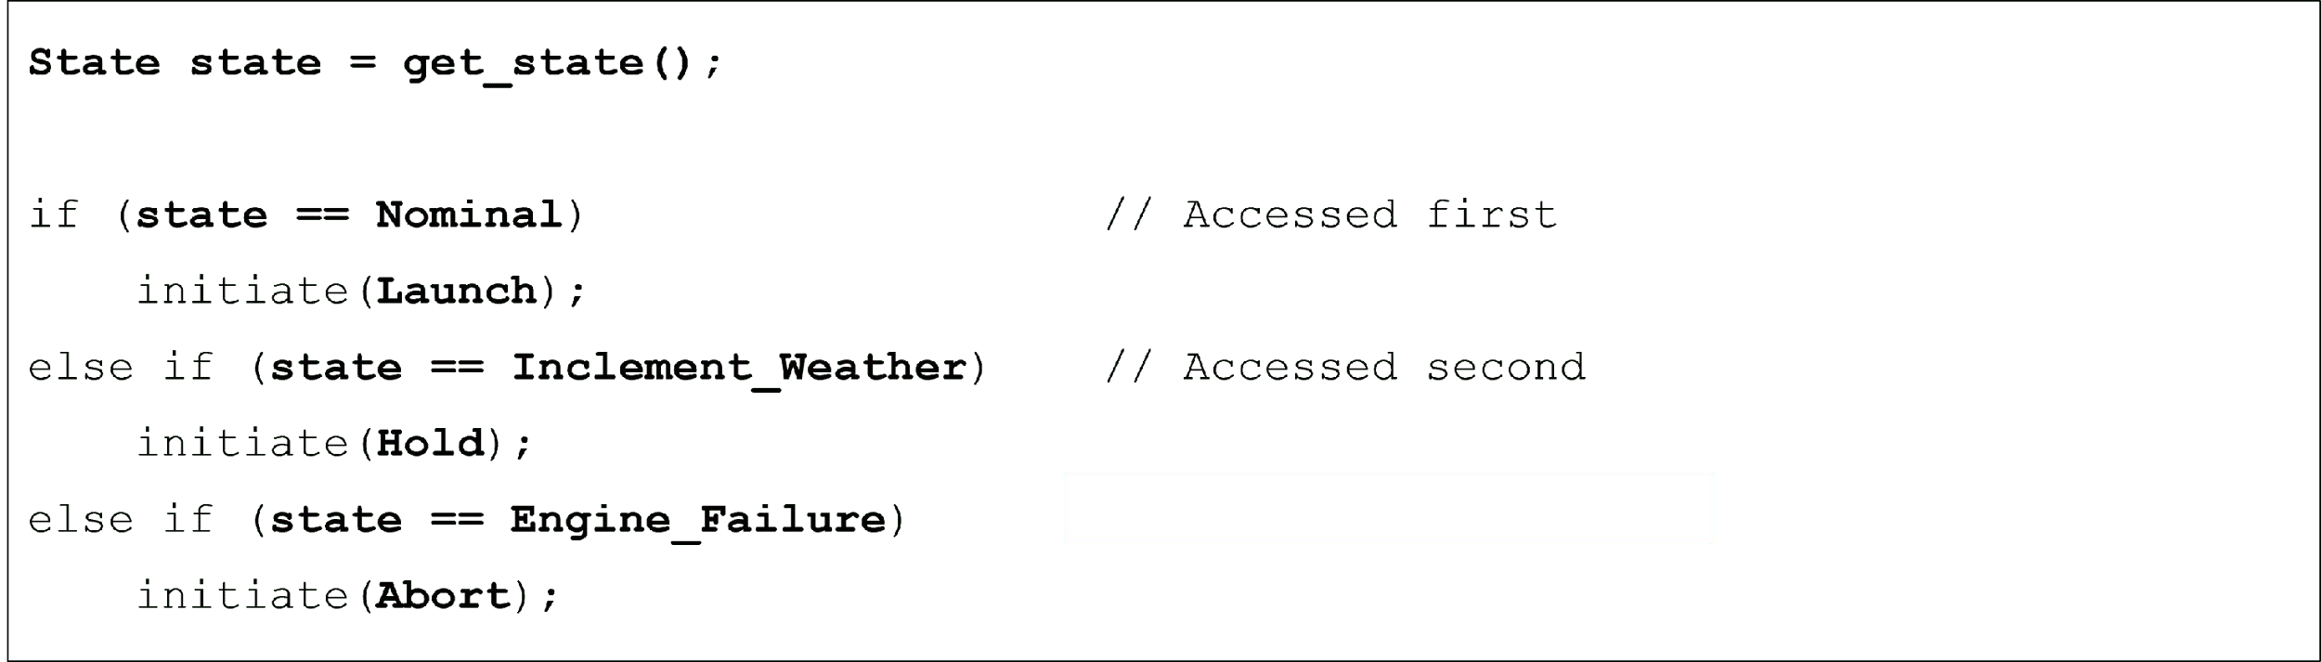

Using if and switch statements with unscoped enumerations

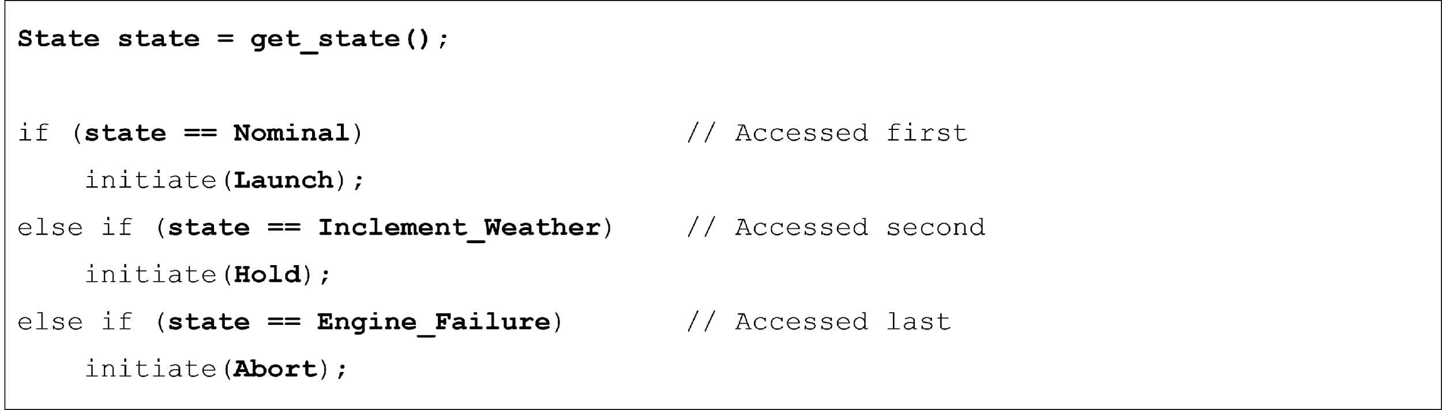

Using if and switch statements with unscoped enumerations

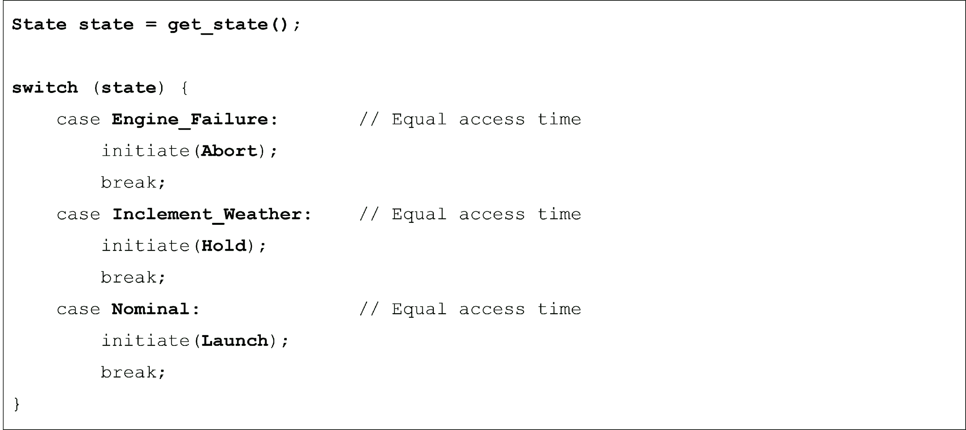

Using cin and cout with unscoped enumerations

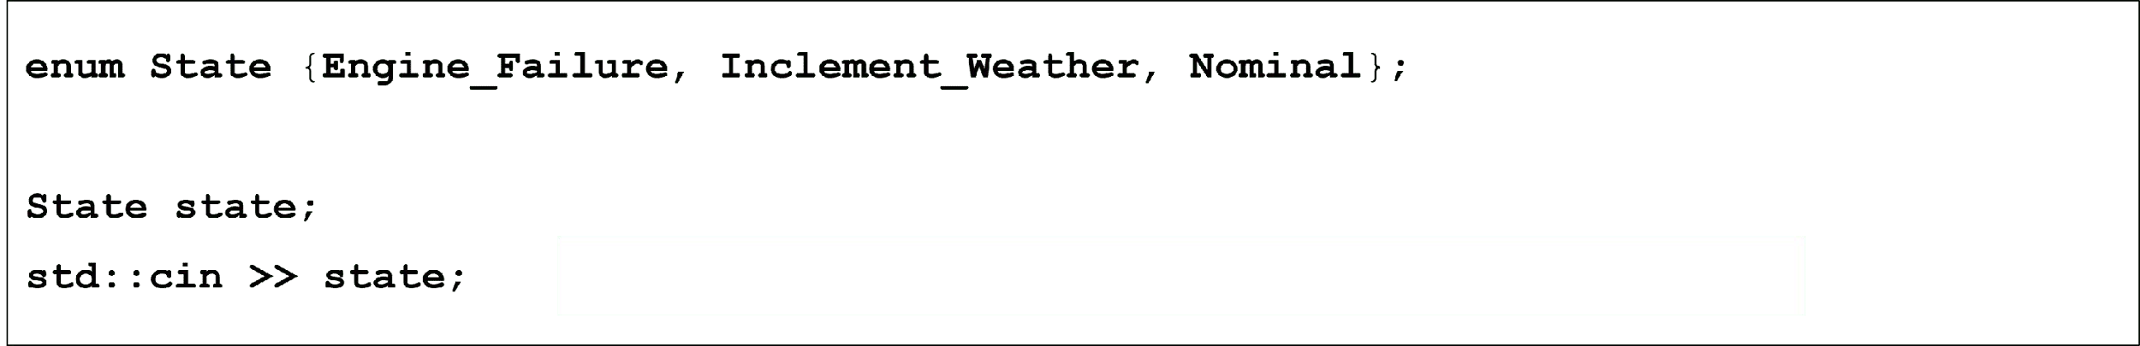

Using cin and cout with unscoped enumerations

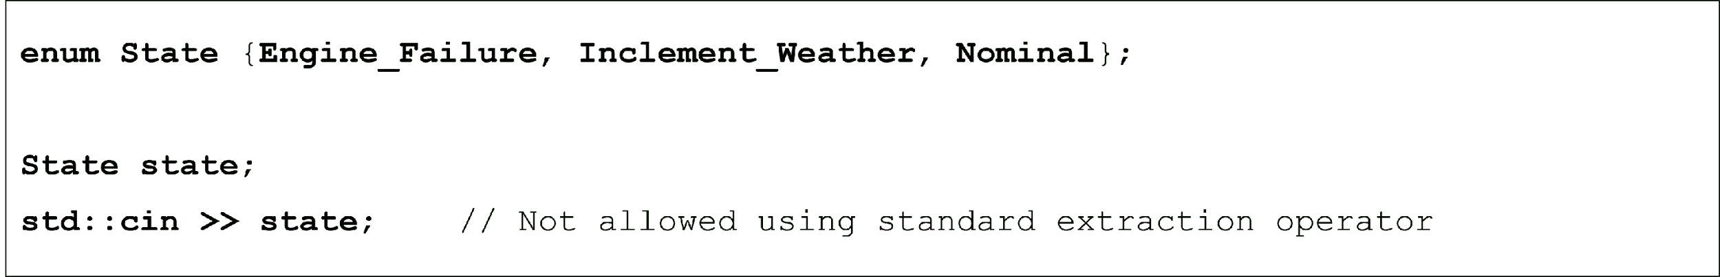

Using cin and cout with unscoped enumerations

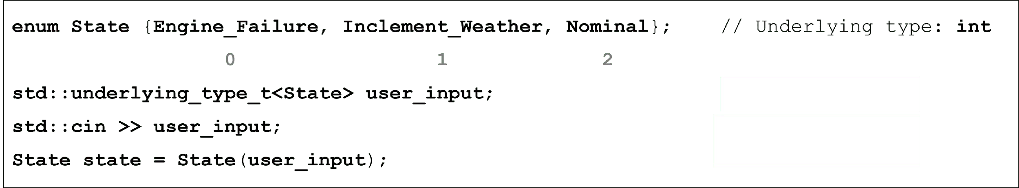

Using cin and cout with unscoped enumerations

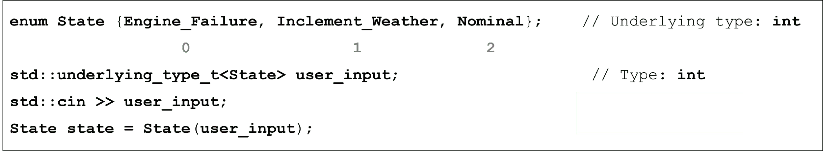

Using cin and cout with unscoped enumerations

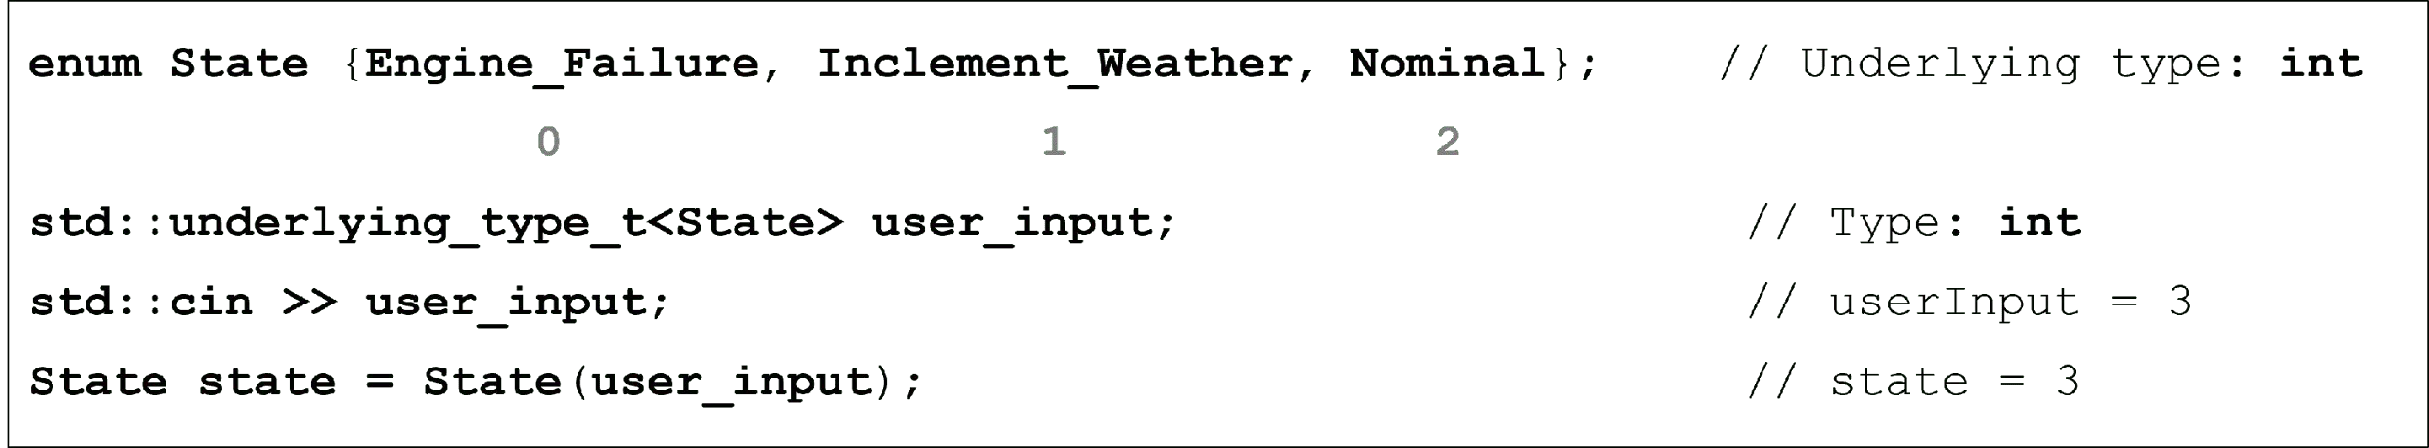

Using cin and cout with unscoped enumerations

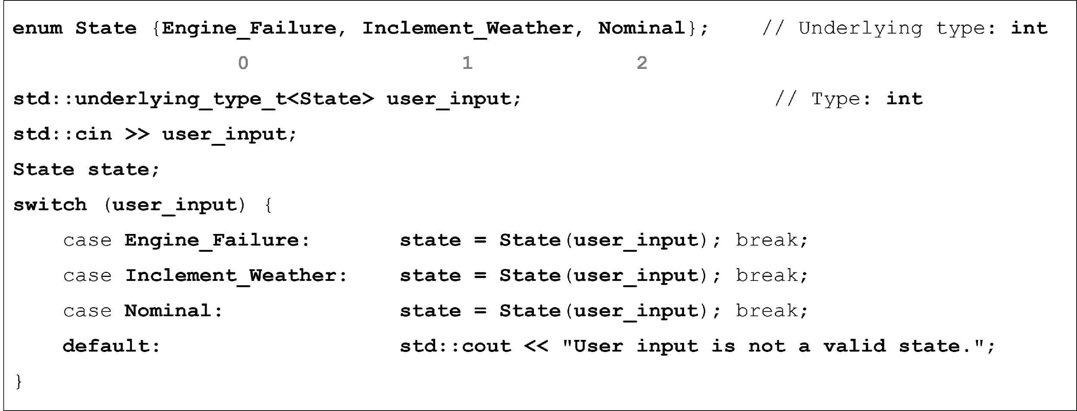

Using cin and cout with unscoped enumerations

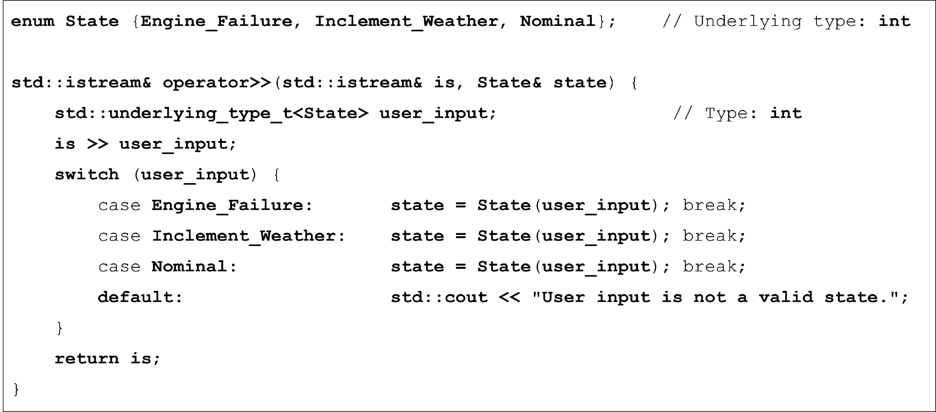

Using cin and cout with unscoped enumerations

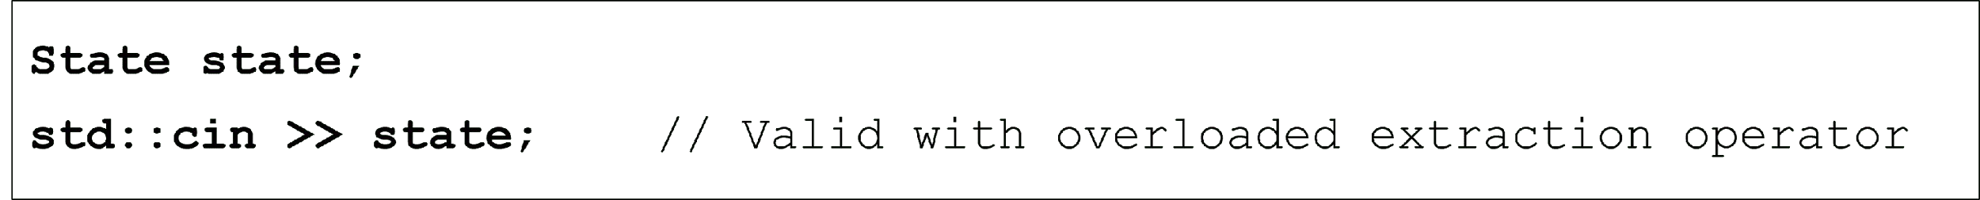

Using cin and cout with unscoped enumerations

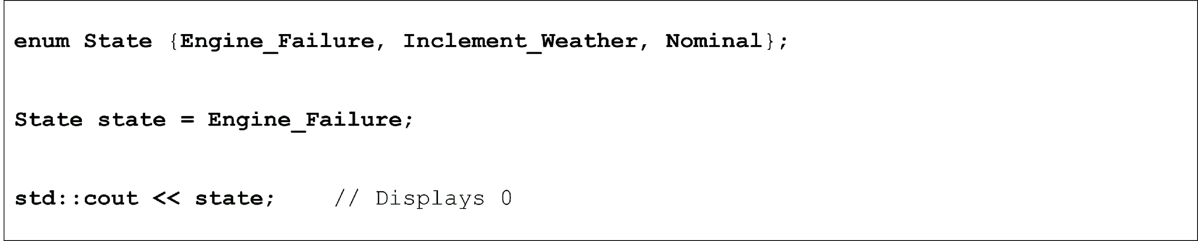

Using cin and cout with unscoped enumerations

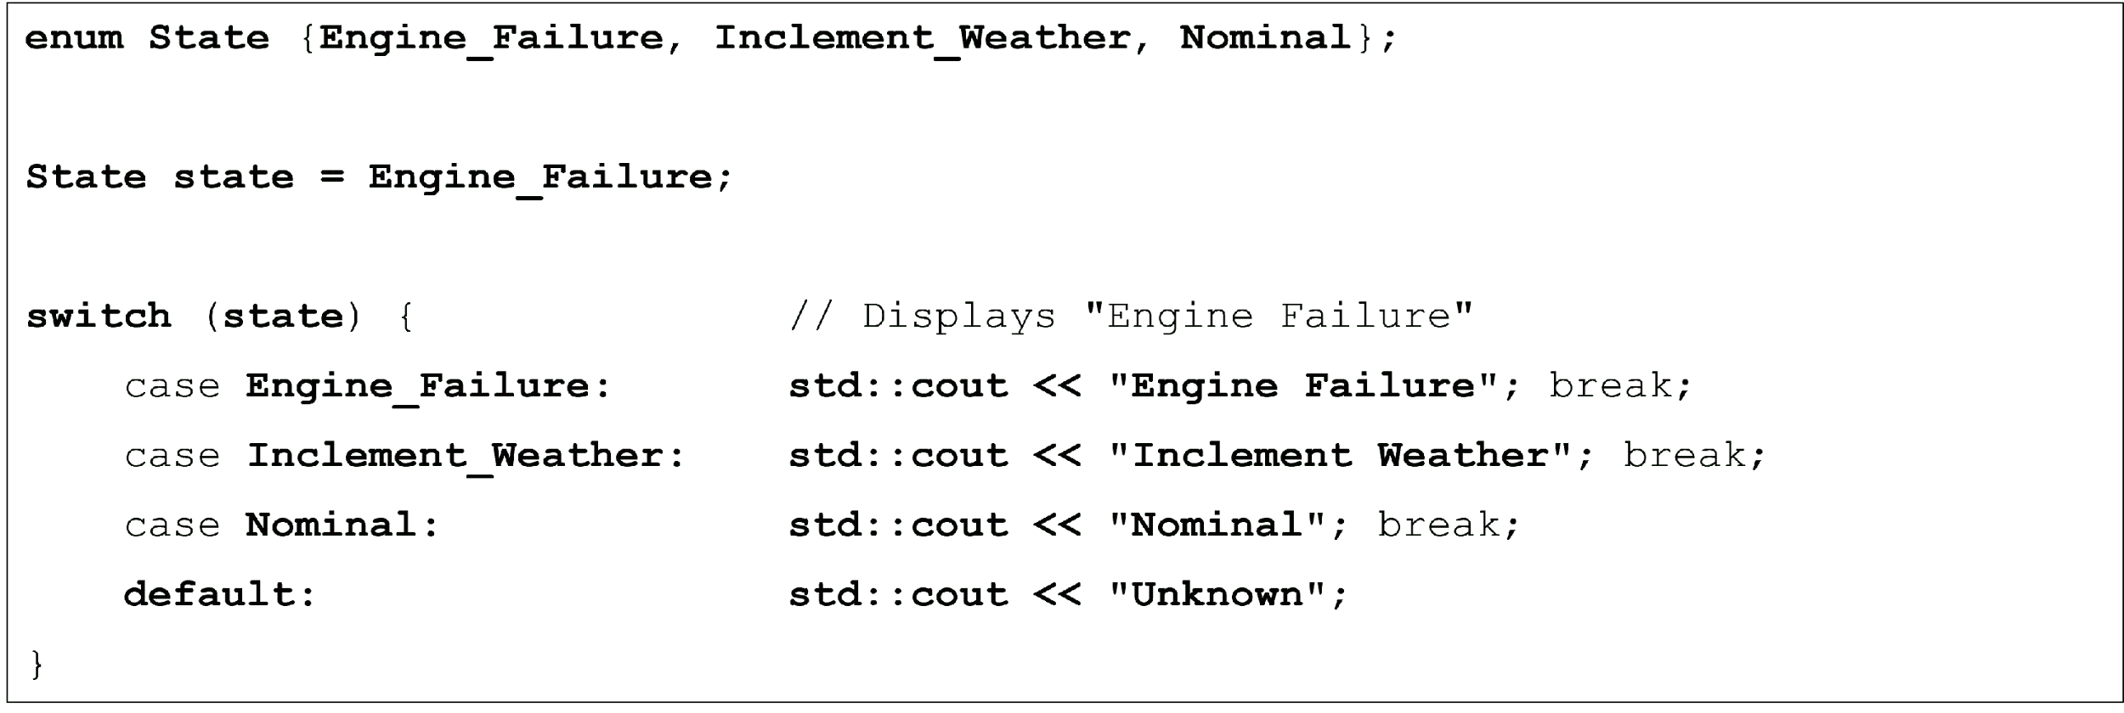

Using cin and cout with unscoped enumerations

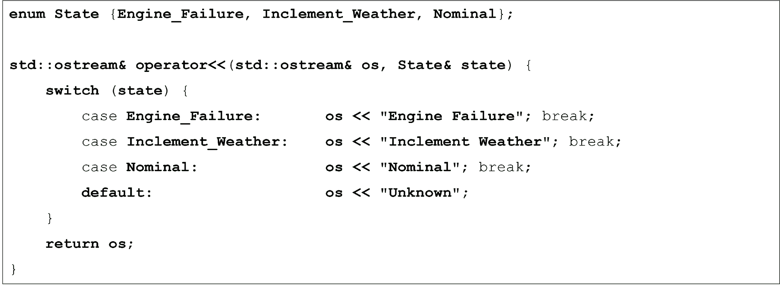

Using cin and cout with unscoped enumerations



Using cin and cout with unscoped enumerations

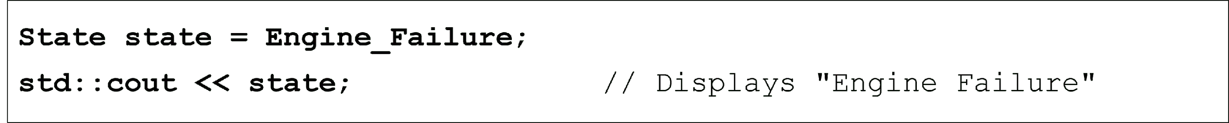

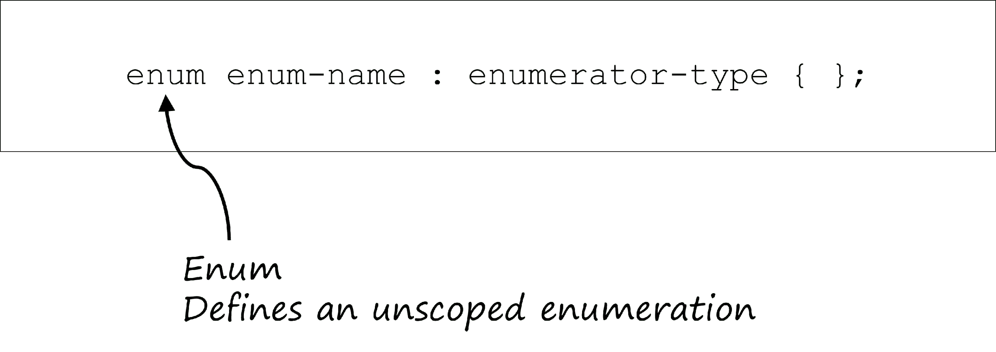

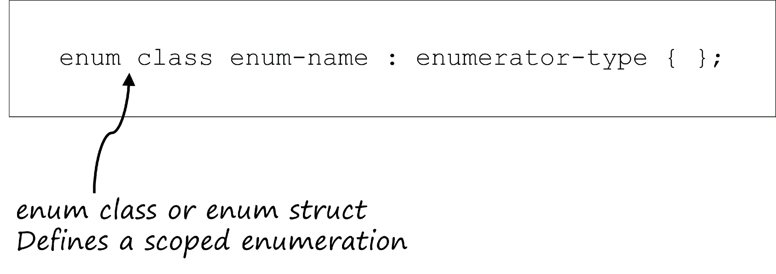

Motivation

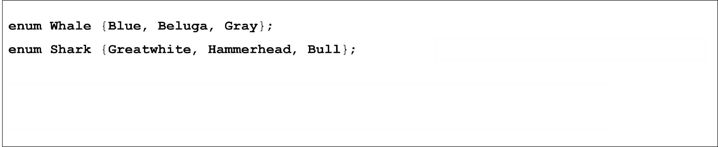

Motivation

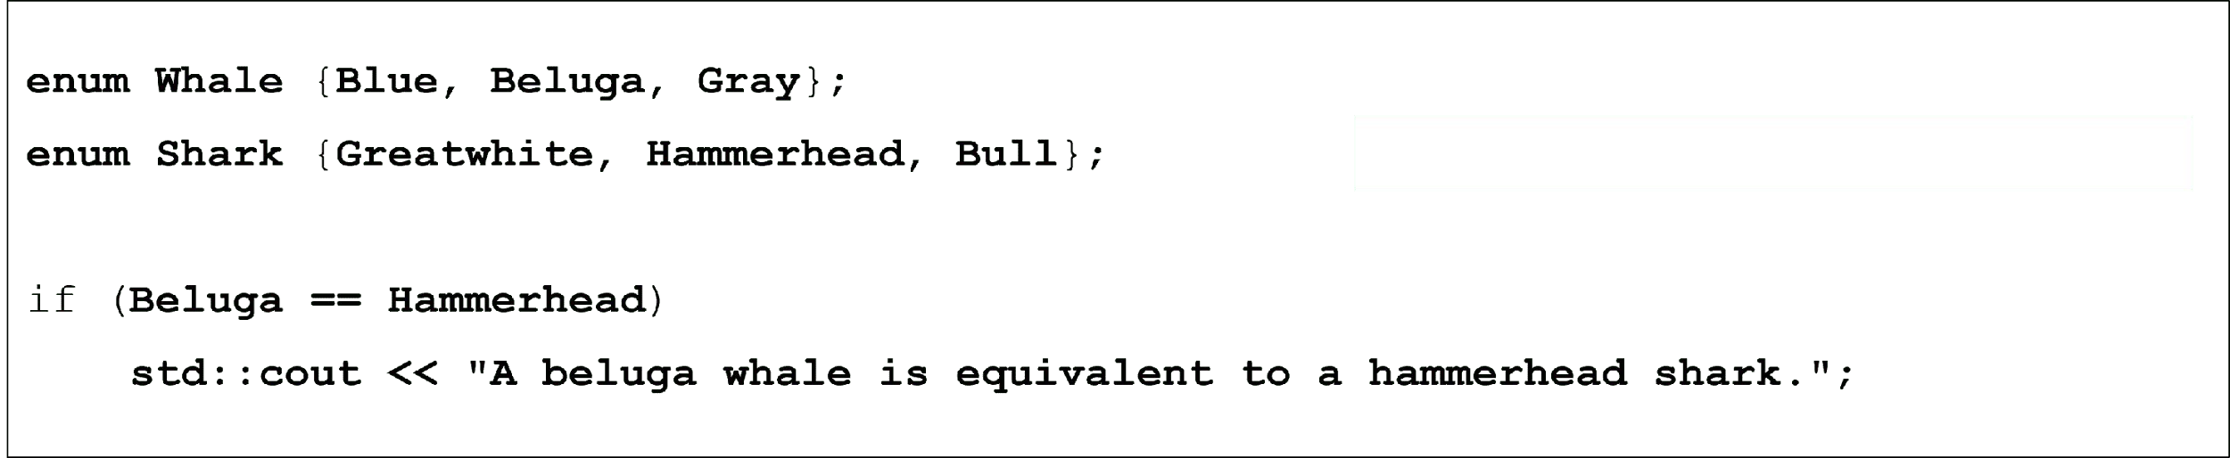

Motivation

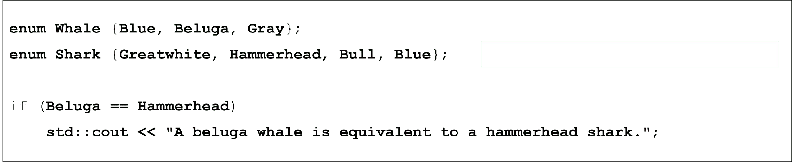

Motivation

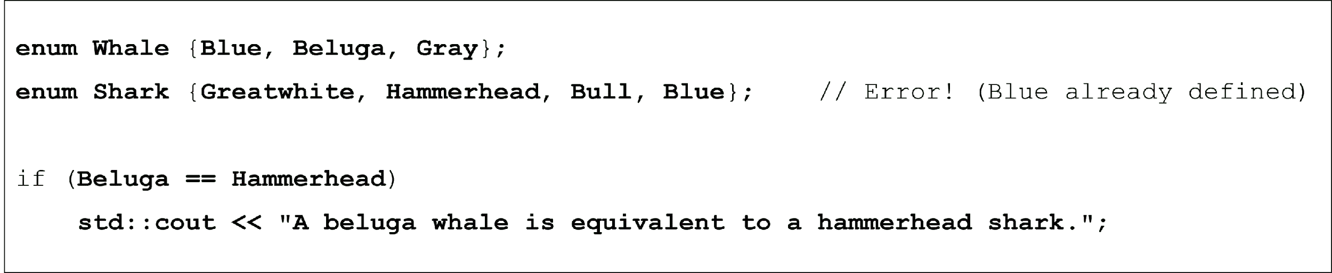

Using if and switch statements with scoped enumerations

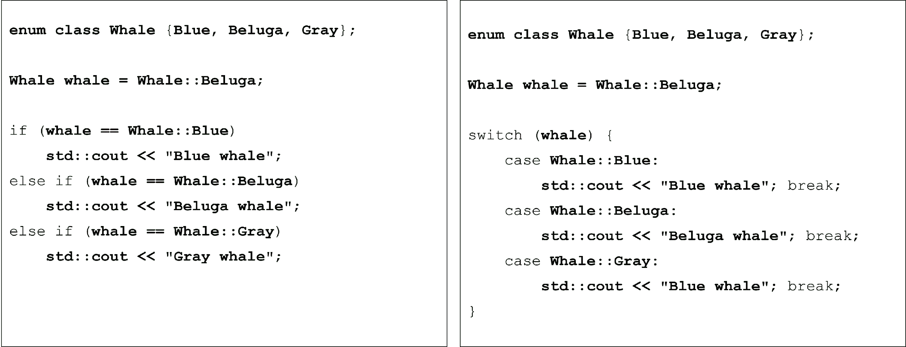

Using scoped enumerator values

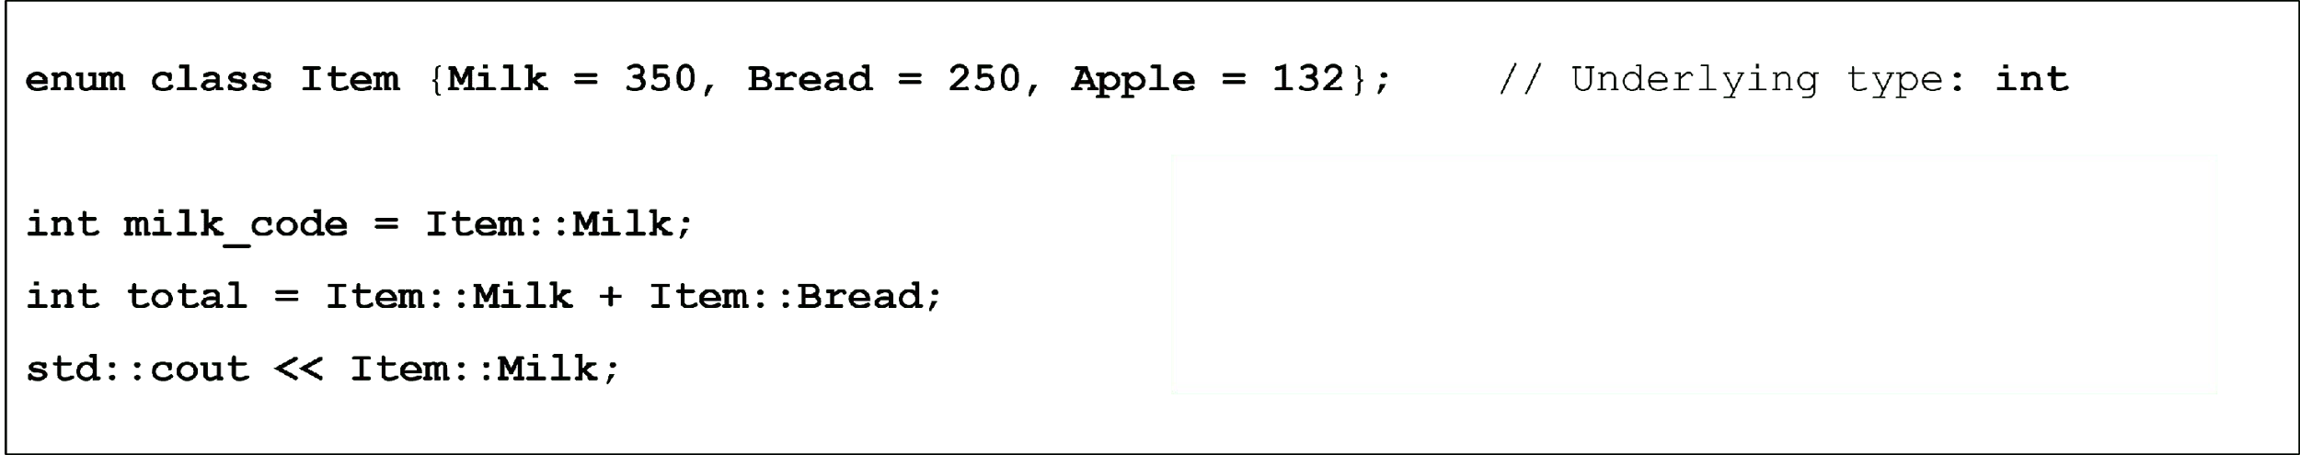

Using scoped enumerator values

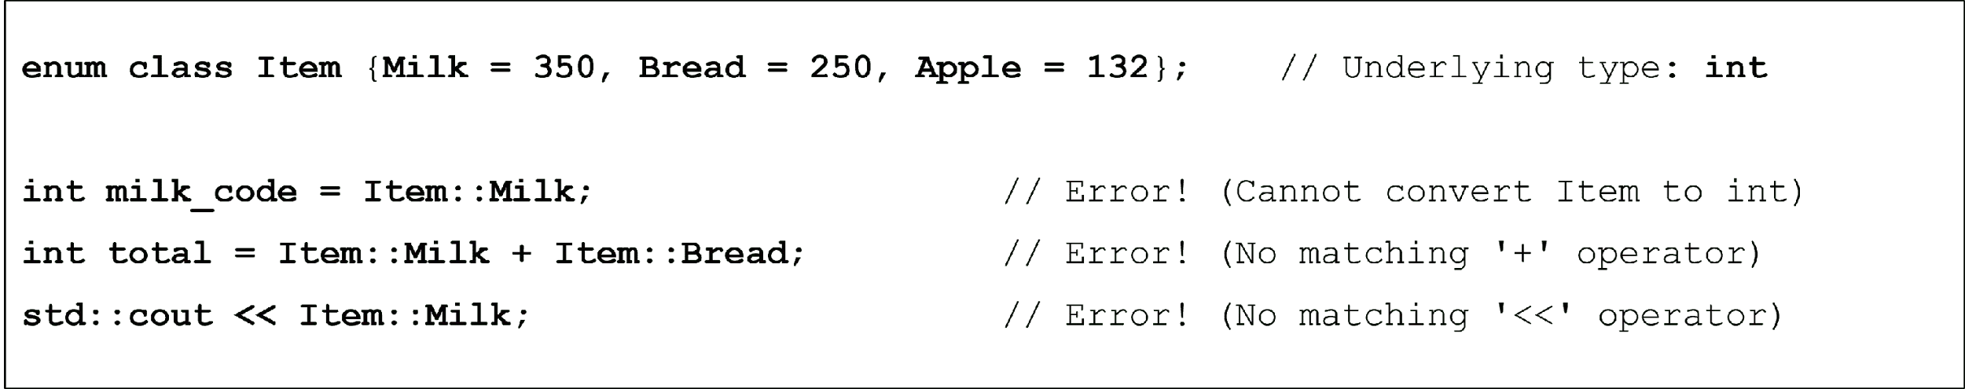

Using scoped enumerator values

